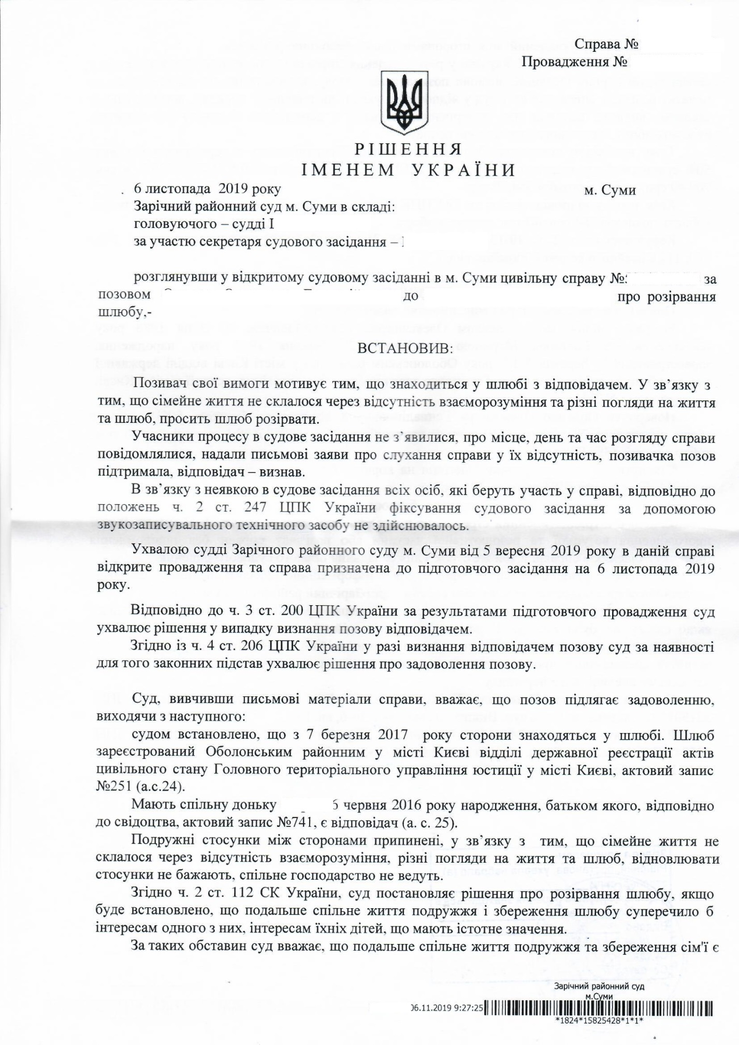

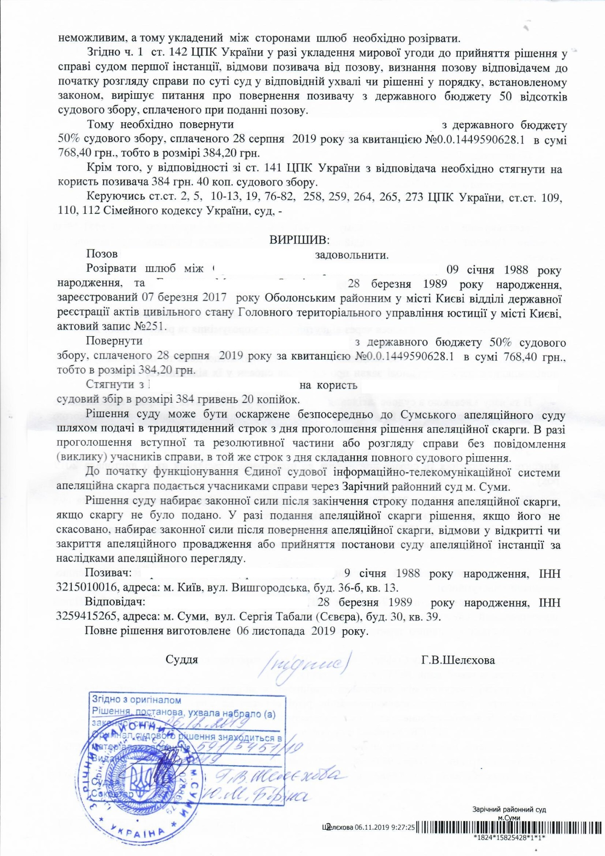


COPY OF DOCUMENT
Case number: #591/5451/19
Court proceedings number: #2/591/2711/19
DECISION
IN THE NAME OF UKRAINE
November 6, 2019 Sumy city
Zarichniy District Court in Sumy city composed of:
the Presiding Judge - G.V. Shelehova
the Secretary - S.M. Bondar,
having examined in a preceding court session in Sumy city a civil case #591/5451/19 on a claim of Oleksandr Henadiyovych Orlenko to Maryna Olehivna Godyniuk on the dissolution of marriage,

FOUND:
The Petitioner has filed his claim for he is married to the Respondent. Due to the lack of common ground and understanding within the family, due to the lack of mutual perspectives on life and marriage, the Petitioner claims on the dissolution of marriage.
The Parties of the case did not appear at the hearing, had been informed of the place, day and time of the case hearing, had stated in writing about hearing the case without their presence, the Petitioner had validated the claim, the Respondent had recognized the claim.
Due to the absence of the Parties at the court hearing, in accordance with the Art. 247 Part 2 of the Code of Civil Procedure of Ukraine, the audio recording of the court hearing with the help of recording equipment was not used.
By the decision of the Judge of Zarichniy District Court in Sumy city on September 5, 2019, there was opened the case and preliminary case hearing was scheduled on November 6, 2019.
According to Art. 200 Part 3 of the Code of Civil Procedure of Ukraine, due to the results of preliminary case hearing, the Court makes a decision in the case if the claim is recognized by the Respondent.
According to Art. 206 Part 4 of the Code of Civil Procedure of Ukraine, if the Respondent recognizes the claim, the Court, if there exist legitimate grounds, makes a decision on the satisfaction of the claim.
The Court, having examined the written case materials, considers the claim to be satisfied, on the following basis:
the Court found that the Parties had been married since March 7, 2017. The marriage was registered by Obolon District in Kyiv city at Civil Status Registration Department of the Main Territorial Department of Justice in Kyiv city, Act #251 (a.с. 24).
The Parties have a common daughter, Sofiia, who was born on June 6, 2016, whose father, according to the birth certificate, Act #741 (a.с. 25), is the Petitioner.
The marital relations between the Parties are terminated due to the lack of common ground and understanding within the family, due to the lack of mutual perspectives on life and marriage, the Parties do not want to re-establish relations, the Parties do not have a joint economy. According to Art. 112 Part 2 of the Civil Code of Ukraine, the Court decides on the dissolution of the marriage, if it is established that further cohabitation of the spouses and preservation of the marriage would be contrary to the interests of one of the Parties or the interests of their children, which are essential.
Under such circumstances, the Court considers the further cohabitation of the Parties and the preservation of the family to be impossible, and, therefore, the marriage between the Parties must be ended. According to Art. 142 Part 1 of the Code of Civil Procedure of Ukraine, if there is a pacific settlement between the Parties before the decision in the Court of the primary jurisdiction, the Petitioner’s waiver claim, the Respondent’s recognition of the claim before the consideration of the case on the merits by the Court, in the relevant decision or the decision in accordance with the legal procedure, decides to return to the Petitioner 50% of the court fee, paid when filing a claim, from the state budget.
Therefore, it is indispensible to return to Oleksandr Henadiyovych Orlenko 50% of the court fee in the amount of UAH 768.40, paid on August 28, 2019, receipt #0.0.1449590628.1, from the state budget, id est., in the amount of UAH 384.20.
In addition, in accordance with Article 141 of the Code of Civil Procedure of Ukraine, the court fee in the amount of UAH 384.20 must be awarded to the Petitioner from the Respondent.
Based on Art. Art. 2, 5, 10-13, 19, 76-82, 258, 259, 264, 265, 273 of the Code of Civil Procedure of Ukraine, and based on Art. Art. 109, 110, 112 of the Family Code of Ukraine, the Court, -

DECIDED:
The claim of Oleksandr Henadiyovych Orlenko to be satisfied.
To dissolve the marriage between Oleksandr Henadiyovych Orlenko, who was born on January 9, 1988, and Maryna Olehivna Godyniuk, who was born on March 28, 1989, registered on March 07, 2017 by Obolon District of Kyiv city at Civil Status Registration Department of the Main Territorial Department of Justice in Kyiv city, Act #251.
To return to Oleksandr Henadiyovych Orlenko 50% of the court fee in the amount of UAH 768.40, paid on August 28, 2019, receipt #0.0.1449590628.1, from the state budget, id est., in the amount of UAH 384.20.
To award the court fee in the amount of UAH 384.20 to the Petitioner from the Respondent.
The court decision can be appealed directly to Sumy Court of Appeal within 30 days from the effective date of announcement. If the introductory and resolutory part is declared or the case is heard without notification of the Parties, the court decision can be appealed within the same period from the effective date.
Until the introduction of the United Court Information and Telecommunication System, an appeal is filed by the Parties in Zarichniy District Court in Sumy city.
The court decision shall enter into force after the deadline for an appeal, if the appeal has not been lodged. If an appeal is filed, the decision, if not reversed, shall enter into force upon the return of the appeal, its denial or the closure, or the decision of the Court of appeal.
The Petitioner: Oleksandr Henadiyovych Orlenko, who was born on January 9, 1988, Tax Identification Code: 3215010016, Address: Kyiv city, 36-b Vyshgorodska Str, app. 13.
The Respondent: Maryna Olehivna Godyniuk, who was born on March 28, 1989, Tax Identification Code: 3259415265, address: Sumy city, 30 Sergiya Tabaly Str. (Severa), app. 39.
The complete decision was made on November 6, 2019.
Judge /signed/ G.V. Shelehova
In accordance with the original
Judge /signed/ G.V. Shelehova
[Round seal Zarichniy District Court*Sumy city*Ukraine*Identification code /illegible/]

