To what extent does eating no meat impact the life expectancy of people?
It is stated in most studies that vegans live longer than meat eaters. This article will have a look at some studies that tried to figure out if the given statement is really true. In fact, there are two major factors that urge people to become vegans: health and the care of people for the environment. Veganism means refusing to eat meat, eggs, dairy products and anything that comes from animals.
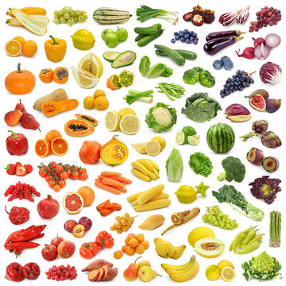
Studies that supported the idea
A great number of studies have been carried out to find out whether veganism influences how long a person can live and most of them have confirmed that vegans have a longer life expectancy than meat eaters. For example, the scientists at the Massachusetts General Hospital looked into the diet and health recorders of over 130.000 people and discovered that a 3% rise in the amount of calories from plant protein may reduce the risk of all deaths by 10%. They also mentioned that it also leads to a decrease in the rate of death from heart disease.
Another study fulfilled by a lecturer at Manchester Metropolitan University showed that vegans eat more dietary fiber, less cholesterol and fat. Cholesterol and fat are contained mostly in meat, so researchers suggest that we should stop eating meat as soon as possible and follow a certain healthy eating habit that prevents us from suffering from several serious illnesses.
And also, the findings published in the Journal of The American Osteopathic Association made the researchers conclude that meat eaters are more likely to suffer from cardiovascular disease as well as cancer. Depending on this study, we may notice that there is a significant difference between the consequences of eating meat and eating no meat.
The reasons why vegans live longer
One of the articles in Time Magazine, which was published on February 24, 2014, was dedicated to seven reasons why vegans live longer than meat eaters. According to the article, those who do not eat meat have a lower risk of some diseases such as heart disease, cancer and diabetes. Furthermore, the article states that vegans mostly tend to be in a good mood, which means that they look at everything optimistically. Most studies point that that optimism keeps you away from all the trials and tribulations of life. And also, eating no meat enables vegans to avoid being overweight, which, in turn, causes a considerable number of diseases. Finally, it is important to mention that if you do not consume meat or meat products, your blood pressure will be at a balanced level. Namely, vegans are recorded to have a lower risk of blood pressure according to some researches.

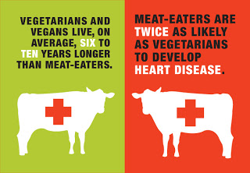

Studied that rejected the idea
However, not all studies support the idea mentioned above. In other words, some scientists have come to the conclusion that veganism makes no difference in how long people live. For instance, the IFL Science and the Sax Institute 45 and Up Study stated that people who do not eat meat and dairy products try to follow a strict healthy lifestyle. Not only do they try to avoid eating meat, but they also pay particular attention to doing more things to maintain their health. Veganism is merely one of the factors that they take into consideration. Besides avoiding eating meat, they try to eat more fruit and vegetables, do exercises regularly and avoid drinking alcohol, which may pose a threat to their health.
Conclusion
In conclusion, it is essential to note that most of the studies indicate that avoiding eating meat can lead to an increase in the life expectancy of people by at least three years. Therefore, people should take full responsibility for their own health and take measures in order to keep their health in good condition.

Advice:
1. Try to make a strict dietary plan.
2. Do not fully rely on a diet itself. Try to spare time for such activities as cycling, hiking, jogging and swimming. Do exercises regularly and follow a strict daily regime.

http://www.independent.co.uk/life-style/health-and-families/health-news/vegan-meat-life-expectancy-eggs-dairy-research-a7168036.html
https://www.unilad.co.uk/featured/vegans-live-a-lot-longer-than-meat-eaters/
https://www.shape.com/healthy-eating/diet-tips/vegetarians-live-35-years-longer-meat-eaters
http://time.com/9463/7-reasons-vegetarians-live-longer/
https://www.indy100.com/article/vegetarians-live-longer-meat-eaters-life-span-7563891

