Presentation

1.All-weather battery

2. Two-phase asynchronous motor

Engineer, a graduate of the Kharkov Polytechnic Institute, Tsehmistro Alexander

Kharkov 2015
Introduction
Lithium-ion (Li-ion) batteries.

Chemical processes in Li-ion battery

Oxides of cobalt is used as the active material for positive electrode in order to the battery voltage has been sufficiently large.
The lithiated cobalt oxide has a potential about 4 V of rather lithium electrode therefore so the operating voltage of Li-ion battery has a typical value of 3 V and above.

When the Li-ion battery discharged it occurs deintercalation of lithium from carbon material (at the negative electrode) and lithium oxide intercalation (at the positive electrode) When battery is charging, the processes are going in the opposite direction.

Therefore, throughout the system there is no metallic (zero-valence), lithium, and processes of discharge and charge are reduced to the transfer of lithium ions of one electrode to the other. That`s why such batteries are called "lithium-ion" or rechargeable batteries of rocking chairs type.

Processes on a negative charge an accumulator Li-ion electrode

All Li-ion batteries, brought to commercialization, the negative electrode is made of carbon materials. The intercalation of lithium into carbon materials is a complex process, the mechanism and kinetics of which substantially depend on natural material and nature of the electrolyte.
The carbon matrix used as the anode, can have an ordered layered structure ,as in natural or synthetic graphite and disordered amorphous or partially ordered(coke, pyrolysis of mesophase carbon, carbon black, etc.)
Lithium ions are moved apart when introducing the layers of the carbon matrix and are located between them, forming a variety of structures intercalate. The specific volume of the carbon materials in the process of intercalation of lithium ions decarcerate change slightly.
Besides carbon materials as a negative electrode of matrix are studied on the basis of tin, silver and their alloys, the sulfides of tin, cobalt phosphorites, composites of carbon with silicon nanoparticles.

Processes at the positive electrode Li-ion battery

Positive electrodes of lithium-ion batteries are created exclusively from lithiated oxides of cobalt or Nickel and lithium-manganese spinels. At present as cathode materials are increasingly used materials based on mixed oxides or phosphates. It is shown that cathodes of mixed oxides achieved the better battery performance. Are developed and technology of surface coating of cathodes by slim dispersed oxides.
When charging Li-ion battery, the following reactions occur on the positive plates:
LiCoO₂→Li_{1-x}CoO₂+xLi⁺+xe
on the negative plates:
C+xLi⁺+xe→CLi_{x}
During the discharge the reverse reactions occur. The charge process is illustrated by figure.

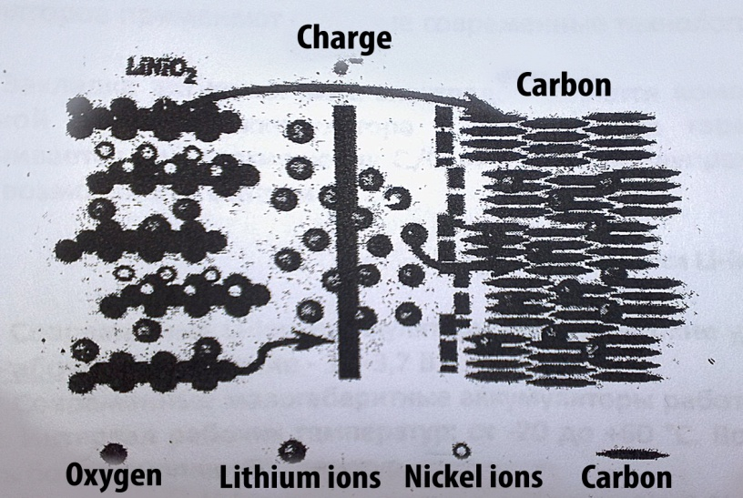

Fig. 1 The process of charging lithium-ion (Li-ion) battery

The design of Li-ion batteries. Structurally, Li-ion batteries are manufactured in cylindrical and prismatic versions. In cylindrical batteries rolled into a roll package of electrodes and a separator placed in steel or aluminum housing, which is connected to the negative electrode. The positive pole of the battery is derived through the insulator to the cover.

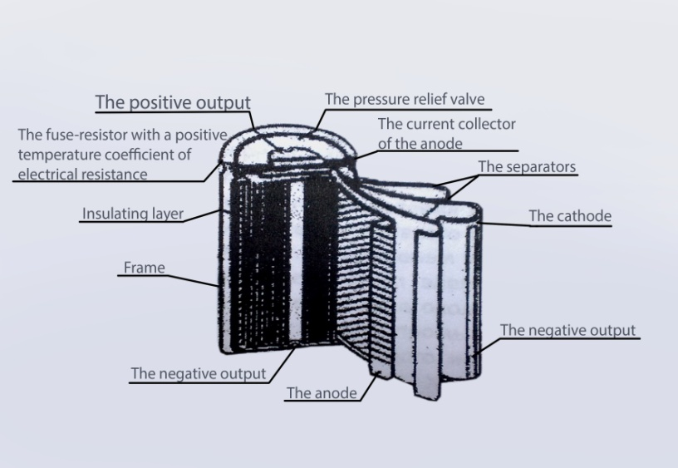

Fig.2 Device of lithium-ion Li-ion battery

Some constructive measures are usually undertaken and for the prevention of a fast warming up and safety of work of Li-ion of accumulators. Under a cover of the accumulator there is a device reacting to positive temperature coefficient increase in resistance, and another which breaks electric link between the cathode and the positive plug at increase of pressure of gases in the accumulator above an admissible example.
To increase of safety of operation of Li-ion of accumulators as a part of the battery it is surely applied also an external electronic protection intended to prevent the possibility of overcharge and overdischarge of each battery, short circuit and excessive heating.
Opposite electrodes in lithium and lithium-ion batteries are separated by separator of porous polypropylene.
The design of Li-ion and other lithium accumulators, as well as design of all primary sources of current ("batteries") with the lithium anode, differs in absolute tightness. The requirement of absolute tightness is defined as an unacceptable leakage of liquid electrolyte(negatively acting on the equipment),and the inadmissibility of the contact in the battery of oxygen and water vapor from the environment. Oxygen and water vapor react with the material of the electrodes and the electrolyte and the cavity removed the battery from the system.
Technological operations of production of electrodes and other details, and also assembly of batteries
are carried out in special dry rooms or in sealed boxes in an atmosphere of pure argon.
In the Assembly of batteries is used difficult modern technology of welding, difficult design of cable glands.
The laying of active mass of electrodes is a compromise between desire to reach a maximum of digit capacity of the accumulator and the requirement to guarantee safety of its functioning which is ensured at С/С1+=>1,1 for the prevention of formation of metal lithium(and thus possibilities of fire)

Product specifications of Li-ion batteries

Modern lithium-ion batteries have high specific characteristics:100-180 WH/kg and 250-400 WH/l Operating voltage of 3.5-3.7 V.
Modern small-sized batteries are operated at discharge currents of up to 2 C, powerful-up to 10-20 C. The working interval: -20 to +60C. It is possible extension of the temperature interval to higher temperatures.
Self-discharge Li-ion batteries is 4-6% for the first month ,then significantly less: over 12 months batteries will lose 10-20% of stored capacity. Loss of capacity in Li-ion batteries in several times less than that of Nickel-cadmium batteries ,as at 20C and 40C. The resource -500-1000 cycles.

Charge Li-ion batteries

Li-ion batteries charge in combined mode: first at constant current( in the range from 0.2 C to 1 C) until the voltage of 4.1-4.2 V (depending on manufacturer's recommendations),then at a constant voltage.
The first stage of charge can lasts about 40 minutes, the second stage is longer. A faster charge can be achieved by impulsive mode.
In the initial period ,when there were only Li-ion accumulator the battery using a graphite system ,required the limitation of the voltage rate of 4.1 V per element. Although the use of a higher voltage allows you to increase the energy density ,oxidative reactions occurring in the elements of this type, when voltages exceeding the threshold of 4.1 V ,leading to a reduction in their lifespan.
Over time this disadvantage was liquidated due to application of chemical additives, and now Li-ion elements can be charged up to the voltage 4,20 V. Voltage tolerance is only about ±0.05 V per element.

Li-ion batteries for industrial and military purpose should have a long service life unlike batteries for commercial use. That`s why for them the threshold voltage of end charge is to 3.90 volts per cell. Although the energy density (kWh/kg) of these batteries is lower, an increased service life with small size, low weight and higher in comparison with batteries of other types put energy density Li-ion batteries apart from the competition.

When charging Li-ion battery current 1C charging time is 2-3 hours.
Li-ion the battery reaches a condition of a total charge when tension on it becomes equal to the pinch-off voltage current thus decreases considerably and is approximately 3% from the current charge.

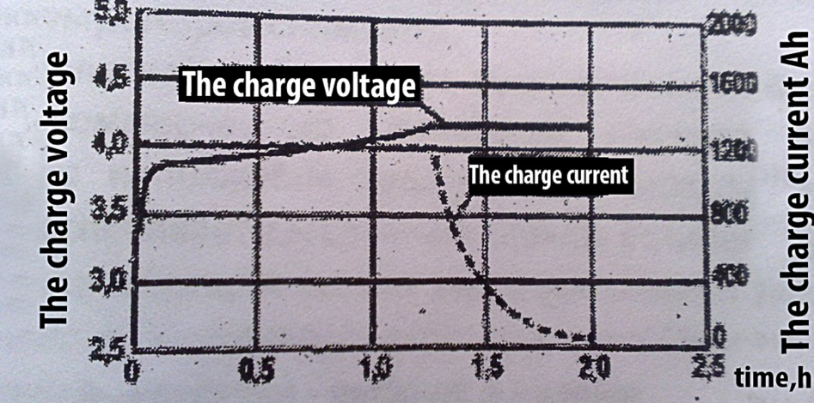
Fig.3 The dependence of the voltage and current versus time during charging lithium-ion (Li-ion) battery

If on Fig.3 shows a typical graph of charge one type of Li-ion batteries, in Fig.4 the charge process are shown more clearly. With increasing charging current Li-ion battery charge time any not significantly reduced.
Although at higher charge current the voltage on the battery increases faster, the charging stage after the first stage of the charge cycle lasts longer.
In some types of chargers for charging lithium-ion battery takes time 1 hour or less. In such charging devices stage 2 is eliminated, and the battery goes into the ready state immediately after the end of phase 1. At this point, Li-ion battery is charged about 70%, and after that additional charge.

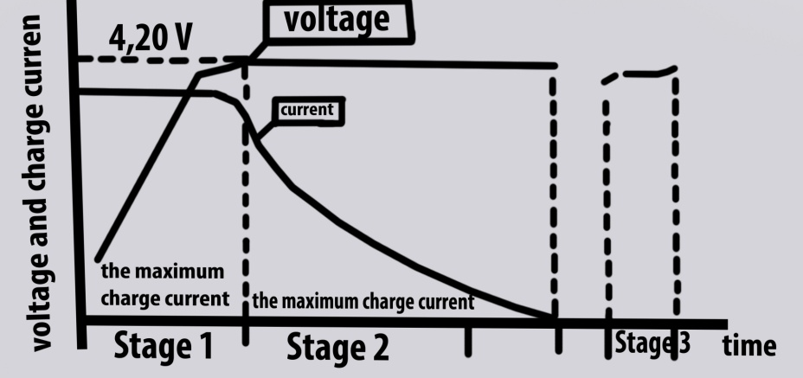

Fig. 4. The dependence of the voltage and current versus time during charging Li-ion battery

PHASE 1 - Through the battery flows maximum permissible charge current until the voltage across it reaches the threshold value.
PHASE 2 -Maximum voltage at the battery is reached, the charge current gradually decreases until it is completely charged. The end of charge occurs when the amount of the charging current will decrease to a value of 3% of the initial.
PHASE 3– The periodic compensating charge which is carried out at the storage of battery, approximately every 500 hours of storages.
The jet stage charging for Li-ion batteries is not applicable due to the fact that they can't absorb energy during recharge
Moreover, jet charging can cause lithium plating, which makes the battery unstable. On the contrary, short recharging direct current is able to compensate for the small self-discharge Li-ion battery and to compensate for energy loss caused by work of protection device. Depending on the charger and the extent of self-discharge Li-ion battery such charge can be performed every 500 hours or 20 days.
Usually it should be realized when reducing the open circuit voltage to 4.05 V/cell and stop when it reaches 4,20 V /cell.
So Li-ion batteries have a low tolerance to overcharging. At the negative electrode on the surface of carbon matrix with a significant overcharge is made possible deposition of metallic lithium (in the form of finely crushed mossy precipitate) having a high reactivity to the electrolyte and the cathode active evolution of oxygen. There is a threat of heat dispersal, increasing the pressure and depressurization. Therefore, the charge Li-ion batteries can lead only to a voltage recommended by the manufacturer. With increased charging voltage, the battery life decreases.
Safe Li-ion batteries should be given serious attention. In Li-ion batteries for commercial use-there is a special protection device that prevents excess voltage above a certain threshold.
An additional security feature ensures the end of charge if the battery temperature reaches 90 °C. The most advanced design batteries have a one more element of protection – mechanical switch that is triggered by increased pressure inside the shell-type battery. Built-in control voltage is set to two voltage cut-off – top and bottom.
There are exceptions - Li-ion battery, in which the protective devices are absent. This battery, which include manganese. Thanks to his presence, when the overcharge reaction of metallization of the anode and oxygen evolution at the cathode are so slow that it became possible to renounce the use of protection devices.

The safety of Li-ion batteries

All lithium batteries have rather good safety.The loss of capacity by self-discharge is 5-10 % per year.

The figures should be regarded as some nominal orientation.For each battery,for example, discharge voltage depends on discharge current,temperature;a resource depends on modes(currents)discharge and charge,temperature,the degree of discharge;operating temperature range depends on the level of resource depletion,the allowable working stress etc. The disadvantages of lithium-ion batteries are sensitivity to overcharges and overdischarges, because of this, they must have the terminators charge and discharge.
A typical view of the discharge characteristics of lithium-ion batteries shown in Fig.5 and 6.

The figures show that with increasing of the discharge current discharge capacity of the battery decreases slightly,but decreases the working voltage. The same effect appears in the discharge at a temperature below 10C.In addition, at low temperatures has the value of the initial voltage drop.
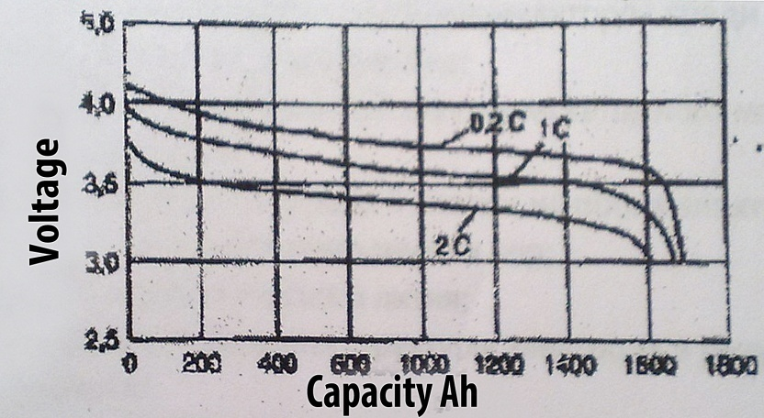

Fig.5 Discharge characteristics of Li-ion battery at different currents

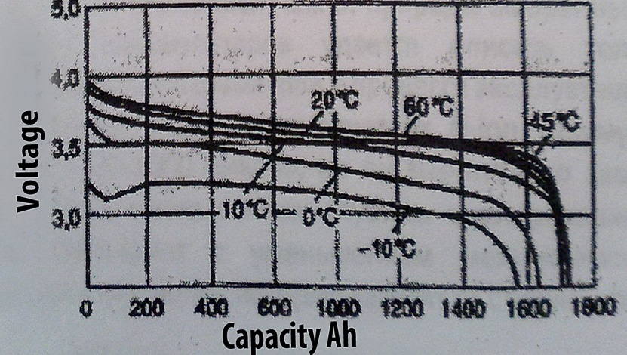

Fig.6 Discharge characteristics of Li-ion battery at different temperatures

As regards the exploitation of Li-ion batteries at all,considering all the design and chemical ways to protect the batteries from overheating and overcharging can be considered the problem of safe operation of Li-ion batteries are solved. As new cathode materials often provide even greater thermal stability of Li-ion batteries.

The safety of Li-ion batteries

In the development of lithium and lithium-ion batteries,as with primary lithium cells,the safety issues of storage and use, special attention was paid .All batteries have a protection against internal short circuits (and in some cases -and from external short circuits).
Effective means of such protection is the application of a double layer of separator,one layer of which is made not of polypropylene and of a material similar to polyethylene.In case of a short circuit(e.g. due to sprouting dendrites of lithium to the positive electrode)by locally heating the layer of the separator fuses and becomes impenetrable, preventing, thus,further the sprouting of dendrites.

Protection device Li-ion battery

Li-ion batteries for commercial use-have the most perfect protection of all types of batteries.Typically, the protection circuit Li-ion battery uses the key a field effect transistor,which when the battery voltage of 4.30 V opens and thereby interrupts the charging process. Furthermore the thermal fuse by heating the battery up to 90 ° C disconnects the circuit to its load,thus ensuring its thermal protection .But that's not all.Some batteries have a switch that is triggered upon reaching a threshold pressure within the housing equal to 1034 kPa(10.5 kg/m2),and breaks the load circuit. There is a protection circuit against deep discharge,which monitors battery voltage and disconnects the load circuit,if the voltage drops to 2.5 volts per cell.

In some types of Li-ion batteries using in its chemical composition manganese and consisting of 1-elementov,the protection scheme does not apply.Instead, there is only one fuse.And these batteries are safe because of their small size and low capacity.In addition,manganese,fairly tolerant of violations of the rules of operation Li-ion battery.The absence of the protection circuit reduces the cost
Li-ion batteries,but introduces new problems.

Mechanisms, resulting to loss of capacity Li-ion batteries
During сycling of lithium-ion batteries among the possible mechanisms to reduce capacity is most often considered the following:

- destruction of the crystal structure of the cathode material (LiMn₂O₄ especially);
- delamination of graphite;
- the buildup of a passivating film on both electrodes, resulting in a reduction of the active surface of the electrodes and blocking the fine pores;
- the deposition of lithium metal;
- mechanical changes in the structure of the electrode as a result of volume fluctuations of the active material during сycling

Researchers disagree about which of the electrodes undergoes major changes during Cycling. It depends on both the nature of the selected electrode materials and their purity. Therefore, for Li-ion batteries are able to describe only qualitatively the changes in their electrical and operational parameters in operation.
Typically, a resource of commercial Li-ion batteries to decrease the discharge capacity makes 20% 500-1000 cycles, but it greatly depends on the magnitude limit of charge voltage (figure 7).
With a decrease of the depth of cycling the resource increases. The observed lifetime improvement is attributed to the decrease of mechanical stresses caused by volume changes of the electrodes of the implementation that depend on the state of charge range.
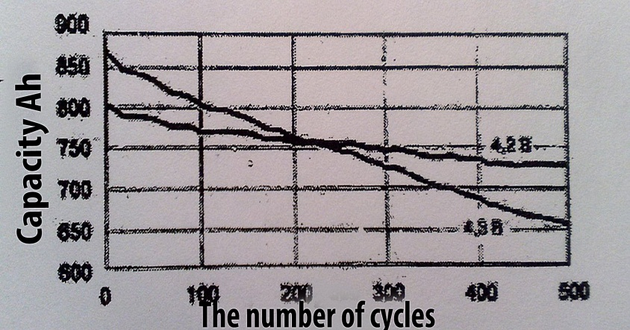
Fig. 7. Change capacity Li-ion battery at different limit charge voltage

The temperature increase operation (within the working interval) can increase the rate of side processes involving the interface electrode-electrolyte, and to increase the speed of diminution of the discharge capacity with the cycles.
Conclusion
As a result of Searches the best material for the cathode a modern lithium-ion batteries turn into a whole family of chemical current sources, differing markedly from each other as the intensity and the profile of charge/discharge. This, in turn, requires a substantial increase of the intellectuality of the control schemes that have since become an integral part of the battery and a powered device – otherwise you can damage (including irreversible) as batteries and devices.
The task is complicated by the fact that the developers are trying to maximize the use of battery power as a way of improving battery life at the minimum occupied by the power source. It allows to reach essential competitive advantages. Eventually the new batteries often have significant limitations of range of operation conditions. Moreover, in recent years the market excepting to traditional manufacturers of rechargeable cells and batteries –Sanyo, Panasonic, and Sony is very active in breaking new manufacturers, mostly from China.

So, at the present time significantly increases the importance of the information provided by the so-called "smart batteries": the identification of battery, battery temperature, residual charge and the allowable stress. Note that battery manufacturers make great efforts to the development of cathodes based on lithium compounds. In this area it seems promising the use of cathodes based on LiMn₂O₄.

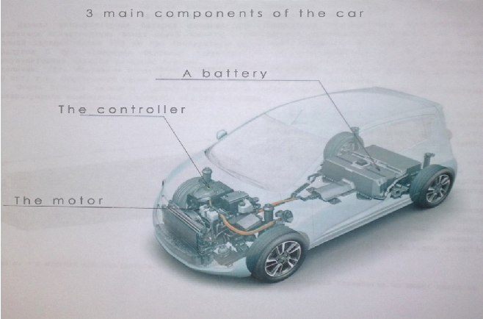
All-weather battery

This battery is created for a comfortable operation of the electric vehicle in different climatic zones of our planet with maximum mileage on a full charge, more than 500 km in ambient temperatures from -80°C to + 80 °C without changing the basic characteristics of Li-ion. In the design of batteries implicit function in which the battery lifetime is significantly increased. There is reason to believe that the life of the battery reaches 10 years, i.e. limit operation of the vehicle prior to its disposal.
Great attention is paid to the safety operation of battery. In the event of an accident the fire suppression system set off a fire cell.
Depending on what the materials used in the manufacture of batteries, its weight up to 800 kg. battery output is 400 V; 250 A. P battery = 100 kW.
I would like to mention the fact that the operation of this battery in winter, energy recovery begins with an initial moment of movement of the car.
This project can find wide application in mobile communication (hard-to-reach high areas), meteorology(probes transmit information about the state of the atmosphere at high altitudes, etc.)
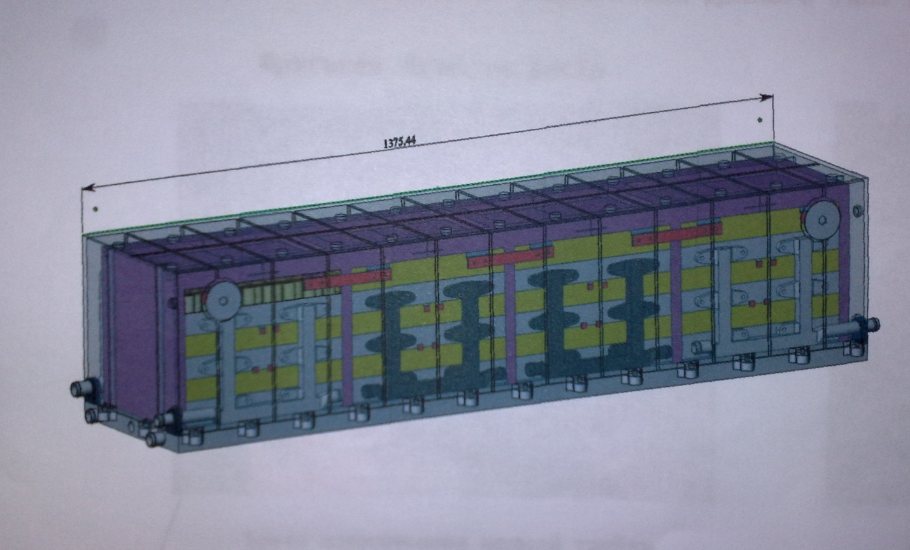
One of four battery modules for the electric car.
*The represented technology does not have analogues on the market.

Comparative characteristics of main indicators of batteries of TESLA and NISSAN Leaf.
During the examination of the TESLA battery that consists of 7104 "18650 elements'' and is shown on the picture 1, the following weaknesses of this construction were found:
1. The heating system of "18650 elements'' is very passive and cannot warm these elements in case of severe frosts. This information was confirmed by the owners of these cars. Only after 30 minutes of exploitation, when the batteries' temperature reaches +5 ˚С, the energy recovery mode begins. This is a weakness of this kind of the battery.
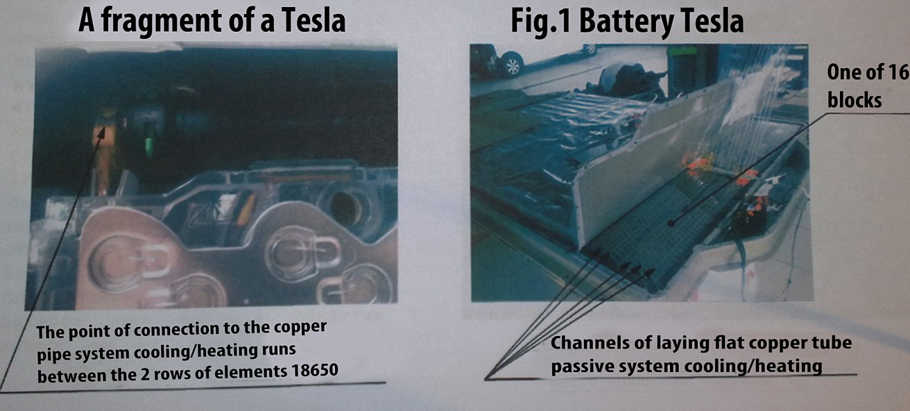
2. During the exploitation of TESLA electric car in hot climate zones and also during fast charging (with high currents), rapid heating of "18650 elements" occurs. The cooling system which is shown as a flat copper tube cannot cool "18650 elements" fast enough. That is why the validity of this battery is very limited. There are witnesses in Internet about this.
3. On the picture 2, there is one of 16 blocks of the battery, where some of "18650 cells" are struck by rust. This shows that the inner micro-climate of the battery is unstable. It means that if the temperature is changes, a drew point appears (condensate is forming). This affects the work of "18650 cells". The oxidation process appears inside of them. It causes the destruction of the batteries.
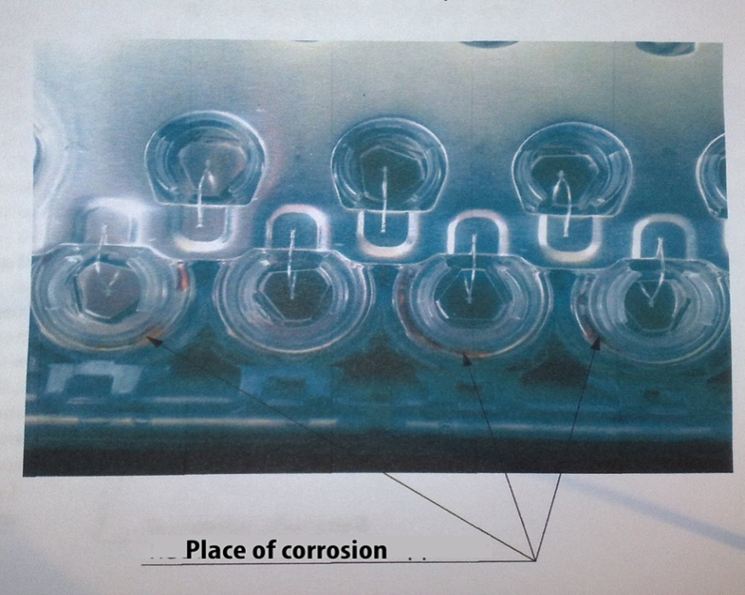
4. We would like to notice that if the battery is damaged, there are no guarantees of fire safety.
On the picture 3, there is shown the 24 kW NISSAN Leaf battery. It is seen that this type of battery does not have cooling system. And the heating system that was released in 2013, is located on the perimeter of the blocks and represents itself as membrane heaters. It is very primitive and cannot adequately deal with fluctuations in subzero temperatures. And during the exploitation of the electric car in hot climate zones and fast charging with high currents, battery elements are often damaged.
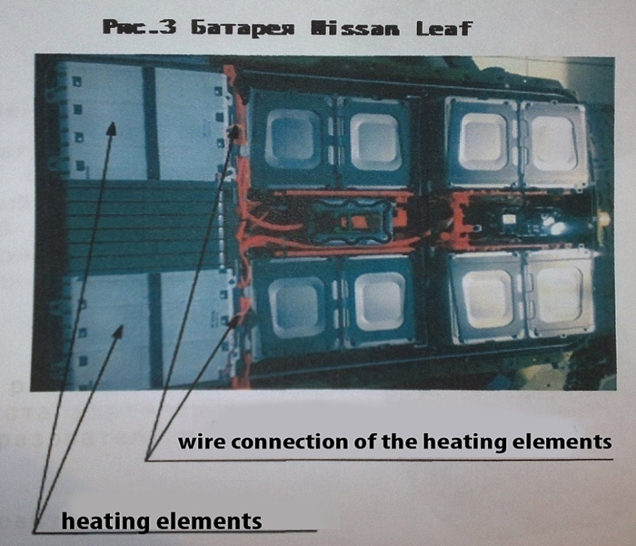
Creating our all-climate battery, we took into account all the above firm's shortcomings. All 18650 elements used in the battery (about 8000 100kWt examples with mileage up to 600 km) have active cooling and heating systems for each element that are within + 25 ° C. This is the optimal temperature for he maximum duration of use of the car from -40 ° C to +60 ° C. Inside of the battery, there is its own micro-climate with no air but with inert gas. This increases the duration of exploitation of the 18650 elements (no oxidation process). Particular attention was paid to safety of the battery in case of an accident. To prevent possible ignition, fire-fighting system is installed inside of the battery. With this structural design of the battery, it is possible to charge it within 5-10 minutes without damaging "18650 elements''.

Double-gap asynchronous motor
The new concept of production of the electrical machine (engine) which combines the strengths of synchronous and asynchronous engines was created.
This type of motor is very practical and is suitable for use in electric cars taken in attention the important role of compactness of the powerplant and the weight of the car in General.

The advantages of double-gap induction machines:
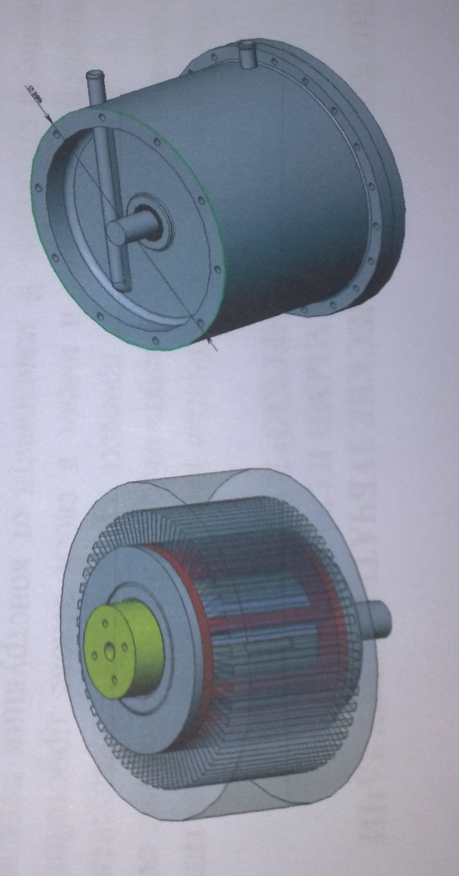

- easy to manufacture;
- small weight;
- high efficiency (93%);
- high torque at start (700 Nm);
-active cooling system of the stator and rotor;
- work in all climatic zones without restrictions.

During the work in the asynchronous mode at various loads takes place the minimum consumption of current (20% lower, than in similar electric motors). When you switch to generator mode happens rapid return of regenerative energy (up to 40%), while capacitors and brush-collector mechanism, thus condensers and the brush and collector mechanism aren't used.
This new generation of asynchronous motors with an increased number of generated regenerative energy without changing the weight and overall dimensions.
This motor requires a special two-channel converter. Control frequency from 0 to 500 Hz.
Reliable and compact frequency converter is located in a single housing with the motor.
The scope of application of the motor:, building of electric cars, etc.

*The represented technology does not have analogues on the market.
TWO-GEAR TRANSMISSION WITH ADJUSTABLE PARAMETERS (MECHANICAL VARIATOR)

Two-gear transmissions based on the types of links that allow you to change the relative position of the axes of the wheels in space in the process without violating the correctness of the gear and are based on the simplest three-tier structure.

Depending on design, the transmission can adjust:

1.The angle of intersection of the axes.
2.The angle of crossing axes.
3.Spacing

Using of these transmission mechanisms will allow to simplify the structure,kinematic scheme,and, thereby,to increase reliability,reduce dimensions and weight.

The possible scope of such transmissions:

1.Joints of robots.
2.Transmission vehicles
3.Adaptations to metal-cutting machines and rolling mills.
COMMERCIAL OFFER NO 1
Within two years new technologies were developed in manufacturing of electric cars:
1. Battery(currently there are no analogues)
2.The motor(and currently there are no analogues)
3.Frequency inverter(vector control)
4.Mechanical variator(development was done for many years,has no analogs)
All of these components together can give a great result to start producing electric vehicles that will be out of competition to foreign analogues.With proper logistics of their operation is possible from the equator to the North pole.

THE MAIN PARAMETERS OF ELECTRIC VEHICLE

2.Acceleration to 100 km/h in 5 seconds
3.Run on one charge-800 km
4.Charging time to 80%:winter-10min,summer-20 min
5.Weight of car is 2000kg

COMMERCIAL PROPOSAL NO. 2

1.Development and production of printed circuit boards according to the customer's specifications, with the possibility of robotic Assembly parts.
2.Production of frequency inverters(vector control)for synchronous and a synchronous of electric motors from 0.5 kW to 20 kW and above (specialised,i.e. electric cars,electric bicycles,electric bikes, etc.)
3.Manufacturing of Turbomechanical power from 1kW to 20 kW for a wide range of consumers on the basis of low-cost asynchronous motors.
4.Production of induction motors for electric cars,electrotraction,electric bicycles,electric bikes, etc.
*All of the above products is high-tech and less expensive (50%) in the production process in comparison with foreign analogues.

