1. What does this indicator do?
Long RSI is a modification of the classic Relative Strength Index (RSI) indicator, focused on long-term analysis. The indicator calculates the RSI with a long period (800 by default), which allows filtering out short-term fluctuations and market noise.
Additionally, the indicator implements:
Moving Average (MA) of RSI with the ability to select one of several types (SMA, EMA, SMMA, WMA, VWMA).
Bollinger Bands for RSI (optional): when selecting “Bollinger Bands”, MA becomes the basis for building the upper and lower bands.
The indicator also contains three horizontal levels (53, 51, 48), which visually help to identify areas of potential reversals or trend continuation.

2. What market conditions it is suitable for
- Long-term trend analysis:
Due to the long length of RSI (800) and MA (1000), the indicator is better suited for identifying global trends than for short-term speculative movements.
- Medium- and low-volatile markets:
The use of smoothing helps to avoid unnecessary signals during periods of high volatility, so this indicator is advisable to use when volatility is moderate or low.
- Instruments with a pronounced trend:
Long calculation periods help to better “capture” the general direction of movement (uptrend/downtrend) for instruments such as stock indices or gold.

3. Main parameters and their values

3.1. RSI Settings
- RSI Length
  - The default value: 800
  - Determines the number of bars/candlesticks for RSI calculation. A long period helps to identify long-term trends..
- RSI Source
  - Default value: open or close (depending on your choice)
  - Determines which price data (open, close, high, low, etc.) is used to calculate the RSI.

3.2. MA Settings
- MA Type
  - Options: “SMA, Bollinger Bands, EMA, SMMA (RMA), WMA, VWMA.
  - If you select Bollinger Bands, the indicator additionally plots the upper and lower bands (BB).
- MA Length
  - The default value: 1000
  - The period for which the moving average is calculated (or the average value for building Bollinger Bands).
- BB StdDev
  - Default value: 2
  - Applies when “Bollinger Bands” is selected. Determines how many standard deviations from the MA the upper and lower bounds are built.

3.3. Calculation
- Timeframe
  - The default timeframe is “Chart” (current). You can select another timeframe if necessary.
- Wait for timeframe closes
  - If enabled, the indicator will update only after the selected timeframe closes.

- BB StdDev
  - Default value: 2.0
  - Used only if “Bollinger Bands” is selected in the MA Type field.
  - Defines the distance (in standard deviations) from the MA to the upper and lower bands.

4. Visual elements
Below are several screenshoots from different charts that demonstrate the indicator's operation. Pay attention to the horizontal levels (53, 51, 48), the main RSI line (blue) and the moving average line (gray). If Bollinger Bands is enabled, additional upper and lower bands will appear.

4.1 General view of the indicator on the chart
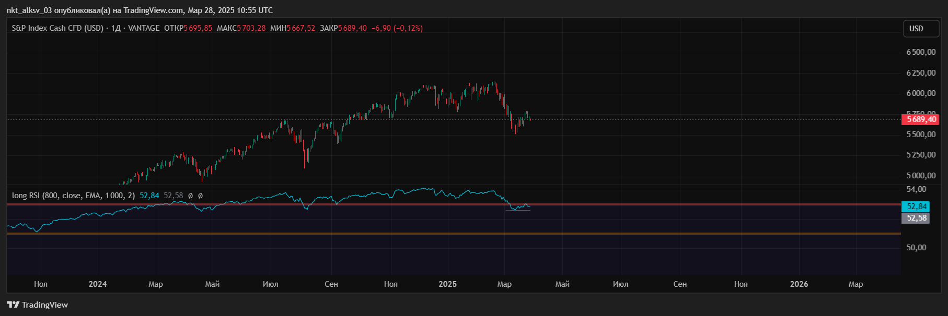
This example shows the Long RSI indicator on the S&P 500 chart. The main RSI line (blue) and the levels (red - 53, orange - 51, green - 48) help to quickly navigate the market dynamics.
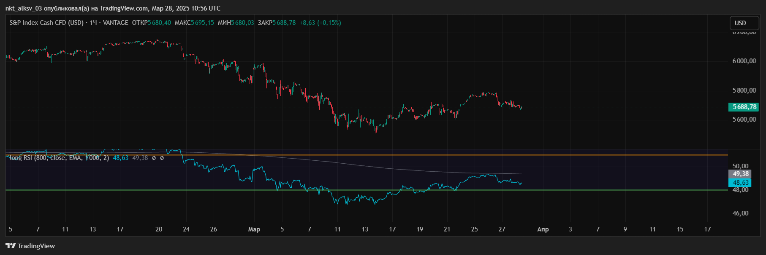
A closer view of the same S&P 500 index with the highlighted area between 48 and 53. The gray line is the RSI moving average (EMA by default).

4.2 Example of application to another asset
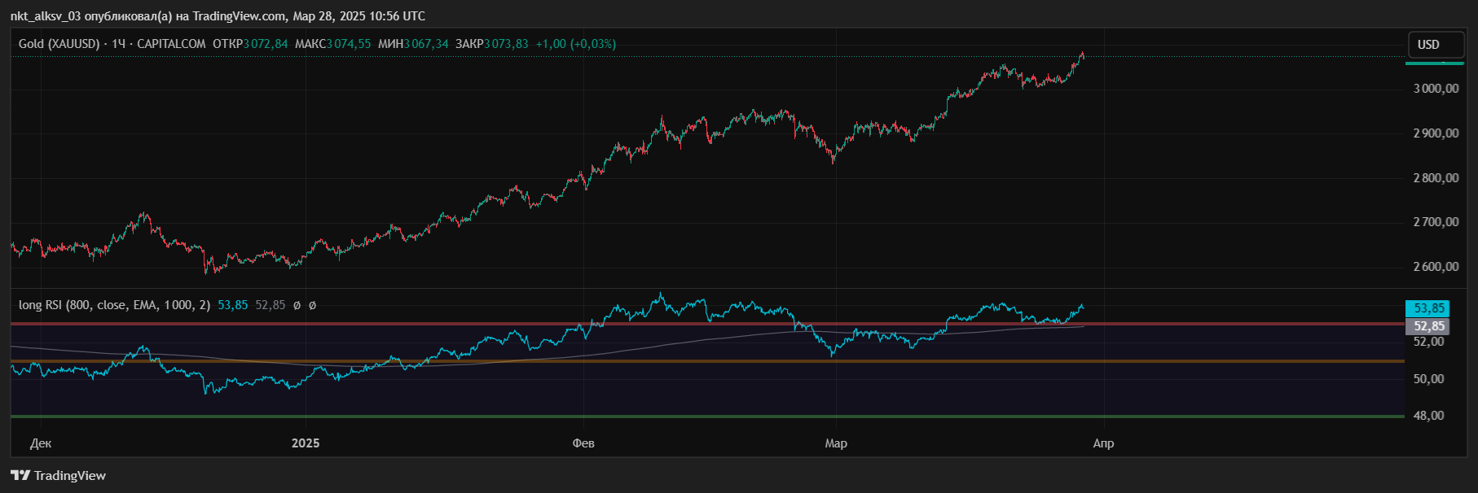
An example of using the indicator on a gold chart (XAUUSD). The RSI shows a rather high value, and the MA (gray) additionally smoothes fluctuations.
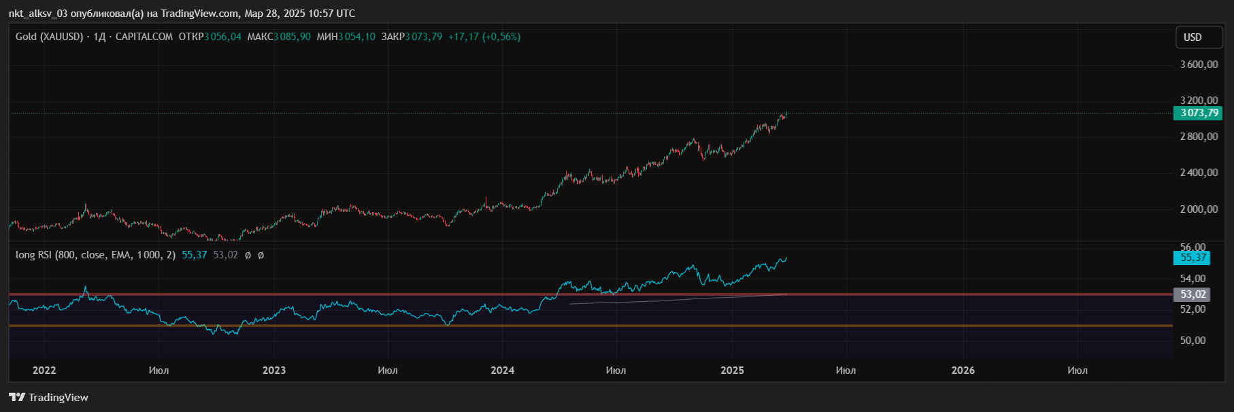
Gold chart from a broader perspective. You can clearly see how the long RSI tracks the global trend without unnecessary fluctuations.

4.3 Examples of indicator settings in TradingView

Below are screenshots of the Long RSI settings window.

4.1 Inputs tab
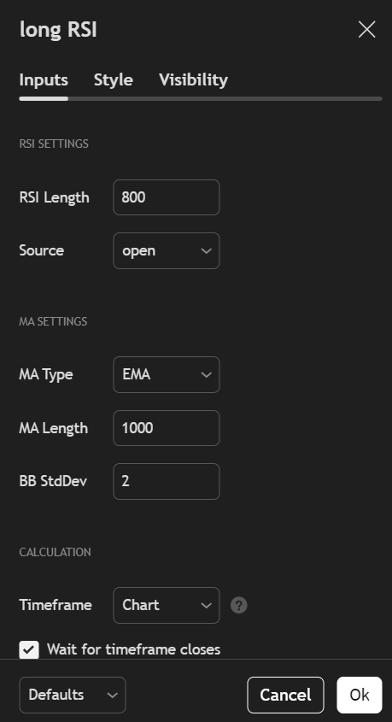

RSI Length: 800

Source: open (can be changed to close, high, low, etc.)

MA Type: EMA (select from the list)

MA Length: 1000

BB StdDev: 2

4.2 Style tab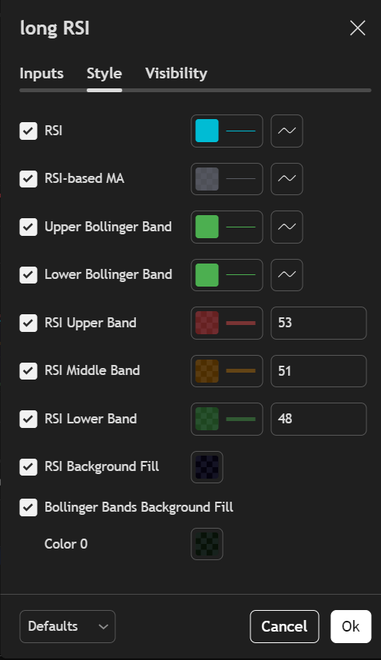

Here you can customize the colors and visibility of elements:

RSI - the main line (blue by default)..

RSI-based MA - RSI moving average (gray line).

Upper/Lower Bollinger Band – top/bottom band if “Bollinger Bands” is selected.

RSI Upper/Middle/Lower Band –three horizontal levels 53 (red), 51 (orange), 48 (green).

Background Fill – translucent filling between the specified levels.

4.3 The Visibility tab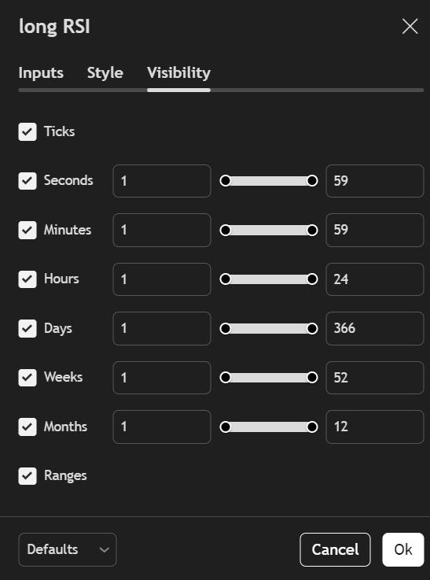

Allows you to select the timeframe for which the indicator is displayed (for example, minutes, hours, days, weeks, etc.).

4.4 Example of MA Type selection
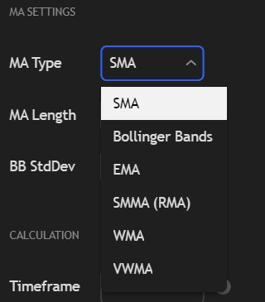

Shows a list of available anti-aliasing methods or an option with Bollinger Bands.

5. How to interpret indicator signals
- RSI line:
  - Indicates the long-term strength of the trend. If it is above 50, the market is inclined to an upward movement, and below 50 - to a downward one.
  - The levels of 53 and 48 help to identify local overbought/oversold zones in the long term.
- RSI moving average (RSI-based MA):
  - Allows you to estimate the overall direction and strength of a trend, ignoring short-term fluctuations.
  - If the RSI crosses the MA from top to bottom, it can be a signal of a trend weakening (and vice versa).
- Bollinger Bands:
  - Show the range of RSI volatility.
  - If the RSI goes beyond the upper or lower bands, it indicates a possible change in the long-term momentum.

The Long RSI indicator with long periods (800 for RSI and 1000 for MA) is designed for traders who want to filter out small fluctuations and focus on global trends. Additional levels (53, 51, 48) make it easier to quickly analyze the current market state. The choice of different types of MAs and the ability to enable/disable Bollinger Bands makes the indicator flexible for various trading strategies.
This indicator can be especially useful for:
- Long-term investors seeking to identify long-term trends.
- Traders who avoid noise on short timeframes.
- Analysts who need an additional level of RSI smoothing.

https://www.tradingview.com/script/nGhIl2sH-Relative-Strength-Index/

