Introduction
Electronics have become an integral part of our daily lives and have a huge impact on every aspect of our culture, science and technology. In this paper, I will explore the importance of the electronics industry in our lives, focusing on the leading electronics market players Apple, Samsung and Google.
These companies make significant contributions to the development and improvement of electronic devices that affect the way we use our daily habits, communicate, entertain and work. They give us access to advanced technologies that make our lives easier and make us more efficient.
Smartphones, tablets, computers, watches and other devices from Apple, Samsung and Google have become an integral part of our communication and entertainment. They allow us to easily communicate with friends and family, conduct important transactions online, keep up to date with news from around the world, and provide various forms of entertainment.

Aim: to analyse and identify the importance of the electronics industry in our lives, focusing on Apple, Samsung and Google.

Object: Apple, Samsung and Google, which are the leading manufacturers of electrical devices.
In my paper, I will analyse Apple, Samsung and Google and compare how they differ.

- Introduction to the leading companies of electronic devices

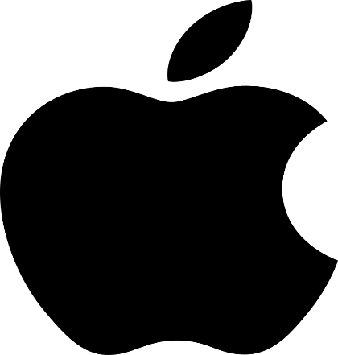
Apple: Apple Inc. is an American technology company that was founded by Steve Jobs, Steve Wozniak and Ronald Wayne in 1976. Currently, the company's chief executive officer is Tim Cook. Apple is known for its innovative products such as iPhone, iPad, Mac, Apple Watch, and others. In addition, the company develops the iOS and macOS operating systems, as well as services such as the App Store, iTunes, and iCloud. Apple is a publicly traded company and its shares are listed on the NASDAQ stock exchange.[1].

Figure 1. Apple logo.

Samsung: Samsung Electronics is a division of the Korean company Samsung Group and is one of the largest electronics manufacturers in the world. It was founded in 1969, and its CEO is Kim Ki-nam. Samsung manufactures a wide range of products, including smartphones, TVs, refrigerators, washing machines, laptops, and more. The company also develops its own operating system for smartphones called Android. Samsung Electronics is a public company and its shares are traded on the Korea Stock Exchange.[2].
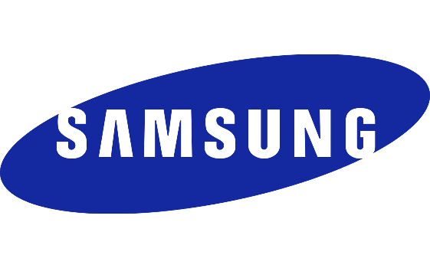
Figure 2. Samsung logo.

Google: Google is part of the American company Alphabet Inc. which was founded by Larry Page and Sergey Brin in 1998. The CEO of Alphabet is Sundar Pichai. Google is one of the largest search engines on the Internet and provides a variety of services and products, including Gmail, Google Maps, YouTube, Google Drive, and more. The company also develops the Android operating system for smartphones. Alphabet Inc. is a public company and its shares are traded on the NASDAQ stock exchange.[3].

Figure 3. Google logo.

- Comparative analysis of companies

 | Feature 1 | Feature 2 | Feature 3 | Feature 4
Your company Apple: | Country: United States of America.  Revenue: In the fiscal year 2020, Apple's revenue was about 274.5 billion US dollars. | Development and production of electronic devices, including iPhone, iPad, Mac, Apple Watch and additional accessories. | Development of iOS and macOS operating systems.  Provision of services such as the App Store, iTunes, Apple Music, Apple Pay, iCloud and others. | Innovative research and development of new technologies.
Competitor 1  Samsung: | Country: South Korea.  Revenue: In fiscal year 2020, Samsung Electronics' revenue was about $236.8 billion. | Manufacture of various electronics, including smartphones, TVs, refrigerators, washing machines, laptops and other household devices. | Development and production of semiconductors, including chips for smartphones and other devices.  They also introduced the Android system. | Innovative research and development of new technologies, such as OLED screens, 5G communications and others.
Competitor 2 Google: | Country: United States of America.  Revenue: In the financial year 2020, the revenue of Alphabet Inc. (Google's parent company) was about 182.5 billion US dollars. | A Google search engine that provides access to a wide range of information on the Internet. | Development and provision of services such as Gmail, Google Maps, YouTube, Google Drive, Google Docs and others. | Innovative research and development of new technologies, including artificial intelligence, autonomous cars, cloud services and much more.

One of the main differences between these companies is their core business. Apple focuses primarily on the development and production of its own devices and software, Samsung on a wide range of electronics and components, and Google on the development and production of Internet services and software. All three companies have significant influence in the global technology market. They compete with each other and innovate to capture the attention of consumers. Each of these companies has its own unique corporate culture and development strategy, but all have had an impact on the modern technology industry.[6].

3. Recommendations for improving Apple's performance
The following recommendations can be made to Apple to improve its performance and reputation:
1. Continue to invest in research and development to create innovative products that meet market needs and exceed customer expectations. Develop new technologies, such as smartwatches, virtual reality and autonomous systems, to expand your audience and attract new customers.
2. Enhance the ecosystem: Enhance integration between Apple devices and services and ensure that data and services flow seamlessly between devices. Expanding Apple's ecosystem, including increasing compatibility with third-party devices and software, can make Apple products even more attractive to consumers.
3. Strengthen the marketing strategy: Develop an effective marketing strategy to increase awareness of Apple's products and services.
4. Expand global presence: Continue to expand Apple's global store network to make products and services available in different parts of the world.
These recommendations will help the company to operate efficiently, increase its products and develop in its field of activity, becoming more popular.
Conclusion.
Expanding into different countries is beneficial for Apple, allowing it to expand its global presence, attract new customers and make its business more resilient to risk. In a changing global market, such development is a strategic necessity for Apple's success.
Other companies also distribute their products globally, which has a positive impact on their reputation and makes them known and their products recognised and used.
References
- Apple Inc.
https://en.wikipedia.org/wiki/Apple_Inc.
- Google.
https://en.wikipedia.org/wiki/Google
- Samsung.
https://en.wikipedia.org/wiki/Samsung
- 19 INTERESTING FACTS ABOUT APPLE.
https://ishop.if.ua/novyny/19-cikavyh-faktiv-pro-apple
5. Eric Schmidt, Jonathan Rosenberg, Alan Eagle How Google Works.
2016. 304 p.
6. Nevzorov V. Apple. The evolution of the computer. 2017. 224 p.
7. Jeffrey Kane. The Dawn of Samsung. 2021. 424 p.

