Odesa I.I Mechnikov National University

Coursework
on the topic:
“Economic factors affecting the strategic development of Chinese enterprises”

Table of contents
Introduction 3
Chapter 1 “Economic factors affecting the strategic development of Chinese enterprises” 7
1.1. Presentation of main definitions, concepts and approaches to the field 7
1.2. The history of China`s economic growth 9
1.3. Defining the problem area within the context and relevance for management performance 12
1.4. Data analysis and systematization 13
2. Infrastructure Development in China 18
2.1. Factors of economic development of the PRC 21
Chapter 2. Theoretical Framework 25
2.1. The Solow Model of growth 25
2.1.1. The simple Solow model 25
Figure 2: The simple Solow model 27
2.1.2. The Solow model augmented with technological progress and human capital 28
2.2. Why use the Solow model? 30
2.3 Key Factors of Development in China`s Economy 33
2.3.1 Agriculture 33
2.3.2 China's industrial performance 34
2.3.3 Employment 35
2.3.4 Capital Investment 35
2.3.5 Export and Import 36
2.3.6 China’s dual circulation 36
Internal Circulation 38
International Circulation 39
Data and Variables 39
Regression Results 40
The Potential Effects of the RCEP 43
4. Conclusion 45
5. Bibliography 49

Introduction
The position of China in the current global market may demonstrate the significance of the selected issue. The nation held the top spot in the Central Intelligence Agency's ranking of the world's top exporters in 2018. The population of China, which currently numbers up to 1,4 billion, is a major role in this situation and is the key to success. The PRC employs workers at low costs and has a considerable labor resource potential. The mixed economy in which the market system operates under government supervision is best shown by the Chinese economy. The PRC works hard to entice international investments by establishing advantageous circumstances and ensuring the safety of incoming foreign financial assets. The effective economic growth of this nation enables a study of it as a singular system with the aim of developing one's own economic vision and putting it into practice to ascertain the benefits and drawbacks of various current economic orientations. Additionally, the research demands highly developed creative and critical thinking abilities, which are prerequisites for certified experts in the field of international economic relations.
A substantial surplus of labor entered the manufacturing and service sectors as a result of the rural economic reform in the late 1970s and early 1980s, which also increased the productivity of rural workers. Foreign direct investment (FDI), which mostly benefited the industrial sector, entered the country thanks to the open economic policy. The export-led growth model needed both affordable labor and more than enough infrastructure. Public investment in infrastructure became the cornerstone of the approach since there appeared to be an endless supply of inexpensive labor from the rural sector. This led to the government at all levels placing a strong emphasis on infrastructure.
The 1994 tax administration reform's functional and financial decentralization significantly enhanced the sub-national governments' financial incentives and capabilities for infrastructure development. The bureaucratic structure was considerably changed to become more pro-business as a result of a number of institutional reforms. Other steps, such streamlining government review and approval processes and introducing performance standards, improved the government's capacity to carry out infrastructure projects.
Although infrastructure expansion undoubtedly contributed to China's export-driven economic growth, fundamental infrastructural limitations have recently caused the Chinese economy to display indications of overheating. There is undoubtedly a sizable gap between the availability of infrastructure needed for fast development and the potential demand for it. Given the significance of infrastructure development for poverty alleviation and sustained economic growth

The current study investigates the production elasticity of infrastructure development in China from 1970 to 20083. The present study is a nation-specific study with a focus on China, as opposed to cross section or panel data studies on a vast number of countries where each country may not be a representative sample.
The present study creates a composite index of a stock of leading physical infrastructure indicators to examine the impact of infrastructure development on overall growth as opposed to previous literature on the growth effects of infrastructure, which focuses on a single infrastructure sector or indicator. For reliable estimates, the empirical analysis handles the problems of reverse causality and an erroneous correlation brought on by the non-stationarity of the data.
The Chinese economy's current fast developments are its most significant feature. Chinese businesspeople are driving the reforms. This article makes an effort to comprehend the characteristics of entrepreneurs, the setting in which they operate, whether the dynamic changes will persist, and what policies may be suggested to enhance the changes.

Economic reform spearheaded by the Chinese government and the Communist Party of China has long been considered the most crucial subject in the study of the Chinese economy. Regarding China's economic reform, see Chow (2007). A large portion of China's economic reform has been finished. The government has created a setting where businesspeople may succeed and improve the economy.
Goal of the research: to take a fresh look on the point of China`s economic factors influence the planned development of the Chinese business sector using theoretical, methodological and practical thesis and methods of research.

Task of the research: to describe the main features of Chinese foreign trade and economic strategy directions, conduct analytical research using a variety of economic indicators (such as GDP indices, geographic and structural divisions of Chinese export and import, growth dynamics, and statistical data), as well as to develop one's own vision of China's economic future and partnership with the rest of the world, especially with the EU and the USA, which have extremely large economic structures.

Subject of the research: The rise of China on the global stage and potential roadblocks to its economic development.

Object of the research: This thesis seeks to identify the key driving forces behind China's economic expansion. Investments, household savings, GDP per capita, population growth, healthcare costs, and educational attainment are among the variables taken into consideration. The following research questions have been developed as a result of them all being based on the Solow model of growth:
What are the primary determinants of China's growth?
Do affluent and poor places experience the same development factors?
Are the growth variables the same in 2020 as they were in 2003?
Are the findings consistent with earlier studies?

Methodology of the research: Analysis includes induction, description, categorization, and the use of numerous sources, including literature (textbooks, articles), internet resources (websites, social media, public forums), and data bases with public access.

Chapter 1 “Economic factors affecting the strategic development of Chinese enterprises”

1.1. Presentation of main definitions, concepts and approaches to the field

China has had a phenomenal ascent over the past 40 years, going from a poor developing nation to a significant economic force. China's real gross domestic product (GDP) increased at an average yearly pace of roughly 10% from 1979 (when economic reforms started) to 2017. China "has enjoyed the fastest continuous expansion by a major economy in history—and has lifted more than 800 million people out of poverty," according to the World Bank. 2 China has grown to be a significant economic force worldwide. It is the leader in value-added manufacturing, merchandise commerce, purchasing power parity (PPP) economic size, and holding foreign exchange reserves, for instance.
The volume of bilateral trade between China and the United States has significantly increased as a result of China's fast economic development. The entire value of commerce between the two nations increased from $5 billion in 1980 to $660 billion in 2018, according to U.S. trade figures. The third-biggest export market, the largest source of imports, and the largest trading partner for goods in the United States at the moment is China. In order to capitalize on the burgeoning Chinese market and reduced labor costs for producing items for export, several American businesses have sizable operations in China. 3 These activities have given certain American businesses assistance in maintaining their competitiveness abroad and have given American customers access to a wide range of affordable items. The federal government has been able to finance its budget deficits because to China's significant purchases of U.S. Treasury securities, which as of April 2019 totaled $1.1 trillion. This helps keep U.S. interest rates relatively low. 4
However, many U.S. leaders are concerned about China's development as a significant economic force. Some contend that China inundates American markets with cheap goods through unfair trade practices (such as undervaluing its currency and providing local manufacturers with subsidies), endangering American employment, wages, and living standards.
Others claim that China's increasing use of industrial policies to support and safeguard specific domestic industries or government-favored firms, as well as its failure to effectively combat widespread violations of and theft of U.S. intellectual property rights (IPR) in China, pose a threat to the competitiveness of U.S. industries that rely heavily on IP. Additionally, despite the fact that China has grown to be a significant and expanding market for American exports, detractors claim that the country's numerous trade and investment restrictions restrict the opportunities for American businesses to sell there or compel them to establish production facilities there as a condition of doing business there.
The Chinese government sees economic expansion as essential to preserving social harmony. However, China faces a number of significant economic obstacles that could stifle future growth. These obstacles include government support for state-owned businesses, a weak banking system, widening income gaps, increasing pollution, and the country's relative lack of the rule of law. Furthermore, China's economic policies have led to an overreliance on fixed investment and exports for economic growth (rather than on consumer demand). The Chinese government has acknowledged these issues and promised to address them by putting in place policies to boost the market's influence over the economy, encourage innovation, make consumer spending the engine of the economy, increase the size of the social safety net, and promote the growth of less-polluting industries.
Whether China can retain its current relatively strong economic growth rates or starts to see considerably slower growth rates will largely depend on the Chinese government's capacity to carry out such changes.
China is taking on more responsibility for global economic initiatives and policies, particularly infrastructure development, as a result of its expanding economic dominance. A comprehensive plan by China to finance infrastructure across Asia, Europe, Africa, and beyond is the Belt and Road Initiative (BRI). China's economic ambitions, if successful, may considerably widen its export and investment markets and boost its "soft power" internationally.
In this paper, the economic ascent of China is explained, the current economic structure is described, and the difficulties China confronts in maintaining economic growth are listed.

1.2. The history of China`s economic growth
Prior to 1979, China's economy was centrally planned, or command economy, under the direction of Chairman Mao Zedong. The state directed and regulated a significant portion of the nation's economic output, setting production objectives, regulating prices, and allocating resources throughout the majority of the economy. All of China's individual home farms were collectivized into sizable communes in the 1950s. The central government made significant expenditures in both human and physical capital during the 1960s and 1970s to promote rapid industrialisation. As a result, state-owned companies (SOEs) that were under central supervision and produced in accordance with centrally planned output objectives accounted for roughly three-fourths of total industrial production by 1978. Private businesses and businesses with foreign investment were often prohibited. Making China's economy mostly self-sufficient was one of the main objectives of the Chinese leadership. The majority of the time, commerce with other countries was used to acquire items that weren't produced or available in China. The economy was distorted by these measures. Since the central government controlled most aspects of the economy, there were no market mechanisms to effectively allocate resources, and as a result, there were few incentives for businesses, employees, and farmers to increase their productivity or care about the quality of the products they produced (since they were mainly focused on production goals set by the government).
China's real GDP increased at an average annual rate of 6.7% from 1953 to 1978, according to Chinese government statistics, but many analysts have questioned the validity of these figures. Some claim that during this time, Chinese government officials, particularly those at the subnational levels, frequently exaggerated production levels for a variety of political reasons. China's actual average yearly real GDP growth over this time period is estimated by economist Angus Maddison to be around 4.4%. 5 Additionally, under Chairman Mao Zedong, China's economy experienced significant downturns, such as those that occurred during the Cultural Revolution from 1966 to 1976 and the Great Leap Forward from 1958 to 1962 (which resulted in a severe famine and the reported deaths of up to 45 million people). China's purchasing power parity (PPP) base per capita GDP, a popular indicator of a nation's living standards, quadrupled between 1950 and 1978. Chinese living standards did, however, decline from 1958 to 1962 by 20.3% and from 1966 to 1968 by 9.6%. (see Figure 1). Additionally, as seen in Figure 2, Chinese living standards grew far more slowly than those in the West, such as Japan.

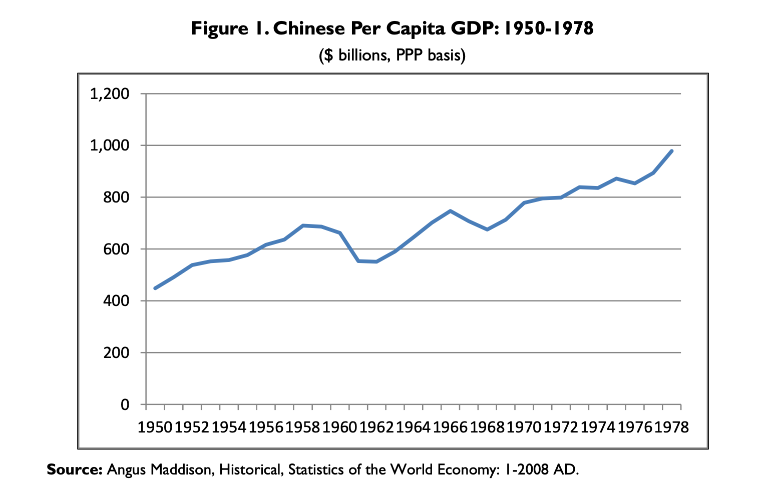
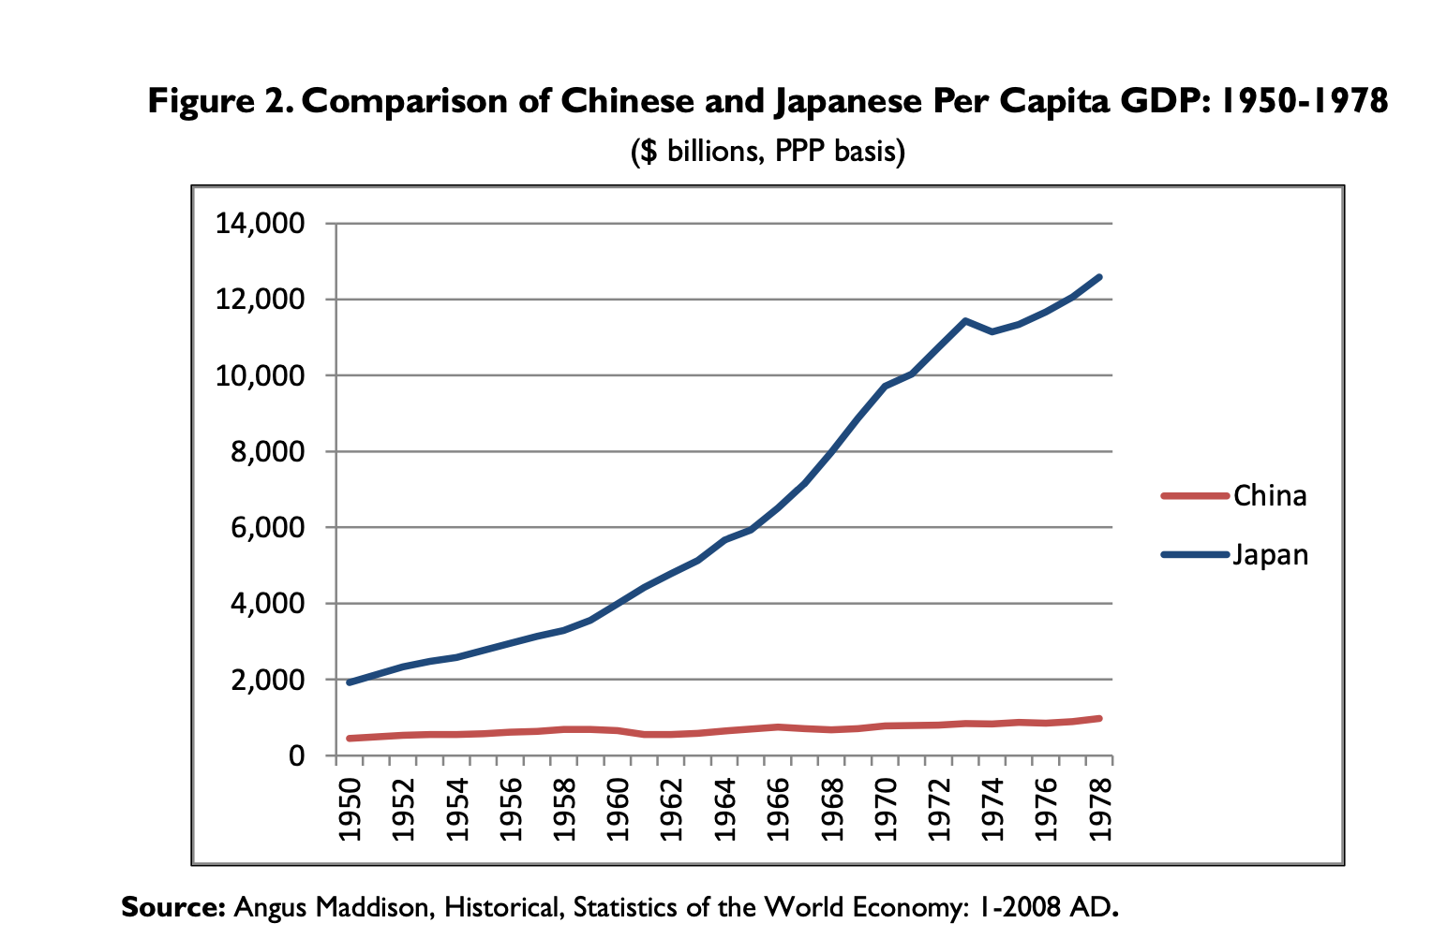
The Chinese government decided to abandon its Soviet-style economic policies in 1978, shortly after Chairman Mao's death in 1976, by opening up trade and investment with the West and gradually reforming the economy in accordance with free market principles, in the hopes that this would significantly boost economic growth and raise living standards. Black cat, white cat, what does it matter what color the cat is as long as it catches mice? is how Chinese leader Deng Xiaoping famously expressed it.
China started implementing significant economic changes in 1979. Farmers were given ownership and price incentives by the central government, which allowed them to sell a part of their harvests on the open market. In order to increase exports, attract foreign investment, and import high-tech goods into China, the government has constructed four special economic zones along the shore. Additional changes, which came gradually afterward, aimed to decentralize the formulation of economic policy in a number of industries, particularly commerce. Provincial and municipal governments were granted economic power over a variety of businesses, and they were typically permitted to operate and compete on free market principles rather than under the direction and control of state planning.
Additionally, people were urged to create their own enterprises. In order to experiment with free-market reforms and to provide tax and trade advantages to draw foreign investment, more coastal cities and areas were designated as open cities and development zones. State pricing restrictions on a variety of goods were also eventually lifted. The prosperity of China's economy was also greatly influenced by trade liberalization. Taking down trade barriers promoted more competition and brought in FDI. China's gradual adoption of economic reforms aimed to determine which measures led to beneficial economic results (and which ones did not), so that they may be applied elsewhere in the world purportedly referred to as "crossing the river by touching the stones" by Deng Xiaoping.

1.3. Defining the problem area within the context and relevance for management performance
China's economy has expanded far more quickly than it did before the adoption of economic reforms, and has, for the most part, avoided significant economic upheavals. 10 China's yearly real GDP averaged 9.5% from 1979 to 2018. (see Figure 3). As a result, China has been able to effectively double the size of its economy every eight years on average. The Chinese economy was significantly impacted by the 2008-onset global economic slump. Early in 2009, the media in China stated that 20 million migrant workers had returned home after losing their employment as a result of the financial crisis and that the real GDP growth rate had plummeted to 6.8% year-over-year in the fourth quarter of 2008.
In response, the Chinese government implemented a $586 billion economic stimulus program, which was primarily intended to finance infrastructure and relax monetary restrictions to boost bank lending. 11 China was able to mitigate the consequences of the significant decline in worldwide demand for Chinese goods because to these efforts. China's real GDP growth averaged 9.7% from 2008 to 2010. However, over the following six years in a row, the pace of GDP growth fell, going from 10.6% in 2010 to 6.7% in 2016. Although it increased to 6.8% in 2017, real GDP dropped to 6.6% in 2018 (after increasing to 6.8% in 2017). China's real GDP growth is predicted by the IMF's April 2019 World Economic Outlook to slow annually during the following six years, reaching 5.5% in 2024.

1.4. Data analysis and systematization
Many experts caution that if the United States and China continue to apply punitive economic measures against each other, such as the tariff increases that have come from American action under Section 301 and Chinese retaliation, China's economic development might decline much further. According to estimates from the Organization for Economic Cooperation and Development (OECD), increasing tariffs on all commerce between the United States and China might cause a real GDP decline in China of 1.1% in 2021–2022, according to the organization's base economic assumptions.
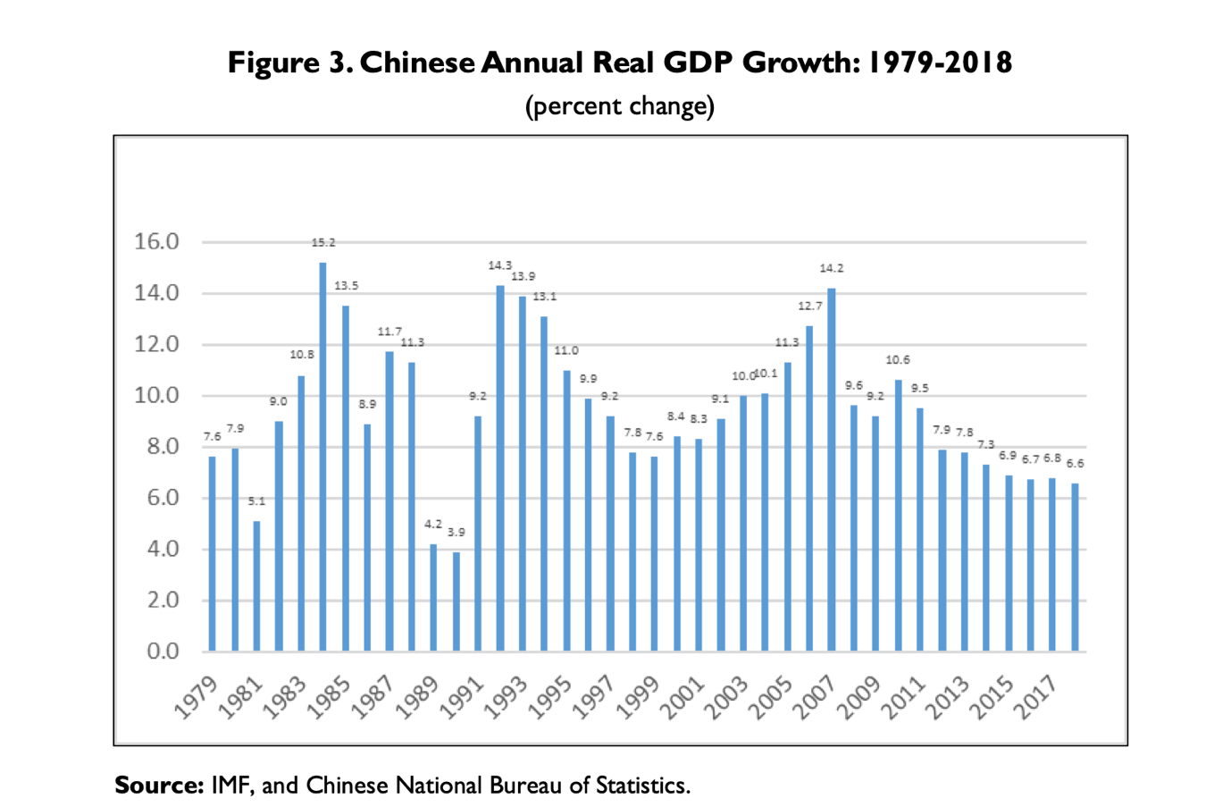
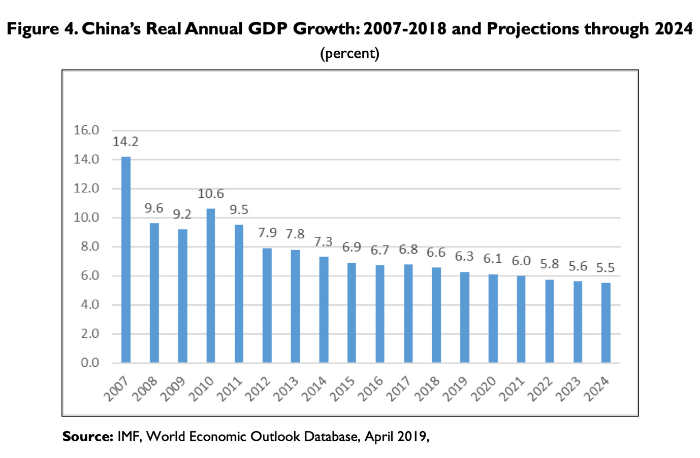
A big portion of China's rapid economic growth is often attributed to two key factors: significant capital investment (funded by significant domestic savings and foreign investment) and high productivity increase. These two elements seem to have coexisted well.
Economic reforms raised the economy's efficiency, which increased resources for new economic investment and increased production.
China has consistently kept its savings rate high. Domestic savings as a proportion of GDP was at 32% when reforms were started in 1979. The profits of SOEs, which the central government utilised for domestic investment, produced the majority of Chinese savings at this time. Decentralization of economic production was one of the economic reforms that significantly increased both corporate and family savings in China. As a result, among the major economies, China has the greatest gross savings as a share of GDP. China has been able to fund significant investment because to the high level of domestic savings.
According to a number of economists, productivity gains—or improvements in efficiency—have also played a significant role in China's fast economic expansion. The reallocation of resources to more productive uses, particularly in industries like agriculture, trade, and services that were formerly severely regulated by the central government, was primarily responsible for the productivity gains. For instance, agricultural reforms increased output and freed up laborers to seek jobs in the more productive manufacturing industry. Due to the decentralization of the Chinese economy, non-state businesses (such as private companies) have grown in prominence. These companies tend to pursue more productive endeavors than the centrally controlled SOEs and are more effective and market-oriented. A larger portion of the economy (mostly the export sector) was also subject to competitive factors.
Governmental meddling was not permitted when local and provincial governments established and ran numerous businesses. Additionally, new technologies and procedures that increased efficiency were introduced to China via FDI.
But unless China becomes a major hub for new technology and innovation and/or introduces fresh comprehensive economic reforms, its level of productivity gains and thus, real GDP growth, could slow significantly from their historical levels as China's technological development begins to converge with major developed countries (i.e., through its adoption of foreign technology). By applying some of the same methods that China has so far used to expand its economy, numerous emerging economies (particularly those in Asia and Latin America) enjoyed fast economic expansion and growth throughout the 1960s and 1970s such are policies to increase exports and industry' promotion and protection. However, at some point throughout their history, several of these nations started to endure protracted economic stagnation (or growth that was considerably slower than it had been previously), a condition known as the "middle-income trap" by economists. This means that while a number of developing (low-income) economies were able to make the transition to a middle-income economy, they were unable to make the same transition to a high-income economy because they were unable to maintain high levels of productivity gains (partly because they were unable to address structural inefficiencies in the economy). China could be facing a similar choice right now. The World Bank uses a per capita gross national income (GNI) approach to classify the economic development levels of nations.
At $8,690, China's 2017 per capita GNI was 38.7% lower than what it would have to be to qualify as a high-income economy. By 2025, according to Chinese official estimates, China will have reached the high-income level. It intends to accomplish this in large part by elevating innovation as a significant driver of future economic growth. The expansion of innovation in China, according to skeptics, will be challenging to achieve, especially if it is heavily state-driven and introduces new regulations for international companies.
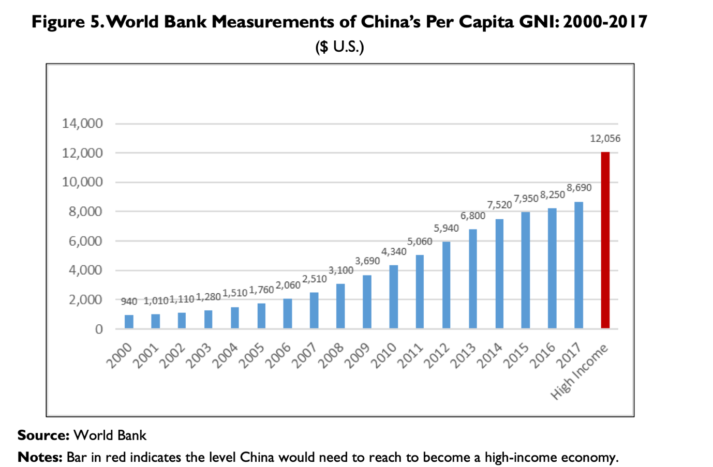
China's real GDP growth is expected to slow down over the coming decades, finally catching up to U.S. growth rates by the year 2037 (U.S. and Chinese real GDP growth rates are both anticipated at 1.9%), according to the Economist Intelligence Unit (EIU). EIU anticipates that for some time after that, U.S. GDP growth will outpace China's.
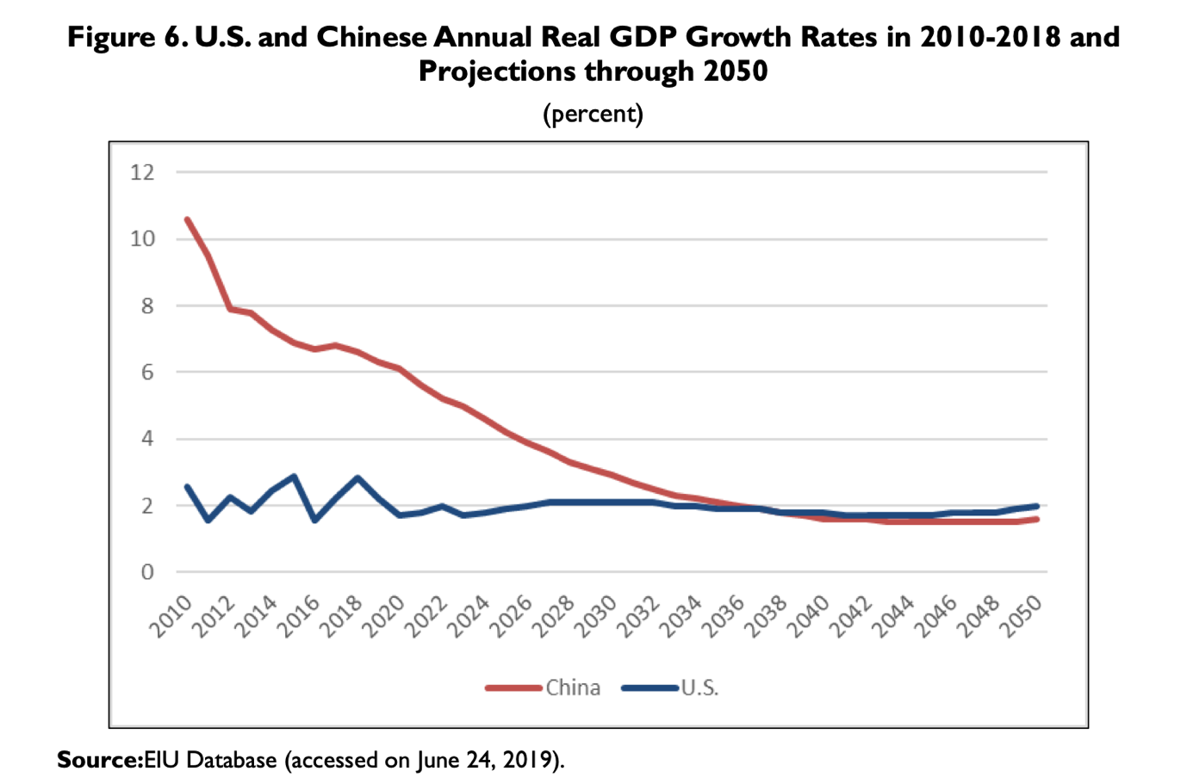
The Chinese government has made it clear that it wants to switch from its present economic model of quick expansion at any costs to more "smart" economic growth, which aims to rely less on energy-intensive and high-polluting sectors and more on advanced technology, renewable energy, and services. China has also said that it seeks to achieve more evenly distributed economic growth. (These topics are ccovered in further length in the report.)

2. Infrastructure Development in China
One of the distinguishing characteristics of China's growth over the past 20 years has been investment-led growth, which is backed by both domestic savings and foreign direct investment. The present boom has not been caused by investment per se, but infrastructure spending, which accounted for almost 14% of GDP in 2006, has been a significant factor (see Table-1A7). Massive infrastructure development, notably in the 1990s, has provided the foundation for China's ongoing high economic growth and enhanced competitiveness.
Three major routes account for the majority of China's infrastructure finance. These include market-based financing, borrowing, and direct budget investment using financial resources. Direct budgetary spending on urban infrastructure includes actions taken at the federal, provincial, and local levels.
A large portion of funding for urban infrastructure is provided by local governments because it is also their local (sub-provincial) duty. Off-budget fees are a second source of direct public funding. These are typically unreasonable costs imposed on things like building permits and different corporate authorizations for domestic and overseas activities (see Table-2A).
However, they offered a stream of unconstrained local cash that was frequently challenged into expenditures in infrastructure. Third, market-based financing and borrowing were used to close the financial gap left by the reduction in direct budgetary spending on infrastructure. Given that the majority of banks were state-owned, it was a national policy to encourage lending towards the construction of urban infrastructure.
However, as sub-national governments have gotten more and more control over the decision-making process for development, the amount of funding for infrastructure in China coming from the state and central budget has been continuously diminishing. Provincial and municipal governments have actively pursued other avenues for generating funding to support infrastructure development. As a result, local governments and other affiliated entities provide the vast majority of the investment money through "self raised and other funds." These funds, which in 2006 accounted for 75% of all investment finance, were primarily made up of a combination of firm retained earnings and additional budgetary income of various types.
There has been virtually little private and international investment in infrastructure development. Less than 2% of the capital funds spent in infrastructure in 2006 came from FDI, which is a relatively small percentage.

Government agencies and state-owned businesses presently control the supply of infrastructure services in developing nations like China and India. China's capacity to obtain appropriate returns, profitability, and execution ability are the causes of its superior success.
Chinese state-owned firms are aggressively encouraged to generate results and take risks, in contrast to bureaucracy in India, where the regulatory environment discourages it (Nataraj, 2007). Table-3A presents a comparison of infrastructure development. The politicization of the government apparatus appears to be beneficial and effective for producing outcomes in China, where incentives between the government and bureaucracy, and by extension, the management of state-owned firms, appear to be aligned10.
The Chinese government conducted a fiscal stimulus program during the 1997–1998 East Asian economic crisis, whereby the Central Government transferred funds to local governments and initiated the issuing of state debt to fund projects.
From 5.7% of GDP in 1998 to over 14% in 2005, infrastructure led fixed capital formation more than quadrupled, and the proportion of infrastructure in overall investment grew to almost one-third of gross capital formation in 2006. Without a variety of new economic infrastructure services in place, China's rise as the global factory would not be conceivable. The industrial and service sectors had a significant inflow of FDI thanks to the open economic policies, accessible infrastructure, and reasonably priced labor, which resulted in growth that was driven by exports and productivity.
There are several participants in the central level planning and policy-making processes for infrastructure.
China's infrastructure development organization is highly structured and active (see Fig.1). At all levels of government, socioeconomic planning, sectoral planning, and urban planning at the municipal level make up the planning framework for infrastructure development. Long-term, medium-term (i.e., five-year), and yearly plans are among the time horizons for socioeconomic and sectoral planning. Typically, a 20-year time frame is covered by an urban master plan. The National Growth and Reform Commission (NDRC, previously National Planning Commission) is at the center of the planning apparatus and creates yearly plans, five-year plans, and strategies for economic development.

2.1. Factors of economic development of the PRC
By itself, China's quick development is a factor that has the potential to have a significant impact on the direction of the global economy. The kind and duration of China's development model in the foreseeable future will have a substantial impact on global economic ties. Because China is changing quickly, even while the general framework of the growth model hasn't changed, it is crucial to take into account the fundamental features of Chinese development and the underlying issues. This component is reaching a completely new level as the nation does. It is important to take into account a number of factors in order to comprehend the Chinese model: What reasons, in general, raised the technical level of the Chinese economy and what reserves underlie growth, and what states do these reserves currently and potentially have in the future?
The Chinese development model is a topic of much discussion. Others feel it may be stated to be nearly universal, that is, acceptable for many developing nations, while certain scholars typically dispute its existence. The most pertinent view is that of the many analysts who think it is an adaptation of the East Asian model of economic development. This model was initially created in post-war Japan, and it has since been adopted by South Korea, Taiwan, Singapore, and Hong Kong, also known as the "Asian tigers." Later, China and, to a lesser extent, ASEAN nations embraced it (Malaysia, Thailand, Indonesia, the Philippines, and later - Vietnam, Kampuchea, Laos, and some others). Thus, the model started to expand throughout APA and South-East Asia (Asian-Pacific area)
This paradigm includes enormous variations for each nation. But these are its salient characteristics: 1) The economy's focus on exports, particularly in the industrial sector; 2) The use of inexpensive labor; 3) a high share of investments in GDP (the share of accumulation is very high, ranging from 30 to 40% or even more); 4) the importation of technology; 5) intensive, to varying degrees, state participation in the development of the economy; f) the creation of special economic zones (as for China and some other countries); and 6) authoritarianism of varying degrees and/or a one-party system (exceptions are possible as in Japan or Taiwan, for instance, the same party remained at the helm of power for a very long time). The final point promotes national stability, which is crucial for generating money.
This approach, which has varied degrees of implementation success depending on the particulars of various nations, generates rapid rates of economic growth over the long run by luring capital and technology. It increases the potential for raising both technical advancement and worker productivity. As a result, the population's standard of life gradually rises, urbanization expands quickly, and the nation modernizes. The East Asian model countries' growth rates do, however, slow down as per capita GDP and domestic consumption rise.
And the fact that they are slowing down provides a strong foundation for many analysts to predict that China's development would slow down when it achieves a specific level of GDP per capita (not more than $10,000). The Chinese model has each of the aforementioned characteristics. However, seat has a few extremely significant characteristics. First, an unusually large population.
China is a powerhouse due to this factor and its vast land. Second, the function of the state under Communist Party control. This idea is crucial to the Chinese model and was the fundamental factor influencing whether reformation was possible. Thirdly, the peculiar condition of the peasants, which lacks numerous civic rights and land ownership. This permitted—and still permits—the use of agricultural resources for national and governmental objectives. The presence of complete distinct governments with a Chinese majority and the significant contribution of ethnic Chinese foreign money round out the list (Hong Kong, Macau, Taiwan and, to a large extent, Singapore).
Since a sizable portion of, and occasionally all, foreign investment still passes through this route, there is little question that the influx of foreign money to China would be significantly lower. The impetus created by Hong Kong and Macau's admission is still somewhat discernible in the expansion of China. Together with the peculiarities of the Chinese reforms, these fundamental aspects of the Chinese model—most notably the expanded role of the state with an obedient and disenfranchised populace—have produced a number of other crucial traits that are both essential to China's success and its potential flaws.
For instance, low-cost ecology (lack of proper attention to environmental protection), low-cost social policy that is not overly taxing on the state (the option to continue to forego state obligations regarding pensions and benefits for a significant portion of the population, tuition and medical care, low levels of workplace safety, etc.), birth control policies that lower costs for the younger generation, and a low Yuan rate that is export-friendly.
China was also spared from the crisis in the 20th century due to the low exchange rate, but many other Southeast Asian nations suffered significantly due to the overvaluation of their local currencies.
The extremely high percentage of GDP that is spent on accumulation is listed further down. This enables massive investments and keeps growth rates high, but is only possible with a strong government presence in the economy like that of China; deliberate state policy in the areas of low tariffs for energy and raw materials, building infrastructure, raising labor productivity, innovation, the level of openness of the nation, etc.
In connection to the latter, it's crucial to recognize the path of progressive opening up to international investment, where China has advanced the most ( it is much larger compared with a policy of encouraging domestic business or the development of domestic consumption).
All of these factors helped China's exports develop more quickly than the country's overall economy, and FDI inflows increased tenfold. It should be highlighted that the PRC's performance and growth are significantly influenced by the credentials of the Chinese leadership, the concentration of the state machinery, and society at large. The aforementioned ongoing expansion of chances for the development of local and international company should be highlighted as a separate growth element. As already mentioned above, there are additional long-term drivers of economic growth. A very high investment level (up to 50% of GDP in certain years), a significant inflow of foreign capital, and comparable increases in labor productivity.
The problem of China's driving forces reflected via investments is very significant for understanding the causes of its fast growth and possibilities for future development. The strong drive for expansion is due to the fact that there are now more organizations looking to invest and increase production in China than in Western economies. Of fact, foreign businesses are heavily involved in investment and output growth. Private local business owners have less impact in China than they do in industrialized nations because they cannot get loans and are subject to several restrictions.
The activity of the authorities (with regard to direct investment as well as activity to attract investors) spreads at all levels: from the central government, which establishes the primary priorities, ratios, and most expensive projects, through the level of the provinces, then at the level of districts, counties, and lower. As a result, the state (and party) participate on several levels in the growth of production and the area of investment. Additionally, there is rivalry for investment and fast growth rates at all provincial and local levels. These domestic investments provide roughly 40% of the increase, compared to the export industry's and FDI's combined contribution of about 30%.
Last but not least, sizable state corporations—including monopolistic ones—serve as a potent growth engine by attempting to reinvest their earnings in brand-new initiatives that the state then approves and manages through loans and other financial and administrative tools. On the one hand, in the PRC, increased production entails new locations for managers and their staff as well as additional resources, the management of which enhances authority. On the other hand, access to resources is always fiercely competitive amongst firms and is influenced by investment activity. In addition, the inability of state-owned firms to profit through any other channels due to improper distribution may also be a factor in active internal investment.

Chapter 2. Theoretical Framework
The Solow model is presented in the following in a fairly simplified form because it comprises expressions and mathematical operations that may be challenging for anyone who are not familiar with national economics.

2.1. The Solow Model of growth

As an expansion of the Harrod-Domar model, Robert Solow created the Solow model in 1956, for which he was given the Nobel Prize in Economics. 25 The model makes an effort to describe how an economy's economy grows. It achieves this by examining how short-term changes in GDP per capita are influenced by changes in labor, capital, and population growth, as well as how long-term changes are influenced by changes in human capital and technological advancement.

2.1.1. The simple Solow model
The basic form of the model explains how GDP per capita, or standard of living, is calculated in an economy using only capital and labor.
Savings and investments produce capital, which includes tangible assets like equipment, buildings, and roads. Governments, businesses, and households all set aside a portion of their income, which is then lent to others for investments. For instance, if a business invests in new machinery, GDP rises, increasing future savings and investments. According to the Solow model, there is a closed economy and all funds go into investments. These two components are therefore regarded as one.
Capital does not just increase via investments; it may also fall through depreciation, for instance, when machinery and roads need to be replaced when they wear out. Savings and investments must be equal to or greater than the rate of capital depreciation in order to maintain a constant level of GDP per capita since capital depreciates.
The other component of production in an economy is labor since it is necessary to put the capital that has been provided to use. Although labor and population are defined differently in the original Solow model, these terms are used interchangeably in this condensed version. The fundamental reason for this is that a high population often suggests a large labor force. This is partially due to the difficulty in locating labor statistics.
The steady state GDP per capita is the result of the interaction between capital and labor. At the steady state, the economy is not growing; rather, the nation's standard of living is stable.

Figure 2: The simple Solow model
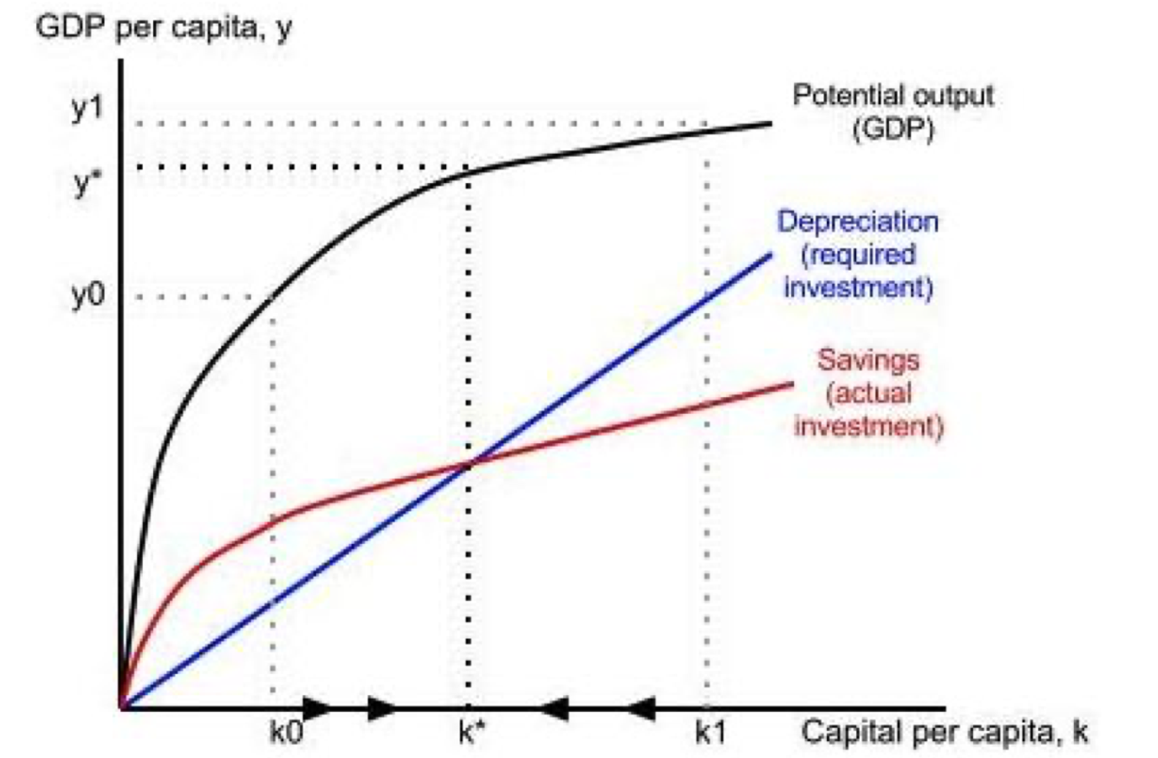
Here, you can see how GDP per capita is created via savings and depreciation. The economy reaches a stable state when savings equal depreciation rate (blue and red intersection), at which point GDP per capita, y*, and capital per capita, k*, are neither increasing nor dropping. No economic growth is occurring. The economy will expand toward k* if the capital stock is at k0 because there are more investments than there are things that are being depreciated. GDP per capita will decrease the next year if investments at k1 do not completely replace all capital that is being depreciated. In this manner, the capital per capita constantly advances in the direction of k*, the steady state.

Figure 4: The simple Solow model with population growth
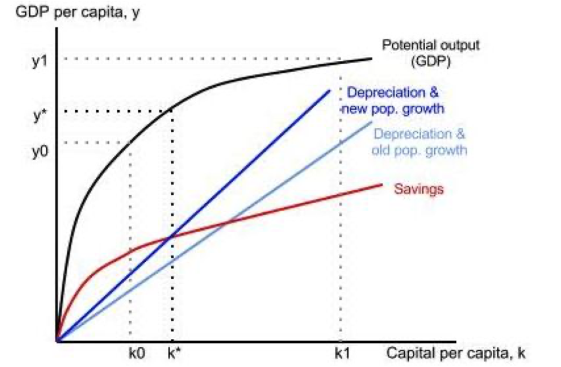
What transpires if population growth occurs? Population growth has been added to the depreciation line, which indicates that savings are now required to cover both the increase in population and depreciation. If savings remain constant, the steady state shifts to a lower point at y* and k*, where both capital and production per worker decline. This explains why nations with fast population growth and low savings typically have lower levels of poverty than those with slower rates of population increase.
Are capital and labor sufficient to generate economic growth? Because of positive but declining marginal productivity, the answer is no. This suggests that if a company has both labor and capital, expanding the workforce will boost output. The output will rise, although at a slower rate, if we keep raising the number of workers. The final worker will not increase output as much as the first one. This is seen in the potential output line's form, which begins steeply then flattens off. Only the level of living in an economy is impacted by capital and labor; the growth rate is unaffected.

2.1.2. The Solow model augmented with technological progress and human capital
To date, changes in the steady state level of GDP per capita have been brought about by changes in capital (savings, investments, depreciation), labor, and population increase. As seen in the accompanying diagram, different nations arrive to various stable states. You can't keep investing in capital and labor to boost economic growth since it will ultimately be ineffective due to declining marginal productivity. The model requires more information to explain long-term growth, the reasons why some countries expand more quickly than others, and the actions that may be taken to boost growth in emerging nations. Human capital and technology advancement are two variables that can accelerate growth.
Technological advancement: Solow introduced technological advancement to the model to clarify why labor and capital are more productive in certain nations than others. The phrase "technological advancement" is a little deceptive since it encompasses all "intangible characteristics of human growth that allow both population and capital to raise their production," which might differ from nation to nation.
Because technological advancement increases the productivity of the current capital and labor, economic development results without an increase in either. As we have seen since industrialisation, better equipment and employees with more expertise produce more. How does the Solow model quantify technical advancement? The issue is that nobody is aware.
Mankiw, Romer, and Weil, rather than Solow, brought human capital to the model. They believed that human capital may explain how technology advanced since a work force that is educated and in good physical and mental health will be more productive. Human capital, including healthcare and education, will thus have a favorable impact on economic growth. According to the model, all changes in labor productivity are caused by human capital because population growth is assumed to be constant.
Similar to how physical capital builds up, so does human capital. By putting more money into education than in physical capital, households, businesses, and the government "save" human capital. The only distinction is that they make the decision to do so; it does not automatically occur, unlike technical advancement or population expansion.
Output is split into two parts: physical capital and human capital. The rate of increase of physical capital and human capital are equal (the growth rates are shown in Appendix 1). These growth rates alter the rate at which the economy expands, which has an impact on production similar to that of technical advancement.

2.2. Why use the Solow model?
Since the 1960s, the Solow model has drawn both acclaim and criticism. One of its flaws is that it leaves out institutions' strength and entrepreneurship as sources of progress. The approach does not address how or why technical advancement takes place, which is why Mankiw, Romer, and Weil decided to include human capital in their solution.
The model has also been subjected to a number of empirical tests, some of which confirm the model and others of which do not. Even yet, it is the most extensively applied model for long-term economic growth and represents the most significant addition to the neoclassical theory of growth.
Econometric models using the expenditure approach for GDP Measurement
The entire GDP of an economy is made up of total consumption, total investment, and net exports according to the expenditure method. China does not employ this technique, unlike several other nations that include government expenditure and investment as a fourth component in their GDP numbers.
Total GDP in China is calculated as total consumption plus total investment plus net exports. Government consumption is added to total consumption, while government investment is added to total investment. Since changes in net exports, investment, and consumption affect yearly GDP growth, our article employs the following specification for Model 1.
GDPr = a + b* Consumptionr + c* Investmentr + d* Net-Exportr
The yearly growth rates for GDP, consumption, investments, and net exports are collectively referred to as GDPr, Consumptionr, Investmentr, and Net-Exportr, respectively. Since the variables' yearly growth rates rather than their initial annual values are employed in our models, the multicollinearity issue is avoided. Data that divides total consumption into personal consumption and government consumption is also reported by China. To replace total consumption with personal consumption and government consumption, we adopt the following specification for Model 2.
GDP^{r} = a + b1*Personal-Consumption^{r} + b2*Government-Consumption^{r} + c*Investment^{r} + d*Net-Export^{r}
Since 1978, China's rapid economic growth has been underpinned by its economic reform and opening up programs. Huge FDI has been attracted by these measures. Joint ventures, wholly foreign-owned businesses, and FDI have all pushed China to open up further and advance reform. China's commerce and economic growth have benefited greatly from FDI. Trade by FDI companies used to make up around 50% of all trade in China, but it is currently only about 40%. As a result, we include an FDI control variable in Model 3. Since FDI data is available from 1981 onward, the Model 3 tests the 1981–2020 timeframe. R&D is also crucial for an economy's productivity and competitiveness.
Spending on R&D in China has grown, from 0.9% of GDP in 2001 to 2.4% of GDP in 2021. To evaluate if R&D investment has had an impact on China's GDP growth, we add another control variable for R&D to Model 3. As a result of the projected coefficients for R&D's relatively low yearly values and the fact that it does not immediately provide income, we anticipate that they will be mostly inconsequential. The specification for Model 3 will be the following after the FDI and R&D control variables have been added:
GDP^{r} = a + b1*Personal-Consumption^{r} + b2*Government-Consumption^{r} + c*Investment^{r} + d*Net-Export^{r} + e*FDI^{r} + f*R&D^{r}
China's economic growth and development have both benefited from international commerce. China is a major hub for manufacturing, while several businesses have lately relocated there from Vietnam and India because of growing costs there. In the future, China will remain be dependent on trade, particularly exports. Table 1 presents the net exports to total GDP ratio for China, and Table 2 the total exports to total GDP ratio for China.
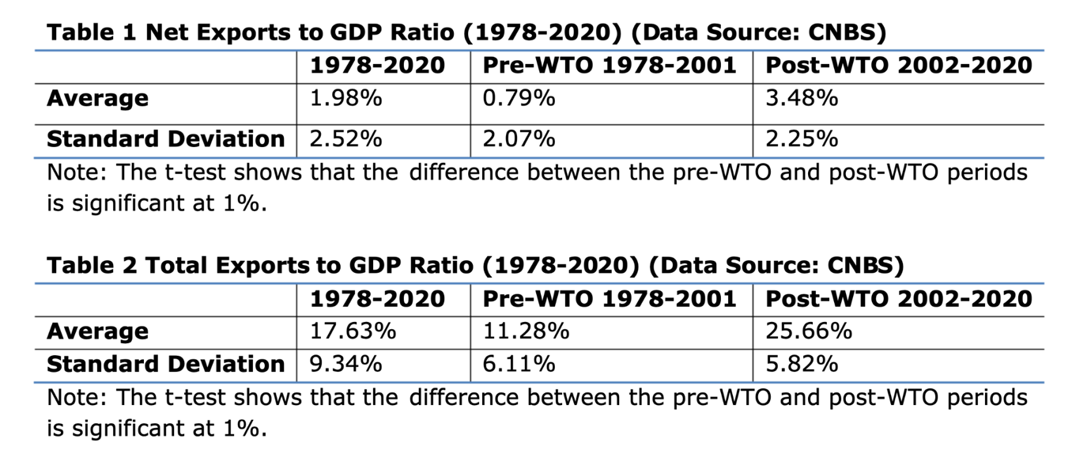
Net exports made a small dent on China's GDP growth, according to Chen et al. (2022). Therefore, we anticipate that the predicted Net-Export coefficient in Models 1, 2, and 3 will either be negligible or close to zero. These findings do not, however, imply that trade is not significant to China's economy. Despite the fact that net export growth does not directly affect GDP growth, exports are nonetheless crucial to the economy because they provide employment that enhance wages and personal spending. The rise in a nation's foreign exchange reserves makes it possible for the government to finance public initiatives. Although imports have a negative impact on GDP, they are nonetheless helpful to the economy since they supply goods and services that are required and raise living standards.
To account for the impact of total exports on China's economy, we replace the net export growth rates in Models 4, 5, and 6 with the total export growth rates. This new variable is anticipated to have a major impact on regressions.
GDP^{r} = a + b*Consumption^{r} + c*Investment^{r} + d*Total-Export^{r} (4)
GDP^{r} = a + b1*Personal-Consumption^{r} + b2*Government-Consumptionr + c*Investment^{r} + d*Total-Export^{r} (5)
GDPr = a + b1*Personal-Consumptionr + b2*Government-Consumptionr + c*Investmentr + d*Total-Exportr + e*FDIr + f* R&Dr
In this study, we contrast how each independent variable affected China's GDP growth before and after the WTO. The pre-WTO period (1978-2001) and post-WTO period (2002-2020) are therefore separated from the entire data period (1978-2020). (2002-2020). We do regressions for the whole period (1978-2020), the pre-WTO era (1978-2001), and the post-WTO period (2002-2020), respectively, for each of the six models. We now have 18 regressions, which are displayed in Section V.

2.3 Key Factors of Development in China`s Economy
The execution of economic policy has been hampered by China's economy being just about at the level of sustenance.
Agriculture was its major industry, although it was very unpredictable due to the difficulty of mastering natural whims, which was greater than that of industrial methods.

2.3.1 Agriculture
Agriculture is the foundation of China's economy. However, China faces increasing constraints due to its weaker than average access to natural resources, including water and arable land per person. The demand for primary agricultural goods is increasing, which improves farmers' income and increases competition among agricultural products.
Chinese agriculture's structure is still ludicrous, with its low level of industrialisation and low-value agricultural goods. Poor ecological and environmental conditions necessitated stringent limitations on further agricultural progress, in addition to challenging issues with food and environmental safety.
China has emerged as a significant leader of global economic growth as a result of economic reforms implemented in the country's agriculture sector, which resulted in a high income growth. Recent data show that China produces 50% of the world's veggies, 29% of the world's meat, and 18% of the world's cereal grains. Due to its agricultural achievements, China now has the greatest economy in the world and is the top producer of fish, cotton, wheat, rice, and pig.
China produces almost 20% of the world's food using just 9% of the world's planted acreage, which is a marvel given the difficulties the Chinese agricultural industry endured in the 1960s and 1970s.

2.3.2 China's industrial performance
A specific Chinese type of industrial capitalism has existed since the start of the twenty-first century. The rapid industrialization of China, which represents the "stage skipping" phenomena, is a result of Chinese and foreign companies' efforts to acquire technology. Some have referred to the straight transition of Chinese industrialisation from copying established technology to invention as
"leapfrogging."
The country's needs for importing airplanes, machinery, production equipment, telecommunications technology, and numerous raw commodities increased as a result of China's industrialisation. International company can benefit from this circumstance while also experiencing certain drawbacks.
Since the first industrial revolution, advancements in the manufacturing sector have been essential to economic growth and transformation. It is linked to increased per capita incomes and productivity rates.

known as a "structural bonus."
It was able to expand its role as a hub for manufacturing throughout the world after joining the WTO in 2001. As a result, China generated enormous exports to Europe, the US, and other parts of the world. MNEs that see China as a promising future as a hub for manufacturing and a sizable consumer market have begun to invest there.
Chinese manufacturing contributed 35.1% more to the gross value added in 2013 than did American manufacturing; this involvement was higher. China's economy places a greater emphasis on manufacturing than do the economies of the US and Japan.

2.3.3 Employment
In China, working conditions are far from being ideal, in particular, for internal migrants.
The informal work does not give any form of social or legal protection, but undoubtedly a very poor and erratic income. China is far superior to the nations in the area in this regard. The fact that much of China's informal labor is semi-formal work with some level of legal and social protection should also be mentioned. It is challenging to find solutions to the employment issue in the world's most populous nation
The Chinese government is well aware that the demand on employment at this time is still high due to the interaction of the following factors: the population's initial high density, age structure, population movement, and the process of social and economic growth. In 2020, there will be 940 million individuals of working age, a growth of 5.5 million yearly throughout the course of this decade.

2.3.4 Capital Investment
Our findings indicate that China's growth was strongly affected by capital investment. To further boost the economy, China must keep up its increase in capital expenditures. How can China increase the productivity of its government investments, in particular, and investment efficiency in general? This topic has come up in several research (Pettis, 2022; Rajah & Leng, 2022). The policy conclusion is that significant private and public investment is required for China's future growth. Government direct investment is vitally required in many fields, including basic infrastructure and other public enterprises. In order to get domestic and international companies to conduct business and increase their investment in China, China must also offer advantages.

2.3.5 Export and Import
Our regression analysis shows that changes in the net export to GDP ratio and total export growth had a substantial impact on yearly GDP growth. China is the second-largest importer after the United States. According to Chen et al. (2019), China's industrial expansion in previous decades was mostly dependent on exports. For China's future, trade, and particularly exports, will continue to be essential. China has to increase its trade and exports and lessen the detrimental impacts of trade on its economic growth, according to the study's policy implications. China should strive to increase service exports while also stabilizing industrial exports.
The RCEP's adoption offers China a significant potential for commerce, similar to the WTO. Exports to the other fourteen RCEP nations now make up 26% of China's overall exports, while imports from these nations make up 37% of China's total imports. China should thus increase its exports to the other RCEP nations and take benefit of the RCEP agreement.

2.3.6 China’s dual circulation
Dual circulation is presently getting more attention both in China and internationally. Despite being a new term, it is expected to represent China's economic growth plan for many years to come, thus it won't likely become a passing fad. The concept of dual circulation will take center stage in China's 14th five-year plan for 2021–2025, which was discussed at the Fifth Plenum of the Chinese Communist Party at the end of October and will be finalized at the following National People's Congress, which is most likely to be held in March. Although there are few formal specifics about the plan, this study will attempt to clarify the dual circulation idea and evaluate what it implies for the Chinese economy and the rest of the globe.
China will place a greater emphasis on using its sizable internal market and local demand under the dual circulation plan. A strategy that simultaneously focuses on the local and international aspects of the economy will now formally replace China's export-led growth model, which has been an important economic engine since the nation's entrance to the WTO in 2001 (chart 1). In fact, because of the dual circulation, the domestic and foreign "circulations" are complementary to one another.
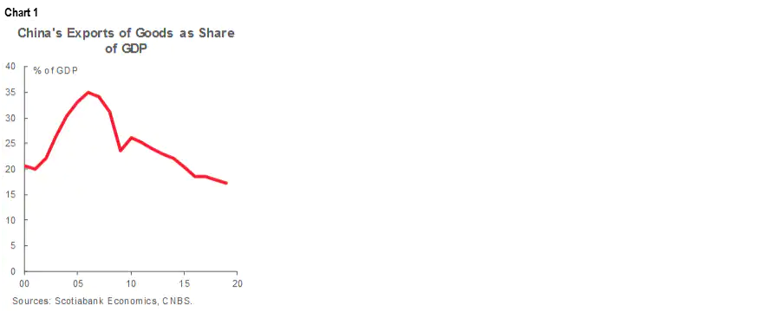
There have been some worries raised about growing protectionism in China due to the timing of the new plan. We admit that the shift in Chinese policymakers' attention to internal demand dynamics comes in the wake of escalating tensions between China and the US as well as a global wave of protectionist sentiment as economies struggle to deal with the COVID-19 pandemic's effects. However, we disagree that the tactic suggests that China is moving inward. The Chinese economy is, and has been for some time now, undergoing a structural shift toward one that is more centered on consumers and services.
We view the dual circulation plan as a practical and crucial component in the nation's effort to increase per-capita income and economic development. In fact, we believe that in order to escape the "middle-income trap" that threatens many newly industrialized export-oriented nations, China will need to increase the importance of the consumer in its economy during the next five years. Nevertheless, we agree that the COVID-19 epidemic exposed several flaws in international supply networks. The internal circulation component of the policy will help China become more self-reliant in strategically significant sectors like technology.

Internal Circulation
Internal circulation policies will put a lot of emphasis on increasing household incomes and the importance of consumers to the economy. Reforming the land and residency system to encourage urbanization can result in higher salaries. The chances for increased consumer spending would be further bolstered by lowering China's very high savings rate (chart 2).
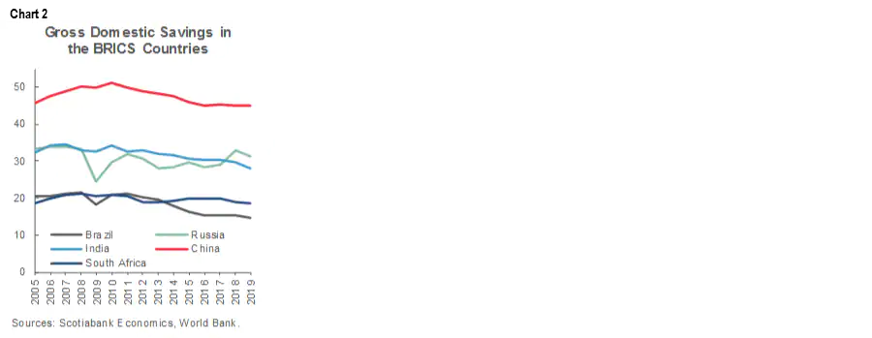
According to our analysis, technical improvement is a crucial component of internal circulation and will be essential to raising the nation up the global value chain. China wants to lead the world in technological advancement, supported by indigenous innovation. The nation's focus on internal technological capabilities, such as domestic semiconductor production, will give it some protection from external tensions given various other countries' concerns regarding China's security and intellectual property practices and the resulting restrictions on China's access to technology resources.
An additional crucial component of internal circulation is China's industrial policy, which is connected to its objectives in terms of technology. China wants to push for higher-end manufacturing while strengthening and diversifying its industrial supply networks. In order to help the economy reach a higher degree of growth that is more in line with major advanced economies, the country simultaneously intends to expand the services sector and promote services-oriented manufacturing.

International Circulation
We can see that China wants to continue to be a relevant player in the international market. In reality, the Chinese government has persisted in promoting further regional and global economic integration as well as closer investment relations. We anticipate that these efforts will continue in the years to come, playing a crucial role in China's international commerce. We believe that this strategy will aid China in strengthening its global economic clout, particularly in light of the US's recent inward turn.
China will be able to enhance its influence in regional and international issues, as evidenced by the Regional Comprehensive Economic Partnership (RCEP), the largest free trade deal in the world that covers 30% of the global GDP. The RCEP was ratified by its 15 members in 2021 after being signed on November 15 by China, Japan, South Korea, Australia, New Zealand, and the 10 Southeast Asian countries that make up the ASEAN group.
China's dual circulation plan is fundamentally based on the execution of structural changes. While reforms will support the growth of the domestic economy, they will also be crucial from the perspective of global trade as they help China integrate with the world economy and financial markets. In fact, Chinese leaders have reaffirmed their dedication to further liberalizing the economy. Although there is a long list of reforms that are required in our opinion, we believe that the government's top priorities over the next five years will continue to be the internationalization of the renminbi (RMB), the development of capital markets, the reinforcement of regulatory standards for the financial markets, and the continued gradual easing of the capital account.

Data and Variables
The National Bureau of Statistics (CNBS) of China provided the data, which span the years 1978 through 2020. The figures in the data are nominal Chinese Yuan. In order to compare the estimated coefficients for the independent variables across the two time periods and demonstrate the effects of the WTO on China, the whole data period (1978-2020) is separated into the pre-WTO era (1978-2001) and post-WTO period (2002-2020).
The yearly rise of net exports is one of the independent variables in Models 1, 2, and 3. Outliers exist for this variable, though. Therefore, it is important to use a proxy variable to replace net export growth. Since the new variable is still connected to the change in net exports and is likewise a percentage variable, it has been chosen to take the place of the net export growth rate. Models 1, 2, and 3 employ the change in the net exports to GDP ratio to better represent the impact of net exports on economic growth.
The yearly GDP growth rate is the dependent variable. Our six models employ a total of eight independent variables. The yearly growth rates for total consumption, total personal consumption, total government consumption, total capital investment, total exports, FDI, and R&D are seven independent variables. Because the goal of this article is to determine which factors substantially influenced GDP growth rather than the actual values of GDP, the annual growth rates of variables are utilized rather than their annual values. Utilizing the growth rates also aids in preventing multicollinearity problems for the model's variables. The ratio of net exports to GDP has changed, making it the seventh independent variable.

Regression Results
The regression findings from Models 1, 2, and 3 are shown in Tables 3, 4, and 5, respectively. The findings indicate that the majority of the coefficients are significant. To assess the impact of the WTO, the coefficients for the pre- and post-WTO periods are contrasted. Table 3 shows that the growth coefficient for total consumption fell after the WTO. Tables 4 and 5 show that in the post-WTO period, the coefficients for personal consumption growth declined while the coefficients for government consumption growth rose. These findings suggest that after China entered the WTO, government expenditure had a higher impact on GDP growth than did individuals consumption. For all three models, the post-WTO period saw an increase in the projected coefficients for capital investment growth. After China joined the WTO, total capital investment had a stronger influence on GDP growth, and the marginal rate of return did not fall as investments rose. The biggest values are seen in the coefficients for change in net export/GDP, but they hardly changed after the WTO.
Table 5 shows that the coefficients for FDI growth are significant for the pre-WTO era (1981-2001) and for the entire period (1981-2020) as well as for the pre-WTO period (1981-2001). The FDI and R&D estimated coefficients are very low. Even if FDI and R&D are still crucial to the economy, these conclusions are fair since their yearly quantities are quite minor when compared to the other independent variables. Consequently, either their predicted coefficients will be negligible or very tiny.
Although FDI may not have a big direct impact on GDP growth, it can nevertheless have a positive impact on the economy. Technology in China has advanced thanks to FDI and the corporations that support it, and Chinese businesses now employ modern management techniques. 40% or more of China's entire commerce is made up of FDI company trade. Similar to FDI, R&D spending accounts for a tiny percentage of GDP (2.4% in 2021), which was considerably lower in previous years. Even while R&D does not directly result in GDP, it is nonetheless essential to a nation's ability to compete globally. R&D is particularly crucial to China's industrial sector and technological breakthroughs.
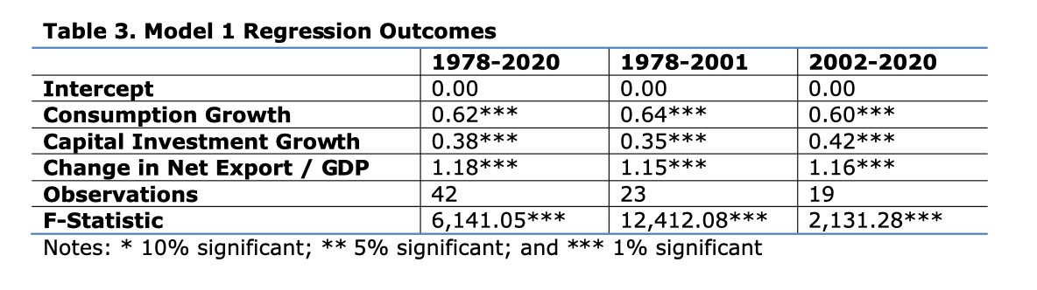
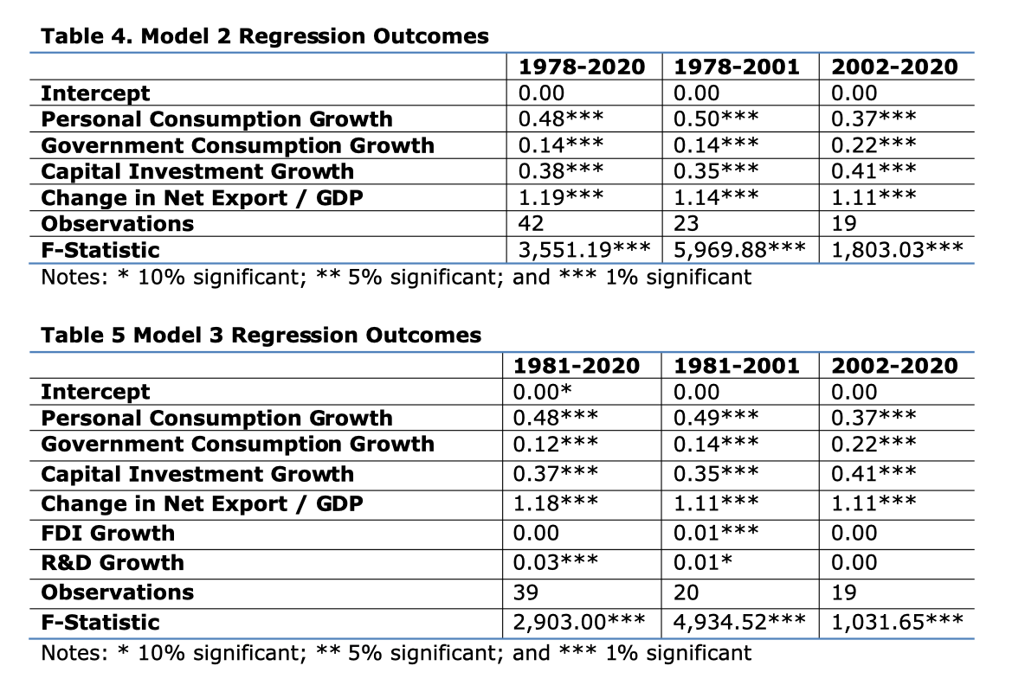
The regression findings for Models 4, 5, and 6 are shown in Tables 6, 7, and 8, respectively. Models 4, 5, and 6 employ the total export growth rate as an independent variable rather than the change in the net export/GDPratio to demonstrate how exports directly effect China's economic growth. Most of the variables' coefficients have substantial values. In Table 6, the coefficient for the growth in total consumption fell after the WTO. Tables 7 and 8 show that while the coefficients for government consumption growth rose in the post-WTO era, the coefficients for personal consumption growth remain negligible. In the years following the WTO, the growth coefficients for capital investments barely changed.
In comparison to the pre-WTO period, the projected coefficients for total export growth are four to five times higher in the post-WTO period. This finding suggests that China's entry into the WTO significantly boosted export growth and supported Chinese economic development. The FDI Growth coefficients in Table 8 are significant for both the entire period and the pre-WTO period. The coefficients for R&D Growth in Table 8 are not significant for any of the three time periods.
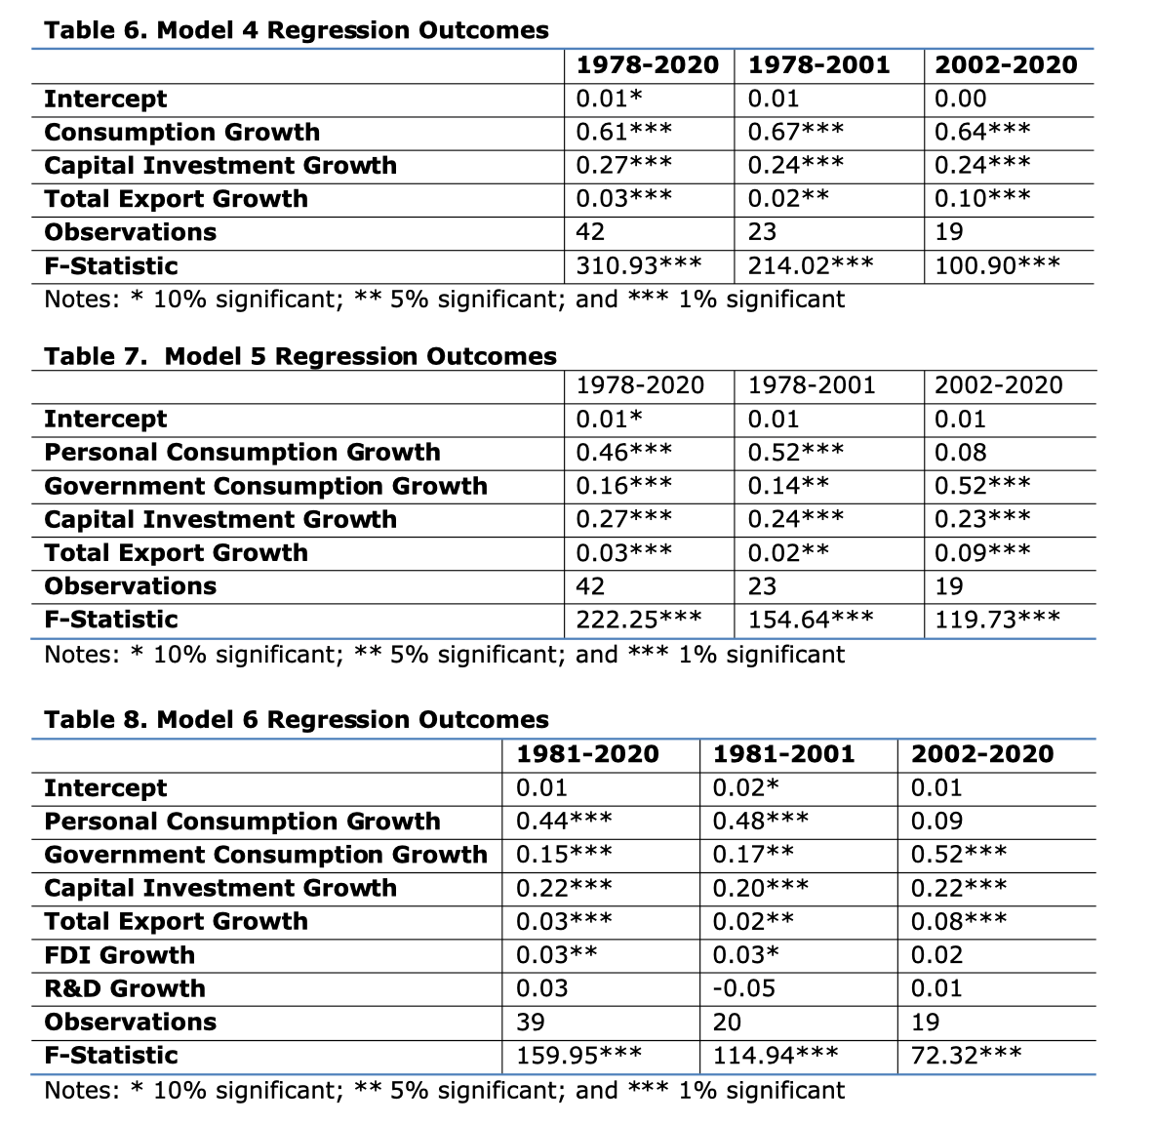
The predicted coefficients for government consumption, capital investment, and total exports, in particular, were higher in the post-WTO period than they were in the pre-WTO period, according to the regression findings. Government expenditure, capital investment, and total exports all had an increased effect on China's economic growth when it joined the WTO.

The Potential Effects of the RCEP
A comparison between the RCEP and the WTO may be seen in Table 12. The RCEP accounts for 31% of global GDP and about 29% of the world's population. To encourage trade and investment, the RCEP aims to further expand markets and lower tariffs. 90% of tariffs are reduced for intraregional trade under the RCEP (Nicita et al., 2021). According to Park et al. (2021), the RCEP will boost its members' exports and revenue by $245 billion and $514 billion annually, respectively.
In 2021, 31% of China's overall commerce, 26% of its total exports, and 37% of its total imports will be with the other 14 RCEP participants. China now buys more goods from RCEP participants than it sends abroad. More markets are available for Chinese exporters according to the RCEP agreement. The RCEP is anticipated to boost China's commerce, particularly its exports. According to Park et alforecast .'s from 2021, the RCEP will boost China's exports and income by $127 billion and $234 billion yearly, respectively.
The WTO raised China's average yearly GDP growth by 2.01-2.37%, according to our research in Table 9. We predict that the impact of the RCEP on China will be at least 31% of the impact of the WTO since the RCEP accounts for around 31% of China's overall trade and 31% of the entire world GDP. As a result, the RCEP will increase China's yearly GDP growth by 0.62 to 0.73 percent. Given that China's total GDP in 2021 was $17.73 trillion, the RCEP will result in an annual GDP increase of between $110 and 130 billion dollars.
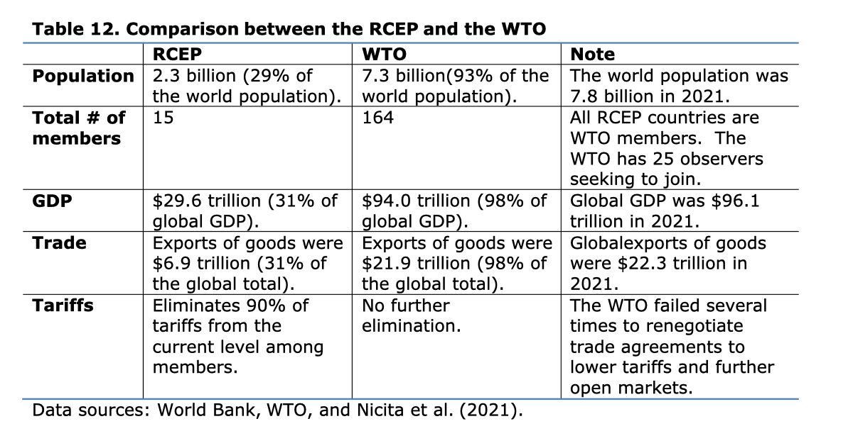

4. Conclusion
Let's go back to the five queries that were posed at the start of this thesis.
- Can the Solow model be applied in the 21st century China to explain economic growth?
Yes, but not entirely. Any theory or model is a condensed representation of reality, and the Solow model is no different. It presupposes a closed economy, and the model enhanced with human capital and technical advancement also presupposes no population increase. Evidently, neither China nor any other nation exhibits this phenomenon. In spite of these problems, the actual findings rather closely match the Solow model. Just as the model predicts, investments and GDP per capita have a positive influence on growth, but population has a negative one.
- Do affluent and poor places have the same growth-promoting factors?
Investments, GDP per capita, and population growth have an impact on growth in both wealthy and underdeveloped nations. While healthcare is more important in wealthy locations, investments and population growth are more crucial in poorer places.
- Are the findings consistent with earlier studies?
Yes, however there has been a wide variety of outcomes from earlier study. One thing they all have in common is that capital, whether in the form of investments or GDP per person, is important to growth and that population expansion is detrimental to it. This is consistent with the thesis's findings.

China has the second-largest economy in the world. Huge population, export-oriented economy, high level of government intervention in economy, intensive cooperation, and various concepts of mutual trade systems (such as one known as "One Zone - One Way"), efficient approach to labor force, programs for attracting foreign investments (in particular, government guarantee), stimulation of technology-related sectors of production, and promotion of national pride are significant factors that have led this country to where it is now.
Some PRC flaws that cannot be overcome are mostly manifested in the country's inexpensive environment and young demography (social policy needs to be improved, but as it is a cultural trend of respect to older share of citizens, government is not in a hurry to make the range of rights, in which young people are interested, wider). Comparing China's approach to international trade structure to that of the EU's approach to economic growth reveals a lack of openness. Europe is now focused on enlarging the market for domestic businesses, including its members in bilateral investment agreements, and looking for ways to transition to creative manufacturing.
In conclusion, it is proven that structural policies and reforms implemented in the areas of agriculture, industry, commerce, and finance were beneficial to China's economy and helped it become a true economic power, as seen by the positive yearly increase of its GDP.
Study examines the primary drivers of GDP growth in China from 1978 to 2020 using the expenditure method of GDP calculation. Study contrasts the pre-WTO (1978-2001) and post-WTO (2002-2020) periods to assess the WTO's effect on China's economic growth. Regression results highlight the beneficial benefits of China's WTO admission on its economy by showing that government consumption, total investment, and total exports contributed more to China's GDP growth in the post-WTO era than in the pre-WTO period.
In an interdependent globe and as a rising economic power, China's rise is undoubtedly one of the most notable economic trends. China challenges local and international hierarchies, which should boost commerce, generate employment, and enhance wealth.
The calculated coefficients for total exports increased four to five times in the post-WTO period, indicating that joining the WTO improved the effect of total exports on GDP growth. Our data also demonstrate that when capital investments increased after the WTO, the marginal rate of investment return did not fall. In order to further investigate the effects of the WTO, our article examines the five-year periods immediately prior to and following China's accession to the organization. In the five years after China joined the WTO, the average GDP growth in China grew by 2.01-2.37% as a result of the WTO. Before China joined the WTO, its yearly GDP growth was decreasing. According to our analysis, China's GDP growth was supported and stabilized as a result of its WTO membership.
Even before the COVID-19 outbreak, China's economic development had been slowing down during the previous ten years. Our analysis investigates whether the RCEP would support China's GDP growth given the parallels between the WTO and the RCEP. According to our results, the RCEP will boost China's annual GDP growth by 0.62–0.73 percent and contribute to stabilizing China's future economic growth.
In this article, we address the policy implications of our research for China and offer recommendations on how China might continue its steady economic development. To boost the level of personal spending, China must first enhance the proportion of worker compensation in its GDP. Second, China should remove needless rules to increase the efficiency of its investment and promote more domestic and international investment. Third, China has to greatly boost its commerce with the other RCEP nations as well as its exports of services. Fourth, China should take steps to encourage FDI into the country as well as FDI out of China into other markets.
China rises effortlessly to become one of the world's economic superpowers thanks to its development in the agricultural, industrial, and commercial sectors, which are bolstered by the number of its population and the tenacity of its culture.
China managed its policies to overtake the United States as the world's top economy sooner than anticipated after surpassing it in 2013 to claim the title of the world's top trade power (2014 against 2019). This is because China underwent a significant transition and implemented several economic reforms, including the Third Plenum Economic Policies, the National Program for S&T Development, and China's Five-Year Plans.

5. Bibliography
- Chang, C., Chen, K., Waggoner, D. F., & Zha, T. (2016). Trends and Cycles in China’s
- Macroeconomy. NBER Macroeconomics Annual, 30(1), 1–84.
- Chen, S., Jefferson, G. H., & Zhang, J. (2011). Structural Change, Productivity Growth
- and Industrial Transformation in China. China Economic Review, 22(1), 133–150.
- Chen, Y. (Bill). (2015). China’s Path to Sustainable, Stable and Rapid Economic Development: From the Largest to the Strongest Manufacturing Country. Journal of World Economic Research, 4(5–1), 8–19.
- Chen, Y. (Bill). (2016a). International Comparisons of Service Industry-What China Can
- Learn from Other Countries? Journal of Advances in Economics and Finance, 1(1), 53–71.
- Chen, Y. (Bill). (2016b). International Comparisons of Agriculture Industry-what China can Learn from Others? International Journal of Agricultural Economics, 1(2), 45–56.
- Chen, Y. (Bill). (2019). The Business Cycle and Economic Crisis—When will China Experience Them? Journal of Advances in Economics and Finance, 4(2), 60–78.
- Chen, Y. (Bill), Li, X., & Pu, C. (2022). China’s Economic Prospects: Can China Achieve Stable and High Economic Growth in Coming Decades? Journal of Global Economics and Business, 3(11) (forthcoming).
- Chen, Y. (Bill), Li, X., Pu, C., & Lin, L. (2019). The Relationship of the Manufacturing
- Growth with the Financial Industry and Real Estate Industry. Journal of Business and Economic Policy, 6(2), 38–47.
- Chen, Y. (Bill), Yu, L., Pu, C., & Lin, L. (2017). The Productivity, Economic Structure and Middle-income Trap—Can China Avoid this Trap? Journal of Applied Business and Economics, 19(11/12), 78–104
- Li, X., Liu, X. and Parker, D (2011), "Foreign Direct Investment and Productivity Spillovers in the Chinese Manufacturing Sector" Economic Systems, 25: 305-321. www.academia.edu
- Lin Wei, Arnold Chao(1983), China's Economic Reforms". University of Pennsylvania Press. https://www.cambridge.org/
- State Statistical Bureau of the People's Republic of China and data given in Jingit Nianjian, (1981) Economic Yearbook.
- Szirmai. A., (2012), "Industrialization as an engine of Growth in developing countries, 1950-2005. Structural Change and Economic Dynamics, 23 (4), December. https://ideas. repec.org/
- The Organization for Economic Cooperation and Development (2007), Chinese Economic Performance in the Long Run, 960-2030, by Angus Maddison, . https://www.amazon.com/Chinese-Economic-Performance/
- Timmer, M. and Szirmai, A. (2000), "Productivity Growth in Asian Manufacturing: The structural Bonus Hypothesis Examined", Structural
- Change and Economic Dynamics, 11:371-392. www.sciencedirect.com
- Whalley. J. and Hamilton. C. (1996), "The Trading System after the Uruguay Round". Washington DC: Institute for International
- Economics. http:// www.economics.uwo.ca/research/
- World Bank (2017), 'China Financial Sector and Institutional Development. http://www.worlddatabank.org
- Xinhua News Agency, Highlights of China's 12 *Five-Year Plan, March 5, 2011; and APCO Worldwide, China's 124 Five-Year Plan: How it Actually Works and What's in store For the Next Five Years, December 10, 2010. https://www.uscc.gov/sites/default/
- Xu,Chenggang. (2011), "The Fundamental Institutions of China's Reforms and Development." Journal of Economics Literature 49 (4):
- 1076-1151. https://www.aeaweb.org/articles.
- Burda, Michael, and Charles Wyplosz. Macroeconomics: a European text. New York: Oxford University Press, 2001.
- Bennich-Björkman, Li. ”Fattigdomsspiral kan brytas med fri sjukvård.” Svenska Dagbladet, 2012- 03-19
- Carlin, Wendy, and David Soskice. Macroeconomics: imperfections, institutions, and policies. Oxford: Oxford University Press, 2006.
- Ding, Sai, and John Knight. Can the Augmented Solow Model Explain China's Economic Growth? A Cross-Country Panel Data Analysis. Discussion Paper, Department of Economics, Oxford: University of Oxford, 2008.
- —. China's Remarkable Economic Growth. Oxford: Oxford University Press, 2012.
Ek, Anna. Utländska direktinvesteringars påverkan på ekonomisk tillväxt: En studie av Kina.
- Bachelor Thesis, Jönköping: Jönköping University, 2007.
- Eklund, Klas. Kina: den nygamla supermakten. Stockholm: Studieförbundet Näringsliv and samhälle, 2011.
- Han, Dongping. ”The Hukou System and China's Rural Development.” The Journal of Developing Areas, 1999: 355-378.
- Hoeffler, Anke E. ”The augmented Solow model and the African growth debate.” Oxford Bulletin of Economics and Statistics, 2002: 135-158.
- Keidel, Albert. The Causes and Impacts of Chinese Regional Inequalities in Income and Well- Being. Carnegie Endowment for International Peace, 2007.
- Kjellgren, Björn. Kinakunskap. Lund: Studentlitteratur AB, 2000.
Lundblad, Therése, and Johan Rosenqvist. Utvecklingsländers ekonomiska tillväxt. Bachelor
- Thesis, Huddinge: Södertörn University, 2012.
- Li, Haizheng. Economic transition and returns to education in China. Atlanta, GA: School of Economics, Georgia Institute of Technology, 2002.
- Loong-yu, Au. Women migrant workers under the Chinese social apartheid. Bangkok: Committee for Asian Women, 2007.
- Macleod, Calum. ”China reviews "apartheid" for 900m peasants.” The Independent, 2001-06-10.
- 35
- Mankiw, Gregory N., David Romer, and David N. Weil. ”A Contribution to the Empirics of Economic Growth.” The Quarterly Journal of Economics,, 1992: 407-437.
- Naughton, Barry. The Chinese economy: transitions and growth. Massachusetts: MIT Press, 2007.
- Ray, Debraj. Development economics. Princeton, N.J.: Princeton University Press, 1998.
- Studenmund, A.H. Using Econometrics: A Practical Guide. Boston: Pearson Education, 2011.
- The World Bank. China 2030, Building a Modern, Harmonious, and Creative High-Income Society . Washington DC: The World Bank, 2012.
- Todaro, Michael P., and Stephen C. Smith. Economic development. Harlow: Pearson/Addison Wesley, 2006.
- Wang, Yan, and Yudong Yao. Sources of China’s Economic Growth, 1952-99: Incorporating Human Capital Accumulation. Discussion Paper, Washington DC: The World Bank, 2001.
- Wixe, Sofia. The Effect of Globalization on Swedish Growth – A study of the years 1980 to 2050. Bachelor Thesis, Linköping: Linköping University, 2009.
- Wong, Ola. ”Kinas nya medelklass.” Kinarapport, 2008: 14-16.
- Park, C.-Y., Petri, P. A., & Plummer, M. G. (2021). The Economics of Conflict and Cooperation in the Asia-Pacific: RCEP, CPTPP and the US-China Trade War. East Asian Economic Review, 25(3), 233–272
- Rajah, R., & Leng, A. (2022). Revising Down the Rise of China. Lowy Institute Analysis.
- Ramo, J. Cooper. (2004). The Beijing Consensus.

