Our Case Studies
Retention marketing

Apollo Moda
𝗧𝗛𝗘 𝗖𝗛𝗔𝗟𝗟𝗘𝗡𝗚𝗘
Apollo Moda, a luxury shoe brand, had 8,000 email subscribers but wasn’t unlocking their full potential. Their goals?
1️⃣ Transform Email Into Revenue: Make their email list a core profit driver.
2️⃣ Deepen Customer Trust: Build loyalty to encourage repeat purchases.
3️⃣ Create Personalized Experiences: Tailor campaigns to captivate their discerning clientele.
𝗢𝗨𝗥 𝗔𝗣𝗣𝗥𝗢𝗔𝗖𝗛
✨ Custom Strategy:
We crafted a bespoke email strategy, delivering visually stunning emails aligned with Apollo Moda’s premium aesthetic.
📊 Data-Driven Campaigns:
Segmented subscribers into tailored groups, launching 6 campaigns and 16 custom emails in 45 days.
🔄 Tailor-Made Flows:
- Welcome Series: Exclusive offers for new subscribers.
- Cart Recovery: Addressed hesitations with persuasive follow-ups.
- Post-Purchase Flows: Turned buyers into brand advocates.

🚀 𝗧𝗛𝗘 𝗥𝗘𝗦𝗨𝗟𝗧𝗦
📈 Engagement: 65% open rate and 2% click-through.
💰Revenue: $10,000+ generated in 45 days.
🤝 Customer Loyalty: Strengthened trust with personalized, handcrafted content.

The review:
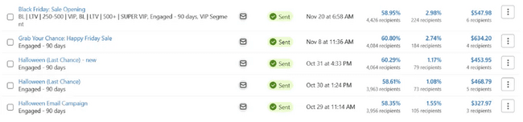
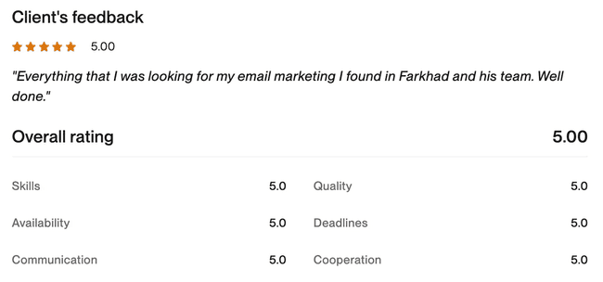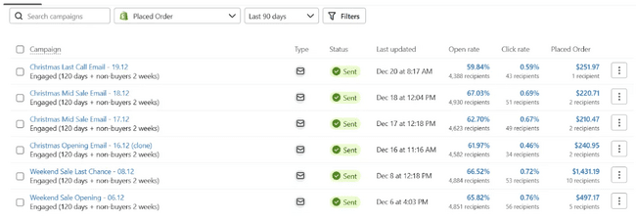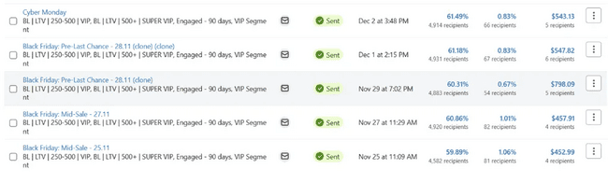

Arts DAO
🛠️ 𝗧𝗛𝗘 𝗖𝗛𝗔𝗟𝗟𝗘𝗡𝗚𝗘
Arts DAO needed an email campaign for their event, but:
1️⃣ Their domain reputation was damaged due to poor practices by past contractors.
2️⃣ MailChimp had frozen their account due to a 5% bounce rate caused by unvalidated contact lists.
💡 𝗢𝗨𝗥 𝗔𝗣𝗣𝗥𝗢𝗔𝗖𝗛
1️⃣ Domain Reputation Repair:
- Activated brand-related domains and linked them to BeeHive.
- Worked with MailChimp support to unfreeze the account under strict anti-spam compliance.
- Validated the contact list via ZeroBounce (official partners).
2️⃣ Warming and Validation:
- Gradually warmed new domains with clean email lists.
- Used Gmail addresses in campaigns to improve domain reputation.
3️⃣ Strategic Campaigns:
- Developed an email flow: Pre-sale (early birds), price increase reminders, and last chance emails with countdown timers.
- Focused on open rates and click rates to ensure effective scaling.

📩 Email Examples:
Pre-sale Email | Price Reminder | Last Chance

🚀 𝗧𝗛𝗘 𝗥𝗘𝗦𝗨𝗟𝗧𝗦
✅ MailChimp account restored with no further issues.
✅ Domain reputation repaired and warmed for future campaigns.
✅ Successful event campaigns with high engagement and improved sender trust.

The review:
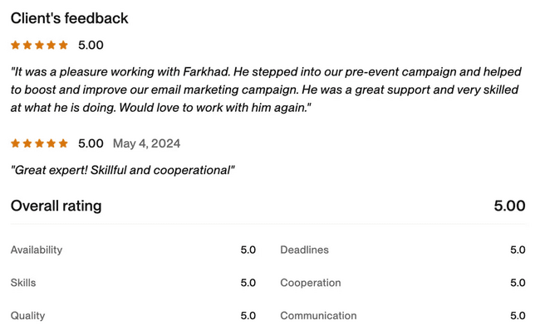
Klinik Europe

🛠️ 𝗧𝗛𝗘 𝗖𝗛𝗔𝗟𝗟𝗘𝗡𝗚𝗘
Klinik Europe, specializing in medical tourism from Europe to Turkey, sought to:
1️⃣ Increase website leads
2️⃣ Reduce negative reviews
3️⃣ Boost payment completions

💡 𝗢𝗨𝗥 𝗔𝗣𝗣𝗥𝗢𝗔𝗖𝗛
1️⃣ Enhanced Lead Generation:
- Performed cold outreach through emails and LinkedIn + replaced generic pop-ups with targeted offers like free PDFs tailored to each service page:
  - 3 Fatal Mistakes to Avoid When Booking Surgery in Turkey
  - 5 Life-Saving Tummy Tuck Woundcare Tips
  - 5 Tips That Prevent Scarring After Arm and Thigh Lift
  - 5 Tips for Safe Recovery from Facial Procedures
  - 5 Insider Tips for Mommy Makeover Recovery
- Automated follow-ups and personalized emails for each form submission: Automation Example.
2️⃣ Encouraging Repeat Business:
- Segmented existing clients by their procedure and created email campaigns promoting related treatments with discounts.
- Sent regular newsletters with segmented offers to maintain engagement.
3️⃣ Welcome Automation:
- Developed a myth-busting email series with incentives like free scar treatment to build trust and increase payment completion rates.
4️⃣ Feedback Management:
- After 3 weeks, clients received an email requesting a review via Typeform.
- Positive reviews prompted a second email encouraging Trustpilot feedback.
- Negative reviews were directed to customer support for resolution, reducing public complaints.

🚀 𝗧𝗛𝗘 𝗥𝗘𝗦𝗨𝗟𝗧𝗦
✅ Increased Leads
✅ Improved Feedback: Reduced negative public reviews and boosted Trustpilot ratings.
✅ Higher Conversions: Automated flows and incentives encouraged more clients to finalize bookings.

The client review:
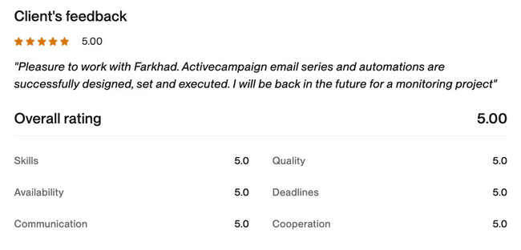

JiveHire
The client approached us with a request to unblock their account on Brevo and ensure the issue wouldn’t happen again. Time was of the essence since they had an important email campaign scheduled in just three days.
When we reviewed the reasons for the block, Brevo highlighted two main issues:
- A significant portion of invalid email addresses in the client’s database.
- Domains were not properly authenticated.
Initially, the client had worked with another agency on a different platform, ActiveCampaign. During their transition to Brevo, several critical mistakes were made:
- The database hadn’t been validated, and emails were sent to an old list that hadn’t been used for years.
- Domains were not authenticated on Brevo, and DNS records still pointed to the previous platform.
- Outdated email templates, created over 10 years ago, were used without adapting them for modern standards like dark mode.
When we analyzed the campaign that caused the block, we identified the following issues:
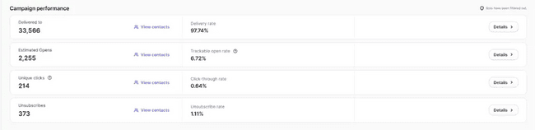
- Very low open rates.
- A high number of unsubscribes.
- Sending emails to a large volume of contacts all at once, whereas previous campaigns had capped at 15,000 addresses.

𝗢𝘂𝗿 𝗣𝗹𝗮𝗻
To resolve the issue, we implemented the following steps:
1️⃣ Contacted Brevo support to lift the block.
2️⃣ Authenticated the domains.
3️⃣ Validated the email database and uploaded a clean list to the platform.
4️⃣ Conducted a test campaign to measure performance metrics.

𝗖𝗼𝗻𝘁𝗮𝗰𝘁𝗶𝗻𝗴 𝗕𝗿𝗲𝘃𝗼
As official Brevo partners, we worked directly with the client’s account manager. After explaining the situation, Brevo agreed to lift the block once we implemented measures to prevent future issues.

𝗔𝘂𝘁𝗵𝗲𝗻𝘁𝗶𝗰𝗮𝘁𝗶𝗻𝗴 𝗗𝗼𝗺𝗮𝗶𝗻𝘀
We added the client’s domains to Brevo and configured all necessary DNS records.
The client operates two companies offering similar services to different audiences, so we authenticated two domains. After waiting 24 hours, all records were verified, and Brevo successfully authenticated the domains.
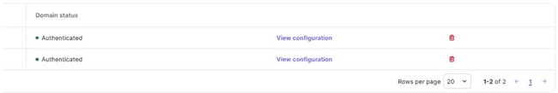

𝗖𝗹𝗲𝗮𝗻𝗶𝗻𝗴 𝘁𝗵𝗲 𝗗𝗮𝘁𝗮𝗯𝗮𝘀𝗲
We utilized the client’s existing EmailListVerify plan to validate their database.
After running the validation, we discovered:
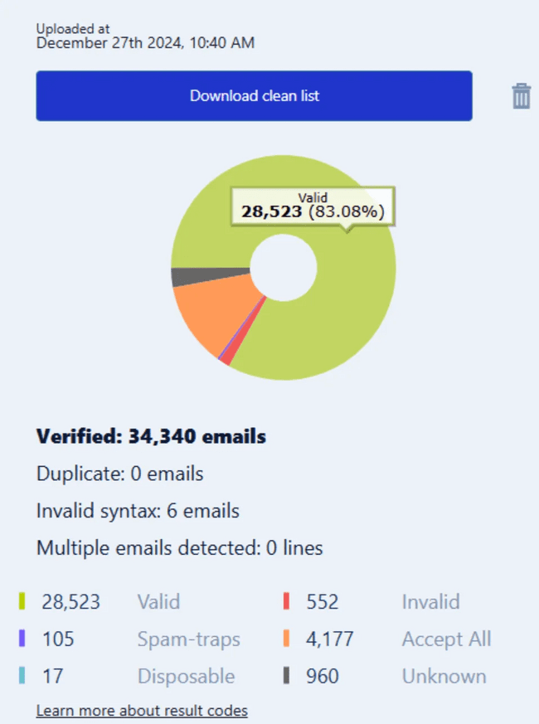
- Only 83.08% of the emails were valid.
- Surprisingly, there were 105 spam traps in the database, even though it was only three years old and confirmed through Double-Opt-In.
This highlights the importance of regularly validating email databases—ideally every six months—and maintaining hygiene by removing inactive, unsubscribed, or problematic contacts.
We uploaded only the valid addresses back to the platform.

𝗧𝗲𝘀𝘁 𝗖𝗮𝗺𝗽𝗮𝗶𝗴𝗻 𝗥𝗲𝘀𝘂𝗹𝘁𝘀
After completing these steps, we conducted a test campaign. Unlike the previous agency, which sent campaigns to large volumes of addresses all at once (damaging domain reputation), we followed a gradual warming process:
- The first campaign targeted 3,100 addresses.
- The second campaign targeted 4,700 addresses.
- The third campaign targeted 6,700 addresses, and so on.
The first campaign after our audit and fixes performed exceptionally well!
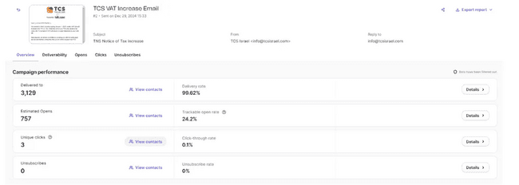

𝗣𝗼𝘀𝗶𝘁𝗶𝘃𝗲 𝗢𝘂𝘁𝗰𝗼𝗺𝗲
Finally, we reached out to Brevo support, and within just 30 minutes, the client received confirmation that their account was unblocked and ready to send campaigns again.
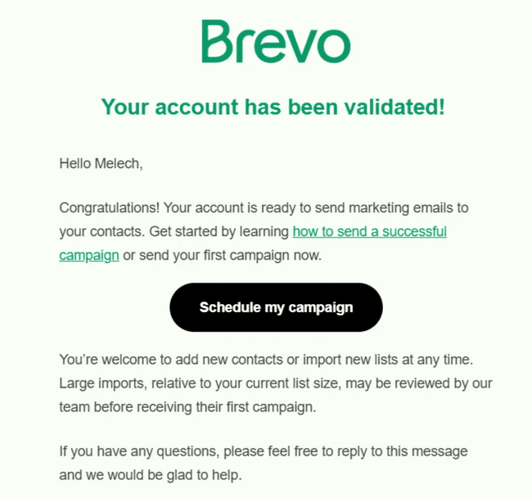

Vegasy Casino
Case Study: Restoring Email Deliverability for Vegasy Casino
Client: Vegasy Casino
Industry: iGaming
Service: Email‑infrastructure setup & deliverability recovery
Agency: GNB Agency

The Challenge
The client ran all bulk emails from its main domain. Gradually, almost every message landed in spam. With its primary retention channel paralyzed, the brand asked us to fix deliverability.

Diagnosis
- Google Postmaster Tools revealed the domain’s reputation had dropped to “Bad”—≈ 99 % of emails were hitting spam.
- Technical audit of lists & sending setup:
  - Connected Email List Verify for address validation
  - Blocked new invalid emails from entering the ESP
  - Cleaned ~15 000‑address list, removing outdated/bounced contacts

Implementation
Step | Action | Purpose
New domains | Registered 3 extra brand‑related domains; “rested” them for 30 days | Avoid “new‑domain” spam flags
Warming the primary domain | Routed it through Warmy; stopped all bulk sends; used only for support replies | Re‑establish positive reputation, prevent traps/blacklists
Stream separation | After warming, mapped each email type to its own domain (campaigns, triggers, welcome) | If one domain’s rep dips, others stay clean

Results (after 2 months)
- Primary domain reputation fully restored
- Test emails land in Inbox, not spam
- Email marketing now runs on a resilient, multi‑domain setup

Recommendations for the Client
- Never send bulk campaigns from the main corporate domain.
- Clean & validate the contact list regularly.
- Keep 4–5 warmed domains in reserve.
- Segregate email types by domain to limit reputation risk.

Takeaway
Even smaller iGaming brands can build a robust email programme. With proper technical setup, domain strategy and list hygiene, deliverability can be recovered and brand reputation protected.

iGaming project (NDA)
Client: iGaming project (NDA)
Vertical: Online casino
Service: Building a player‑retention strategy from scratch & migrating the entire email infrastructure
Agency: GNB Agency

Challenge
The client tried to run retention marketing on Brevo but saw no results. Our audit uncovered critical issues:
- No coherent retention strategy in place
- A few email flows existed but were non‑responsive and broke on mobile
- Dedicated IP had a very poor sender reputation
- No address validation before import
- Cold blasts to purchased, unverified lists
- Brevo support refused to swap the compromised IP

Solution

1. Platform migration
We recommended abandoning Brevo entirely and moving to Customer.io – our trusted partner that allows rapid technical changes. This eliminated reputation risk and let us rebuild the architecture from zero.

2. Retention strategy – three pillars

Pillar | Key tools
CRM | Email + SMS automations & pop‑ups
AI Live Chat | Conversational retention via TEXT
AI Video | Conversational retention via TEXT

CRM build‑out in Customer.io

Welcome flow – for all new sign‑ups

Nutrition #1 / #2 / #3 – for 1st, 2nd, 3rd deposits

Retention flow – post‑welcome non‑depositors

Depositors Retention – lapsed payers

High‑impact pop‑ups

Exit (desktop) – hooks unregistered users on exit

30‑sec no‑registration (mobile) – nudges mobile sign‑ups

Upsell – prompts deposit at zero balance

AI Live‑chat by TEXT

Auto‑launches on behavioural triggers

Personalised offers & promo codes

Guides players through all bonus stages

Smooth shift to non‑bonus deposits

AI Video for VIP segment

Streamed, name‑personalised clips with synthetic voice‑over

Creates “white‑glove” feel and lifts loyalty

Results

Fully quit the toxic IP & platform

End‑to‑end retention framework deployed

Responsive email/SMS journeys live

Pop‑up stack maximised on‑site conversion

AI chat now drives repeat deposits autonomously

AI videos boosted VIP satisfaction and brand perception

Takeaway

Through a deep audit, platform switch and layered retention toolkit we delivered a durable, cost‑controlled player‑marketing system with maximum personalisation.

Social media and content marketing

ProCoders

𝗧𝗛𝗘 𝗖𝗛𝗔𝗟𝗟𝗘𝗡𝗚𝗘
ProCoders, a SaaS-focused company, needed expertly crafted content to establish their authority in the software development space. Their goal was to:
- Enhance organic traffic with well-researched, SEO-friendly blog articles.
- Leverage strategic keywords to complement their broader SEO efforts.
- Educate their audience with high-quality, actionable insights in the SaaS industry.

𝗢𝗨𝗥 𝗔𝗣𝗣𝗥𝗢𝗔𝗖𝗛
We partnered with ProCoders to create:
1️⃣ Comprehensive Blog Content: In-depth articles that not only rank but also resonate with their target audience.
2️⃣ SEO-Optimized Pages: Strategically written website pages that improved search engine visibility.
3️⃣ Keyword Integration: Ensuring every piece aligns with their keyword strategy while maintaining a natural, engaging tone.

𝗥𝗘𝗦𝗨𝗟𝗧𝗦
Our work resulted in consistent organic traffic growth and improved search rankings. Here are some standout blog articles we created:
Article Title | Organic Views
Web Development Outsourcing Guide | 2015
Software Development Time Estimation | 1988
Dedicated Team vs Fixed Price vs Time-and-Material | 1867
Outsource UX/UI Design | 2032
Hire UX/UI Designers | 1794
Hire Rust Developers | 1666
How to Make Money with DApps | 1988
How to Build a Chatbot with React | 1907

𝗛𝗢𝗪 𝗪𝗘 𝗠𝗔𝗗𝗘 𝗔 𝗗𝗜𝗙𝗙𝗘𝗥𝗘𝗡𝗖𝗘

Our efforts helped ProCoders:

✅ Boost organic views across multiple articles, some surpassing 2000 views.

✅ Strengthen their online authority in the competitive SaaS space.

✅ Build a resource hub that engages and converts their target audience.

DSCVR

𝗧𝗛𝗘 𝗖𝗛𝗔𝗟𝗟𝗘𝗡𝗚𝗘
DSCVR, a travel-focused brand, sought assistance in creating impactful video content for Instagram. The project requirements included:
1️⃣ Consistent Weekly Content: Videos highlighting features, event announcements, and editorial themes.
2️⃣ Creative Sourcing: Incorporating both brand assets and relevant content curated from other pages.
3️⃣ Platform-Specific Expertise: Ensuring high engagement on both Instagram and TikTok.

𝗢𝗨𝗥 𝗔𝗣𝗣𝗥𝗢𝗔𝗖𝗛
1️⃣ Dynamic Video Creation:
- Produced weekly videos tailored to travel enthusiasts, leveraging vibrant visuals and engaging storytelling.
- Combined DSCVR’s branded assets with curated, high-quality content from relevant pages.
2️⃣ Content Categories:
- Weekly Features: Spotlighting must-visit destinations and unique travel tips.
- Event Announcements: Generating buzz for upcoming DSCVR-hosted events.
- Editorial Content: Inspiring viewers with cinematic and immersive travel narratives.
3️⃣ Optimized for Engagement:
- Ensured all videos were optimized for Instagram Reels and TikTok trends to maximize organic reach and visibility.
- Included dynamic captions and calls to action to drive interactions.

𝗧𝗛𝗘 𝗥𝗘𝗦𝗨𝗟𝗧𝗦
While DSCVR managed the posting and analytics, the performance metrics showcase the content’s success:

Video Title/Link | Organic Views | Likes | Comments
Feature Video – Destination Highlights | 25,000 | 556 | 25
Event Announcement | 5,600 | 303 | 6
Editorial Content | 6,410 | 879 | 2
Weekly Highlight | 14,000 | 493 | 2
Bar Partout

🛠️ THE CHALLENGE
Bar Partout, an innovative bar construction company specializing in the hospitality sector, faced a critical need:
1️⃣ Boost Brand Awareness: Their Instagram page was almost dormant with just 500 followers, and they had no presence on LinkedIn.
2️⃣ Generate Leads Through Word of Mouth: They wanted to attract high-quality leads organically, relying on the power of genuine engagement rather than paid advertising.
3️⃣ Establish Strong Industry Relationships: Aiming to become a recognized name in their field and foster deeper connections with potential clients and partners.

💡 OUR APPROACH
1️⃣ Strategic Content Creation:
- Developed a comprehensive content strategy focusing on showcasing Bar Partout's projects, industry insights, and team achievements.
- Created visually appealing posts and stories to capture attention and encourage sharing.
2️⃣ Organic Growth on Instagram:
- Revitalized the Instagram account, increasing followers from 500 to over 800 organically.
- Fostered community engagement through interactive content and responsive communication.
3️⃣ Establishing LinkedIn Presence:
- Launched their LinkedIn profile from scratch, targeting industry professionals and decision-makers.
- Shared thought leadership content to position Bar Partout as an authority in the hospitality construction industry.
4️⃣ Facilitating Word of Mouth:
- Encouraged followers to share content, amplifying reach through their networks.
- Built trust and credibility, leading to increased referrals and inquiries.
5️⃣ Building Personal Relationships:
- Our successful collaboration led to an invitation from Bar Partout to visit their headquarters in Belgium.
- Held in-person strategy sessions to discuss future plans, solidifying a strong partnership.

🚀 THE RESULTS
📈 Instagram:
- Grew followers organically from 500 to 800+ with the target audience only.
- Achieved 41.1K video views and 1.5K content interactions total through organic growth only from July to November 2024.
- Consistently increased reach and engagement (+1.8K%).
📊 LinkedIn:
- Built a professional presence from 0 to 299 followers, establishing a trusted brand reputation.
- Achieved 6,954 impressions (+86,825%) and reached 1,901 members (+47,425%) over the 3 months.
- Secured 168 engagements, including meaningful conversations with key industry leaders.
🤝 Lead Generation:
- Successfully strengthened Bar Partout’s position in the market through word of mouth, resulting in organic leads and inquiries.

LinkedIn:
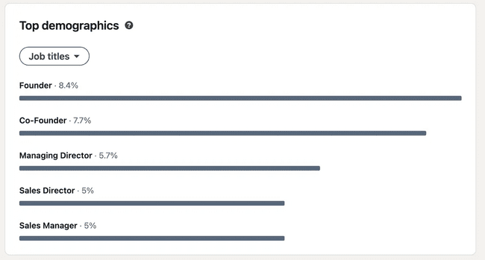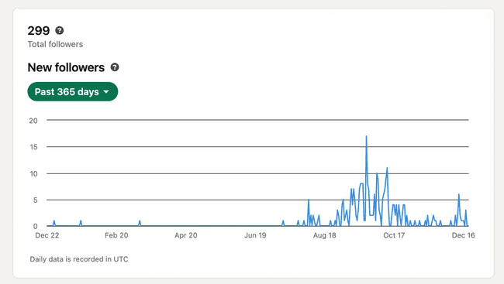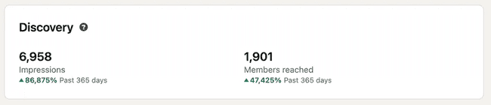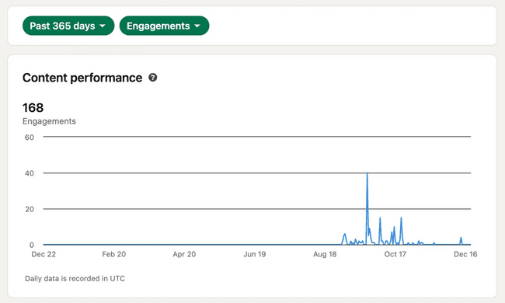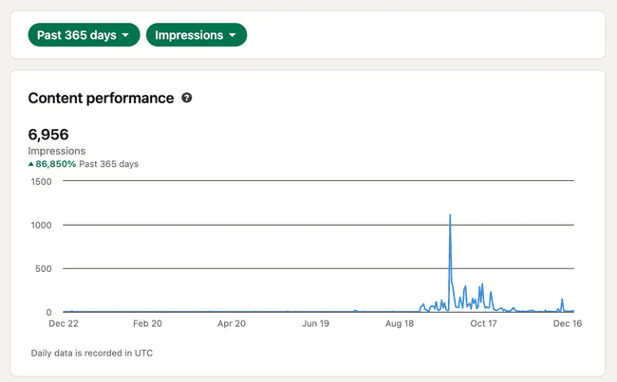
Facebook:
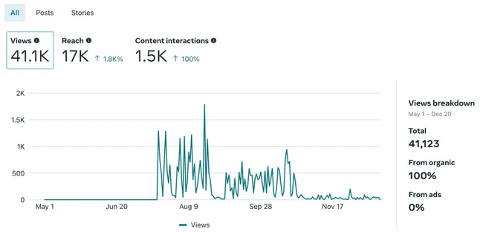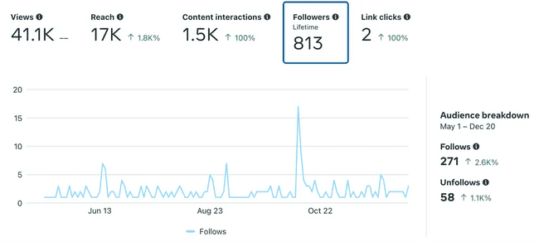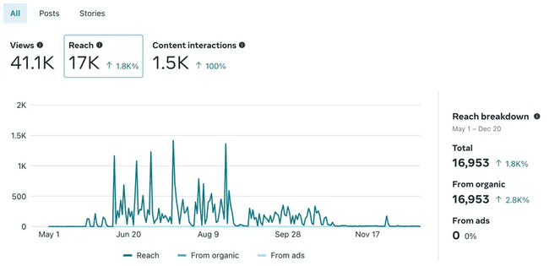

📹 THE HIGHLIGHT
Our partnership reached a new level when Bar Partout invited us to Belgium. We sat together to map out the future, symbolizing the success and trust we've built.
👉 Check out our in-person strategy session: Collaborating with Bar Partout

🎯 WHAT WE ACHIEVED
✅ Amplified Brand Awareness: Transformed their social media presence, making Bar Partout a recognizable name in their industry.
✅ Generated Organic Leads: Successfully attracted new clients through word of mouth and authentic engagement.
✅ Built Lasting Relationships: Developed a partnership that extends beyond business, rooted in mutual respect and shared goals.
Woof&Joy

𝗧𝗛𝗘 𝗖𝗛𝗔𝗟𝗟𝗘𝗡𝗚𝗘
Woof & Joy, an educational animation series, sought to:
1️⃣ Launch 4 new TikTok channels targeting Indonesia, Brazil, Mexico, and Vietnam.
2️⃣ Repurpose content from their existing TikTok channel to jumpstart the new accounts.
3️⃣ Manage multiple TikTok accounts and their YouTube channel efficiently.

𝗢𝗨𝗥 𝗔𝗣𝗣𝗥𝗢𝗔𝗖𝗛
1️⃣ Global Rollout: Set up and managed 6 TikTok channels across different countries, tailoring strategies to target audiences.
2️⃣ Content Management: Published over 700 content pieces in just 4 months, ensuring consistency and quality across platforms.
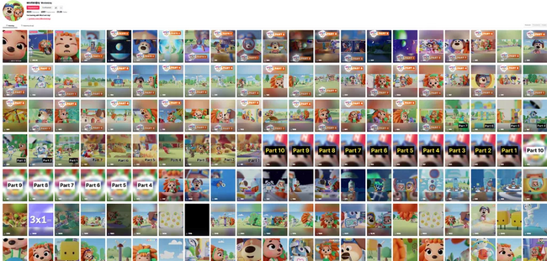
3️⃣ Maximizing YouTube: Leveraged Woof & Joy’s educational appeal to grow 370,000 organic views on their YouTube channel.
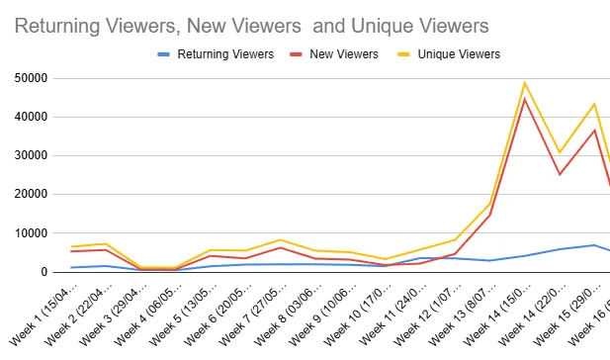

𝗧𝗛𝗘 𝗥𝗘𝗦𝗨𝗟𝗧𝗦
✅ Global Reach: Successfully established TikTok channels in 6 regions, generating high engagement and reach.
✅ Content at Scale: Delivered an impressive volume of content across platforms without compromising quality.
✅ YouTube Success: Achieved 370,000 organic views in just 4 months, significantly increasing brand visibility.

MAKAN Home

𝗧𝗛𝗘 𝗖𝗛𝗔𝗟𝗟𝗘𝗡𝗚𝗘
MAKAN Home, a dynamic startup in the furniture industry, sought a Senior Community Manager to:
1️⃣ Manage social media platforms and content creation with a focus on Reels and TikTok.
2️⃣ Deliver a high volume of quality content, including posts, stories, and blogs.
3️⃣ Drive organic growth while maintaining consistent engagement and trust.

𝗢𝗨𝗥 𝗔𝗣𝗣𝗥𝗢𝗔𝗖𝗛
1️⃣ Content at Scale: Produced and published over 400 Reels and posts in 1.5 years, ensuring consistent delivery and relevance.
2️⃣ Engaging Visuals: Focused on creating compelling video content for TikTok and Instagram, aligning with MAKAN’s modern furniture aesthetic.
3️⃣ High-Impact Results: Leveraged TikTok’s potential, resulting in 8.5M views on a single post and 290K organic views within 90 days across platforms.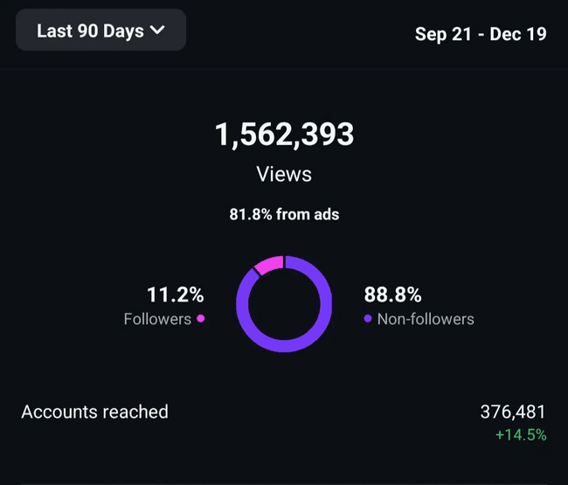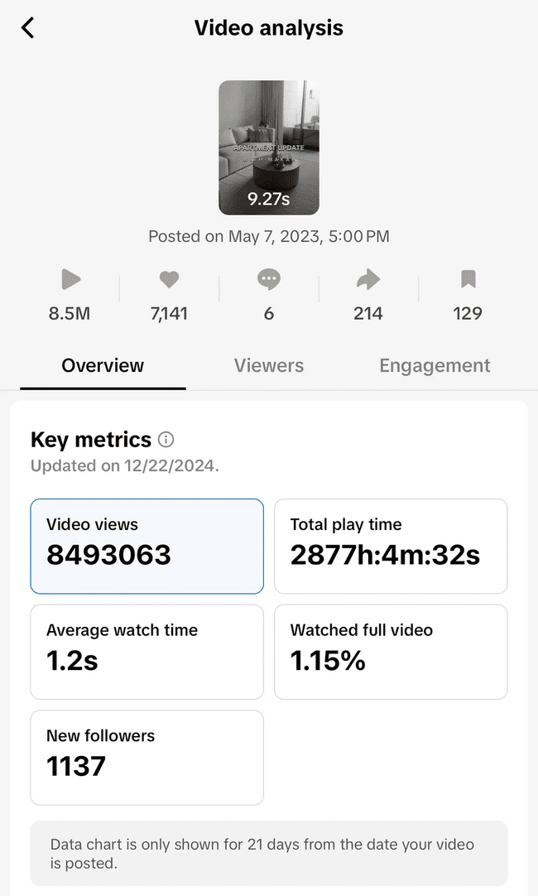
4️⃣ Streamlined Operations: Developed and managed content calendars, wrote engaging captions, and collaborated closely with MAKAN’s leadership for seamless execution.

𝗧𝗛𝗘 𝗥𝗘𝗦𝗨𝗟𝗧𝗦
✅ Massive Visibility: Achieved a viral TikTok post with 8.5M views, driving significant traffic and brand awareness.
✅ Consistent Growth: Maintained high-quality output with 400+ posts and videos delivered on schedule.
✅ Organic Reach: Generated 290K organic views in just 90 days, showcasing the power of strategic content.
The feedback:
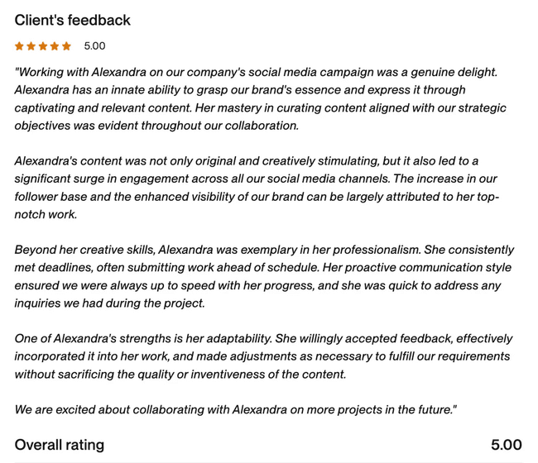

NAC

𝗧𝗛𝗘 𝗖𝗛𝗔𝗟𝗟𝗘𝗡𝗚𝗘
NAC Society aimed to boost local brand awareness in Baku, Azerbaijan, and engage the community through:
1️⃣ Improved online presence.
2️⃣ Social media support.
3️⃣ Creative video content.

𝗢𝗨𝗥 𝗔𝗣𝗣𝗥𝗢𝗔𝗖𝗛
1️⃣ Landing Page Creation: Designed and launched a professional landing page (NAC Society Landing) to centralize event information and attract local visitors.
2️⃣ Event Promotion: Provided full social media support for the international dog exhibition, showcasing event highlights and engaging with the community: https://www.instagram.com/reel/DA1i3QxONhx/
3️⃣ Video Production for Target Ads: Created dynamic and captivating videos tailored for targeted advertising campaigns, driving attendance and awareness.
Videos: https://drive.google.com/drive/folders/1uIvxV1Y2v73kmMYEpQpRpHbFSSoRWgwE?usp=sharing

𝗧𝗛𝗘 𝗥𝗘𝗦𝗨𝗟𝗧𝗦
✅ Enhanced Online Presence: The landing page became a hub for event details and audience engagement.
✅ Increased Community Engagement: Effective social media campaigns brought attention to the event and fostered local interest.
✅ Targeted Advertising Success: High-quality videos boosted the reach of NAC’s campaigns, effectively increasing brand awareness.

Motion design
PriPost

𝗧𝗛𝗘 𝗖𝗛𝗔𝗟𝗟𝗘𝗡𝗚𝗘
PriPost, a company specializing in virtual mailbox solutions, sought a video creation expert to:
1️⃣ Transform their provided scripts into engaging, high-quality videos.
2️⃣ Initially planned to use Lumen5 for video production but faced limitations in meeting the client’s desired creative outcomes.
3️⃣ Deliver visually appealing videos that combined storytelling, effective transitions, and relevant visual elements.

𝗢𝗨𝗥 𝗔𝗣𝗣𝗥𝗢𝗔𝗖𝗛
1️⃣ Customized Software Transition:
- After identifying the limitations of Lumen5, we pivoted to using in-house video editing software to meet PriPost’s creative and technical requirements.
- This approach provided greater flexibility in video design, ensuring that the client’s vision was realized.
2️⃣ Story-Driven Video Creation:
- Focused on PriPost’s key messages to craft videos that were not only visually appealing but also compelling from a storytelling perspective.
- Used custom transitions and effects to maintain audience engagement while highlighting the brand’s services.
3️⃣ Attention to Detail and Collaboration:
- Ensured consistent communication with the PriPost team to incorporate feedback and align with their brand guidelines.
- Delivered polished videos within the agreed-upon timeline, emphasizing accuracy, creativity, and engagement.

𝗥𝗘𝗦𝗨𝗟𝗧𝗦
✅ Tailored Marketing Videos: Produced high-quality videos that effectively communicated PriPost’s unique value proposition.
✅ Enhanced Creative Control: By transitioning to in-house software, we delivered videos that exceeded the limitations of Lumen5, achieving a more polished and professional look.
✅ Audience Engagement: Videos successfully captured attention, effectively explaining PriPost’s services while aligning with their branding and storytelling goals.
Videos: https://drive.google.com/drive/folders/1cLZj79z0s9wHkTCYJX8E7t6CumoofYfx?usp=drive_link

IGC

𝗧𝗛𝗘 𝗖𝗛𝗔𝗟𝗟𝗘𝗡𝗚𝗘
IGC, a B2B technology company based in Australia, required a video production expert to:
1️⃣ Produce high-quality internal and external-facing video content tailored to their marketing needs.
2️⃣ Create an introductory promotional video for their natively owned software platform, featuring animation, screen recordings, and creative graphics.
3️⃣ Work autonomously to deliver professional and polished videos based on specific project briefs.

𝗢𝗨𝗥 𝗔𝗣𝗣𝗥𝗢𝗔𝗖𝗛
1️⃣ Collaborative Brief Analysis:
- Worked closely with IGC’s marketing department to understand their software platform and messaging goals.
- Clarified deliverables and milestones for their promotional video, ensuring alignment with the company’s objectives.
2️⃣ Creative Video Production:
- Designed an engaging promotional video using:
  - Motion graphics to highlight features and benefits.
  - Screen recordings to demonstrate the software interface.
  - Animations to visually explain complex concepts in an accessible way.
- Ensured the video matched IGC’s brand identity and resonated with their target audience.
3️⃣ Flexible Execution:
- Delivered raw files alongside the final polished video to allow for future adjustments.
- Maintained open communication during Australian business hours to ensure timely feedback and project updates.

𝗥𝗘𝗦𝗨𝗟𝗧𝗦
✅ Professional Introduction Video: Delivered a polished promotional video that effectively showcased IGC’s software platform, combining technical precision with creative visuals.
✅ Streamlined Collaboration: Maintained a smooth workflow across time zones, meeting project deadlines and exceeding expectations.
✅ Increased Engagement: The video enhanced IGC’s marketing campaigns by clearly communicating the software’s value to potential clients and internal stakeholders.
The videos: https://drive.google.com/drive/folders/1fs7SqPEBr2nVkXIyB-AI9tOxqrHBx5SB?usp=drive_link
The client feedback:
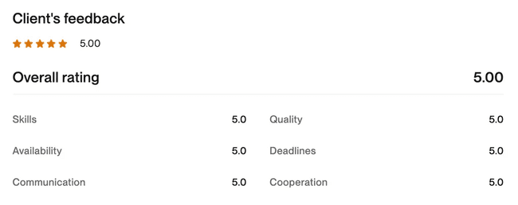

Yarn

𝗧𝗛𝗘 𝗖𝗛𝗔𝗟𝗟𝗘𝗡𝗚𝗘
Yarn, an e-commerce brand, needed expertly crafted videos for their Google PMax campaigns to:
1️⃣ Transform photos and copy into visually compelling videos that drive engagement and conversions.
2️⃣ Meet the technical and creative requirements of PMax video formats.
3️⃣ Maintain a polished, professional aesthetic that aligns with Yarn’s brand identity.

𝗢𝗨𝗥 𝗔𝗣𝗣𝗥𝗢𝗔𝗖𝗛
1️⃣ E-commerce Expertise:
- Used our deep understanding of e-commerce dynamics to design videos that resonate with Yarn’s target audience.
- Highlighted key product benefits and unique selling points through dynamic transitions and engaging copy overlays.
2️⃣ Tailored Video Production:
- Transformed static product photos and written copy into smooth, high-quality videos optimized for Google PMax campaigns.
- Ensured seamless transitions and professional edits to create a polished final product.
3️⃣ Format Optimization:
- Adhered to Google PMax’s specifications, including aspect ratio, resolution, and content structure.
- Delivered videos ready for immediate use in Yarn’s advertising campaigns.

𝗥𝗘𝗦𝗨𝗟𝗧𝗦
✅ High-Quality Video Ads: Created visually stunning videos that seamlessly combined photos, copy, and transitions, elevating Yarn’s e-commerce presence.
✅ Ad Performance Boost: Delivered video content designed to capture attention and drive clicks in competitive Google PMax campaigns.
✅ Efficient Turnaround: Produced and delivered multiple videos within tight deadlines, ensuring Yarn’s campaigns launched on schedule.
Videos: https://drive.google.com/drive/folders/1sAdOY_kO-u2zktrH_CxWGBnn3olY7En9?usp=sharing

Clear Vision Technologies

𝗧𝗛𝗘 𝗖𝗛𝗔𝗟𝗟𝗘𝗡𝗚𝗘
Clear Vision Technologies, a leader in thermal imaging solutions, needed expertly crafted videos to:
1️⃣ Showcase their thermal imaging products for diverse use cases such as recreational activities, navigation, and collision avoidance.
2️⃣ Highlight key features and benefits in engaging, professional marketing videos.
3️⃣ Ensure the videos were optimized for Facebook and Instagram ads, capturing the attention of their target audience.

𝗢𝗨𝗥 𝗔𝗣𝗣𝗥𝗢𝗔𝗖𝗛
1️⃣ Content-Focused Editing:
- Reviewed all provided footage to select the most impactful clips that demonstrated the products’ key functionalities and real-world applications.
- Created visually engaging videos that highlighted the advanced technology and unique features of Clear Vision’s thermal imaging products.
2️⃣ Audience Engagement Strategy:
- Designed videos to be attention-grabbing within the first few seconds, focusing on the needs and interests of Clear Vision’s target audience.
- Incorporated product benefits that resonate with specific use cases, such as safety, convenience, and reliability.
3️⃣ Ad-Ready Deliverables:
- Ensured all videos met the technical and creative requirements for Facebook and Instagram ads, including aspect ratios, resolution, and duration.

𝗥𝗘𝗦𝗨𝗟𝗧𝗦
✅ Professional Marketing Videos: Delivered high-quality videos that effectively showcased Clear Vision’s products, emphasizing their versatility and advanced features.
✅ Enhanced Engagement Potential: The final videos were optimized to attract attention and drive engagement on social media platforms.
✅ Brand Alignment: Ensured all videos maintained Clear Vision’s branding, enhancing their overall marketing consistency.
Videos: https://drive.google.com/drive/folders/1iA6RrhPYuMJUz9kj2nKZpmAgW6Hwy8UZ?usp=sharing

Beautique

𝗧𝗛𝗘 𝗖𝗛𝗔𝗟𝗟𝗘𝗡𝗚𝗘
Beautique, a leading name in the Beauty & Wellness industry, sought to promote their Anti-Pigmentation Facial treatment on Facebook and Instagram. The client required:
1️⃣ Advertisements and Stories: Designs tailored to both platforms.
2️⃣ Variety in Content: A mix of static visuals and video creatives.
3️⃣ Simple Yet Effective Messaging: Clear communication of the benefits of the featured treatment.

𝗢𝗨𝗥 𝗔𝗣𝗣𝗥𝗢𝗔𝗖𝗛
1️⃣ Visual Excellence:
- Designed 2-3 variations of static and video content to captivate and convert audiences.
- Leveraged sleek and minimalistic layouts to resonate with Beautique’s premium branding.
2️⃣ Targeted Messaging:
- Focused on the benefits of the Anti-Pigmentation Facial: improving skin tone, reducing dark spots, and promoting radiant skin.
- Created concise, audience-friendly captions highlighting results.
3️⃣ Platform-Specific Optimization:
- Facebook Ads: Attention-grabbing headlines paired with high-quality imagery.
- Instagram Stories: Interactive elements like swipe-ups and animations for higher engagement.

𝗧𝗛𝗘 𝗥𝗘𝗦𝗨𝗟𝗧𝗦
✅ Enhanced Engagement: The campaign attracted more clicks and inquiries for the Anti-Pigmentation Facial than previous ads.
✅ Versatile Content: Static and video variations provided the client with flexibility to test and optimize ad performance.
✅ Increased Bookings: Beautique reported a noticeable rise in bookings for the promoted treatment.
1.png
2.png
3.png
73.png
74.png
75.png
76.png
77.png
78.png
Video ads: https://drive.google.com/drive/folders/1mChNp75NPYrh_oZX89JgcqFfsk71husN?usp=sharing

Blue Ridge

𝗧𝗛𝗘 𝗖𝗛𝗔𝗟𝗟𝗘𝗡𝗚𝗘
Blue Ridge, an HVAC company, sought a video editor with specific expertise to:
1️⃣ Transform raw job site footage (photos and videos) into polished, professional marketing videos.
2️⃣ Highlight key HVAC industry elements, ensuring the content resonates with both commercial and residential clients.
3️⃣ Leverage industry-specific knowledge to understand and emphasize important aspects of the HVAC business within the videos.

𝗢𝗨𝗥 𝗔𝗣𝗣𝗥𝗢𝗔𝗖𝗛
1️⃣ Understanding the HVAC Audience:
- Focused on crafting content that aligns with the interests and needs of HVAC clients, such as showcasing efficiency, quality installations, and customer satisfaction.
- Integrated messaging about HVAC benefits like energy savings, reliability, and expert craftsmanship.
2️⃣ Story-Driven Editing:
- Cut and stitched together B-Roll footage, creating seamless and engaging videos.
- Highlighted key moments from job sites, such as before-and-after transformations, expert technicians at work, and high-quality equipment installations.
3️⃣ Industry Expertise:
- Leveraged prior experience with HVAC marketing to include essential elements, such as system efficiency highlights, customer testimonials, and technical details that build credibility.
- Ensured the videos followed industry trends and remained visually appealing to the target audience.

𝗥𝗘𝗦𝗨𝗟𝗧𝗦
✅ Professional Video Content: Delivered polished, high-quality videos that showcased Blue Ridge’s expertise and reliability.
✅ Enhanced Brand Credibility: By emphasizing industry-specific details, the videos helped position Blue Ridge as a trusted leader in the HVAC space.
✅ Audience Engagement: The final videos successfully captured the attention of both commercial and residential clients, generating increased inquiries and positive feedback.
✅ Efficient Process: Streamlined video production and editing, ensuring quick turnaround times while maintaining exceptional quality.

𝗖𝗟𝗜𝗘𝗡𝗧 𝗙𝗘𝗘𝗗𝗕𝗔𝗖𝗞
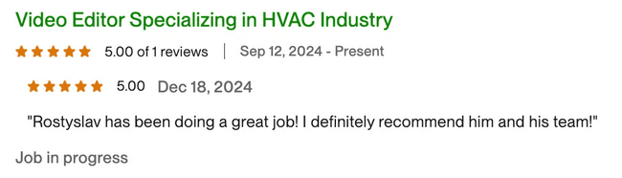

Videos: https://drive.google.com/drive/folders/1Re4QAKgxvyG0--FiWx8fD9bqJQKgMq_L?usp=sharing

