Xiaomi smartphones will appear in the UK, France and ITaly
Xiaomi is going to conquer the European market

First of all, think about this question: “Could you live a day without a smartphone?” Probably not, as our life has become closely connected with such devices. Moreover, they have become an integral part of our routine, helping with many everyday tasks including home stuff, work, connection and entertainment. So the next question is what smartphone to choose.
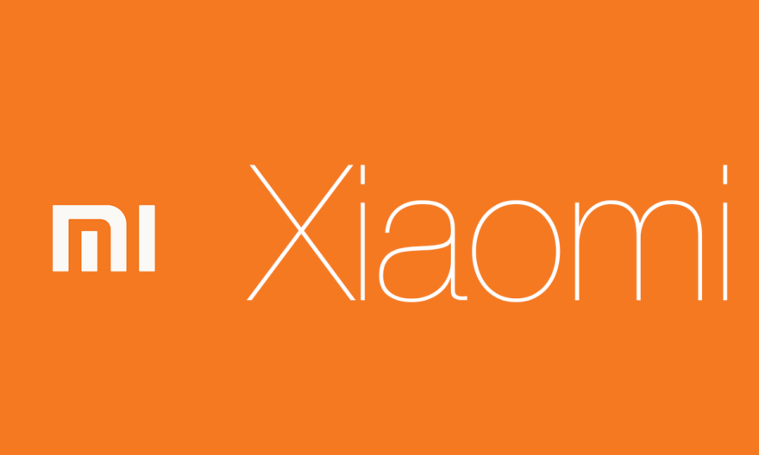
One of the best devices both by functional features and characteristic as well as friendly prices is Xiaomi. The company has been working mainly on Chinese and Indian markets having extremely successful results in it. Xiaomi obtains the fifth place in the world and the fourth in China after Huawei, Oppo and Vivo. In 2017 the sales grew by 83% and they sold more than 93 million smartphones. Specialists have already shared their thoughts about the forecast on 2018 and it is also favorable. The secret lies in an excellent price-quality combination.
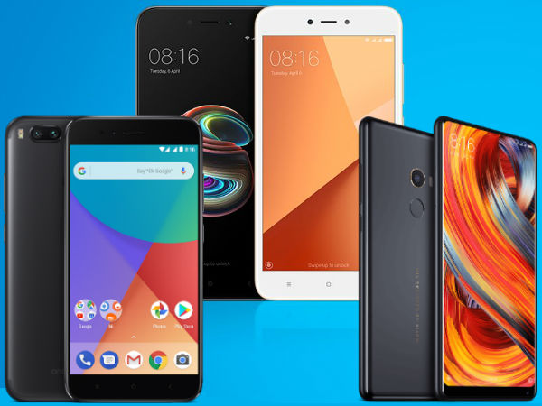
Nevertheless, the company hasn’t even tried to enter the US market as it is highly competitive and refuses any Chinese devices to be sold here. Sometime ago there was a big crush of Huawei and ZTE, so Xiaomi might have taken it into consideration and decided to start over Europe. In November 2017 Spain became the first European country which started to sell official Xiaomi flagships. Now the company is negotiating with the Three UK and is going to present its devices in the UK by the end of May. Besides, MIUI forums said that there will be presentations in France (May 22) and in Italy (May 24). According to previous information that the first Xiaomi products sold in the UK such as TVs, power banks or air purifiers had great success, so the customers may have a positive opinion about the Chinese manufacturer which can also contribute to the positive outcome of MI in Europe.
As it was mentioned above, Xiaomi has taken the Chinese and Indian markets, however their devices had great popularity in Ukraine and Russia too. The collaboration with the Three UK will bring an opportunity to widespread flagships not only to England, Ireland, France and Italy, but also to Austria, Denmark and Sweden. Despite the fact of set up data of presentations the company still has not given any information about the models that are going to be shown there. The premium segment in all these countries is already taken by two major companies Apple and Samsung, thought the battle for middle class price devices may be easy to win. The approximate price for Xiaomi smartphones is from 150 and up to 600 USD and it includes: modern design, good working and stable hardware, which meets both working and entertainment needs, high sensitivity camera as well as bright and colorful screens. The most popular devices of this manufacturer are: Redmi Note 5A, Redmi 4X, Mi Max 2, Redmi Note 4X, Mi A1, Mi 6, Mi Mix 2, Mi Note 3, Redmi 5 Plus.
