ANIMALE MALE ENHANCEMENT: A true story about a remedy that defeated impotence and knocked out the famous Viagra.

Today, we have invited a true rock legend of Australia, Jimmy Barnes, to our studio! And we will talk about a very delicate topic, which is not often discussed by celebrities. But a legend is a legend for a reason, and can afford to talk about anything. Today, Jimmy Barnes will tell us about how he was able to solve a very delicate problem that affects millions of men – weak erections.

Host: Jimmy, what made you take action to solve this problem?
Jimmy Barnes: It was the weak erections that made me take action! What real man would be content with his important organ hanging like a rope and only able to pee? Besides, as a creative person, I am convinced that potency and creativity are interconnected. If you have weak potency, you won't create anything worthwhile. And it was awkward for me and my wife, Jane. She suffered a lot because of my infidelity.

Host: Yes, two illegitimate daughters that the world learned about almost 40 years after their birth did not add to your wife's happiness.

Jimmy Barnes: Exactly. But most importantly – it's creativity!

Host: When did you start noticing problems with your potency?

Jimmy Barnes: About five years ago.

Host: And what did you do about it?

Jimmy Barnes: At first, I thought I would solve this problem easily. There is Viagra or its analogs. But it turned out to be much more complicated. Viagra turned out to be very hard on the heart. After three months of taking it, my heart started to feel numb and hurt under my shoulder blade. Besides, I started to experience a tolerance effect. I had to constantly increase the dose of Viagra.

Host: And what did you do about it?

Jimmy Barnes: What did I do? I stopped taking Viagra! And I stopped touring for a while. In short, I was very disappointed in Viagra. I felt like I had hit a dead end.



Host: Yes, indeed, I remember that three years ago you took a break from touring. People even started to say that Jimmy Barnes was done for.

Jimmy Barnes: They'll have to wait!

Host: And what about your intimate life?
Jimmy Barnes: To be honest, it was really stressing me and my wife Jane out. We had all sorts of problems. We'd have fights, make up, and everything in between.
Host: And what happened next?
Jimmy Barnes: I tried other medications. I tried about five different ones, but I didn't get any positive results.
Host: So how did you end up solving the problem?
Jimmy Barnes: I was lucky that I'm a well-known person and have many acquaintances working in various fields. One day, there was a rumor going around our music scene that there was some kind of new medication in Australia that could enhance male potency. This medication naturally increases testosterone levels in the blood and provides an enhanced blood flow to the penis, which springs to life like a coil! Of course, I was very interested in this. I called a few people, and eventually, I was introduced to Professor Sean Anderson. He works at the South Australian Institute of Health and Medical Research. Rumor has it that he leads the group that invented this medication.
Host: That's the one located in Adelaide?

Jimmy Barnes: Yes. I had a very heartfelt conversation with the professor. Fortunately, it turned out that he loves rock, and we talked about it for a long time. I even sang one of my favorite songs, Flame Trees, to him over the phone. We chatted for a whole hour. At the end of the conversation, I asked him straight up if it was true that he had invented some cool medication to enhance male potency. Sean said that the medication was still undergoing clinical trials. But I couldn't wait! I practically begged him for this medication. We arranged to meet, and the next day in the evening, I flew to Adelaide. Sean Anderson invited me to his place, and we talked and sang songs together until late at night!
Host: And in the end, did you get the medication?
Jimmy Barnes: Of course!
Host: And what is it? What's it called?
Jimmy Barnes: It comes in capsules. I had to take one capsule a day. Sean Anderson called it ANIMALE MALE ENHANCEMENT.
Host: And you started taking it...
Jimmy Barnes: The evening after I arrived.
Host: And what?
Jimmy Barnes: It was amazing sex! Wow! And the next day, no problems with my heart.
Host: But you took it every day, not like Viagra - only before sex?

Jimmy Barnes: Of course! Sean Anderson emphasized that his product is primarily for addressing potency issues, not for short-term erection. So I took ANIMALE MALE ENHANCEMENT one capsule per day.

Host: And what changes did you notice?
Jimmy Barnes: After about a week, I suddenly realized in the morning that I had an erection! I hadn't had one like that in a long time! And that's when I fully believed in this medication. After two weeks, my morning erection was like it was in my youth. And I could have sex with Jane without any arousal aids. I also noticed that my dick was getting bigger. I remember calling Sean and asking him what was going on. He reassured me and said that this was normal. ANIMALE MALE ENHANCEMENT causes a strong influx of blood into the cavernous bodies of the dick, which stretch out. Hence the increase in length and diameter of the dick.
Host: Not a bad side effect!
Jimmy Barnes: It's not a side effect! That's how it was intended by the developers. It's no secret that a large dick gives a man confidence. And vice versa. So everything in this product works to enhance potency.
Host: How long did you take this product and what were the results?
Jimmy Barnes: I took it for exactly thirty days. It definitely helped me. Firstly, my potency was completely restored. No failures. And without taking any stimulating drugs like Viagra. Secondly, and this is no less important for me as a musician, I feel a surge of energy. I want to compose songs and pick up the guitar.
Host: You recently released a new album?
Jimmy Barnes: Yes! It's called Flesh and Blood. Its title hints at the changes that happened to my flesh and blood thanks to ANIMALE MALE ENHANCEMENT.
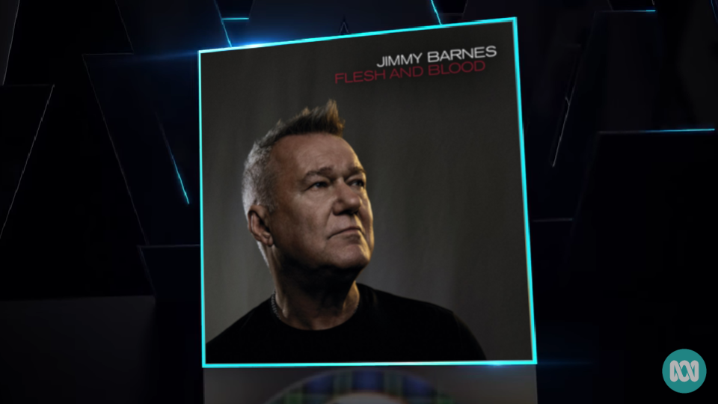
Host: The album topped the ARIA chart.
Jimmy Barnes: Yes, it's my thirteenth album. And I'm sure it won't be the last!
Host: And what about this ANIMALE MALE ENHANCEMENT product? Has it passed all the tests?
Jimmy Barnes: As Sean Anderson told me, all the necessary certificates are already available. But the problem is that ANIMALE MALE ENHANCEMENT was created at an Australian institute, not at some transnational pharmaceutical corporation like Pfizer. So Sean Anderson and his colleagues are looking for resources to produce it. For now, they have established a small production volume at the institute's facilities.
Host: So, there is no ANIMALE MALE ENHANCEMENT available in pharmacies, is that right?
Jimmy Barnes: Yes. The distribution of the product is organized through the official website to reduce costs.
Host: And as far as I know, you have prepared a little surprise for our viewers?
Jimmy Barnes: Yes! I arranged with Sean Anderson that the viewers of your show can purchase ANIMALE MALE ENHANCEMENT at a 50% discount. And I will bring him on stage at my concert in Melbourne as a thank you.
Host: On this wonderful note, we will end today's show. I want to thank Jimmy Barnes for taking the time to come to our studio and, of course, for the interesting and I'm sure very useful for many men story about the new Australian potency-enhancing drug ANIMALE MALE ENHANCEMENT. The link to order it with a 50% discount will be located below. Until next time!

ORDER ANIMALE MALE ENHANCEMENT WITH 50% DISCOUNT
Comments
Mark
Thanks for the information about ANIMALE MALE ENHANCEMENT. I will definitely order it!
Paul
I'm a fan of Jimmy Barnes. And now I love him even more. He honestly and openly shared his life experience. A real man.
Jennifer
Thank you so much for the advice! ANIMALE MALE ENHANCEMENT has been a great help to my husband and me! Now we have a full intimate life again. Thanks again!
Gary
Thanks for the information! It's very relevant right now.
Gregory W.
Using it for the second week already. Honestly, I didn't expect such an effect. It's AMAZING.
Patricia
Hi everyone! I ordered it for my husband. Can't wait to receive the package. :)
David
Strange, my brother lives in the US and, according to him, you've been able to order this medication there for several months already. Are we supplying America first?
Robert
I'm satisfied with the medication. My penis also increased in size. But, to be honest, I would like more in this regard.
Stephen
I've been using it for a week. Now I won't part with these capsules, everything is super))
Phillip
Bought it, liked it! Previously, I lacked strength in bed, my penis was not great, and orgasms were weak. Now everything has changed for the better.
Peter
It works. I recommend it!
Anthony
My wife is over the moon with happiness. She asks, "What happened to you?" The erection is excellent, and sex lasts for 2 hours. Really cool product!
Robert
Excellent product! Thanks to Jimmy Barnes for the information. You're a real guy!
Michael
I watched the show and couldn't resist - I ordered it. I was too curious. The effect is stunning! Endurance increased by 2 times, and pleasure was five times greater. I had no idea it could be like this! Thanks a lot for the show! It opened my eyes to a lot.
Ian
A sexologist friend recommended this medication to me. I had no idea that I would see a show about it. The medication is really great. It helps and is safe! A friend of mine died from Viagra, and he was only 55 :(

