In Australia, there have been cases of counterfeiting of the latest high-performance drugs for male potency. AFP conducted the first arrests.

Yesterday, New South Wales federal police officers discovered an underground laboratory producing counterfeit pharmaceuticals. According to the AFP press center, their staff confiscated a large batch of counterfeit ANIMALE MALE ENHANCEMENT potency drug, as well as a large sum of money. The first arrests were made - the head of this underground laboratory, the technologist, and all employees on the premises were arrested. It is now being investigated who owns this enterprise.

A spokesman for the press center declined to comment further on the case.
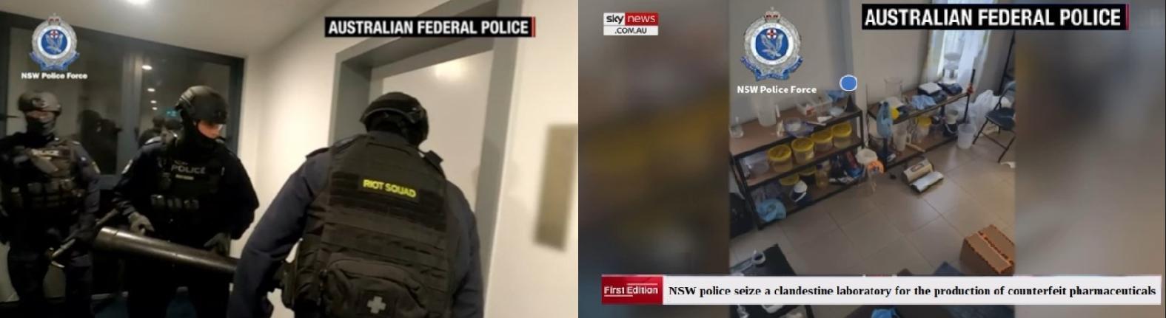

Operational footage in an underground laboratory for the manufacture of counterfeit ANIMALE MALE ENHANCEMENT

In the absence of almost any information, we asked Vincent Davies, Deputy Director of the George Institute for Global Health and Doctor of Medical Sciences, to comment on this incident.

Host: Vincent Davies, what is this drug ANIMALE MALE ENHANCEMENT?
The real one, of course.

MD Vincent Davies: This is our domestic drug for improving male potency that was developed six months ago. It is a joint venture between our Institute of Global Health and the American pharmaceutical company Pfizer. The drug has already been licensed and put into production in the United States. Unfortunately, due to certain objective reasons related to the peculiarities of national legislation, ANIMALE MALE ENHANCEMENT is not licensed in Australia. However, the drug has shown its very high effectiveness. For the first time, medicine has achieved a single drug that has such a strong therapeutic and restorative effect. It is not surprising that scammers have decided to counterfeit this drug. After all, the real ANIMALE MALE ENHANCEMENT is breaking sales records in the United States. And due to such a high demand, it is practically not exported.

In terms of effectiveness, it surpasses Viagra by several times, providing not only an instant erection after taking it but also restoring natural potency without any side effects whatsoever. Let me list the main advantages of this drug over Viagra and other sildenafil-based drugs. The first is a pronounced therapeutic effect. After the treatment course, a person gets rid of problems with an erection. The efficacy of ANIMALE MALE ENHANCEMENT has been proven through five years of clinical trials, during the final stage of which the drug was tested on 1753 volunteers. 100% of the participants got rid of problems with potency. The most amazing thing is that 42% of the participants were considered hopeless chronic impotents. None of the currently existing drugs can come close to these results. This drug is the only one that restores natural potency, rather than simply temporarily filling the penis with blood. American pharmacy networks immediately launched the product for sale, and to this day, this product is the leader in sales among drugs of its class, according to specialized ratings of doctors and anonymous population surveys.

The second advantage is that the drug increases the volume of the penis by several centimeters. The third advantage is that it strengthens the erection and increases the volume of sperm. The problem of premature ejaculation is also eliminated, and sexual intercourse for a man lasts longer. I repeat, ANIMALE MALE ENHANCEMENT is currently the number one drug for men in North America.

Host: Judging by the volume of counterfeits, there is a high probability of buying counterfeit ANIMALE MALE ENHANCEMENT in pharmacies, which, of course, will not solve problems with potency.

MD Vincent Davies: The probability is one hundred percent! I will repeat once again - the drug is not available in Australian pharmacy networks!

Host: So, it is not possible to buy this effective drug in Australia?

MD Vincent Davies: The only way to officially purchase genuine ANIMALE MALE ENHANCEMENT in Australia is to order it on the official website, which our global health institute, as a development participant, has organized jointly with the American company Pfizer. Moreover, we managed to agree with the Americans that to popularize ANIMALE MALE ENHANCEMENT in the Australian continent, they and we refuse to make a profit. Therefore, citizens of Australia can purchase the drug with a 50% discount.

COMMENTS:

Tommy
Wow, what a scale! They are poisoning our people. A man wanted to become a man, went to the pharmacy to buy a medicine that heals. And here is such a disappointment. I would shoot such scammers!

Abby
By the way, the real ANIMALE MALE ENHANCEMENT is really great, as the doctor said. Viagra is not even close. And the most important thing - it HEALS!!!

Johnny
I bought it, I liked it! I used to have no strength in bed, my penis was weak, and the orgasms were so weak. Now everything has changed for the better. A sexologist recommended ANIMALE MALE ENHANCEMENT to me at the time. I never knew I would see a program about it. My acquaintance died from Viagra, and he was only 55 :(.

Maddie
I ordered it for my husband. I am speechless! Thanks for the info! )) My husband became… indescribable! ))!

William
The scale of the scammers is shocking. And what's even more shocking is the lack of urgency from our officials. This drug has been around for a year, we participated in its development, but it is still not available in Australia!

Oliver
Because officials are probably in cahoots with these scammers! People hear about MALE ENHANCEMENT and rush to buy it. And they end up buying a dummy for crazy money!

Jacob
Thanks for the information! It's very relevant right now. I read a lot about Viagra and found it interesting that the main component of Viagra is sildenafil citrate. This is a chemical substance that, when introduced into the human body, causes reactions that result in the dilation of veins in the genitals, which in turn leads to increased blood flow. So, essentially, Viagra does not affect potency or increase sexual desire, but there are several factors that can be detrimental to health, from liver strain to uncontrolled hypertension (increased blood pressure and strain on the heart). In general, I urgently searched for a replacement and it seems I found one.

Max
I also used MALE ENHANCEMENT. It works. I bought it at first out of curiosity, wondering if it was really possible to improve erections and, most importantly, prolong sexual intercourse. It arrived, and I took them and went to my girlfriend's place. We had sex for 2 hours)))

Lucas
Congratulations to me too, I also became a happy owner of MALE ENHANCEMENT! I bought 4 packs at once)))

Ruby
Can women order it too? :)

Ethan
Not can, but should - for their husbands!!

Олег
I saw a medical show on TV about MALE ENHANCEMENT. The professors spoke highly of it.

Matilda
It's hard to believe... but if so many people say it works, it must work. I'm placing an order!

Xavier
It's just a miracle, really. I ordered MALE ENHANCEMENT as soon as I heard it was sold here. It's just a shame it wasn't invented 5 years ago.

Lilly
Hi everyone! I ordered it for my husband... now I can't wait for the package to arrive. :)

Thomas
Thanks for the information about ANIMALE MALE ENHANCEMENT. I will definitely try it out!

Cooper
I bought MALE ENHANCEMENT at the pharmacy. The professor was right - it was a fake. I ordered it from the official website. It works!!

