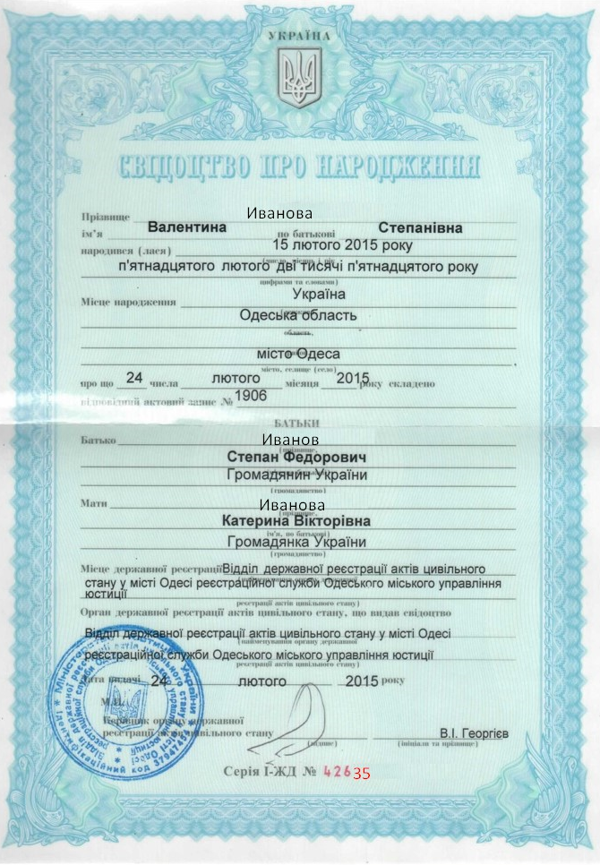

Переклад з української на англійську
Translation from Ukrainian into English

UKRAINE
[State Emblem of Ukraine]
CERTIFICATE OF BIRTH
Ivanova
Surname _________________________________________
Stepanivna
Valentyna
first name _____________ patronymic __________________
February 15th , 2015
born _______________________________________________________________
(day, month, year
fifteenth of February, two thousand fifteenth
____________________________________________________________________
in figures and words)
Ukraine
Place of birth _______________________________________
(state,
Odesa region
_________________________________________________
region,

_________________________________________________
area,
The city of Odesa
_________________________________________________
city, town, countryside
2015
February
24
whereof _____ day ________ month _____ year
1906
a corresponding registration record № _________ was drawn up
PARENTS
Ivanov
Father _____________________________________________________
(surname
Stepan Fedorovych
__________________________________________________
Citizen of Ukraine
first name, patronymic)
__________________________________________________
Ivanova

(nationality)
Mother _____________________________________________________
Kateryna Viktorivna
(surname,
___________________________________________________________
Citizen of Ukraine
first name, patronymic)
___________________________________________________________
Department of state registration of acts of
(nationality)
Place of state registration__________________________________________
(name of the authority of the state
________________________________________________________
registration of acts of civil status)
civil status in the city of Odesa of the Registration Service of the Odesa City Justice Department

Authority of the state registration of acts of civil status that issued the certificate
Department of the state registration of acts of civil status in the city of Odesa
________________________________________________________
(name of the authority of the state

of the Registration Service of the Odesa City Justice
________________________________________________________
registration of acts of civil status)

2015
February 24th,
Date of issue _____________ ______ year
Official Round Seal:
Ministry of Justice of Ukraine
*Identification code 37947454*
*Department of the state registration of acts of civil status in the city of Odesa*
*of the State Service of the Odesa City Justice*
V.I. Heorhiiev
Head of the authority of the State Registration of acts of civil status _______ ____________
[in handwriting]
(initials and surname)

Number І-ЖД № 42635

