Assignment #3

Product-Experience Proposal

TMGT 4010

Experience Creation and Product Development

FALL 2015

David A. Carter

Tetiana Shyshkova T00055572 12.04.2015
Section 1: Concept

Content:
- Introduction;
- Product Description;
- Walkthrough;
- Itinerary,
- Detailed standardized increment,
- Scheduling and Progression of activities effect on the proposed product-experience,
- Engagement;
Themes
Stories
The five senses
- Visual Description.

Section 2: Target Market

Content:
- Targeted Explorer Quotient (EQ) Explorer type
- Rationale for “Fit” with the chosen EQ type
- Link with Social Values, Travel Values and Experience Appeal
- Additional insights or WHY questions
♣ Why these consumers?
♣ Why will these consumers buy/like this product-experience?

Section 1.
- Introduction
Each particular individual represents a single unit which has a direct influence on the internal processes of the vast mechanism called society. Tourism in general could be considering as the result of this processes and social activity. It is obvious that tourism sector is an integral part of the modern world and develops with the rapid speed every single day along with the modernization. I consider the culture as one of the greatest consequence of human activity and for the base of my work I choose the Cultural Tourism concept, which defines as: “All movement of persons outside of their place of residence with the goal to learn, experience and contribute to the cultural heritage of the host community widen their cultural understanding and emotional pleasure of encounters.” (Cultural Realms: A blog about the business of cultural and creative tourism. Rossitza Ohridska-Olson 2008-2010). In the course of further product development I am going to narrow the topic of interests to the “Aboriginal Tourism” which is small, however rapidly growing sector of British Columbia tourism industry. “Aboriginal Tourism is a kind of travel that is motivated or enriched by participation in aboriginal culture, history and lifestyles” (Destination British Columbia, (2014, May 1). Tourism Sector Profile. Aboriginal Cultural Tourism. p.3.)
2. Product Description
An aboriginal cultural tourism target often includes tourism product or activity in first visiting Beautiful British Columbia with its treasure preserved wildlife. As for the specific tourism product and experience packaging with a final memorable and emotional experiential background, I identified 5 days eventual railway tour along the East Coast of Vancouver Island. After the arriving on the territory of Canada, our first stop will be the city of Victoria (July 26) which is the perfect destination for those visitors who are passionate the history of past decades staying connected with the modern world. Our agents will meet guests at the central airport of Victoria. After fascinating railway trip that gives an opportunity to enjoy the beauty of the local landscapes through Nanaimo (July 27) and Courtenay (July 28), we will get by car to our final destination – Comox (July 29) visited its annual Filberg Festival 2016 (July 29- Aug 1).
Our package tour calls “M.A.C. (Magic of Aboriginal Civilization) Vancouver Island BC 2016” and has a slogan: “Leave your comfort zone! It’s an adventure time!” This is a great opportunity to diverse already exist knowledge for those who are interested in the particular issue as well as for those who are unfamiliar with it. Our offer is perfect suitable to the Cultural Explorers EQ profile, who are always stay in passion with travelling and exploring the new locations with a cultural heritage treasures.
3. Walkthrough
A clear understanding of the target market segment as well as detailed analyzing of the destination specifics can guarantee the success in the tourism product and experience compiling. This is a first and main key point that ensures the sustainability of its further implementation. It is important to follow the interests of your target clients who are always desired to see, experience, buy, learn items of attributes as well as contribute other life enjoyment staying conscious about the cultural preservation.
Generally, the M.A.C. BC project development strategy was aimed to meet the interests of a target group and ensure the further satisfaction of requirements listed in application blanks. After analyzing gathered data we conducted our tour packaging based on the most preferable features. First of all, the M.A.C BC product 2016 includes visiting the Victoria, Nanaimo, Courtenay and Comox destinations with further thematic activities such as visiting the historical museums and free-of-activity time. Second of all, it covers the participation in upcoming annual Filberg Festival event in the Filberg Heritage Park located in Comox. And the last but not least, this is a deep delving into the Aboriginal culture.
From the consumer perspective, the M.A.C. Vancouver Island, East Coast BC 2016 tourism product is very convenient proposal, because it gives the possibility to order and get the full package of all necessary services at the same place without ordering them from different offices. "Time is Money" and only for a small fee our clients will significantly reduce spending of their time. Filling out the online application form our customers will provide us the information about their preference, special limitations or suggestions. Further our staff will do everything possible to offer them only their best among the available options. In addition, the application requires providing of individual information (passport or ID) for the flight tickets and accommodation booking.
Valid summer seasoned “M.A.C. Vancouver Island BC” 2016 pricelist includes accommodation, transportation, food/beverage and recreation/entertainment services, provided by private business owner “Tetiana & Co.” Important to remember, that our travel packaging does not include personal wastes and will charge you for the additional services. “Tetiana & Co.” is our general investor, who keeps in touch only with sustainable partnership relations.

- Itinerary
The “M.A.C. Vancouver Island BC” tourism product is the packaging of the available services whereas the “M.A.C. Vancouver Island BC” tourism experience is the impression entrenched in customer’s consciousness at the end of the trip.

Detailed standardized increment
c.) Scheduling and Progression of activities effect on the proposed product-experience
During the process of transformation Vancouver Island, BC destination into a product I conducted a short overview of the cultural tourism experiences. However, it does not include specific time schedule planning in order to provide more freedom to our Cultural Explorer’s group who prefers not to follow the specified time sections.
Destination: Vancouver Island, Canada, BC; Time Period: July 26- Aug 2, 2016; Locations: Victoria; Nanaimo; Courtenay; Comox.
Schedule:
Victoria. July 26
- Arriving to the Victoria International Airport (YYJ);
- Check in to the “Capital CityCenter Hotel”;
- Visiting historical places: Royal BC Museum and the Legislative Assembly of British Columbia;
- Free time (could be spend on shopping, spa relaxation and beauty procedures or any other kind of activities in preferable local area. The main condition is to return into apartments till 11 p.m.);
- Checking out (morning);
- Arriving to the central railway station of Victoria;
- Boarding the train.

Nanaimo July 27
- Get of the train on the stop of Nanaimo;
- Check in the “Tigh-Na-Mara Seaside Spa Resort”;
- Short destination overview in the Nanaimo Visitor Centre;
- Visiting historical places: Hill's Native Art Gallery Nanaimo and Nanaimo Museum;
- Free time (necessary returning into the hotel till 11 pm);
- Checking out (early-morning meeting in the lobby);
- Boarding the train and departing the final railway trip section.

Courtney July 28
- Arriving on the main railway station of Courtney (minivan will be waiting nearby the main entrance);
- Visiting Wachiay Friendship Centre Society with watching the thematic movie. All visitors are encouraged to ask questions to Local Chief who will be glad to answer them;
- Boarding on the private minivan.

Comox July 29
- Late at night arriving to Comox “Port Augusta Inn and Suites” hotel and check in;
- First Day of Filberg Festival. Participation (noon);

Comox July 30
- Second Day of Filberg Festival. Volunteering;
- Hiking and fishing around the local area accompanied by expeditours from the local First Nation community;
- Wildlife observation;

Comox Aug 1
- Comox Valley Canoe trip
- Third Day of Filberg Festival. Final Exploring of the Aboriginal Culture.

Comox Aug 2
- Check out;
- Boarding the minivan;
- Arriving to the Courtenay Airport (Smit Field);
- Making final group-photo, sharing the personal impressions, getting gifts from the firm, receiving flight tickets and a final walk to the flight gates.

Now it’s time for our cultural explorers to say “goodbye” this adventure and begin to prepare for the next one.

- Engagement: Themes, Stories, The five senses
A number of informative entertainments including local music, dance, food and art provide a verbal and visual contact with the community representatives illustrated the specific cultural features. It opens the direct access to the primary source of knowledge and transfers an ordinary people into another fantastic storytelling reality. Tourists are encouraged to buy souvenirs, clothes and other goods in the local craft-shops, thus contribute the local economy.
Besides the exploring the First Nation Aboriginal traditions, art, dance, music, food and storytelling, which have passed through the centuries and survived till nowadays, recently we received an additional proposal from “Tetiana and Co.” private agency to hand out gifts to all participants. In addition, our cultural explorers will have a chance to enjoy not only ocean beaches and lakes with crystal water, but will have a chance to get as much tourism experience from the shopping, nightlife, spas, restaurants and other facilities, as they can. During the whole trip the tourists group will be accompanied by professional photographer and a private driver that have a significant impact on the consolidation of a positive experiences memorabilia.
The smells of fresh air and coniferous rainforest, the visual wildlife monitoring, sense of being in touch with the powerful ocean and magic sound of the supreme nature will leave a huge imprint in a human consciousness.

- Visual Description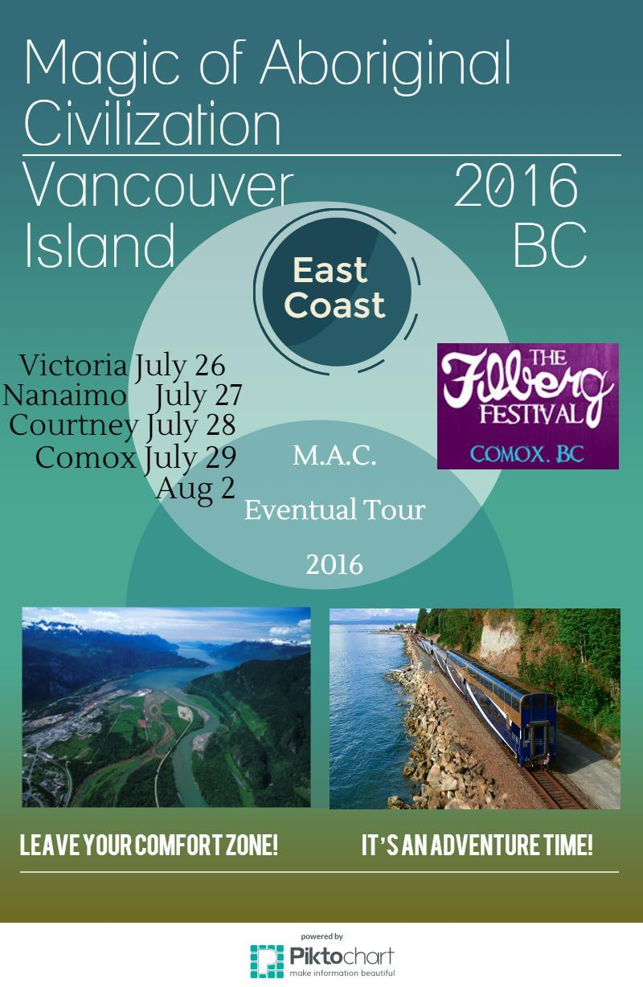
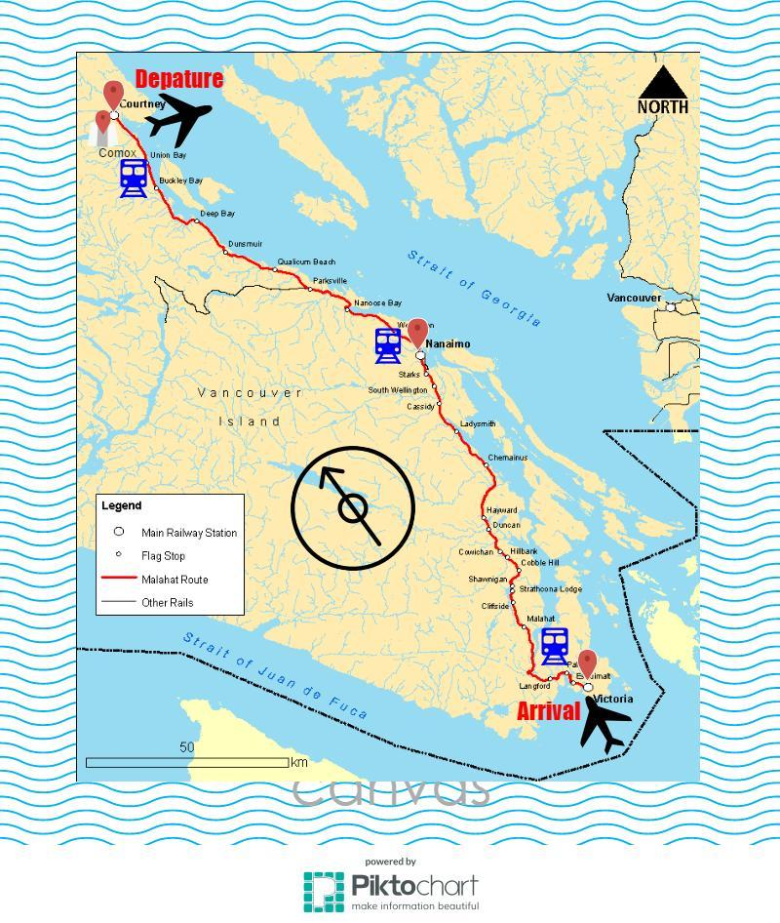
Section 2.
  - Targeted Explorer Quotient (EQ) Explorer type
Referring the statistic data provided by Canadian Tourism Commission (CTC): “The first eight months of 2015 saw a 7% rise in visitors to Canada from DC’s 11 international markets” that evidences about rising the Destination BC indicators on the international tourism level. (August 2015: Understanding of who, what, when and how of travel to Canada. (n.d.) Retrieved December 1, 2015)
The 2012-13 Global Tourism Watch report, BC illustrates top visitor countries:
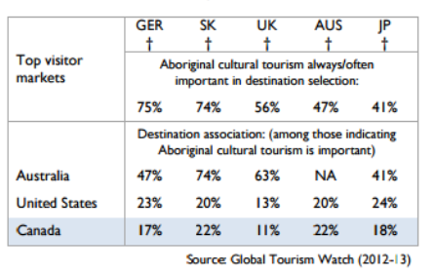

After analyzing CTC statistic data and EQ profiles, I identified Cultural Explorers as for my target audience. Cultural Explorers EQ profile could be represented by well-educated male or female persons or group of individuals (families, mature, middle age no kids at home, young no kids) among the middle to late age range who earns an upper-middle income and significantly concerns about immerse themselves in the local area, culture and community. General amount of particular tourists arrives mostly from Germany, South Korea, United Kingdom, United States, Australia and Canada.
  - Rationale for “Fit” with the chosen EQ type
The summer season with its favorable weather conditions opens access to the most preferable activities of the Cultural Explorers, avoiding the winter-season difficulties such as road access or inability to visit local cultural events, which are mostly held during the summer. Free access to local beaches maximizes the pleasure getting from swimming, fishing, canoeing staying connected with an aboriginal culture on the one hand and modern civilization on the other hand. All above listed reasons make Vancouver Island East Coast rational and beneficial option for the chosen EQ profile. Most time of our tour imply staying on the open air that creates a necessary feeling of freedom outside civilization.
- Link with Social Values, Travel Values and Experience Appeal
Our tourism product is not just a simple packaging of services and experiences that have significantly cultural character. T.F.M.A.C. Vancouver Island BC 2016 follows the idea of preservation the Aboriginal heritage and prevention the cultural loss, which is rapidly growing along with industrialization and commodification of the rural areas. The Cultural Explorers who are aimed on the establishing of personal moral and ethical priorities would appreciate these specific features. We encourage our customers to contribute the aboriginal society by making donations and fundraising that increases a self-estimation, feeling of self-importance and responsibility for the future course of events. We are always considering personal income status and ensure the financial security.

b.) Additional insights or needs identified for your proposed “users”
One of the important aspects in the tourism product and experience creation strategy are sustainable partners and stakeholders, such as tour operators, travel agencies, hotels, transportation companies and restaurants along with local museums, craft centers, producing souvenirs and gifts galleries, spa centers and entertainment companies.
Our main sustainable stakeholder is a non-profitable owner of the Vancouver Island railway “Island Corridor Foundation (ICF)” which links Victoria, Courtenay, Nanaimo and Port Alberni. In addition, cooperation with non-profitable society “Nanaimo Aboriginal Centre” and ensures the beneficial partnership with the following organizations: Mid Island Metis Nation, Boys and Girls Clubs of Central Vancouver Island, NDSS - School District #68, Strong Start Programs and Literacy Central Vancouver Island, which are able to provide their services and features to our customers. For example, it could be a personal membership card or bonuses for the active participation in the thematic events.

c.) WHY this product?
The main argument in favors the successful implementation of the “T.F.M.A.C. Vancouver Island, East Coast BC 2016” tourism product and experience packaging is the fact that whole development strategy based on the sociological, geographical, geopolitical and cultural researches, interviews and statistic data on the particular focus group. Our high quality professionals from the strategy development department considered various sampling errors and deviations from the schedule of applying product in the real tourism industry.
We do not seeking to increase our sell rates through the mass media therefore significantly reduces the costs of potential advertising. The main part of income invested to assure the quality of services and to meet the target audience preferences. You can learn about us from the main source visiting our office, in the special meeting events or from the satisfied clients. We cooperate with world known companies as well as small private businesses which are listed on the M.A.C. BC web-site, where listed the partnerships and other kind of information. Since Vancouver Island purchased a regional EQ license, it became possible to find us on pages of Travel Experience Guide.
In conclusion, all that persons who would like to explore the Vancouver Island with M.A.C. BC 2016 project can be identified at the crossroads of two opposite worlds where ancient and modern types of society contributed each other permeated their lifestyles, borrowing and sharing social and cultural features using the links of their mechanism.

References

Ohridska-Olson's, R. (2008). Cultural Realms - Rossitza Ohridska-Olson's blog about the business of cultural tourism. Retrieved December 1, 2015, from http://culturalrealms.typepad.com/culturalrealms/culturaltourismproductcreation.html

August 2015: Understanding the who, what, when and how of travel to Canada. (n.d.). Retrieved December 1, 2015, from http://en.destinationcanada.com/content/ctc_news/tourism-snapshot-august-2015
Destination British Columbia, (2014, May 1). Tourism Sector Profile. Aboriginal Cultural Tourism. p.3. Retrieved December 1, 2015, from http://www.destinationbc.ca/getattachment/Research/Research-by-Activity/Aboriginal-Tourism/Tourism-Sector-Profile_AboriginalCulturalTourism_May2014.pdf.aspx

Explorer Quotient® Profiles. (2012, October 1). Retrieved from http://en.destinationcanada.com/sites/default/files/pdf/Resources/ctc_eq_profiles_2012-eng-lowres.pdf

