Tokyo (Japan)
A city that knows how to break the rules and lamatiped stereotypes. Tokyo is the city of the future. The city which gathered all the exotic. Extraordinary discoveries await you. Tokyo truly can amaze you.
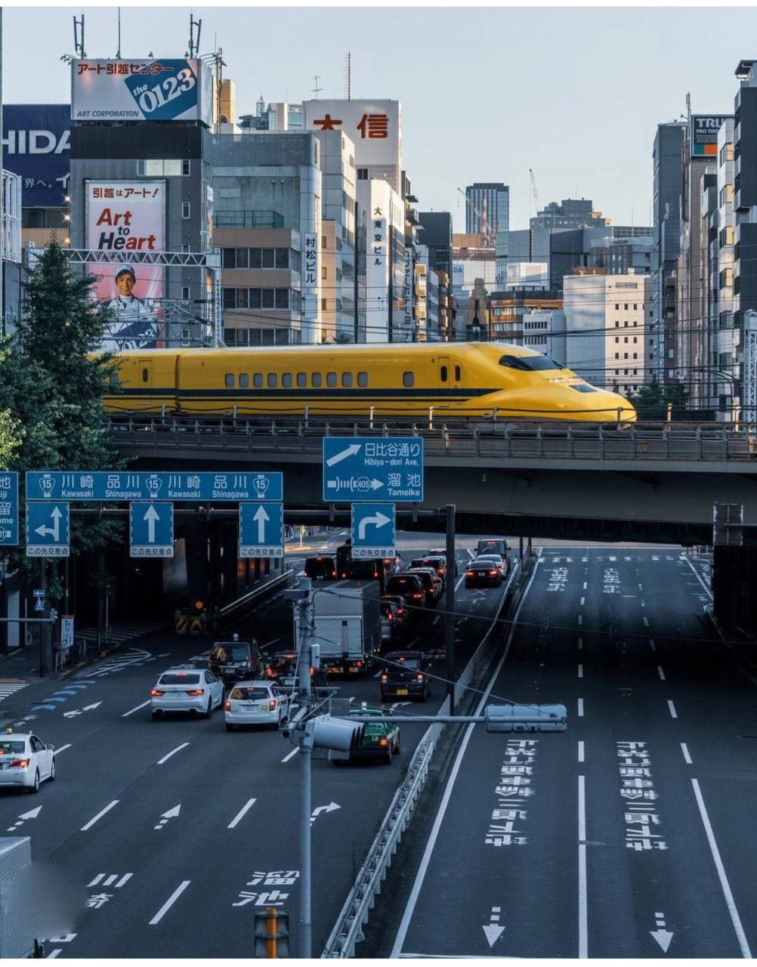
Upon arrival there will be a pleasant surprise. Tourists will be pleased. The text on the signboards can be read in English. The most interesting transport in Tokyo is the subway. The subway in Tokyo is more than 300 kilometers of twisting roads, 13 halls, 285 stations and 3 billion passengers per year!
Rules of the Yaontsy: if you don't sleep anywhere, you don't hurry anywhere. So in the subway you can't see people walking or going anywhere. A sound for tourists can be a control person. This person regulates the flow of people.
There will be no problems with catering. There are many local catering facilities in every district of the city. Almost all of them are fully operational.

They are overcrowded with buildings. Residents of the city is so great that even the temperature of the air in the city is more than 10 degrees. Since the population is extremely large, and in order to regulate the traffic flow, there are too many roads in Tokyo. Two-overhead roads are not a division for local residents.

The introduction to the great city of Tokyo, you should start from the central area - Shibuya. Arriving there you can see the great buildings on which housed a huge cranes. This is the area where the most overcrowded crossroads are located. There are so many people here that you literally have to wade through the nativity to cross the road at the light. Here you can understand how small you are.
After that, you can visit the Harajuku neighborhood. The world's most famous brands are collected here. Here you can see extremely large stores of every known world brand. People on the streets are distinguished.

And if you want to see Japan through the eyes of the young people of Tokyo, then you need to come to the area of Akihabara. Heroes from the comics, contemporary cartoons and anime, just walk around the area.
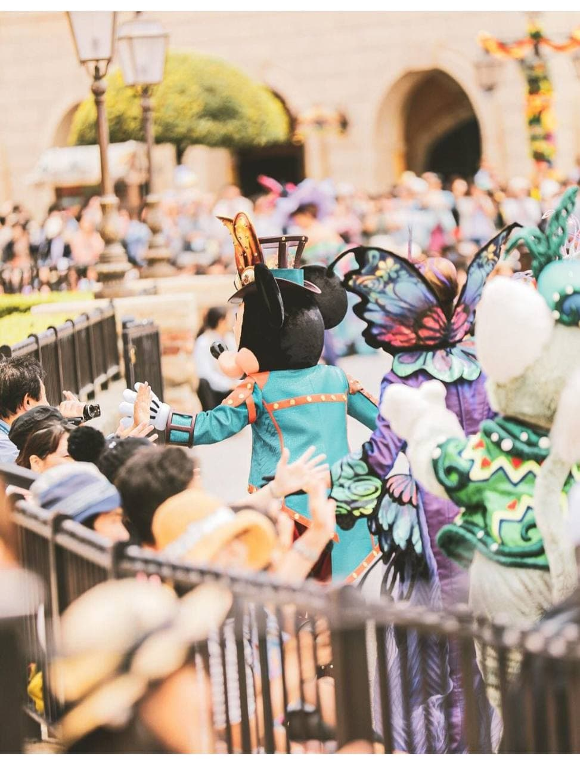
And if you want to see how the elite live in Tokyo, you have to go to the Gindza neighborhood. The most expensive shopping centers, restaurants and housing in the city are located in this area of the city. Here you will find the latest brands of cars, the most expensive hotels. Robotics - which are installed instead of dovidniki.
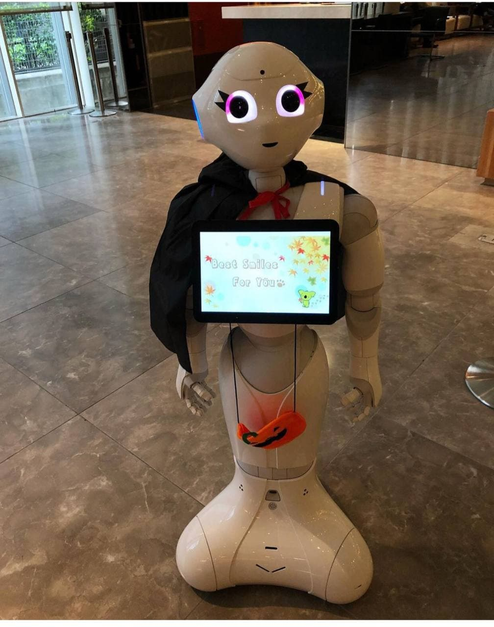
In any of the districts of the city you can go on a free excursion on the water channels of Tokyo. It is very interesting because the scale will amaze you. The height of these channels is more than 20 meters, width more than 180 meters. And in the volume of such a canal, more than 67 thousand tons of water.
You will be revolted at every cross!

