1.1 Create a new user (POST)
enter the data of a non-registered user
PASSED
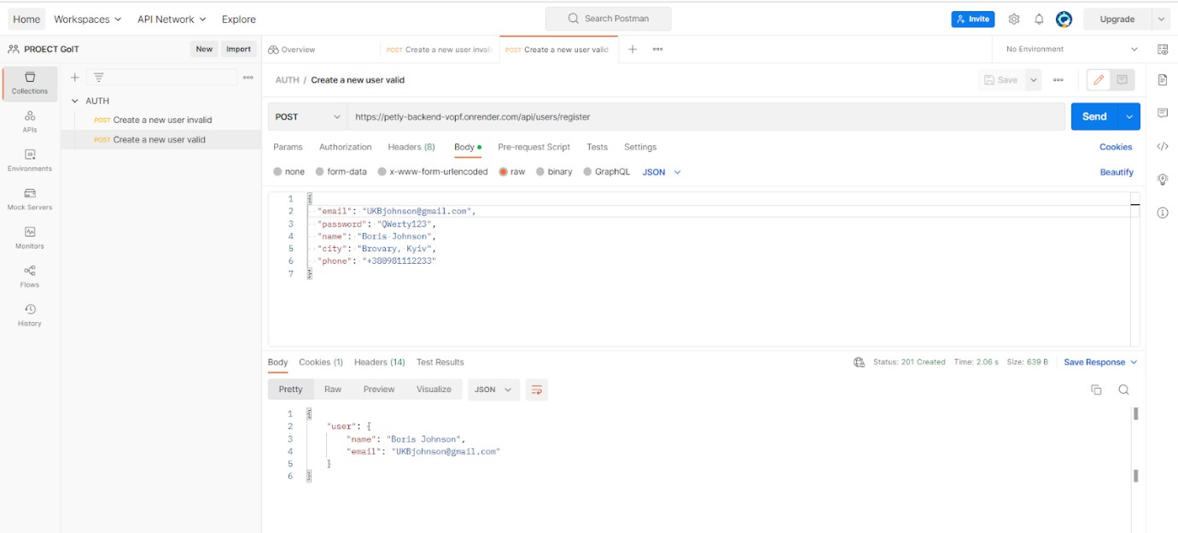

1.2. Create a new user (POST)
enter the data of a registered user
PASSED
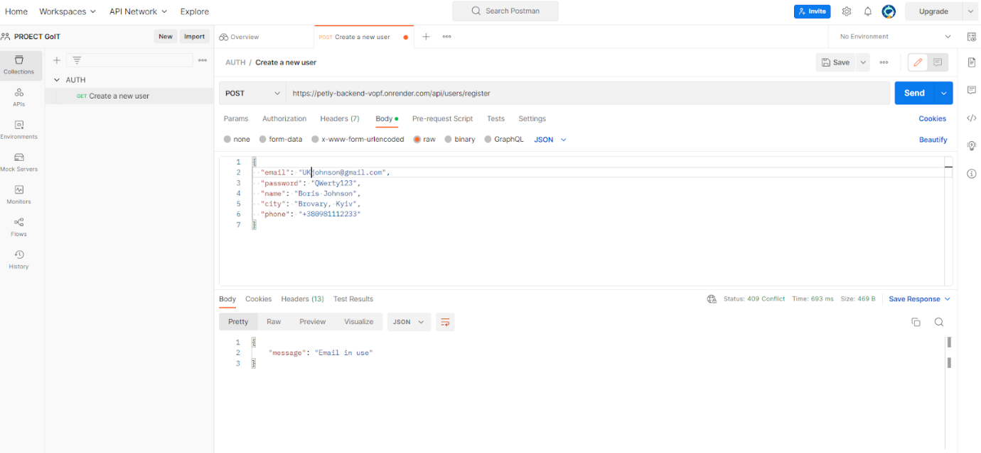

1.3 Create a new user (POST)
enter incomplete data of a non-registered user
PASSED
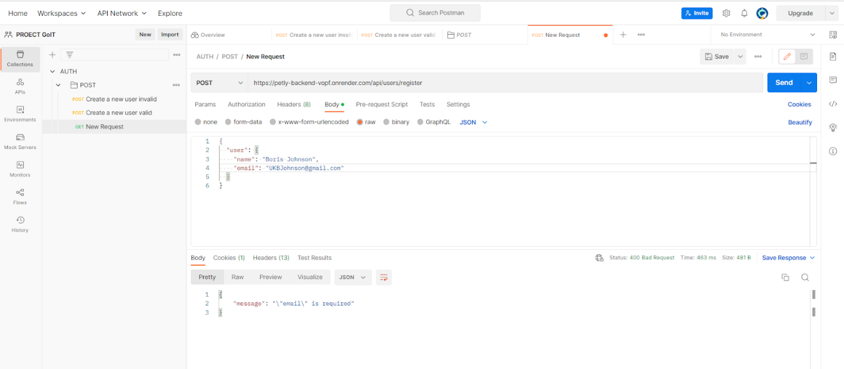

2.1 User login (POST)
enter the data of a registered user
PASSED
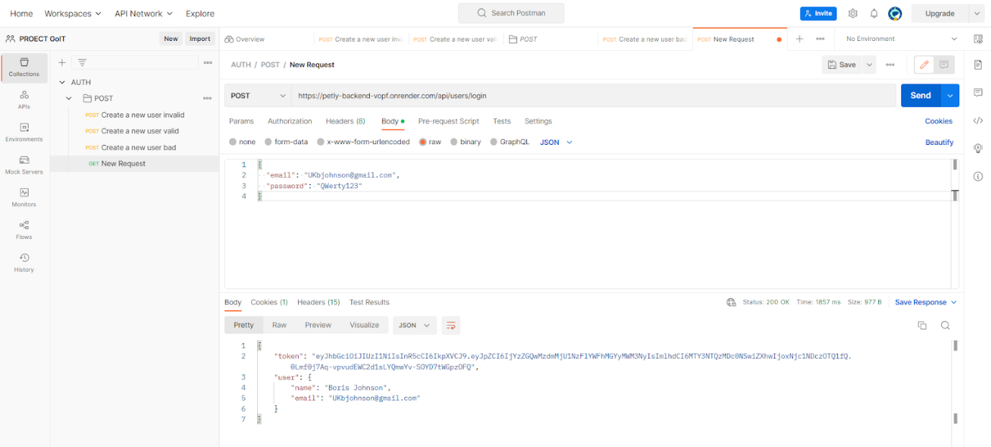

2.2. User login (POST)
enter the data of a non-registered user
PASSED
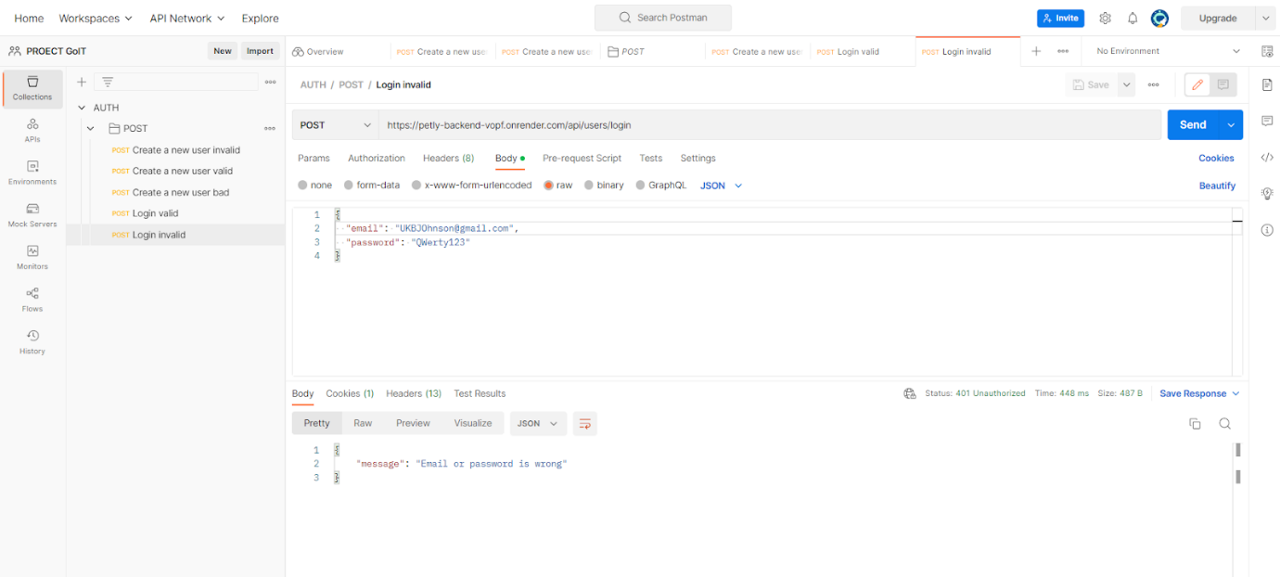

3. Log out user
PASSED
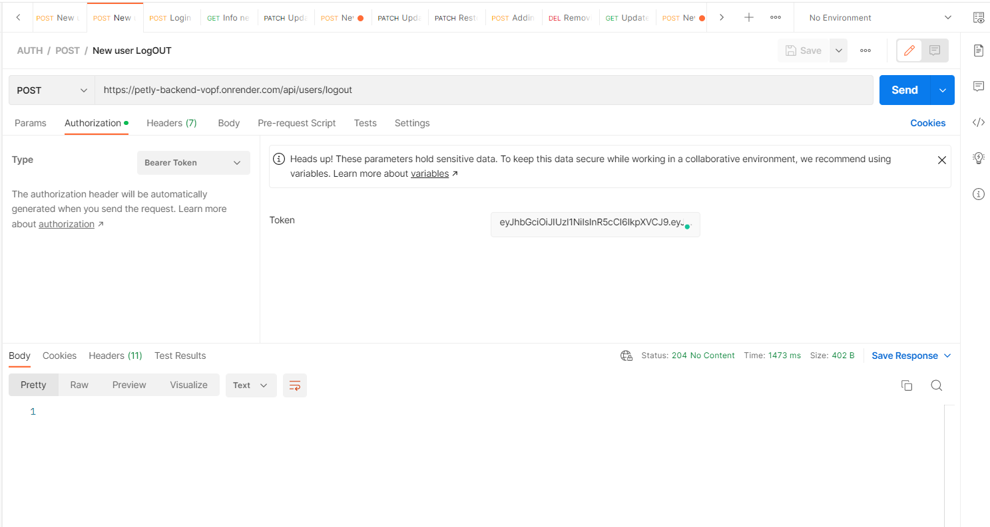

4. Get information about the current user
PASSED
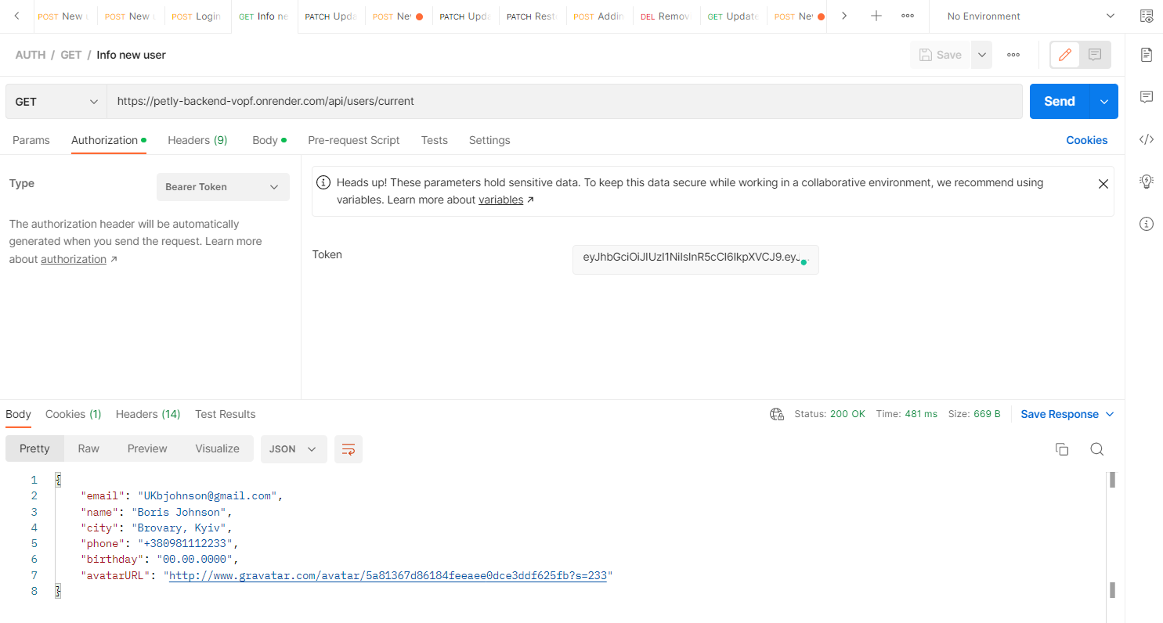

5. Update information about the current user
PASSED
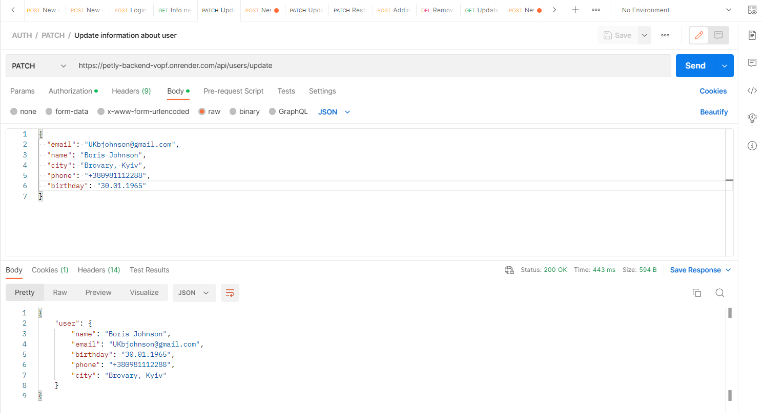

6. Update user avatar
PASSED
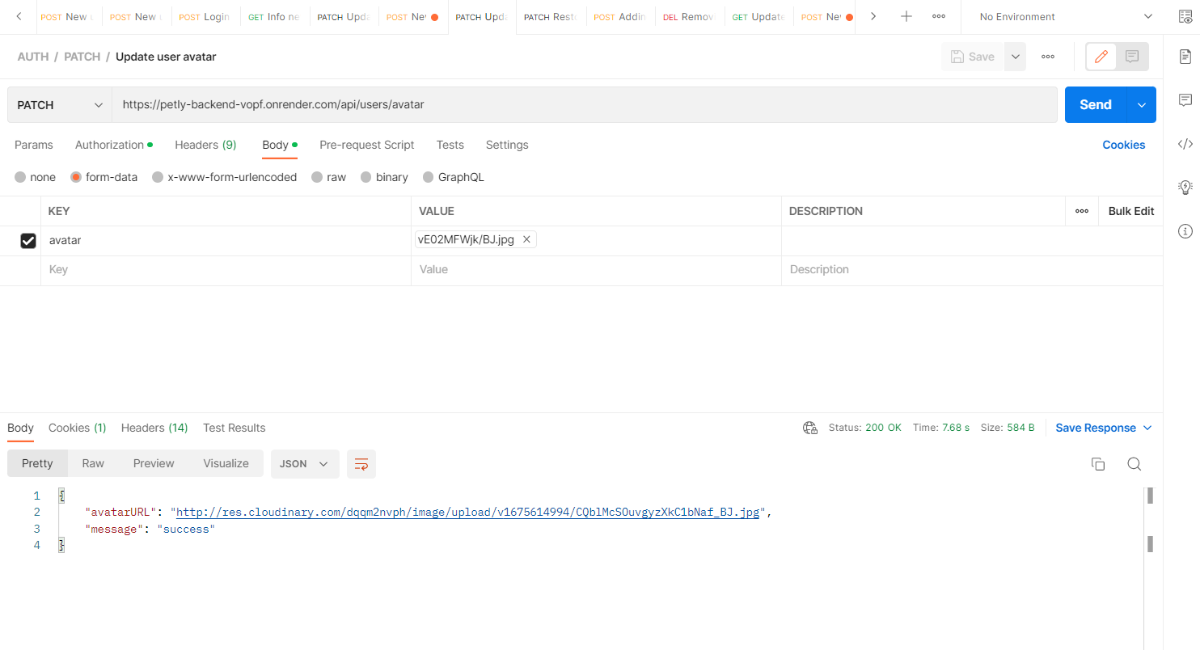

7. Receiving personal information about the user and information about the user’s animal
PASSED
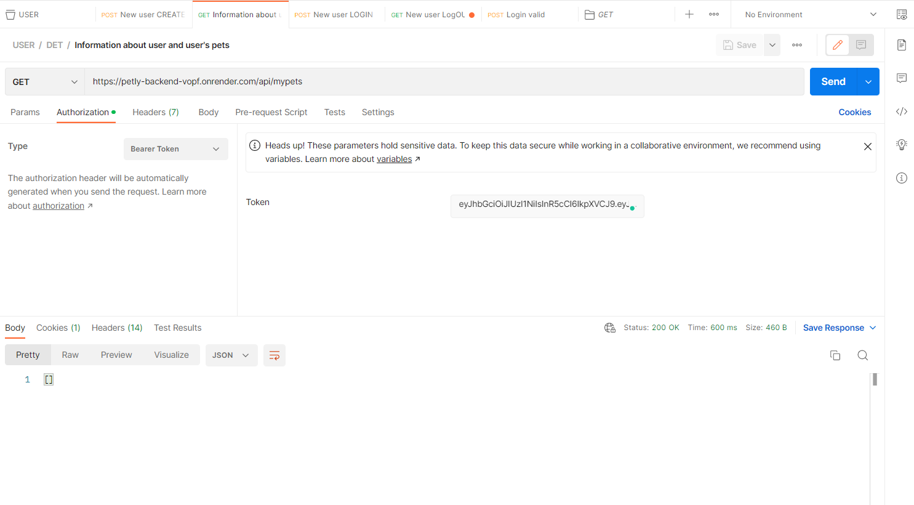

8. Adding a user animal card
PASSED
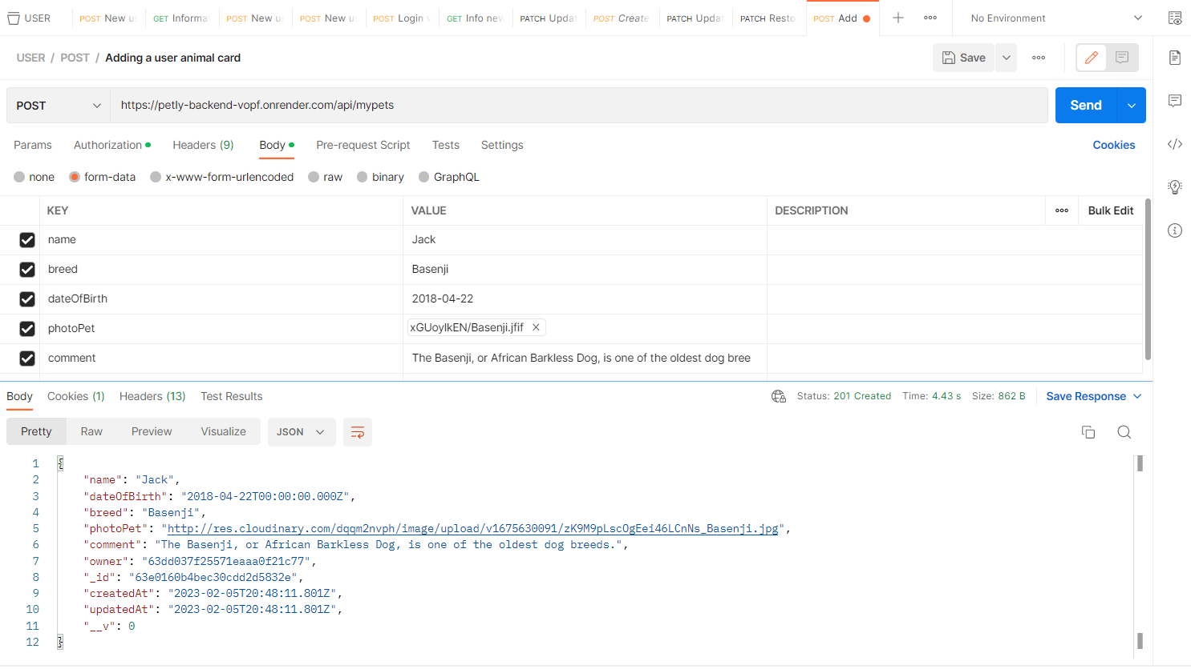

9. Removing the card with the user’s animal
PASSED
