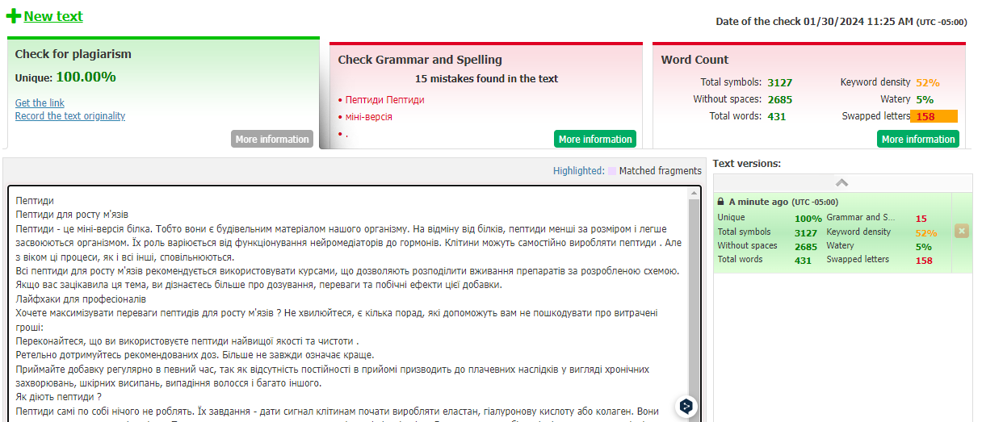


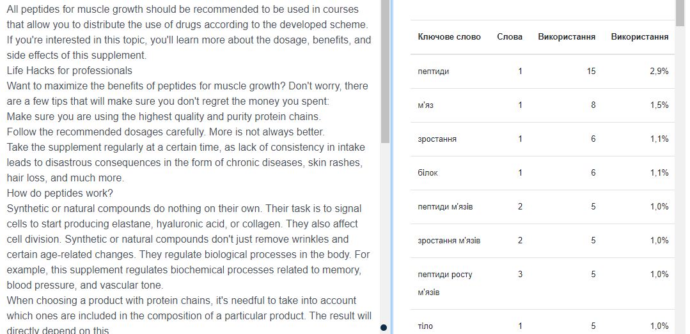

Peptides

Peptides for muscle growth
Peptides are a mini version of a protein. That is, they are the building blocks of our body. Unlike proteins, peptides are smaller and easier to absorb by the body. Their roles range from functioning as neurotransmitters to hormones. Cells can produce synthetic or natural compounds on their own. But with age, these processes, like all others, slow down.
All peptides for muscle growth should be recommended to be used in courses that allow you to distribute the use of drugs according to the developed scheme. If you're interested in this topic, learn more about the dosage, benefits, and side effects of this supplement.

Life Hacks for professionals
Want to maximize the benefits of peptides for muscle growth? Don't worry, there are a few tips that will make sure you don't regret the money you spent:
- Make sure you are using the highest quality and purity protein chains.
- Follow the recommended dosages carefully. More is not always better.
- Take the supplement regularly at a certain time, as lack of consistency in intake leads to disastrous consequences in the form of chronic diseases, skin rashes, hair loss, and much more.

How do peptides work?
Synthetic or natural compounds do nothing on their own. Their task is to signal cells to start producing elastane, hyaluronic acid, or collagen. They also affect cell division. Synthetic or natural compounds don't just remove wrinkles and certain age-related changes. They regulate biological processes in the body. For example, this supplement regulates biochemical processes related to memory, blood pressure, and vascular tone.
When choosing a product with protein chains, it's needful to take into account which ones are included in the composition of a particular product. The result will directly depend on this.
Overall, the following common positive effects of peptides can be identified:
- production of own growth hormone;
- improves muscle definition;
- fat burning;
- healthy appetite;
- relieving inflammation and strengthening bones.
Another great benefit of peptides is that they promote regeneration after injuries and increase muscle strength in athletes.

Side Effects of Peptides
This is not something alien to our body, so negative reactions to peptides are extremely rare. Aging processes begin after 30 years, so it is recommended to use these synthetic chemical compounds from this age.
Of the side effects of protein chains, the following are known:
- water retention;
- numbness in the hands and feet;
- fatigue.
In fact, to avoid unwanted consequences, you should use only original peptides, but not cheap, obscure impurities. Naturally, you can't just "buy peptides for bodybuilding" without choosing the type you need (structural or functional).
You shouldn’t expect that peptides for muscle growth for sale will be absorbed and act 100% - some parts will still pass by the body, since the elimination of excess amino acids occurs at the cellular level.

Peptides for muscle growth for sale
Collagen Protein provides approximately 22 g of protein per 25 g serving, which will help to build and maintain muscle mass.
You can buy original peptides for bodybuilding on this website. Our main advantages include the quality of the product and the satisfaction of the purchase and benefits for the buyer.

