Summary 1 | The “Profile” menu element displayed overseas of the menu after hiding it.
Component | Profile
Version | V 23.67
Severity | Minor
Priority | Low
Status | New
Environment | Windows 10/Google chrome 79.0.3945.88
Steps to Reproduce | - Open the site http://testingtoolreview.com/classifieds/  - Register on the site.  - Click the “Profile” (green) button.  - Click the “Collapse menu” button.  - Pay attention to the location of the inscription list.
Actual Result | The “Profile” menu element displayed overseas of the menu after hiding it.
Expected Result | The “Profile” menu element hidden after clicking the “collapse menu” button.
Attachment | 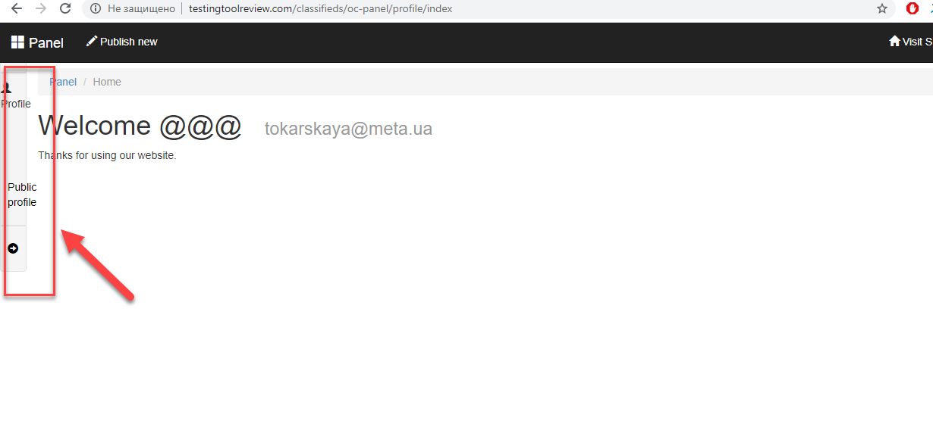

Summary 2 | The error message is not displayed in the “Name” field after entering invalid data.
Component | Edit profile
Version | V 23.67
Severity | Major
Priority | Low
Status | New
Environment | Windows 10/Google chrome 79.0.3945.88
Steps to Reproduce | - Open the site http://testingtoolreview.com/classifieds/  - Register on the site.  - Click the “Profile” (green) button.  - Click the “Edit profile” link.  - Enter invalid data in the “Name” field.  - Click the “Send” button.  - Take a look at the “Name” field.
Actual Result | The error message is not displayed in the “Name” field after entering invalid data.
Expected Result | The error message is displayed in the “Name” field after entering invalid data.
Attachment | 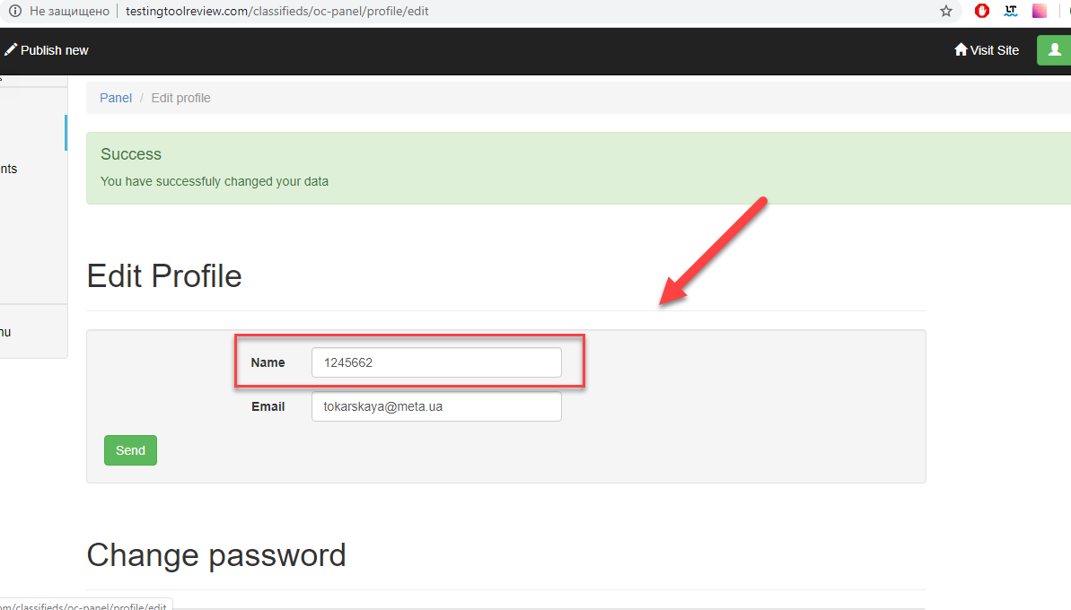

Summary 3 | The error message is not displayed in the “Price from”/”Price to” fields after entering invalid data
Component | Advanced search
Version | V 23.67
Severity | Major
Priority | Low
Status | New
Environment | Windows 10/Google chrome 79.0.3945.88
Steps to Reproduce | - Open the site http://testingtoolreview.com/classifieds/  - Click the “Search” link  - Enter invalid date in the “Price from”/”Price to” fields.  - Click the “Search” button.  - Take a look at the “Price from”/”Price to” fields.
Actual Result | The error message is not displayed in the “Price from”/”Price to” fields after entering invalid data.
Expected Result | The error message is displayed in the “Price from”/”Price to” fields after entering invalid data.
Attachment | 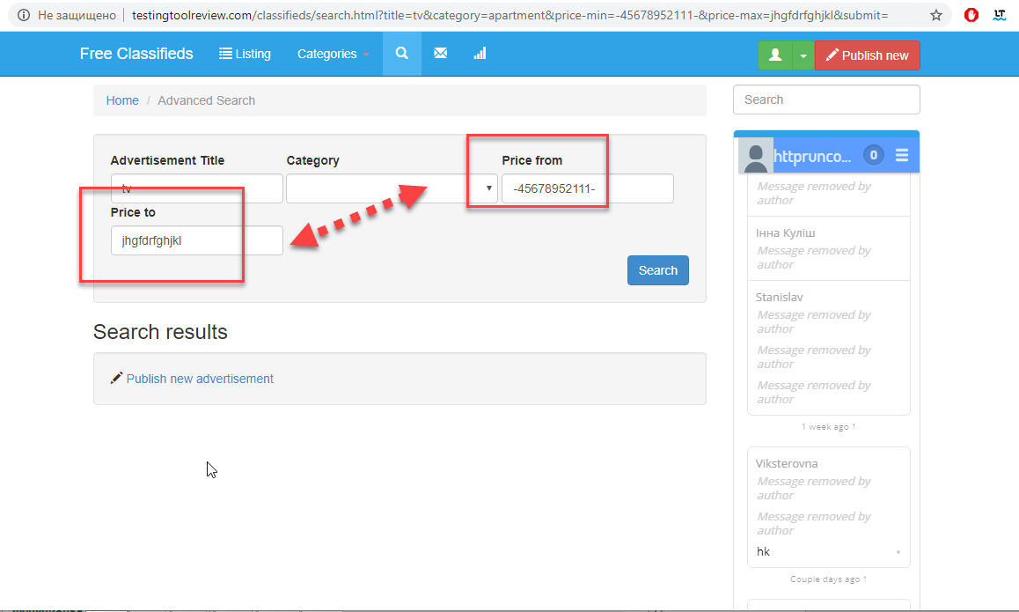

Summary 4 | The tooltip displayed hidden in the main page after clicking the “Login” button.
Component | Login
Version | V 23.67
Severity | Minor
Priority | Low
Status | New
Environment | Windows 10/Google chrome 79.0.3945.88
Steps to Reproduce | - Open the site http://testingtoolreview.com/classifieds/  - Click the “Login” button.  - Take a look at the “Login” button.
Actual Result | The tooltip displayed hidden in the main page after clicking the “Login” button.
Expected Result | The tooltip displayed fully in the main page after clicking the “Login” button.
Attachment | 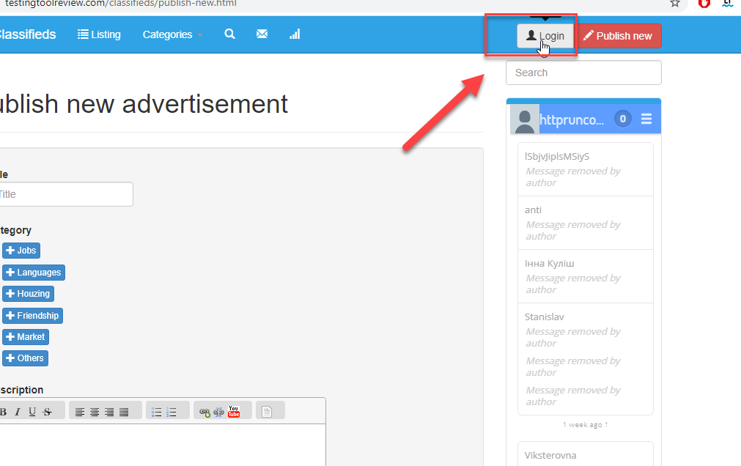

Summary 5 | The horizontal scrolling is displayed in the main page after zooming (150%) this page.
Component | Zooming
Version | V 23.67
Severity | Major
Priority | Medium
Status | New
Environment | Windows 10/Google chrome 79.0.3945.88
Steps to Reproduce | - Open the site http://testingtoolreview.com/classifieds/  - In the browser menu select the line scale 150%  - Take a look at the page size.
Actual Result | The horizontal scrolling is displayed in the main page after zooming (150%) this page.
Expected Result | The content is fully viewed in the main page after zooming.
Attachment | 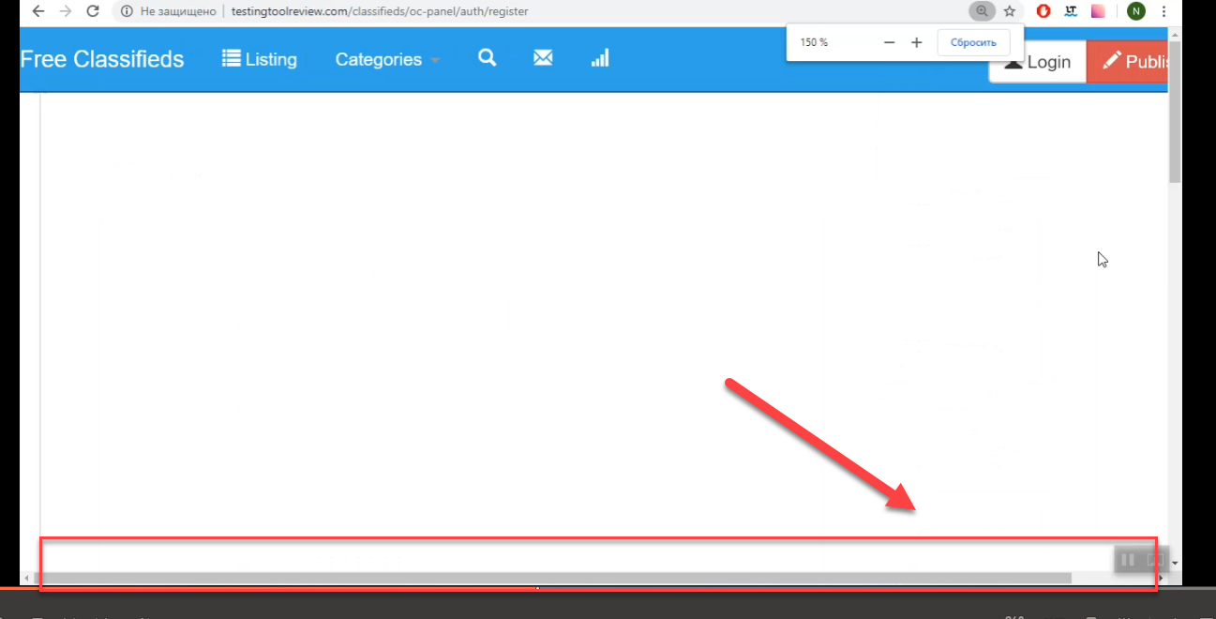

Summary 6 | The picture in the “Publish new advertisement” category displayed upside down after publishing the new advertisement.
Component | Publish new
Version | V 23.67
Severity | Minor
Priority | Low
Status | New
Environment | Windows 10/Google chrome 79.0.3945.88
Steps to Reproduce | - Open the site http://testingtoolreview.com/classifieds/  - Register on the site.  - Click the “Publish new” button.  - Enter valid data into the required fields.  - Click the “Publish new” button.  - Take a look at the pictures.
Actual Result | The picture in the “Publish new advertisement” category displayed upside down after publishing the new advertisement.
Expected Result | The picture in the “Publish new advertisement” category displayed in a suitable orientation after publishing the new advertisement.
Attachment | 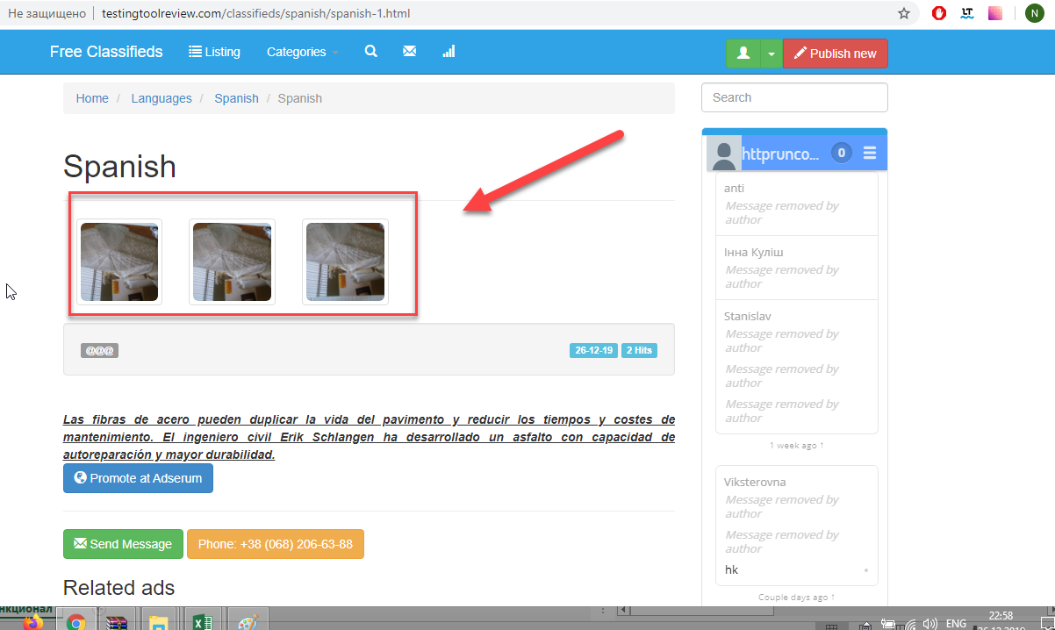

Summary 7 | The site date format is displayed inappropriately with the site language format after creating classifieds.
Component | Publish date
Version | V 23.67
Severity | Minor
Priority | Low
Status | New
Environment | Windows 10/Google chrome 79.0.3945.88
Steps to Reproduce | - Open the site http://testingtoolreview.com/classifieds/  - Register on the site.  - Choose the “Latest ads” category.  - Take a look at the date format.
Actual Result | The site date format is displayed inappropriately with the site language format after creating classifieds
Expected Result | The date format is marched with the site language format after creating classifieds
Attachment | 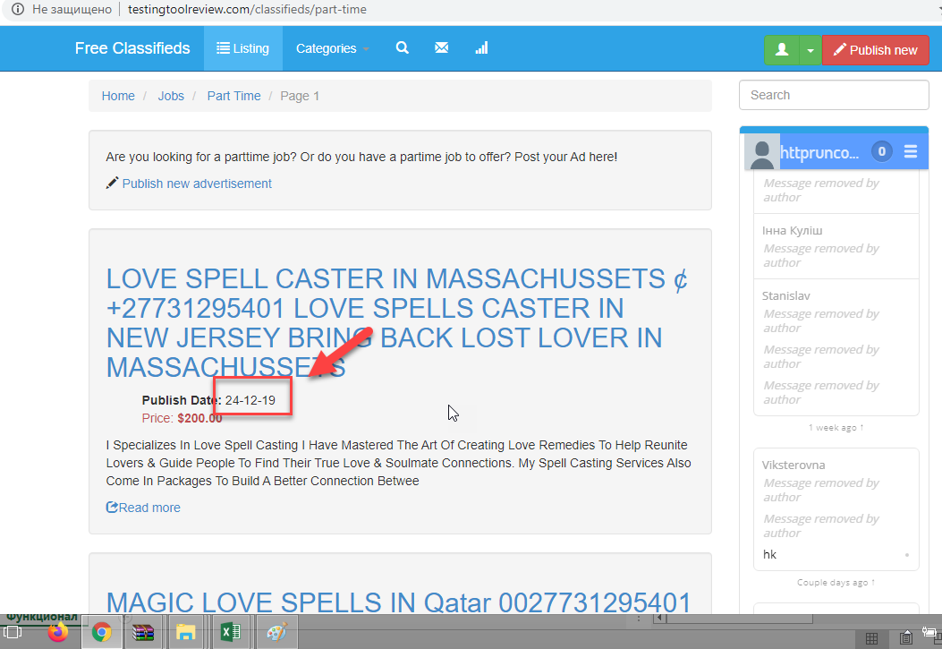

Summary 8 | The error message is not displayed and fields are not highlighted in red on the “Register” form after not living out the fields blank.
Component | Register form
Version | V 23.67
Severity | Major
Priority | High
Status | New
Environment | Windows 10/Google chrome 79.0.3945.88
Steps to Reproduce | - Open the site http://testingtoolreview.com/classifieds/  - Click the “Login” button.  - Click the “Register” button.  - Leave form fields blank.  - Click the “Register” button.  - Look at the “Register” form.
Actual Result | The error message is not displayed and fields are not highlighted in red on the “Register” form after not living out the fields blank.
Expected Result | The error message is displayed and fields are highlighting in red on “Register” form after not living out the fields blank.
Attachment | 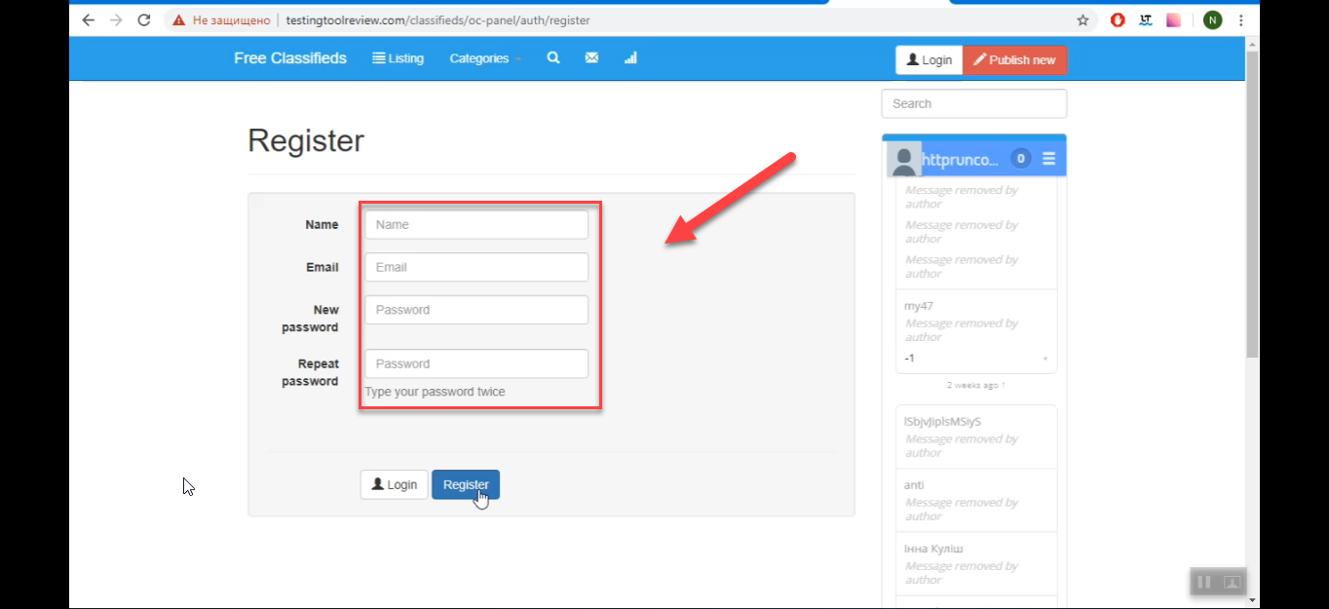

Summary 9 | The ”Send”/”Cancel” buttons are displayed in different colors on the “Edit profile” form after choosing the “Edit profile” button.
Component | Edit profile
Version | V 23.67
Severity | Minor
Priority | Low
Status | New
Environment | Windows 10/Google chrome 79.0.3945.88
Steps to Reproduce | - Open the site http://testingtoolreview.com/classifieds/  - Register on the site.  - Choose the “Profile” button.  - Choose the “Edit profile” link.  - Take a look at the buttons.
Actual Result | The ”Send”/”Cancel” buttons are appeared in different colors on the “Edit profile” form after choosing the “Edit profile” button.
Expected Result | The “Send”/”Cancel” buttons are appeared in same colors on the “Edit profile” form after choosing the “Edit profile” button.
Attachment | 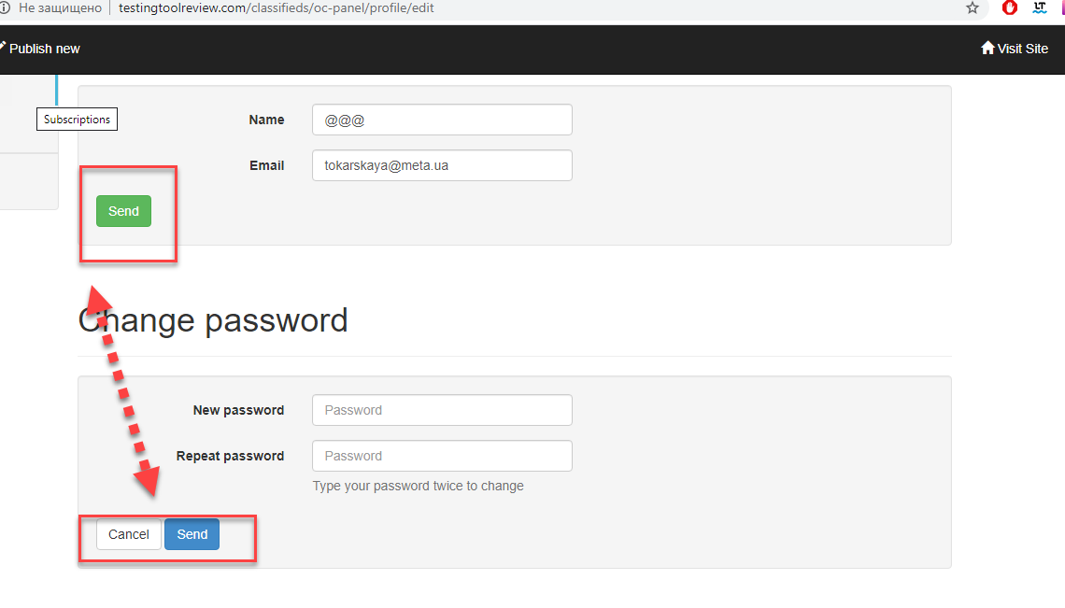

Summary 10 | The “Send message” button and the text “Файл не выбран” are displayed abroad on the “Chat” form after choosing in drop - down list menu the “Science” line.
Component | Chat form
Version | V 23.67
Severity | Minor
Priority | Low
Status | New
Environment | Windows 10/Google chrome 79.0.3945.88
Steps to Reproduce | - Open the site http://testingtoolreview.com/classifieds/  - Register on the site.  - Choose the “Category” button.  - Choose from drop-down list the “Science” line.  - Take a look at the “Send message” button and at the text “Файл не выбран”.
Actual Result | The “Send message” button and the text “Файл не выбран” are displayed abroad on the “Chat” form after choosing in drop - down list menu the “Science” line.
Expected Result | The “Send message” button and the text “Файл не выбран” are displayed aligned on the “Chat” form after choosing in drop - down list menu the “Science” line.
Attachment | 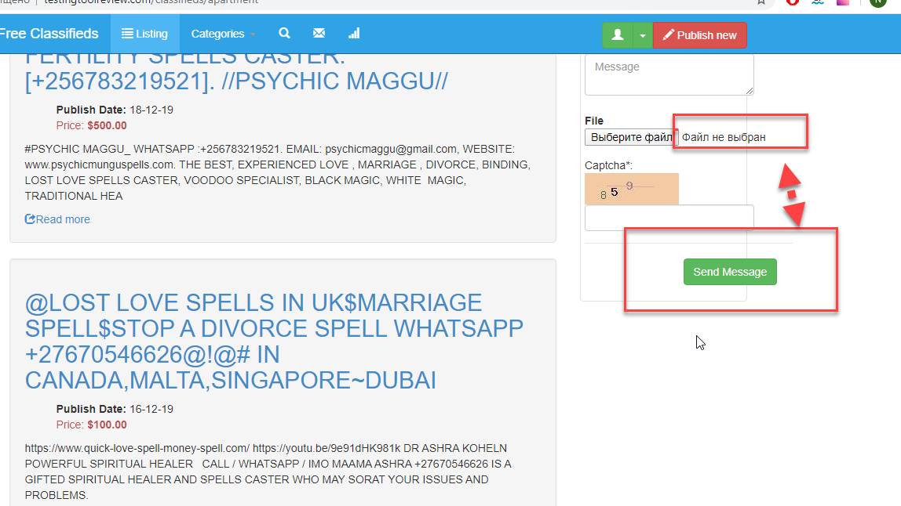

Summary 11 | The “Images” button displayed in the “Publish new advertisement” form in the Russian language after choosing the “Publish new” button.
Component | Publish new
Version | V 23.67
Severity | Major
Priority | Low
Status | New
Environment | Windows 10/Google chrome 79.0.3945.88
Steps to Reproduce | - Open the site http://testingtoolreview.com/classifieds/  - Register on the site.  - Choose the “Publish new” button.  - Take a look at the “Images” button.
Actual Result | The “Images” button displayed in the “Publish new advertisement” form in the Russian language after choosing the “Publish new” button.
Expected Result | The “Images” button displayed in the “Publish new advertisement” form in appropriate language after choosing the “Publish new” button.
Attachment | 