4 METHODS FOR DETERMINING THE TOTAL MODULUS OF ELASTICITY OF THE ROAD STRUCTURE
4.1 General
4.1.1 Determination of the modulus of elasticity of a road construction is performed during field tests, which are usually carried out during the calculation period. The beginning of the calculation period coincides with the date of transition of the average daily air temperature through 0° С in the spring, when the soil moisture approaches the calculated one. The approximate start and end dates of the calculation period for all regions of Ukraine and the duration of the tests are given in Appendix A.
4.1.2 Before the tests according to the passport and reconnaissance surveys, the highway is divided into characteristic areas that differ in category, type of pavement, construction of pavement, soil, terrain, engineering and geological conditions, the type of moisture and the degree of water drainage in accordance with 6.1.4 DBN V.2.3-4, deformations and destruction of the roadway, the intensity and composition of traffic.
4.1.3 At least 5 diameters per kilometer shall be selected on each characteristic section of the road. At the stage of pre-design surveys, the number of diameters should be at least 20 per kilometer. It is determined the total modulus of elasticity of the road construction in each diameter.
4.1.4 By processing the results obtained in the diameters, according to 4.8 it determines the total actual modulus of elasticity of the characteristic section of the road.
4.1.5 In the case when the determination of the modulus of elasticity is carried out at other times, the results lead to the calculation period according to the method that takes into account changes in temperature and humidity of the soil of the roadbed [1].
4.2 Tools and supporting equipment
4.2.1 It applies when determining the total modulus of the road construction of elasticity in diameter:
- method of static loads by means of the plate-bearing test (Appendixes Б-E), [2,3]. As supporting equipment, it uses a truck or a road vehicle, which make it possible to provide the calculated load on the plate-bearing device depending on the category of road and type of pavement in accordance with DBN V.2.3-4 and the distance from the nearest wheel to the center of the plate-bearing device not less than 1.7 m. Instead of deflectors, highly accurate levels and hydrostatic deflectors can be used, which make it possible to measure the deflection with a maximum permissible tolerance of ±0.01 mm;
- method of dynamic loading (Appendixes Ж-K), [4,5,6,7];
- method of static loading by a wheel of the car with calculated parameter of loading with using of deflectors. A truck is used as a supporting equipment, which makes it possible to provide the calculated load parameters depending on the road category and type of pavement in accordance with DBN V.2.3-4. Instead of deflectors, highly accurate levels and hydrostatic deflectors can be used, which make it possible to measure the deflection with a maximum permissible tolerance of ±0.01 mm;
- other methods, devices and equipment.
4.2.2 Uncertainties of measurements by means of the above equipment must be known with a certain probability and must not exceed the limits set for these measurements.
4.3. Preparation for tests
4.3.1 When determining the elastic deflection in the diameter by the method of static loading by means of a plate-bearing test:
- install a road vehicle or a truck on a level section of the pavement. The longitudinal slope of the coating surface should not exceed 35 ‰;
- in case of using the autograder, its forward dump is lowered on the bearing surface to fix the car in the longitudinal direction and brake wheels with a handbrake lower. In case of using the truck, put the wheel block under the wheels to fix the car in the longitudinal direction and brake wheels with a handbrake;
- the place of installation of the plate-bearing device is chosen providing that the distance from it to the wheels of the autograder or truck was not less than 1.7 m;
- the place of installation of the plate-bearing device (under the hydraulic cylinder) is sprinkled with sand and leveled to thin layer with a thickness of 1 mm to 3 mm;
- install a plate-bearing device with a hydraulic cylinder on the surface of the pavement so that the vertical axis of the hydraulic cylinder passes through the bearing heel of the device and the point of contact of the hydraulic cylinder with a road car or truck;
- lift a stock of the hydraulic cylinder to a point of contact with the road car or the truck by means of the manual pump;
- install the bearing heel of the deflector on the plate-bearing device and the movement indicator on the deflector.
4.3.2 Preparation for the determination of the total modulus of elasticity in the diameter by the method of dynamic loading is carried out in accordance with [4,5,6,7].
4.3.3 When determining the elastic deflection in the diameter by the method of static loading of the wheel of the calculation vehicle with the use of deflectors:
- install the truck on a level section of pavement. The longitudinal slope of the coating surface should not exceed 35‰. The wheels are broken with the handbrake;
- install the deflector on the floor so that the heel of device will be based on the coating in the center between the back paired wheels of the car;
- install the displacement detector on the deflector.
4.3.4 Preparing to the determination of the elastic deflection in the diameter using an electronic deflector is carried out in accordance with [8].
4.4 Determination of the total modulus of elasticity of the road structure in diameter
4.4.1 When determining the elastic deflection in diameter by static loading by means of the plate-bearing test:
- it is carried out the calculated static load of the road construction by means of a hydraulic pump;
- after the attenuation of the deformation of the pavement, when the counting on the displacement detector changes no more than 0.01 mm in (20-30) s, the counting i_{o} is recorded in the deflection measurement log, the form of which is given in Appendix Л;
- the road structure is unloaded by means of declining the pressure in the hydraulic pump;
- after attenuation of the reverse deformation, when the counting on the displacement detector changes no more than 0.01 mm in (20-30) s, the counting i is recorded in the deflection measurement log, the form of which is given in Appendix Л;
- repeat the previous four operations. If the two obtained values ​​of deflections differ by no more than 10%, the measurement is completed and determine the average value of the deflection, which is taken as the value of the elastic deflection l_{пр} for the diameter. If this condition is not met, the measurement should be continued.
4.4.2 When determining the elastic deflection in the diameter by the method of static loading of the wheel of the calculation vehicle using deflectors:
- after the attenuation of the deformation of the pavement, when the counting on the displacement detector changes by no more than 0.01 mm per (20 - 30) seconds, the counting i_{o} is recorded in the deflection log, the shape of which is given in the Appendix Л;
- the car is moved at a distance (5 - 7) m forward;
- after the attenuation of the deformation of the pavement, when the counting on the displacement detector changes by no more than 0.01 mm per (20 - 30) seconds, the counting i_{o} is recorded in the deflection log, the shape of which is given in the Appendix Л. Elastic deflection is defined as the difference of counting before and after car leaving;
- the deflector is moved to the parking place of the car and repeat the operations. If the two obtained values of deflections differ by no more than 10%, the measurement is completed and determine the average value of the deflection, which is taken as the value of the elastic deflection l_{пр} for the diameter. In the case that the two obtained values ​​of deflections differ from each other by more than 10%, the test is continued.
4.4.3 Determination of the total modulus of elasticity in the diameter by the method of dynamic loading is carried out in accordance with [4, 5, 6, 7].
4.4.4 Determination of the total modulus of elasticity of the road structure in the diameter using an electronic deflector is carried out in accordance with [8]
4.5 Processing of results during determination the total modulus of elasticity of the road construction in diameter
4.5.1 When determining the elastic deflection in diameter by the method of static loading, the value of the total modulus of elasticity E_{пр} in diameter is determined by the formula: 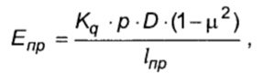
where K_{q} is a coefficient that depends on the kind of the load transfer to the coating; when tested with a plate-bearing device K_{q} = 0.25 π, with the wheel of a counting car K_{q} ≈ 0.6 It is possible to establish other values of K_{q} to the calculation with the appropriate reason;
p - design pressure on the coating, MPa;
D - diameter of the plate-bearing device, m
µ - Poisson's ratio (µ = 0.30);
l_{пр} -elastic deflection of the road construction surface, m.
4.5.2 When determining the total modulus of elasticity by the method of static loading of the wheel of a calculation vehicle using the deflector or highly accurate levels and the method of dynamic loading of indication of all devices lead to values of the total modulus of elasticity determined during static plate-bearing tests on annual comparative correlation tests of means of assessment of the pavement strength [9], calculated by magnitude of elastic deflections.
4.6 Formalization of results determination of the total modulus of elasticity of a road construction in diameter
The act form of definition of the total modules of elasticity is given in Appendix M.
4.7 Uncertainties of measurements
4.7.1 Extended uncertainty in the measurement of the deformation of the road construction or its layer is 0.01 mm at a coverage coefficient k = 2 with a probability of P = 0.95 assuming a allowing a uniform distribution.
4.7.2 Extended uncertainty when measuring the pressure transmitted by the plate-bearing device to the surface – 0,1 MPa at a coefficient of coverage k = 2 with a probability of P = 0,95 allowing a uniform distribution.
4.8 Processing of test results to determine the actual total modulus of elasticity of the road construction of the characteristic section of the road
The actual total modulus of elasticity of the road construction of the characteristic section of the road as a whole is calculated by the formula:
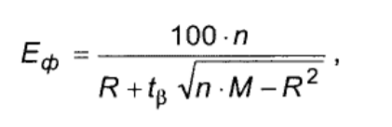
where n is the number of diameters, grands;
t_{β} - normalized deviation, the values ​​of which are taken for roads I and II category t_{β} = 1,45;
for roads III and below categories t_{β} = 1,282;

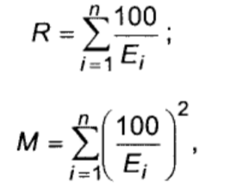
where E_{i} is the value of the total modulus of elasticity in the i diameter, MPa.
An example of processing the results is given in Appendix H.
5 METHODS OF DETERMINATION OF THE DEFORMATION MODULE
5.1 General
5.1.1 Evaluation of deformation properties of soil bases, roadbed layers and road bases are carried out by static or dynamic plate-bearing tests. Static plate-bearing tests are preferred as those that give the most objective results.
5.2 Selection of diameters for testing
5.2.1 When controlling the soil base from the local soil of natural occurrence and the surface of each technological layer of the roadbed diameters are chosen choose diameters placed on each variable grip of sealing equipment at least every 100 m.
5.2.2 When controlling the top layer of the roadbed and the bases of the pavement diameters are chosen at least after 50 m.
5.2.3 Above the pipes, in the cones and at the junction of the roadbed with bridges, the diameters are placed at least through (5 -10) m. When filling the pipes, the diameters are also placed in each sinus.
5.3 Selection of test points during operational control
5.3.1 During operational control tests are carried out at points of diameter located below the axis of the dividing strip, under the axis of the carriageway, at a distance of 1,5 m to 2,0 m from each eyebrow and at intermediate points located under the outer lane of each lane of the carriageway.
5.3.2 When controlling areas and sites, test points are selected because of the condition: not less than one point per 100 m². Additionally, the tests are carried out at points located at the places of entry and exit from areas, sites.
5.3.3 Test points are marked on the scheme of the construction site, which is attached to the test acts of the soil base, each technological layer of the roadbed and the base of the pavement. An example of the scheme of the construction site is given in Appendix П.
5.3.4 During operational control, static plate-bearing tests shall be performed at least at one of the diameter points. At other diameter points, as well as when filling the sinuses of the pipes, static tests can be replaced by dynamic plate-bearing tests.
During the operational control of the area and ​​the sites there are performed two plate-bearing tests every 200 m², one of which can be replaced by a plate-bearing test.
5.4 Selection of test points during acceptance control
5.4.1 During an acceptance control of the upper layer of the roadbed and the base of the pavement, static plate-bearing tests are performed at diameter points located below the outer lane of each of the extreme lanes of the carriageway.
5.4.2 During an acceptance control of areas and sites it is performed one static plate-bearing test every 200 m². The tests are performed additionally at points located entry and exit from the areas, sites.
5.5 Carrying out static plate-bearing tests to obtain the dependence of the deflection of the plate-bearing device from the pressure at two serial loads-unloads
5.5.1 Tools and supporting equipment
5.5.1.1 Construction of the dependence of the deflection of the plate-bearing device from the pressure at two serial loads-unloads is carried out by means of plate-bearing equipment for making load to the layers of road construction, measuring equipment, supporting devices.
5.5.1.2 Plate-bearing equipment for loading includes a plate-bearing device with a diameter of 30 cm, a hydraulic pump, a hydraulic cylinder and a hose that connects the pump to the cylinder. An example of plate-bearing equipment for making a load on the layers of the road construction is given in Appendix Б.
5.5.1.3 The measuring equipment includes a deflector and a displacement detector. Instead of deflectors, highly accurate levels and hydrostatic deflectors can be used, which make it possible to measure the deflection with a maximum permissible tolerance of ±0.01 mm. An example of measuring equipment is given in Appendix B.
5.5.1.4 A truck or road vehicle are used as a supporting equipment, which makes it possible to provide a load of 60 kH on the plate-bearing device.
5.5.1.5 In order to exclude manual labor, increase productivity, accuracy of measurements and automation of tests and calculations, it can be used an electronic deflector (Appendix Г) [8], measuring stations for plate-bearing tests of road constructions (Appendices Д, E) [2-3].
5.5.2 Preparing for test, testing, processing and designing of results
5.5.2.1 You should install the truck or road vehicle on the surface of the layer. Longitudinal profile of the bearing surface should not exceed 35 ‰.
5.5.2.2 Brake the truck or road vehicle wheels with the handbrake, put the wheel block under the wheels. If an autograder is used to load, you should lower the front blade onto the surface of the layer to fix it in the longitudinal direction.
5.5.2.3 Remove the top layer of soil with a thickness of 8 cm to 1/3 of the depth of the compacted layer of soil to a width of 1.5 to 2 diameters of the equipment (plate-bearing device). If necessary, the place of installation plate-bearing device sprinkled with sand and level it to thin layer with a thickness of 1 mm to 3 mm.
5.5.2.4 Install the plate-bearing device on the surface and circular motions in the horizontal flatness to grind it to the surface of the layer.
5.5.2.5 Install the hydraulic cylinder to the plate-bearing device and connect it to the hydraulic pump, using connecting hose
5.5.2.6 Raise the stock of the hydraulic cylinder up to the stop to the element of the truck of the road vehicle.
5.5.2.7 Carry out a preliminary load on the plate-bearing device (0.35 ± 0.05) tons of forces during 30 s. Unload the device.
5.5.2.8 Install the measuring heel of the deflector as close as possible to the center of the plate-bearing device.
5.5.2.9 Install the displacement detector on the deflector. Read off the detector.
5.5.2.10 Carry out the first load from 0 MPa to 0.5 MPa, fixing the counting on the displacement detector after 0.1 MPa after attenuation of the deformation (not more than 0.01 mm for a time from 20 s to 30 s) at each load values.
5.5.2.11 Construct the dependence of the deflection of the plate-bearing device from the pressure at the first load. The example is shown in Figure 5.1.
Pressure p, MPa
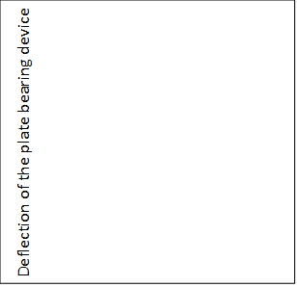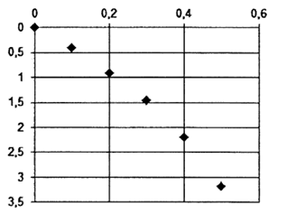
Figure 5.1 – The example the dependence of the deflection of the plate-bearing device from the pressure at the first load.
5.5.2.12 Build a trend line in the form of a polynomial of the second degree:
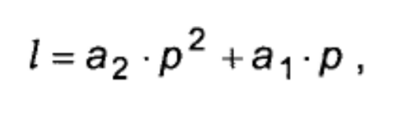
where a₂, a₁ are the coefficients of the polynomial;
p - pressure, MPa;
l - the deflection of the plate-bearing device, mm.
Select the coefficients a₁ and a₂ (Figure 5.2).
Pressure p, MPa
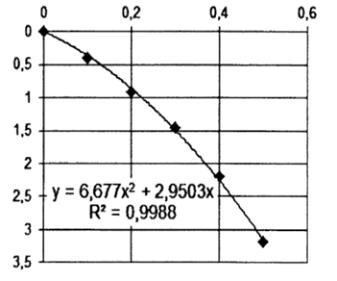
The deflection of the plate-bearing device/, mm
Figure 5.2 – The example of building a trend line dependence of the deflection of the plate-bearing device from the pressure at the first load and select the coefficients a₁=2.95 and a₂=6.677.
5.5.2.13 Calculate the value of the total deformation modulus at the first imposition of E1:
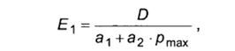
where D is the diameter of the plate-bearing device, mm;
p_{max} is the maximum value of the pressure, MPa.
5.5.2.14 Carry out another load, repeating the operations, shown in 5.5.2.10 -5.5.2.13 and calculate the value of the total deformation modulus during another load E₂.
5.5.2.15 Calculate the value of the criterion of the sufficient compaction according to the formula (3.4).
5.5.2.16 The test results are designed as act, the form of which is given in Appendix P.
5.5.2.17 Uncertainty of measurements by means of the above-stated devices should be known with a certain probability and should not exceed the limits established for these measurements.
5.6 Carrying out dynamic plate-bearing tests.
5.6.1 Tools and supporting equipment
5.6.1.1 To determine the actual total dynamic deformation modulus and the maximum total dynamic deformation modulus, devices with manual lifting of loads and with automatic lifting of loads are used. The recommended characteristics of the devices are given in Appendix C.
5.6.1.2 The supporting equipment that are used:
- shovel,
- trowel,
- brush,
- carpenter level.
5.6.2 Preparation for tests
5.6.2.1 At the test point on a crushed stone basis from the site for the test it should be removed individual protruding crushed stone, if any. The plate-bearing device is installed directly on the surface of the layer.
5.6.2.2 Remove with a shovel or trowel the top layer of soil with a thickness of 8 cm to 1/3 of the depth of the compacted layer of earth at the test point on the soil foundation. Arrange the site with a width of 1.5 to 2 diameters of the device. Level its surface so that the slope determined by the carpenter level does not exceed 1% according to DSTU B V.2.8-19.
If necessary, the place of installation plate-bearing device sprinkled with sand and level it to thin layer with a thickness of 1 mm to 3 mm.
5.6.3 Testing
5. 6.3.1 The tests are carried out at air temperature in the range from 10° C to 32° C. On frozen bases tests are not carried out.
5.6.3.2 The device is installed on the prepared site, put it into working condition, turn on and perform shock loads in accordance with operation of the device.
5.6.3.3 During determination the actual dynamic modulus of deformation perform four shock loads. The first load is a trial and is carried out to ensure a tight contact without fixing the deflection of the plate-bearing device. In the second, third and fourth loads, the deflection of the plate-bearing device is fixed.
5.6.3.4 When determining the maximum dynamic modulus of deformation of the base, the number of shock loads is taken as when E_{d} becomes constant, but not less than 40. The results of determining the deflection and calculation of the modulus of deformation at each shock load can be fixed by the device automatically and displayed on the screen in the form of a graph [10].
An example of a graph of the dependence of the modulus of deformation on the number of shock loads is shown in Figure 5.3.

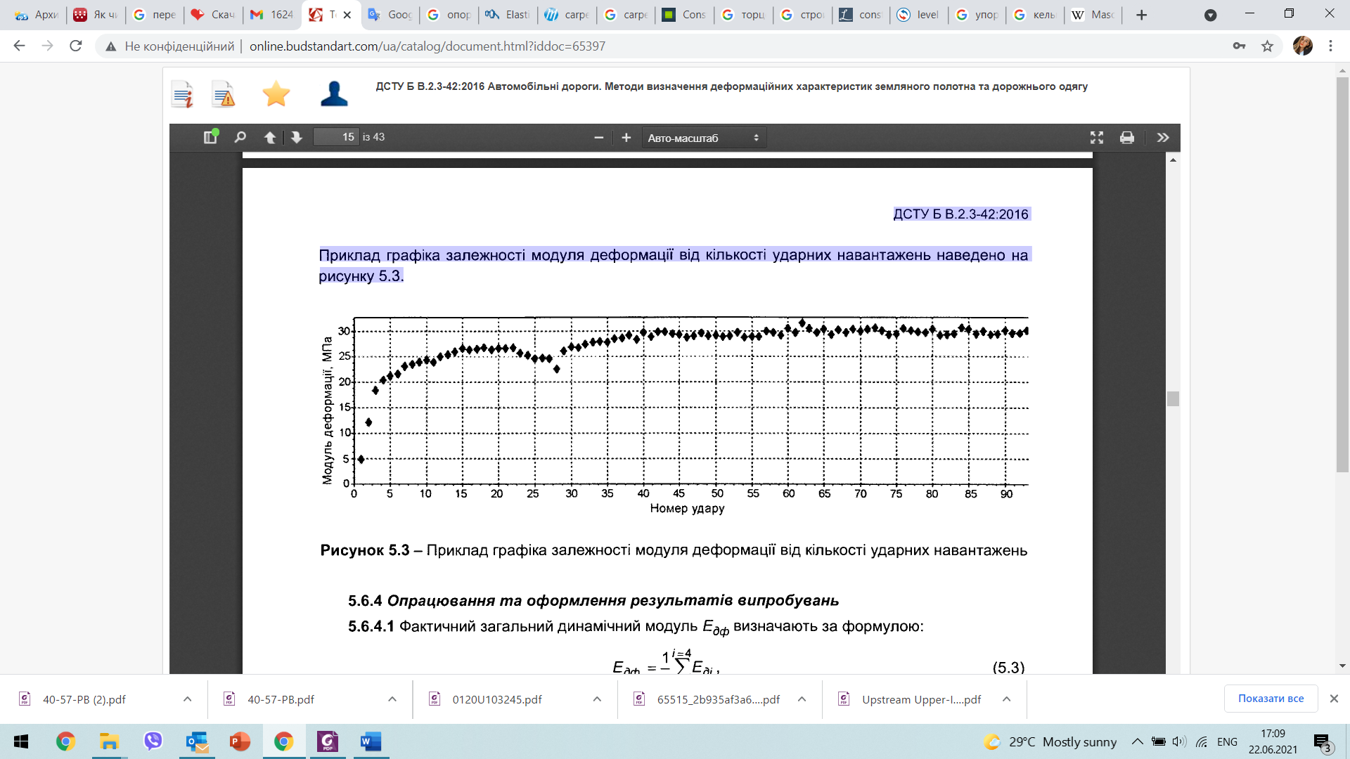
The modulus of deformation, MPa
The number of shock loads

Figure 5.3 - An example of a graph of the dependence of the modulus of deformation on the number of shock loads
5.6.4 Processing and design of test results
5.6.4.1 The actual total dynamic modulus of E_{дф} is determined by the formula:
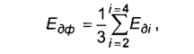
where Е_{ді} is the value of the dynamic modulus of deformation in another measurement, MPa, calculated by formula (3.5).
Calculations can be performed automatically using the devices software.
5.6.4.2 According to the test results draw up an act, the form of which is given in Appendix T.
5.6.4.3 Maximum the dynamic modulus of deformation of the base E_{д max} is defined as the horizontal asymptote of the graph of the dependence of the dynamic modulus of deformation on the number of shock loads (Figure 3.1, 5.3).
5.6.4.4 Calculate the value of the criterion of sufficient compaction k_{д} a by formula (3.6) .
5.6.4.5 The test results shall be drawn up an act, the form of which is given in Appendix Ф. An example of the act is given in Appendix Ц.
5.6.3 Uncertainty of measurements by means of the dynamic plate-bearing tests measurements must be known with a certain probability and must not exceed the limits set for these measurements.
5.7 Uncertainty of measurements
5.7.1 Extended uncertainty when measuring deformation of roads construction or its layer – 0.01 mm at a coefficient of coverage k = 2 with a probability of P = 0.95 allowing a uniform distribution.
5.7.2 Extended uncertainty when measuring the pressure transmitted by the plate-bearing device to the surface – 0.1 MPa at a coefficient of coverage k = 2 with a probability of P = 0.95 allowing a uniform distribution.

