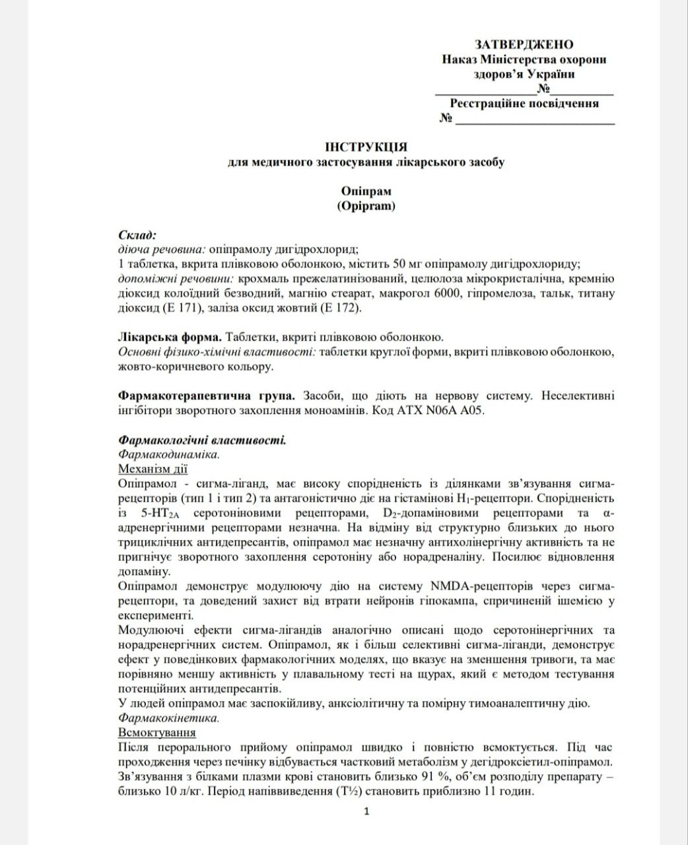

APPROVED
Order of the Ministry of Health
of Ukraine
________________№__________
Registration certificate
№ ________________

INSTRUCTIONS
for medical use of the medicinal product

Opipram

Ingredients:
active ingredient: opipramol dihydrochloride;
1 film-coated tablet contains 50 mg of opipramol dihydrochloride;
excipients: pregelatinised starch, microcrystalline cellulose, colloidal silicon dioxide anhydrous, magnesium stearate, macrogol 6000, hypromellose, talc, titanium dioxide (E 171), iron oxide yellow (E 172).

Pharmaceutical form. Film-coated tablets.
Basic physical and chemical properties: tablets of round shape, film-coated, yellow-brown in colour.

Pharmacotherapeutic group. Products acting on the nervous system. Non-selective monoamine reuptake inhibitors. Code АТХ N06A A05.

Pharmacological properties.
Pharmacodynamics.
Mechanism of action.
Opipramol is a sigma ligand with a high affinity for sigma receptor binding sites (type 1 and type 2) and antagonistic effects on histamine H₁- receptors. The affinity for 5-HT₂A serotonin receptors, D₂-dopamine receptors and α-adrenergic receptors is low. In contrast to structurally similar tricyclic antidepressants, opipramol has little anticholinergic activity and does not inhibits serotonin or norepinephrine reuptake. Enhances the recovery of dopamine.
Opipramol exhibits a modulatory effect on the NMDA-receptor system via sigma receptors and proved protection against hippocampal neuronal loss caused by ischemia in experiment.
The modulating effects of sigma ligands are similarly described for serotonergic and noradrenergic systems. Opipramol, as well as more selective sigma ligands, demonstrates effect in behavioural pharmacological models, indicating a reduction in anxiety, and has comparatively lower activity in the rat swimming test, which is a method of testing of potential antidepressants.
In humans, opipramol has a calming, anxiolytic and moderate thymo-analeptic effect.
Pharmacokinetics.
Absorption
After oral administration, opipramol is rapidly and completely absorbed. Partial metabolism to dehydroxyethyl-opipramol occurs during liver passage. The binding to plasma proteins is about 91%, and the volume of drug distribution is about 10 l/kg. The elimination half-life (T½) is approximately 11 hours.

