Heroes of Mykolaiv
- Before an invasion and how it started
- Situation at the front before the start
- Progress of the fighting
- Ukrainian fighters’ thoughts
- My personal comment
At the 24th of February all of Ukrainian people waked up in a new world – world with war. In a fact, war in Ukraine started 8 years ago before this when russia captured a part of Donetsk and Luhansk oblast on Donbass. Especially, main cities in this region – Donetsk and Luhansk. Also, in 2014 russia annexed Crimea peninsula without any combat operations, but this was the moment, when Ukraine started to be incomplete. Lots of Ukrainian people left those territories including me (I was born in Donetsk), but Europe didn’t make a serious reaction on those events and people just changed their city because they wanted to live in liberate Ukraine and they were not able to something to liberate cities where they were living before. 8 years have gone and russia understood that it wants more, so they invaded in Ukraine with a goal to capture all Ukraine. russian soldiers attacked from 4 ways: from occupied Crimea, from belarus, from occupied territories on Donbass (fortunately, russia didn’t capture all Donbass in 2014 and won’t do this now) and from russian territories. Europe didn’t believe that Ukraine will hold defence a long time, but Ukraine shocked Europe and USA because Ukrainian Armed Forces held Kyiv and sent out occupiers of North. russia didn’t occupy any big city during this invasion and everybody in civilized world knows that Ukraine will win this war through liberating all Ukrainian territories including Donetsk, Luhansk and Crimea that are under occupation from 2014. One of the big cities that russia could take was Mykolaiv, but UAF’s (Ukrainian Armed Forces) actions safed this city from occupation. In this article I will write about fightings near Mykolaiv and Ukrainian Armed Forces saved this city from occupation and being under siege.
How I said russia was attacking by 4 directions. On the south direction russian soldiers came out from occupied since 2014 Crimea. Unfortunately, Ukraine didn’t make defence on the south direction, so russia occupied territory on the south of Ukraine. russia, fortunately, didn’t occupy all south, so Mykolaiv was saved before russia didn’t try to capture him as well, but heroic actions of Ukrainian soldiers saved this big city.

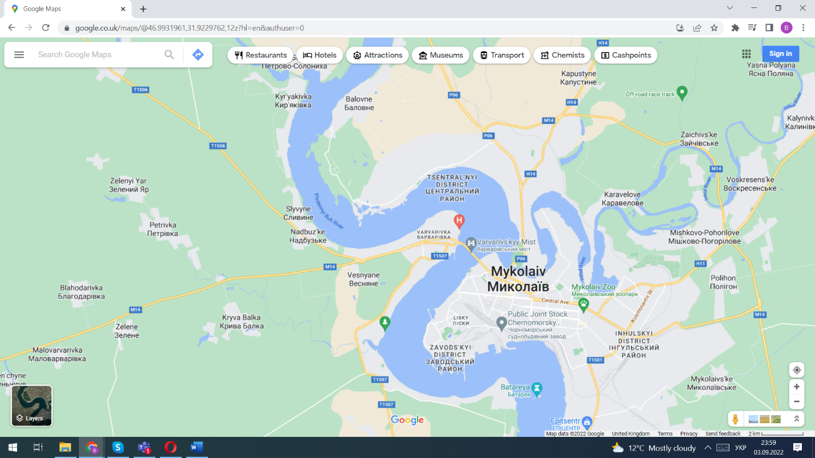

On the map you can see that Mykolaiv locates on the right coast of river Pivdennyi Buh, so russian soldiers were planning to put it under siege with subsequent occupation through coming as landing from Kropivnitskaya track and occupied Kherson.

russians occupied airport little bit norther than Mykolaiv near village Balovne and were waiting for reserve from Kherson direction. If this would happen Mykolaiv would be put under siege and Mykolaiv could get very big injuries and really destroyed as city Mariupol, but Mykolaiv patrol police called “danylivtsi” because of a name of their leader Vitaliy Danila and Ukrainian soldiers were against this horrible idea.

The one of the most important fightings took place near the airport and airfield called Kulbakine. It’s very close to Mykolaiv and near this airport there was fighting. Fighting took place in the first dates of March 2022. Ukrainian soldiers were fighting with britain RPG. Ukrainian soldiers cleaned up airport and then they climbed on the building and saw that russian soldiers are going away. Also, they saw that a russian soldier holds another wounded russian soldier. Vitaliy Danila said that he will go to take them to captivity, but other soldiers asked him to take with him Ukrainian soldier with nickname ‘Kozak’. When Vitaliy Danila and Kozak came to wounded russian soldier they have seen a lot of russian military equipment. A tank shouted in Kozak but, fortunately, didn’t hit him. Then russians shouted Ukrainians with automats. Russian landing was trying to go into the airport to capture it and then go to Mykolaiv which would be very and very terribly, but UAF shouted with RPG on russian hard military equipment. After this Vitaliy Danila recorded a video that UAF controls airport to appease people in Mykolaiv. Fighting finished with russian shout using ‘hail’ and then russian landing retreated for the track.
We all know Ukraine will win this war and will liberate all Ukrainian territory: from Simferopol to Donetsk, from Melitopol’ to Mariupol, from Luhansk to Berdiansk. This will happen. Glory for Ukraine!

