No. 1 Location of SPP: Biloghirya territorial community of Khmelnytskyi region
Gulivtsi Lyceum
Description: Rooftop SPP
Power of the solar field: 15 kW
Inverter power: 12 kW

CALCULATION
Name | Description | K-  St | Costunits | Price
1. Solar panel | Risen 550W | 27 | 8,282.90 ₴ | 223,638.30 ₴
2. Electricity inverter | Solis S5-GR3P12K | 1 | 54,975.00 ₴ | 54,975.00 ₴
3. The controller for the export of electricity to the network | Solis EPM3-5G  plus | 1 | 23,199.45 ₴ | 23,199.45 ₴
4. Assembly structure
Type of metal construction | aluminum | 1 | 14,843.25 ₴ | 14,843.25 ₴
5. Electrical products
cable | AVVG4X16 | 10 | 600.00 ₴ | 600.00 ₴
cable for solar panels | KBE | 120 | 40.00 ₴ | 4,800.00 ₴
automatics protection DC | ETI fuSPP,  shield ETI | 1 | 3,800.00 ₴ | 3,800.00 ₴
automatics protection AC | shield ETI, automatichull Hager,Shnider SSRIs | 1 | 4,000.00 ₴ | 4,000.00 ₴
switching facilities | MC4 connectors, tips, copper wire, grounding bus | 1 | 2,500.00 ₴ | 2,500.00 ₴
6. Consumables |  | 1 | 3,000.00 ₴ | 3,000.00 ₴
7. Transportation |  | 1 | 5,000.00 ₴ | 5,000.00 ₴
8. Assembly works |  | 1 | 42,000.00 ₴ | 42,000.00 ₴
9. Design and estimate documentation |  | 1 | 12,000.00 ₴ | 12,000.00 ₴
CAPEX |  |  | Total: | 394,356.00 ₴

CAPEX
SPP 15 KW.

INDICATORS GENERATIONS AND CONSUMPTION
SPP 15 KW.

3,300
3,000
2,700
2,400
2 100
1,800
1,500
1,200
900
600
300
0
SCHEDULE OF SPP GENERATION AND ELECTRICITY CONSUMPTION BY THE FACILITY


3,200
2,868
3,000 3,000
2,500 2,500 2,500
2,660
1 828
2,2122,274 2,236
2 306
1 932
2,529
1 928
1 313
1 681 1 391
761
913
453
434
340
Jan Feb Mar April May June July Aug Sept Oct Nov Dec
SPP generation, kW/h Electricity consumption, kW/h

 | SPP generation, kW/h | Consumption object, kW/h | Purchase from the network, kWh
January | 453 | 2500 | 2047
February | 761 | 2500 | 1739
March | 1313 | 2500 | 1187
April | 1828 | 2868 | 1040
May | 2212 | 2660 | 448
June | 2274 | 2306 | 32
July | 2236 | 1932 | -
August | 1928 | 1681 | -
September | 1391 | 2529 | 1138
October | 913 | 3000 | 2087
November | 434 | 3000 | 2566
December | 340 | 3200 | 2860
TOTAL: | 16083 | 30676 | 15144

PROJECTED PERFORMANCE INDICATORS OF THE PROJECT
CAPEX (SPP cost) | 394,356.00 | UAH
Power of SPP | 15 | kW
The rate of $ in calculations | 36.65 | UAH
Generation SPP by 1 year | 16,083 | kW/h
Consumption electricity an object | 30,676 | kW/h
Online purchase | 15 144 | kW/h
Coverage of consumption by own SPP | 15,532 | kW/h
The projected amount of electricity that will not be used from its own SPP | 551 | kW/h
Estimated price for 1 kWh from the grid | 6 | UAH
Costs for purchasing electricity from the grid after installation of the SPP | 90,864 | UAH
Costs on service by 1 year | 8,000 | UAH
The cost of projected energy consumption from own SPP | 93 192 | UAH
Cost consumption electricity without installed SPP | 184,056 | UAH
Savings of funds after the installation of SPP in the year before full payback | 85 192 | UAH
Payback of the project | 4.6 | years
The cost of generated electricity after payback | 0.50 | UAH per kWh

SPP 15 KW.

No. 2 Location of SPP: Biloghirya territorial community of Khmelnytskyi region
Denisiv Gymnasium
Description: Rooftop SPP
Power of the solar field: 8 kW
Inverter power: 6 kW

CALCULATION
Name | Description | K-  St | Costunits | Price
1. Solar panel | Risen 550W | 15 | 7,586.55 ₴ | 110,349.82 ₴
2. Electricity inverter | Solis S5-GR3P6K | 1 | 45,812.50 ₴ | 45,812.50 ₴
3. The controller for the export of electricity to the network | Solis EPM3-5G  plus | 1 | 23,199.45 ₴ | 23,199.45 ₴
4. Assembly structure
Type of metal construction | aluminum | 1 | 7,996.36 ₴ | 7,996.36 ₴
5. Electrical products
cable | AVVG4X16 | 10 | 600.00 ₴ | 600.00 ₴
cable for solar panels | KBE | 80 | 40.00 ₴ | 3,200.00 ₴
automatics protection DC | ETI fuSPP,  shield ETI | 1 | 3,000.00 ₴ | 3,000.00 ₴
automatics protection AC | shield ETI, automatichull Hager,Shnider SSRIs | 1 | 3,000.00 ₴ | 3,000.00 ₴
switching facilities | MC4 connectors, tips, copper wire, grounding bus | 1 | 2,000.00 ₴ | 2,000.00 ₴
6. Consumables |  | 1 | 2,500.00 ₴ | 2,500.00 ₴
7. Transportation |  | 1 | 3,000.00 ₴ | 3,000.00 ₴
8. Assembly works |  | 1 | 22,400.00 ₴ | 22,400.00 ₴
9. Design and estimate documentation |  | 1 | 12,000.00 ₴ | 12,000.00 ₴
CAPEX |  |  | Total: | 239,058.13 ₴

CAPEX
SPP 8 KW.

INDICATORS GENERATIONS AND CONSUMPTION
SPP 8 KW.

1,350

1,200

1,050

900

750

600

450

300

150

0
SCHEDULE OF SPP GENERATION AND ELECTRICITY CONSUMPTION BY THE FACILITY

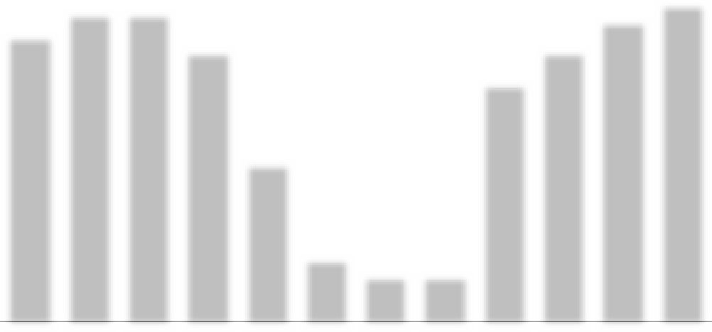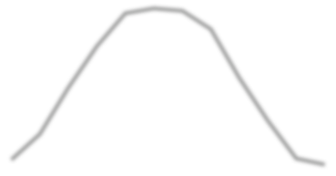
1 2081 240 1 224
1 104
992
900
970
970
720
9501,000
850
784
750
850
504
416
500
248
256
216
200 150 150
Jan Feb Mar April May June July Aug Sept Oct Nov Dec
SPP generation, kW/h Electricity consumption, kW/h

 | SPP generation, kW/h | Consumption object, kW/h | Purchase from the network, kWh
January | 248 | 900 | 652
February | 416 | 970 | 554
March | 720 | 970 | 250
April | 992 | 850 | -
May | 1 208 | 500 | -
June | 1,240 | 200 | -
July | 1 224 | 150 | -
August | 1 104 | 150 | -
September | 784 | 750 | -
October | 504 | 850 | 346
November | 256 | 950 | 694
December | 216 | 1000 | 784
TOTAL: | 8,912 | 8240 | 3280

PROJECTED PERFORMANCE INDICATORS OF THE PROJECT
CAPEX (SPP cost) | 239,058.13 | UAH
Power SPP | 8 | kW
The rate of $ in calculations | 36.65 | UAH
Generation SPP by 1 year | 8,912 | kW/h
Consumption electricity an object | 8,240 | kW/h
Online purchase | 3,280 | kW/h
Coverage of consumption by own SPP | 4,960 | kW/h
The projected amount of electricity that will not be used from its own SPP | 3,952 | kW/h
Estimated price for 1 kWh from the grid | 6 | UAH
Costs for purchasing electricity from the grid after installation of the SPP | 19,680 | UAH
Costs on service by 1 year | 5,000 | UAH
The cost of projected energy consumption from own SPP | 29,760 | UAH
Cost consumption electricity without installed SPP | 49,440 | UAH
Savings of funds after the installation of SPP in the year before full payback | 24,760 | UAH
Payback of the project | 9.7 | years
The cost of generated electricity after payback | 0.56 | UAH per kWh

SPP 8 KW.

No. 3 Location of SPP: Biloghirya territorial community of Khmelnytskyi region
Kvitneve Lyceum
Description: Rooftop SPP
Power of the solar field: 8 kW
Inverter power: 6 kW

CALCULATION
Name | Description | K-  St | Costunits | Price
1. Solar panel | Risen 550W | 15 | 7,586.55 ₴ | 110,349.82 ₴
2. Electricity inverter | Solis S5-GR3P6K | 1 | 45,812.50 ₴ | 45,812.50 ₴
3. The controller for the export of electricity to the network | Solis EPM3-5G  plus | 1 | 23,199.45 ₴ | 23,199.45 ₴
4. Assembly structure
Type of metal construction | aluminum | 1 | 7,996.36 ₴ | 7,996.36 ₴
5. Electrical products
cable | AVVG4X16 | 10 | 600.00 ₴ | 600.00 ₴
cable for solar panels | KBE | 80 | 40.00 ₴ | 3,200.00 ₴
automatics protection DC | ETI fuSPP,  shield ETI | 1 | 3,000.00 ₴ | 3,000.00 ₴
automatics protection AC | shield ETI, automatichull Hager,Shnider SSRIs | 1 | 3,000.00 ₴ | 3,000.00 ₴
switching facilities | MC4 connectors, tips, copper wire, grounding  bus | 1 | 2,000.00 ₴ | 2,000.00 ₴
6. Consumables |  | 1 | 2,500.00 ₴ | 2,500.00 ₴
7. Transportation |  | 1 | 3,000.00 ₴ | 3,000.00 ₴
8. Assembly works |  | 1 | 22,400.00 ₴ | 22,400.00 ₴
9. Design and estimate documentation |  | 1 | 12,000.00 ₴ | 12,000.00 ₴
CAPEX |  |  | Total: | 239,058.13 ₴

CAPEX
SPP 8 KW.

INDICATORS GENERATIONS AND CONSUMPTION
SPP 8 KW.

1,800

1,600

1,400

1,200

1,000

800

600

400
SCHEDULE OF SPP GENERATION AND ELECTRICITY CONSUMPTION BY THE FACILITY

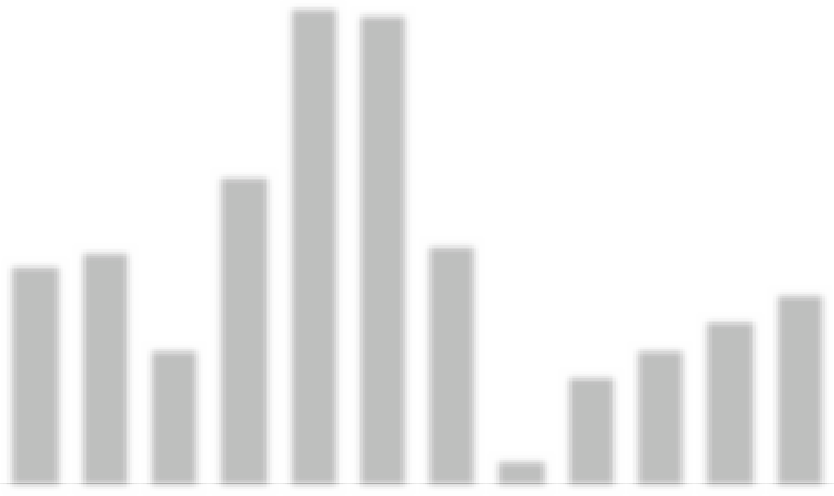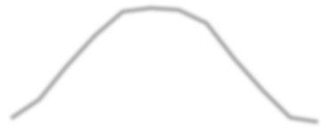200
1 728 1 702
1 2081 240 1 224
1 104
1919224
800
850
720
876
784
416 500
504
500
700
248 400
600
256
216
100

0
Jan Feb Mar April May June July Aug Sept Oct Nov Dec

SPP generation, kW/h Electricity consumption, kW/h

 | SPP generation, kW/h | Consumption object, kW/h | Purchase from the network, kWh
January | 248 | 800 | 552
February | 416 | 850 | 434
March | 720 | 500 | -
April | 992 | 1124 | 132
May | 1 208 | 1728 | 520
June | 1,240 | 1702 | 462
July | 1 224 | 876 | -
August | 1 104 | 100 | -
September | 784 | 400 | -
October | 504 | 500 | -
November | 256 | 600 | 344
December | 216 | 700 | 484
TOTAL: | 8,912 | 9880 | 2928

PROJECTED PERFORMANCE INDICATORS OF THE PROJECT
CAPEX (SPP cost) | 239,058.13 | UAH
Power of SPP | 8 | kW
The rate of $ in calculations | 36.65 | UAH
Generation SPP by 1 year | 8,912 | kW/h
Consumption electricity an object | 9,880 | kW/h
Online purchase | 2,928 | kW/h
Coverage of consumption by own SPP | 6,952 | kW/h
The projected amount of electricity that will not be used from its own SPP | 1 960 | kW/h
Estimated price for 1 kWh from the grid | 6 | UAH
Costs for purchasing electricity from the grid after installation of the SPP | 17,568 | UAH
Costs on service by 1 year | 5,000 | UAH
The cost of projected energy consumption from own SPP | 41,712 | UAH
Cost consumption electricity without installed SPP | 59,280 | UAH
Savings of funds after the installation of SPP in the year before full payback | 36,712 | UAH
Payback of the project | 6.5 | years
The cost of generated electricity after payback | 0.56 | UAH per kWh

SPP 8 KW.

No. 4 Location of SPP: Biloghirya territorial community of Khmelnytskyi region
Pererosliv Lyceum
Description: Rooftop SPP
Power of the solar field: 8 kW
Inverter power: 6 kW

Biloghirya territorial community

CALCULATION
Name | Description | K-  St | Costunits | Price
1. Solar panel | Risen 550W | 15 | 7,586.55 ₴ | 110,349.82 ₴
2. Electricity inverter | Solis S5-GR3P6K | 1 | 45,812.50 ₴ | 45,812.50 ₴
3. The controller for the export of electricity to the network | Solis EPM3-5G  plus | 1 | 23,199.45 ₴ | 23,199.45 ₴
4. Assembly structure
Type of metal construction | aluminum | 1 | 7,996.36 ₴ | 7,996.36 ₴
5. Electrical products
cable | AVVG4X16 | 10 | 600.00 ₴ | 600.00 ₴
cable for solar panels | KBE | 80 | 40.00 ₴ | 3,200.00 ₴
automatics protection DC | ETI fuSPP,  shield ETI | 1 | 3,000.00 ₴ | 3,000.00 ₴
automatics protection AC | shield ETI, automatichull Hager,Shnider SSRIs | 1 | 3,000.00 ₴ | 3,000.00 ₴
switching facilities | MC4 connectors, tips, copper wire, grounding  bus | 1 | 2,000.00 ₴ | 2,000.00 ₴
6. Consumables |  | 1 | 2,500.00 ₴ | 2,500.00 ₴
7. Transportation |  | 1 | 3,000.00 ₴ | 3,000.00 ₴
8. Assembly works |  | 1 | 22,400.00 ₴ | 22,400.00 ₴
9. Design and estimate documentation |  | 1 | 12,000.00 ₴ | 12,000.00 ₴
CAPEX |  |  | Total: | 239,058.13 ₴

CAPEX
SPP 8 KW.

INDICATORS GENERATIONS AND CONSUMPTION
SPP 8 KW.

1,650
1,500
1,350
1,200
1,050
900
750
600
450
300
150
0
SCHEDULE OF SPP GENERATION AND ELECTRICITY CONSUMPTION BY THE FACILITY

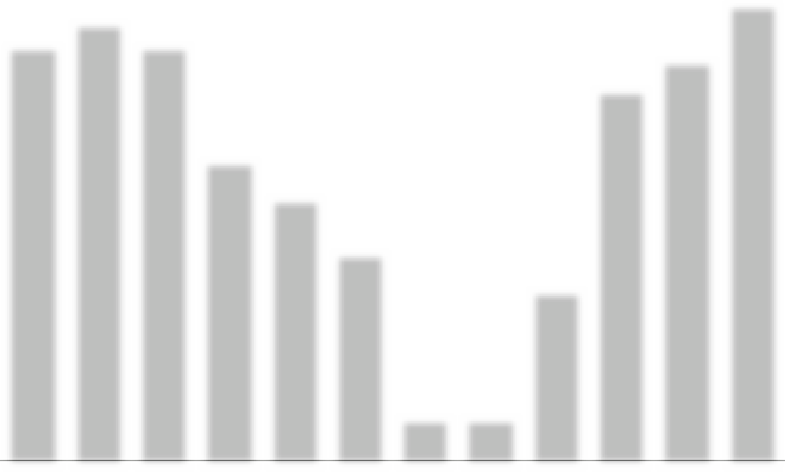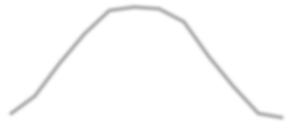
1,450
1,530
1,600
1,450
1 2081 240 1 224
1 104
1,400
1,300
992
1,050
720
920
784
730
416
600
504
248
256
216
150 150
Jan Feb Mar April May June July Aug Sept Oct Nov Dec SPP generation, kW/h Electricity consumption, kW/h

 | SPP generation, kW/h | Consumption object, kW/h | Purchase from the network, kWh
January | 248 | 1450 | 1 202
February | 416 | 1530 | 1 114
March | 720 | 1450 | 730
April | 992 | 1050 | 58
May | 1 208 | 920 | -
June | 1,240 | 730 | -
July | 1 224 | 150 | -
August | 1 104 | 150 | -
September | 784 | 600 | -
October | 504 | 1300 | 796
November | 256 | 1400 | 1 144
December | 216 | 1600 | 1 384
TOTAL: | 8,912 | 12330 | 6428

PROJECTED PERFORMANCE INDICATORS OF THE PROJECT
CAPEX (SPP cost) | 239,058.13 | UAH
Power of SPP | 8 | kW
The rate of $ in calculations | 36.65 | UAH
Generation SPP by 1 year | 8,912 | kW/h
Consumption electricity an object | 12,330 | kW/h
Online purchase | 6,428 | kW/h
Coverage of consumption by own SPP | 5,902 | kW/h
The projected amount of electricity that will not be used from its own SPP | 3,010 | kW/h
Estimated price for 1 kWh from the grid | 6 | UAH
Costs for purchasing electricity from the grid after installation of the SPP | 38,568 | UAH
Costs on service by 1 year | 5,000 | UAH
The cost of projected energy consumption from own SPP | 35,412 | UAH
Cost consumption electricity without installed SPP | 73,980 | UAH
Savings of funds after the installation of SPP in the year before full payback | 30,412 | UAH
Payback of the project | 7.9 | years
The cost of generated electricity after payback | 0.56 | UAH per kWh

SPP 8 KW.

No. 5 Location of SPP: Biloghirya territorial community of Khmelnytskyi region
Sosnivka Gymnasium
Description: Rooftop SPP
Power of the solar field: 8 kW
Inverter power: 6 kW

CALCULATION
CAPEX
Name | Description | K-  St | Costunits | Price
1. Solar panel | Risen 550W | 15 | 7,586.55 ₴ | 110,349.82 ₴
2. Electricity inverter | Solis S5-GR3P6K | 1 | 45,812.50 ₴ | 45,812.50 ₴
3. The controller for the export of electricity to the network | Solis EPM3-5G  plus | 1 | 23,199.45 ₴ | 23,199.45 ₴
4. Assembly structure
Type of metal construction | aluminum | 1 | 7,996.36 ₴ | 7,996.36 ₴
5. Electrical products
cable | AVVG4X16 | 10 | 600.00 ₴ | 600.00 ₴
cable for solar panels | KBE | 80 | 40.00 ₴ | 3,200.00 ₴
automatics protection DC | ETI fuSPP,  shield ETI | 1 | 3,000.00 ₴ | 3,000.00 ₴
automatics protection AC | shield ETI, automatichull Hager,Shnider SSRIs | 1 | 3,000.00 ₴ | 3,000.00 ₴
switching facilities | MC4 connectors, tips, copper wire, grounding  bus | 1 | 2,000.00 ₴ | 2,000.00 ₴
6. Consumables |  | 1 | 2,500.00 ₴ | 2,500.00 ₴
7. Transportation |  | 1 | 3,000.00 ₴ | 3,000.00 ₴
8. Assembly works |  | 1 | 22,400.00 ₴ | 22,400.00 ₴
9. Design and estimate documentation |  | 1 | 12,000.00 ₴ | 12,000.00 ₴
CAPEX |  |  | Total: | 239,058.13 ₴

SPP 8 KW.

INDICATORS GENERATIONS AND CONSUMPTION
SPP 8 KW.

1,650
1,500
1,350
1,200
1,050
900
750
600
450
300
150
0
SCHEDULE OF SPP GENERATION AND ELECTRICITY CONSUMPTION BY THE FACILITY

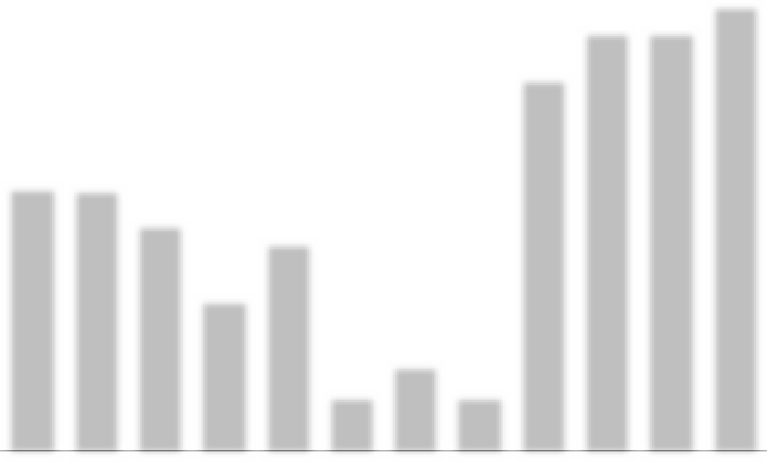
1,600
1,500 1,500
1 2081 240 1 224
1 335
1 104
992
950 943
782106
784
747
416
504
544
248
312
256
216
200
200
Jan Feb Mar April May June July Aug Sept Oct Nov Dec SPP generation, kW/h Electricity consumption, kW/h

 | SPP generation, kW/h | Consumption object, kW/h | Purchase from the network, kWh
January | 248 | 950 | 702
February | 416 | 943 | 527
March | 720 | 816 | 96
April | 992 | 544 | -
May | 1 208 | 747 | -
June | 1,240 | 200 | -
July | 1 224 | 312 | -
August | 1 104 | 200 | -
September | 784 | 1335 | 551
October | 504 | 1500 | 996
November | 256 | 1500 | 1 244
December | 216 | 1600 | 1 384
TOTAL: | 8,912 | 10647 | 5500

PROJECTED PERFORMANCE INDICATORS OF THE PROJECT
CAPEX (SPP cost) | 239,058.13 | UAH
Power of SPP | 8 | kW
The rate of $ in calculations | 36.65 | UAH
Generation SPP by 1 year | 8,912 | kW/h
Consumption electricity an object | 10,647 | kW/h
Online purchase | 5,500 | kW/h
Coverage of consumption by own SPP | 5 147 | kW/h
The projected amount of electricity that will not be used from its own SPP | 3,765 | kW/h
Estimated price for 1 kWh from the grid | 6 | UAH
Costs for purchasing electricity from the grid after installation of the SPP | 33,000 | UAH
Costs on service by 1 year | 5,000 | UAH
The cost of projected energy consumption from own SPP | 30,882 | UAH
Cost consumption electricity without installed SPP | 63,882 | UAH
Savings of funds after the installation of SPP in the year before full payback | 25,882 | UAH
Payback of the project | 9.2 | years
The cost of generated electricity after payback | 0.56 | UAH per kWh

SPP 8 KW.

No. 6 Location of SPP: Biloghirya territorial community of Khmelnytskyi region
Biloghirya support institution of the general secondary education named after I.O. Weaver
Description: Rooftop SPP
Power of the solar field: 12 kW
Inverter power: 10 kW

CALCULATION
CAPEX
Name | Description | K-  St | Costunits | Price
1. Solar panel | Risen 550W | 22 | 7,586.55 ₴ | 165,524.73 ₴
2. Electricity inverter | Solis S5-GR3P10K | 1 | 53,142.50 ₴ | 53,142.50 ₴
3. The controller for the export of electricity to the network | Solis EPM3-5G  plus | 1 | 23,199.45 ₴ | 23,199.45 ₴
4. Assembly structure
Type of metal construction | aluminum | 1 | 11,994.55 ₴ | 11,994.55 ₴
5. Electrical products
cable | AVVG4X16 | 10 | 600.00 ₴ | 600.00 ₴
cable for solar panels | KBE | 100 | 40.00 ₴ | 4,000.00 ₴
automatics protection DC | ETI fuSPP,  shield ETI | 1 | 3,500.00 ₴ | 3,500.00 ₴
automatics protection AC | shield ETI, automatichull Hager,Shnider SSRIs | 1 | 3,600.00 ₴ | 3,600.00 ₴
switching facilities | MC4 connectors, tips, copper wire, grounding  bus | 1 | 2,300.00 ₴ | 2,300.00 ₴
6. Consumables |  | 1 | 2,800.00 ₴ | 2,800.00 ₴
7. Transportation |  | 1 | 4,500.00 ₴ | 4,500.00 ₴
8. Assembly works |  | 1 | 33,600.00 ₴ | 33,600.00 ₴
9. Design and estimate documentation |  | 1 | 12,000.00 ₴ | 12,000.00 ₴
CAPEX |  |  | Total: | 320,761.22 ₴

SPP 12 KW.

INDICATORS GENERATIONS AND CONSUMPTION
SPP 12 KW.

5,800

5,220

4,640

4,060

3 480

2,900

2,320

1 740

1 160

580

0
SCHEDULE OF SPP GENERATION AND ELECTRICITY CONSUMPTION BY THE FACILITY

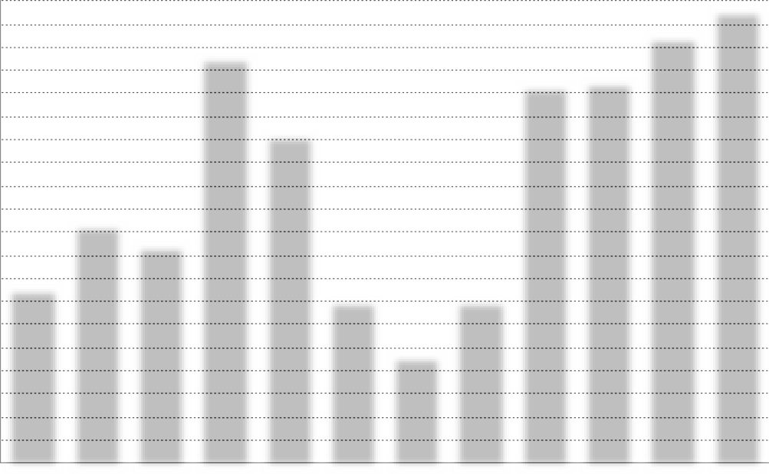
5,700
5 104
5,350
4,7504,800
4 114
2,986
2,729
2 211
1 488
1,812 1,860 1,836 1,656
2,050
2 043
1,080
1,350
1 176
372
624
756
384
324
Jan Feb Mar April May June July Aug Sept Oct Nov Dec SPP generation, kW/h Electricity consumption, kW/h

 | SPP generation, kW/h | Consumption object, kW/h | Purchase from the network, kWh
January | 372 | 2 211 | 1 839
February | 624 | 2,986 | 2 362
March | 1,080 | 2,729 | 1 649
April | 1 488 | 5 104 | 3,616
May | 1 812 | 4 114 | 2 302
June | 1 860 | 2,050 | 190
July | 1 836 | 1,350 | -
August | 1 656 | 2 043 | 387
September | 1 176 | 4,750 | 3,574
October | 756 | 4,800 | 4,044
November | 384 | 5,350 | 4,966
December | 324 | 5,700 | 5,376
TOTAL: | 13,368 | 43 187 | 30,305

PROJECTED PERFORMANCE INDICATORS OF THE PROJECT
CAPEX (SPP cost) | 320,761.22 | UAH
Power of SPP | 12 | kW
The rate of $ in calculations | 36.65 | UAH
Generation SPP by 1 year | 13,368 | kW/h
Consumption electricity an object | 43 187 | kW/h
Online purchase | 30,305 | kW/h
Coverage of consumption by own SPP | 12,882 | kW/h
The projected amount of electricity that will not be used from its own SPP | 486 | kW/h
Estimated price for 1 kWh from the grid | 6 | UAH
Costs for purchasing electricity from the grid after installation of the SPP | 181,830 | UAH
Costs on service by 1 year | 7,000 | UAH
The cost of projected energy consumption from own SPP | 77,292 | UAH
Cost consumption electricity without installed SPP | 259 122 | UAH
Savings of funds after the installation of SPP in the year before full payback | 70,292 | UAH
Payback of the project | 4.6 | years
The cost of generated electricity after payback | 0.52 | UAH per kWh

SPP 12 KW.

No7 Location of SPP: Medzhybizh territorial community
Trebuhivtsi secondary school of grades I-III
Description: Rooftop SPP
Power of the solar field: 8 kW
Inverter power: 6 kW

CALCULATION
Name | Description | K-  St | Costunits | Price
1. Solar panel | Risen 550W | 15 | 7,586.55 ₴ | 110,349.82 ₴
2. Electricity inverter | Solis S5-GR3P6K | 1 | 45,812.50 ₴ | 45,812.50 ₴
3. The controller for the export of electricity to the network | Solis EPM3-5G  plus | 1 | 23,199.45 ₴ | 23,199.45 ₴
4. Assembly structure
Type of metal construction | aluminum | 1 | 7,996.36 ₴ | 7,996.36 ₴
5. Electrical products
cable | AVVG4X16 | 10 | 600.00 ₴ | 600.00 ₴
cable for solar panels | KBE | 80 | 40.00 ₴ | 3,200.00 ₴
automatics protection DC | ETI fuSPP,  shield ETI | 1 | 3,000.00 ₴ | 3,000.00 ₴
automatics protection AC | shield ETI, automatichull Hager,Shnider SSRIs | 1 | 3,000.00 ₴ | 3,000.00 ₴
switching facilities | MC4 connectors, tips, copper wire, grounding  bus | 1 | 2,000.00 ₴ | 2,000.00 ₴
6. Consumables |  | 1 | 2,500.00 ₴ | 2,500.00 ₴
7. Transportation |  | 1 | 3,000.00 ₴ | 3,000.00 ₴
8. Assembly works |  | 1 | 22,400.00 ₴ | 22,400.00 ₴
9. Design and estimate documentation |  | 1 | 12,000.00 ₴ | 12,000.00 ₴
CAPEX |  |  | Total: | 239,058.13 ₴

CAPEX
SPP 8 KW.

INDICATORS GENERATIONS AND CONSUMPTION
SPP 8 KW.

3,800

3,420

3,040

2,660

2,280

1,900

1,520

1 140

760

380

0
SCHEDULE OF SPP GENERATION AND ELECTRICITY CONSUMPTION BY THE FACILITY

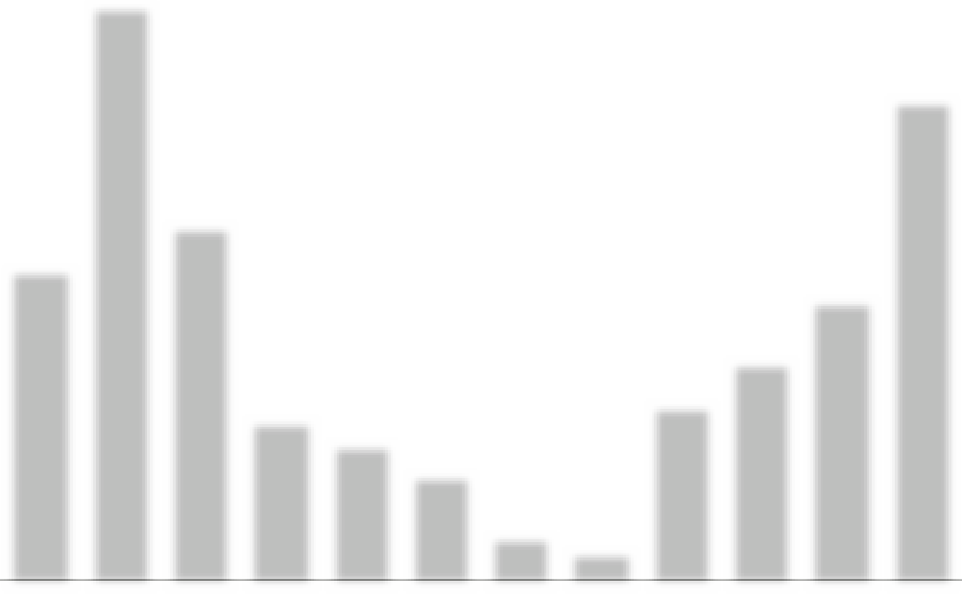
3,780
3 150
2 335
2,050
1 843
992
7201,050
1,208 1,240 1,224 1,104
900
700
300 200
1 447
1718640
504
248
416
256
216
Jan Feb Mar April May June July Aug Sept Oct Nov Dec SPP generation, kW/h Electricity consumption, kW/h

 | SPP generation, kW/h | Consumption object, kW/h | Purchase from the network, kWh
January | 248 | 2,050 | 1 802
February | 416 | 3,780 | 3 364
March | 720 | 2 335 | 1,615
April | 992 | 1,050 | 58
May | 1 208 | 900 | -
June | 1,240 | 700 | -
July | 1 224 | 300 | -
August | 1 104 | 200 | -
September | 784 | 1 160 | 376
October | 504 | 1 447 | 943
November | 256 | 1 843 | 1 587
December | 216 | 3 150 | 2,934
TOTAL: | 8,912 | 18,915 | 12,679

PROJECTED PERFORMANCE INDICATORS OF THE PROJECT
CAPEX (SPP cost) | 239,058.13 | UAH
Power of SPP | 8 | kW
The rate of $ in calculations | 36.65 | UAH
Generation SPP by 1 year | 8,912 | kW/h
Consumption electricity an object | 18,915 | kW/h
Online purchase | 12,679 | kW/h
Coverage of consumption by own SPP | 6,236 | kW/h
The projected amount of electricity that will not be used from its own SPP | 2,676 | kW/h
Estimated price for 1 kWh from the grid | 6 | UAH
Costs for purchasing electricity from the grid after installation of the SPP | 76,074 | UAH
Costs on service by 1 year | 5,000 | UAH
The cost of projected energy consumption from own SPP | 37,416 | UAH
Cost consumption electricity without installed SPP | 113,490 | UAH
Savings of funds after the installation of SPP in the year before full payback | 32,416 | UAH
Payback of the project | 7.4 | years
The cost of generated electricity after payback | 0.56 | UAH per kWh

SPP 8 KW.

No. 8 Location of SPP: Stara Ushytsia territorial community
Stara Ushytsia Local Government Building
Description: Rooftop SPP
Power of the solar field:15 kW
Inverter power:12 kW

CALCULATION
Name | Description | K-  St | Costunits | Price
1. Solar panel | Risen 550W | 27 | 8,282.90 ₴ | 223,638.30 ₴
2. Electricity inverter | Solis S5-GR3P12K | 1 | 54,975.00 ₴ | 54,975.00 ₴
3. The controller for the export of electricity to the network | Solis EPM3-5G  plus | 1 | 23,199.45 ₴ | 23,199.45 ₴
4. Assembly structure
Type of metal construction | aluminum | 1 | 14,843.25 ₴ | 14,843.25 ₴
5. Electrical products
cable | AVVG4X16 | 10 | 600.00 ₴ | 600.00 ₴
cable for solar panels | KBE | 120 | 40.00 ₴ | 4,800.00 ₴
automatics protection DC | ETI fuSPP,  shield ETI | 1 | 3,800.00 ₴ | 3,800.00 ₴
automatics protection AC | shield ETI, automatichull Hager,Shnider SSRIs | 1 | 4,000.00 ₴ | 4,000.00 ₴
switching facilities | MC4 connectors, tips, copper wire, grounding  bus | 1 | 2,500.00 ₴ | 2,500.00 ₴
6. Consumables |  | 1 | 3,000.00 ₴ | 3,000.00 ₴
7. Transportation |  | 1 | 5,000.00 ₴ | 5,000.00 ₴
8. Assembly works |  | 1 | 42,000.00 ₴ | 42,000.00 ₴
9. Design and estimate documentation |  | 1 | 12,000.00 ₴ | 12,000.00 ₴
CAPEX |  |  | Total: | 394,356.00 ₴

CAPEX
SPP 15 KW.

INDICATORS GENERATIONS AND CONSUMPTION
SPP 15 KW.

10,000

9,000

8,000

7,000

6,000

5,000

4,000

3,000

2,000

1,000

0
SCHEDULE OF SPP GENERATION AND ELECTRICITY CONSUMPTION BY THE FACILITY

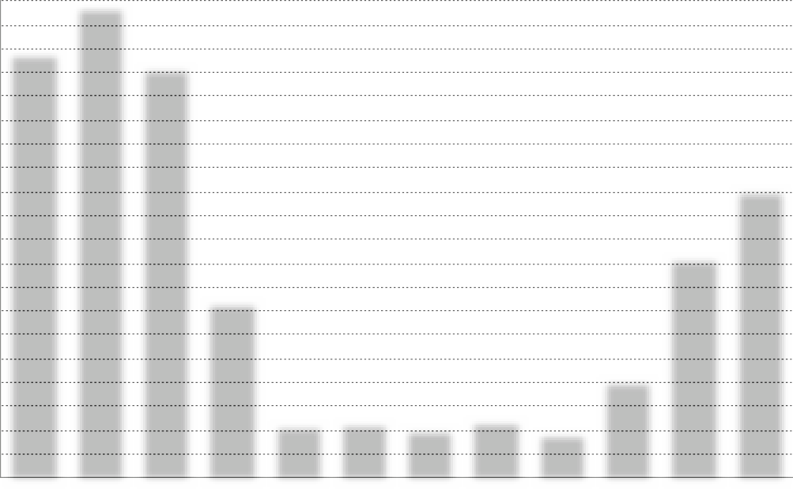Jan Feb Mar April May June July Aug Sept Oct Nov Dec SPP generation, kW/h Electricity consumption, kW/h
9,885
8,921
8,614
6,040
4,626
1 313
3,697
1 8282,212 2,274 2,236 1,928
1 391 2 060
453
761
1 141 1 183
1,050
1 231
913
956
434
340

 | SPP generation, kW/h | Consumption object, kW/h | Purchase from the network, kWh
January | 453 | 8,921 | 8 468
February | 761 | 9,885 | 9 124
March | 1 313 | 8,614 | 7 301
April | 1 828 | 3,697 | 1 869
May | 2,212 | 1 141 | -
June | 2,274 | 1 183 | -
July | 2 236 | 1,050 | -
August | 1 928 | 1 231 | -
September | 1 391 | 956 | -
October | 913 | 2,060 | 1 147
November | 434 | 4,626 | 4 192
December | 340 | 6,040 | 5,700
TOTAL: | 16,083 | 49 404 | 37,801

PROJECTED PERFORMANCE INDICATORS OF THE PROJECT
CAPEX (SPP cost) | 394,356.00 | UAH
Power of SPP | 15 | kW
The rate of $ in calculations | 36.65 | UAH
Generation SPP by 1 year | 16,083 | kW/h
Consumption electricity an object | 49 404 | kW/h
Online purchase | 37,801 | kW/h
Coverage of consumption by own SPP | 11,603 | kW/h
The projected amount of electricity that will not be used from its own SPP | 4,480 | kW/h
Estimated price for 1 kWh from the grid | 6 | UAH
Costs for purchasing electricity from the grid after installation of the SPP | 226,806 | UAH
Costs on service by 1 year | 8,000 | UAH
The cost of projected energy consumption from own SPP | 69,618 | UAH
Cost consumption electricity without installed SPP | 296 424 | UAH
Savings of funds after the installation of SPP in the year before full payback | 61,618 | UAH
Payback of the project | 6.4 | years
The cost of generated electricity after payback | 0.50 | UAH per kWh

SPP 15 KW.

No. 9 Location of SPP: Stara Ushytsia territorial community
Stara Ushytsia Lyceum
Description: Rooftop SPP
Power of the solar field:8 kW
Inverter power:6 kW

CALCULATION
Name | Description | K-  St | Costunits | Price
1. Solar panel | Risen 550W | 15 | 7,586.55 ₴ | 110,349.82 ₴
2. Electricity inverter | Solis S5-GR3P6K | 1 | 45,812.50 ₴ | 45,812.50 ₴
3. The controller for the export of electricity to the network | Solis EPM3-5G  plus | 1 | 23,199.45 ₴ | 23,199.45 ₴
4. Assembly structure
Type of metal construction | aluminum | 1 | 7,996.36 ₴ | 7,996.36 ₴
5. Electrical products
cable | AVVG4X16 | 10 | 600.00 ₴ | 600.00 ₴
cable for solar panels | KBE | 80 | 40.00 ₴ | 3,200.00 ₴
automatics protection DC | ETI fuSPP,  shield ETI | 1 | 3,000.00 ₴ | 3,000.00 ₴
automatics protection AC | shield ETI, automatichull Hager,Shnider SSRIs | 1 | 3,000.00 ₴ | 3,000.00 ₴
switching facilities | MC4 connectors, tips, copper wire, grounding  bus | 1 | 2,000.00 ₴ | 2,000.00 ₴
6. Consumables |  | 1 | 2,500.00 ₴ | 2,500.00 ₴
7. Transportation |  | 1 | 3,000.00 ₴ | 3,000.00 ₴
8. Assembly works |  | 1 | 22,400.00 ₴ | 22,400.00 ₴
9. Design and estimate documentation |  | 1 | 12,000.00 ₴ | 12,000.00 ₴
CAPEX |  |  | Total: | 239,058.13 ₴

CAPEX
SPP 8 KW.

INDICATORS GENERATIONS AND CONSUMPTION
SPP 8 KW.

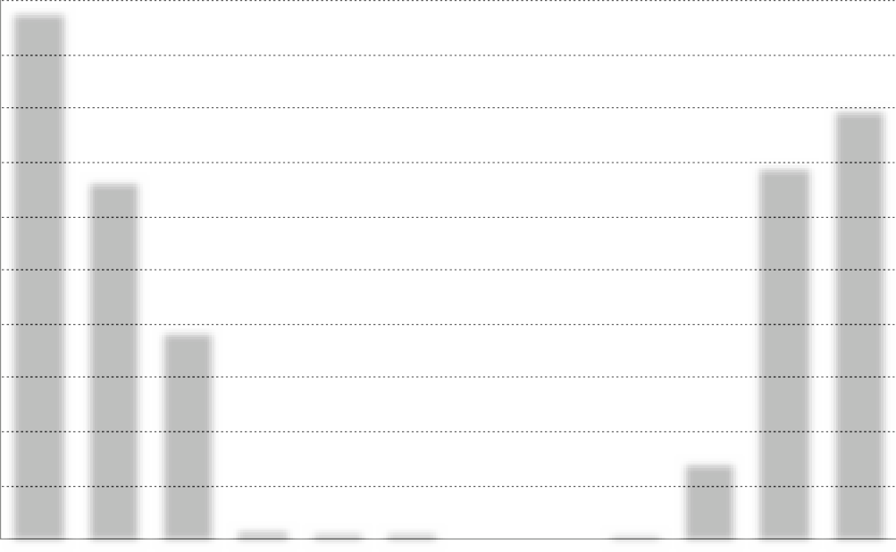60,000
59,220
48,222
40 163
41,847
23,650
248
January
416
February
9,001
720 1939629 1 230386 1 124403 1 820241 41404 788441 504
256 216
Mar April May June July Aug Sept Oct Nov Dec

54,000

48,000

42,000

36,000

30,000

24,000

18,000

12,000

6,000

0
SCHEDULE OF SPP GENERATION AND ELECTRICITY CONSUMPTION BY THE FACILITY

SPP generation, kW/h Electricity consumption, kW/h

 | SPP generation, kW/h | Consumption object, kW/h | Purchase from the network, kWh
January | 248 | 59,220 | 58,972
February | 416 | 40 163 | 39,747
March | 720 | 23,650 | 22,930
April | 992 | 1 369 | 377
May | 1 208 | 1 336 | 128
June | 1,240 | 1 133 | -
July | 1 224 | 80 | -
August | 1 104 | 44 | -
September | 784 | 841 | 57
October | 504 | 9,001 | 8,497
November | 256 | 41,847 | 41,591
December | 216 | 48,438 | 48,222
TOTAL: | 8,912 | 227 122 | 220,521

PROJECTED PERFORMANCE INDICATORS OF THE PROJECT
CAPEX (SPP cost) | 239,058.13 | UAH
Power of SPP | 8 | kW
The rate of $ in calculations | 36.65 | UAH
Generation SPP by 1 year | 8,912 | kW/h
Consumption electricity an object | 227 122 | kW/h
Online purchase | 220,521 | kW/h
Coverage of consumption by own SPP | 6,601 | kW/h
The projected amount of electricity that will not be used from its own SPP | 2 311 | kW/h
Estimated price for 1 kWh from the grid | 6 | UAH
Costs for purchasing electricity from the grid after installation of the SPP | 1,323,126 | UAH
Costs on service by 1 year | 5,000 | UAH
The cost of projected energy consumption from own SPP | 39,606 | UAH
Cost consumption electricity without installed SPP | 1,362,732 | UAH
Savings of funds after the installation of SPP in the year before full payback | 34,606 | UAH
Payback of the project | 6.9 | years
The cost of generated electricity after payback | 0.56 | UAH per kWh

SPP 8 KW.

No10
Location of SPP: Berezdiv territorial community
Berezdiv Lyceum
Description: Rooftop SPP
Power of the solar field: 15 kW
Inverter power: 12 kW

CALCULATION
Name | Description | K-  St | Costunits | Price
1. Solar panel | Risen 550W | 27 | 8,282.90 ₴ | 223,638.30 ₴
2. Electricity inverter | Solis S5-GR3P12K | 1 | 54,975.00 ₴ | 54,975.00 ₴
3. The controller for the export of electricity to the network | Solis EPM3-5G  plus | 1 | 23,199.45 ₴ | 23,199.45 ₴
4. Assembly structure
Type of metal construction | aluminum | 1 | 14,843.25 ₴ | 14,843.25 ₴
5. Electrical products
cable | AVVG4X16 | 10 | 600.00 ₴ | 600.00 ₴
cable for solar panels | KBE | 120 | 40.00 ₴ | 4,800.00 ₴
automatics protection DC | ETI fuSPP,  shield ETI | 1 | 3,800.00 ₴ | 3,800.00 ₴
automatics protection AC | shield ETI, automatichull Hager,Shnider SSRIs | 1 | 4,000.00 ₴ | 4,000.00 ₴
switching facilities | MC4 connectors, tips, copper wire, grounding  bus | 1 | 2,500.00 ₴ | 2,500.00 ₴
6. Consumables |  | 1 | 3,000.00 ₴ | 3,000.00 ₴
7. Transportation |  | 1 | 5,000.00 ₴ | 5,000.00 ₴
8. Assembly works |  | 1 | 42,000.00 ₴ | 42,000.00 ₴
9. Design and estimate documentation |  | 1 | 12,000.00 ₴ | 12,000.00 ₴
CAPEX |  |  | Total: | 394,356.00 ₴

CAPEX
SPP 15 KW.

INDICATORS GENERATIONS AND CONSUMPTION
SPP 15 KW.

8,200

7,380

6,560

5,740

4,920

4 100

3,280

2,460

1,640

820

0
SCHEDULE OF SPP GENERATION AND ELECTRICITY CONSUMPTION BY THE FACILITY

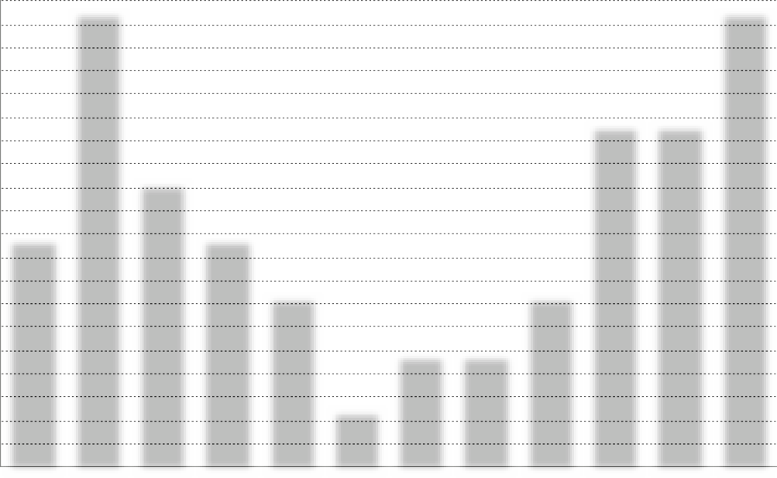
1 828
2,212 2,274 2,236 1,928
1 313
1 391
913
453 761
434
340
4,000 8000 5000 4000 3000 1000 2000 2000 3000 6000 6000 8000
Jan Feb Mar April May June July Aug Sept Oct Nov Dec SPP generation, kW/h Electricity consumption, kW/h

 | SPP generation, kW/h | Consumption object, kW/h | Purchase from the network, kWh
January | 453 | 4,000 | 3 547
February | 761 | 8,000 | 7,239
March | 1 313 | 5,000 | 3,687
April | 1 828 | 4,000 | 2 172
May | 2,212 | 3,000 | 788
June | 2,274 | 1,000 | -
July | 2 236 | 2,000 | -
August | 1 928 | 2,000 | 72
September | 1 391 | 3,000 | 1 609
October | 913 | 6,000 | 5,087
November | 434 | 6,000 | 5,566
December | 340 | 8,000 | 7,660
TOTAL: | 16,083 | 52,000 | 37,427

PROJECTED PERFORMANCE INDICATORS OF THE PROJECT
CAPEX (SPP cost) | 394,356.00 | UAH
Power of SPP | 15 | kW
The rate of $ in calculations | 36.65 | UAH
Generation SPP by 1 year | 16,083 | kW/h
Consumption electricity an object | 52,000 | kW/h
Online purchase | 37,427 | kW/h
Coverage of consumption by own SPP | 14,573 | kW/h
The projected amount of electricity that will not be used from its own SPP | 1,510 | kW/h
Estimated price for 1 kWh from the grid | 6 | UAH
Costs for purchasing electricity from the grid after installation of the SPP | 224,562 | UAH
Costs on service by 1 year | 8,000 | UAH
The cost of projected energy consumption from own SPP | 87 438 | UAH
Cost consumption electricity without installed SPP | 312,000 | UAH
Savings of funds after the installation of SPP in the year before full payback | 79,438 | UAH
Payback of the project | 5.0 | years
The cost of generated electricity after payback | 0.50 | UAH per kWh

SPP 15 KW.

No11
Location of SPP: Berezdiv territorial community
Malopravutyn Lyceum
Description: Rooftop SPP
Power of the solar field: 8 kW
Inverter power: 6 kW

CALCULATION
Name | Description | K-  St | Costunits | Price
1. Solar panel | Risen 550W | 15 | 7,586.55 ₴ | 110,349.82 ₴
2. Electricity inverter | Solis S5-GR3P6K | 1 | 45,812.50 ₴ | 45,812.50 ₴
3. The controller for the export of electricity to the network | Solis EPM3-5G  plus | 1 | 23,199.45 ₴ | 23,199.45 ₴
4. Assembly structure
Type of metal construction | aluminum | 1 | 7,996.36 ₴ | 7,996.36 ₴
5. Electrical products
cable | AVVG4X16 | 10 | 600.00 ₴ | 600.00 ₴
cable for solar panels | KBE | 80 | 40.00 ₴ | 3,200.00 ₴
automatics protection DC | ETI fuSPP,  shield ETI | 1 | 3,000.00 ₴ | 3,000.00 ₴
automatics protection AC | shield ETI, automatichull Hager,Shnider SSRIs | 1 | 3,000.00 ₴ | 3,000.00 ₴
switching facilities | MC4 connectors, tips, copper wire, grounding  bus | 1 | 2,000.00 ₴ | 2,000.00 ₴
6. Consumables |  | 1 | 2,500.00 ₴ | 2,500.00 ₴
7. Transportation |  | 1 | 3,000.00 ₴ | 3,000.00 ₴
8. Assembly works |  | 1 | 22,400.00 ₴ | 22,400.00 ₴
9. Design and estimate documentation |  | 1 | 12,000.00 ₴ | 12,000.00 ₴
CAPEX |  |  | Total: | 239,058.13 ₴

CAPEX
SPP 8 KW.

INDICATORS GENERATIONS AND CONSUMPTION
SPP 8 KW.

3,200

2,880

2,560

2,240

1 920

1,600

1,280

960

640

320

0
SCHEDULE OF SPP GENERATION AND ELECTRICITY CONSUMPTION BY THE FACILITY

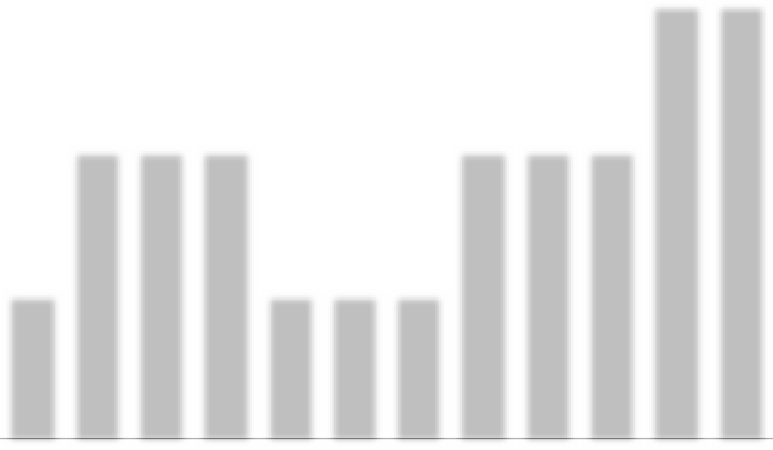
1 2081 240 1 224
992
1 104
720
784
416 504
248 256
216
1,000 2,000 2,000 2,000 1,000 1,000 1,000 2,000 2,000 2,000 3,000 3,000
Jan Feb Mar April May June July Aug Sept Oct Nov Dec SPP generation, kW/h Electricity consumption, kW/h

 | SPP generation, kW/h | Consumption object, kW/h | Purchase from the network, kWh
January | 248 | 1,000 | 752
February | 416 | 2,000 | 1,584
March | 720 | 2,000 | 1,280
April | 992 | 2,000 | 1 008
May | 1 208 | 1,000 | -
June | 1,240 | 1,000 | -
July | 1 224 | 1,000 | -
August | 1 104 | 2,000 | 896
September | 784 | 2,000 | 1 216
October | 504 | 2,000 | 1 496
November | 256 | 3,000 | 2,744
December | 216 | 3,000 | 2,784
TOTAL: | 8,912 | 22,000 | 13,760

PROJECTED PERFORMANCE INDICATORS OF THE PROJECT
CAPEX (SPP cost) | 239,058.13 | UAH
Power of SPP | 8 | kW
The rate of $ in calculations | 36.65 | UAH
Generation SPP by 1 year | 8,912 | kW/h
Consumption electricity an object | 22,000 | kW/h
Online purchase | 13,760 | kW/h
Coverage of consumption by own SPP | 8,240 | kW/h
The projected amount of electricity that will not be used from its own SPP | 672 | kW/h
Estimated price for 1 kWh from the grid | 6 | UAH
Costs for purchasing electricity from the grid after installation of the SPP | 82,560 | UAH
Costs on service by 1 year | 5,000 | UAH
The cost of projected energy consumption from own SPP | 49,440 | UAH
Cost consumption electricity without installed SPP | 132,000 | UAH
Savings of funds after the installation of SPP in the year before full payback | 44,440 | UAH
Payback of the project | 5.4 | years
The cost of generated electricity after payback | 0.56 | UAH per kWh

SPP 8 KW.

No12
Location of SPP: Berezdiv territorial community
Berezdiv AZPSM
Description: Rooftop SPP
Power of the solar field: 8 kW
Inverter power: 6 kW

CALCULATION
Name | Description | K-  St | Costunits | Price
1. Solar panel | Risen 550W | 15 | 7,586.55 ₴ | 110,349.82 ₴
2. Electricity inverter | Solis S5-GR3P6K | 1 | 45,812.50 ₴ | 45,812.50 ₴
3. The controller for the export of electricity to the network | Solis EPM3-5G  plus | 1 | 23,199.45 ₴ | 23,199.45 ₴
4. Assembly structure
Type of metal construction | aluminum | 1 | 7,996.36 ₴ | 7,996.36 ₴
5. Electrical products
cable | AVVG4X16 | 10 | 600.00 ₴ | 600.00 ₴
cable for solar panels | KBE | 80 | 40.00 ₴ | 3,200.00 ₴
automatics protection DC | ETI fuSPP,  shield ETI | 1 | 3,000.00 ₴ | 3,000.00 ₴
automatics protection AC | shield ETI, automatichull Hager,Shnider SSRIs | 1 | 3,000.00 ₴ | 3,000.00 ₴
switching facilities | MC4 connectors, tips, copper wire, grounding  bus | 1 | 2,000.00 ₴ | 2,000.00 ₴
6. Consumables |  | 1 | 2,500.00 ₴ | 2,500.00 ₴
7. Transportation |  | 1 | 3,000.00 ₴ | 3,000.00 ₴
8. Assembly works |  | 1 | 22,400.00 ₴ | 22,400.00 ₴
9. Design and estimate documentation |  | 1 | 12,000.00 ₴ | 12,000.00 ₴
CAPEX |  |  | Total: | 239,058.13 ₴

CAPEX
SPP 8 KW.

INDICATORS GENERATIONS AND CONSUMPTION
SPP 8 KW.

2,600

2,275

1 950
SCHEDULE OF SPP GENERATION AND ELECTRICITY CONSUMPTION BY THE FACILITY

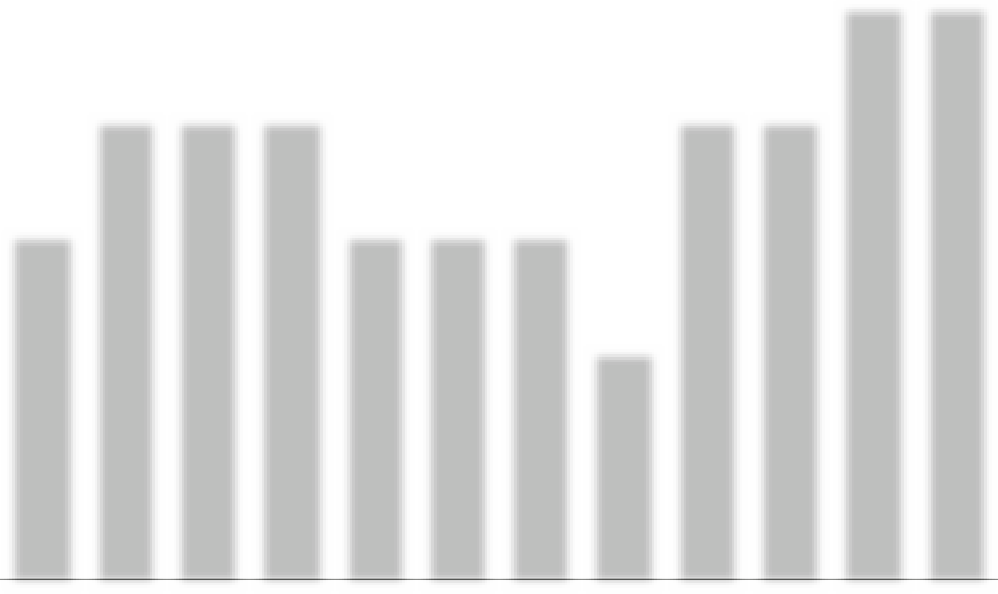1,625
1 2081 240 1 224
992
1 104
720
784
416
504
248
256
216
1,500 2000 2000 2000 1500 1500 1500 1000 2000 2000 2500 2500

1,300

975

650

325

0

Jan Feb Mar April May June July Aug Sept Oct Nov Dec SPP generation, kW/h Electricity consumption, kW/h

 | SPP generation, kW/h | Consumption object, kW/h | Purchase from the network, kWh
January | 248 | 1,500 | 1 252
February | 416 | 2,000 | 1,584
March | 720 | 2,000 | 1,280
April | 992 | 2,000 | 1 008
May | 1 208 | 1,500 | 292
June | 1,240 | 1,500 | 260
July | 1 224 | 1,500 | 276
August | 1 104 | 1,000 | -
September | 784 | 2,000 | 1 216
October | 504 | 2,000 | 1 496
November | 256 | 2,500 | 2 244
December | 216 | 2,500 | 2,284
TOTAL: | 8,912 | 22,000 | 13 192

PROJECTED PERFORMANCE INDICATORS OF THE PROJECT
CAPEX (SPP cost) | 239,058.13 | UAH
Power of SPP | 8 | kW
The rate of $ in calculations | 36.65 | UAH
Generation SPP by 1 year | 8,912 | kW/h
Consumption electricity an object | 22,000 | kW/h
Online purchase | 13 192 | kW/h
Coverage of consumption by own SPP | 8,808 | kW/h
The projected amount of electricity that will not be used from its own SPP | 104 | kW/h
Estimated price for 1 kWh from the grid | 6 | UAH
Costs for purchasing electricity from the grid after installation of the SPP | 79 152 | UAH
Costs on service by 1 year | 5,000 | UAH
The cost of projected energy consumption from own SPP | 52,848 | UAH
Cost consumption electricity without installed SPP | 132,000 | UAH
Savings of funds after the installation of SPP in the year before full payback | 47,848 | UAH
Payback of the project | 5.0 | years
The cost of generated electricity after payback | 0.56 | UAH per kWh

SPP 8 KW.

No13
Location of SPP: Dunayevetsi territorial community
SE "Miskwodokanal"
Description: Rooftop SPP
Power of the solar field: 30 kW
Inverter power: 30 kW

CALCULATION
Name | Description | K-  St | Costunits | Price
1. Solar panel | Risen 550W | 55 | 8,466.15 ₴ | 461,790.00 ₴
2. Electricity inverter | SolisS5-GC30K | 1 | 76,965.00 ₴ | 76,965.00 ₴
3. The controller for the export of electricity to the network | Solis EPM3-5G  plus | 1 | 23,199.45 ₴ | 23,199.45 ₴
4. Assembly structure
Type of metal construction | aluminum | 1 | 39,981.82 ₴ | 39,981.82 ₴
5. Electrical products
cable | AVVG4X25 | 10 | 800.00 ₴ | 800.00 ₴
cable for solar panels | KBE | 200 | 40.00 ₴ | 8,000.00 ₴
automatics protection DC | ETI fuSPP,  shield ETI | 1 | 5,000.00 ₴ | 5,000.00 ₴
automatics protection AC | shield ETI, automatichull Hager,Shnider SSRIs | 1 | 5,500.00 ₴ | 5,500.00 ₴
switching facilities | MC4 connectors, tips, copper wire, grounding  bus | 1 | 3,500.00 ₴ | 3,500.00 ₴
6. Consumables |  | 1 | 4,000.00 ₴ | 4,000.00 ₴
7. Transportation |  | 1 | 10,000.00 ₴ | 10,000.00 ₴
8. Assembly works |  | 1 | 84,000.00 ₴ | 84,000.00 ₴
9. Design and estimate documentation |  | 1 | 12,000.00 ₴ | 12,000.00 ₴
CAPEX |  |  | Total: | 734,736.27 ₴

CAPEX
SPP 30 KW.

INDICATORS GENERATIONS AND CONSUMPTION
SPP 30 KW.

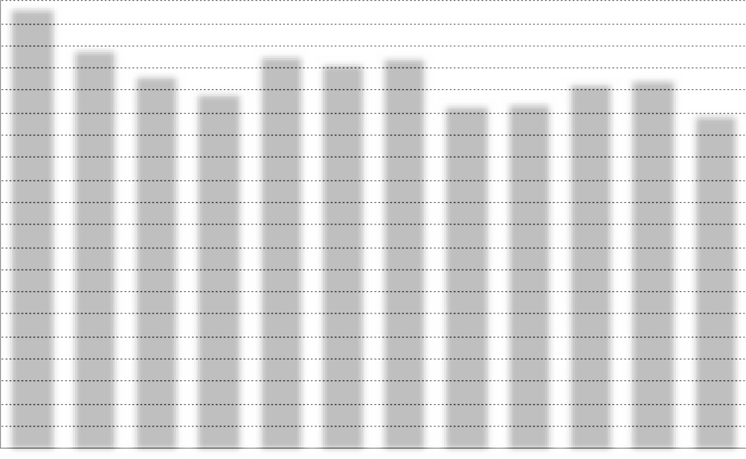82,000
81,300
73,717
68,804
72 439 71 10272 133
65,737
67,39068,243
63 463 63 630
61,681
930
January
1,560 2,700 3,7204,530 4,650 4,590 4,140 2,940 1,890
February
Mar
Ap
May
June
July
Aug
Sept Oct
960 810
Nov Dec

73,800

65,600

57,400

49,200

41,000

32,800

24,600

16,400

8,200

0
SCHEDULE OF SPP GENERATION AND ELECTRICITY CONSUMPTION BY THE FACILITY

SPP generation, kW/h Electricity consumption, kW/h

 | SPP generation, kW/h | Consumption object, kW/h | Purchase from the network, kWh
January | 930 | 81,300 | 80,370
February | 1,560 | 73,717 | 72 157
March | 2,700 | 68,804 | 66 104
April | 3,720 | 65,737 | 62,017
May | 4,530 | 72,439 | 67,909
June | 4,650 | 71 102 | 66,452
July | 4,590 | 72 133 | 67,543
August | 4 140 | 63 463 | 59,323
September | 2,940 | 63,630 | 60,690
October | 1 890 | 67,390 | 65,500
November | 960 | 68,243 | 67,283
December | 810 | 61,681 | 60,871
TOTAL: | 33,420 | 829,639 | 796 219

PROJECTED PERFORMANCE INDICATORS OF THE PROJECT
CAPEX (SPP cost) | 734,736.27 | UAH
Power of SPP | 30 | kW
The rate of $ in calculations | 36.65 | UAH
Generation SPP by 1 year | 33,420 | kW/h
Consumption electricity an object | 829,639 | kW/h
Online purchase | 796 219 | kW/h
Coverage of consumption by own SPP | 33,420 | kW/h
The projected amount of electricity that will not be used from its own SPP | 0 | kW/h
Estimated price for 1 kWh from the grid | 6 | UAH
Costs for purchasing electricity from the grid after installation of the SPP | 4,777,314 | UAH
Costs on service by 1 year | 17,000 | UAH
The cost of projected energy consumption from own SPP | 200,520 | UAH
Cost consumption electricity without installed SPP | 4,977,834 | UAH
Savings of funds after the installation of SPP in the year before full payback | 183,520 | UAH
Payback of the project | 4.0 | Years
The cost of generated electricity after payback | 0.51 | UAH per kWh

SPP 30 KW.

No14
Location of SPP : Zinkiv territorial community
Zinkiv Lyceum
Description: Rooftop SPP
Power of the solar field:12 kW
Inverter power:10 kW

CALCULATION
Name | Description | K-  St | Costunits | Price
1. Solar panel | Risen 550W | 22 | 8,282.90 ₴ | 180,717.82 ₴
2. Electricity inverter | Solis S5-GR3P10K | 1 | 53,142.50 ₴ | 53,142.50 ₴
3. The controller for the export of electricity to the network | Solis EPM3-5G  plus | 1 | 23,199.45 ₴ | 23,199.45 ₴
4. Assembly structure
Type of metal construction | aluminum | 1 | 11,994.55 ₴ | 11,994.55 ₴
5. Electrical products
cable | AVVG4X16 | 10 | 600.00 ₴ | 600.00 ₴
cable for solar panels | KBE | 100 | 40.00 ₴ | 4,000.00 ₴
automatics protection DC | ETI fuSPP,  shield ETI | 1 | 3,500.00 ₴ | 3,500.00 ₴
automatics protection AC | shield ETI, automatichull Hager,Shnider SSRIs | 1 | 3,600.00 ₴ | 3,600.00 ₴
switching facilities | MC4 connectors, tips, copper wire, grounding  bus | 1 | 2,300.00 ₴ | 2,300.00 ₴
6. Consumables |  | 1 | 2,800.00 ₴ | 2,800.00 ₴
7. Transportation |  | 1 | 4,500.00 ₴ | 4,500.00 ₴
8. Assembly works |  | 1 | 33,600.00 ₴ | 33,600.00 ₴
9. Design and estimate documentation |  | 1 | 12,000.00 ₴ | 12,000.00 ₴
CAPEX |  |  | Total: | 335,954.31 ₴

CAPEX
SPP 12 KW.

INDICATORS GENERATIONS AND CONSUMPTION
SPP 12 KW.

5,800

5,220

4,640

4,060

3 480

2,900

2,320

1 740

1 160

580

0
SCHEDULE OF SPP GENERATION AND ELECTRICITY CONSUMPTION BY THE FACILITY

5,700
5 104
5,350
4,7504,800
4 114
2,986
2,729
2 211
1 488
1,812 1,860 1,836 1,656
2,050
2 043
1,080
1,350
1 176
372
624
756
384
324
Jan Feb Mar April May June July Aug Sept Oct Nov Dec SPP generation, kW/h Electricity consumption, kW/h

 | SPP generation, kW/h | Consumption object, kW/h | Purchase from the network, kWh
January | 372 | 2,200 | 1 828
February | 624 | 6,200 | 5,576
March | 1,080 | 4,050 | 2,970
April | 1 488 | 1,300 | -
May | 1 812 | 3,080 | 1 268
June | 1 860 | 1,590 | -
July | 1 836 | 190 | -
August | 1 656 | 340 | -
September | 1 176 | 2,760 | 1,584
October | 756 | 2,460 | 1 704
November | 384 | 4,200 | 3,816
December | 324 | 5,530 | 5,206
TOTAL: | 13,368 | 33,900 | 23952

PROJECTED PERFORMANCE INDICATORS OF THE PROJECT
CAPEX (SPP cost) | 335,954.31 | UAH
Power of SPP | 12 | kW
The rate of $ in calculations | 36.65 | UAH
Generation SPP by 1 year | 13,368 | kW/h
Consumption electricity an object | 33,900 | kW/h
Online purchase | 23,952 | kW/h
Coverage of consumption by own SPP | 9,948 | kW/h
The projected amount of electricity that will not be used from its own SPP | 3,420 | kW/h
Estimated price for 1 kWh from the grid | 6 | UAH
Costs for purchasing electricity from the grid after installation of the SPP | 143,712 | UAH
Costs on service by 1 year | 7,000 | UAH
The cost of projected energy consumption from own SPP | 59,688 | UAH
Cost consumption electricity without installed SPP | 203,400 | UAH
Savings of funds after the installation of SPP in the year before full payback | 52,688 | UAH
Payback of the project | 6.4 | years
The cost of generated electricity after payback | 0.52 | UAH per kWh

SPP 12 KW.

No15
Location of SPP : Zinkiv territorial community
Zinkiv Center for the Provision of Administrative Services
Description: Rooftop SPP
Power of the solar field:12 kW
Inverter power:10 kW

CALCULATION
Name | Description | K-  St | Costunits | Price
1. Solar panel | Risen 550W | 22 | 8,282.90 ₴ | 180,717.82 ₴
2. Electricity inverter | Solis S5-GR3P10K | 1 | 53,142.50 ₴ | 53,142.50 ₴
3. The controller for the export of electricity to the network | Solis EPM3-5G  plus | 1 | 23,199.45 ₴ | 23,199.45 ₴
4. Assembly structure
Type of metal construction | aluminum | 1 | 11,994.55 ₴ | 11,994.55 ₴
5. Electrical products
cable | AVVG4X16 | 10 | 600.00 ₴ | 600.00 ₴
cable for solar panels | KBE | 100 | 40.00 ₴ | 4,000.00 ₴
automatics protection DC | ETI fuSPP,  shield ETI | 1 | 3,500.00 ₴ | 3,500.00 ₴
automatics protection AC | shield ETI, automatichull Hager,Shnider SSRIs | 1 | 3,600.00 ₴ | 3,600.00 ₴
switching facilities | MC4 connectors, tips, copper wire, grounding  bus | 1 | 2,300.00 ₴ | 2,300.00 ₴
6. Consumables |  | 1 | 2,800.00 ₴ | 2,800.00 ₴
7. Transportation |  | 1 | 4,500.00 ₴ | 4,500.00 ₴
8. Assembly works |  | 1 | 33,600.00 ₴ | 33,600.00 ₴
9. Design and estimate documentation |  | 1 | 12,000.00 ₴ | 12,000.00 ₴
CAPEX |  |  | Total: | 335,954.31 ₴

CAPEX
SPP 12 KW.

INDICATORS GENERATIONS AND CONSUMPTION
SPP 12 KW.

5,800

5,220

4,640

4,060

3 480

2,900

2,320

1 740

1 160

580

0
SCHEDULE OF SPP GENERATION AND ELECTRICITY CONSUMPTION BY THE FACILITY

5,700
5 104
5,350
4,7504,800
4 114
2,986
2,729
2 211
1 488
1,812 1,860 1,836 1,656
2,050
2 043
1,080
1,350
1 176
372
624
756
384
324
Jan Feb Mar April May June July Aug Sept Oct Nov Dec SPP generation, kW/h Electricity consumption, kW/h

 | SPP generation, kW/h | Consumption object, kW/h | Purchase from the network, kWh
January | 372 | 1 960 | 1,588
February | 624 | 2,266 | 1 642
March | 1,080 | 2,270 | 1 190
April | 1 488 | 2,000 | 512
May | 1 812 | 3 190 | 1 378
June | 1 860 | 716 | -
July | 1 836 | 395 | -
August | 1 656 | 384 | -
September | 1 176 | 690 | -
October | 756 | 726 | -
November | 384 | 1 022 | 638
December | 324 | 3 127 | 2,803
TOTAL: | 13,368 | 18,746 | 9,751

PROJECTED PERFORMANCE INDICATORS OF THE PROJECT
CAPEX (SPP cost) | 335,954.31 | UAH
Power of SPP | 12 | kW
The rate of $ in calculations | 36.65 | UAH
Generation SPP by 1 year | 13,368 | kW/h
Consumption electricity an object | 18,746 | kW/h
Online purchase | 9,751 | kW/h
Coverage of consumption by own SPP | 8,995 | kW/h
The projected amount of electricity that will not be used from its own SPP | 4,373 | kW/h
Estimated price for 1 kWh from the grid | 6 | UAH
Costs for purchasing electricity from the grid after installation of the SPP | 58,506 | UAH
Costs on service by 1 year | 7,000 | UAH
The cost of projected energy consumption from own SPP | 53,970 | UAH
Cost consumption electricity without installed SPP | 112,476 | UAH
Savings of funds after the installation of SPP in the year before full payback | 46,970 | UAH
Payback of the project | 7.2 | years
The cost of generated electricity after payback | 0.52 | UAH per kWh

SPP 12 KW.

No16
Location of SPP: Krupetsk territorial community
Krupetsk Lyceum
Description: Rooftop SPP
Power of the solar field:15 kW
Inverter power:12 kW

CALCULATION
Name | Description | K-  St | Costunits | Price
1. Solar panel | Risen 550W | 27 | 8,282.90 ₴ | 223,638.30 ₴
2. Electricity inverter | Solis S5-GR3P12K | 1 | 54,975.00 ₴ | 54,975.00 ₴
3. The controller for the export of electricity to the network | Solis EPM3-5G  plus | 1 | 23,199.45 ₴ | 23,199.45 ₴
4. Assembly structure
Type of metal construction | aluminum | 1 | 14,843.25 ₴ | 14,843.25 ₴
5. Electrical products
cable | AVVG4X16 | 10 | 600.00 ₴ | 600.00 ₴
cable for solar panels | KBE | 120 | 40.00 ₴ | 4,800.00 ₴
automatics protection DC | ETI fuSPP,  shield ETI | 1 | 3,800.00 ₴ | 3,800.00 ₴
automatics protection AC | shield ETI, automatichull Hager,Shnider SSRIs | 1 | 4,000.00 ₴ | 4,000.00 ₴
switching facilities | MC4 connectors, tips, copper wire, grounding  bus | 1 | 2,500.00 ₴ | 2,500.00 ₴
6. Consumables |  | 1 | 3,000.00 ₴ | 3,000.00 ₴
7. Transportation |  | 1 | 5,000.00 ₴ | 5,000.00 ₴
8. Assembly works |  | 1 | 42,000.00 ₴ | 42,000.00 ₴
9. Design and estimate documentation |  | 1 | 12,000.00 ₴ | 12,000.00 ₴
CAPEX |  |  | Total: | 394,356.00 ₴

CAPEX
SPP 15 KW.

INDICATORS GENERATIONS AND CONSUMPTION
SPP 15 KW.

6,800

6 120

5,440

4,760

4,080

3,400

2,720

2,040

1 360

680

0
SCHEDULE OF SPP GENERATION AND ELECTRICITY CONSUMPTION BY THE FACILITY

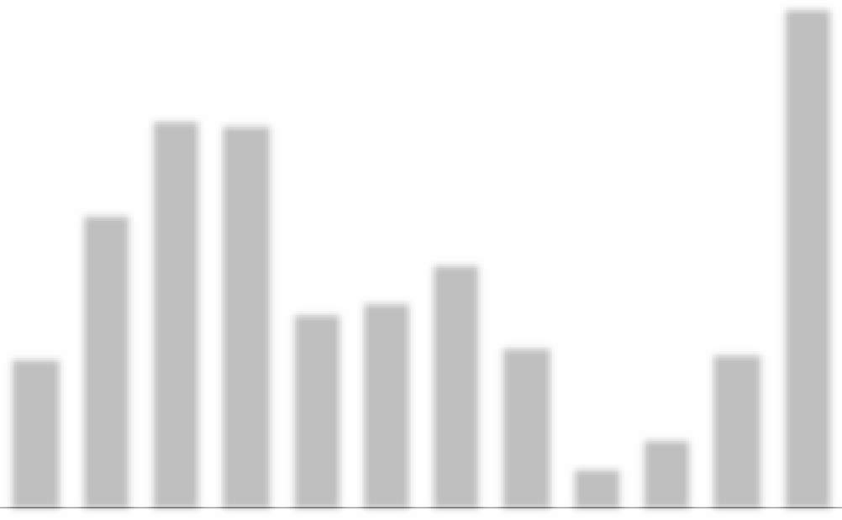
2,212 2,274 2,236
1 828
1 928
1 313
1 391
761
913
453 434
340
2,077 3986 5271 5197 2677 2824 3326 2230 596 976 2120 6762
Jan Feb Mar April May June July Aug Sept Oct Nov Dec SPP generation, kW/h Electricity consumption, kW/h

 | SPP generation, kW/h | Consumption object, kW/h | Purchase from the network, kWh
January | 453 | 2,077 | 1,624
February | 761 | 3,986 | 3,225
March | 1 313 | 5,271 | 3,958
April | 1 828 | 5 197 | 3,369
May | 2,212 | 2,677 | 465
June | 2,274 | 2,824 | 550
July | 2 236 | 3 326 | 1,090
August | 1 928 | 2,230 | 302
September | 1 391 | 596 | -
October | 913 | 976 | 63
November | 434 | 2 120 | 1 686
December | 340 | 6,762 | 6,422
TOTAL: | 16,083 | 38,042 | 22,754

PROJECTED PERFORMANCE INDICATORS OF THE PROJECT
CAPEX (SPP cost) | 394,356.00 | UAH
Power of SPP | 15 | kW
The rate of $ in calculations | 36.65 | UAH
Generation SPP by 1 year | 16,083 | kW/h
Consumption electricity an object | 38,042 | kW/h
Online purchase | 22,754 | kW/h
Coverage of consumption by own SPP | 15,288 | kW/h
The projected amount of electricity that will not be used from its own SPP | 795 | kW/h
Estimated price for 1 kWh from the grid | 6 | UAH
Costs for purchasing electricity from the grid after installation of the SPP | 136,524 | UAH
Costs on service by 1 year | 8,000 | UAH
The cost of projected energy consumption from own SPP | 91,728 | UAH
Cost consumption electricity without installed SPP | 228 252 | UAH
Savings of funds after the installation of SPP in the year before full payback | 83,728 | UAH
Payback of the project | 4.7 | Years
The cost of generated electricity after payback | 0.50 | UAH per kWh

SPP 15 KW.

No17
Location of SPP: Krupetsk territorial community
Polyan Gymnasium
Description: Rooftop SPP
Power of the solar field:8 kW
Inverter power:6 kW

CALCULATION
Name | Description | K-  St | Costunits | Price
1. Solar panel | Risen 550W | 15 | 8,282.90 ₴ | 120,478.55 ₴
2. Electricity inverter | Solis S5-GR3P6K | 1 | 45,812.50 ₴ | 45,812.50 ₴
3. The controller for the export of electricity to the network | Solis EPM3-5G  plus | 1 | 23,199.45 ₴ | 23,199.45 ₴
4. Assembly structure
Type of metal construction | aluminum | 1 | 7,996.36 ₴ | 7,996.36 ₴
5. Electrical products
cable | AVVG4X16 | 10 | 600.00 ₴ | 600.00 ₴
cable for solar panels | KBE | 80 | 40.00 ₴ | 3,200.00 ₴
automatics protection DC | ETI fuSPP,  shield ETI | 1 | 3,000.00 ₴ | 3,000.00 ₴
automatics protection AC | shield ETI, automatichull Hager,Shnider SSRIs | 1 | 3,000.00 ₴ | 3,000.00 ₴
switching facilities | MC4 connectors, tips, copper wire, grounding  bus | 1 | 2,000.00 ₴ | 2,000.00 ₴
6. Consumables |  | 1 | 2,500.00 ₴ | 2,500.00 ₴
7. Transportation |  | 1 | 3,000.00 ₴ | 3,000.00 ₴
8. Assembly works |  | 1 | 22,400.00 ₴ | 22,400.00 ₴
9. Design and estimate documentation |  | 1 | 12,000.00 ₴ | 12,000.00 ₴
CAPEX |  |  | Total: | 249,186.86 ₴

CAPEX
SPP 8 KW.

INDICATORS GENERATIONS AND CONSUMPTION
SPP 8 KW.

1 770
1 609
1 448
1 287
SCHEDULE OF SPP GENERATION AND ELECTRICITY CONSUMPTION BY THE FACILITY

1 126
965
804
643
483
322
161
0
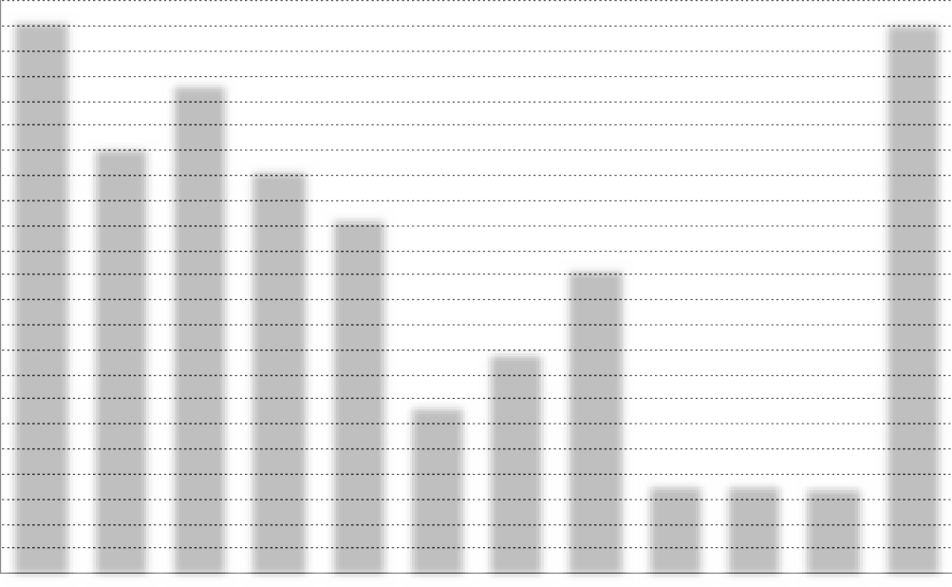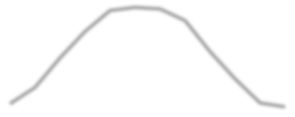Jan Feb Mar April May June July Aug Sept Oct Nov Dec SPP generation, kW/h Electricity consumption, kW/h
1 2081 240 1 224
1 104
992
720
784
504
416
248
256
216
1,800 1,393 1,591 1,314 1,158 555 727 1000 300 300 290 1789

 | SPP generation, kW/h | Consumption object, kW/h | Purchase from the network, kWh
January | 248 | 1800 | 1 552
February | 416 | 1393 | 977
March | 720 | 1591 | 871
April | 992 | 1314 | 322
May | 1 208 | 1158 | -
June | 1,240 | 555 | -
July | 1 224 | 727 | -
August | 1 104 | 1000 | -
September | 784 | 300 | -
October | 504 | 300 | -
November | 256 | 290 | 34
December | 216 | 1789 | 1 573
TOTAL: | 8,912 | 12217 | 5329

PROJECTED PERFORMANCE INDICATORS OF THE PROJECT
CAPEX (SPP cost) | 249,186.86 | UAH
Power of SPP | 8 | kW
The rate of $ in calculations | 36.65 | UAH
Generation SPP by 1 year | 8,912 | kW/h
Consumption electricity an object | 12,217 | kW/h
Online purchase | 5,329 | kW/h
Coverage of consumption by own SPP | 6,888 | kW/h
The projected amount of electricity that will not be used from its own SPP | 2 024 | kW/h
Estimated price for 1 kWh from the grid | 6 | UAH
Costs for purchasing electricity from the grid after installation of the SPP | 31,974 | UAH
Costs on service by 1 year | 5,000 | UAH
The cost of projected energy consumption from own SPP | 41,328 | UAH
Cost consumption electricity without installed SPP | 73,302 | UAH
Savings of funds after the installation of SPP in the year before full payback | 36,328 | UAH
Payback of the project | 6.9 | years
The cost of generated electricity after payback | 0.56 | UAH per kWh

SPP 8 KW.

No18
Location of SPP: Krupetsk territorial community
Holovliv Affiliate of Krupetsk Lyceum
Description: Rooftop SPP
Power of the solar field:8 kW
Inverter power:6 kW

CALCULATION
Name | Description | K-  St | Costunits | Price
1. Solar panel | Risen 550W | 15 | 8,282.90 ₴ | 120,478.55 ₴
2. Electricity inverter | Solis S5-GR3P6K | 1 | 45,812.50 ₴ | 45,812.50 ₴
3. The controller for the export of electricity to the network | Solis EPM3-5G  plus | 1 | 23,199.45 ₴ | 23,199.45 ₴
4. Assembly structure
Type of metal construction | aluminum | 1 | 7,996.36 ₴ | 7,996.36 ₴
5. Electrical products
cable | AVVG4X16 | 10 | 600.00 ₴ | 600.00 ₴
cable for solar panels | KBE | 80 | 40.00 ₴ | 3,200.00 ₴
automatics protection DC | ETI fuSPP,  shield ETI | 1 | 3,000.00 ₴ | 3,000.00 ₴
automatics protection AC | shield ETI, automatichull Hager,Shnider SSRIs | 1 | 3,000.00 ₴ | 3,000.00 ₴
switching facilities | MC4 connectors, tips, copper wire, grounding  bus | 1 | 2,000.00 ₴ | 2,000.00 ₴
6. Consumables |  | 1 | 2,500.00 ₴ | 2,500.00 ₴
7. Transportation |  | 1 | 3,000.00 ₴ | 3,000.00 ₴
8. Assembly works |  | 1 | 22,400.00 ₴ | 22,400.00 ₴
9. Design and estimate documentation |  | 1 | 12,000.00 ₴ | 12,000.00 ₴
CAPEX |  |  | Total: | 249,186.86 ₴

CAPEX
SPP 8 KW.

INDICATORS GENERATIONS AND CONSUMPTION
SPP 8 KW.

1,400

1,260

1 120

980

840

700

560

420

280

140

0
SCHEDULE OF SPP GENERATION AND ELECTRICITY CONSUMPTION BY THE FACILITY

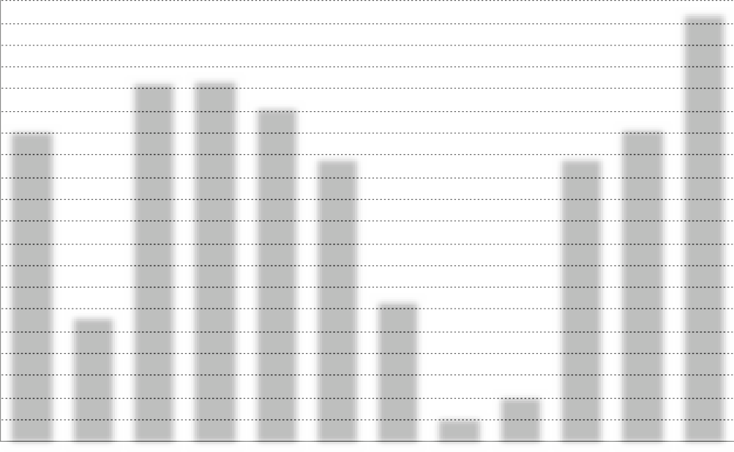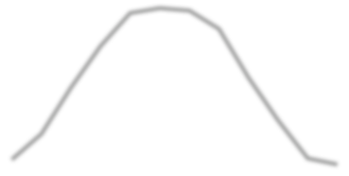
1 2081 240 1 224
1 104
992
784
720
504
416
248
256 216
998 409 1 151 1 160 1 072 911 457 86 155 907 1 004 1 368
Jan Feb Mar April May June July Aug Sept Oct Nov Dec SPP generation, kW/h Electricity consumption, kW/h

 | SPP generation, kW/h | Consumption object, kW/h | Purchase from the network, kWh
January | 248 | 998 | 750
February | 416 | 409 | -
March | 720 | 1151 | 431
April | 992 | 1160 | 168
May | 1 208 | 1072 | -
June | 1,240 | 911 | -
July | 1 224 | 457 | -
August | 1 104 | 86 | -
September | 784 | 155 | -
October | 504 | 907 | 403
November | 256 | 1004 | 748
December | 216 | 1368 | 1 152
TOTAL: | 8,912 | 9678 | 3652

PROJECTED PERFORMANCE INDICATORS OF THE PROJECT
CAPEX (SPP cost) | 249,186.86 | UAH
Power of SPP | 8 | kW
The rate of $ in calculations | 36.65 | UAH
Generation SPP by 1 year | 8,912 | kW/h
Consumption electricity an object | 9,678 | kW/h
Online purchase | 3,652 | kW/h
Coverage of consumption by own SPP | 6,026 | kW/h
The projected amount of electricity that will not be used from its own SPP | 2,886 | kW/h
Estimated price for 1 kWh from the grid | 6 | UAH
Costs for purchasing electricity from the grid after installation of the SPP | 21,912 | UAH
Costs on service by 1 year | 5,000 | UAH
The cost of projected energy consumption from own SPP | 36 156 | UAH
Cost consumption electricity without installed SPP | 58,068 | UAH
Savings of funds after the installation of SPP in the year before full payback | 31 156 | UAH
Payback of the project | 8.0 | years
The cost of generated electricity after payback | 0.56 | UAH per kWh

SPP 8 KW.

No.

19
Location of SPP: Letychiv territorial community
Letychiv Lyceum
Description: Rooftop SPP
Power of the solar field: 15 kW
Inverter power: 12 kW

CALCULATION
Name | Description | K-  St | Costunits | Price
1. Solar panel | Risen 550W | 27 | 8,282.90 ₴ | 223,638.30 ₴
2. Electricity inverter | Solis S5-GR3P12K | 1 | 54,975.00 ₴ | 54,975.00 ₴
3. The controller for the export of electricity to the network | Solis EPM3-5G  plus | 1 | 23,199.45 ₴ | 23,199.45 ₴
4. Assembly structure
Type of metal construction | aluminum | 1 | 14,843.25 ₴ | 14,843.25 ₴
5. Electrical products
cable | AVVG4X16 | 10 | 600.00 ₴ | 600.00 ₴
cable for solar panels | KBE | 120 | 40.00 ₴ | 4,800.00 ₴
automatics protection DC | ETI fuSPP,  shield ETI | 1 | 3,800.00 ₴ | 3,800.00 ₴
automatics protection AC | shield ETI, automatichull Hager,Shnider SSRIs | 1 | 4,000.00 ₴ | 4,000.00 ₴
switching facilities | MC4 connectors, tips, copper wire, grounding  bus | 1 | 2,500.00 ₴ | 2,500.00 ₴
6. Consumables |  | 1 | 3,000.00 ₴ | 3,000.00 ₴
7. Transportation |  | 1 | 5,000.00 ₴ | 5,000.00 ₴
8. Assembly works |  | 1 | 42,000.00 ₴ | 42,000.00 ₴
9. Design and estimate documentation |  | 1 | 12,000.00 ₴ | 12,000.00 ₴
CAPEX |  |  | Total: | 394,356.00 ₴

CAPEX
SPP 15 KW.

INDICATORS GENERATIONS AND CONSUMPTION
SPP 15 KW.

15,600

14,040

12,480

10,920

9,360

7,800

6,240

4,680

3 120

1,560

0
SCHEDULE OF SPP GENERATION AND ELECTRICITY CONSUMPTION BY THE FACILITY

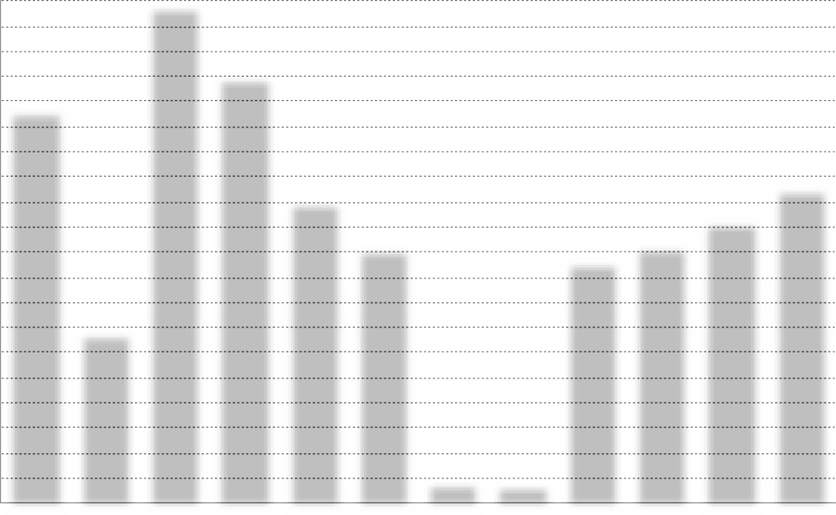SPP generation, kW/h Electricity consumption, kW/h
15,419
13,270
12 182
9,388
9,800
8,742
7,951
7,500
8,000
5,295
2,212 2,274 2,236
1 313 1 828 1 928 1 391
453
761
913
434
Jan Feb Mar April May June
650
July
600
Aug
340
Sept Oct Nov
Dec

 | SPP generation, kW/h | Consumption object, kW/h | Purchase from the network, kWh
January | 453 | 12 182 | 11,729
February | 761 | 5,295 | 4,534
March | 1 313 | 15,419 | 14 106
April | 1 828 | 13,270 | 11,442
May | 2,212 | 9,388 | 7 176
June | 2,274 | 7,951 | 5,677
July | 2 236 | 650 | -
August | 1 928 | 600 | -
September | 1 391 | 7,500 | 6 109
October | 913 | 8,000 | 7,087
November | 434 | 8,742 | 8 308
December | 340 | 9,800 | 9,460
TOTAL: | 16,083 | 98,797 | 85,628

PROJECTED PERFORMANCE INDICATORS OF THE PROJECT
CAPEX (SPP cost) | 394,356.00 | UAH
Power of SPP | 15 | kW
The rate of $ in calculations | 36.65 | UAH
Generation SPP by 1 year | 16,083 | kW/h
Consumption electricity an object | 98,797 | kW/h
Online purchase | 85,628 | kW/h
Coverage of consumption by own SPP | 13 169 | kW/h
The projected amount of electricity that will not be used from its own SPP | 2,914 | kW/h
Estimated price for 1 kWh from the grid | 6 | UAH
Costs for purchasing electricity from the grid after installation of the SPP | 513,768 | UAH
Costs on service by 1 year | 8,000 | UAH
The cost of projected energy consumption from own SPP | 79,014 | UAH
Cost consumption electricity without installed SPP | 592,782 | UAH
Savings of funds after the installation of SPP in the year before full payback | 71,014 | UAH
Payback of the project | 5,6 | Years
The cost of generated electricity after payback | 0.50 | UAH per kWh

SPP 15 KW.

No. 20
Location of SPP: Novodunayeveti territorial community
Treatment Plant
Description: Rooftop SPP
Power of the solar field: 15 kW
Inverter power: 12 kW

CALCULATION
Name | Description | K-  St | Costunits | Price
1. Solar panel | Risen 550W | 27 | 8,282.90 ₴ | 223,638.30 ₴
2. Electricity inverter | Solis S5-GR3P12K | 1 | 54,975.00 ₴ | 54,975.00 ₴
3. The controller for the export of electricity to the network | Solis EPM3-5G  plus | 1 | 23,199.45 ₴ | 23,199.45 ₴
4. Assembly structure
Type of metal construction | aluminum | 1 | 14,843.25 ₴ | 14,843.25 ₴
5. Electrical products
cable | AVVG4X16 | 10 | 600.00 ₴ | 600.00 ₴
cable for solar panels | KBE | 120 | 40.00 ₴ | 4,800.00 ₴
automatics protection DC | ETI fuSPP,  shield ETI | 1 | 3,800.00 ₴ | 3,800.00 ₴
automatics protection AC | shield ETI, automatichull Hager,Shnider SSRIs | 1 | 4,000.00 ₴ | 4,000.00 ₴
switching facilities | MC4 connectors, tips, copper wire, grounding  bus | 1 | 2,500.00 ₴ | 2,500.00 ₴
6. Consumables |  | 1 | 3,000.00 ₴ | 3,000.00 ₴
7. Transportation |  | 1 | 5,000.00 ₴ | 5,000.00 ₴
8. Assembly works |  | 1 | 42,000.00 ₴ | 42,000.00 ₴
9. Design and estimate documentation |  | 1 | 12,000.00 ₴ | 12,000.00 ₴
CAPEX |  |  | Total: | 394,356.00 ₴

CAPEX
SPP 15 KW.

INDICATORS GENERATIONS AND CONSUMPTION
SPP 15 KW.

8,000

7,200

6,400

5,600

4,800

4,000

3,200

2,400

1,600

800

0
SCHEDULE OF SPP GENERATION AND ELECTRICITY CONSUMPTION BY THE FACILITY


7,500 7500 7500 7500 7500 7500 7500 7500 7500 7500 7500 7500
2,212 2,274 2,236
1 828
1 928
1 313
1 391
913
453
761
434
340
Jan Feb Mar April May June July Aug Sept Oct Nov Dec SPP generation, kW/h Electricity consumption, kW/h

 | SPP generation, kW/h | Consumption object, kW/h | Purchase from the network, kWh
January | 453 | 7,500 | 7,047
February | 761 | 7,500 | 6,739
March | 1 313 | 7,500 | 6 187
April | 1 828 | 7,500 | 5,672
May | 2,212 | 7,500 | 5,288
June | 2,274 | 7,500 | 5,226
July | 2 236 | 7,500 | 5,264
August | 1 928 | 7,500 | 5,572
September | 1 391 | 7,500 | 6 109
October | 913 | 7,500 | 6,587
November | 434 | 7,500 | 7,066
December | 340 | 7,500 | 7 160
TOTAL: | 16,083 | 90,000 | 73,917

PROJECTED PERFORMANCE INDICATORS OF THE PROJECT
CAPEX (SPP cost) | 394,356.00 | UAH
Power of SPP | 15 | kW
The rate of $ in calculations | 36.65 | UAH
Generation SPP by 1 year | 16,083 | kW/h
Consumption electricity an object | 90,000 | kW/h
Online purchase | 73,917 | kW/h
Coverage of consumption by own SPP | 16,083 | kW/h
The projected amount of electricity that will not be used from its own SPP | 0 | kW/h
Estimated price for 1 kWh from the grid | 6 | UAH
Costs for purchasing electricity from the grid after installation of the SPP | 443 502 | UAH
Costs on service by 1 year | 8,000 | UAH
The cost of projected energy consumption from own SPP | 96 498 | UAH
Cost consumption electricity without installed SPP | 540,000 | UAH
Savings of funds after the installation of SPP in the year before full payback | 88,498 | UAH
Payback of the project | 4.5 | Years
The cost of generated electricity after payback | 0.50 | UAH per kWh

SPP 15 KW.

No21
Location of SPP: Novoushytsk settlement territorial community
SE "Miskvodokanal"
Description: Rooftop SPP
Power of the solar field: 30 kW
Inverter power: 30 kW

CALCULATION
CAPEX
Name | Description | K-  St | Costunits | Price
1. Solar panel | Risen 550W | 55 | 8,466.15 ₴ | 461,790.00 ₴
2. Electricity inverter | SolisS5-GC30K | 1 | 76,965.00 ₴ | 76,965.00 ₴
3. The controller for the export of electricity to the network | Solis EPM3-5G  plus | 1 | 23,199.45 ₴ | 23,199.45 ₴
4. Assembly structure
Type of metal construction | aluminum | 1 | 39,981.82 ₴ | 39,981.82 ₴
5. Electrical products
cable | AVVG4X25 | 10 | 800.00 ₴ | 800.00 ₴
cable for solar panels | KBE | 200 | 40.00 ₴ | 8,000.00 ₴
automatics protection DC | ETI fuSPP,  shield ETI | 1 | 5,000.00 ₴ | 5,000.00 ₴
automatics protection AC | shield ETI, automatichull Hager,Shnider SSRIs | 1 | 5,500.00 ₴ | 5,500.00 ₴
switching facilities | MC4 connectors, tips, copper wire, grounding  bus | 1 | 3,500.00 ₴ | 3,500.00 ₴
6. Consumables |  | 1 | 4,000.00 ₴ | 4,000.00 ₴
7. Transportation |  | 1 | 10,000.00 ₴ | 10,000.00 ₴
8. Assembly works |  | 1 | 84,000.00 ₴ | 84,000.00 ₴
9. Design and estimate documentation |  | 1 | 12,000.00 ₴ | 12,000.00 ₴
CAPEX |  |  | Total: | 734,736.27 ₴

SPP 30 KW.

INDICATORS GENERATIONS AND CONSUMPTION
SPP 30 KW.

12,200

10,980

9,760

8,540

7,320

6 100

4,880

3,660

2 440

1,220

0
SCHEDULE OF SPP GENERATION AND ELECTRICITY CONSUMPTION BY THE FACILITY

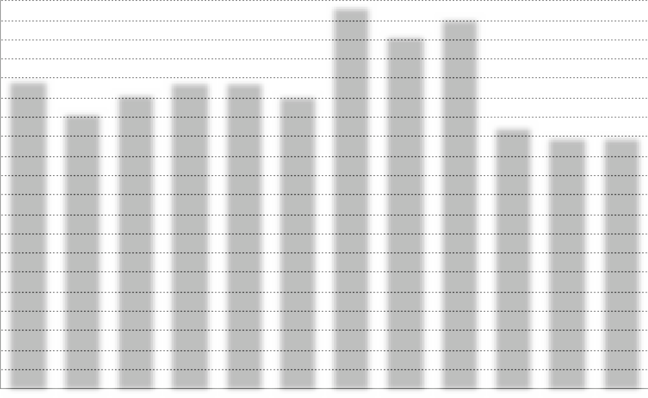
12,080
11,720
11,160
9,760
9,320
9,680 9,720
9,280
8,720
8,300
8,000 8000
4,5304,650 4,590
3,720
4 140
2,700
2,940
1,560 1 890
930 960
810
Jan Feb Mar April May June July Aug Sept Oct Nov Dec SPP generation, kW/h Electricity consumption, kW/h

 | SPP generation, kW/h | Consumption object, kW/h | Purchase from the network, kWh
January | 930 | 9,760 | 8,830
February | 1,560 | 8,720 | 7 160
March | 2,700 | 9,320 | 6,620
April | 3,720 | 9,680 | 5,960
May | 4,530 | 9,720 | 5 190
June | 4,650 | 9,280 | 4,630
July | 4,590 | 12,080 | 7,490
August | 4 140 | 11,160 | 7,020
September | 2,940 | 11,720 | 8,780
October | 1 890 | 8,300 | 6,410
November | 960 | 8,000 | 7,040
December | 810 | 8,000 | 7 190
TOTAL: | 33,420 | 115,740 | 82,320

PROJECTED PERFORMANCE INDICATORS OF THE PROJECT
CAPEX (SPP cost) | 734,736.27 | UAH
Power of SPP | 30 | kW
The rate of $ in calculations | 36.65 | UAH
Generation SPP by 1 year | 33,420 | kW/h
Consumption electricity an object | 115,740 | kW/h
Online purchase | 82,320 | kW/h
Coverage of consumption by own SPP | 33,420 | kW/h
The projected amount of electricity that will not be used from its own SPP | 0 | kW/h
Estimated price for 1 kWh from the grid | 6 | UAH
Costs for purchasing electricity from the grid after installation of the SPP | 493,920 | UAH
Costs on service by 1 year | 17,000 | UAH
The cost of projected energy consumption from own SPP | 200,520 | UAH
Cost consumption electricity without installed SPP | 694 440 | UAH
Savings of funds after the installation of SPP in the year before full payback | 183,520 | UAH
Payback of the project | 4.0 | Years
The cost of generated electricity after payback | 0.51 | UAH per kWh

SPP 30 KW.

No. 22
Location of SPP : Smotrych territorial community
Smotrych Lyceum
Description: Rooftop SPP
Power of the solar field: 12 kW
Inverter power: 10 kW

CALCULATION
Name | Description | K-  St | Costunits | Price
1. Solar panel | Risen 550W | 22 | 8,282.90 ₴ | 180,717.82 ₴
2. Electricity inverter | Solis S5-GR3P10K | 1 | 53,142.50 ₴ | 53,142.50 ₴
3. The controller for the export of electricity to the network | Solis EPM3-5G  plus | 1 | 23,199.45 ₴ | 23,199.45 ₴
4. Assembly structure
Type of metal construction | aluminum | 1 | 11,994.55 ₴ | 11,994.55 ₴
5. Electrical products
cable | AVVG4X16 | 10 | 600.00 ₴ | 600.00 ₴
cable for solar panels | KBE | 100 | 40.00 ₴ | 4,000.00 ₴
automatics protection DC | ETI fuSPP,  shield ETI | 1 | 3,500.00 ₴ | 3,500.00 ₴
automatics protection AC | shield ETI, automatichull Hager,Shnider SSRIs | 1 | 3,600.00 ₴ | 3,600.00 ₴
switching facilities | MC4 connectors, tips, copper wire, grounding  bus | 1 | 2,300.00 ₴ | 2,300.00 ₴
6. Consumables |  | 1 | 2,800.00 ₴ | 2,800.00 ₴
7. Transportation |  | 1 | 4,500.00 ₴ | 4,500.00 ₴
8. Assembly works |  | 1 | 33,600.00 ₴ | 33,600.00 ₴
9. Design and estimate documentation |  | 1 | 12,000.00 ₴ | 12,000.00 ₴
CAPEX |  |  | Total: | 335,954.31 ₴

CAPEX
SPP 12 KW.

INDICATORS GENERATIONS AND CONSUMPTION
SPP 12 KW.

7,000

6,300

5,600

4,900

4,200

3,500

2,800

2 100

1,400

700

0
SCHEDULE OF SPP GENERATION AND ELECTRICITY CONSUMPTION BY THE FACILITY

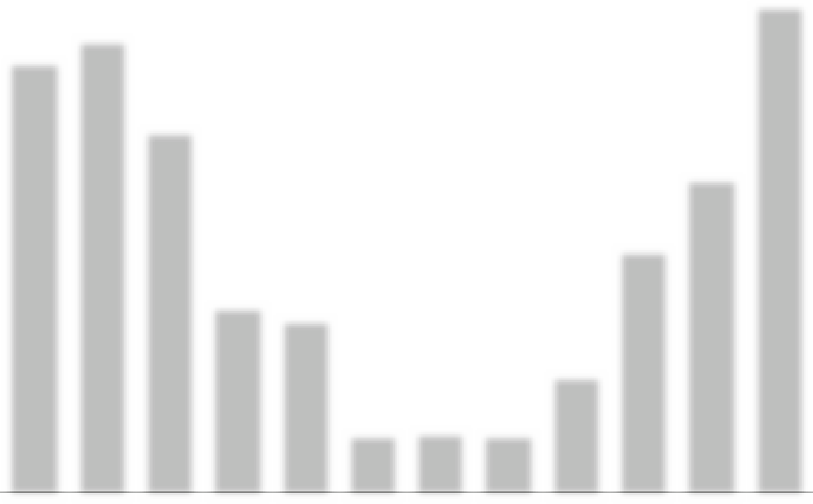
1 488
1,812 1,860 1,836 1,656
1,080
1 176
372
624
756
384
6,200 6,500 5,200 2,700 2,500 860 890
860 1 700 3,500 4,500 7,000
324
Jan Feb Mar April May June July Aug Sept Oct Nov Dec SPP generation, kW/h Electricity consumption, kW/h

 | SPP generation, kW/h | Consumption object, kW/h | Purchase from the network, kWh
January | 372 | 6,200 | 5,828
February | 624 | 6,500 | 5,876
March | 1,080 | 5,200 | 4 120
April | 1 488 | 2,700 | 1 212
May | 1 812 | 2,500 | 688
June | 1 860 | 860 | -
July | 1 836 | 890 | -
August | 1 656 | 860 | -
September | 1 176 | 1,700 | 524
October | 756 | 3,500 | 2,744
November | 384 | 4,500 | 4 116
December | 324 | 7,000 | 6,676
TOTAL: | 13,368 | 42,410 | 31,784

PROJECTED PERFORMANCE INDICATORS OF THE PROJECT
CAPEX (SPP cost) | 335,954.31 | UAH
Power of SPP | 12 | kW
The rate of $ in calculations | 36.65 | UAH
Generation SPP by 1 year | 13,368 | kW/h
Consumption electricity an object | 42,410 | kW/h
Online purchase | 31,784 | kW/h
Coverage of consumption by own SPP | 10,626 | kW/h
The projected amount of electricity that will not be used from its own SPP | 2,742 | kW/h
Estimated price for 1 kWh from the grid | 6 | UAH
Costs for purchasing electricity from the grid after installation of the SPP | 190,704 | UAH
Costs on service by 1 year | 7,000 | UAH
The cost of projected energy consumption from own SPP | 63,756 | UAH
Cost consumption electricity without installed SPP | 254,460 | UAH
Savings of funds after the installation of SPP in the year before full payback | 56,756 | UAH
Payback of the project | 5.9 | years
The cost of generated electricity after payback | 0.52 | UAH per kWh

SPP 12 KW.

No23
Location of SPP: Khmelnytskyi territorial community
Khmelnytskyi City Children's Hospital
Description: Rooftop SPP
Power of the solar field: 30 kW
Inverter power: 30 kW

CALCULATION
Name | Description | K-  St | Costunits | Price
1. Solar panel | Risen 550W | 55 | 8,466.15 ₴ | 461,790.00 ₴
2. Electricity inverter | SolisS5-GC30K | 1 | 76,965.00 ₴ | 76,965.00 ₴
3. The controller for the export of electricity to the network | Solis EPM3-5G  plus | 1 | 23,199.45 ₴ | 23,199.45 ₴
4. Assembly structure
Type of metal construction | aluminum | 1 | 39,981.82 ₴ | 39,981.82 ₴
5. Electrical products
cable | AVVG4X25 | 10 | 800.00 ₴ | 800.00 ₴
cable for solar panels | KBE | 200 | 40.00 ₴ | 8,000.00 ₴
automatics protection DC | ETI fuSPP,  shield ETI | 1 | 5,000.00 ₴ | 5,000.00 ₴
automatics protection AC | shield ETI, automatichull Hager,Shnider SSRIs | 1 | 5,500.00 ₴ | 5,500.00 ₴
switching facilities | MC4 connectors, tips, copper wire, grounding  bus | 1 | 3,500.00 ₴ | 3,500.00 ₴
6. Consumables |  | 1 | 4,000.00 ₴ | 4,000.00 ₴
7. Transportation |  | 1 | 10,000.00 ₴ | 10,000.00 ₴
8. Assembly works |  | 1 | 84,000.00 ₴ | 84,000.00 ₴
9. Design and estimate documentation |  | 1 | 12,000.00 ₴ | 12,000.00 ₴
CAPEX |  |  | Total: | 734,736.27 ₴

CAPEX
SPP 30 KW.

INDICATORS GENERATIONS AND CONSUMPTION
SPP 30 KW.

34,400
34,381
33 133
32,986
28,668
29,613 28,788
26,512
27,026
24,073
24,790
23,514
22,032
2,700
3,7204 530 4 650 4 590 4 140 2 940
930
January
1,560
February
1 890 960
Mar
Apr
May
Jun
July
Aug
Sept Oct Nov
810
Dec

30,960

27,520

24,080

20,640

17,200

13,760

10,320

6,880

3 440

0
SCHEDULE OF SPP GENERATION AND ELECTRICITY CONSUMPTION BY THE FACILITY

SPP generation, kW/h Electricity consumption, kW/h

 | SPP generation, kW/h | Consumption object, kW/h | Purchase from the network, kWh
January | 930 | 33 133 | 32,203
February | 1,560 | 28,668 | 27 108
March | 2,700 | 24,073 | 21,373
April | 3,720 | 26,512 | 22,792
May | 4,530 | 22,032 | 17,502
June | 4,650 | 23,514 | 18,864
July | 4,590 | 24,790 | 20,200
August | 4 140 | 27,026 | 22,886
September | 2,940 | 32,986 | 30,046
October | 1 890 | 34,381 | 32,491
November | 960 | 29,613 | 28,653
December | 810 | 28,788 | 27,978
TOTAL: | 33,420 | 335,516 | 302,096

PROJECTED PERFORMANCE INDICATORS OF THE PROJECT
CAPEX (SPP cost) | 734,736.27 | UAH
Power of SPP | 30 | kW
The rate of $ in calculations | 36.65 | UAH
Generation SPP by 1 year | 33,420 | kW/h
Consumption electricity an object | 335,516 | kW/h
Online purchase | 302,096 | kW/h
Coverage of consumption by own SPP | 33,420 | kW/h
The projected amount of electricity that will not be used from its own SPP | 0 | kW/h
Estimated price for 1 kWh from the grid | 6 | UAH
Costs for purchasing electricity from the grid after installation of the SPP | 1,812,576 | UAH
Costs on service by 1 year | 17,000 | UAH
The cost of projected energy consumption from own SPP | 200,520 | UAH
Cost consumption electricity without installed SPP | 2,013,096 | UAH
Savings of funds after the installation of SPP in the year before full payback | 183,520 | UAH
Payback of the project | 4.0 | Years
The cost of generated electricity after payback | 0.51 | UAH per kWh

SPP 30 KW.

No. 24
Location of SPP: Khmelnytskyi territorial community
SE Khmelnytskyi City Hospital, Main building
Description: Rooftop SPP
Power of the solar field: 30 kW
Inverter power: 30 kW

CALCULATION
Name | Description | K-  St | Costunits | Price
1. Solar panel | Risen 550W | 55 | 8,466.15 ₴ | 461,790.00 ₴
2. Electricity inverter | SolisS5-GC30K | 1 | 76,965.00 ₴ | 76,965.00 ₴
3. The controller for the export of electricity to the network | Solis EPM3-5G  plus | 1 | 23,199.45 ₴ | 23,199.45 ₴
4. Assembly structure
Type of metal construction | aluminum | 1 | 39,981.82 ₴ | 39,981.82 ₴
5. Electrical products
cable | AVVG4X25 | 10 | 800.00 ₴ | 800.00 ₴
cable for solar panels | KBE | 200 | 40.00 ₴ | 8,000.00 ₴
automatics protection DC | ETI fuSPP,  shield ETI | 1 | 5,000.00 ₴ | 5,000.00 ₴
automatics protection AC | shield ETI, automatichull Hager,Shnider SSRIs | 1 | 5,500.00 ₴ | 5,500.00 ₴
switching facilities | MC4 connectors, tips, copper wire, grounding  bus | 1 | 3,500.00 ₴ | 3,500.00 ₴
6. Consumables |  | 1 | 4,000.00 ₴ | 4,000.00 ₴
7. Transportation |  | 1 | 10,000.00 ₴ | 10,000.00 ₴
8. Assembly works |  | 1 | 84,000.00 ₴ | 84,000.00 ₴
9. Design and estimate documentation |  | 1 | 12,000.00 ₴ | 12,000.00 ₴
CAPEX |  |  | Total: | 734,736.27 ₴

CAPEX
SPP 30 KW.

INDICATORS GENERATIONS AND CONSUMPTION
SPP 30 KW.

36,600
36,353
32,833
32,332
33,517
32,396
31 471
29,554
29,304
26,677 25,904 25,546
24,627
2,700
3,7204 530 4 650 4 590 4 140 2 940
930
January
1,560
February
1 890
Mar
Apr
May
Jun
July
Aug
Sept Oct
960 810
Nov Dec

32,940

29,280

25,620

21,960

18,300

14,640

10,980

7,320

3,660

0
SCHEDULE OF SPP GENERATION AND ELECTRICITY CONSUMPTION BY THE FACILITY

SPP generation, kW/h Electricity consumption, kW/h

 | SPP generation, kW/h | Consumption object, kW/h | Purchase from the network, kWh
January | 930 | 32,833 | 31,903
February | 1,560 | 29,554 | 27,994
March | 2,700 | 32,332 | 29,632
April | 3,720 | 29,304 | 25,584
May | 4,530 | 26,677 | 22 147
June | 4,650 | 25,904 | 21,254
July | 4,590 | 25,546 | 20,956
August | 4 140 | 24,627 | 20,487
September | 2,940 | 32,396 | 29,456
October | 1 890 | 33,517 | 31,627
November | 960 | 31 471 | 30,511
December | 810 | 36,353 | 35,543
TOTAL: | 33,420 | 360,514 | 327,094

PROJECTED PERFORMANCE INDICATORS OF THE PROJECT
CAPEX (SPP cost) | 734,736.27 | UAH
Power of SPP | 30 | kW
The rate of $ in calculations | 36.65 | UAH
Generation SPP by 1 year | 33,420 | kW/h
Consumption electricity an object | 360,514 | kW/h
Online purchase | 327,094 | kW/h
Coverage of consumption by own SPP | 33,420 | kW/h
The projected amount of electricity that will not be used from its own SPP | 0 | kW/h
Estimated price for 1 kWh from the grid | 6 | UAH
Costs for purchasing electricity from the grid after installation of the SPP | 1,962,564 | UAH
Costs on service by 1 year | 17,000 | UAH
The cost of projected energy consumption from own SPP | 200,520 | UAH
Cost consumption electricity without installed SPP | 2,163,084 | UAH
Savings of funds after the installation of SPP in the year before full payback | 183,520 | UAH
Payback of the project | 4.0 | Years
The cost of generated electricity after payback | 0.51 | UAH per kWh

SPP 30 KW.

No. 25
Location of SPP: Khmelnytskyi territorial community
Economic building of Maternity Hospital
Description: Rooftop SPP
Power of the solar field: 15 kW
Inverter power: 12 kW

CALCULATION
Name | Description | K-  St | Costunits | Price
1. Solar panel | Risen 550W | 27 | 8,282.90 ₴ | 223,638.30 ₴
2. Electricity inverter | Solis S5-GR3P12K | 1 | 54,975.00 ₴ | 54,975.00 ₴
3. The controller for the export of electricity to the network | Solis EPM3-5G  plus | 1 | 23,199.45 ₴ | 23,199.45 ₴
4. Assembly structure
Type of metal construction | aluminum | 1 | 14,843.25 ₴ | 14,843.25 ₴
5. Electrical products
cable | AVVG4X16 | 10 | 600.00 ₴ | 600.00 ₴
cable for solar panels | KBE | 120 | 40.00 ₴ | 4,800.00 ₴
automatics protection DC | ETI fuSPP,  shield ETI | 1 | 3,800.00 ₴ | 3,800.00 ₴
automatics protection AC | shield ETI, automatichull Hager,Shnider SSRIs | 1 | 4,000.00 ₴ | 4,000.00 ₴
switching facilities | MC4 connectors, tips, copper wire, grounding  bus | 1 | 2,500.00 ₴ | 2,500.00 ₴
6. Consumables |  | 1 | 3,000.00 ₴ | 3,000.00 ₴
7. Transportation |  | 1 | 5,000.00 ₴ | 5,000.00 ₴
8. Assembly works |  | 1 | 42,000.00 ₴ | 42,000.00 ₴
9. Design and estimate documentation |  | 1 | 12,000.00 ₴ | 12,000.00 ₴
CAPEX |  |  | Total: | 394,356.00 ₴

CAPEX
SPP 15 KW.

INDICATORS GENERATIONS AND CONSUMPTION
SPP 15 KW.

4,800

4,320

3,840

3,360

2,880

2,400

1 920

1 440

960

480

0
SCHEDULE OF SPP GENERATION AND ELECTRICITY CONSUMPTION BY THE FACILITY

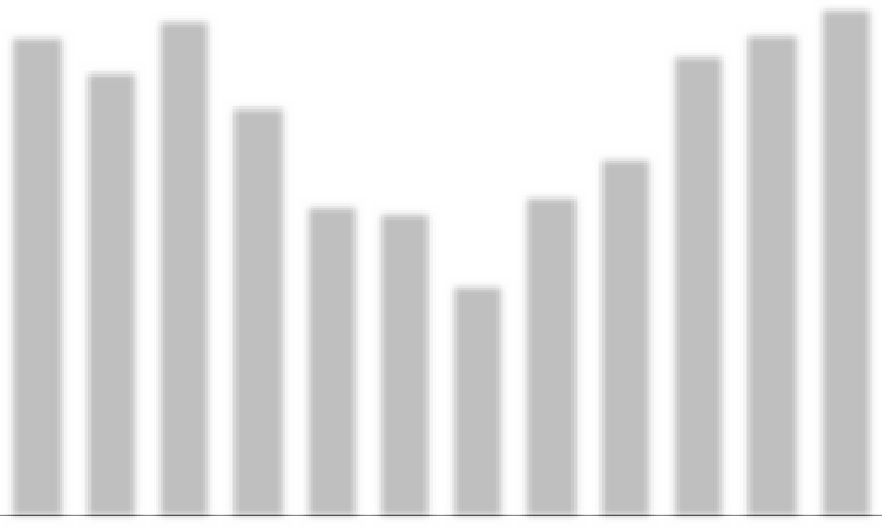
2,2122,274 2,236
1 828
1 928
1 313
1 391
761
913
453
434
340
4,377 4056 4518 3735 2840 2770 2108 2933 3270 4209 4383 4625
Jan Feb Mar April May June July Aug Sept Oct Nov Dec SPP generation, kW/h Electricity consumption, kW/h

 | SPP generation, kW/h | Consumption object, kW/h | Purchase from the network, kWh
January | 453 | 4,377 | 3,924
February | 761 | 4,056 | 3,295
March | 1 313 | 4,518 | 3 205
April | 1 828 | 3,735 | 1 907
May | 2,212 | 2,840 | 628
June | 2,274 | 2,770 | 496
July | 2 236 | 2 108 | -
August | 1 928 | 2,933 | 1 005
September | 1 391 | 3,270 | 1 879
October | 913 | 4 209 | 3,296
November | 434 | 4,383 | 3,949
December | 340 | 4,625 | 4,285
TOTAL: | 16,083 | 43,824 | 27,869

PROJECTED PERFORMANCE INDICATORS OF THE PROJECT
CAPEX (SPP cost) | 394,356.00 | UAH
Power of SPP | 15 | kW
The rate of $ in calculations | 36.65 | UAH
Generation SPP by 1 year | 16,083 | kW/h
Consumption electricity an object | 43,824 | kW/h
Online purchase | 27,869 | kW/h
Coverage of consumption by own SPP | 15,955 | kW/h
The projected amount of electricity that will not be used from its own SPP | 128 | kW/h
Estimated price for 1 kWh from the grid | 6 | UAH
Costs for purchasing electricity from the grid after installation of the SPP | 167,214 | UAH
Costs on service by 1 year | 8,000 | UAH
The cost of projected energy consumption from own SPP | 95,730 | UAH
Cost consumption electricity without installed SPP | 262,944 | UAH
Savings of funds after the installation of SPP in the year before full payback | 87,730 | UAH
Payback of the project | 4.5 | Years
The cost of generated electricity after payback | 0.50 | UAH per kWh

SPP 15 KW.

No26
Location of SPP: Khmelnytskyi territorial community
Khmelnytskyi City Hospital
Description: Rooftop SPP
Power of the solar field: 30 kW
Inverter power: 30 kW

CALCULATION
Name | Description | K-  St | Costunits | Price
1. Solar panel | Risen 550W | 55 | 8,466.15 ₴ | 461,790.00 ₴
2. Electricity inverter | SolisS5-GC30K | 1 | 76,965.00 ₴ | 76,965.00 ₴
3. The controller for the export of electricity to the network | Solis EPM3-5G  plus | 1 | 23,199.45 ₴ | 23,199.45 ₴
4. Assembly structure
Type of metal construction | aluminum | 1 | 39,981.82 ₴ | 39,981.82 ₴
5. Electrical products
cable | AVVG4X25 | 10 | 800.00 ₴ | 800.00 ₴
cable for solar panels | KBE | 200 | 40.00 ₴ | 8,000.00 ₴
automatics protection DC | ETI fuSPP,  shield ETI | 1 | 5,000.00 ₴ | 5,000.00 ₴
automatics protection AC | shield ETI, automatichull Hager,Shnider SSRIs | 1 | 5,500.00 ₴ | 5,500.00 ₴
switching facilities | MC4 connectors, tips, copper wire, grounding  bus | 1 | 3,500.00 ₴ | 3,500.00 ₴
6. Consumables |  | 1 | 4,000.00 ₴ | 4,000.00 ₴
7. Transportation |  | 1 | 10,000.00 ₴ | 10,000.00 ₴
8. Assembly works |  | 1 | 84,000.00 ₴ | 84,000.00 ₴
9. Design and estimate documentation |  | 1 | 12,000.00 ₴ | 12,000.00 ₴
CAPEX |  |  | Total: | 734,736.27 ₴

CAPEX
SPP 30 KW.

INDICATORS GENERATIONS AND CONSUMPTION
SPP 30 KW.

108,000
107 433
99,588
92,830
87,720
78 457
74,924
65,90567,649
65 905 63 989
51 003
45,504
930
January
1,560 2,700 3,7204,530 4,650 4,590 4,140 2,940 1,890
960
February
Mar
Apr
May
June
July
Aug
Sept Oct Nov
810
Dec

97,200

86,400

75,600

64,800

54,000

43,200

32,400

21,600

10,800

0
SCHEDULE OF SPP GENERATION AND ELECTRICITY CONSUMPTION BY THE FACILITY

SPP generation, kW/h Electricity consumption, kW/h

 | SPP generation, kW/h | Consumption object, kW/h | Purchase from the network, kWh
January | 930 | 87,720 | 86,790
February | 1,560 | 78 457 | 76,897
March | 2,700 | 65,905 | 63,205
April | 3,720 | 67,649 | 63,929
May | 4,530 | 74,924 | 70,394
June | 4,650 | 65,905 | 61,255
July | 4,590 | 63,989 | 59,399
August | 4 140 | 51 003 | 46,863
September | 2,940 | 45,504 | 42,564
October | 1 890 | 99,588 | 97,698
November | 960 | 107 433 | 106,473
December | 810 | 92,830 | 92,020
TOTAL: | 33,420 | 900 907 | 867 487

PROJECTED PERFORMANCE INDICATORS OF THE PROJECT
CAPEX (SPP cost) | 734,736.27 | UAH
Power of SPP | 30 | kW
The rate of $ in calculations | 36.65 | UAH
Generation SPP by 1 year | 33,420 | kW/h
Consumption electricity an object | 900 907 | kW/h
Online purchase | 867 487 | kW/h
Coverage of consumption by own SPP | 33,420 | kW/h
The projected amount of electricity that will not be used from its own SPP | 0 | kW/h
Estimated price for 1 kWh from the grid | 6 | UAH
Costs for purchasing electricity from the grid after installation of the SPP | 5,204,922 | UAH
Costs on service by 1 year | 17,000 | UAH
The cost of projected energy consumption from own SPP | 200,520 | UAH
Cost consumption electricity without installed SPP | 5,405,442 | UAH
Savings of funds after the installation of SPP in the year before full payback | 183,520 | UAH
Payback of the project | 4.0 | Years
The cost of generated electricity after payback | 0.51 | UAH per kWh

SPP 30 KW.

No. 27
Location of SPP: Khmelnytsyi territorial community
Khmelnytsky Infectious Diseases Hospital
Description: Rooftop SPP
Power of the solar field: 30 kW
Inverter power: 30 kW

CALCULATION
Name | Description | K-  St | Costunits | Price
1. Solar panel | Risen 550W | 55 | 8,466.15 ₴ | 461,790.00 ₴
2. Electricity inverter | SolisS5-GC30K | 1 | 76,965.00 ₴ | 76,965.00 ₴
3. The controller for the export of electricity to the network | Solis EPM3-5G  plus | 1 | 23,199.45 ₴ | 23,199.45 ₴
4. Assembly structure
Type of metal construction | aluminum | 1 | 39,981.82 ₴ | 39,981.82 ₴
5. Electrical products
cable | AVVG4X25 | 10 | 800.00 ₴ | 800.00 ₴
cable for solar panels | KBE | 200 | 40.00 ₴ | 8,000.00 ₴
automatics protection DC | ETI fuSPP,  shield ETI | 1 | 5,000.00 ₴ | 5,000.00 ₴
automatics protection AC | shield ETI, automatichull Hager,Shnider SSRIs | 1 | 5,500.00 ₴ | 5,500.00 ₴
switching facilities | MC4 connectors, tips, copper wire, grounding  bus | 1 | 3,500.00 ₴ | 3,500.00 ₴
6. Consumables |  | 1 | 4,000.00 ₴ | 4,000.00 ₴
7. Transportation |  | 1 | 10,000.00 ₴ | 10,000.00 ₴
8. Assembly works |  | 1 | 84,000.00 ₴ | 84,000.00 ₴
9. Design and estimate documentation |  | 1 | 12,000.00 ₴ | 12,000.00 ₴
CAPEX |  |  | Total: | 734,736.27 ₴

CAPEX
SPP 30 KW.

INDICATORS GENERATIONS AND CONSUMPTION
SPP 30 KW.

71,400

64,260

57 120

49,980

42,840

35,700

28,560

21,420

14,280

7 140

0
SCHEDULE OF SPP GENERATION AND ELECTRICITY CONSUMPTION BY THE FACILITY

SPP generation, kW/h Electricity consumption, kW/h
71 148
61 14161,938
49,396
44,746
42 44142,801
36,762
38,067
28,677
24,310
17,660
930
January
1,560
February
2,700 3,7204 530 4 650 4 590 4 140 2 940
1 890
960
Mar Apr May June July Aug Sept Oct Nov
810
Dec

 | SPP generation, kW/h | Consumption object, kW/h | Purchase from the network, kWh
January | 930 | 44,746 | 43,816
February | 1,560 | 36,762 | 35,202
March | 2,700 | 42 441 | 39,741
April | 3,720 | 42,801 | 39,081
May | 4,530 | 49,396 | 44,866
June | 4,650 | 28,677 | 24,027
July | 4,590 | 24,310 | 19,720
August | 4 140 | 17,660 | 13,520
September | 2,940 | 38,067 | 35 127
October | 1 890 | 61 141 | 59,251
November | 960 | 61,938 | 60,978
December | 810 | 71 148 | 70,338
TOTAL: | 33,420 | 519,087 | 485,667

PROJECTED PERFORMANCE INDICATORS OF THE PROJECT
CAPEX (SPP cost) | 734,736.27 | UAH
Power of SPP | 30 | kW
The rate of $ in calculations | 36.65 | UAH
Generation SPP by 1 year | 33,420 | kW/h
Consumption electricity an object | 519,087 | kW/h
Online purchase | 485,667 | kW/h
Coverage of consumption by own SPP | 33,420 | kW/h
The projected amount of electricity that will not be used from its own SPP | 0 | kW/h
Estimated price for 1 kWh from the grid | 6 | UAH
Costs for purchasing electricity from the grid after installation of the SPP | 2,914,002 | UAH
Costs on service by 1 year | 17,000 | UAH
The cost of projected energy consumption from own SPP | 200,520 | UAH
Cost consumption electricity without installed SPP | 3,114,522 | UAH
Savings of funds after the installation of SPP in the year before full payback | 183,520 | UAH
Payback of the project | 4.0 | Years
The cost of generated electricity after payback | 0.51 | UAH per kWh

SPP 30 KW.

No. 28
Location of SPP : Shchyborivka territorial community
Kuzmin Lyceum
Description: Rooftop SPP
Power of the solar field: 12 kW
Inverter power: 10 kW

CALCULATION
Name | Description | K-  St | Costunits | Price
1. Solar panel | Risen 550W | 22 | 8,282.90 ₴ | 180,717.82 ₴
2. Electricity inverter | Solis S5-GR3P10K | 1 | 53,142.50 ₴ | 53,142.50 ₴
3. The controller for the export of electricity to the network | Solis EPM3-5G  plus | 1 | 23,199.45 ₴ | 23,199.45 ₴
4. Assembly structure
Type of metal construction | aluminum | 1 | 11,994.55 ₴ | 11,994.55 ₴
5. Electrical products
cable | AVVG4X16 | 10 | 600.00 ₴ | 600.00 ₴
cable for solar panels | KBE | 100 | 40.00 ₴ | 4,000.00 ₴
automatics protection DC | ETI fuSPP,  shield ETI | 1 | 3,500.00 ₴ | 3,500.00 ₴
automatics protection AC | shield ETI, automatichull Hager,Shnider SSRIs | 1 | 3,600.00 ₴ | 3,600.00 ₴
switching facilities | MC4 connectors, tips, copper wire, grounding  bus | 1 | 2,300.00 ₴ | 2,300.00 ₴
6. Consumables |  | 1 | 2,800.00 ₴ | 2,800.00 ₴
7. Transportation |  | 1 | 4,500.00 ₴ | 4,500.00 ₴
8. Assembly works |  | 1 | 33,600.00 ₴ | 33,600.00 ₴
9. Design and estimate documentation |  | 1 | 12,000.00 ₴ | 12,000.00 ₴
CAPEX |  |  | Total: | 335,954.31 ₴

CAPEX
SPP 12 KW.

INDICATORS GENERATIONS AND CONSUMPTION
SPP 12 KW.

11,000

9,900

8,800

7,700

6,600

5,500

4,400

3,300

2,200

1 100

0
SCHEDULE OF SPP GENERATION AND ELECTRICITY CONSUMPTION BY THE FACILITY

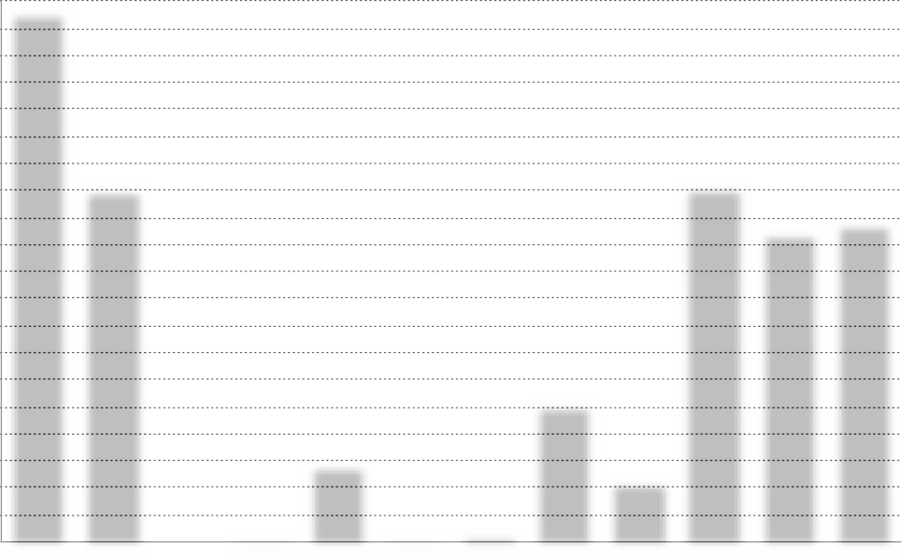SPP generation, kW/h Electricity consumption, kW/h
1 488
1 812 1 860 1 836
1 656
1,080
1 176
10,804 7,170
372
624
0 70 1589 78 169 2780 1250
Jan Feb Mar Apr May June July Aug Sept
756
384
7,250 6300
Oct Nov
6,507
Dec
324

 | SPP generation, kW/h | Consumption object, kW/h | Purchase from the network, kWh
January | 372 | 10,804 | 10,432
February | 624 | 7 170 | 6,546
March | 1,080 | 0 | -
April | 1 488 | 70 | -
May | 1 812 | 1,589 | -
June | 1 860 | 78 | -
July | 1 836 | 169 | -
August | 1 656 | 2,780 | 1 124
September | 1 176 | 1,250 | 74
October | 756 | 7,250 | 6,494
November | 384 | 6,300 | 5,916
December | 324 | 6,507 | 6 183
TOTAL: | 13,368 | 43,967 | 36769

PROJECTED PERFORMANCE INDICATORS OF THE PROJECT
CAPEX (SPP cost) | 335,954.31 | UAH
Power of SPP | 12 | kW
The rate of $ in calculations | 36.65 | UAH
Generation SPP by 1 year | 13,368 | kW/h
Consumption electricity an object | 43,967 | kW/h
Online purchase | 36,769 | kW/h
Coverage of consumption by own SPP | 7 198 | kW/h
The projected amount of electricity that will not be used from its own SPP | 6 170 | kW/h
Estimated price for 1 kWh from the grid | 6 | UAH
Costs for purchasing electricity from the grid after installation of the SPP | 220,614 | UAH
Costs on service by 1 year | 7,000 | UAH
The cost of projected energy consumption from own SPP | 43 188 | UAH
Cost consumption electricity without installed SPP | 263,802 | UAH
Savings of funds after the installation of SPP in the year before full payback | 36 188 | UAH
Payback of the project | 9.3 | years
The cost of generated electricity after payback | 0.52 | UAH per kWh

SPP 12 KW.

No29
Location of SPP: Shchyborivka territorial community
Secondary school, preschool, village club of vil. Radisne
Description: Rooftop SPP
Power of the solar field:15 kW
Inverter power:12 kW

CALCULATION
Name | Description | K-  St | Costunits | Price
1. Solar panel | Risen 550W | 27 | 8,282.90 ₴ | 223,638.30 ₴
2. Electricity inverter | Solis S5-GR3P12K | 1 | 54,975.00 ₴ | 54,975.00 ₴
3. The controller for the export of electricity to the network | Solis EPM3-5G  plus | 1 | 23,199.45 ₴ | 23,199.45 ₴
4. Assembly structure
Type of metal construction | aluminum | 1 | 14,843.25 ₴ | 14,843.25 ₴
5. Electrical products
cable | AVVG4X16 | 10 | 600.00 ₴ | 600.00 ₴
cable for solar panels | KBE | 120 | 40.00 ₴ | 4,800.00 ₴
automatics protection DC | ETI fuSPP,  shield ETI | 1 | 3,800.00 ₴ | 3,800.00 ₴
automatics protection AC | shield ETI, automatichull Hager,Shnider SSRIs | 1 | 4,000.00 ₴ | 4,000.00 ₴
switching facilities | MC4 connectors, tips, copper wire, grounding  bus | 1 | 2,500.00 ₴ | 2,500.00 ₴
6. Consumables |  | 1 | 3,000.00 ₴ | 3,000.00 ₴
7. Transportation |  | 1 | 5,000.00 ₴ | 5,000.00 ₴
8. Assembly works |  | 1 | 42,000.00 ₴ | 42,000.00 ₴
9. Design and estimate documentation |  | 1 | 12,000.00 ₴ | 12,000.00 ₴
CAPEX |  |  | Total: | 394,356.00 ₴

CAPEX
SPP 15 KW.

INDICATORS GENERATIONS AND CONSUMPTION
SPP 15 KW.

3,400

3,060

2,720

2,380

2,040

1,700

1 360

1,020

680

340

0
SCHEDULE OF SPP GENERATION AND ELECTRICITY CONSUMPTION BY THE FACILITY

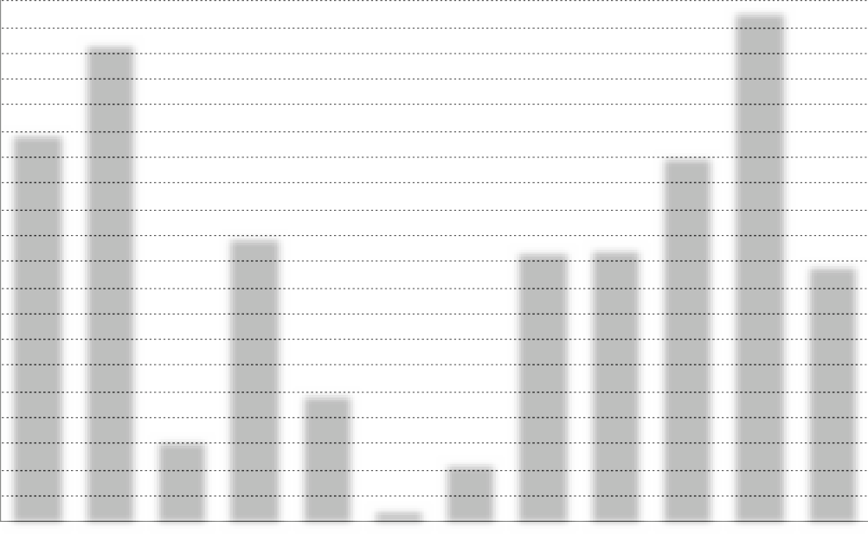
2,2122,274 2,236
1 828 1 928
1 313
1 391
913
761
453
434 340
2 551 3 140 554 1879 850 93 406 1 786 1,800 2,403 3,357 1,693
Jan Feb Mar April May June July Aug Sept Oct Nov Dec SPP generation, kW/h Electricity consumption, kW/h

 | SPP generation, kW/h | Consumption object, kW/h | Purchase from the network, kWh
January | 453 | 2 551 | 2,098
February | 761 | 3 140 | 2 379
March | 1 313 | 554 | -
April | 1 828 | 1 879 | 51
May | 2,212 | 850 | -
June | 2,274 | 93 | -
July | 2 236 | 406 | -
August | 1 928 | 1 786 | -
September | 1 391 | 1,800 | 409
October | 913 | 2 403 | 1 490
November | 434 | 3 357 | 2,923
December | 340 | 1 693 | 1 353
TOTAL: | 16,083 | 20,512 | 10,703

PROJECTED PERFORMANCE INDICATORS OF THE PROJECT
CAPEX (SPP cost) | 394,356.00 | UAH
Power of SPP | 15 | kW
The rate of $ in calculations | 36.65 | UAH
Generation SPP by 1 year | 16,083 | kW/h
Consumption electricity an object | 20,512 | kW/h
Online purchase | 10,703 | kW/h
Coverage of consumption by own SPP | 9,809 | kW/h
The projected amount of electricity that will not be used from its own SPP | 6,274 | kW/h
Estimated price for 1 kWh from the grid | 6 | UAH
Costs for purchasing electricity from the grid after installation of the SPP | 64,218 | UAH
Costs on service by 1 year | 8,000 | UAH
The cost of projected energy consumption from own SPP | 58,854 | UAH
Cost consumption electricity without installed SPP | 123,072 | UAH
Savings of funds after the installation of SPP in the year before full payback | 50,854 | UAH
Payback of the project | 7,8 | Years
The cost of generated electricity after payback | 0.50 | UAH per kWh

SPP 15 KW.

No. 30
Location of SPP: Berezdiv territorial community
Berezdiv Lyceum
Description: Rooftop SPP
Power of the solar field: 12 kW
Inverter power: 10 kW

CALCULATION
Name | Description | K-  St | Costunits | Price
1. Solar panel | Risen 550W | 22 | 8,282.90 ₴ | 180,717.82 ₴
2. Electricity inverter | Solis S5-GR3P10K | 1 | 53,142.50 ₴ | 53,142.50 ₴
3. The controller for the export of electricity to the network | Solis EPM3-5G  plus | 1 | 23,199.45 ₴ | 23,199.45 ₴
4. Assembly structure
Type of metal construction | aluminum | 1 | 11,994.55 ₴ | 11,994.55 ₴
5. Electrical products
cable | AVVG4X16 | 10 | 600.00 ₴ | 600.00 ₴
cable for solar panels | KBE | 100 | 40.00 ₴ | 4,000.00 ₴
automatics protection DC | ETI fuSPP,  shield ETI | 1 | 3,500.00 ₴ | 3,500.00 ₴
automatics protection AC | shield ETI, automatichull Hager,Shnider SSRIs | 1 | 3,600.00 ₴ | 3,600.00 ₴
switching facilities | MC4 connectors, tips, copper wire, grounding  bus | 1 | 2,300.00 ₴ | 2,300.00 ₴
6. Consumables |  | 1 | 2,800.00 ₴ | 2,800.00 ₴
7. Transportation |  | 1 | 4,500.00 ₴ | 4,500.00 ₴
8. Assembly works |  | 1 | 33,600.00 ₴ | 33,600.00 ₴
9. Design and estimate documentation |  | 1 | 12,000.00 ₴ | 12,000.00 ₴
CAPEX |  |  | Total: | 335,954.31 ₴

CAPEX
SPP 12 KW.

INDICATORS GENERATIONS AND CONSUMPTION
SPP 12 KW.

6,900

6,210

5,520

4,830

4 140

3,450

2,760

2,070

1,380

690

0
SCHEDULE OF SPP GENERATION AND ELECTRICITY CONSUMPTION BY THE FACILITY

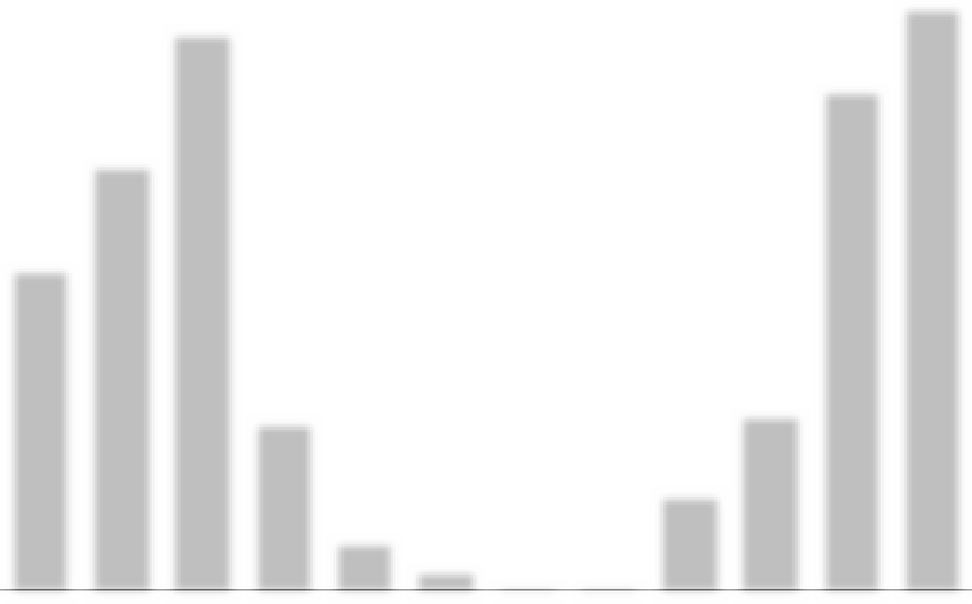
1 488
1,812 1,860 1,836 1,656
1,080
1 176
372
624
756
384
324
3,820 5,012 6,575 2,010 595 267 88
90 1 140 2 085 5 927 6 884
Jan Feb Mar April May June July Aug Sept Oct Nov Dec SPP generation, kW/h Electricity consumption, kW/h

 | SPP generation, kW/h | Consumption object, kW/h | Purchase from the network, kWh
January | 372 | 3,820 | 3 448
February | 624 | 5,012 | 4,388
March | 1,080 | 6,575 | 5,495
April | 1 488 | 2010 | 522
May | 1 812 | 595 | -
June | 1 860 | 267 | -
July | 1 836 | 88 | -
August | 1 656 | 90 | -
September | 1 176 | 1 140 | -
October | 756 | 2,085 | 1 329
November | 384 | 5,927 | 5,543
December | 324 | 6,884 | 6,560
TOTAL: | 13,368 | 34,493 | 27285

PROJECTED PERFORMANCE INDICATORS OF THE PROJECT
CAPEX (SPP cost) | 335,954.31 | UAH
Power of SPP | 12 | kW
The rate of $ in calculations | 36.65 | UAH
Generation SPP by 1 year | 13,368 | kW/h
Consumption electricity an object | 34,493 | kW/h
Online purchase | 27,285 | kW/h
Coverage of consumption by own SPP | 7,208 | kW/h
The projected amount of electricity that will not be used from its own SPP | 6 160 | kW/h
Estimated price for 1 kWh from the grid | 6 | UAH
Costs for purchasing electricity from the grid after installation of the SPP | 163,710 | UAH
Costs on service by 1 year | 7,000 | UAH
The cost of projected energy consumption from own SPP | 43,248 | UAH
Cost consumption electricity without installed SPP | 206,958 | UAH
Savings of funds after the installation of SPP in the year before full payback | 36,248 | UAH
Payback of the project | 9.3 | years
The cost of generated electricity after payback | 0.52 | UAH per kWh

SPP 12 KW.

No31
Location of SPP: Dunayevtsi territorial community. SE "Miskwodokanal" Treatment plant
Description: Rooftop SPP
Power of the solar field: 30 kW
Inverter power: 30 kW

CALCULATION
Name | Description | K-  St | Costunits | Price
1. Solar panel | Risen 550W | 55 | 8,466.15 ₴ | 461,790.00 ₴
2. Electricity inverter | SolisS5-GC30K | 1 | 76,965.00 ₴ | 76,965.00 ₴
3. The controller for the export of electricity to the network | Solis EPM3-5G  plus | 1 | 23,199.45 ₴ | 23,199.45 ₴
4. Assembly structure
Type of metal construction | aluminum | 1 | 39,981.82 ₴ | 39,981.82 ₴
5. Electrical products
cable | AVVG4X25 | 10 | 800.00 ₴ | 800.00 ₴
cable for solar panels | KBE | 200 | 40.00 ₴ | 8,000.00 ₴
automatics protection DC | ETI fuSPP,  shield ETI | 1 | 5,000.00 ₴ | 5,000.00 ₴
automatics protection AC | shield ETI, automatichull Hager,Shnider SSRIs | 1 | 5,500.00 ₴ | 5,500.00 ₴
switching facilities | MC4 connectors, tips, copper wire, grounding  bus | 1 | 3,500.00 ₴ | 3,500.00 ₴
6. Consumables |  | 1 | 4,000.00 ₴ | 4,000.00 ₴
7. Transportation |  | 1 | 10,000.00 ₴ | 10,000.00 ₴
8. Assembly works |  | 1 | 84,000.00 ₴ | 84,000.00 ₴
9. Design and estimate documentation |  | 1 | 12,000.00 ₴ | 12,000.00 ₴
CAPEX |  |  | Total: | 734,736.27 ₴

CAPEX
SPP 30 KW.

INDICATORS GENERATIONS AND CONSUMPTION
SPP 30 KW.

32,000
30,000 30,000 30,000 30,000 30,000 30,000 30,000 30,000 30,000 30,000 30,000 30,000
2,700
3,7204,530 4,650 4,590 4,140
2,940
930
January
1,560
February
1 890 960
Mar
Apr
May
June
July
Aug
Sept Oct Nov
810
Dec

28,800

25,600

22,400

19,200

16,000

12,800

9,600

6,400

3,200

0
SCHEDULE OF SPP GENERATION AND ELECTRICITY CONSUMPTION BY THE FACILITY

SPP generation, kW/h Electricity consumption, kW/h

 | SPP generation, kW/h | Consumption object, kW/h | Purchase from the network, kWh
January | 930 | 30,000 | 29,070
February | 1,560 | 30,000 | 28,440
March | 2,700 | 30,000 | 27,300
April | 3,720 | 30,000 | 26,280
May | 4,530 | 30,000 | 25,470
June | 4,650 | 30,000 | 25,350
July | 4,590 | 30,000 | 25,410
August | 4 140 | 30,000 | 25,860
September | 2,940 | 30,000 | 27,060
October | 1 890 | 30,000 | 28 110
November | 960 | 30,000 | 29,040
December | 810 | 30,000 | 29,190
TOTAL: | 33,420 | 360,000 | 326,580

PROJECTED PERFORMANCE INDICATORS OF THE PROJECT
CAPEX (SPP cost) | 734,736.27 | UAH
Power of SPP | 30 | kW
The rate of $ in calculations | 36.65 | UAH
Generation SPP by 1 year | 33,420 | kW/h
Consumption electricity an object | 360,000 | kW/h
Online purchase | 326,580 | kW/h
Coverage of consumption by own SPP | 33,420 | kW/h
The projected amount of electricity that will not be used from its own SPP | 0 | kW/h
Estimated price for 1 kWh from the grid | 6 | UAH
Costs for purchasing electricity from the grid after installation of the SPP | 1,959,480 | UAH
Costs on service by 1 year | 17,000 | UAH
The cost of projected energy consumption from own SPP | 200,520 | UAH
Cost consumption electricity without installed SPP | 2,160,000 | UAH
Savings of funds after the installation of SPP in the year before full payback | 183,520 | UAH
Payback of the project | 4.0 | Years
The cost of generated electricity after payback | 0.51 | UAH per kWh

SPP 30 KW.

No. 32
Location of SPP: City SE “Misksvitlo” Admin building
Description: Rooftop SPP
Power of the solar field: 12 kW
Inverter power: 10 kW

CALCULATION
Name | Description | K-  St | Costunits | Price
1. Solar panel | Risen 550W | 22 | 8,282.90 ₴ | 180,717.82 ₴
2. Electricity inverter | Solis S5-GR3P10K | 1 | 53,142.50 ₴ | 53,142.50 ₴
3. The controller for the export of electricity to the network | Solis EPM3-5G  plus | 1 | 23,199.45 ₴ | 23,199.45 ₴
4. Assembly structure
Type of metal construction | aluminum | 1 | 11,994.55 ₴ | 11,994.55 ₴
5. Electrical products
cable | AVVG4X16 | 10 | 600.00 ₴ | 600.00 ₴
cable for solar panels | KBE | 100 | 40.00 ₴ | 4,000.00 ₴
automatics protection DC | ETI fuSPP,  shield ETI | 1 | 3,500.00 ₴ | 3,500.00 ₴
automatics protection AC | shield ETI, automatichull Hager,Shnider SSRIs | 1 | 3,600.00 ₴ | 3,600.00 ₴
switching facilities | MC4 connectors, tips, copper wire, grounding  bus | 1 | 2,300.00 ₴ | 2,300.00 ₴
6. Consumables |  | 1 | 2,800.00 ₴ | 2,800.00 ₴
7. Transportation |  | 1 | 4,500.00 ₴ | 4,500.00 ₴
8. Assembly works |  | 1 | 33,600.00 ₴ | 33,600.00 ₴
9. Design and estimate documentation |  | 1 | 12,000.00 ₴ | 12,000.00 ₴
CAPEX |  |  | Total: | 335,954.31 ₴

CAPEX
SPP 12 KW.

INDICATORS GENERATIONS AND CONSUMPTION
SPP 12 KW.

3,400

3,060

2,720

2,380

2,040

1,700

1 360

1,020

680

340

0
SCHEDULE OF SPP GENERATION AND ELECTRICITY CONSUMPTION BY THE FACILITY

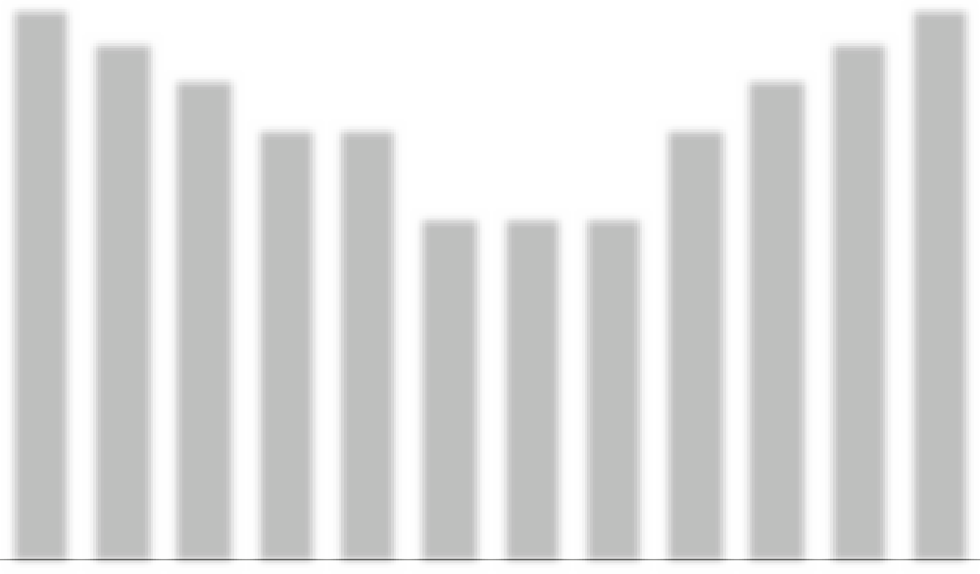
1 812
1 860
1 836
1 656
1 488
1,080
1 176
756
624
372
384
324
3,200 3000 2800 2500 2500 2000 2000 2000 2500 2800 3000 3200
Jan Feb Mar April May June July Aug Sept Oct Nov Dec SPP generation, kW/h Electricity consumption, kW/h

 | SPP generation, kW/h | Consumption object, kW/h | Purchase from the network, kWh
January | 372 | 3,200 | 2,828
February | 624 | 3,000 | 2 376
March | 1,080 | 2,800 | 1,720
April | 1 488 | 2,500 | 1 012
May | 1 812 | 2,500 | 688
June | 1 860 | 2,000 | 140
July | 1 836 | 2,000 | 164
August | 1 656 | 2,000 | 344
September | 1 176 | 2,500 | 1 324
October | 756 | 2,800 | 2 044
November | 384 | 3,000 | 2,616
December | 324 | 3,200 | 2,876
TOTAL: | 13,368 | 31,500 | 18 132

PROJECTED PERFORMANCE INDICATORS OF THE PROJECT
CAPEX (SPP cost) | 335,954.31 | UAH
Power of SPP | 12 | kW
The rate of $ in calculations | 36.65 | UAH
Generation SPP by 1 year | 13,368 | kW/h
Consumption electricity an object | 31,500 | kW/h
Online purchase | 18 132 | kW/h
Coverage of consumption by own SPP | 13,368 | kW/h
The projected amount of electricity that will not be used from its own SPP | 0 | kW/h
Estimated price for 1 kWh from the grid | 6 | UAH
Costs for purchasing electricity from the grid after installation of the SPP | 108,792 | UAH
Costs on service by 1 year | 7,000 | UAH
The cost of projected energy consumption from own SPP | 80,208 | UAH
Cost consumption electricity without installed SPP | 189,000 | UAH
Savings of funds after the installation of SPP in the year before full payback | 73 208 | UAH
Payback of the project | 4.6 | years
The cost of generated electricity after payback | 0.52 | UAH per kWh

SPP 12 KW.

No33
Location of SPP: City SE “Misksvitlo” Workshop
Description: Rooftop SPP
Power of the solar field: 3.3 kW
Inverter power: 5 kW

CALCULATION
Name | Description | K-  St | Costunits | Price
1. Solar panel | Risen 550W | 6 | 8,282.90 ₴ | 49,697.40 ₴
2. Electricity inverter | Solis S5-GR3P10K | 1 | 53,142.50 ₴ | 53,142.50 ₴
3. The controller for the export of electricity to the network | Solis EPM3-5G  plus | 1 | 23,199.45 ₴ | 23,199.45 ₴
4. Assembly structure
Type of metal construction | aluminum | 1 | 3,298.50 ₴ | 3,298.50 ₴
5. Electrical products
cable | AVVG4X16 | 10 | 600.00 ₴ | 600.00 ₴
cable for solar panels | KBE | 20 | 40.00 ₴ | 800.00 ₴
automatics protection DC | ETI fuSPP,  shield ETI | 1 | 2,500.00 ₴ | 2,500.00 ₴
automatics protection AC | shield ETI, automatichull Hager,Shnider SSRIs | 1 | 2,600.00 ₴ | 2,600.00 ₴
switching facilities | MC4 connectors, tips, copper wire, grounding  bus | 1 | 1,800.00 ₴ | 1,800.00 ₴
6. Consumables |  | 1 | 1,500.00 ₴ | 1,500.00 ₴
7. Transportation |  | 1 | 2,500.00 ₴ | 2,500.00 ₴
8. Assembly works |  | 1 | 9,240.00 ₴ | 9,240.00 ₴
9. Design and estimate documentation |  | 1 | 12,000.00 ₴ | 12,000.00 ₴
CAPEX |  |  | Total: | 162,877.85 ₴

CAPEX
SPP 3.3 KW.

INDICATORS GENERATIONS AND CONSUMPTION
SPP 3.3 KW.

550

495

440

385

330

275

220

165

110

55

0
SCHEDULE OF SPP GENERATION AND ELECTRICITY CONSUMPTION BY THE FACILITY

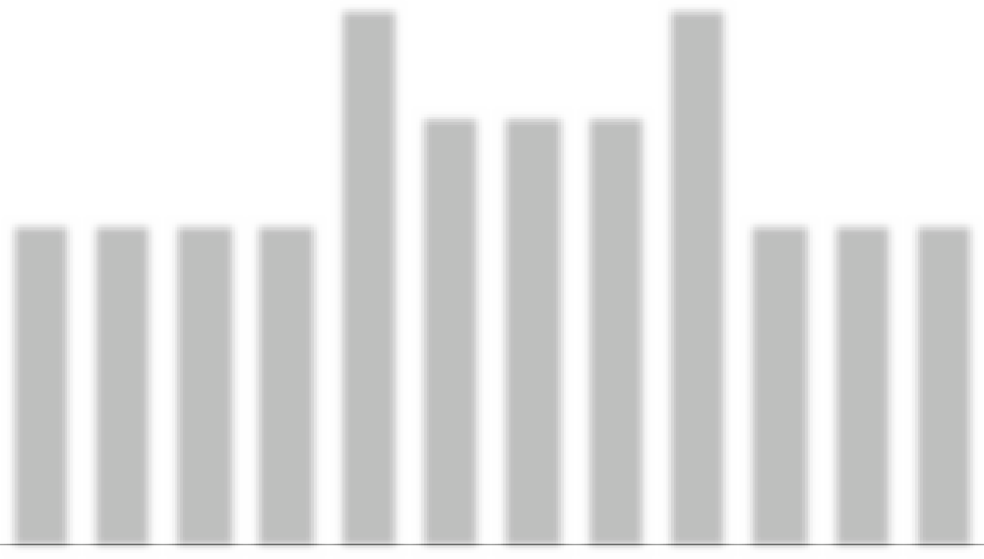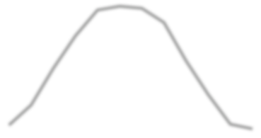
498
511
504
455
409
323
297
207
171
102
105 89
300 300 300 300 500 400 400 400 500 300 300 300
Jan Feb Mar April May June July Aug Sept Oct Nov Dec SPP generation, kW/h Electricity consumption, kW/h

 | SPP generation, kW/h | Consumption object, kW/h | Purchase from the network, kWh
January | 102.3 | 300 | 197.7
February | 171.6 | 300 | 128.4
March | 297 | 300 | 3
April | 409.2 | 300 | -
May | 498.3 | 500 | 1.7
June | 511.5 | 400 | -
July | 504.9 | 400 | -
August | 455.4 | 400 | -
September | 323.4 | 500 | 176.6
October | 207.9 | 300 | 92.1
November | 105.6 | 300 | 194.4
December | 89.1 | 300 | 210.9
TOTAL: | 3,676.2 | 4,300 | 1004.8

PROJECTED PERFORMANCE INDICATORS OF THE PROJECT
CAPEX (SPP cost) | 162,877.85 | UAH
Power of SPP | 3.3 | kW
The rate of $ in calculations | 36.65 | UAH
Generation SPP by 1 year | 3,676.2 | kW/h
Consumption electricity an object | 4,300 | kW/h
Online purchase | 1,004.8 | kW/h
Coverage of consumption by own SPP | 3,295.2 | kW/h
The projected amount of electricity that will not be used from its own SPP | 381 | kW/h
Estimated price for 1 kWh from the grid | 6 | UAH
Costs for purchasing electricity from the grid after installation of the SPP | 6,028.8 | UAH
Costs on service by 1 year | 2,500 | UAH
The cost of projected energy consumption from own SPP | 19,771.2 | UAH
Cost consumption electricity without installed SPP | 25,800 | UAH
Savings of funds after the installation of SPP in the year before full payback | 17,271.2 | UAH
Payback of the project | 9.4 | years
The cost of generated electricity after payback | 0.68 | UAH per kWh

SPP 3.3 KW.

