Ministry of Education and Science of Ukraine
Ukrainian-American Concordia University
Department of International Economic Relations, Business & Management

Complex professional qualification practice
Practice Report
(on the basis LPP )

Bachelor’s student of  Field of Study 29 – International Relations  Specialty 292 – International Economic Relations  Educ. program – International Business | (First Name, Last Name)  ______________________________  (signature)
Research supervisor | ______________________________  (First Name, Last Name)  Doctor of Philosophy  (academic degree, full name)  ____________________________  (signature)

Kyiv – 2022

Table of context
Introduction 3
1. General information about the company 5
1.1. History 5
1.2. Shops and distribution centres 6
1.3. Production 6
2. Some awards and honours 7
2.1. Production in Asia, control of the supply chain and the ACCORD agreement 9
2.2. LPP as a taxpayer 10
2.3. Some of LPP's environmental activities 11
2.4. Functions of the manager, administrator, sales consultant 11
3. Finance 12
3.1. Turnover 12
3.2. The main objectives of the enterprise's turnover analysis: 15
4. Human resources management 16
4.1 Human resources and pay 16
5. Forms, methods of selling and their effectiveness 18
5.1. Omnichannel-Organization 19
5.2. Development through brands 20
5.3. Development through offline and online retail network expansion 20
5.4. Digitalization of organization 22
5.5. Sustainable development 22
6. Finance 2 23
6.1. LPP in numbers 23
6.2. LPP - AREA EXPANSION IN THOUSANDS OF M2 (2012-2021) 24
6.3. THE DEVELOPMENT OF LPP SHOP NETWORK (2012-2021) 24
6.4. SALES (MLN PLN) (2012-2021) 25
6.5. NET PROFIT (MLN PLN) (2012-2021) 26
7. Headquarets, offices and logistics 26
8. DISTRIBUTION CENTRES 28
9. FULFILMENT CENTRES 29
Conclusion 30
References 31

Introduction
Work experience is an important part of the educational process. The student receives deepening and consolidation of knowledge and professional skills acquired during the course of study through the study of practical situations.
The goal of industrial practice is to put economic knowledge gained during core discipline study into practice by utilizing modern regulatory, organizational, managerial, and economic documents of various levels and nature that are available in the enterprise's economic services.
Trade is a significant economic sector. It contributes significantly to the country's tax revenue and employs a large number of people. According to data, this sector employs roughly half of all Ukrainian small businesses. Retailers work hard to meet public demand for goods and services.
Since antiquity, sellers have been in high demand. Salespeople now work not only in stores and markets, but also online.
A salesperson offers a wide range of services to a customer. His job is to help customers make purchases and choose goods as quickly and easily as possible, as well as to determine their weight, price, and subsequent packaging.
The sales assistant is likely to be very familiar with the product in question and will explain it to the potential buyer in an understandable manner. He actively participates in the selection process by highlighting the best features of specific products.
The salesperson is familiar with using a computerized cash register and accepting credit and other bank cards. In addition, they must examine expiration dates, price lists, and inventory.
They must have good communication skills and the ability to approach customers, whether they work as a cashier or a sales assistant. As a result, this job is best suited for people who speak English fluently. Furthermore, salespeople must frequently be attentive, responsible, and adaptable.
Politeness, assertiveness, stress resistance, language ability, and a proactive attitude are all required.You cannot succeed without a thorough understanding of sales psychology.
The average salesperson is between the ages of 18 and 40. After 50 years, it is difficult to find work. Because of the nature of the work, this is the case. The majority of the shift must be spent on one's feet. It is a major challenge for the elderly. Because salespeople are financially responsible individuals, employers are wary of hiring people under the age of 18.
A sales assistant must have three qualifications: junior salesperson, salesperson, and senior salesperson.
You can advance to the position of administrator or even director of a sales company with ongoing training.
At the CZN job base in Kiev, there are currently over 700 job openings for salesmen, with salaries ranging from 32,000 to 32 thousand uah.
For reference:
As far back as the Soviet Union, there was a "Day of Trade, Consumer Services, and Communal Services Workers." Since 1966, it has been observed on the last Sunday of July. In 1988, the day was moved to the third Sunday of March.
According to the Presidential Decree, "Trade Workers' Day" became an independent holiday in Ukraine in 2013, and its new date - the fourth Saturday of July - was established.
The date will be July 31, 2022.
On this day, organizations typically award certificates of merit and bonuses to their best employees, as well as host corporate parties.

General information about the company

History
Marek Piechocki and Jerzy Lubaniec established a clothing business in Gdask in 1991. The company, which was originally known as PH Mistral s.c., was renamed LPP four years later (an acronym for Lubianiec, Piechocki I Partnerzy).
The company officially opened an office in Shanghai in 1997. At the end of the 1990s, LPP's owners decided to create the first Reserved brand and launch a retail chain. The first stores of this brand, which serves as the flagship for the LPP Group, opened in 1998.
LPP debuted on the Warsaw Stock Exchange in 2001. The Reserved brand was promoted in Central and Eastern European markets for the next two years. Russia, Estonia, the Czech Republic, Latvia, and Hungary opened stores in 2002, followed by Lithuania, Ukraine, and Slovakia in 2003. Because of the brand's success, the company expanded its portfolio and opened a Cropp shop in Poland in 2004. In the years that followed, the company expanded the brand to Estonia, Slovakia, and Latvia (2005), as well as Lithuania, Russia, and the Czech Republic (2006). In 2007-2008, the company concentrated its efforts on expanding into the Romanian and Bulgarian markets. LPP's distribution center in Pruszcz Gdaski was opened in 2008. Artman, the owner of the House and Mohito brands, merged with Krakow-based Artman the same year. LPP became the largest clothing chain in Poland and the owner of four brands as a result of this transaction. The Sinsay brand was added to the company's portfolio in 2012-2013.
The company was added to the WIG20 stock index in 2014, and the flagship Reserved brand entered the German market. The same year, Croatia saw the debut of all LPP products in the Balkans. The following year saw the company's entry into the Middle Eastern markets. At the end of 2017, LPP's sales network included over 1,700 stores covering a total area of 1 million square meters. In 2017, LPP's product department office in Warsaw opened, and the Reserved, Cropp, and House brands debuted in Belarus and Serbia. LPP opened a shop on Oxford Street in London in 2017. LPP shops debuted in new markets in 2018, including Israel, Kazakhstan, and Slovenia. The company opened its first stores in Bosnia and Herzegovina and Finland in 2019.

Shops and distribution centres
LPP has a sales network of over 2,000 stores across five clothing brands. The products sold under these brands are available in 26 countries.
In Pruszcz Gdaski, LPP owns the largest and most modern clothing distribution center in Central and Eastern Europe. LPP opened a new warehouse in "SEGRO Logistics Park Stryków" near ód in 2017 to handle online orders for LPP brand clothing. Arvato manages this facility. Simultaneously, LPP opened a similar facility near Moscow.
As a result of the company's continued dynamic development of its offline shop network and online sales network, the company announced in 2019 that it had opened a warehouse in Romania to handle online orders. A year later, the company signed a contract to lease warehouse space in Slovakia to serve customers of the company's online shops in Slovakia, the Czech Republic, Hungary, Slovenia, Croatia, and Bosnia and Herzegovina.
In 2021, the company will begin construction on a distribution center in Brzez Kujawski, as well as warehouses dedicated to e-commerce in Moscow and Pruszcz Gdaski. The company's modern warehouse infrastructure enables it to sell and distribute over 259 million pieces of clothing and accessories per year.

Production
LPP does not have its own production facilities. The clothing brands of the group are made primarily in Asia, but also in Poland and other European countries, particularly Italy, Portugal, Romania, Bulgaria, and Turkey. In 1997, the company opened an office in Shanghai, and since 2015, it has also had a presence in Dhaka, Bangladesh's capital. These offices' employees are in charge of sourcing and supporting.
Coordination and monitoring of all production phases, as well as quality control

Some awards and honours
- 2001: Award from Puls Biznesu newspaper - "Gazele Biznesu" - for LPP as one of the most dynamically developing companies
- 2002: Award from Giełdy Parkiet newspaper - "Best Managed Stock Exchange Company" (Najlepiej Zarządzana Spółka Giełdowa)
- 2003: Award for Business of the President of the Republic of Poland - "The Best Polish Enterprise" (Najlepsze Polskie Przedsiębiorstwo)
- 2004: Rzeczpospolita weekly magazine award - "Eagle of the Polish-Lithuanian Commonwealth" (Orzeł Rzeczpospolitej)
- 2004: Best Retailer of the Year in Central and Eastern Europe
- 2008: Rzeczpospolita weekly magazine's "Eagle of Rzeczpospolita" award
- 2008: Puls Biznesu daily award - Pillars of the Polish Economy (Filary Polskiej Gospodarki)
- 2008: Award of weekly paper Rzeczpospolita - Rating of the most valuable Polish brands
- 2009: Award from Puls Biznesu daily - Exchange Company of the Year (Giełdowa Spółka Roku) - Investor Relations
- 2011: Award from Puls Biznesu - Exchange Company of the Year (Giełdowa Spółka Roku): First place in the main ranking, category "Management competence", category "Success in 2011
- 2012: Giełdy Parkiet Newspaper Award - "mWIG40 Company of the Year" (Spółka Roku mWIG40)
- 2013: Forbes Monthly Award - "Diamonds
- 2013: Rzeczpospolita weekly magazine award - "Good Company" (Dobra Firma)
- 2014: Polish Agency for Enterprise Development (PARP) Award - "Employer of Tomorrow" (Pracodawca Jutra)
- 2015: Award from Giełdy Parkiet newspaper - ranking of companies with the best investor relations - 1st place
- 2015: Ranking of American monthly magazine Forbes - Most Innovative Growth Companies
- 2015: Ranking of the 200 largest Polish companies 2017 by Wprost weekly
- 2016: "Construction Company of the Year 2015" (Budowa Roku 2015) - competition organized by the Ministry of Construction, the Polish Union of Construction Engineers and Technicians and the General Directorate of Construction Supervision
- 2016: "Decade Award" (Nagroda dziesięciolecia) - Rzeczpospolita and Deloitte ranking
- 2017: Award from Forbes monthly magazine
- 2017: "Polish Company - International Champion" (Polska Firma - Międzynarodowy Czempion): Award from Puls Biznesu Editorial Board, Award in the category "Exporter: Polish Private Company - Large Enterprise" (Eksporter: Polska Firma Prywatna - duże przedsiębiorstwo)
- 2018: Rzeczpospolita Weekly Awards - Ranking of the Most Valuable Polish Brands: first place Reserved, third place House, fourth place Cropp
- 2018: 3rd place in the Investor Relations Survey of WIG30 companies according to institutional investors
- 2019: "National Success" - during "Congress 590", one of the biggest annual economic forums in Poland, at the President of the Republic of Poland's business awards ceremony the company was awarded in the "National Success" (Narodowy Sukces) category.9
- 2020: In the Digital Excellence competition, which recognizes companies that are driving digital transformation, LPP was awarded Digital Excellence in the Digital Capabilities category.
- 2020: Eagle of Innovation - an award from the newspaper Rzeczpospolita.
- 2020: Green Eagle - awarded by the newspaper Rzeczpospolita

Production in Asia, control of the supply chain and the ACCORD agreement
LPP has been working systematically since 2013 to implement standards to ensure safety and working conditions in Asia's garment industry. Since 2014, all LPP suppliers have been subject to a Code of Conduct. The document incorporates the main provisions of the International Labour Organization Convention and the Universal Declaration of Human Rights and establishes supplier requirements such as wage policies, the prohibition of child labor, the principle of voluntary work, freedom of association, and health and safety regulations. In order to increase oversight of factories manufacturing products for LPP in Bangladesh, the company decided to commission international auditors, SGS, to verify actual compliance with the Code of Conduct by suppliers in Bangladesh, in addition to monitoring its own inspectors.[1]
Furthermore, in October 2013, LPP, the only Polish apparel company, joined the ACCORD agreement aimed at improving safety in Bangladeshi garment factories (Accord on Fire and Building Safety in Bangladesh). Thanks to the signatories' cooperation and financial support, over 1,600 Asian factories and ateliers have been monitored. In addition, the ACCORD agreement has facilitated repair programs in over 90% of factories (as of the end of 2017). One of the agreement's key projects, the Safety Committee Training program, delivered 882 training sessions by the end of 2017, reaching approximately 1.2 million workers.
The LPP renewed the agreement, known as the Transition ACCORD, for another three years in early 2018. Its primary goal is to prepare the Bengal government to conduct self-inspection and audits in factories, as well as to ensure that long-term measures to improve working conditions are implemented. The former ACCORD initiative was replaced on September 1, 2021, by a new initiative called the International Accord for Health and Safety in the Textile and Garment Industry (short: International Accord). It aims to continue and expand the collaborative efforts of the agreement's signatories with trade unions to ensure the safety of garment factories.

LPP as a taxpayer
According to a report by the Ministry of Finance in 2018, LPP ranked third among Poland's largest payers of corporate income tax in the area of trade.
Table 1
Year | Revenue (PLN billion) | Profit (mln PLN) | NPC (mln PLN)
2021 | 8,2 | 850 | 108
2020 | 6,9 | 1044 | 144,8
2019 | 6,1 | 536 | 41
2018 | 5,2 | 243 | 6
2017 | 4,8 | 419 | 44
2016 | 4,4 | 622 | 86
2015 | 3,8 | 542 | 87
2014 | 3 | 393 | 57
Corporate social responsibility and charitable activities
LPP has worked for people in need and local communities since its inception. 1 LPP also established the LPP Foundation in December 2017. Its mission is to assist people at risk of social exclusion, to assist people in difficult life situations, and to protect people's health.
Caring for the environment
LPP implements environmentally conscious measures at all stages of its operations, from the selection of raw materials from which clothes are made, to sales, to the operation of the company's offices and logistics facilities.

Some of LPP's environmental activities
- the introduction of the Eco Aware range in the collections of the flagship Reserved brand, made from sustainable materials (organic cotton, TencelTM lyocell, EcoVeroTM, certified linen);
- the announcement of the introduction of eco-lines in the collections of all brands owned by LPP from 2019;
- The abandonment of the use of natural fur and angora wool in the production of garments;
- a statement on eliminating the use of mohair by 2020 or obtaining it in a humane way;
- introduction of recycled cardboard for online sales of Reserved and Mohito collections;
- Reducing electricity consumption in LPP's new showrooms through the use of modern HVAC equipment and advanced LED lighting;
- conducting energy audits in LPP offices and shops;
- Launching a programme to collect used clothing and donate it to the homeless as part of activities related to relief, environmental protection and giving a second life to textiles;
- Joining the New Plastics Economy Global Commitment initiative and committing to eliminate plastic packaging that cannot be reused, recycled or composted by 2025;
- announcement of a new sustainable development strategy For People for Our Planet 2020-2025.
- Accession to the Polish Plastic Pact.
Accession to the global Zero Discharge Hazardous Chemicals initiative to ensure chemical safety in the apparel industry. .[3]

Functions of the manager, administrator, sales consultant
Managers are primarily responsible for the shop's sales volume and profits, and the figures they achieve serve as the primary criterion for evaluating the managers' performance. Even in national retail chains, they operate as independent business owners within the same corporation. Managers must train employees who are capable of taking on additional responsibility and are deserving of higher positions.
The receptionist keeps a separate location and ensures that all employees are aware of the contents of regulations, directives, orders, and job descriptions; he or she also keeps a record of cash transactions and other reports. When receiving goods, the administrator checks expiry dates and ensures that storage conditions are strictly followed. He takes all necessary steps to dispose of expired products or return them to the supplier when necessary. He or she must also modify working conditions, observe employee rights and obligations, and ensure that working hours are adhered to. To skillfully direct the activities of their subordinates, the administrator must have an excellent knowledge of the Ukrainian Labour Code, an understanding of collective work organization, a combination of professions, employee appraisal, and much more. The supervisor is responsible for ensuring that internal regulations are followed as well as strictly controlling the absence of violations of occupational health and hygiene, fire safety, and civil defense regulations. A sales assistant is a salesperson who advises customers as well as dispenses goods from a display case. The specialist advises the buyer on which product to purchase, answers his questions, and assists him in making the best decision. Following the client's approval, the seller packs and ships the goods and issues a warranty card.
One of the fundamental skills of a sales assistant is the ability to communicate effectively with customers, keeping in mind that you must sell a product or service rather than simply "talk for a living." .[4]

Finance

Turnover
The volume of goods sold by a retail organization in monetary terms over a given time period is referred to as trade turnover.
Analysis of trade turnover enables one to assess the compliance of available goods with population demand in order to take measures to optimize the structure of trade turnover, increase sales, accelerate trade turnover, and improve the rhythm and uniformity of sales. Turnover is classified as wholesale, retail, or catering.Retail turnover is the volume of sales expressed in monetary terms to the population to meet their personal needs, as well as the implementation of goods to various institutions, organizations, enterprises (rest homes and sanatoriums, etc.) for the contingents served by them.
Relationships involving the exchange of money for goods express the economic essence of retail turnover. Retail turnover characterizes the completion of the circulation process by transferring goods to final consumers. Goods from the circulation sphere enter the consumption sphere and become the consumer's property.
Through retail circulation, the value of goods changes form. As a result, the conditions for further production development are created.
The most important indicator of a trading company is retail turnover. It is the outcome of a trading company's activity and determines the amount of gross revenue and profit, which characterizes the efficiency of trading activitiesThe importance of a given enterprise in the consumer goods market can be measured by its turnover, which is expressed in cash proceeds for goods sold.
Turnover can be classified according to quantity and quality.
The qualitative characteristic of turnover is related to the turnover structure, i.e. the assortment composition, whereas the quantitative characteristic is determined by the company's monetary sales volume.
Retail turnover is made up of the following components:
Revenues from the sale of food and non-food products via the retail trade network (shops, stalls, tents), a vending machine network, or the use of take-away or carry-out trade;
- The sale of goods to the public on credit with payment by instalments;
- The turnover of catering enterprises selling semi-finished goods, home-made products and purchased goods
- sale of printed publications;
- sale of goods to various organizations, institutions and enterprises for their non-productive consumption and other types of sales.
The turnover of a trade enterprise is characterized by the following indicators: the volume of turnover in value terms in current and comparable prices, assortment structure by product groups (in Uah and percentages), one-day turnover, turnover per employee, including the employee of the counter (trade group), the circulation time of goods in days, and the turnover rate (number of turns).
Turnover analysis aids in identifying key qualitative and quantitative indicators of the trade organization in the current period. The correctness of the analysis's conclusions is dependent on the economic feasibility of calculations for the coming period, according to the analysis.
According to the analysis results, it can be judged to what extent sales forecasts are met and customer demand is satisfied, what caused the changes in turnover in the reporting period, and to assess the degree of compliance of the company's actual results with the planned strategy.
The primary sources of information for turnover analysis are accounting, statistical, and operational reporting data. It starts with calculating the volume of turnover in monetary or physical terms for a given time period (decade, month, quarter, half-year, year). The reported figures are compared to the projected figures for these time periods.
Regularities in the turnover's development are identified by analyzing it. To that end, the turnover dynamics in current and comparable prices are computed.
The primary indicators of an enterprise's activity are the volume of production and sold products. Sales volume is critical for establishing standardised cost items such as advertising costs, entertainment expenses, and tax calculations. In economic terms, the volume of products sold characterizes the enterprise's final financial result, the fulfillment of its obligations to consumers, and the degree of participation in satisfying market needs. The rate of increase in production and sales volume, as well as the improvement in quality, have an impact on the amount of costs, profit, and profitability of the enterprise. As a result, analyzing these indicators is critical. .[5], [6].

The main objectives of the enterprise's turnover analysis:
- To evaluate the plan's implementation, dynamics, and product sales;
- To determine the influence of factors on the change of these indicators;
- Research into the composition, structure, and assortment of sold products;
- Research into product quality and competitiveness; - Evaluation of completeness and production rhythm;
- Identifying intrafarm reserves in order to increase output and product sales;
- Developing measures to develop the identified reserves.
The data base for analyzing the volume of product realization is:
- Form No.2 of the accounting reports "Profit and Loss Statement";
- Various types of supporting documentation;
Thus, complete and accurate accounting and in-depth analysis of the movement of goods allows the trade organization to influence the speed of trade capital turnover, prevent overstocking, control the preservation of goods, avoid shortages, and, ultimately, maximize profits.
Because the volume of sales is the end result of the enterprise as a production complex, revenue analysis is performed for the enterprise as a whole, as well as in the context of its structural units or product types, and by its separate business units that conduct independent production activities (shops, branches). Such an analysis makes sense only if the revenue of a specific division can be isolated from the financial flows of the entire enterprise, and if the value of this revenue is significant for the enterprise as a whole. Revenue analysis, like production analysis, would necessitate a significant investment of time by employees from both the analytical services and line departments. As a result, it can only be justified to the extent that it provides useful information for determining the enterprise's and its individual units' prospects.
The analysis of the total turnover plan's implementation is supplemented by an examination of the turnover's commodity structure.
The commodity structure of turnover refers to how individual products and services are distributed in terms of total volume of sale, as expressed by relative values: the share (proportion) of goods and the ratio of goods.[7]
In terms of marketing, the composition of sales of goods reflects market segmentation, allows for the evaluation of the effectiveness of diversification processes, and is also a component of firm competitiveness. With some reservations, the product mix can thus be viewed as a reflection of the structure of the demand sold. The merchandise turnover for the entire enterprise is assumed to be 100 percent, and the relative value of the structure is calculated by dividing the turnover for each product group by the turnover of the shop and multiplying by 100 percent. The total of all the resulting unit weights should be 100%.[8]
A long-standing issue in analyzing commodity turnover structure is determining the size of sales of individual goods in assortment terms. It stems from the fact that, in the absence of a complete and functional accounting system, sales of individual goods are not always recorded. This is especially true for small retail outlets, as well as large non-computerized stores that sell a diverse range of goods.

Human resources management

Human resources and pay
The market's formation has introduced new challenges that cannot be met with outdated assumptions, approaches, and methods. In this regard, the issues of personnel work restructuring are particularly pressing today. In the industry, as well as in other sectors of the economy, the issues of intensification of production, increased efficiency, and better utilization of expensive and scarce human resources have come to the fore and begun to take on critical importance for the survival and adaptation of enterprises to the new economic situation.[9]
Modern technology and production necessitate not only a high level of qualification and executive discipline from employees, but also their creative participation in production and the search for reserves of rationalization. In recent years, many enterprises have been using in their everyday practice a system of competitive replacement of managerial positions and election of managers, increasing expenditure on personnel training, professional selection and occupational guidance, actively cooperating with personnel consulting centres, etc. Measures are being taken to improve personnel management in the country as a whole.[10]
However, these measures are insufficient to improve enterprises' readiness to work in a market environment. In the short term, the entire personnel work system should be restructured, including personnel assessment and attestation, recruitment, training and professional development, and work with the personnel reserve for managerial positions. Simultaneously, it is necessary to significantly improve the professional level of personnel services employees themselves, as well as to increase the real responsibility of managers of all ranks for identifying, developing, and effectively utilizing the potential of their subordinates.[11]
It is the manager's responsibility to create a workforce management concept. The main task in this area is his ability to create conditions for each employee to realize his or her potential, excite people's enthusiasm, and strive to do their jobs to the best of their abilities. Today, it is widely accepted that a manager's ability to work with colleagues, personal qualities, and ability to lead people effectively are almost entirely determinants of business success.. Here, the manager's ability to organize the team's work optimally, communicate with each employee on the basis of current requirements, and find the right tool to influence the individual to resolve problems are especially important.
The participants in the labor process must understand the goals and the means to achieve them in order for effective human resource management to occur in an enterprise. It is a matter of creating a mechanism that allows those who work within the enterprise to influence both the development of activity plans and the methods and means by which the plans are implemented. Such a mechanism can only function properly if the enterprise has a well-functioning communication system that ensures each worker clearly understands his functions both in his personal labor process and in the activities of the entire production team.[12] Simultaneously, it is critical to ensure that human resources are kept up to date on how each participant in the production process perceives and performs his or her work assignments. To put it another way, communication is a tool that human resources can use to influence everyone involved in the work process.

Forms, methods of selling and their effectiveness
The sale of goods with open display is the mode of sale in this shop. The customer has the opportunity to become acquainted with and select the necessary goods on his or her own in this type of sale. The shop assistant advises the customer, assists in the selection of goods, and provides information on care, fabric properties, and so on. In the specially equipped fitting booths, the customer can try on the garments he or she prefers.[13] At the checkout counter, the shop assistant handles the checkout. Following that, the goods are packed and delivered to the buyer. The shop's method of sale is an individual service method in which all transactions take place with the seller's participation.In Monsoon every shop assistant must know 8 rules of service:
1 Every customer must be seen within two minutes of entering the shop. This may include a greeting and a smile.
2 Each unit has a three-hour 'busy window' (the time of highest footfall in the shop).
3 If the customer is holding an item, a member of staff should always approach him or her and offer help.
4 If the customer is trying on an item, the shop assistant should actively work with it.
5 Every customer with whom the shop assistant is actively working should be asked to try on (purchase) another item.
6 if the product needed by the buyer is not currently available, the seller should offer an alternative product, or offer another solution to the situation, for example, offer to call another shop or order the buyer that product.
7 While paying the customer at the cash register, the customer should make a positive comment about his purchase. If possible, this should be an advantage or a nice feature of the product.
8 the salesman should thank and smile at the end of his purchase.
Increased throughput, higher turnover, gross revenue, higher productivity, a broader and deeper assortment, and more space on the sales floor and in the exhibition area all contribute to the economic effect of this form and method of sale. [14]
This type of sale necessitates a special display of goods in order to improve inspection conditions, product selection, and reduce the cost of replenishing working stock.

Omnichannel-Organization
LPP is an omnichannel company that integrates offline and online sales. We are committed to giving our customers the best shopping experience possible, whether they purchase our collections in traditional stores or online. As a result, we develop both channels concurrently while ensuring a consistent presentation of our offer.
The following are our top priorities:
further development of our five clothing brands (Reserved, Cropp, House, Mohito, and Sinsay) in the mid-price range or Affordable Fashion Retail segment, with different target groups in mind; [15]
increased accessibility of our brands’ offer by way of simultaneous development of the traditional retail network and the online offer so that our customers interact with the brand wherever, whenever and however they wish thanks to integrated channels. [16]

Development through brands
We prioritize attracting new customers and increasing existing customer satisfaction. Our Reserved brand and the opening of its first store in 1998 mark the beginnings of our portfolio. We currently manage five brands, each aimed at a different demographic. Our collection includes collections for both men and women, as well as children's and teen clothing.
Reserved, Cropp, House, and Mohito are mid-priced, whereas
Sinsay in the Affordable Fashion Retail segment.
We do not intend to launch any new brands at this time. Our actions are concentrated on the brands that already comprise our portfolio, with a special emphasis on Sinsay. Originally aimed at adolescent girls, the brand now caters to both young women and men. Sinsay also has collections for mothers, as well as children's products and accessories. Sinsay's product line includes home décor items as well as a make-up and skincare line. The market's positive reaction to the new Sinsay concept, combined with the intensive development of the stationary network, primarily in small towns, will result in a gradual increase in Sinsay's share of LPP's brand portfolio over the next few years.

Development through offline and online retail network expansion
Brand development would be incomplete unless we simultaneously expanded our traditional and online retail networks.
We intend to diversify Group revenues by maintaining our current position in the Polish market and increasing our share of foreign sales, particularly in the European Union region. Currently, domestic market revenues account for more than half of our Group's total revenues.
We are now present in six geographical areas across three continents, each with its own set of growth prospects:
Central and Eastern Europe (CEE), Poland, the Czech Republic, Slovakia, and Hungary are among the countries represented. We consider this market to be mature due to the well-established presence of all of our brands in it. As a result, the emphasis here is primarily on expanding the stationary network in smaller towns where we see development potential for younger brands, particularly Sinsay. We are expanding the traditional store chain primarily through retail parks, but also through traditional high-street stores. Simultaneously, we are modernizing the stationary network in major cities and gradually expanding and refreshing store concepts in order to fully implement the omnichannel model and adapt our stores to new market demands and customer expectations. [19]
The countries of the Baltic Sea Region (BSR), Our brands are currently available in Lithuania, Latvia, and Estonia. We consider all three countries, as well as the CEE markets, to be mature, and thus concentrate on developing younger brands in smaller towns, primarily in retail parks.
The Eastern European region i.e. Ukraine, Belarus, and Kazakhstan Our development in Eastern Europe has been halted due to military operations in Ukraine.
South-Eastern Europe (SEE) Bulgaria, Romania, Croatia, Serbia, Slovenia, Bosnia and Herzegovina, and North Macedonia, for example, are markets with significant growth potential for all LPP brands. We are gradually expanding our stationary network there, and we intend to strengthen our presence in the Balkans further by launching all five LPP brands in Albania and introducing the Sinsay brand in Greece.Western Europe (WE) Germany, the United Kingdom, and Finland, for example, are countries where we want to strengthen our brands' positions and expand our retail network. We also intend to open the first Sinsay stores in Italy.The Middle East (ME) Egypt, Qatar, Kuwait, the United Arab Emirates, and Israel are examples. Our presence in this region with the Reserved brand is based on collaboration with a franchise partner. At the same time, we continue to sell online via third-party platforms. [13]
In response to changing customer preferences and behaviors, as well as the pervasive digitalisation and transformation in retail, our omnichannel strategy takes a comprehensive approach to both traditional and online sales channels. As a result of the situation surrounding the COVID-19 pandemic, LPP has prioritized the qualitative and quantitative development of the online channel. Logistics and technology, which determine the success of e-commerce and customer satisfaction, are inseparable elements supporting the development of the online channel. As a result, our company's activities are focused on expanding its distribution network (distribution centers and warehouses dedicated to e-commerce services, i.e. fulfilment centers) in Poland and abroad, as well as gradually increasing the share of cutting-edge technologies in logistics and customer service processes.

Digitalization of organization
We work in the fashion industry, but we are also a tech-oriented company in response to the clothing industry's revolution. We develop unique IT solutions that are tailored to our requirements. We use cutting-edge technologies, known as Fashion Tech, throughout the value chain, beginning with the product and ending with sales. We have our own analytical facilities, allowing us to comprehend megatrends and customer expectations. As a result, we are able to respond flexibly and quickly to changes in shopping preferences and design collections that are in tune with our customers' current needs. The implementation of LPP's business strategy would be impossible without the digitalization of our organization.
As part of our Fashion Tech activities, we focus our efforts on using modern technology to:
- continuously improve our collections in line with our customers’ expectations,
- expand our range of sales and after-sales services in line with global retail trends,
- increase the flexibility of our distribution network,
- fully integrate traditional and online channels in the spirit of the omnichannel strategy.

Sustainable development
The LPP strategy reflects our concern for our surroundings - the environment and people alike - at a time when there is a growing awareness of the importance of responsible business. We base the company's development on long-term rules for all internal processes.[19]
Our sustainable development strategy is synonymous with responsible fashion, which means considering our collections not only from the standpoint of clothing design, production, distribution, and use, but also from the standpoint of giving our clothes a "second life" after the end of the process of customer use. Our response to today's climate challenges requires such a comprehensive approach. Every year, we strive to not only reduce the negative environmental impact of LPP, but also to educate our customers and business partners on how we can work together to effectively care for the planet, not only for ourselves, but also for future generations. In 2019, we announced our second LPP Sustainable Development Strategy "For People For Our Planet," which will be implemented between 2020 and 2025 and will be built on four pillars: design and production, plastics elimination, chemical safety, and infrastructure and buildings. This is our action plan and the goals we have set for ourselves in the near future, but it is also a demonstration of our environmental responsibility. [20]
Our long-term development also includes the Company's socially responsible actions, the vast majority of which are carried out through our LPP Foundation, which was established in 2017. We assist children and youth in difficult situations, as well as the sick. Furthermore, we support medical care facilities and organizations that care for people at risk of social exclusion.

Finance 2

LPP in numbers
LPP is a Polish clothing company. For over 30 years, the company has effectively expanded its outreach and retail network of its brands, promoting Polish creativity, thanks to our consistent approach, teamwork, and strategy of expansion into foreign markets. Customers enjoy our collections, which results in increased annual sales.

LPP - AREA EXPANSION IN THOUSANDS OF M2 (2012-2021)
Table 2
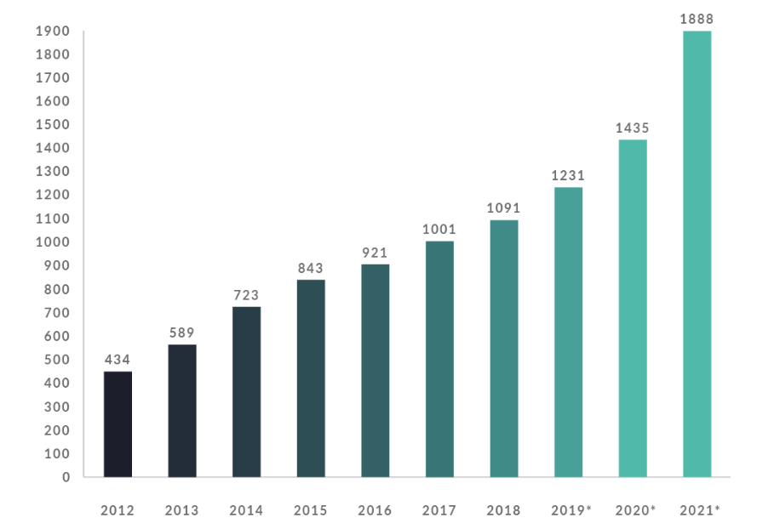
The financial year is the period from February to January of the following year.

THE DEVELOPMENT OF LPP SHOP NETWORK (2012-2021)
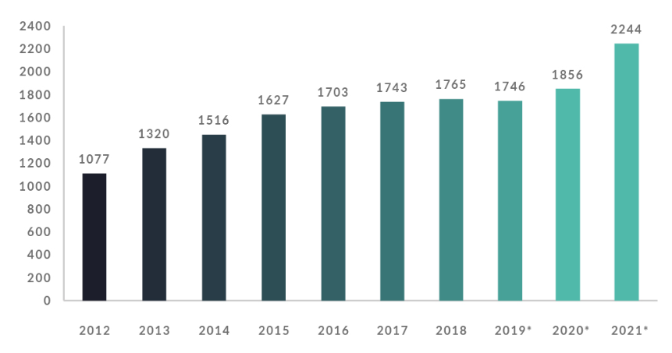

SALES (MLN PLN) (2012-2021)
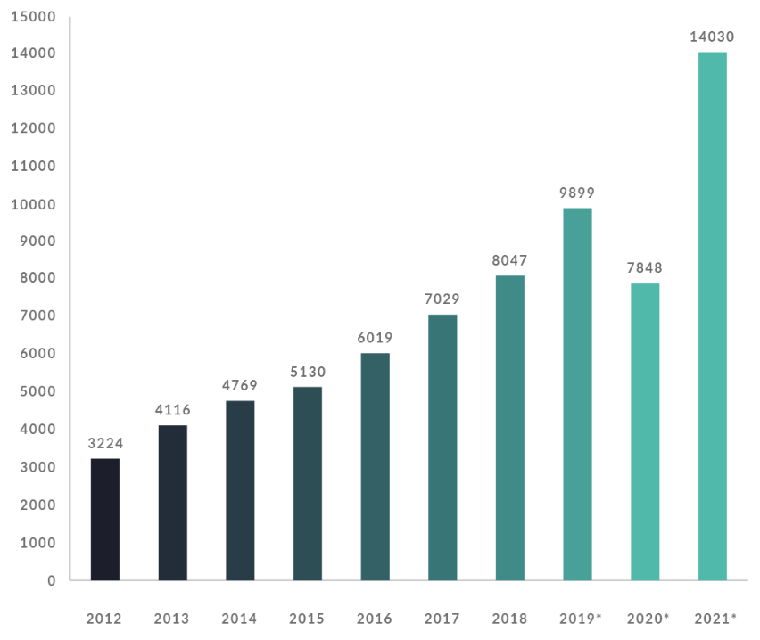

NET PROFIT (MLN PLN) (2012-2021)
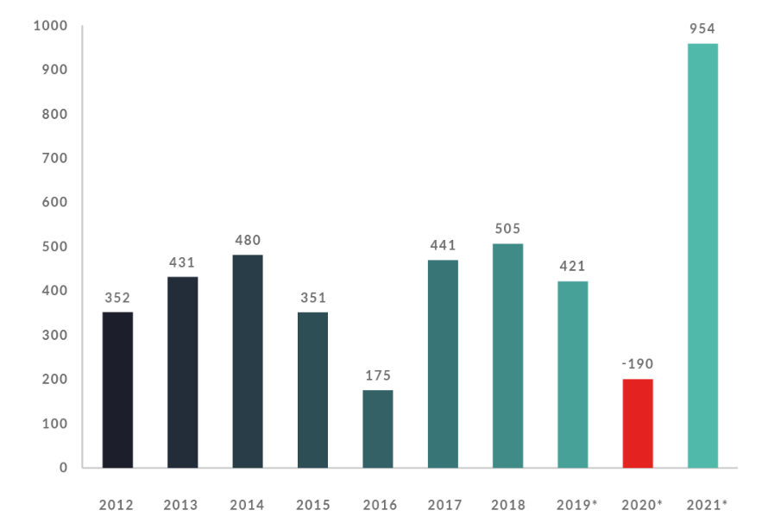

Headquarets, offices and logistics
- The headquarters of the LPP are in Gdask. We also have offices in Pruszcz Gdaski, Cracow, Warsaw, Shanghai, and Dhaka, Bangladesh's capital. We have a large and modern distribution network that serves all of our stores and ensures that our products are delivered efficiently to nearly 40 countries worldwide.
GDANSK
- LPP's headquarters. This is where the Reserved, Cropp, and Sinsay collections' designs are created. The Management Board of LPP makes the most important decisions for the Company's operation and development in Gdask. All of the Company's key departments are also housed here.WARSAW
In 2017, in Warsaw, we activated a product office of the RESERVED brand. Its team of dozens of people supports the Gdańsk Product Preparation Department both in the creation of regular collections but also in special projects.
CRACOW
Cracow is the hub of design facilities of House and Mohito brands, as well as the brands’ sales departments. Our administration department serving both brands is also established here.
SHANGHAI
- Since 1997, our Asian offices in Shanghai have employed more than 100 people. Employees look for new suppliers, assist with production at each stage, and are in charge of quality control. Another important task of the office is to ensure that our suppliers follow the Code of Conduct in terms of safety and employee rights.
DHAKA
- In 2015, we launched our LPP representative office in the capital of Bangladesh – Dhaka. People employed there are responsible for coordinating and supervising the production of our collections in local factories. An important task of our employees is also auditing the production facilities we cooperate with in terms of appropriate working conditions and respecting human rights.
LOGISTICS
- The role of Logistics in LPP is to support the implementation of commercial strategies of particular brands. This applies both to the operation of brick-and-mortar stores, as well as the execution of orders in the e-commerce channel. These operations are possible thanks to an extensive supply and distribution network with a global reach.
The global sourcing and distribution network of LPP is centrally managed and covers operations based on its own infrastructure as well as in cooperation with logistics operators. This network consists of an integrated system of Distribution Centres as well as Fulfilment Centres – each playing and important role in the implementation of logistics processes.
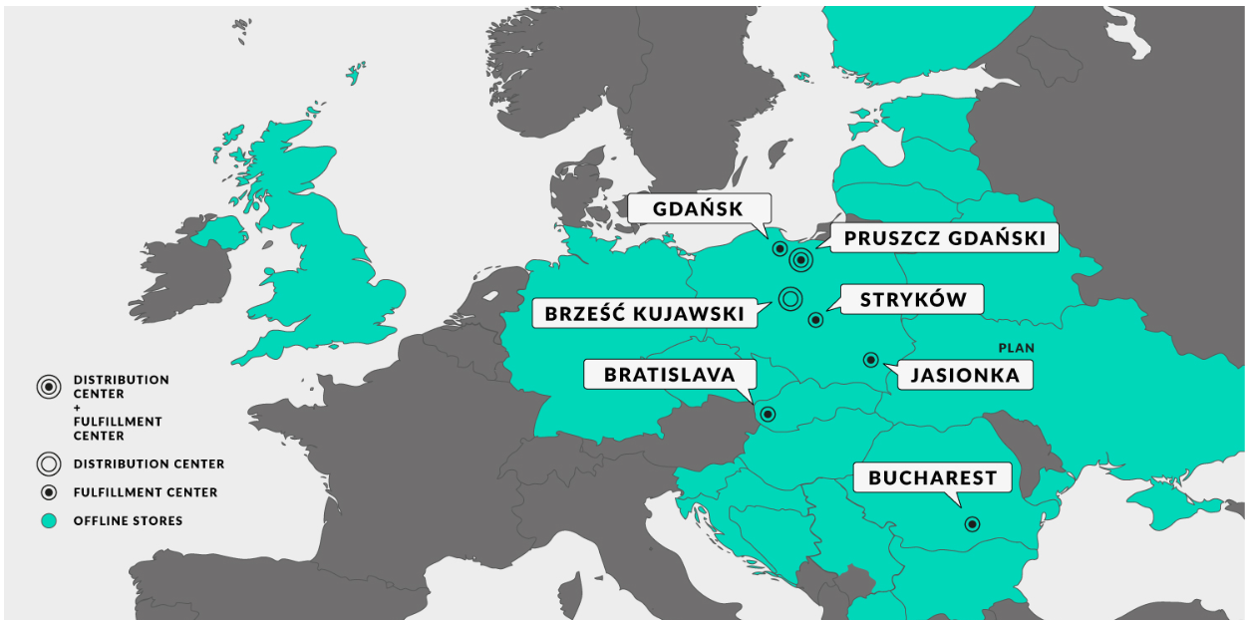

DISTRIBUTION CENTRES
We have two modern distribution centers in Pruszcz Gdaski and Brze Kujawski. Both are dedicated to providing logistics services to over 1,700 LPP stores around the world, as well as Fulfillment Centers that support online sales.
Distribution Centers are an important component of our logistics network, serving as the link between the supply and distribution systems. All shipments from our suppliers arrive here. They are then verified and stored to ensure timely and continuous delivery for the entire distribution system, including the physical chain and Fulfilment Centers for online sales. Our goods are prepared for sale in distribution centers, where they are sorted according to the orders placed by individual stores, packed, and refreshed. RFID clips are also encoded here..
(DC – PRUSZCZ GDAŃSKI)
The LPP Distribution Centre in Pruszcz Gdański was established in 2008. In the years 2013-2015 the facility underwent modernization. In 2020, its extension was completed. Currently, it is one of the largest and most state-of-the-art distribution centres in Central and Eastern Europe. Its area amounts to 100,000 m2. The centre handles deliveries to over 1,700 brick-and-mortar stores located in Europe and the Middle East, as well as to regional Fulfilment Centres.

(DC – BRZEŚĆ KUJAWSKI)
In response to the company's rapid growth, a 75 thousand m2 distribution center will be built in 2022. The facility has been designed to serve stationery stores and ship up to 8 million clothing and accessory items per week. The warehouse is outfitted with automation solutions that allow it to handle deliveries to 1,000 stores at once.

FULFILMENT CENTRES
Fulfilment Centres (FC) are responsible for fast order processing for our online store customers. This process consists of receiving and placing goods in the picking area, picking, packing orders and shipping. The right quantity, location and capacity of each FC allows us to offer the highest level of service, including delivery to customers the day after order placement.
(FC – GDAŃSK)
The centre with an area of 30,000 m2 is responsible for servicing LPP online stores. It handles domestic and international shipments – to Germany, Ukraine, the Baltic States, Italy and Spain.
(FC – STRYKÓW)
The Fulfillment Center with an area of 46,000 m2 is located in Stryków close to Łódź, just by the main highways. It realizes shipments within Poland and in the region of Central Europe. Yearly, the number of shipped products reaches several hundred million pieces.
(FC – ROMANIA)
A centre of the area of 43,000 m2 supports the e-commerce operations of all LPP brands in the region of South-Eastern Europe. Additionally, it carries out cross-deck operations – supplying stores in Romania and Bulgaria.
(FC – SLOVAKIA)
The Fulfillment Center is a 32,000-square-meter warehouse dedicated to logistical support for online sales in Slovakia and throughout the Central European region. It is outfitted with a cutting-edge automatic sorting system that streamlines the process of completing and shipping orders.

Conclusion
During my internship at the "LPP" store, I was able to apply the knowledge I gained during the educational process in practice. Thanks to this work practice I was able to improve my knowledge and acquired skills as a goods clerk.
I learned how to work with documents such as bills of lading, price lists, certificates. It is very difficult to work as a commodity trader, because he is responsible for the quality of goods and for the accuracy of filling out documents.
During my internship in the store I participated in the process of receiving goods in quantity and quality, checking out the goods, worked with bills of lading, certificates for incoming goods, made out the store windows. I would like to recommend the store:
- Check the quality of merchandise more thoroughly, to maximize customer satisfaction;
- Reconsider prices of many goods, as the cost of goods is higher than in neighboring grocery stores, which negatively affects most customers;
- tighten control over the work of the security guards, as the bags of the employees are not checked carefully.
Greater knowledge about the work of the team in a production company
-Expanding and deepening the knowledge gained from the study of special subjects
- Improving the professional skills of the organisation
- Getting acquainted with work organisation, technology and production economics
- getting acquainted with new technologies, equipment and computer maintenance.
In conclusion of my work, I have come to the following conclusions:
- Shops are the most important element of the social sphere, which plays an important role in increasing the efficiency of social production
- Selling is an indispensable process of value exchange, for consumers.
- The shop staff - must be cohesive, stable, professional, able to solve any tasks, which is important for the work in the field of sales;
- "LPP" is an advanced shop of electrical household appliances and is currently one of the leading retailers of household appliances in Kazakhstan;
By the end of my practice, I had gained practical skills in working with customers of varying ages and worldviews in a computer component of household appliances shop. I gained experience working with both staff and partners. I learned firsthand that working as a sales assistant is simple, especially if you have theoretical knowledge from college and a willingness to work and learn more about the profession.
Based on my research, I've concluded that LPP appliance shop strives to make the purchasing process as simple as possible for customers. This shop is ideal for shopping because of the variety of products available at low prices.
My internship at the LPP shop was rewarding. The first and subsequent days were both easy and productive. I didn't lose interest in Management after the internship because every customer who made a purchase and thanked me for advice reinforced my belief that Management is a great profession where you help people make the right decisions.
I read the instructions about confidentiality, internal regime, appropriate workplace behavior, Customer Service Standards, job descriptions, induction training about safety engineering, and I signed them.
The labor process was mastered by the seller-tasks consultant's and main activities: the layout of goods on the shelves in the sales area, rotation of goods, and checking the availability of price tags on goods. Stock balance control
Was familiar with the storekeeper's duties, including receiving goods and mastering the use of the cash register, scales, and packing.
Investigated the retail chain's organizational structure.
Passing practice allowed me to better understand and imagine the structure of a retail chain, as well as the content of the work: sales assistants, faschists, cashiers, operators, and storekeepers, as well as to develop skills in the team and with customers.
In general, there is a good working atmosphere in the store. There is understanding and mutual respect between the employees, which affects the coherence of the work performed.

References
- KOFASE, 2019. https://www.coface.cz/content/download/186543/3096111/file/CER-CZ-CEE Top 500 2019 booklet.zip
- https://www.lppsa.com/relacje-inwestorskie/materialy-inwestorskie/prezentacje/prezentacja-wynikow-za-4q2017-rok. Accessed February 14, 2020. 1 March 2021 Archived
- https://www.money.pl/gielda/wiadomosci/artykul/lpp-salon-reserved-londyn,255,0,2362367.html. The access date is February 14, 2020. Archived on November 27, 2020
- GK LPP quarterly report for the third quarter of 2021/22 (str. 19). The reference date is January 24, 2022. Archived on January 20, 2022.
- Online - PL (lppsa.com) LPP Raport Zintegrowany 2020 (str. 10). The reference date is August 6, 2021. Archived on August 19, 2021.
- https://www.lppsa.com/wp-content/uploads/2018/02/LPP-raport2018-online.pdf. The access date is February 14, 2020. 1 September 2021 Archived
- Raport LPP 2019 (unreported). Date of access: June 8, 2020. Archived on August 21, 2021.
- https://www.coface.cz/content/download/186543/3096111/file/CER-CZ-CEE_Top_500_2019_booklet.zip - KOFASE, 2019.
- https://www.lppsa.com/relacje-inwestorskie/materialy-inwestorskie/prezentacje/prezentacja-wynikow-za-4q2017-rok. Accessed 14 February 2020. Archived 1 March 2021.
- https://www.money.pl/gielda/wiadomosci/artykul/lpp-salon-reserved-londyn,255,0,2362367.html. Date of access: 14 February 2020. Archived 27 November 2020.
- GK LPP Śródroczny skonsolidowany raport za 3Q 2021/22 (str. 19). Date of reference: 24 January 2022. Archived 20 January 2022.
- LPP Raport Zintegrowany 2020 - Online - PL (lppsa.com) (str. 10). Date of reference: 6 August 2021. Archived 19 August 2021.
- https://www.lppsa.com/wp-content/uploads/2018/02/LPP-raport2018-online.pdf. Date of access: 14 February 2020. Archived 1 September 2021.
- LPP Raport 2019 (unreported). Access date: 8 June 2020. Archived 21 August 2021.
- https://retailnet.pl/2019/10/17/150975-lpp-debiutuje-w-finlandii-to-25-kraj-na-mapie-gdanskiej-spolki/ (No link was found). The deadline for access is February 14, 2020. The date was October 21, 2019.
- LPP is a Polish advertising firm. Date of access: January 24, 2022; archived on January 20, 2022.
- https://www.lppsa.com/wp-content/uploads/2018/02/LPP-raport2017PL.pdf. Access date: 14 February 2020; archived on 23 January 2021.
- https://www.bankier.pl/inwestowanie/profile/quote.html?symbol=LPP. The access date is February 14, 2020. Archived on April 18, 2021.
- https://www.lppsa.com/informacje-prasowe/rekordowe-zyski-i-ponad-8-mld-przychodu-lpp-w-2018-roku. The access date is February 14, 2020. 1 December 2020 Archived
- https://retailnet.pl/2019/04/12/146206-lpp-wzrosty-lfl-i-podwojenie-sprzedazy-internetowej-napedzily-przychody-spolki/ (Unavailable link) Accessed February 14, 2020. Archived on April 26, 2019.
- https://www.msci.com/documents/10199/202e8e97-6662-4501-b5db-448f8f759768. The access date is February 14, 2020. Retrieved on September 7, 2020.
- https://finanse.wp.pl/lpp-6166085269121153c. The access date is February 14, 2020. Archived on April 15, 2021.
- https://www.lppsa.com/o-nas/historia-lpp. The access date is February 14, 2020. May 18, 2021 Archived
- https://www.gpw.pl/spolka?isin=PLLPP0000011.
- https://www.stockwatch.pl/wiadomosci/grupa-lpp-ma-juz-milion-metrow-kwadratowych-powierzchni-sklepow,akcje,207693. The access date is February 14, 2020. Archived on January 16, 2021.
- https://www.money.pl/gospodarka/wiadomosci/artykul/wegrzy-i-rumuni-oszaleli-na-punkcie-reserved,191,0,2400703.html. The access date is February 14, 2020. 2 March 2021 Archived
- http://wgospodarce.pl/informacje/56565-przyszlosc-lpp-zwiazana-z-rynkami-zagranicznymi. Access date: 14 February 2020; archived 1 March 2021.
- https://www.rp.pl/Handel/311059941-LPP-zaczelo-dzialalnosc-w-Kazachstanie.html. Access date: 14 February 2020; archived on 25 February 2021.
- https://www.rp.pl/Handel/308169886-LPP-weszlo-do-Izraela—z-marka-Reserved.html. The access date is February 14, 2020. 4 March 2021 Archived
- https://www.propertynews.pl/centra-handlowe/lpp-rusza-na-podboj-nowych-rynkow,72789.html. Access date: 14 February 2020; archived on 26 February 2021.
- http://www.dlahandlu.pl/nonfood/lpp-otworzyl-w-bosni-salony-pieciu-swoich-marek,78954.html. The access date is February 14, 2020. 5 February 2020 Archived
- LPP 2020 Raport Zintegrowany Online - PL (lppsa.com) (str. 10). Accession date: 6 August 2021; Archived: 19 August 2021.
- LPP makes its debut in Macedonia. Polish product salons are now available on 26 markets. Date of access: January 24, 2022; archived on January 20, 2022.
- https://www.lppsa.com/wp-content/uploads/2018/11/LPP-3Q18-prezentacja-1.pdf. Access date: 14 February 2020; archived 1 March 2021. https://polskatimes.pl/gdanska-firma-lpp-otworzyla-pierwszy-sklep-w-bosni-i-hercegowinie-to-salon-reserved-w-banja-luce/ar/c3-14087765. Access date: 14 February 2020; archived on 19 August 2021.
- https://retailnet.pl/2019/10/17/150975-lpp-debiutuje-w-finlandii-to-25-kraj-na-mapie-gdanskiej-spolki (link unavailable). Archived on October 21, 2019. Accessed 14 February 2020.
- http://www.dlahandlu.pl/detal-hurt/wiadomosci/lpp-otwiera-centra-dystrybucyjne-w-strykowie-i-moskwie,65627.html. Date of access: February 14, 2020; archived on February 5, 2020.
- Wirtualna Polska Grupa LPP has established a magazine in Romania. Online shopping will be monitored (Polish). www.money.pl. Date of access: August 6, 2021; archived on May 18, 2021.
- http://wyborcza.biz/biznes/1,100969,24755520,lpp-ma-umowe-na-wynajem-magazynu-pod-e-commerce-na-slowacji.html?disableRedirects=true. Access date: 14 February 2020; archived on 12 August 2020.

