http://www.comunaligenova2012.it/category/bellezza/

5 Essential Tips on How to Stay Slim This Winter
Winter is a period of holidays, sitting in home and an abundance of food which is not always healthy. During this time of year the main temptation is to relax, hibernate, stop doing exercises and overeat. In average, person can gain from 5 to 7 pounds over the chilly season. The problem is that even a few days of overeating are so that staying slim becomes harder and harder with every kilo of gained weight. Only one feast spent with a redundant pleasure from eating pasta, bread and cookies can change a body fat level. Unfortunately, fat is lighter than muscles, so extra calories don’t reflect on the at once affecting mainly on body shape.
Here are some basic tips on how to avoid winter weight gain and stay in shape.
- Some Food Before a Party
http://bi-diekko-chan.com/diet/5774/
If one is planning to go to a party with an empty stomach, realization of such an extreme idea may result in healthy problems. If you feel hungry but you know that within 3-4 hours you will join the party, don’t wait, take some healthy snack to satisfy your hunger.
The reason for such behavior has scientific background. There’s a lag time between eating and feeling full, so if you delay time of taking your meal when you have a huge appetite, be ready that you can fall ill. Generally, one must have small meals every 3 hours. Eating food in excessive quantities after a long hunger is the first step to irregular meals which cause a lot of different diseases.
2. Hot Water before Eating
http://www.rahmionur.com/tr/news/desc/4725/yemek-yerken-su-icmek-zararli-mi.html
In winter a very important task is to preserve one’s body temperature on the level at which the body will stay safe from a dehydration and infectious diseases such as cold and flu. This aim can be reached in two ways. The first is by having a big glass of the warm drink (hot water, green, cinnamon tea or light soup) just before having dinner. Drinking a hot liquid decreases a feeling of hunger. Generally, it positively influences on the metabolism.

3. Healthy Breakfast
http://goodbelly.com/2015/09/15/importance-of-breakfast/

The second way to stay safe from diseases and in good shape is to have a healthy breakfast. Having meal in the morning allows staying full but not overeaten. Achieving this balance implies having breakfast which includes either low-fat proteins such as lean meats, fish, chicken, eggs, and legumes or wholesome foods such as brown rice, and oats rich in slowly digested fibra.
4. Amount of Food
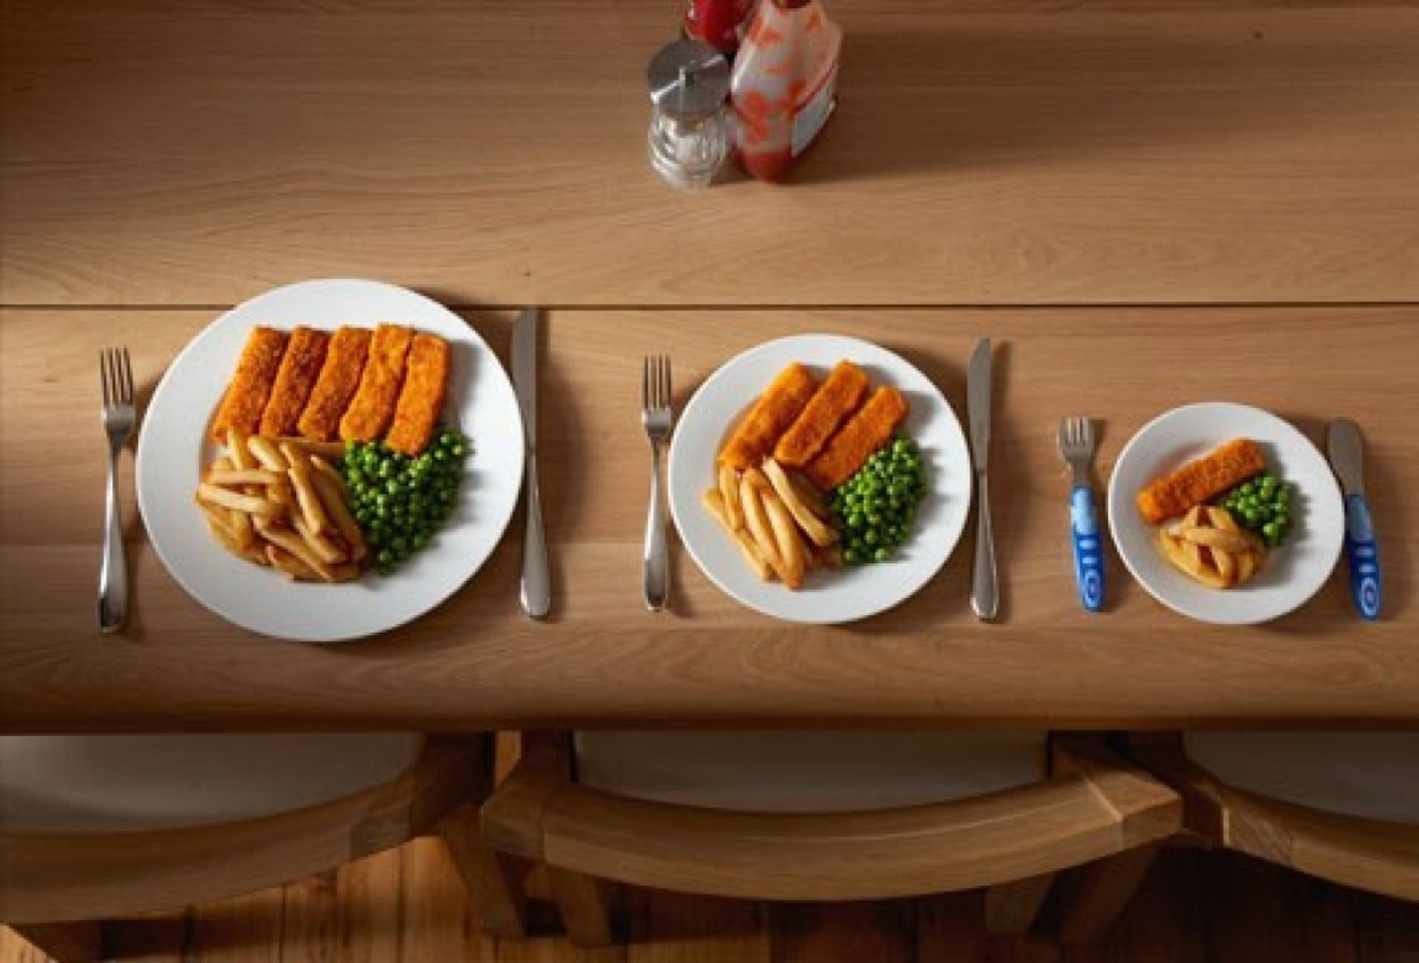
http://the-people.com/8-cekretov-pitaniya-frantsuzov
An essential element of staying slim is a diet, controlling of portion sizes. Try to have your meal only when you feel hungry, keep a food diary.
5. Exercise Routine

http://msgajic.rs/sta-obuci-za-trcanje-po-hladnom-vremenu/

To avoid extra winter kilos one should regularly do some exercises during at least 10 minutes per day. To adapt to the cold winter temperatures one may go for a quick jog outside which is better when doing in the morning rather than before bedtime.

