English-Ukrainian Translation
1. Scientific and technical translation || Науково-технічний переклад
Source text | Target text
The Need for Translation in the Globalized World  English Arabic Contact in the Algerian Academic Context  Abstract  The neck-breaking changes imposed by the process of globalization demand a reconsideration of the mundane scholarly dealings.  The constant need for communication in a scientific area to keep pace with the continuing advancements and the newly published research works, mainly in the Speech-language Pathology branch, pushes the researcher to look for the appropriate tools which bridge the gap and ease the task.  The researcher tries to find out how translation can bridge the gap between the technological improvements, anglicized data, and the actual context in which the Algerian students and teachers work?  This research paper aims, thus, at researching the significance of translation from English to Arabic in an Algerian academic context (at the University of Oran 2).  To reach the predetermined objective, the researcher uses of descriptive case study research in which a students’ questionnaire, a teachers’ interview, and program analysis are used.  The findings show that a total absence of both the English language and translation in such a scientific discipline widens the gap between the requirements of the age and the actual practice enormously.  A set of recommendations, including insertion of a specialized translation module, are suggested to help both the teachers and the students in this department.  Keywords: Algerian, academic, context, English, Arabic, language contact, globalized world,Speech-Language Pathology, translation.  Introduction  Globalization is a process driven by international communication in different domains, including commerce and investment.  It started as an economic process and pervaded every sphere of human activity.  A global interaction and integration among people who look for suitable ways to connect is a direct result of such a process.  Owing to the quick improvements in technologies, an understanding of our global world is required to keep up with the forces that had thrust upon us.  This impacts the environmental, cultural, political, economic, educational, academic as well as physical well-being in societies.  Translation is getting recognition due to its extreme importance in a globalized world.  We as part of the globe must consider it as an ally that helps us keep pace with the development of globalization, in the age of globalized knowledge, which is limited neither by space nor by time.  The de facto language chosen universally is English, and the best way to spread this knowledge is through this language.  In an academic context and for the speakers of the other languages, whether in the advanced or third world nations, the imperative need for translating the latest researches and books in different fields must be highlighted.  In Algeria, for instance, university teachers and students find it challenging to access world knowledge due to the policies imposed in the educational landscape.  Thus, how can translation bridge the gap between the technological improvements, anglicized data, and the actual context in which the Algerian students and teachers work?  To what extent can translation from English to Arabic and vice versa help researchers access the main published scientific productions in the globalized world?  For this, we try through the current research to analyze language contact between English and Arabic in an Algerian academic context, and then to reveal the continuous importance of translation.  The rational of this study is to highlight the role of translation fostering language contact between Arabic and English and thereby improving the students’ understanding of the subject matter.  Literature Review  English: An International Academic Language  Besides its flexibility and easy grammar, nearly four to five million people used English during the reign of Queen Elizabeth I (1533-1603), it is now used by around 1.5 billion people to become a widely spoken language, (Crystal, 1999).  After the Second World War USA purchased the world’s gold and the gifted spirits that migrated from Europe escaping wars there, these two powerful motives led to US dominance over the global economy and knowledge (Genç & Bada, 2010).  Dieu (2005) states that exactly after the Treaty of Versailles, “English started being used in diplomacy and gradually in economic relations and the media”.  The huge American productions in different fields, including science, economy, art, and others, were exported to the outer world aided a great deal in the spread of English is chosen as the official language of business and science (Altbach, 2007).  English: The Language of Scholarly Communication  Larivière (2018), an associate professor of information science at Montréal University, has enquired how and why the wave of Anglicization is sweeping throughout the social sciences and humanities, through an analysis of a vast corpus of articles indexed in Thomson Reuters’ Web of Science database of more than 3,500 specialized journals.  Larivière (2018, as quoted in the CAUT) asserted that publishing “in the natural and medical sciences field, the debate is a foregone conclusion. If we don’t publish in English, we are not even on the map as researchers” he adds “University rankings only take into account the number of articles published in the most prestigious journals, and these are all in English. That’s one of the main reasons why our universities are pushing us to publish in English.”  Within the last few decades, English has become one of the most important academic and professional tools.  More than 90% of the indexed scientific productions are in the English language, for it is recognized as the essential language to learn by the international community.  English is, in fact, the standard language in the international research community, especially in natural sciences (Bada &Genç, 2010, Di Bitetti & Ferreras, 2016).  English is thereby the language of scientific publication, considering the latest universities ranking.  According to the three most reliable scientific institutions, including ARWU (Academic Ranking of World Universities) Shanghai ranking, Times Higher Education ranking, and QS World University Ranking, we can assume that the top ten universities are either from the USA or England where English is their publishing language.  English in Algeria  Algeria is a culturally and linguistically diverse North African country.  Its population is around 42 million.  There are two main linguistic communities in Algeria: Arab and Berbers.  70 % of the Algerians speak different varieties known as colloquial or Algerian Arabic, while 30% consists of Berber including, the Chaoui, the Kabyles, the Mezab, and the Tuareg speak Berber variety (Chaker, 2007).  Code-switching using a Berber variety and French or Algerian Arabic and French is common in Algeria.  English as a second foreign language is thought to have the potential to help raise the quality of education in Algeria and promote external mutual understanding and internal social progress since English was recognized as the language of science and technology.  English in Algeria was supported by the British and the Americans in the 1980s by establishing the British Council and the American corner in Algiers, which also helped with teacher-training and provided scholarships for study in Britain. (Belmihoub, 2016)  The attempts of the ministry of national education in the mid-1990s to offer English as an option besides French in the fourth grade in primary schools, unfortunately, failed as most parents chose French over English for they thought French easier to acquire in Algeria.  The government's move is because English is a tool to show solidarity with the Arabic-speaking Middle East (Belmihoub, 2018).  The initially flourishing ELT industry and then its decline in Algeria in the 1900s ends in the actual resurrection of English reflects the competitive linguistic environment created by the cultural and academic programs which the British, French, and American embassies promote to spread their languages.  In other words, English teaching competes French teaching since 2000 (Miliani, 2000).  In universities, for instance, English was introduced as a module in many disciplines as a foreign language within the introduction of the LMD (Licence-Master-Doctorate) system.  The programs focus on the students’ needs and the language for special purposes objectives.  The Place of Translation in the Algerian University in the Era of Globalization  The Mother Tongue as a Basis for Language Education  Atkinson (1987) provides three reasons for L1 use in ELT.  First of all, the mother tongue is thought to be the learner’s preferred strategy, especially for beginners and intermediate students (as cited in Harbord, 1992).  Translation and transfer are natural strategies and inevitable processes a student use to avoid some problems; therefore, teachers should find systematic ways to employ them rather than struggling to keep them away.  L1 is also perceived as a time-saving technique when explaining certain aspects.  Further, giving students a chance to use their mother tongue is humanistic in that it helps them to express themselves clearly and fuel their motivation to learning at the same time, it allows them to involve in the process of language construction.  Translation in the Algerian University  “Algeria was, in fact, one of the first Arab countries that started to deliver translation at university as a separate independent discipline at the Institute of Translation” (Goui, 2016).  Translation was integrated in the Algerian university since 1943 at the faculty of arts human sciences in the University of Algiers.  Due to the ministerial decree 73-139, an institute was created.  Shortly after establishing of the institute an administrative change transformed it into an independent department in the faculty of foreign languages in the Algerian universities (Benouda, 2020).  In 2010, all the translation departments were closed to become a module in the faculty of foreign languages except some universities where it remains a department (Batna, Constantine, Annaba, Tlemcen).  Two national institutes were established in Algiers and Oran.  Translation in the Academic Context  In an Algerian context, we notice an absence of translation in most of the branches of human and social sciences except in the Arabic department and foreign languages department (French, English, Spanish) for 2nd and 3rd -year license degrees and some master degree specialties as an optional module with lower credits and coefficients.  The main objective of translation here is to improve the language.  In medical, natural, and technical sciences, we note a total absence of translation.  Here, the problem lies, the students’ mother tongue is Arabic, and he learns either in Arabic or in French.  However, in the globalized world, the student researcher is in urgent need for translation as a key to access knowledge that is generally produced in the English language.  The following sections will present the importance of such a discipline in bridging the gap between Arabic and English.  Methodology  The researcher used descriptive research to probe the status of the global language, English, and translation in an academic context.  A case study was then conducted to find out whether the hypothesis is true or not.  Both quantitative as well as qualitative research tools were employed to ensure triangulation and thereby to seek reliable findings.  The researcher has designed a students’ questionnaire, where 30 Master students from the Speech Language Pathology (SLP) branch at the University of Oran 2 in Algeria were questioned, and an interview for five (05) teachers in the same department.  An analysis of the administered program followed to unveil reality.  Participants  The researcher has chosen second-year Masters from the department of psychology as a case study.  Five teachers from the same department were interviewed to collect the raw data, as shown in the following table.  Table1. Research Participants  Instruments  The teachers’ interview and the students’ questionnaire included two main sections.  The first one is composed of four questions aimed at probing the status of the English language in the Algerian university.  The second section is devoted to find out the significance of translation to ease the mundane academic practices.  The program imposed by the ministry of higher education was then analyzed to find out whether Arabic English contact is ensured or not.  Data Analysis  The status of the English language in Algerian universities  1.The language used in writing the latest researches in the SLP field  The result is as follows: 70% respond that Arabic is used most often to conduct studies, 23% answer: French, while the tiny minority represents 7% of the whole state that English is indeed the language of science and thereby of the newest researches.  Accordingly, the majority of the students are not aware of the importance of English, which is the most widely used language in their field of interest, and they do not read in English; this is because they study either in Arabic or in French.  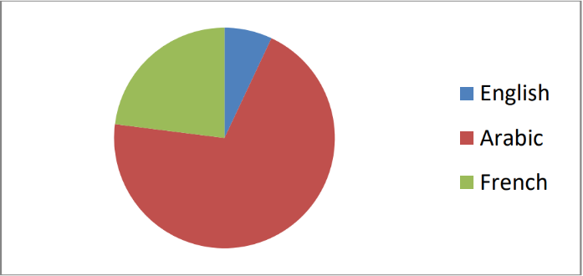  Figure1. The use of the English language in conducting researches  According to the results, 7% of our respondents answer yes, while 93% state that they do not use English in researching.  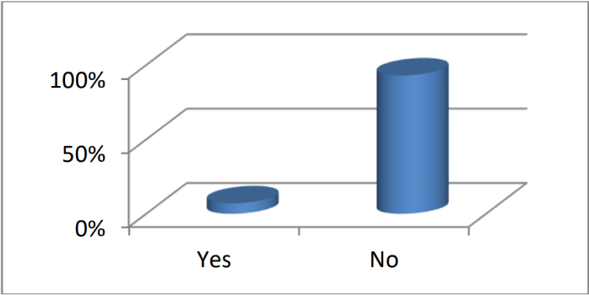  Figure2. The way English is used in researches  This confirms their tendency towards Arabic and French in the first question.  The tiny minority that answered with yes most often reads articles in English or researches the important websites and, when needed, uses translation to understand better.  2.The students level in the English language  2% of the informants claim that their English level is good, 5% reckon that they are average, and 93% say that they are weak.  The findings reflect that there is always a split between what to be taught or learned and how to approach or collect the latest data in the domain.  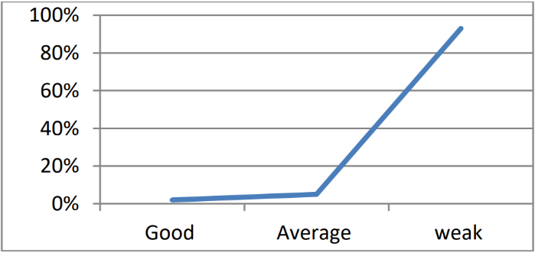  Figure3. The main tools which enable the student in their studies  Translation: a handy tool in improving scholarly communication  According to this item, the majority of the students (67%) is opting for translation or seeks help from translators to find the exact equivalents for the concepts and terminology used in the field.  27% ask their teachers to understand better.  6% are not interested in improving their knowledge.  The practical use of translation demonstrates its importance though not used officially in their studies.  1.Knowing the equivalent of the specialty in the English language  The majority of the students and who represent 73%, do not know the equivalent of their specialty in English, but they know it in Arabic and French that indicates their deep ignorance of an important concept in English, so what about the remaining concepts and terms.  This indeed widens the gap between their actual knowledge and the significant novelties in their domain.  Translation here can play an essential role in bridging the gap and keeping pace with the quick advancements.  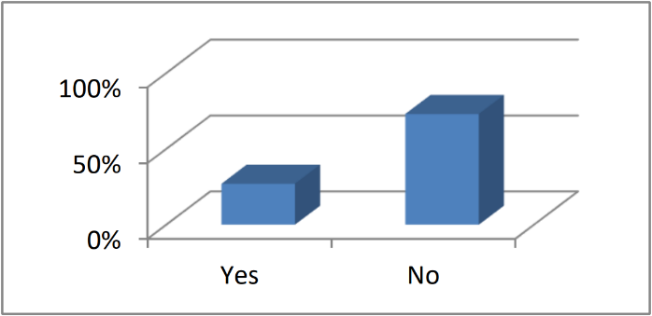  Figure4. The translation of the references in the mother tongue  70% of the respondents are aware of the imperative need for intensifying the translation of the resources into Arabic, for they are very scarce.  The students are in need of references in their mother tongue.  Speech -Language Pathology is a relatively new branch of science which most of its researches are written in the first place in English than in French and some other languages.  Table2. The language of the Resources Students Read  The majority of the students (80%) prefer reading the important references in their native language, while only 20% of the informants read them in French.  This denotes that, first, they cannot use the English language, in the short and medium-term, as a tool to research and, second, they need a translated version of the latest studies into their mother tongue and then into French.  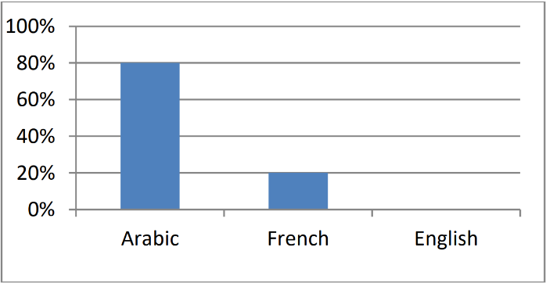  Figure5. The Language Students Use  1.The Solution Students Resume to when they Encounter an Interesting English Resource  The majority of the respondents (77%) resort to Google Translate to read an important book or article in their area of interest in English, while, 6% of the questioned students ask the help of a specialized translator.  For this reason, we recognize the continuing importance of translation in their educational journey.  The absence of translation and a systematized policy translation in the official program at university and the ministry drives backward results that are not pedagogical at all.  Table3. Students’ Solutions  2.The ways, according to the students, translation can be used to carry on studies  All the students agreed on the importance of translation and their need for necessary references to fulfill the Master dissertation.  They indicate that translation into Arabic at the level of concepts and terminology is very important.  Thus, they suggest the inclusion of translation modules in the License and Master programs and translating a larger number of resources into Arabic, the language that they prefer to read in.  The Teachers’ Interview  Two of the teachers state that the English language aids them a lot in carrying on their studies related to Speech-Language Pathology, for it was founded for the first time in the USA in 1932.  Three of them affirm that, as Algerian teachers, they refer to French resources for their research is based on the French school, and they do not master the English language.  Besides, all of the respondents that most of the important references are produced in English, especially in the field of language disorder, psycholinguistics, neurolinguistics, and developmental psychology.  They also reckon that the English language, unfortunately, is not used in conducting scientific researches for the teachers and the students do not master the language.  In the field of Language Pathology, for instance, most of the second-year master modules require the use of the latest resources that are written in the English language.  The researchers are thus obliged to translate the French versions into Arabic as they understand it.  The students cannot use English resources because they cannot understand and translate English texts.  In their entire career, they rely on French as an intermediary for translation.  All of the respondents declare that there is no English Arabic dictionary specialized in Language Pathology to be used as pedagogical support.  Two of the informants confirm that they generally translate texts and the most important terms and concepts from English to Arabic while the others use the French as an intermediary language to translate and understand the resources, and most often they use translation software such as deepl.com so, when asked about the solution that helps both the students and the teachers, our respondents suggest that implementing a module of specialized translation, particularly from English to Arabic, of the terminology or the concepts in the field aids a great deal.  Translation accordingly bridges the gap in our globalized atmosphere where researchers and specialists have to keep pace with the continuing scientific advancements in speech therapy and language pathology.  They suggest an urgent inclusion of a specialized translation in all the pedagogical research teams for master studies.  Program analysis  Through the analysis of the official program of the Language Pathology and Communication specialty Master 2, which spans for one semester composed of 16 weeks, an equivalent of 337.30 hours.  The weekly volume of hours is divided into TD sessions (10.5 hours) and lectures (12 hours).  We can observe a total absence of the English language, translation, or even a module to teach the main terminology and concepts or their translations.  We recognize only a module in the transversal unit, which is French as a foreign language taught 22, 30 hours per semester, around 6.5% of the total.  This semester is a primary preparation for a dissertation that the students are supposed to be produced by the end of their Master studies.  It can be seen that Arabic is the language of scholarly dealings in all the modules.  There is an ignorance of the importance of the English language and translation.  They are the basis for the preparation and training of the enthusiastic students’ researchers to their scientific journey.  The students are deprived of the most essential tools for scientific research in the era of globalized thoughts, science, and knowledge.  Discussion of the Results  The data collected show that there is a great gap between the real academic context where French pervades all the student-teacher contact and the required methods to ensure an up-to-date understanding of the major findings in the domain of Speech-Language Pathology.  The researcher, thus, should highlight the necessary requirements to aid students and teachers keep pace with the constant improvements.  Conclusion  The study probed primarily the relevance of translation in strengthening English-Arabic language contact in a globalized world where science is continuously evolving.  The findings of the students’ questionnaire, the teachers’ interview, and the program analysis pulled up that the gap between English, the language of knowledge, and scientific research, and Arabic, their native language, is so deep.  Both of the students and teachers agreed upon the significance of translation to approach the latest findings and data in their area of interest.  They are deeply aware of the impact of the absence of translation as a governmental and a pedagogical policy in the Algerian university in general and in their specialty in particular.  Accordingly, the researcher suggests the following recommendations:  1. The foundation of a national center for academic translation belongs to the ministry of higher education.  2. The integration of translation modules in the Master degree program to translate the important concepts and terminology from English to Arabic.  3. Editing specialized bilingual dictionaries in the Language pathology domain.  4. It is time to reactivate the role of translation in an academic context as a research tool, especially in the field of Language pathology. | Необхідність перекладу в глобалізованому світі.  Англо-арабський контакт в алжирському академічному контексті.  Анотація  Кардинальні зміни, викликані процесом глобалізації, вимагають перегляду мирських наукових відносин.  Постійна потреба в спілкуванні у науковій галузі, щоб йти в ногу з безперервними досягненнями і недавно опублікованими дослідницькими роботами, головним чином в області патології мови, підштовхує дослідника до пошуку відповідних інструментів, які усувають розрив і полегшують завдання.  Дослідник намагається з’ясувати, як переклад може подолати розрив між технологічними вдосконаленнями, англізованими даними та реальним контекстом, в якому працюють Алжирські студенти та викладачі.  Таким чином, ця дослідницька робота спрямована на вивчення значимості перекладу з англійської мови на арабську в алжирському академічному контексті (в університеті Орану 2).  Для досягнення поставленої мети дослідник використовує описове тематичне дослідження, в якому використовуються анкети учнів, інтерв’ю з викладачами та аналіз програм.  Результати показують, що повна відсутність як англійської мови, так і перекладу в такій науковій дисципліні значно збільшує розрив між вимогами епохи і реальною практикою.  Пропонується ряд рекомендацій, включаючи впровадження спеціалізованого модуля перекладу, який допоможе як викладачам, так і студентам цього факультету.  Ключові слова: алжирська, академічна, контекст, англійська, арабська, мовний контакт, глобалізований світ, патологія мови, переклад.  Вступ  Глобалізація – це процес, обумовлений міжнародними комунікаціями в різних областях,включаючи торгівлю та інвестиції.  Він почався як економічний процес і проник в усі сферилюдської діяльності.  Глобальна взаємодія та інтеграція між людьми, які шукають відповідні способи спілкування є прямим результатом такого процесу.  Внаслідок швидкого вдосконалення технологій, розуміння нашого глобального світу необхідне, щоб не відстати від насуваючихся на нас сил.  Це впливає на екологічне, культурне, політичне, економічне, освітнє, академічне, а також фізичне благополуччя в суспільстві.  Переклад отримує визнання через його надзвичайну важливість у глобалізованому світі.  Ми, як частина земної кулі, повинні розглядати його як союзника, який допомагає нам йти в ногу з розвитком глобалізації, в століття глобалізації знань, які не обмежені ні простором, ні часом.  Фактично, мовою обраною повсюдно, є англійська, і найкращий спосіб поширення знань - через цю мову.  В академічному контексті і для носіїв інших мов, будь то в розвинених країнах або країнах третього світу, необхідно підкреслити нагальну необхідність перекладу новітніх досліджень і книг в різних область.  Наприклад, в Алжирі викладачам і студентам університетів складно отримати доступ до світових знань через політику, що проводиться в сфері освіти.  Таким чином, як переклад може подолати розрив між технологічними удосконаленнями, англізованими даними і реальним контекстом, в якому працюють алжирські студенти та викладачі?  Якою мірою може переклад з англійської мови на арабську, і навпаки, допомагати дослідникам отримати доступ до основних опублікованих наукових робіт у глобалізованому світі?  Для цього ми намагаємося в рамках даного дослідження проаналізувати мовний контакт між англійською та арабською мовою в алжирському академічному контексті, а потім виявити постійну важливість перекладу.  Мета даного дослідження полягає в тому, щоб підкреслити роль перекладу, що сприяє мовному контакту між арабською та англійською мовами, і тим самим поліпшити розуміння предмета студентами.  Огляд літератури  Англійська: Міжнародна Академічна Мова  Окрім гнучкості та легкої граматики англійської, майже чотири-п’ять мільйонів людей використовували цю мову під час правління королеви Єлизавети I (1533-1603), в даний час він використовується приблизно 1,5 мільярдами чоловік, щоб стати широко поширеною мовою (Crystal, 1999).  Після Другої світової війни США придбали світове золото і обдарованих духів, які мігрували з Європи, рятуючись від воєн. Ці два потужні мотиви призвели до домінування США над світовою економікою та знаннями (Genç & Bada, 2010).  Dieu (2005) стверджує, що саме після Версальського договору: «Англійська мова почала використовуватися в дипломатії і поступово в економічних відносинах і засобах масової інформації».  Величезні американські виробництва в різних областях, включаючи науку, економіку, мистецтво, тощо, були експортовані в зовнішній світ, що багато в чому сприяло поширенню англійської мови, обраної в якості офіційної мови бізнесу і науки (Altbach, 2007).  Англійська мова: мова наукового спілкування  Ларів’єр (2018), доцент кафедри інформатики Монреальського університету, поцікавився, як і чому хвиля англізації поширюється по соціальним і гуманітарним наукам, проаналізувавши великий звід статей у базі даних Web of Science компанії Thomson Reuters, що включає більше 3 500 спеціалізованих журналів.  Ларів’єр (2018, за цитатою CAUT) стверджує, що публікація: «в галузі природних і медичних наук - це вирішене питання. Якщо ми не публікуємося англійською мовою, то нас як дослідників навіть немає на карті». Також, він додає: «Рейтинги університетів враховують тільки кількість статей, опублікованих в найпрестижніших журналах, а вони всі англійською мовою. Це одна з головних причин, чому наші університети змушують нас публікуватися англійською мовою.»  За останні кілька десятиліть англійська мова стала одним з найважливіших академічних і професійних інструментів.  Більше 90 % індексованих наукових праць написані англійською мовою, оскільки вона визнана міжнародною спільнотою, як основна мова для вивчення.  Англійська мова, по суті, є стандартною мовою в міжнародному дослідницькому співтоваристві, особливо в галузі природничих наук (Bada &Genç, 2010, Di Bitetti & Ferreras, 2016).  Таким чином, англійська мова є мовою наукових публікацій, враховуючи останній рейтинг університетів.  Згідно з трьома найбільш надійними науковими установами, включаючи ARWU (Academic Ranking of World Universities) шанхайський рейтинг, рейтинг Times Higher Education і QS World University Ranking ми можемо припустити, що в першу десятку входять університети або з США, або з Англії, де англійська мова є їх мовою публікації.  Англійська в Алжирі  Алжир – це культурно і лінгвістично різноманітна північно-африканська країна.  Його населення становить близько 42 мільйони чоловік.  В Алжирі існують дві основні мовні громади: арабська і берберська.  70 % алжирців говорять на різних діалектах, відомих як розмовна або алжирсько-арабська, в той час як 30% складають бербери, включаючи в себе: чауї, кабили, мезаби і туареги, котрі говорять на берберському (Chaker, 2007).  Перемикання кодів з використанням берберського різновиду та французького або алжирсько-арабської та французької мов дуже поширені в Алжирі.  Вважається, що англійська як друга іноземна мова має потенціал для підвищення якості освіти в Алжирі та сприяння зовнішньому взаєморозумінню та внутрішньому соціальному прогресу, оскільки англійська мова була визнана мовою науки і техніки.  Англійська мова в Алжирі була підтримана британцями та американцями в 1980-х роках шляхом створення Британської ради та Американського куточку в Алжирі, які також допомогли з підготовкою вчителів і надали стипендії для навчання у Великобританії. (Belmihoub, 2016)  Спроби міністерства національної освіти в середині 1990-х років запропонувати англійську мову в якості альтернативи французькому в четвертому класі початкової школи, на жаль, не увінчалися успіхом, оскільки більшість батьків віддали перевагу французькій, а ніж англійській мові, оскільки вони вважали, що французьку мову легше придбати в Алжирі.  Цей крок уряду пояснюється тим, що англійська мова є інструментом прояву солідарності з арабомовним Близьким Сходом (Belmihoub, 2018).  Спочатку, процвітаюча індустрія ELT, а потім її занепад в Алжирі в 1900-х роках закінчилося фактичним відродженням англійської мови, що відображає конкурентне мовне середовище, створене культурними та академічними програмами, які британське, французьке та американське посольства просувають для поширення своїх мов.  Іншими словами, викладання англійської мови конкурує з викладанням французької мови з 2000 року (Miliani, 2000).  Наприклад, в університетах англійська мова була введена в якості модуля в багатьох дисциплінах в якості іноземної мови в рамках впровадження системи LMD (Licence-Master-Doctorate).  Програми орієнтовані на потреби студентів і мову для спеціальних цілей.  Місце перекладу в алжирському університеті в епоху глобалізації  Рідна мова як основа мовної освіти  Аткінсон (1987) наводить три причини використання L1 в ELT.  Перш за все, вважається, що рідна мова є кращою стратегією учня, особливо для початківців і учнів середнього рівня (як зазначено в Harbord, 1992).  Переклад і передача є природними стратегіями і неминучими процесами, які учень використовує, щоб уникнути деяких проблем; тому вчителі повинні знаходити систематичні способи їх використання, а не боротися з ними.  L1 також сприймається як метод економії часу при поясненні певних аспектів.  Крім того, надання учням можливості використовувати рідну мову має гуманістичний характер, так як допомагає їм ясно висловлювати свої думки і стимулює їх мотивацію до навчання, а також дозволяє їм брати участь в процесі побудови мови.  Переклад в алжирському університеті  «Алжир був, по суті, однією з перших арабських країн, яка почала викладати переклад в університеті в якості окремої незалежної дисципліни в інституті перекладу» (Goui, 2016).  Переклад був інтегрований в Алжирський університет в 1943 році на факультеті гуманітарних наук алжирського університету.  Інститут був створений відповідно до міністерського указу 73-139.  Незабаром після створення інституту, адміністративні зміни перетворили його на самостійну кафедру на факультеті іноземних мов алжирських університетів (Бенсуда, 2020).  У 2010 році всі перекладацькі кафедри були закриті, щоб надалі стати модулем на факультеті іноземних мов, за винятком деяких університетів, де він залишається кафедрою (Батна, Костянтин, Аннаба, Тлемсен).  Два національні інститути були створені в Алжирі та Орані.  Переклад в академічному контексті  В алжирському контексті ми помічаємо відсутність перекладу в більшості галузей гуманітарних та соціальних наук, за винятком кафедри арабської мови та кафедри іноземних мов (французька, англійська, іспанська) для дворічних та трьохрічних ліцензійних ступенів та деяких спеціальностей магістратури в якості додаткового модуля з більш низькими кредитами і коефіцієнтами.  Основна мета перекладу тут – це поліпшити мову.  У медичних, природничих і технічних науках ми відзначаємо повну відсутність перекладу.  Тут виникає проблема: рідна мова студента – арабська, і він вчиться або арабською, або французькою.  Проте в глобалізованому світі студент-дослідник гостро потребує перекладу як ключей для доступу до знань, які, як правило, здійснюються англійською мовою.  У наступних розділах буде представлена важливість такої дисципліни для подолання розриву між арабською та англійською мовами.  Методологія  Дослідник використовував описові дослідження для вивчення статусу глобальної мови, англійської мови та перекладу в академічному контексті.  Потім, було проведено тематичне дослідження, щоб з’ясувати, вірна ця гіпотеза чи ні.  Для забезпечення тріангуляції і, отже, пошуку надійних результатів використовувалися як кількісні, так і якісні інструменти дослідження.  Дослідник розробив анкету для студентів, в якій було опитано 30 магістрантів з відділення патології мови (SLP) в університеті Оран 2 в Алжирі, та інтерв’ю для п’яти (05) викладачів того ж факультету.  Потім йде аналіз керованої програми, задля розкриття реальності.  Учасники  Як приклад дослідник вибрав магістрів другого курсу факультету психології.  П’ять викладачів з одного і того ж факультету були опитані для збору вихідних даних, як показано у наступній таблиці.  Таблиця 1. Учасники дослідження  Інструменти  Інтерв’ю викладачів та анкета студентів включали два основні розділи.  Перший складається з чотирьох питань, спрямованих на вивчення статусу англійської мови в алжирському університеті.  Другий розділ присвячений з’ясуванню значення перекладу для полегшення повсякденної академічної практики.  Потім, була проаналізована програма, введена міністерством вищої освіти, щоб з’ясувати, чи забезпечується контакт арабською мовою з англійською мовою чи ні.  Аналіз даних  Статус англійської мови в Алжирських університетах  1.Мова, що використовується при написанні останніх досліджень в області SLP  Результат такий: 70% відповіли, що арабська мова найчастіше використовується для проведення досліджень, 23% відповіли: французька, в той час як меншість становить 7% від усього штату, що англійська дійсно є мовою науки і, отже, новітніх досліджень.  Відповідно, більшість студентів не усвідомлюють важливості англійської мови, яка є найбільш широко використовуваною мовою в їх сфері інтересів, і вони не читають по-англійськи; це тому, що вони вчаться або арабською, або французькою.  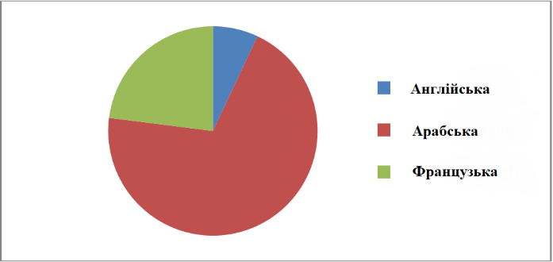  Малюнок2. Використання англійської мови при проведенні досліджень  Згідно з результатами, 7% наших респондентів відповіли ствердно, в той час як 93% заявили, що вони не використовують англійську мову в дослідженнях.  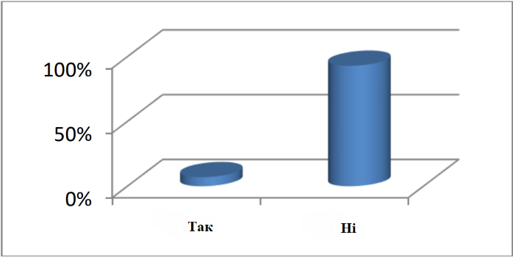  Малюнок2. Спосіб використання англійської мови в дослідженнях  Це підтверджує їх схильність до арабської та французької мов в першому питанні.  Меншість, яка відповіла ствердно, найчастіше читає статті англійською мовою або досліджує важливі веб-сайти і, при необхідності, використовує переклад для кращого розуміння.  2.Рівень володіння студентами англійською мовою  2% інформантів стверджують, що їх рівень англійської мови нормальний, 5% вважають, що він середній, а 93% кажуть, що рівень слабкий.  Отримані результати свідчать про те, що завжди існує розрив між тим, чому слід вчити або чому вчитися, і тим, як підходити до останніх даних в даній області або збирати їх.  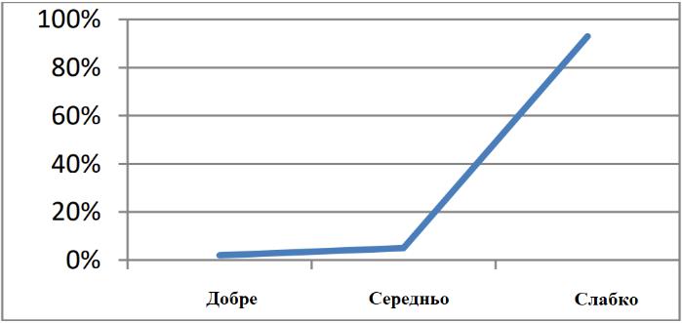  Малюнок3. Основні засоби, які дають змогу студенту навчатися  Переклад: зручний інструмент для поліпшення наукової комунікації  Згідно з цим пунктом, більшість студентів (67%) вибирають переклад або звертаються за допомогою до перекладачів, щоб знайти точні еквіваленти поняттям і термінології, використовуваним в даній області.  27% просять своїх вчителів краще зрозуміти їх.  6% не зацікавлені в поліпшенні своїх знань.  Практичне використання перекладу демонструє його важливість, хоча і не використовується офіційно в їхніх дослідженнях.  1.Знання еквівалента спеціальності англійською мовою  Більшість студентів, які складають 73%, не знають еквівалента своєї спеціальності англійською мовою, але вони знають її арабською та французькою мовами, що вказує на їх глибоке незнання важливого поняття англійською мовою, також і щодо інших понять і термінів.  Це дійсно збільшує розрив між їх фактичними знаннями і значними новинками в їх області.  Переклад тут може зіграти важливу роль у подоланні розриву і в тому, щоб йти в ногу з швидкими досягненнями.  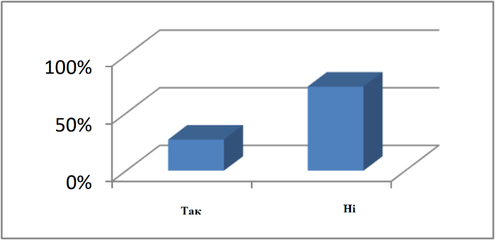  Малюнок4. Переклад літератури рідною мовою  70% респондентів усвідомлюють нагальну необхідність активізації перекладу ресурсів на арабську мову, оскільки їх дуже мало.  Студенти потребують рекомендацій на своїй рідній мові.  Патологія мови – це відносно нова галузь науки, більшість досліджень якої написано в першу чергу англійською мовою, а не французькою та деякими іншими мовами.  Таблиця 2. Мова ресурсів, які читають студенти  Більшість студентів (80%) вважають за краще читати важливі посилання на своїй рідній мові, в той час як тільки 20% інформантів читають їх французькою.  Це означає, що, по-перше, вони не можуть використовувати англійську мову в короткостроковій та середньостроковій перспективі в якості інструменту для досліджень, і по-друге, їм потрібна вже перекладена версія останніх досліджень на рідну мову, а потім на французьку.  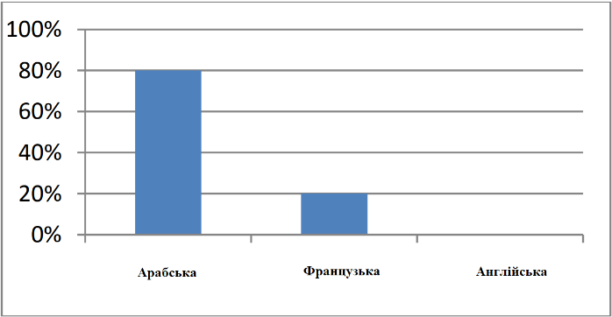  Малюнок5. Мова, якою користуються студенти  1.Рішення, до якого повертаються студенти, коли вони стикаються з цікавим англійським ресурсом  Більшість респондентів (77%) вдаються до гугл перекладача, щоб прочитати важливу книгу або статтю англійською мовою в області, котра їх цікавить, в той час як 6% опитаних студентів звертаються за допомогою до спеціалізованого перекладача.  З цієї причини ми визнаємо беззаперечну важливість перекладу в їх освітньому процесі.  Відсутність загального перекладу та систематизованого перекладу політики в офіційній програмі університету та міністерства призводить до зворотних результатів, які взагалі є не педагогічними.  Таблиця 3. Рішення студентів  2.Способи перекладу, котрі можуть бути використані для продовження навчання на думку студентів  Всі студенти погодилися з важливістю перекладу і потребою отримання необхідних посилань для виконання магістерської дисертації.  Вони зазначають, що переклад на арабську мову на рівні понять і термінології дуже важливий.  Таким чином, вони пропонують включити модулі перекладу в ліцензійні та магістерські програми, також переклад більшої кількості ресурсів на арабську мову, мова, якою вони вважають за краще читати.  Інтерв’ю з вчителями  Двоє з вчителів стверджують, що англійська мова дуже допомагає їм у проведенні досліджень, пов’язаних з патологією мови, оскільки вона була вперше заснована в США в 1932 році.  Троє з них стверджують, що, будучи алжирськими вчителями, вони посилаються на французькі ресурси, оскільки їх дослідження засновані на французькій школі, бо вони не володіють англійською мовою.  Крім того, всі респонденти зазначили, що більшість важливих довідкових матеріалів складені англійською мовою, особливо в області мовних розладів, психолінгвістики, нейролінгвістики та психології розвитку.  Вони вважають, що англійська мова, на жаль, не використовується при проведенні наукових досліджень для викладачів, тож і студенти не опановують мову.  В області патології мови, наприклад, більшість магістерських модулів другого курсу вимагають використання новітніх ресурсів, написаних англійською мовою.  Таким чином, дослідники зобов’язані перевести французькі версії на арабську, як вони їх розуміють.  Студенти не можуть використовувати ресурси англійською мовою, тому що вони не можуть зрозуміти і перекласти англійські тексти.  Протягом своєї кар’єри вони покладаються на французьку мову, як на посередника при перекладі.  Всі респонденти заявили, що не існує англо-арабського словника, що спеціалізується на патології мови, який можна було б використовувати в якості педагогічної підтримки.  Двоє респондентів підтвердили, що вони, як правило, перекладають тексти та найважливіші терміни та поняття з англійської на арабську мову, тоді як інші використовують французьку мову, як мову посередника для перекладу та розуміння ресурсів, і найчастіше вони використовують програмне забезпечення для перекладу, таке як deepl.com.  Тому, відповідаючи на питання про рішення, яке допоможе і студентам, і викладачам, наші респонденти вважають, що впровадження модуля спеціалізованого перекладу, особливо з англійської на арабську, термінології або понять в даній області дуже допоможе.  Переклад, відповідно, усуває розрив у нашій глобалізованій атмосфері, де дослідники та фахівці повинні йти в ногу з постійними науковими досягненнями в галузі логопедії та мовної патології.  Вони пропонують терміново включити спеціалізований переклад в усі педагогічні дослідницькі групи для магістерських досліджень.  Аналіз програми  Через аналіз офіційної програми спеціальності «патологія мови та комунікації», яка розрахована на один семестр, що складається з 16 тижнів, що еквівалентно 337,30 годинам.  Щотижневий обсяг годин розділений на сеанси TD (10,5 годин) і лекції (12 години).  Ми можемо спостерігати повну відсутність англійської мови, перекладу або навіть модуля для навчання основній термінології та поняттям або їх перекладам.  Ми визнаємо тільки модуль в поперечному блоці, який є французьким як іноземною мовою, що викладається 22-30 годин на семестр, близько 6,5% від загального числа.  Цей семестр є початковою підготовкою до дисертації, яку студенти повинні підготувати до кінця навчання в магістратурі.  Ми бачимо, що арабська мова є мовою наукової роботи у всіх модулях.  Існує ігнорування важливості англійської мови та перекладу.  Вони є основою для підготовки та навчання ентузіастів-студентів до їх наукової подорожі.  Студенти позбавлені найнеобхідніших інструментів для наукових досліджень в епоху глобалізації думки, науки і знань.  Обговорення результатів  Зібрані дані показують, що існує великий розрив між реальним академічним контекстом, де французька мова пронизує всі контакти між студентами і викладачами, і необхідними методами для забезпечення сучасного розуміння основних відкриттів в області патології мови.  Дослідник, таким чином, повинен виділити необхідні вимоги, щоб допомогти студентам і викладачам йти в ногу з постійними поліпшеннями.  Висновок  У дослідженні, в першу чергу, розглядалася актуальність перекладу для зміцнення англо-арабського мовного контакту в глобалізованому світі, де наука постійно розвивається.  Результати опитування студентів, інтерв’ю з викладачами та аналізу програми показали, що розрив між англійською мовою – мовою знань, наукових досліджень та арабською, їх рідною мовою, настільки великий.  Студенти та викладачі погодилися з важливістю перекладу для наближення до останніх висновків і даних в області, що їх цікавить.  Вони глибоко усвідомлюють наслідки відсутності перекладу державної та педагогічної політики в алжирському університеті в цілому, так і в їх спеціальності зокрема.  Відповідно, дослідник пропонує наступні рекомендації:  1. Заснування національного центру академічного перекладу, яке належитиме міністерству вищої освіти.  2. Інтеграція модулів перекладу в магістерську програму для перекладу важливих понять та термінології з англійської на арабську.  3. Редагування спеціалізованих двомовних словників в області мовної патології.  4. Настав час активізувати роль перекладу в академічному контексті, як інструменту дослідження, особливо в області мовної патології.
  Participants | Males | Females
  Teachers | 3 | 2
  Students | 12 | 18
  References | Statistics
  Available | 70%
  Not available | 30%
  The solution | Statistics
  I read it myself because I understand English | 17%
  I translate it myself using Google translate or other tools of automatic translation | 77%
  I ask the help of a translator | 06%
  Учасники | Чоловіки | Жінки
  Викладачі | 3 | 2
  Студенти | 12 | 18
  Статус | Статистика
  Доступні | 70%
  Не доступні | 30%
  Рішення | Статистика
  Я читаю сам, тому що розумію англійську | 17%
  Я перекладаю сам, використовуючи гугл перекладач або інші інструменти автоматичного перекладу | 77%
  Я прошу допомоги перекладача | 06%

Переклад: Бистрова Тетяна Сергіївна

