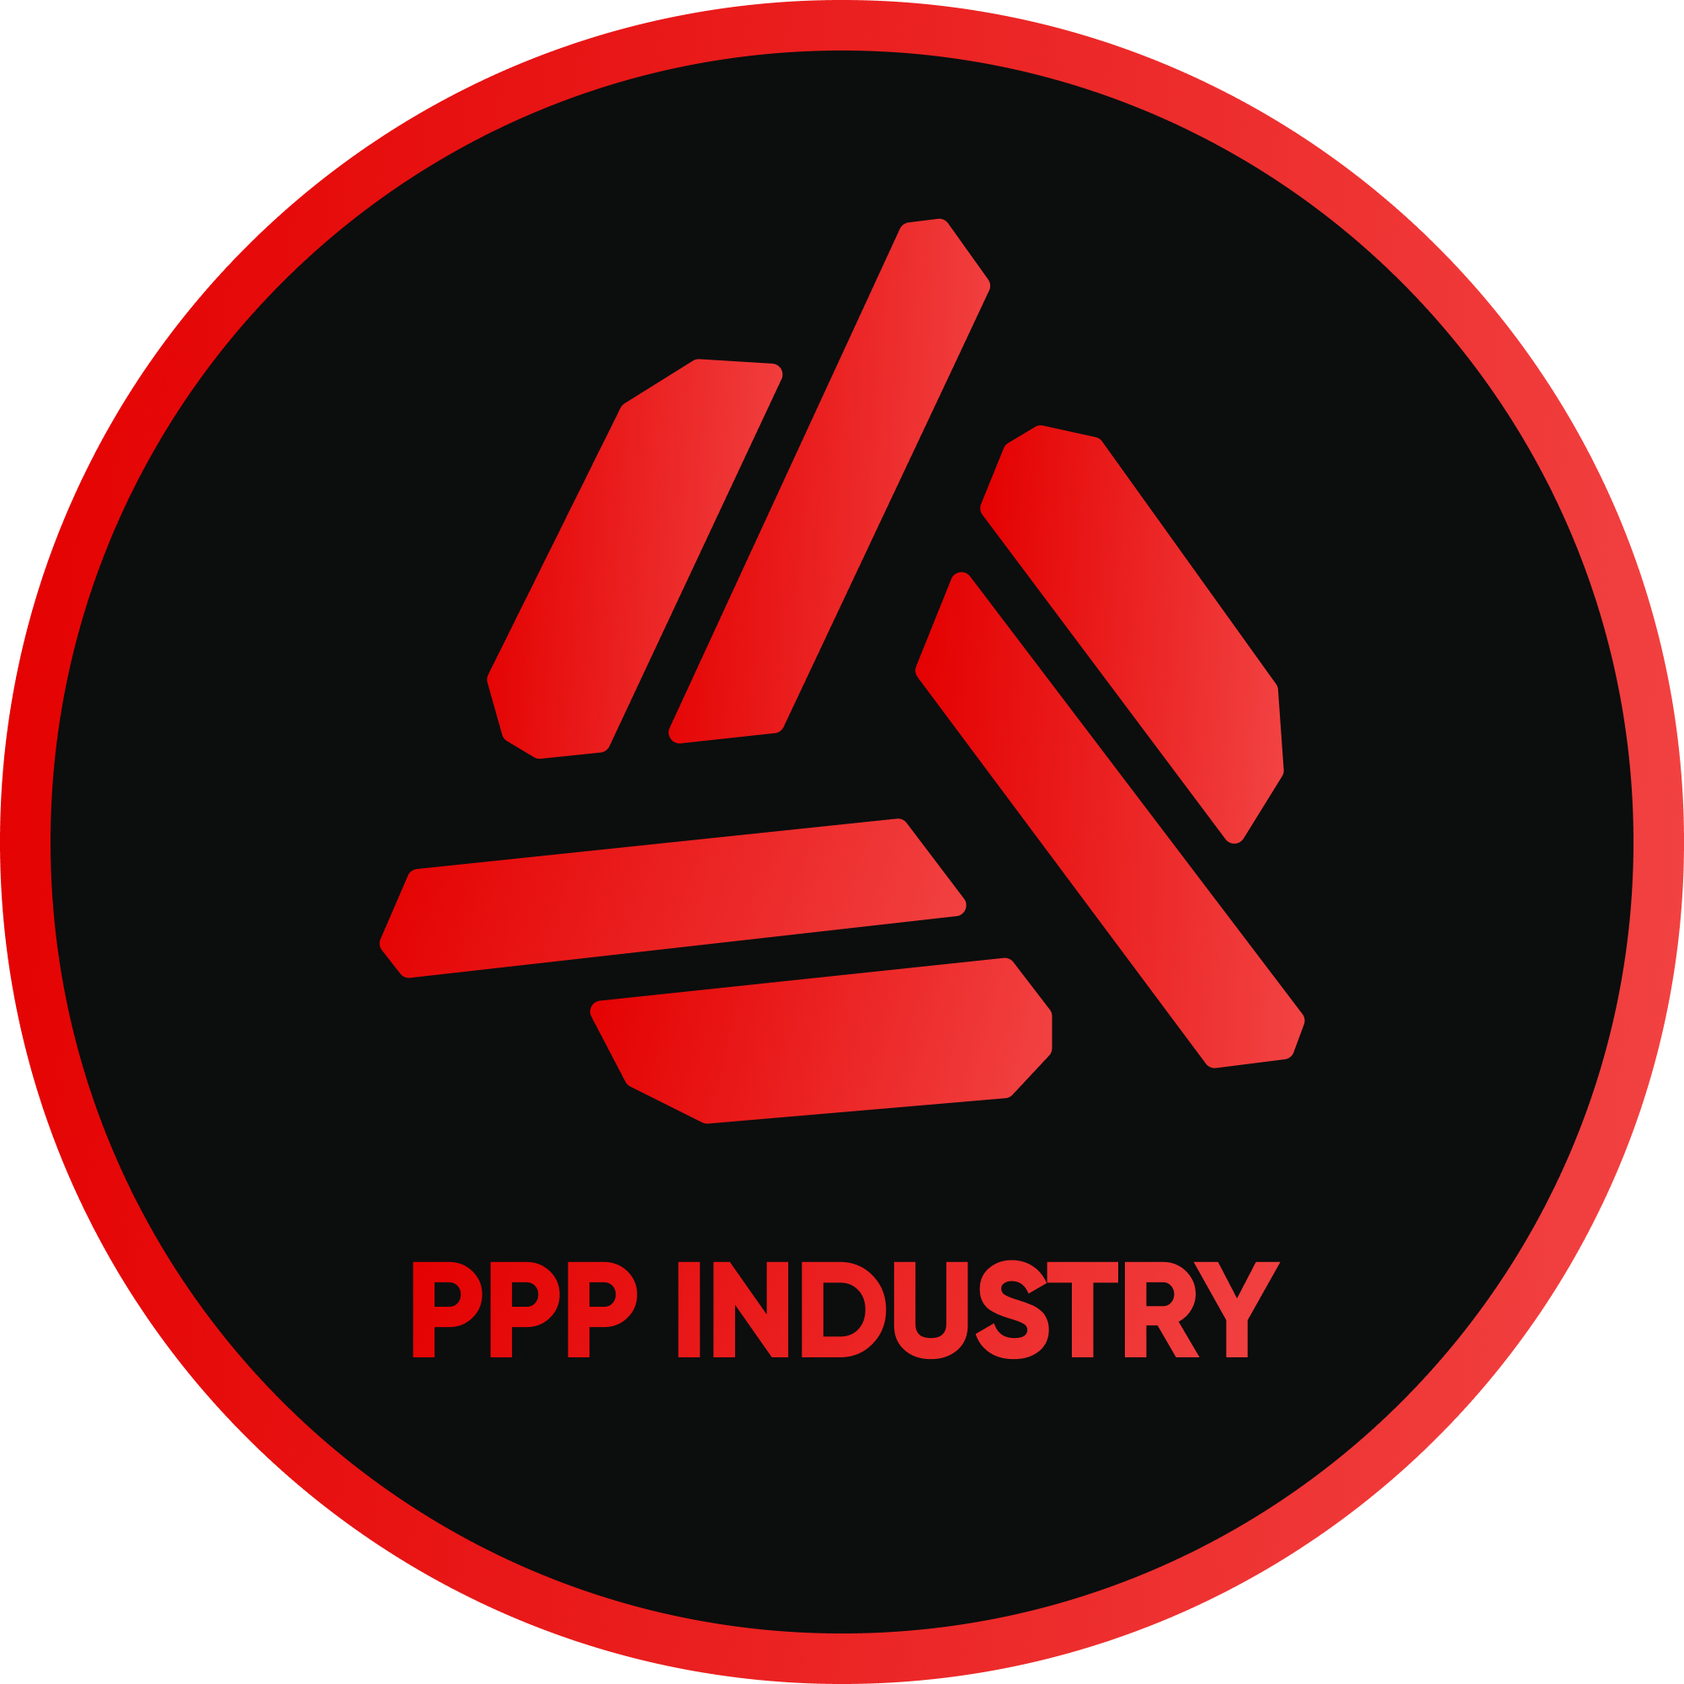
PPP INDUSTRY
WEB & MOBILE DEVELOPMENT
PPP-INDUSTRY.COM

CONTACT

WEB SITE

Petro Pasteruk,
15.03.2023
I recently had the opportunity to collaborate with PPP Industry, and I was impressed by their level of professionalism. The company demonstrated a high level of expertise in their industry, adhered to our agreement, and was willing to help at every stage of the project. I appreciated their openness to communication, quick response to questions, and willingness to answer any inquiries. All of this, combined with their high level of professionalism, made our collaboration with them very pleasant and successful. Overall, I can recommend PPP Industry as a reliable and professional partner.
petropasteruk@gmail.com
+38 (097) 622-63-62
Sincerely,
Petro Pasteruk
e.g P.Pasteruk

