- https://fastfrom.com/Instagram-downloaderInstagram video downloader

Download videos from Instagram freely and without restrictions
Users often faced with problem of downloading videos from social networks. The reason is a loss to the original file. Problem can be solved easily. Download Instagram video and get the best quality for free. Still wondering how to download Instagram videos? Check our service out.

Service advantages
Download video from Instagram with our brand new service that allows to get original files without registration. Developers created a service that allows to access the original file even if you don’t own the account on which the video is posted. See next advantages:
- Free use.
- Fast downloading.
- High quality.
- Easy to access.
- No registration needed.

How to use it?
Here you can download any videos and IGTV from Instagram posts absolutely free. The service is as simple and convenient as possible, the whole process of downloading is done in 2 clicks. Insert the link from Instagram and download what you need. The service works in all modern browsers and on all modern devices.

What can you find in this service?
Now you can fully appreciate the benefits of our new service for uploading photos and videos to Instagram via computer online! It will be useful for everyone who prefers to upload images in good quality. For example for those who are engaged in handmade and any kind of art, for owners of pages dedicated to creativity or small business, where good quality photos play a role. For example, for online stores, clothing stores, creative studios and other users. Downloader for Instagram is available to every user.

If you don’t know how to download Instagram videos on PC we have good news. The system will perform all downloads independently and on time. And if you own several Instagram accounts, this service is just for you. This is certainly a very useful feature, for online stores and other active users. Start to use this service today! If you come across any problems write to us, if you like it, leave comments and share our service on social networks. Download videos from Instagram easily with this service!

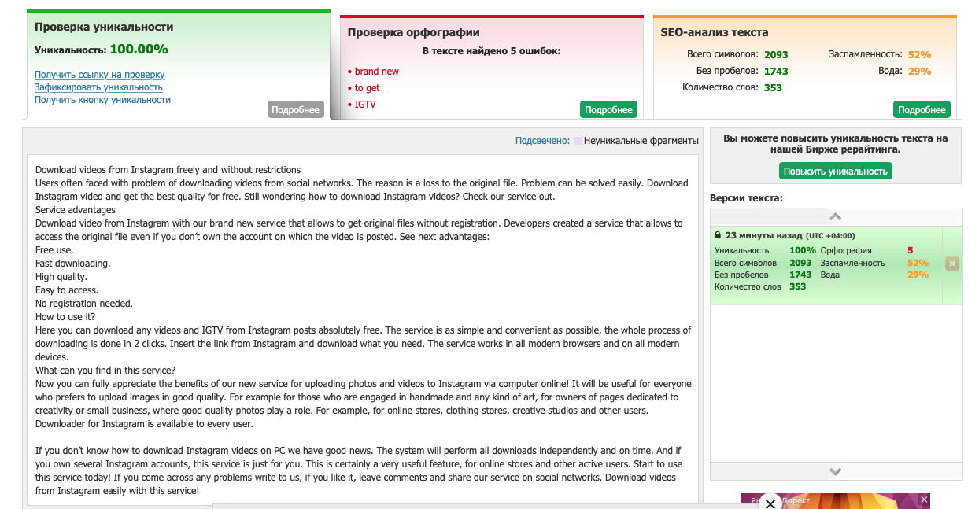

2. https://fastfrom.com/Facebook-video-downloader

Free Facebook video downloader without registration
Facebook video downloader online is available for free. Our convenient service provides a unique opportunity to download video source files that are stored on Facebook servers. The standard social network does not allow you to download the original file even if the user owns it, not to mention those who saw this video on other pages. To solve this problem, special services were invented that allow you to get the source file online. However, they do not ask for registration and account creation. Our service also belongs to such a project. Facebook video downloader helps to get needed video.

Advantages of using the service
Service allows to download video from Facebook. The social network does not provide other options for downloading files. but the developers of our service have found a way that allows you to download the source file for free and without registering an account. In this case, the owner of the video will not be able to find out that his file has been downloaded. We live in a time when every minute counts. The computational abilities of technology are not enough to perform all the functions. Therefore, some elementary tasks are carried over to execution in web services.

Service functionality
The site's functionality includes a number of advantages that are difficult to meet with competitors. The average user does not have the opportunity and simply does not want to waste his precious time searching and downloading and installing special programs that offer access to the original Facebook video files. If the live streaming video is incomplete, you cannot download it. Still questioning how to download a video from Facebook?

Service benefit
Most of the other services that advertise themselves as free set certain restrictions on the size of the downloaded file or its resolution. Try to download a video from Facebook with our service. For this reason, we strongly recommend using our service, which provides a completely transparent service. If you don't know how to download video from Facebook to computer, we can help you. Start working with us today and see how convenient this process can be!

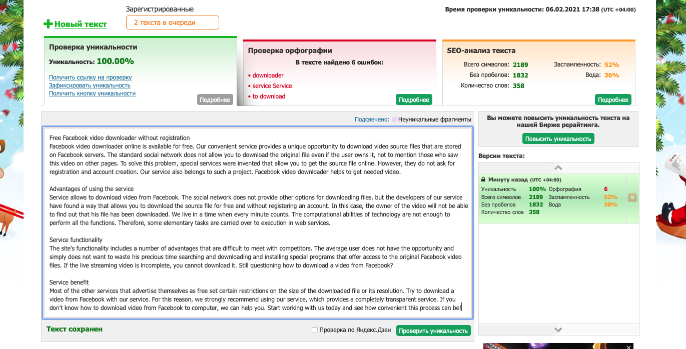

3. https://fastfrom.com/Twitter-video-downloader

Download videos from Twitter with our convenient online service
Twitter video downloader is a shortest way to get file you need. Have been seen the video in the feed? Forget the tedious process of searching for special programs to download videos from Twitter. You no longer need to waste your precious time searching and installing free programs. Our service will independently perform the entire range of works. The video is in your hands! Try to download video from Twitter with our service.

What are the benefits of our service?
Download Twitter videos right now! Downloading videos just got a lot easier thanks to the online video downloader. In just a couple of seconds, you can save the video to your personal computer. It's completely free. No registration required. After entering the site, just follow the simple instructions. Go to the online downloader page and paste the link of the video you want to download into the special form.

The main advantage of our service is that it works completely transparently and allows you to download the source file in the available resolutions. If you still don’t know how to download Twitter videos online we can help you. Here you will not find restrictions on the size of the downloaded files or their number.

Functionality and benefits of our service
Our service is the shortest way to download a video from Twitter. The functionality of the service is as simple as possible and will suit any user, regardless of his level of computer skills. All you have to do to get the original file is to copy the video link and paste it in the special field located in the center of the screen when you open the service. Start working with our service today and get the opportunity to independently evaluate all its benefits. Of particular interest is the absence of any restrictions on the way you use our service.

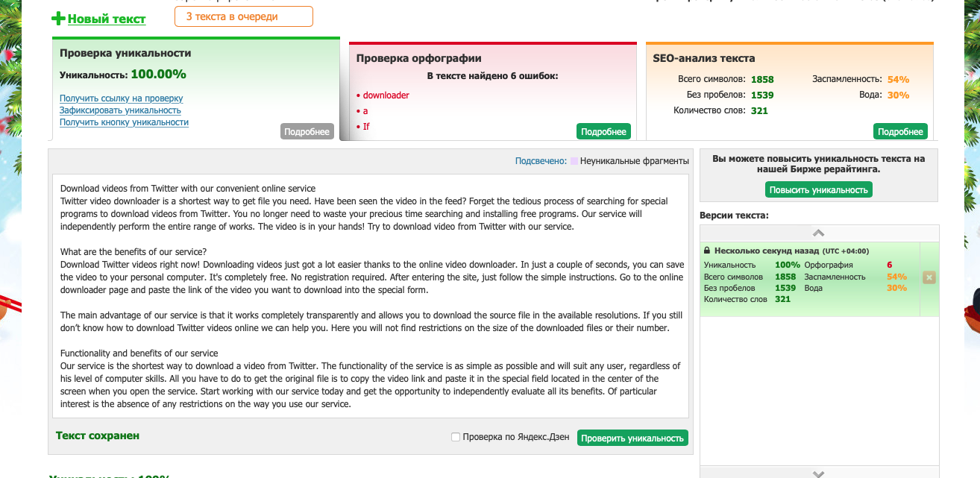

4. https://fastfrom.com/TikTok-video-downloader

Looking for a shortcut to download Tik Tok videos?
TikTok video downloader is available online. This social network is gaining popularity all over the world. But, like most other modern platforms, it does not provide access to download the source file from the video. It doesn't matter if you own the video or watch it from another user. Fortunately, this problem can be easily resolved with third-party services. Our service offers just such an opportunity, so we recommend that you pay attention to it.

What are the advantages of our unique service?
Download TikTok video without watermark here for free! From a desktop computer or smartphone, you can use a dedicated website to upload videos to Twitter. The fastest and easiest way to download a video is to copy the tweet link and paste it on the main page of our service. It is quite difficult to imagine the current social networks without videos, even if they are very short. Tik Tok video downloader allows to get source file. Service gives permission to download Tik Tok video without watermark. One of the main advantages of this service is that it does not impose any restrictions on the amount of its use. Enjoy unique opportunity. Download videos without limits. Don't be worried about file size or previous downloads.

What functions does the service offer?
The popular microblogging service allows you to upload and share short videos that can vary in length. Now you can access the source files without special programs and applications. TikTok video download is the most comfortable way to get file. You will not have any questions about using this service because its interface is intuitive for everyone, no matter how well the user knows the computer. We explain how to download a TikTok video. Jump into this feature today and appreciate how easy it is to access your original Tik Tok video file without a watermark on it. You don't need to register or create an account for these purposes, you can get started right away!

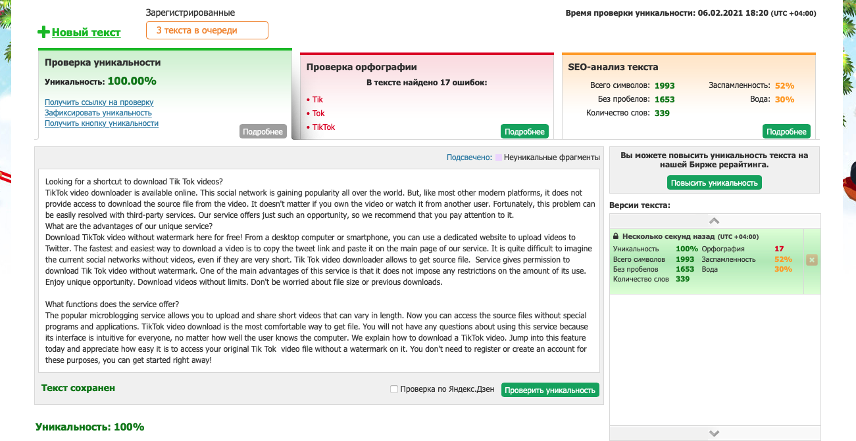

5. https://fastfrom.com/how-to-download-from-SoundCloud

Download your favorite music from SoundCloud
Finding and downloading your favorite music can be time consuming. SoundCloud downloader is the best way to get your desired video. This kind of social network has brought musicians from all over the world. Each user can share his work with the audience. But other users do not have the ability to download music to their device. These restrictions can be bypassed by using our unique service that allows you to access the source file.

Next benefits of service are available
We will explain to you how to download SoundCloud songs. The service works according to the simplest logic and all that is required to get the file is to copy the link with the address to the music track and paste it into the corresponding field of our service. Here you can see the "download" button, after clicking on which you will be able to get the original track file. You can download SoundCloud songs here.

Rich site functionality with free access
The main advantage is the ability to download music files for free an unlimited number of times without worrying about their actual size or resolution. The main difference from other programs and projects is that the work of our service is reduced to the simplest movements.

Features of SoundCloud Music Downloader:
- Using the service is completely free.
- You do not need to register or create any accounts.
- Just download files in one simple click.

Try to download SoundCloud music right now. Try to download from SoundCloud and see how easy it is. Start using our service today and get access to the source files of musicians and performers. You can save your favorite music on your phone, computer or even listen in the car.We invite you to start using our service immediately to appreciate the richness of all its functions. Use his services at least once and see how convenient it is to work with it.

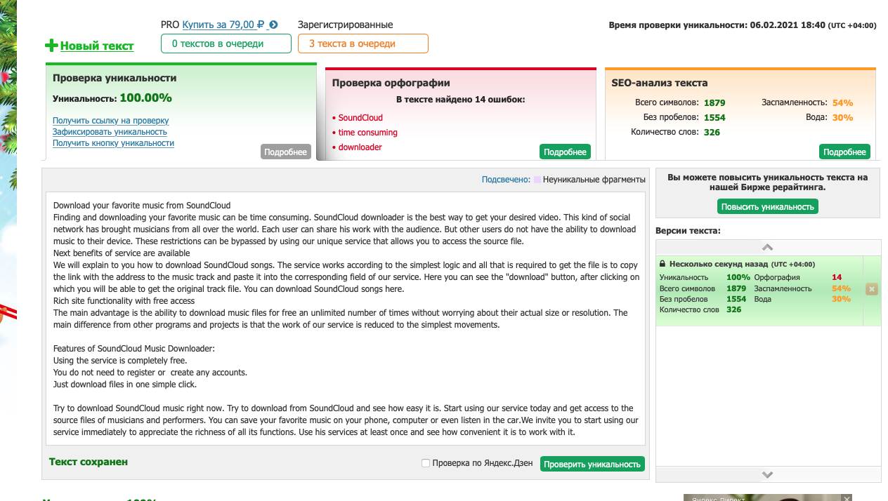

6. https://fastfrom.com/Vimeo-video-downloader

Download your favorite Vimeo videos for free
Vimeo downloader online is the best way to get the file. Tired of the endless promises of many sites and programs to download your favorite videos from various networks? Not to mention the fact that the procedure for finding a suitable tool can take up a lot of precious time, which is less and less with the modern pace of life. We suggest using our service, which will allow you to download videos from your favorite social network without registration. Vimeo video downloader is free to use.

What features does our free service provide?
If you don't know yet how to download a video from Vimeo, then we’ll tell you everything. This simple Vimeo downloader will allow you to access the original file that can be saved to your device. The service works according to the following logic:
- You copy the link with the file from the social network.
- Then go to our service.
- Leave the link in the special input field.
- Click on the download button.
- And you will get the desired file in the selected resolution.

It would seem that everything is very simple. But not all modern services keep promises and impose restrictions on the number of downloaded files or their size. You will not face such a problem here.

Use the services today and enjoy all the benefits of the service
Here you will not find restrictions on either the number of downloaded files or their size. But the list of available permissions depends on the quality of the original file uploaded by the user. If it's available in HD, you can get it in high definition. If the original file size and resolution is not high, we will call you for the highest quality download available.

Vimeo downloader mp3 also allows you to save selected tracks. The service allows you to download a video from any site online via a link or during its playback. We suggest you use the service as soon as possible in order to fully appreciate the degree of its convenience. You don't need to go through the grueling registration process or create an account. Start using service and discover new way to download source media files.
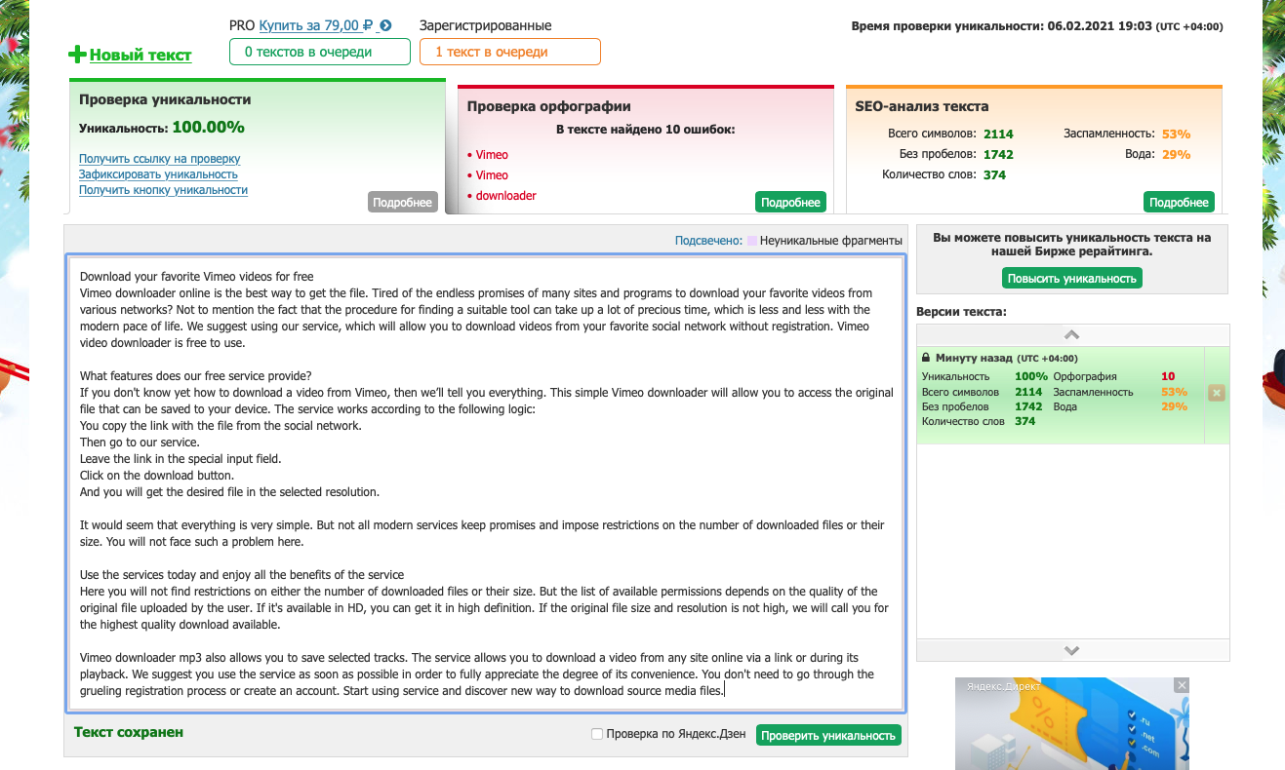

7. https://fastfrom.com/vLive-downloader

Download vLive videos with our service
vLive downloader has spread over the world. South Korean services are gaining popularity. Users can meet favorite stars in vLive. Well, like other social networks, vLive doesn’t allow you to download videos to phone or personal computer. Well, this limitation might be passed if you use a quality third-party service that will allow you to download the selected file. At the same time, it does not matter at all whether you are the owner of this post or met it from another user. With our service, you get unlimited opportunities to download files from various social networks, including vLive.

Functions that project offers
If you are looking for a way to download vLive videos our service can help you. You no longer have to waste time looking for a suitable solution, which will not set a limit on the type of size or number of downloaded files. Our service allows to use an unlimited number of times without fear of limiting the file size. All you need is Internet access. You can choose the extension that suits you. Get started immediately and evaluate the level of quality and ease of use with this service. We will show you how to download vLive videos. This is another tool offering download from a link on the internet.

What other benefits can you find here?
You can download any files from vLive. Depending on browser you use, the file should be opened in a new window. Providing opportunity to select any other of the valid files to open in programs that you prefer to use. Still not enough reasons for you? Then go to using our service and evaluate all its capabilities. The huge number of programs that are released daily make it difficult to find and select really working tools. Not all programs cope with the stated capabilities. Our service provides access to download an unlimited number of high-resolution files.

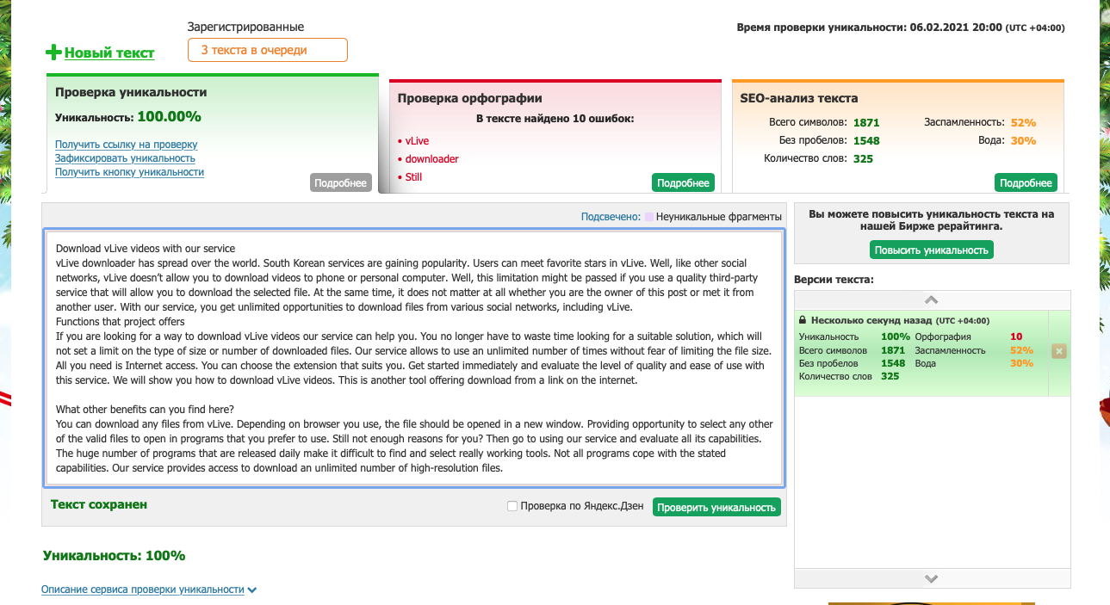

8. https://fastfrom.com/how-to-download-DailyMotion-videos

Service offering free video download from DailyMotion
DailyMotion downloader is a great way to get access to source files. French video distribution technology has become popular all over the world. But like many other online projects, there is no way to download videos directly. It becomes necessary to use third-party services that allow you to download videos in any quantity and format.

Huge number of advantages our service has
You can save the entire clip or the audio track, which is a great choice for music videos and podcasts. Convenient way to access the source file and watch favorite movies or TV shows at any preferable time. Even without Internet access. Don't miss this unique opportunity to become the owner of any video you want to download.

The downloader is safe and be sure that the original video files are obtained without any malware or viruses. Stop looking for tools - we offer the best one. Simple, fast, free. Forget about restrictions. DailyMotion video downloader helps you get the file you want. This video hosting site is one of the most visited in the world. His work began in 2005. He now works in 44 countries around the world. If you want to download any video from this hosting, you need a dedicated service.

What capabilities does our service represent?
The interface here is simple and straightforward, and even a novice user will be able to get the file he needs using a link. The service allows you to download videos from DailyMotion online. Just decide on the type of file, or its format, in order to be able to view the downloaded videos on the device you want. Because different formats are suitable for iPhone and Android. To determine the choice of the correct format, then you can read the tips in the search engine.

Many formats presented by our service do not require the use of any third-party players; they can be played on your device through the internal means of the operating system. If you don't know how to download DailyMotion videos yet, then our service is ready to help you. The logic of our service is designed in such a way that all users can interact with it, regardless of their level of computer skills. Start using our service today, don't evaluate its endless possibilities yourself! Try to download video from DailyMotion and see how easy it is. Download high quality videos in top resolution to watch offline on device.
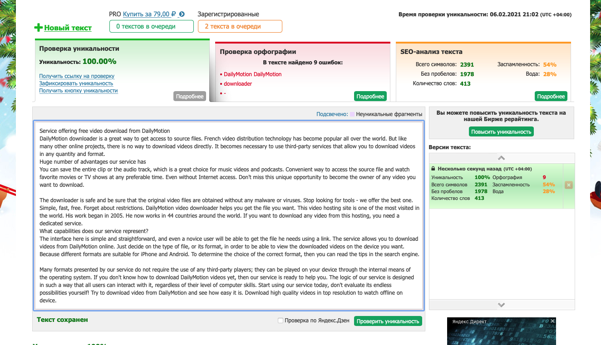

9. https://fastfrom.com/Twitch-video-downloader

Service for downloading videos from the popular Twitch platform
Twitch clip downloader is gaining popularity all over the world. This software is a clear, powerful and well tool that supports multiple sites, the ability to download 4K video and downloads multiple video clips or movies. A simple and intuitive interface will not create any difficulties - paste the URL of the required video, decide on the output format, mark the quality settings and the necessary parameters will be added.

Wide service functionality
Twitch video downloader is a convenient way to get the source file directly from the site. After adding all the parameters necessary for loading - click "Load", then processing and saving will be carried out in a favorite folder. Now there is no need to install various software applications or search for a web resource that will actually work, and not just promise.

Videos from this category are of particular interest to users. Many people are looking for an op-hack way to download videos on this topic, but spend a lot of time unsuccessfully looking for a program or service to complete the task. We are able to simplify the process for you and provide unlimited access to download files and videos that you need to watch offline. A convenient and reliable way that will definitely not harm your device. And all these features became available without registration and account creation.

If you are looking for an affordable way to download video from Twitch, then our service is for you. Just enter the URL / name of the video, select the format and click "Download"! Supports advanced communication protocols. Another free downloader of video and audio content from the Internet, will quickly save video and music to your computer. Every user can understand how to download a Twitch video through this service.

Benefits of using this free service
Other tools will download videos according to the standard format and don't offer the option to convert them to other formats. Since the service has a built-in converter, there is no need to use a separate video conversion program. You can select a format that is compatible with the player or device on which you want to play it. Twitch clips downloader is a free service that does not require registration or creating an account.
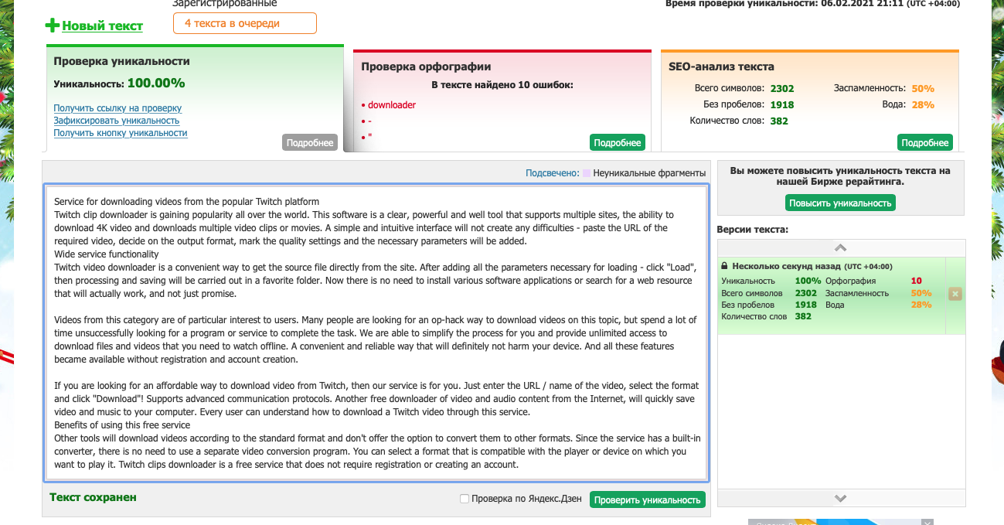

10. https://fastfrom.com/how-to-download-ted-talks

We offer you to download Ted Talks for free without registration and SMS!
Forget about complicated and exhausting registration procedures forever. We offer to download Ted Talks. According to experts, the share of video content on social networks has exceeded 80%. Videos, live broadcasts and streams are much stronger than plain text and photos to attract the attention of users. Sharing videos for viewing leads to a rise in popularity and a viral effect. It is important to be able to download a video file in order to watch it anytime, anywhere and on any device, even without access to the Internet.

Benefits of using our service
To download Ted Talk you need to use our service. To download a video file, you need a quality online video downloader. This is a free and fast online video download service without any restrictions and installation of programs on a computer, tablet or smartphone. Just 3 clicks are enough to save the video you like!

If you want to keep a copy of the video so that you can play it on your computer or compatible devices without going online, you can use a video downloader. There are free apps that you can use to download videos online. Some of them are web-based, while others need to be installed on your web browser as plugins or on your computer as stand-alone applications. If you are looking for an easy way how to download a Ted Talk, then we can help you.

Use our service today and evaluate its functionality
Online video web downloader can be accessed in any web browser. This means that whatever platform you use, you can go to the site and use the app. One of the online tools that you can use to download videos from different sites is our service. The service does not require any installation. As mentioned, you just need to go to the site, copy and paste the URL of the video you want to download, and click a button. Then you can select the video format and wait for the download process to complete. Ted downloader is completely free.

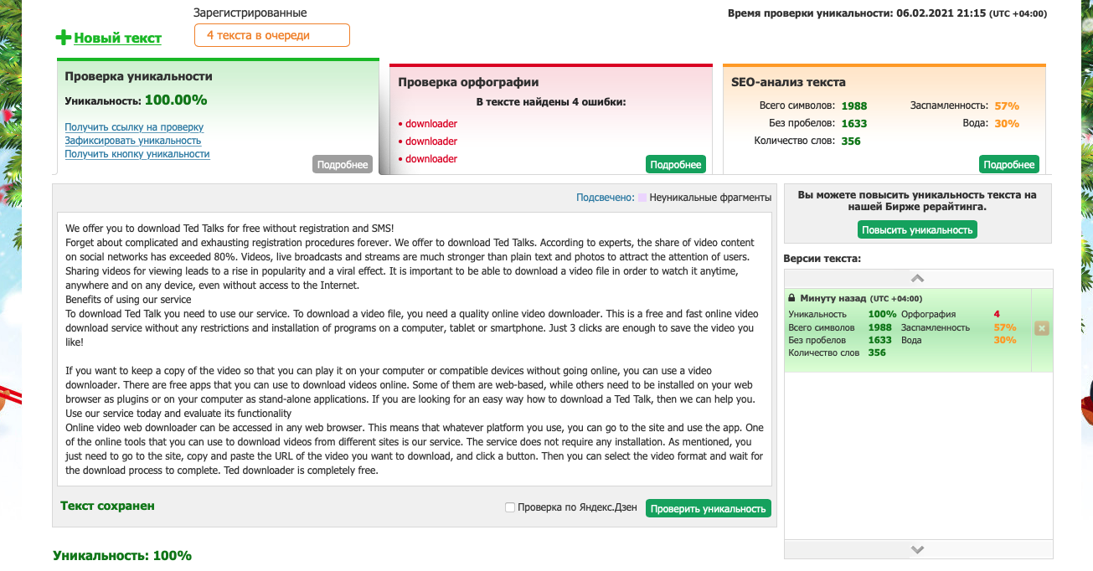

11. https://fastfrom.com/Flickr-downloader

Looking how to download Flickr videos? Our service is the answer
Flickr downloader allows access to source files. Video sharing websites are quite limited for uploading videos to social media and apps. The work comes down to the fact that the user copies the link to the file he needs and copies it into a special field of our service. After that, there is an automatic conversion on the server side, after which the video becomes available in the specified format.

What opportunities does our project offer?
Wondering how to download from Flickr? We have a simple and affordable method for you. After that, you just need to download the video in your preferred format. It also supports downloading HD videos. Some well-known video and TV sites offer live streaming videos, movies, TV shows, and series that do not contain the actual video file. So you cannot download videos using regular video grabber programs. Easy to use, fast performance, high quality and wide range of video formats.

And if earlier users had to spend a lot of time searching for correctly working programs and registering a new account, now this problem has been completely solved. Or (more likely) you will be blocked if you are using a regular video downloader. Fortunately for you, there is our service, which is designed to download just such protected video streams. With it, you will not miss a single episode or movie that you like. Flickr video download is available to all users.

Enjoy the full range of benefits
If you feel tired and exhausted from searching for high quality service working well, we have good news for you. Start using our service today and feel the difference! Here you can download Flickr video completely free of charge. Start using our amazing service today and see how comfortable it is. No limits, free access, wide choice of formats - we collected everything you need!

