Bitcoin price prediction for 2020

What is Bitcoin (BTC)?
Bitcoin is a digital and fully decentralized currency. Decentralization of the network is the main goal of the Bitcoin. The fundamental achievement of bitcoin is its genuine peer-to-peer payment system; no person or even institution was “in charge” of bitcoin.
Three main ideas were embedded in the Bitcoin code:
- Bitcoin should not be regulated by anyone;
- Its emission should not be infinite;
- The cost of a coin depends on its demand.
The maximum number of bitcoins - 21 million, and the possibility of their extraction were laid in the bitcoin algorithm.
Bitcoin statistics
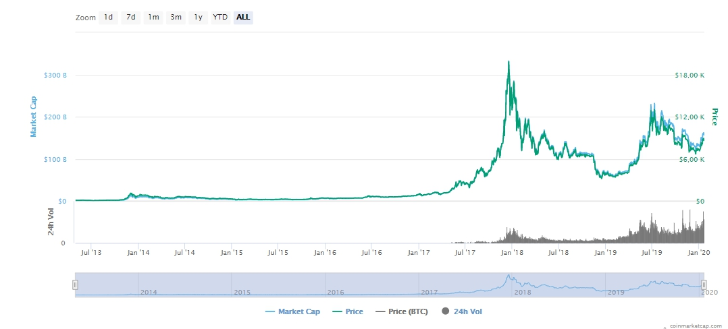

Current Price | $8 632,12
ROI since launch | 6 279,99%
Market Cap | $2, $156 856 429 531 ,490,754
Market Rank | #1
Circulating Supply | 18 171 250 BTC
Total Supply | 18 171 250 BTC

Source: CoinMarketCap, Data was taken on 20 of January

Bitcoin achievements and plans

In 2019 Bitcoin
- Its price has more than doubled.
- Outsize returns could attract interest from big investors.
- For the first time in history Bitcoin was assigned a rating of “A”.
- British court recognized Bitcoin as property.
- The second largest in Germany and ninth in Europe, the Stuttgart Stock Exchange launched Bitcoin spot trading.
- In Russia, for the first time, Bitcoin was added to the authorized capital of a company.
- Bitcoin Named the Best Asset of the Decade by Bank of America Merrill Lynch
- Bitcoin miners earned $5 billion.

Bitcoin in 2020
- John MacAfee predicted that Bitcoin will reach $1million in 2020.
- Bitcoin “halving” is scheduled approximately for May 2020. This means that its miners’ remuneration will be halved.
- The dominance of Bitcoin and the disappearance of altcoins. Bitcoin value will increase, which means it will be more attractive to investors.
- Amid the general crisis and the depreciation of money, which is expected in 2020, the value of the currency will increase.

Bitcoin Technical Analysis
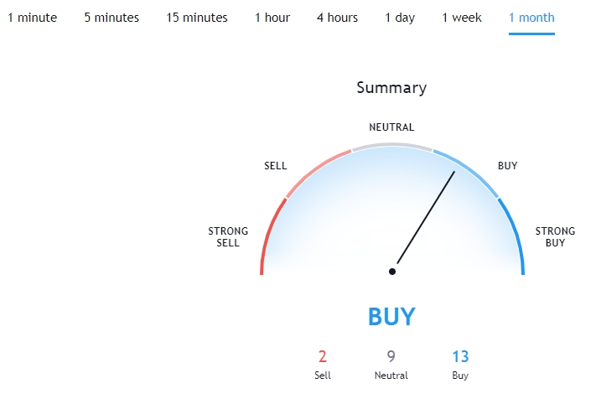

Source: TradingView, the screenshot was taken on 20 January 2020
Bitcoin Price Prediction in 2020

- TradingBeasts BNB price prediction
The Bitcoin price is forecasted to reach $7,660.246 by the beginning of February 2020. At the end of 2020 BNB price will be $ 9,080.070.

- Wallet investor BNB price prediction
Bitcoin price prediction: maximum price by the end of January 2020 $9499.290, a minimum price $ 8845.890.
- DigitalCoinPrice BTC price prediction
According to present data Bitcoin (BTC) and potentially its market environment has been in a bullish cycle in the last 12 months. There will be a positive trend in the future and the BTC might be good for investing. BTC price will be equal to $10723.46 in 2020.

- Crypto-Rating BNB price forecast
The current Bitcoin price is $8 664.11, Analysis of the cryptocurrency market shows that Bitcoin price may reach $26 173.76 by 1st of January 2020 driven by the potential interest from large institutional investors and more regulation expected in the field of digital currencies.
- CryptoInfoBase BNB price forecast
Bitcoin Price Prediction In 5 Years and in 2025
What will Bitcoin be worth in five years? According to the Walletinvestor website, its future price will be approximately $32,000 this year. However, this forecast has been made based on technical analysis (by Machine Learning developed by the website’s team). It is our understanding that it does not take into account fundamental factors, such as the launch of the Bakkt platform.

