

Geddy Lee: ANIMALE MALE ENHANCEMENT gave me back a taste for life!
Today in our studio is the idol of millions of people of all ages, the Cavalier of the Order of Canada, his name in the Rock and Roll Hall of Fame, the lead vocalist, bassist and keyboardist of the legendary rock band Rush Geddy Lee! The subject of our interview today is unusual for this man. But for sure it is interesting and actual for majority of our audience - it is the subject of male potency, or to be more precise, its decrease and how we can increase it. And Geddy Lee agreed to talk frankly about his struggle to remain a man, despite his age. Agree, it takes courage to tell such a frank story. It takes a real man. Meet Geddy Lee!
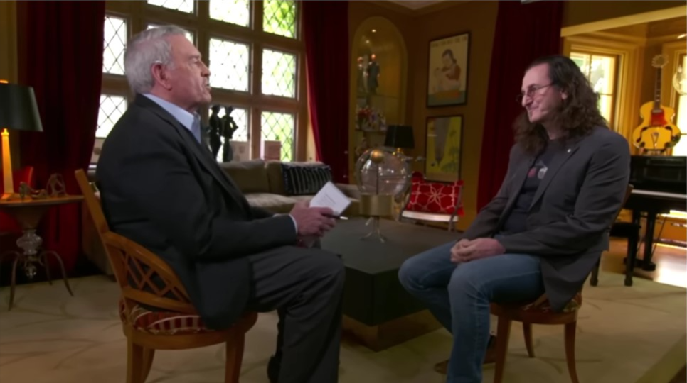

Dan Rather: Hi, glad to be your guest. I'm a long time Rush fan.

Geddy Lee: Likewise!

Dan Rather: You are known as one of the most secretive musicians. About your private life almost nothing is known. Even your wife's picture is practically not freely available. We could only find one from at least 30 years ago.
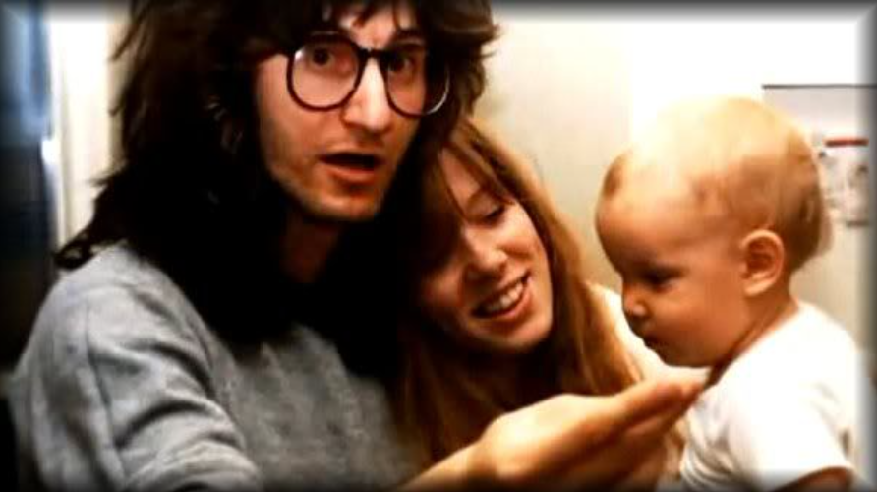

Geddy Lee: Wow! You guys are the real detectives!

Dan Rather: Such closeness and suddenly agreeing to a frank interview on such an intimate topic. Why did you make that decision?

Geddy Lee: When I keep my private life private, it neither hot nor cold other people. Well, except that my fans are left with some unsatisfied itch of curiosity. But now the situation is somewhat different. The information I have can help millions of people. So I have no right to keep it quiet.

Dan Rather: Commendable life attitude. And now the first intimate question - when did your potency problems start?

Geddy Lee: I've had periodically misfires for a long time. Surely almost every man in his 50s has had one. I was well aware of that and didn't worry for it. Besides, Nancy and I had been married since 1976, with two children, so it wasn't a problem for us. And then there's Viagra, which can always be a safety net. But gradually there were more and more misfires in bed. I had to take Viagra almost on a regular basis. Immediately my heart began to feel the effects. My kidneys began to ache. Once, five years ago I had a heart attack after taking Viagra.

Dan Rather common, by the way. According to statistics, 35,000 men in the world die every year after taking Viagra.

Geddy Lee: I'm sure it wasn't their first time taking Viagra. And their heart didn't stop right away. It had yelled before, "Hey, man! I don't feel good! Stop taking that shit!" But they thought it was worth the risk, sex was more important to them.

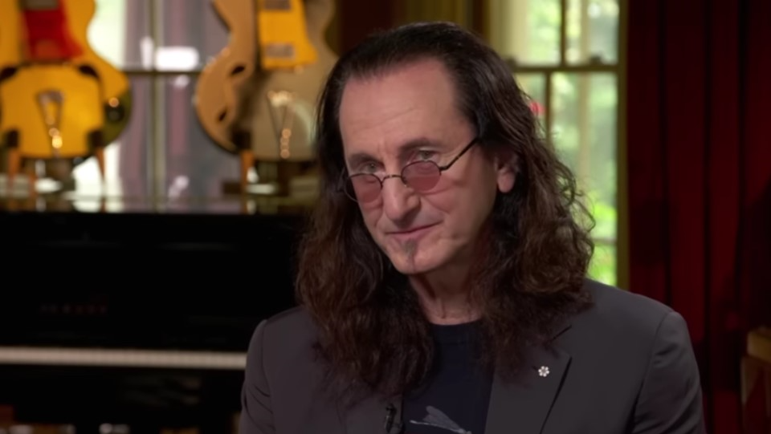

Dan Rather: And for you, no?

Geddy Lee: After that incident, when I even had to call an ambulance, Nancy told me: "Sex isn't the most important thing at our age. We'll manage somehow. Life is more important."

Dan Rather: A wise woman!

Geddy Lee: I agree! But I began to notice that there was a chill between us. Sex plays a big role in a personal relationship, though.

Dan Rather: And you decided to eliminate that chill between you and the woman you love, too? That's what I call love!

Geddy Lee: Frankly, not really. More precisely, it was not the main motive why I decided to restore my potency.

Dan Rather: What was the main thing? The mistress? Does Geddy Lee have a mistress?

Geddy Lee: You, like most men, have the wrong stereotype. They say that an aging man wants to regain his potency because he has a young mistress. This is fundamentally a wrong stereotype! What is potency in the first place?

Dan Rather: An erection probably...
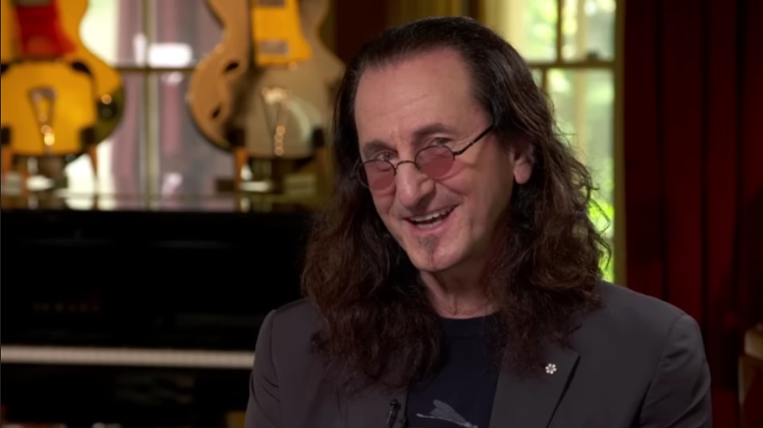

Geddy Lee: There you go again, it's all about sex! (laughs) First of all it's testosterone! The most important male hormone. Not enough testosterone - a man turns into a sissy. Indecisive, afraid of everything, uninitiative, no creative sparkle in his eyes!

Dan Rather: I think I'm beginning to understand...

Geddy Lee: What is there to understand! Lack of testosterone is creative death for a creative person. You can't create anything but a pile of shit in your toilet. Why is it that the older you get, the less you write music, songs that aren't hits anymore? Because your testosterone levels drop. You lose your taste for life. You're not interested in anything. You're already living half, even a quarter.

Dan Rather: And you decided for yourself to fix it.

Geddy Lee: Of course! I suddenly found myself thinking that I hadn't written a song in a good five or six years. I stopped experimenting on stage.

Dan Rather: Oh, your experiments were something! I remember your performance when you had a giant old-style phonograph horn on stage behind you, a huge brain model in a jar and a working popcorn popper. And the grill ovens for the chicken on stage!

Geddy Lee: I wanted it all back!

Dan Rather: And how did you do that?

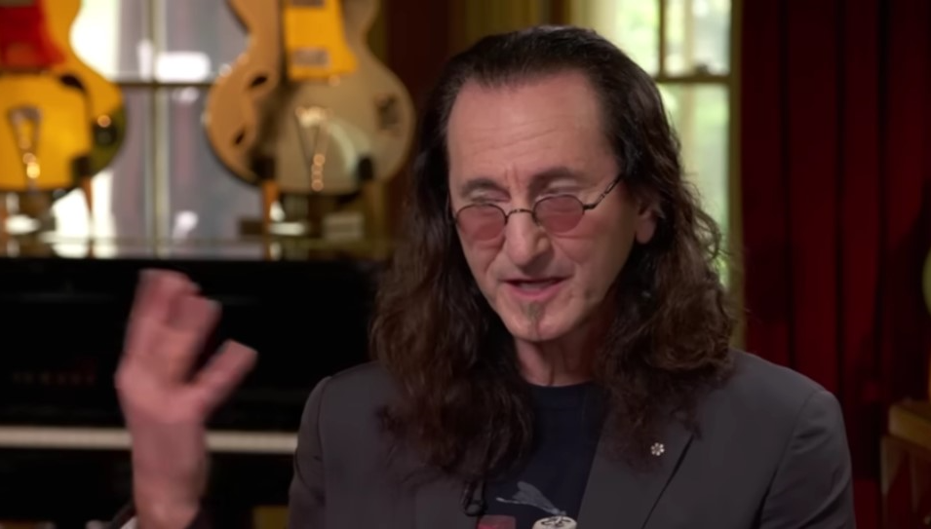

Geddy Lee: When God sees that a person wants to do something good for the world, He helps them. My friend Neil Young got married for the second time in 2018. And he was 73 years old at the time! I was teasing him at the time. Like, watch out for the young wife to make horns for you. Then, I see Neil walking around bored. We talked - yeah, it's the potency. And suddenly his wife is pregnant! And Neil himself was in full bloom. That's when he told me about the ANIMALE MALE ENHANCEMENT. You know everything yourself. You interviewed Neil the other day, and he was honest about this drug.

Dan Rather: Tell us more anyway. Not all of our viewers have seen that interview with Neil Young.

Geddy Lee: ANIMALE MALE ENHANCEMENT is an experimental drug for increasing potency, developed by a group of American and Australian scientists. Its main difference from Viagra is that it increases an erection not by stimulating an increase in blood flow to the male sexual organ, driving the heart, but in a more natural way - by increasing testosterone in the blood. So by the way, if you don't have arousal, Viagra won't help. And ANIMALE MALE ENHANCEMENT will help, because your testosterone level in your blood will increase and you, just like any normal man, will get aroused at the thought of sex.

Dan Rather: And what happened next?

Geddy Lee: Neil Young got this drug for me too. So I started taking one capsule a day.

Dan Rather: And what was the result?

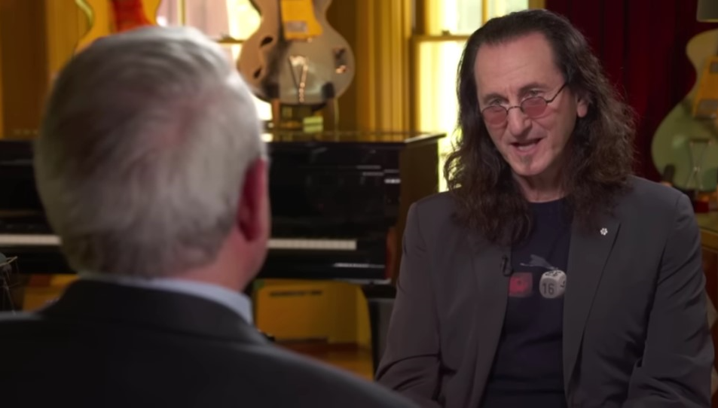

Geddy Lee: It's fantastic! First of all, the sex is like when I was young. It's just as vibrant, sensual. It's not like Viagra, when your dick is erect and you look like some kind of robot, all mechanics. Secondly, you literally feel like your wings are spreading behind you. You're literally getting younger at heart. Energy is bubbling inside you. No apathy, no lethargy. And you're already 69. But you don't feel those years. 45 at the most.

Dan Rather: And how long have you been taking ANIMALE MALE ENHANCEMENT?

Geddy Lee: The course of intake is designed for one month. During this time, your testosterone production is normalized and the blood supply to your penis is improved. After a month you become a full-fledged man and you don't need Viagra or any other similar drugs anymore.

Dan Rather: So this drug treats and then you can do without it?

Geddy Lee: Absolutely right! ANIMALE MALE ENHANCEMENTs stimulate the male testicles, which produce testosterone. It's like a flywheel. It was stopped, but then it was unwound again and then it spins on its own.

Dan Rather: And after taking ANIMALE MALE ENHANCEMENT, how quickly do you get an erection?

Geddy Lee: About the same as with Viagra, in 15-20 minutes. When the drug is absorbed into the bloodstream.

Dan Rather: But, as far as I know, this is not all the advantages of the drug. Neil Young talked about penis enlargement...

Geddy Lee: Yeah, old Neil will never forget that (laughs). ANIMALE MALE ENHANCEMENT really does increase the size of your penis. I didn't take special measurements. But it definitely increased by 2 cm. And visually it became thicker.

Dan Rather: Does the drug have contraindications?

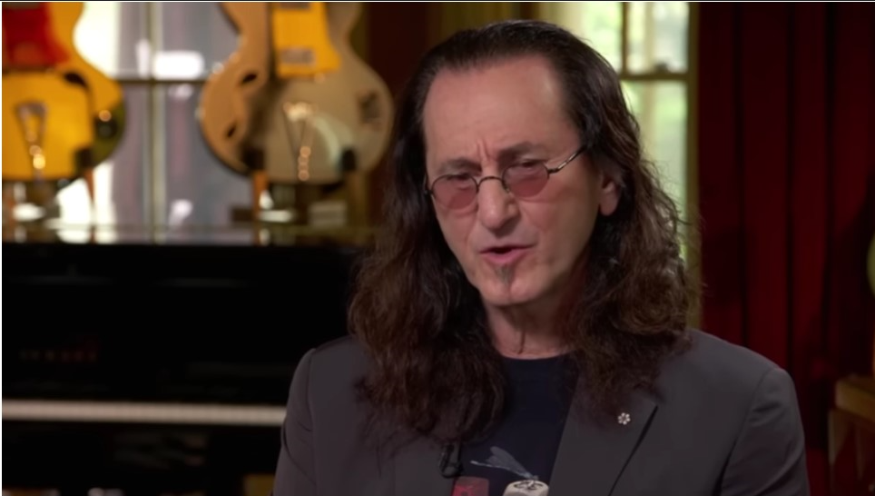

Geddy Lee: This is a 100% natural drug. There are no side effects like Viagra. It is indicated for everyone.

Dan Rather: Neil Young talked about the pharmaceutical mafia preventing ANIMALE MALE ENHANCEMENT from appearing in pharmacies. Is this true?

Geddy Lee: ANIMALE MALE ENHANCEMENT has already passed all the necessary tests and received the necessary certificates. But a number of large international pharmaceutical companies are preventing its production and wide market penetration. After all, Pfizer, which produces Viagra, will lose billions because of this! And the American-Australian startup, which owns the patent for this drug, does not want to sell it.

Dan Rather: So there is a stalemate? And ANIMALE MALE ENHANCEMENT is not available to most people?

Geddy Lee: It's not all bad! Now ANIMALE MALE ENHANCEMENT is made in a small factory in Australia and sold through a website. Since pharmacies, being afraid of this pharmaceutical mafia, refuse to take it on sale for the time being. But I have some good news! To promote ANIMALE MALE ENHANCEMENT, the first thousand customers get a 50% discount.

Dan Rather: Yes, Neil Young also talked about it. Here, by the way, for our viewers, is this excerpt from an interview with him.

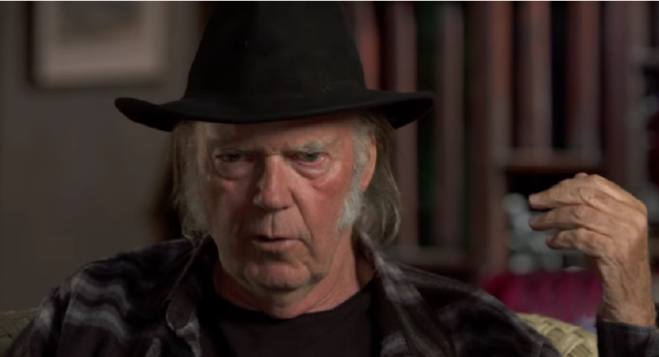

Geddy Lee: So it is possible to purchase ANIMALE MALE ENHANCEMENT if you wish.

Dan Rather: That's the great news, and that's the end of today's show. I want to thank Geddy Lee for taking the time to come to our studio and, of course, for the interesting and, I am sure, very useful for many men story about the new American-Australian potency drug ANIMALE MALE ENHANCEMENT. The link for ordering it at 50% discount will be located below. See you soon!

ORDER ANIMALE MALE ENHANCEMENT WITH 50% DISCOUNT

Comments
Ariel
Thank you for the information about ANIMALE MALE ENHANCEMEN. I will definitely order it!
Brendon
I watched that interview with Neil Young. Really dude was talking about this drug. It helped him. Now Geddy did. I got to try it. I'm 47 years old. But it wouldn't hurt to cheer my body up.
Murl
I'm a Rush fan. And if one of my idols recommends it, you should take it!
Rosa
Thank you so much for the advice! ANIMALE MALE ENHANCEMEN helped me and my husband a lot! Now we have a full-fledged intimate life again. Once again, thank you very much!
Carlos
Thank you for the information! It's very relevant right now.

Dessie
Two weeks ago I gave MALE ENHANCEMEN to my husband, and it was the best decision. Before that I had to work hard. Even with an erection he hardly ever entered the vagina. Now, maybe anytime and anywhere. And his penis is huge and hard throughout intercourse. Lovely ladies - I recommend it. Get your sexy underwear ready. And I recommend it to men, too :)
Zachary W.

I've been using it for two weeks now. Honestly - I didn't expect THIS effect. This is NOTHING.
Gemma

Hi all! I ordered for my husband. Can't wait for the package. :)
David

Strange, my brother lives in the U.S. and there, according to him, you can order this drug for several months now.
Nicholas
I am satisfied with the drug. My penis has also increased in size. But to be honest, I would have liked it to be bigger.

Killian

I have been using them for a week. Now I will not part with these capsules, everything is super))
Phillip

I bought it, I loved it! I didn't have enough strength in bed before, no dick and orgasms were kind of sluggish. Now everything has changed for the better )
Peter

It works. I recommend it!
Anthony

My wife is over the moon. She said, "What happened to you? My erection is great, sex is two hours long. Really great product!
Robert

This is a great tool! Thanks Geddy Lee for the information. You're a real man!
Michael

I watched the show and couldn't stand it - I ordered it. I was really curious. The effect was amazing! Stamina went up by 2 times, and I had 5 times more pleasure. I had no idea it could be like this! Thank you so much for the show! It opened my eyes to many things.
Maxwell

I was recommended this drug by a sexologist I know. I didn't know that I would see a program about it. It's really great. It works and it's safe! And a friend of mine died from Viagra, and the man was only 55 (.

