Задание к тесту
График (стр 6) нужно распознать, а точнее текст вокруг графика, саму середину и шкалы можете оставить картинкой, удобнее всего такие графики делать в таблице
Таблицы нужно распознавать. (стр 2)
Текст на картинках распознать (стр 4,5), его можно вставить с помощью вставки надпись (автофигура)
Table 3-I
Sample Schedule
Stream | Sample Point Location² | Measurement | Test Method^{2,5} | Sample Size, mL | Frequency
 |  |  |  |  | Startup | Test Run³ | Normal
Waxy Lube Base Oil to the Base Oil | Upstream of the Waxy | Gravity | ASTM D1298, ASTM D4052 | 1000 | Once/Day | 3 Level/Tank | Once/Tank
Waxy Lube Base Oil to the Base Oil | Lube Feed / Product | Distillation | ASTM D2887, ASTM D1160 | 1000 | Once/Day | 3 Level/Tank | Once/Tank
Hydrogenation Unit. | Stripper Bottoms | Nitrogen | ASTM D4629 | 50 | Once/Day | 3 Level/Tank | Once/Tank
 | Exchanger (T-801) | Sulfur | ASTM D2622 | 125 | Once/Day | 3 Level/Tank | Once/Tank
 |  | Pour Point | ASTM D5949, ASTM D5950 | 50 | Once/Day | 3 Level/Tank | Once/Tank
 |  | Viscosity @ 70°C | ASTM D445 | 500 | Once/Day | 3 Level/Tank | Once/Tank
 |  | Viscosity @ 100°C | ASTM D445 | 500 | Once/Day | 3 Level/Tank | Once/Tank
 |  | V.I. | ASTM D2270 | - | Once/Day | 3 Level/Tank | Once/Tank
 |  | UV Absorption | CTM 5-16, ASTM D2008⁶ | 100-1000g | Once/Day | 3 Level/Tank | Once/Tank
 |  | Aniline Point | ASTM D611 | 50 | Once/Day | 3 Level/Tank | Once/Tank
 |  | % Wax by Solvent Dewaxing | CTM 5-13 | 100g | Once/Day | 3 Level/Tank | Once/Tank
 |  | Solvent Dewaxed Oil Viscosity @ 40°C | ASTM D445 | 500 | Once/Tank | 3 Level/Tank | Once/Tank
 |  | Solvent Dewaxed Oil Viscosity @ 100°C | ASTM D445 | 500 | Once/Tank | 3 Level/Tank | Once/Tank
 |  | Solvent Dewaxed Oil V.I. | ASTM D2270 | - | Once/Tank | 3 Level/Tank | Once/Tank
 |  | Solvent Dewaxed Oil Pour Point | ASTM D7, ASTM D5950 | 50 | Once/Tank | 3 Level/Tank | Once/Tank
Make-Up Hydrogen | Upstream of XB-804 | Composition | ASTM D1945 | 125 | Once/Day | Once/Day | Once/Week
 |  | Specific Gravity | ASTM D1945 | 125 | Once/Day | Once/Day | Once/Week
 |  | CO + CO2 | Gastech Tube or Equivalent, ASTM D1945 | - | Once | - | (Note 4)
 |  | Chloride | Gastech Tube or Equivalent | - | Once/Day | Once/Day | Once/Week
Recycle Gas | At Recycle Gas | Composition | ASTM D1945 | 125 | Once/Day | Once/Day | Once/Week
 | Specific Gravity | H2S | Gastec Tube or Equivalent | - | Once/Day | Once/Day | Once/Week
 | Analyzer | NH3 | Gastec Tube or Equivalent | - | Once/Day | Once/Day | Once/Week
 |  | Specific Gravity | ASTM D1945 | 125 | Once/Shift | Once/Shift | Once/Week
 |  | CO + CO₂ | Gastec Tube or Equivalent | - | Once | - | (Note 4)
Make-Up Hydrogen and Recycle Gas | At Recycle Gas | Composition | ASTM D1945 | 125 | Once/Day | Once/Day | Once/Week
Make-Up Hydrogen and Recycle Gas | Specific Gravity | H2S | Gastec Tube or Equivalent | - | Once/Day | Once/Day | Once/Week
Mixture | Analyzer | NH3 | Gastec Tube or Equivalent | - | Once/Day | Once/Day | Once/Week
 |  | Specific Gravity | ASTM D1945 | 125 | Once/Shift | Once/Shift | Once/Week
 |  | CO + CO₂ | Gastec Tube or Equivalent | - | Once | - | (Note 4)
IDW Feed Surge | Downstream of E-801 | Gravity | ASTM D1298, ASTM D4052 | 1000 | Once/Day | Composite | Once/Day
Drum Liquid |  | Distillation | ASTM D2887, ASTM D1160 | 1000 | Once/Day | Composite | Once/Day
 |  | Nitrogen | ASTM D4629 | 50 | Once/Day | Composite | Once/Day
 |  | Sulfur | ASTM D2622 | 125 | Once/Day | Composite | Once/Day
 |  | Pour Point | ASTM D5949, ASTM D5950 | 50 | Once/Day | Composite | Once/Day
 |  | Viscosity, cSt @ 70°C | ASTM D445 | 500 | Once/Day | Composite | Once/Day

- Remove the heating tape from the column. Unscrew the nut holding the filter column to the filter base. Carefully tilt the filter column back and wash the white O-ring with hot n-heptane from a wash bottle.

- Hold the filter column over the sample beaker and rinse the inside and bottom edge with chloroform. This will dissolve any asphaltenes sticking to the sides of the column.

- Carefully swirl the chloroform around the beaker and pour it into the aluminum weighing dish. Rinse the inside of the beaker with 50, 10-mL portions of chloroform until the washes are colorless. Transfer the chloroform to the weighing dish.

- Carefully wash the outer edge of the filter with hot n-heptane from a wash bottle.

- Put the dish containing chloroform washes on a low temperature hot plate. Allow the chloroform to evaporate slowly. Any boiling or spattering due to overheating can lead to loss of sample and, thus, low results.

- Turn off the vacuum and carefully lift the filter using forceps. Check the bottom of the filter for a dark spot. If an oil spot is present, replace the filter on the filter holder and turn on the vacuum. Carefully wash the filter and asphaltenes with hot n-heptane from a wash bottle. Release the vacuum and check the bottom of the filter again. Repeat washing if necessary.

- Carefully move the filter from the filter holder to the aluminum weighing dish.

- Put the aluminum weighing dish containing the filter and asphaltenes in the drying oven for 10 minutes.

- Remove the dish and cool to room temperature under an inverted beaker.

- Weigh the dish on an analytical balance. Record the weight to the nearest 0.00001 g.

NOTE: You should try to collect a minimum of 50 mg of asphaltenes. If the net weight of asphaltenes is less than 50 mg and the sample size taken is less than 20 g, then the sample should be rerun using a larger sample size.

Calculations

ppm Insolubles = | Weight of Insolubles, g | x 10⁶
ppm Insolubles = | Weight of Sample, g | x 10⁶

Wt % Insolubles = | Weight of Insolubles,g | x 100
Wt % Insolubles = | Weight of Sample, g | x 100

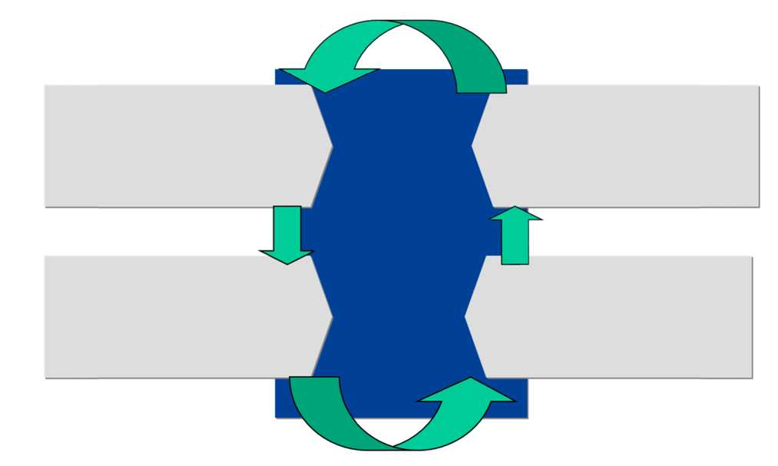
4. Succession Planning
the approach taken to ensure that there is a sufficiently broad Kazakh talent pipeline

3. Development
defines the state-of-the-art models, tools and plans to develop Kazakh staff

2. Attraction and Recruitment captures the approach to deliver Kazakh staff to NCPOC
Nationalisation

1. Manpower Planning defining the manpower required to deliver the Project

In terms of future versions of NCPOC's Organisation Plan, Succession Planning will be the key enabling process.

NCPOC will strive to fill as many of these positions and any positions filled in the future by expatriates with Kazakh staff as the expatriates complete their assignments.

8. TRAINING AND DEVELOPMENT
The measure of NCPOC's success in contributing to the development of oil and gas professionals in Kazakhstan is the company's ability to develop the capabilities of Kazakh nationals in NCPOC.

NCPOC is committed to staff development and is implementing a comprehensive training plan to ensure access to learning interventions that develop personal and professional effectiveness aligned with identified longer term business requirements and Individual Development Plans (IDPs).

Each Kazakh national in NCPOC will have an IDP documenting:

• Strengths

• Development needs

• Development actions

• Future career considerations.

Each supervisor's duty is to support their team members in fulfilling their development actions identified in the IDPs and that the IDPs contain measurable objectives and plans. NCPOC HR Directorate review IDPs on quality and feed back to the supervisors and the team members how to further improve the plans. The NCPOC Leadership Team also reviews Kazakh nationals' development at least twice a year in a meeting dedicated to the topic.

NCPOC will adopt a blended learning approach whereby the process of staff development is based on a combination of formal training programmes (both classroom based and virtual learning) and on-the-job workplace assignments. As part of their roles, Expatriate line managers take the responsibility to provide on-the-job development and knowledge transfer and development should discussed as part of the regular mid and end year reviews. NCPOC staff will also have access to state-of-the art learning models such as the Shell ‘4 box' model which outlines the blended learning approach to staff development. This incorporates the use of reference materials, training courses, on-the-job

coaching and professional experience, in addition to e-Learning programmes (such as Skillsoft and IPIMS) and the suite of opportunities available through classroom based learning in order to develop staff in broadly four areas:

• Completion of Republic of Kazakhstan mandatory Training and HSSE training
• Technical and Functional training (e.g. a Wells and Reservoirs programme for Engineers or finance and HR
programmes) for building Technical and Professional Competence
• Personal and Business skills (e.g. Microsoft Excel training)
• Leadership training - applicable to all disciplines (e.g. Foundation leadership courses) for developing Supervisory and Leadership capability.

As a growing company in Kazakhstan, it is assumed that the key priorities for training within the start-up period would be:

A model for the overall NCPOC training approach has been constructed as below:

 | For Supervisors: People Management |  | For Managers: Managerial Programs
 | On The Job Coaching and Mentoring
 | Special Project Program Training (including Competence Assessment and mentoring) |  | Personal and Business Training Programmes
 |  |  | Competence Development (skillpool driven) and Individual Development Plan
 | Mandatory RoK and NCPOC Training
 |  |  |  | |
 | Special Project Trainees |  | Young Professionals Development Programme  Employees & Managers Development and Training Programme

More courses and development actions are identified as current skill gaps have been verified and analysed. Kazakh staff have access to Shell's learning curriculum for the identified development needs and NCPOC works closely with Agip KCO with access to Agip KCO's learning offering.
Table 1 Baseline characteristics of baseline PPI users and nonusers | Characteristic | PPI users (n=261) | Non-PPI users (n=9,162) |  | p values
 | Age, mean (SD) (years) | 67.6 (11.1) | 61.9 (13.4) | <0.001
 | Female gender (%) | 204 (78.2) | 6,334 (69.1) | 0.001
 | BMI, mean (SD) | 28.3 (5.3) | 26.9 (4.8) | <0.001
 | Femoral neck T-score, mean (SD) | -1.4 (1.0) | -1.1 (1.0) | <0.001
 | Prevalent clinical fragility fracture (%) | 97 (37.1) | 2,392 (26.1) | <0.001
 | Daily calcium supplement use (%) | 113 (43.3) | 3,592 (39.2) | 0.103
SD standard deviation, BMI body mass index, BMD bone mineral density  ªEver use daily for >6 months ^{b}Oral or IV, ever use daily for >1 month | Cigarette use (%)ª | 147 (56.3) | 4,859 (53.0) | 0.162
 | Alcohol use, mean (SD), drinks per week | 2.3 (4.9) | 3.0 (5.9) | 0.052
 | Regular physical activity (%) | 108 (41.4) | 5,085 (55.5) | <0.001
 | Corticosteroid use (%)^{b} | 42 (16.1) | 414 (4.5) | <0.001
 | Bisphosphonate use (%)^{b} | 88 (33.7) | 2,220 (24.2) | <0.001

study supports the growing body of literature linking PPI use with greater fracture risk. A recent meta-analysis, examining 11 different observational studies, found the relative risk of fracture in PPI users to be 1.30 (95 % CI 1.041.30) for hip fractures, 1.56 (95 % CI 1.31-1.85) for vertebral fractures, and 1.16 (95 % CI 1.04-1.30) for fracture at any site [10]. Similarly, we found a significant increase in risk of fractures at any site in PPI users (adjusted HR 1.40; 95 % CI 1.13-1.77; p0 0.004), with higher hazard ratios for hip fracture (lack of statistical significance in the adjusted models could relate to the small number of hip fractures observed).  The nature of the association between increased fracture risk and PPI use has been questioned with the suggestion that residual confounding due to unmeasured or unmeasurable factors may be a source of bias [19]. There are no | randomized control trials looking at this question, and therefore, we must rely on observational studies. Unfortunately, observational studies, especially those examining administrative databases, are often limited by the information collected. As such, many previous studies on PPIs and fracture risk have controlled for a limited number of risk factors. CaMos, however, was specifically designed to study osteoporosis and fractures. Therefore, detailed information on many different fracture risk factors was available to include in our analysis. It has been suggested that PPI users tend to have more fracture risk factors than the general population. At study baseline, we did find that multiple known fracture risk factors were more common in the PPI user group than the non-PPI user group. However, the elevated fracture risk remained even after these variables were controlled for in our analysis. Bone mineral density, an important fracture

Fig. 1 Kaplan-Meier curve showing unadjusted fragility fracture-free survival by PPI use (defined as PPI ever use).  PPI= proton pump inhibitor. P- value from the log rank test | 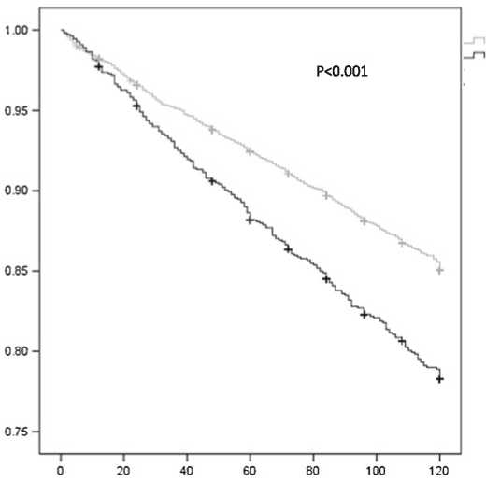  Fraction of participants not experiencing a fragility fracture |  | PPI non-users  PPI "ever" users
 |  | Time to first fragility fracture, months

Springer

