Transforming the Fear of the Unknown:
How anxiety shifted my mindset
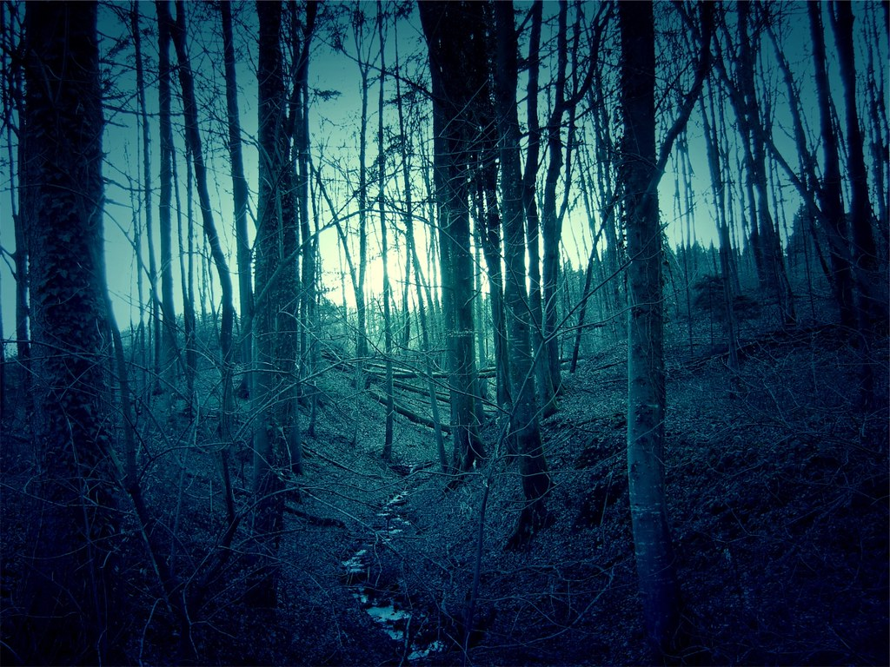

How often do we find ourselves stressed up when facing unpredictable situations and admitting the inability to take control of them?
You’ve done all you could, but things may get out of plan. Or worse. You’re so frightened by the prospect of a worse-ever-turnout that you simply can’t calm down and find any solution.
I asked myself this question yesterday. And what? I tried to count how often I was terrified when the uncertainty came across my seemed stable life. Those feelings were always followed by drawing pictures of the worst scenarios, and even making mistakes caused by my own panic.
At no time did it help to resolve the problem or foresee the future! The fear instead led me to terrible anxiety, which day by day literally ate my energy but never made me closer to finding the right solution.
So how many times did I let my inner monsters take control of me? 10, 20, 30 times?.. I couldn’t count.
The only thing I remembered was that the problem had always been resolved. My worst scenario had never come to reality.
At that point, catching myself building tries in my mind of how to deal with a situation, that seemed life-mattered and unresolvable, another voice of mine said: “Wait… Do you remember that just recently you experienced the same when faced another hitch on your way? You almost ate yourself for it!”
True. I’ve remembered that last challenge in my life. Eventually, a solution was found and nothing bad happened.
Has this reminder helped me to reduce my anxiety? Not for yesterday. Moreover, I started to fight my fear which brought me even more helplessness and scariness. Eventually, a sleepless night, another disgusting set of accidents – but the next day began.
Having woken up in a bad mood, and hating every single minute, I was so exhausted by blowing up the problem that overtook my mind recently. Having no energy to solve that puzzle, I finally just wished the current troubles to disappear somehow!
Instead, the idea of figuring out the purpose of coming uncertainty replaced the fear. Do my anxiety and anger over it all show up for something worth it?
Sure, I did know that every challenge coming across our journey has its own mission for us. It appears like an unwelcoming ghost that came to kill us. However, along with the pain it gives, that demon is actually screaming to us: “Hear me! Now I’m here to hurt you, but you’ll later be grateful to me helped to open your eyes. ”
But what does the uncertainty and our anxiety around it in fact do for us?
Why are we sometimes so terrified of facing unpredictable changes or unforeseen future at all?
“It’s important to find a place where you feel trust, you feel belonging and stability” – Bojan Krkic
True, we all naturally tend to seek a constancy that gives us some sort of stability, followed by daily routine and a more or less predictable future. In other words, we used to cling to our “comfort zone”.
As a result, the habit of setting walls around us takes its place. Sometimes it’s easier to stick to how life is settled already over embarking on unforeseen adventures.
“Should I avoid risking or give it a try?” – the question is circulating.
However, life never remains static. Changes do happen.
There’s nothing certain, but the uncertain”. - Proverb

But, rarely do chances happen without stress and the necessity to bear with instability, make decisions, and take risks. Unexpected turnouts sometimes freak us out.
Some people are more resistant to facing things going out of hand, while vulnerable ones might need a lot of effort to master strong resilience to experience them.
Shifting mindset towards embracing the unknown instead of getting mad once facing it? Easy to say, hard to do?
Ever thought about the multiple choices we make every day? How would your life look like if once you took another turn on your trail?
Surely, your mind regularly draws pictures of these varieties of life scenarios. Some of them look scary, others handle promises. At some points, missing chances appear. Meanwhile, greater luck is might still hidden from your eyes.
Imagine the big hall with multiple doors to open. We open one, enter the room, and see the other variety of doors for our choice to open.
Multiple choices come across every day. But we make one decision. Then another set of choices is revealed, and a solution has to be found. That’s the picture of how different life scenarios are swirling around all the time.
Thus, every single challenge, uncertainty, and fear of change reminds us that life is never linear. The more we are open to those challenges the more we can cooperate with our fear of unpredictable circumstances. We don’t know the exact answer and there is no only one correct answer.
“Uncertainty is the only certainty there is, and knowing how to live with insecurity is the only security” – John Allen Paulos.
We might not find the solution now, either solution doesn’t exist. We just walk our way in our imaginary forest.
The rocks on your way prevent you from clinging to your current comfort zone. Instead, they are the sign for you to wake up and see those multiple trails in your life.
That’s how embracing your challenge, anxiety, and inability to foresee the outcome can transform your mindset and let you embark on your self-growth.
The acceptance and embracing of the unknown future indeed build our resistance and make us watch and think.
“Trust the wait. Embrace the uncertainty. Enjoy the beauty of becoming. When nothing is certain, anything is possible”. – Twin Flame Rehab

Quick question for you. Did you remember that the brightest ideas came into your mind when you didn’t expect them? Not when you spent hours searching that only one right decision which simply never exists.
At the end of the day, I said to myself: well, I do need to keep walking and watching. Not only should I run to my desired result, but I also learn. Not only hear what’s around me, but listen. Let the unknown be unrevealed.
Not a time to live in constancy but a time to discover curiosity.
I might not find the answer because I don’t need it now. This is for something other worth it.
How do you overcome the fear of uncertainty? Have you ever considered the challenges as new opportunities? Feel free to share your thoughts down below, and I’m looking forward to hearing from you.

Written by Oliarela, February 2nd, 2025

