A picture description
Birth of Venus
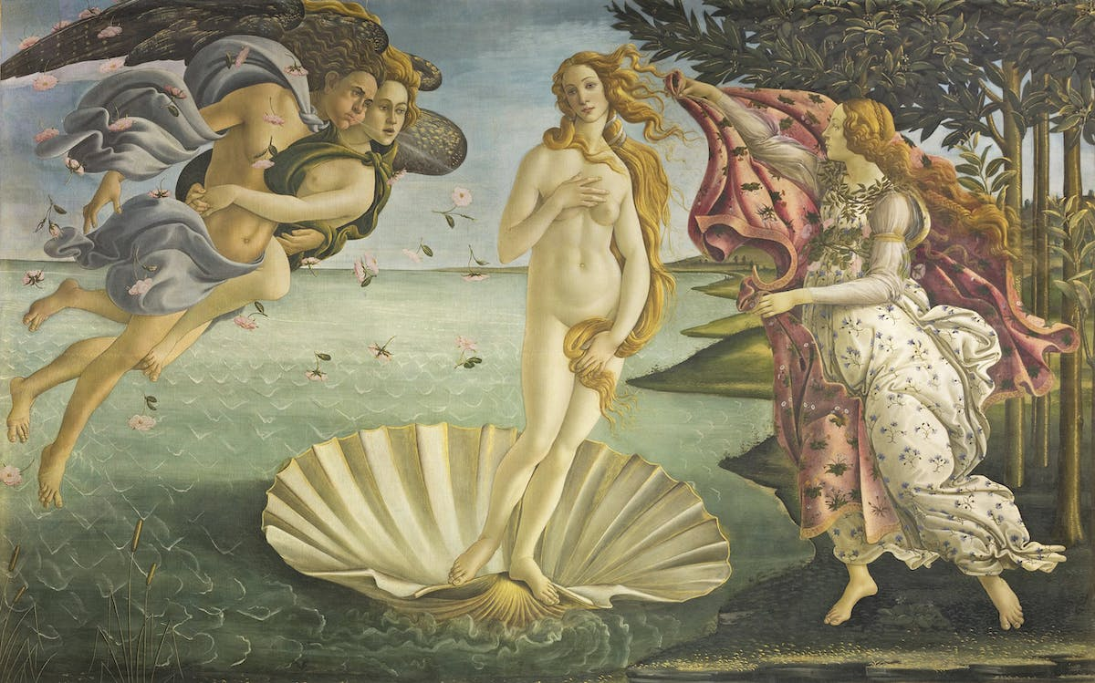
- The general effect. (The title and name of the artist. The period or trend represented.
The Birth of Venus is a painting by the Italian artist Sandro Botticelli, probably executed in the mid 1480s. The painting is in the Uffizi Gallery in Florence, Italy. It is the most famous paintings in the world, and icon of the Italian Renaissance
- The contents of the picture.
The composition actually shows the goddess of love and beauty arriving on land, on the island of Cyprus, born of the sea spray and blown there by the winds, Zephyr(god of the west wind) and, perhaps, Aura(goddess of the breeze and the fresh, cool air.) The goddess is standing on a giant scallop shell, as pure and as perfect as a pearl. She is met by a young woman, who is sometimes identified as one of the Graces or as the Hora of spring, and who holds out a cloak covered in flowers. Even the roses, blown in by the wind are a reminder of spring. The subject of the painting, which celebrates Venus as symbol of love and beauty, was perhaps suggested by the poet Agnolo Poliziano.
- The composition and the colouring. Light and shade effects.
Botticelli's art was never fully committed to naturalism; Botticelli seldom gave weight and volume to his figures and rarely used a deep perspectival space.
The painting is on two pieces of canvas, sewn together before starting, with a gesso ground tinted blue. There are differences to Botticelli's usual technique, working on panel supports, such as the lack of a green first layer under the flesh areas. There are a number of pentimenti (the presence or emergence of earlier images, forms, or strokes that have been changed and painted over) revealed by modern scientific testing. The Hora originally had "low classical sandals", and the collar on the mantle she holds out is an afterthought. The hair of Venus and the flying couple was changed. There is heavy use of gold as a pigment for highlights, on hair, wings, textiles, the shell and the landscape. This was all apparently applied after the painting was framed. It was finished with a "cool gray varnish", probably using egg yolk.
- Interpretation and evaluation. Impression, general comments.
It practically embodies the rebirth of civilization, a new hope, geopolitical, social and cultural shift which occurred after the Middle Age turmoil. But also according to many art historians is to be found in the Neoplatonic interpretations, which claim that Botticelli wanted to represent the Neoplatonic idea and meaning of divine love in the form of a nude Venus.

