We often people have a lot of leisure time, but we do not know what to do. However, one company created a real miracle for all venturous risk lovers. NetEnt casino slots are famous among players from all over the world. The company released a game called Blood Suckers II for the Halloween holiday. This online slot will appeal to the most demanding users who are not indifferent to the level of graphics and a variety of bonuses.
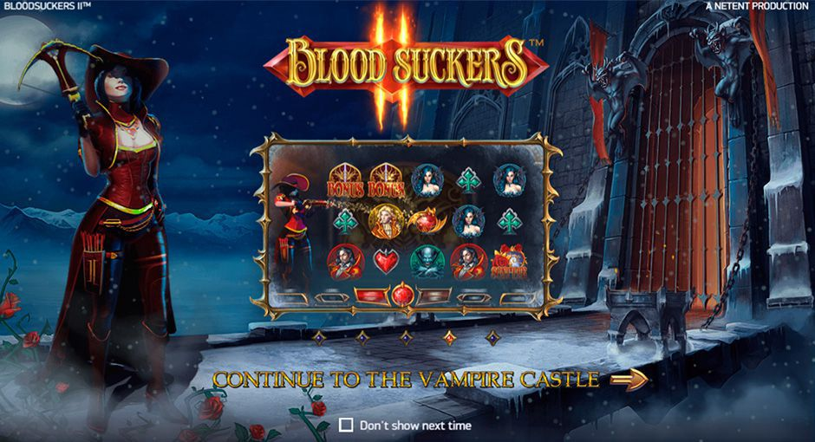
There are only ten levels of rates with chip values from one cent to one euro in this slot machine game. Images of four card suits and four inhabitants of a vampire castle act as ordinary icons. Winning combinations of basic icons are formed from several identical elements from left to right on the active line.
The following icons perform special functions:
Wild - appears in all columns and makes up the chains that are paid at the highest odds. In addition, it replaces the missing basic icons in the sequences.
Scatter – is paid when falling in any position on the screen. Winnings are calculated by the total bet. Three scatters launch Blood Rose Free Spins.
Bonus - starts a round of the Hidden Treasure Bonus Game. At least three characters must appear in adjacent columns so that it starts.
You not only play these free slots for fun, but you can even hit a huge jackpot!

