

Technical data sheet
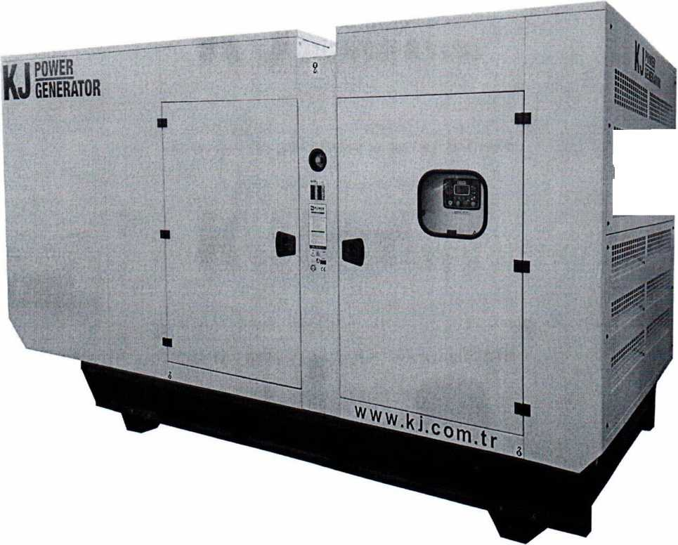
Diesel generator set KJS440
Serial number № 561668

2018
ІІШІІІІІІИШ
ІІІІІЦІІШН0
„„„„«.І.-' • ;
GENERAL GUIDELINES
- Before starting the equipment operation, it is necessary to read carefully the instruction (manual, guidelines) for operation and maintenance.
- The given data sheet must be kept permanently with the equipment.
- It is not allowed to make entries into the data sheet with a pencil, dilutable ink and cleaning.
- An incorrect entry must be carefully crossed out, and a correct entry must be written next, which have to be certified by the responsible person for the safe operation of the equipment, indicating his surname and position.
- When transferring equipment to another company or another owner, the final lifelength entries on the progress shall be certified by the stamp of the enterprise that transmits the equipment.

1. General information
- Product name-Diesel generator set
- Model: KJS440
- Manufacturer - KJ Роwer
- Date of manufacture: 07.11.2018 р.
- Factory number: 561668
- Installation and operation of the diesel generator set of the model is carried out in accordance with the requirements of the manufacturer's plant.
- Purpose and general design of the set
A diesel generator set of the KJS440 model is a mobile power plant that is used as an autonomous power source for powering electrical equipment. The diesel generator set of the KJS440 model consists of the following components:
- diesel engine;
- generator;
- noise-proof housing;
- control panel;
- radiator;
- rechargeable batteries;
- automatic heating of the coolant liquid;
- industrial muffler;
- automatic safety switch
Structural design: on a rigid metal frame there is a diesel engine and an electric generator, which are interconnected by an elastic coupling.
The diesel generator set of the KJS5440 model is equipped with a control and automation unit, which provides the automatic control of the generator and diesel engine and all necessary functions for this. It can be used in automatic, test or manual modes. It consists of digital indicators, which ensure the functioning of all analogue indicators that are required for the generator control. Digital indicators show the generator network and voltage phases, generator current phase, network and generator frequency, battery voltage, oil pressure, engine temperature and operating time. The generator is checked continuously and then when the value of the generator or line power reaches the limit specified in the parameter menu, the necessary actions are performed and the fault signal is activated.
Functions that can be performed by the automation control unit:
- automatic start and stop of the electric generator;
- network control, the function of automatic switching on and off, the power switch function;
- error control;
- preheating;
- manual, automatic and test mode;
- ability to measure analogue engine temperature and oil pressure;
- engine operating time record and constant maintenance information.

- Main technical parameters
General characteristics
Maximum power | kVA | 440
 | kW | 352
Rated power | kVA | 400
 | kW | 320
Voltage | V | 400/230
Dimensions | mm | 4300*1500*2450
Weight | kg | 4050
Controller |  | DАТАКОМ D500

Diesel engine
Serial number |  | G9184001385
Fuel type |  | Diesel
Manufacturer |  | SDЕС
Model |  | SС15G500D2
Engine power | kW | 373
Total volume | l | 14,16
Number of engine revolutions | Rpm | 1500
Speed governor |  | electronic
Number of cylinders | pcs. | 6
Compression ratio |  | 15:1
Cooling system |  | liquid + air
Fuel consumption 100% | l/hour | 81,2
Fuel consumption 75% | l/hour | 59,8
Fuel consumption 50% | l/hour | 41,1
Volume of fuel tank | l | 576

Synchronous generator
Serial number ТР17070011213
Excitation system SHUNT
Maximum load | А | 636
Rated load | А | 578
Voltage regulation | +/- | 1%
Power factor |  | 0,8
Frequency | Hz | 50
Insulation class |  | Н
Degree of protection |  | ІР23
Permissible overload |  | 110% for 1 hour
Connection type of outputs |  | star
Number of poles |  | 4
Number of bearings |  | 1

- Equipment description

Equipment design
Engine SDEC - 6-cylinder four-stroke diesel engine with inline cylinder arrangement and direct fuel injection.
The industrial diesel engine is characterized by the unmatched productivity and durability required to maintain production processes in many industries. These engines provide high output power, with proven reliability and high fuel efficiency. World-class manufacturing and processing technologies combined with proven engine designs ensure reliability, quietness, durability and performance of the equipment. The fuel consumption of the engine is optimized to match the operating cycles of a wide range of equipment in different areas of the application while maintaining low operating costs.
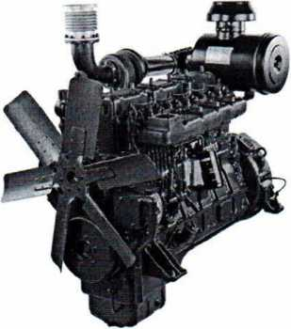
Fig. 1 - engine SDEC SC15G500D2

The engine is equipped with all the necessary devices for alerting the operator and automatically switching off to prevent breakdowns. The sensors, installed inside the engine, provide for the rapid detection of any faults and errors of the operator. If the disconnection from normal operation mode can have serious negative consequences, then the sensors send signals to certain control devices which, in turn, ensure the engine systems without which its operation is impossible, for example, fuel or air, as a result of which the engine stops. Emergency states of the engine, in case of which it becomes necessary to switch it off, include:
- reduction in oil pressure, which may result from damage to the bearings and the crankshaft, as well as the piston seizure;
- increase in water temperature, which leads to deterioration of oil properties, increased wear of piston rings and bearings, appearance of cracks in the cylinders, as well as the piston seizure;
- exceeding of the set speed, which causes weakening or even separation of rotor windings.
Emergency stop of the engine can be carried out using two basic methods. For stopping by means of automatic switching off of the fuel rail, which can be done remotely, an electromagnet or a hydraulic cylinder is provided in the housing of a high-pressure fuel pump, which, upon the receiving of the respective command, transmits the fuel rail to the switch off position, while the fuel supply to the engine stops.
Stopping by the stopping of air supply is provided by a hydraulic cylinder, which blocks the air supply into the engine cylinders. The oil pressure of the hydraulic system drives a piston, the rod of which actuates the spring-cam mechanism or the air supply shutoff valve.

Generator
In the diesel generator set KJS440 a three-phase brushless alternator LYG 314 Е is used.
Generators LYG 314 E are characterized by higher efficiency and stability of electric power supply.
Generators LYG 314 E of large standard sizes have the following additional features:
- one-piece housing provides high performance of the generator's working node with more convenient access for cleaning and convenient arrangement of the heating device.;
- more simple design in maintenance with easy access to the bearing;
- air discharge through the top of the generator, not through the bearing bracket, which provides better cooling;
- step 2/3 enables connection of the generator according to the delta circuit;
- excitation from permanent magnets in combination with three-phase measurement allows to provide high efficiency of the voltage regulator
- availability of temperature sensors inside the stator.
The generator is equipped with a digital voltage regulator with voltage control of all three phases, excitation current limitation, control of reactive power generation.
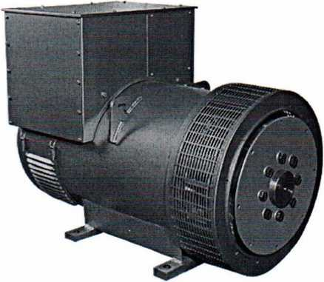
Fig.2 - synchronous generator

Semiconductor voltage regulator
The voltage regulator SX440 provides voltage level regulation within the range from +10 to -10%.

Voltage drop and rise control device
The voltage drop control is necessary in order to minimize the circulating current between the parallel connected generators. The voltage rise control allows to adjust the voltage drop circuit, providing a voltage stabilization within ± 1% when operating with the motor speed controllers.
Overload protection
A safety fuse is used to protect the voltage and exciting regulator from overload. A disconnector switch is used for additional protection of the exciter from overheating.
Connection according to the "star" scheme
The generator windings are connected according to the "star" scheme. This configuration is optimal for most applications and minimizes the possibility of incorrect installation.

- Acceptance certificate
Diesel generator set of KJS440 model, factory (serial) number 561668, date of manufacture 07.11.2018, meets the requirements:
- АРІ S8РЕС 7К Specification for Threading and Gauging of Rotary Shouldered Thread Connections.
- NPAOP 11.1-1.01-08. Safety rules in the oil and gas industry of Ukraine.
- GOST 16293-89 Complete drilling rigs for operation and deep exploration drilling. Main parameters.
- RD 08-272-99 Safety requirements for drilling equipment for the oil and gas industry.
- GOST 12.2.041-79 Occupational safety standards system. Drilling equipment. Safety requirements
- DSTU ЕN 60034-5:2015 (ЕN 60034-5:2001, IDT) Electric rotary machines. Part 5
- DSTU ЕN 60034-6:2015 Electric rotary machines. Part 6
- DSTU ЕN 60034-7:2015 Electric rotary machines. Part 7
- DSTU ЕN 60034-8:2015 Electric rotary machines. Part 8
- DSTU ЕN 61000-6-4:2015 Electromagnetic compatibility. Part 6-4
7. Accounting of the operating time
No. of  operation beginning | Equipment location (address/field) ending of operation | Date  at the facility | Operating time, hours from the beginning of operation

8. Person, responsible for the proper condition and safe operation
Number and date of the appointment order | Position, surname, name, patronymic | Date of knowledge assessment of relevant Rules | Signature of responsible person

Maintenance accounting
Date | Type of maintenance | Notes on the technical condition | Position, surname and signature of the responsible person

9. Repair (to be completed by repair company)
Description of the performed repair
Operating time since the beginning of operation hours
Operating time after the last repair hours
Reason for the repair
_____________________________________________________________________________________________________________________________________________________________________________________________________________________________________________
Repair, was conducted to the equipment
_________________________________________________________________________________________________________________________________________________________________________________________________________________________________
according to the technical documentation
_________________________________________________________________________________________________________________________________________________________________________________________________________________________________

Repair: started 20
finished 20
When repairing the equipment: modernization was conducted according to
_______________________________________________________________________________________________
replacement of the main assembly units
__________________________________________________________________________________________________________________________________________________________________________________________________________________________________________________________________________________________________________________________________________________________________________________________________________________________________________________________________________________________________________________________________________________________________________________________
- Certificate of equipment acceptance after repair
The diesel generator set of the KJS440 model, factory (serial) number 561668, date of manufacture 07.11.2018, repaired in accordance with the applicable requirements of the technical documentation and is considered suitable for further industrial operation.
Resource to the next repair of _______ hours over _______ years, including the period of preservation at the repair enterprise:
under the shed months/years;
on the open area months/years.
Assigned equipment resource hours.
The repairer guarantees the conformity of the quality of the equipment or its component parts to the technical requirements, subject to the conditions of storage, transportation, installation and operation, established by the relevant documentation.
(signature) (initials and surname)
(signature) (initials and surname) 20 р.

