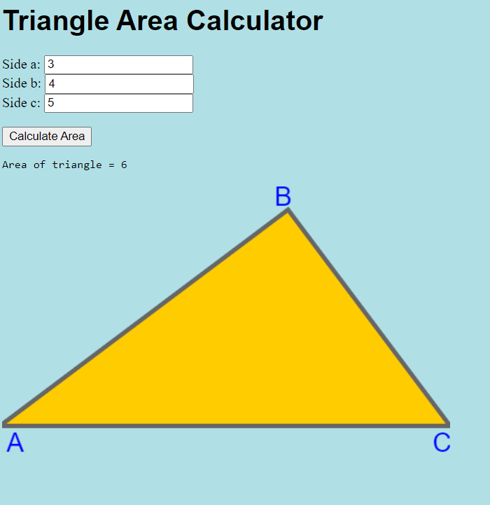
1.The sides of the triangle are unknown to the user

Defects:
- Expected result: when entering the data, the sides of the triangle are labeled as AB, BC and AC instead of a,b,c
2.If you enter no number program shows “Incorrect side value for side: sideC”
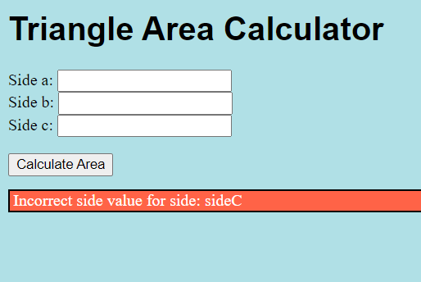
Defects:
- Expected the message: Incorrect side value for side AB
- Expected the message: Incorrect side value for side BC
- Expected the message: Incorrect side value for side AC

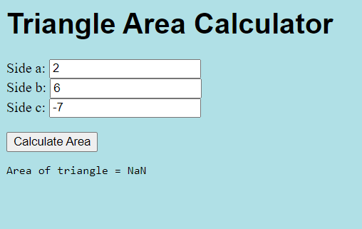
3.When the user enters incorrect data, the program displays an error. If the user then enters a single negative value, nothing happens.
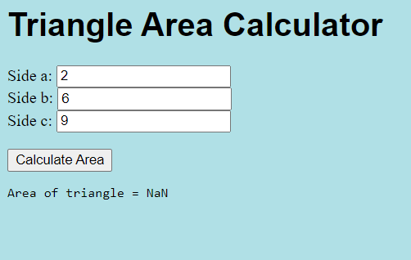
Defects:
- Left: Expected the message: Error: It is not possible to build triangle by specified sides
No: “Area of triangle …” message should be shown in this case.
- Right pic. Expected message: “ The side AC is entered incorrectly”
No: “Area of triangle …” message should be shown in this case.
4.If the user enters only side c, we see the following bug
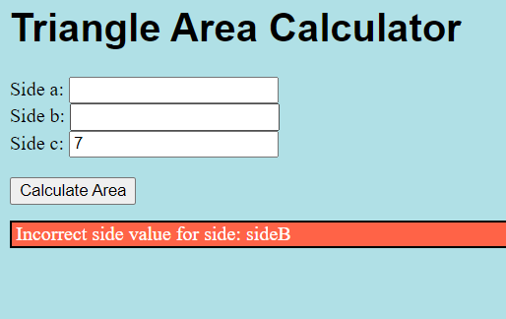
Defects:
- Expected the message: Incorrect side value for side AB
- Expected the message: Incorrect side value for side BC
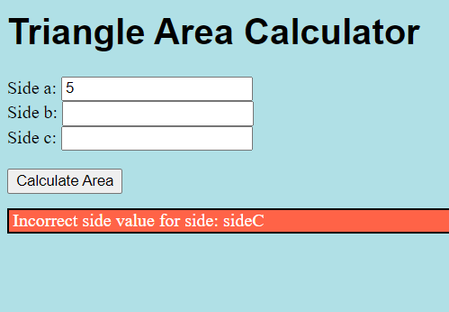
5.If the user enters only side a, we see the following bug

Defects:
- Expected the message: Incorrect side value for side BC
- Expected the message: Incorrect side value for side AC
6. Problems with decimal points
Picture 1
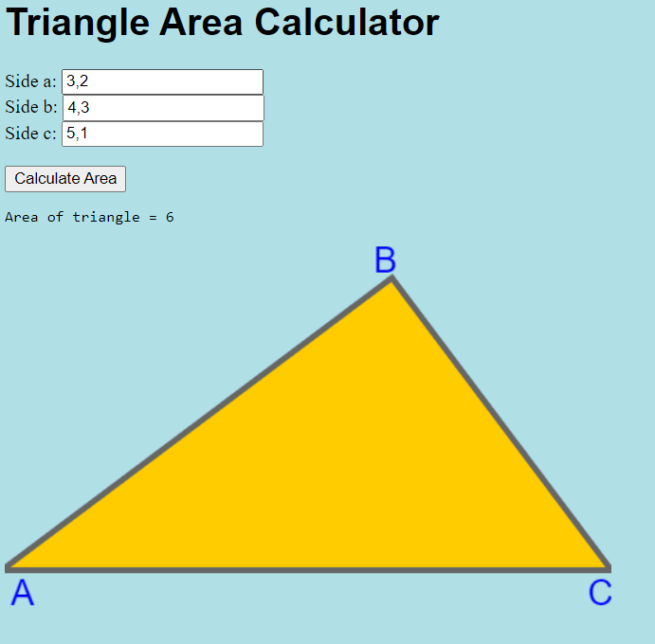

Picture 2
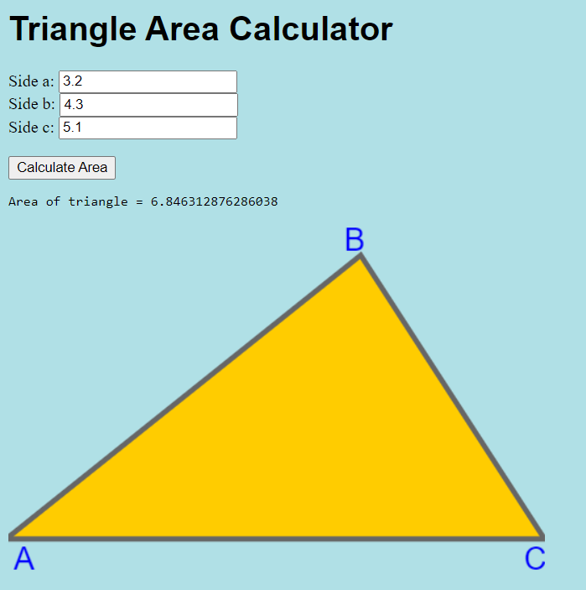

Defects:
- Picture 1: Expected the message: Area of triangle = 6.846312…
- Picture 2: Expected the message: Area of triangle = 6.846312…
7. When the user enters words, we see a bug
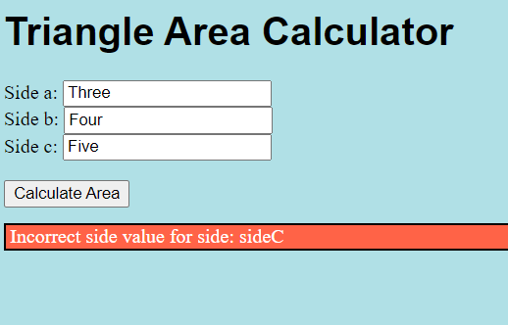
Defects:
- Expected message: Error: Please enter numbers
8. When the user made gaps between numbers, we see a bug
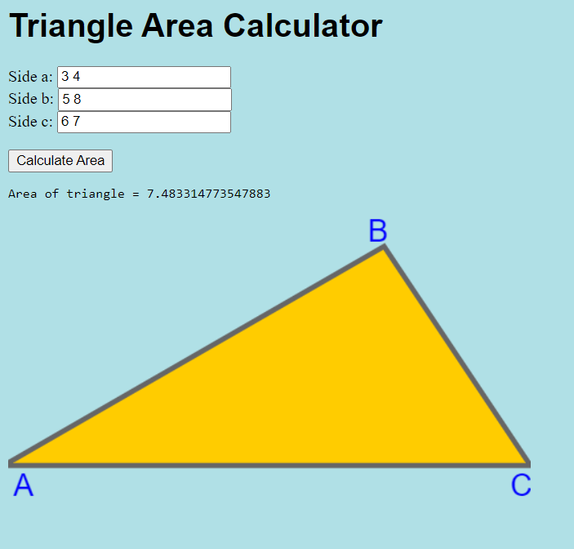
Defects:
- Expected message: Error: You entered the numbers incorrectly
9.When the user enters such values, we see the following bug
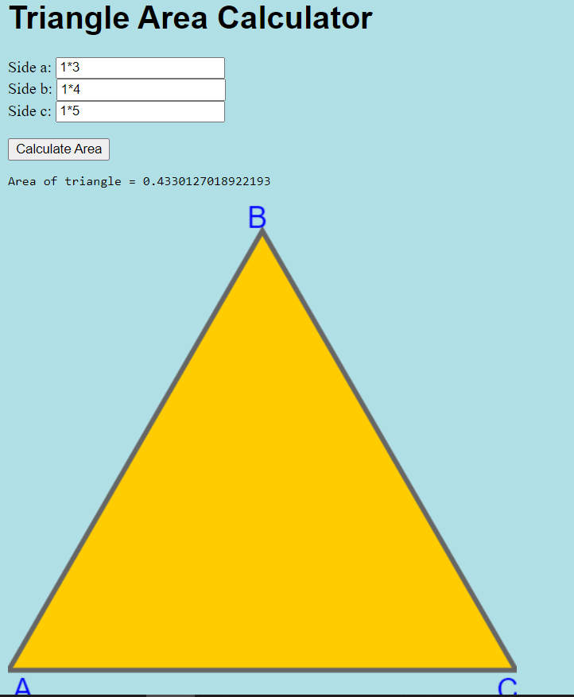
Defects:
- Expected message: Error: You entered the numbers incorrectly
No “Area of triangle = …” message should be shown in this case.
No triangle picture should be shown in this case.

