We’ve all known that person who always seems to be getting things done.
Whether a friend or a colleague, this is the person whose work is always done early. The one who somehow manages to finish hour-long tasks in 20 minutes.
The one people describe as a robot or machine because surely no simple human could work as quickly as they do.
And yet these people exist, cranking away at maximum efficiency. What do these highly productive people have in common? How do they do it?

The habits of highly productive people
It’s tempting to look at highly productive people as machines (or wizards). But by studying how they work efficiently and overcome the challenges we all experience, it’s possible to boost your own productivity as well.
How do the most efficient people overcome challenges like:
- Procrastinating on tasks—both small, nagging ones and large, challenging ones
- Boring work that needs just to get done
- Responding to emails and other messages while working
- Staying motivated and energized throughout the entire workday
- Focusing and finishing the most important projects on their plates
As much as I would like to claim the status of “highly productive person,” the best I can do is say: I’m working on it. But from reading articles, checking out books, and asking questions of productive people, I’ve pulled together the best advice I could find on their productivity habits.
What follows are 18 of the most important habits of highly productive people. From ways to spend less time on emails to methods of staying focused, these productivity tips can help you maximize your efficiency — and get more done.
You can’t become more productive overnight. But if you make small changes and put some of these habits into place, you’ll be well on your way to becoming more efficient.

How to be more productive
Increase productivity and become highly efficient with these habits:
- Focus on the most important tasks first
- Cultivate deep work
- Keep a distraction list to stay focused
- Use the Eisenhower Matrix to identify long-term priorities
- Use the 80/20 rule
- Break tasks into smaller pieces
- Take breaks
- Make fewer decisions
- Eliminate inefficient communication
- Find repeatable shortcuts
- Learn from successes as well as mistakes
- Plan for when things go wrong
- Work before you get motivated or inspired
- Don’t multitask
- Fill the tank — recharge
- Sharpen the axe
- Manage your energy (not just time)
- Get better at saying “no”

1. Focus on the most important tasks (MITs) first
The theory behind Most Important Tasks is that any given to-do list has some tasks that are more important than others. If you focus on simply checking off to-do list items, you’ll end up with a mix of important and less important tasks completed.
It also exposes you to the potential for procrastination — it’s easy to spend the whole day checking off easy, less important to-dos instead of buckling down on the hard stuff.
Instead, spend a few minutes at the beginning of your day to choose 1–3 MITs — the things that, no matter what, you need to finish by the end of the day.
With a renewed focus on what’s important, it’s easier to create a meaningful to-do list — make sure the important things get done.
Laura Earnest of Whole Life Productivity had this to say on the importance of prioritization as a productivity habit:
“Let me say that I distinguish between efficient and effective, but that both are needed for peak productivity. Efficient is doing things right and effective is doing the right things. So the most productive people work on the high value tasks, making sure that how they are doing those tasks is the best way.
I also believe that the most productive people are able to discern which are the high value tasks, and are able to either let the others go or delegate them. It’s not a crazy rush to get everything done, because they recognize that they can’t get everything done.”

2. Cultivate deep work
Everybody has a few daily to-dos that could almost be knocked out while sleeping. These are the tasks that you need podcasts to get through — if anything, they’re hard to get yourself to do because they’re not especially interesting.
At the same time, some tasks are just difficult. You can’t multitask your way to finishing them. You need to devote serious time and mental effort to knocking them out of the park. These tasks are called “deep work.”
Cal Newport wrote about this type of work in his bestselling book, Deep Work: Rules for Focused Success in a Distracted World. Newport argues that the skill of intense focus is increasingly rare—and that those who can master it are at an enormous advantage.
A few of Newport’s recommendations to cultivate deep work are:
- Schedule deep work: Plan deep work into your schedule at a similar time every day, probably in the morning. Having regular time to do deep work helps you make it a habit.
- Get bored: It sounds counterintuitive to call being bored a productive habit, but being comfortable with boredom is important. Deep work isn’t always enjoyable, and boredom or frustration are what cause us to seek out distractions. Avoid using social media for entertainment as much as possible, and get more comfortable doing nothing.
- Be harder to contact: Email and other distractions can be reduced by asking people who contact you to do more work upfront. Ask people to research their questions before coming to you, and provide as much info as possible in their emails. The same goes for you—spending time on communications instead of dashing off a quick email can minimize back and forth.
- Know your work habits: Do you work best in isolation? With periodic breaks? Are you working around a hectic schedule? You don’t need to overhaul your entire schedule—just set aside some time for deep work.
Highly productive people have mastered the skill of deep work.

3. Keep a distraction list to stay focused
With emails, social media, and a thousand little to-dos, it’s easy to get distracted when you’re trying to be productive.
Whether you’re trying to focus on deep work or just dealing with smaller tasks, distractions are the bane of productivity. It’s hard to maintain efficient work habits with distractions around.
One powerful method of reducing distractions is creating a “distraction list.”
Keep this list — whether it’s a Google Doc or a physical piece of paper — nearby while you’re working. Whenever a distracting thought pops up, write it down on the list and get back to work.
This technique, which is one of the secrets to the Pomodoro Technique, is powerful because a lot of the time your distractions legitimately require attention.
If I’m doing deep work and suddenly remember a bill that needs to be paid, or have an idea for a new blog post, those are thoughts that deserve attention.
They just don’t deserve it right now.
As thoughts arise during your work, jot them down. Once you reach a break in your work, you can come back and either tackle them or add them to your larger to-do list.

4. Use the Eisenhower Matrix to identify long-term priorities
One of the dangers of productivity is a focus on the short term. As management legend Peter Drucker once said, “there is nothing so useless as doing efficiently that which should not be done at all.” When you study productivity habits, it’s easy to fall into that trap.
On any given workday, it’s easy to get caught up in things that seem important right now.
The Eisenhower Matrix, used by Dwight Eisenhower to make decisions during his time as a general, was popularized by Stephen Covey’s book The 7 Habits of Highly Effective People. It helps you to quickly determine what you should work on and what you should ignore.
To create an Eisenhower Matrix, make a 2 x 2 square. On one axis, write “important” and “not important.” On the other, “urgent” and “not urgent.”
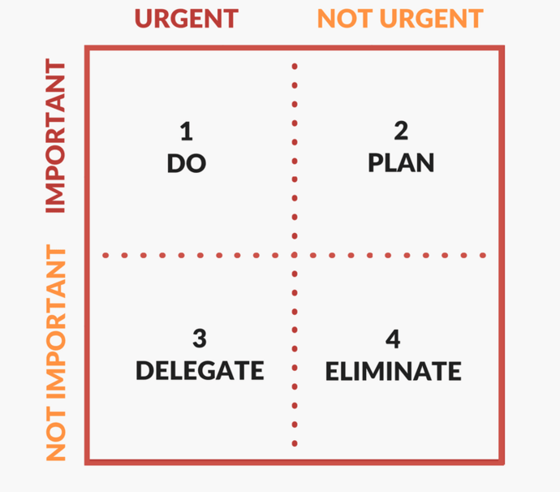
Source: Develop Good Habits
Organizing your to-do list based on each task’s importance and urgency can help you identify time sinks that aren’t worth it.
Are you spending most of your day doing things that are urgent but not important? Look for ways to delegate, automate, or eliminate.
Are you spending time on things that aren’t important or urgent? Ignore those things.
Are you making time to work on things that are important but not urgent? If you’re like most people, you could be spending more time in this quadrant. The Eisenhower Matrix makes it easier to see what matters and what doesn’t.

5. Use the 80/20 rule
Another way to prioritize tasks comes from the 80/20 principle.
Discovered by Italian economist Vilfredo Pareto, the 80/20 rule (also called the Pareto Principle) states that, in any pursuit, 80% of the results will come from 20% of the efforts.
To maximize efficiency, highly productive people identify the most important 20% of their work. Then, they look at ways to cut down the other 80% of their schedule, to find more time for the things that make the biggest impact.

