5 Best Money-Saving Shopping Tips
http://malled.blog.palmbeachpost.com/2016/03/30/what-to-buy-skip-in-april/
When buying things online or traditionally one may wonder how to save money on shopping. If you often spend a lot of cash or in opposite are unhappy because of high prices, here are some basic rules applying which you will be able to make purchases more effectively and save much more money than earlier without making big sacrifices.
- Create a Standardized List

http://mytalenthub.in/gov-jobs/
2. Special offers
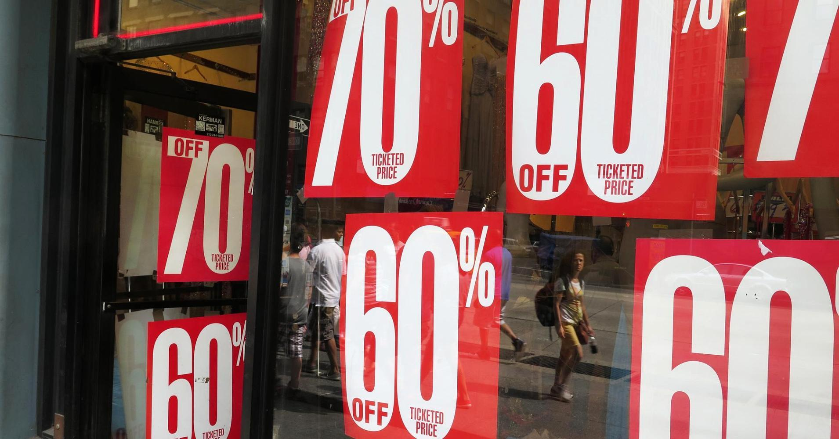
http://www.cnbc.com/2015/08/19/how-retailers-can-end-price-wars-commentary.html
Special offers imply that customers spend more money. Making an impulse purchase you spend more and retailers earn more nevertheless bought items were on offer.
It is very tempting to buy something at lowered prices but the positive thing is that you may make use of the sales as well. For example, leaving a supermarket grab a circular offered by a store. Browse through the weekly special offers planning the next purchases including items which are on sale. Usually there are many items that are not necessarily needed right away, so they are sold cheaper. Also, compare prices in different supermarkets and develop your shopping experience. You will learn that at some places such as airports, railway stations, in the city centers some items are more expensive than in the outskirts of the town, in supermarkets, and so on.
3. Buying in Bulk
http://www.wisegeek.org/what-is-a-wholesale-price.htm
Consider buying items in bulk visiting the big box stores instead of by retail in small stores. It is profitably to buy in bulk different industrial products such as a laundry detergent, toothpaste, shampoo and other. Bulk buying should be planned because it can be even more expensive, when made without any preparations. Shop in bulk monthly at weekends, the least number of times possible. Buying in bulk at a grocery store, as a rule, have advantages for those who has a family trying to stick to vegetables and fruits that are in season.
4. Making Purchases without Buying
http://ballesses.blogspot.com/2015/04/80s-prom-dresses-for-rent.html
A great money-saving tactic is renting and borrowing things. When shopping online, browse for stores which offer different coupons such as buy-one-get-one-free and other. Also, look around to find stores selling item you need at lower price. Be especially careful when surfing in the internet to avoid impulse buying.
5. Open a Savings Account
http://www.diarioextra.com/
In average, one can save up to 15-20 percent monthly. Create an account in a bank and fill it up on established date. Plan your budget in advance to avoid unplanned purchases.

