How to run the Gzip data condensation on the website?
For site optimization switching on the Gzip data condensation is a great solution because the searching systems rank pages with the compressed text rather better. By the way fast-uploaded pages are more useful for users. To compress the page, activate one of the htaccess modules.

What’s the pages Gzip data condensation process?
When the page is opening, browser uploads files with different extension. Gzip-compressing of HTML pages is available for the following file types:
- .html;
- .xml;
- .js;
- .css.
The bigger is file the longer content will be uploading. If you run the data condensation process, servers will need less time to process it. The server gives files in the compressed form and browser unpacks them and shows it in the full form on the display.
Search systems index sites with the compressed data better. The transferring data in this way means faster page loading and as a result - user doesn’t need to wait. So the file submission in compressed form has a positive effect on a search systems ranking and users’ loyalty to the online project.

How to check Gzip data condensation availability on the site?
Some hosting providers include a default information compressing for all customers despite the server uploading. On the sites constructed by WordPress, the content of pages is also compressed. You can use the online services to check the availability of compressing technology of your site with the help of CMS or hosting. For example, GidZipTest:
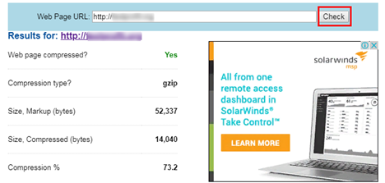
As you can see, the content compression reaches 73,2%. If the data condensation procedure isn’t used, you will see «No» in the first line and the file size remains the same.
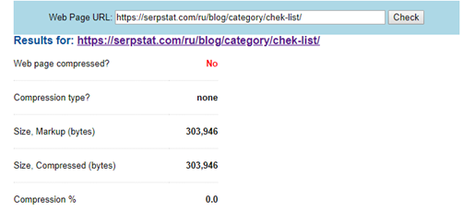
You can use the Google tool PageSpeed Insights to check the speed of site loading online. After analyzing, server gives some advice to increase the loading speed. Usually there is an advice for efficient compressing procedure to run:
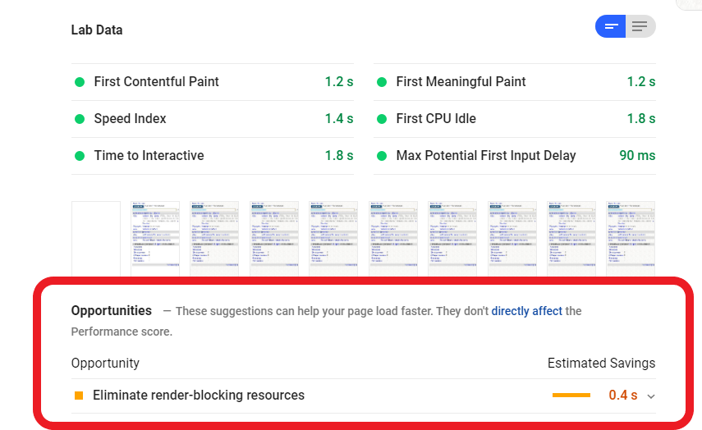
Using this and similar online tools, you can check the level of Gzip data condensation on the OpenCart sites and other website engine versions. You do not have to neglect the recommendation to compress the content because it influences directly to the SEO promotion and namely to the wish of users to stay on the site longer.
For a maximum efficiency one compression is not enough. It must be combined with other ways of reducing the total weight of the website pages:
- using .gif, .jpeg, .png forms of images according to their type;
- using the technology of caching;
- reducing the .css и .js files;
- adding .css files to the beginning of the page and .js – to the end;
- reducing the HTTP-queries.
All these ways at once will reduce the page weight, increase the loading speed and will positively affect website ranking.

How to run Gzip data condensation procedure in Apache
The compressing content may be dynamic and static. In the first variant, data is compressed by the server when the data is sent to the browser. Page has less weight and faster loading are advantages in this case.
The main disadvantage is the server’s overload. The hosting resources cannot operate high traffic sites. You have to pay more expensive tariffs or just change the provider. To compress data with the help of Apache, you should add an element of code into the file htaccess. You can find access to this code only in the admin panel of the hosting or in any FTP client:
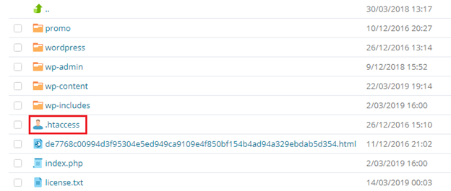
After the file is opened, activate the mod_deflate module by adding the following command:
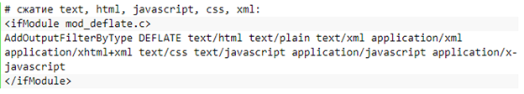
After the code is saved, analyze the site loading speed again. This procedure will show if there is a lack of compression. In such case you should find the problem in server. Some providers use the mix of Apache and Nginx services. In this situation, it is impossible to make a compression on your own. You should ask for help hosting providers` customer service representatives.
If you cannot fix the problem using mod_deflate, try to use other mod_gzip module. To do this, add commands to the htaccess file:
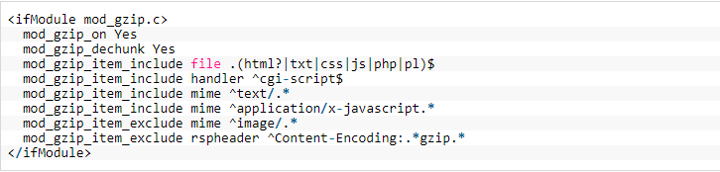
Check the module operativity.
Static compression is different from dynamic one in the lack of server load. You compress each file of your interest yourself and upload them to the root folder of the website. After that, the server will send data to the browser in compressed form. You don’t need to buy more expensive tariff acting this way. But after the files are updated, you need to make compressed copies manually.
To plug a static compress, upload on the computer all the files of the form you need by using file manager or a hosting panel. Then download a 7-zip. Find every file by the program, click on it by the right button of the mouse and add them to the archive:
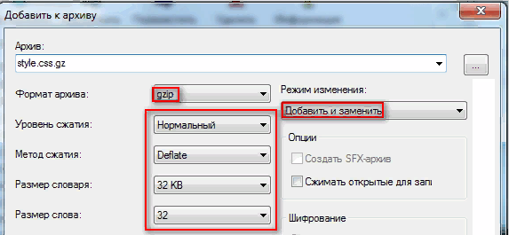
Choose the needed form and click «Save»
After creating of all archives, upload compressed versions to the root folder. Actually, there will be compressed and uncompressed files. To activate a static compression, plug mod_rewrite module to the .htaccess:
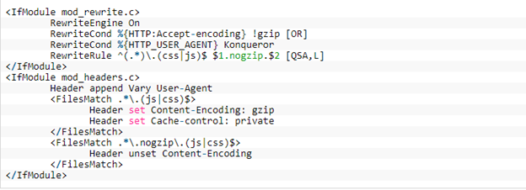
You have to use only one type of compression – dynamic or static. If you plug two types at the same time, no one of them won`t work. After adding each module, you have to inspect the site loading speed and compressed content presence.
How to make a compression on the Nginx and on other servers?
To spot the type of server your site is located you can using the admin panel of hosting or ask hosting provider`s customer service. If your site is located on the Nginx server, you must write a following fragment into the /etc/nginx/nginx.conf file:
Then you have to restart the server.
If site is located on Beget, IspManager and you couldn’t compress files by adding a fragment of the code to the .htaccess, ask hosting customer service to switch on the compressing on server.
How to increase the speed of site loading in WordPress

To make a Gzip compression in WordPress, you can also use plugins. For example, there is a function «Compressing» in the Hyper Cache:
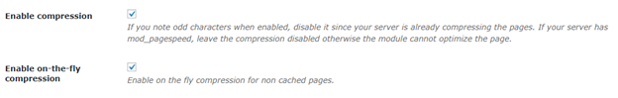
While you activate this function, you don’t need to plug this modules by .htaccess file.
Conclusion
The technology of Gzip – compression for increasing site loading speed is used in the complex with other actions. Using the compressed data makes users more loyal and helps to improve positions of the site in search system. You can check the compression by online services. For plugin, you can use static or dynamic compression.
In the first variant, you must create Gzip archives manually and reduce with this action a strain on the server. In the second variant, you can just plug a module to the .htaccess file and again check a compression of Gzip pages. If this changes are unsuccessful, you have to call hosting provider customer service for help.

