40 Impressive hibiscus tattoos on foot
- Exceptive hibiscus tattoo on foot.
One of the non-standard types of tattoos is the tattoo on the foot. Such an image is a great decoration that can be easily hidden from prying eyes. But in the summer, you can put it on public display, to draw to your legs numerous views.
https://www.instagram.com/p/BFrp9WoNX71/
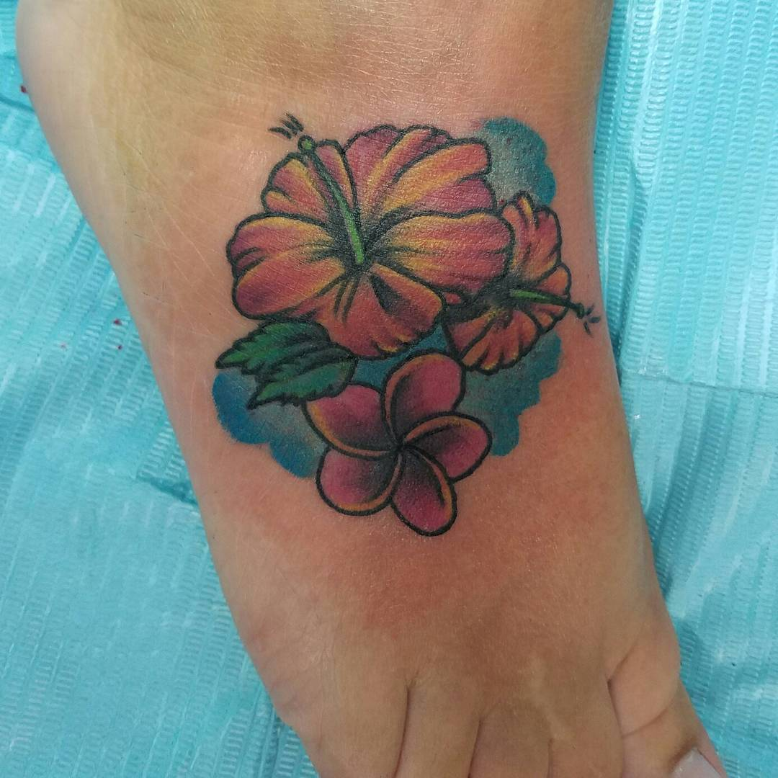
- Refined hibiscus tattoo on foot.
Such luxurious and exquisite tattoos that can be applied to the foot, virtually endless selection. This tattoo will make you think about the application of your tattoo on this part of the body.
https://www.instagram.com/p/BFRstCiPkt3/
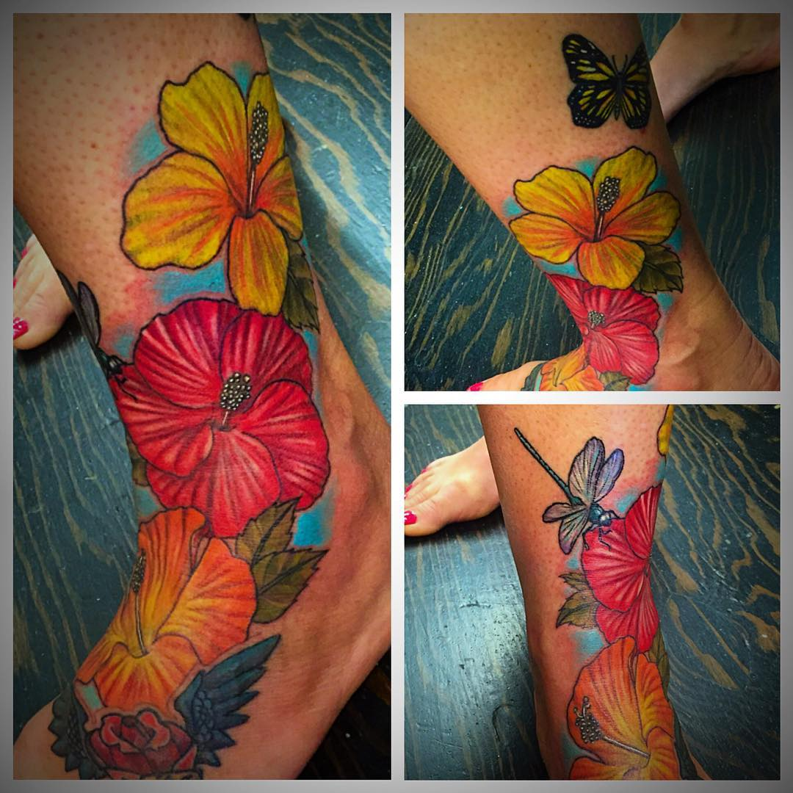
- Hibiscus tattoo on foot.
This tattoo for girls on the foot is a delicate decoration.
https://www.instagram.com/p/BFHilqmnrZA/
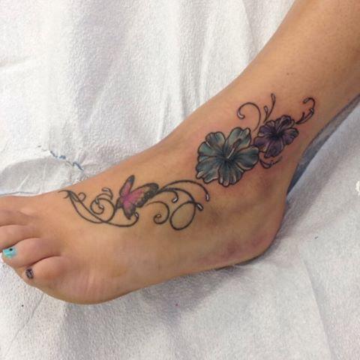
- Splendid hibiscus tattoo on foot.
A realistic picture that is ideal for those who feel their unity with nature. The result will be delightful and incomparable.
https://www.instagram.com/p/BEzSjHPJjNR/
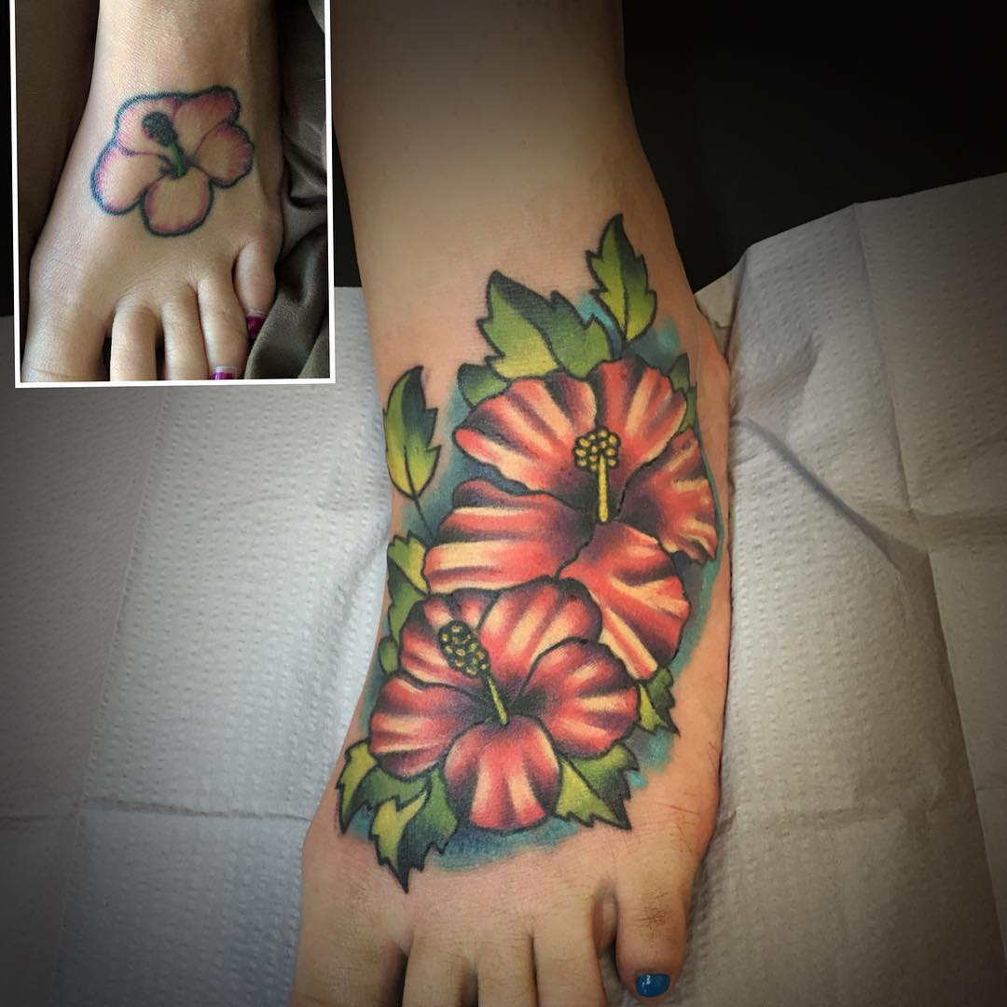
- Tribal hibiscus tattoo on foot.
Choosing a picture of a tattoo do not forget the main rule - tattoo should carry meaning. This may be an expression of your inner world, a manifestation of love for someone or something, call success and happiness and another expression.
https://www.instagram.com/p/BFGHUtEQiax/
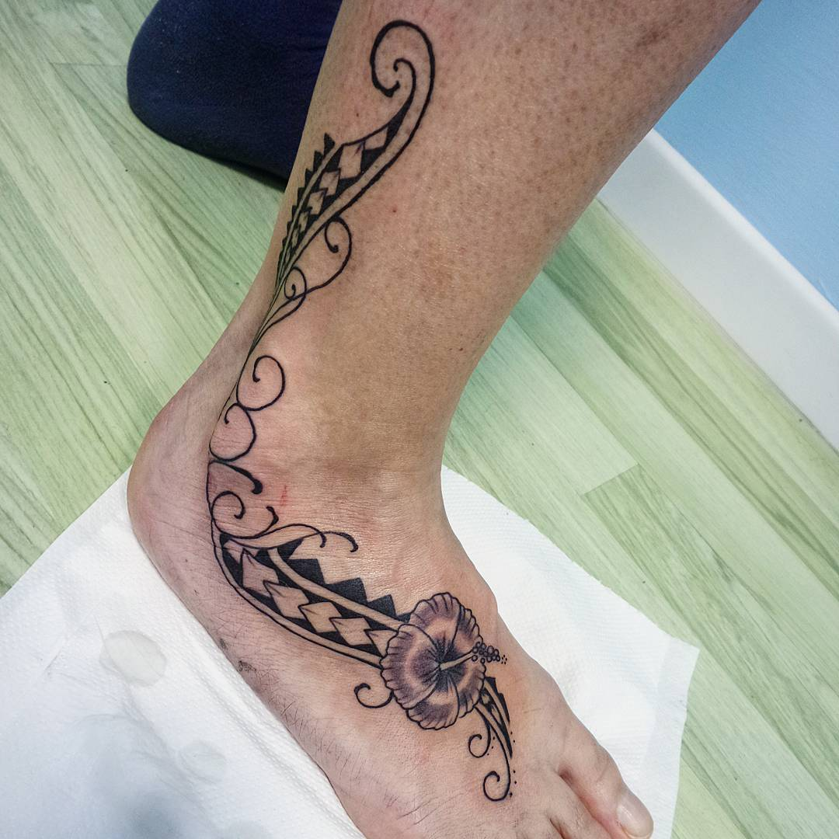
- Cute hibiscus tattoo on foot.
Tattoo in this area of the body especially like by the girl, because it is not as provocative, but very stylish and spectacular.
https://www.instagram.com/p/BFGrN4USGzW/
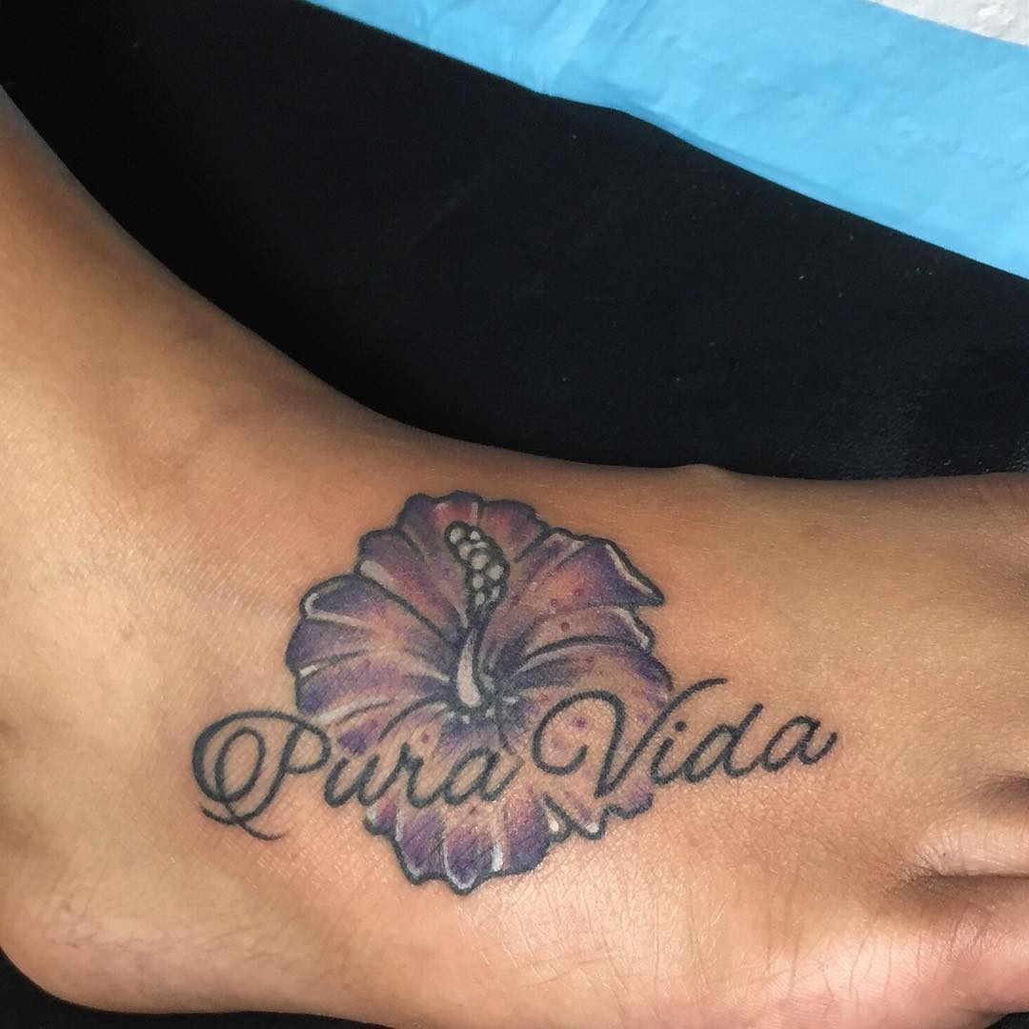
- Excellent hibiscus tattoo on foot.
This tattoo can differ in their design and size. Flowers adorn the female legs, look unmatched with other symbols.
https://www.instagram.com/p/BD5XEuNCzCw/
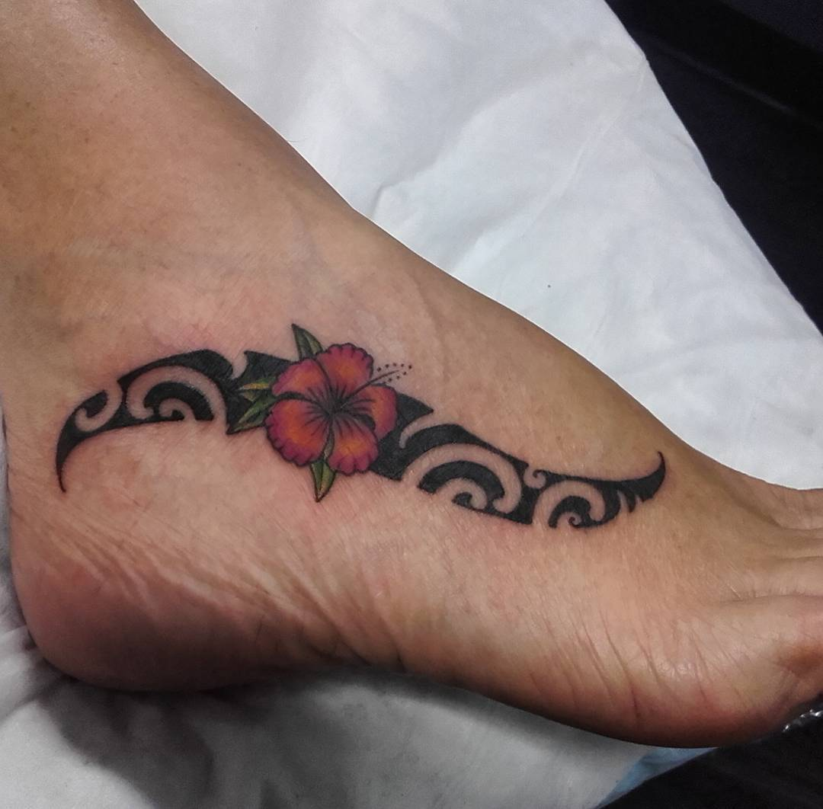
- Original hibiscus tattoo on foot.
Tattoo on the foot is a perfect solution to emphasize the boldness and originality of its owner.
https://www.instagram.com/p/BD-9Tx7ATqe/
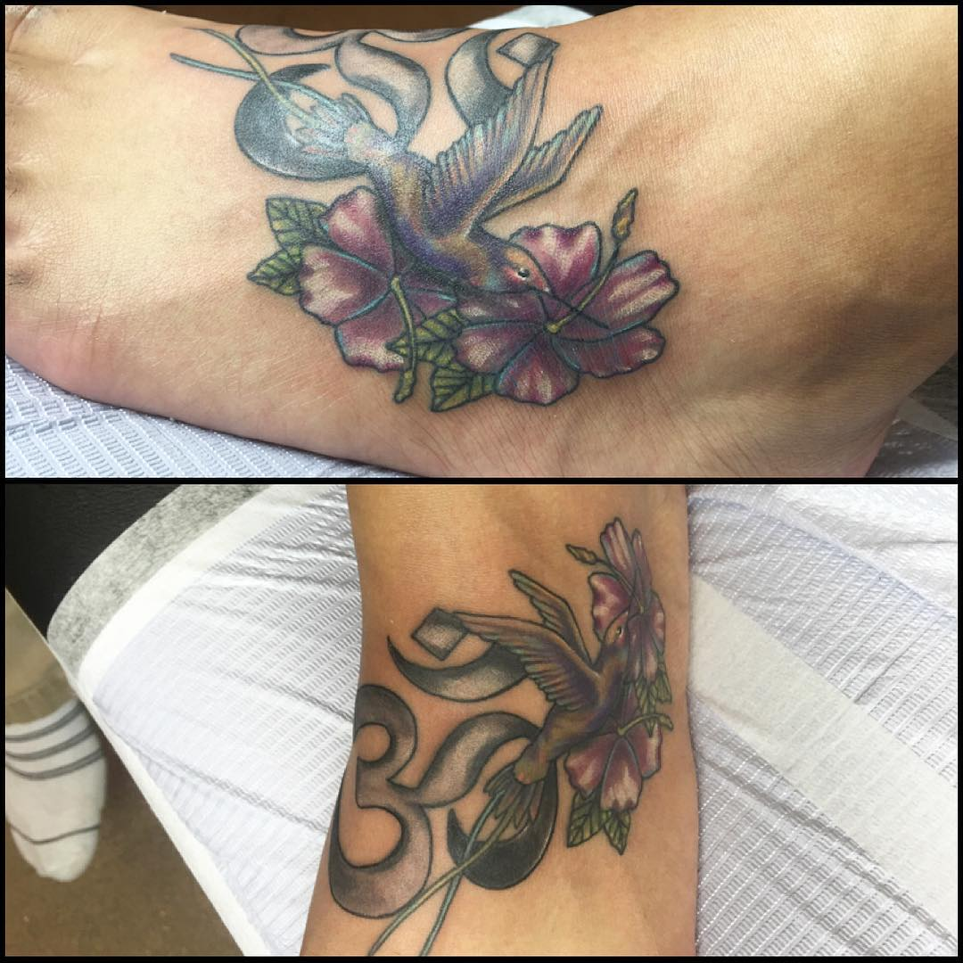
- Amazing hibiscus tattoo on foot.
Women's tattoo on the foot looks very brightly and impressively emphasizes the diminutive size, the fragility of its owner. With such a decoration on the body of the girl looks much more attractive and sexy.
https://www.instagram.com/p/BD_Zgt9G99i/
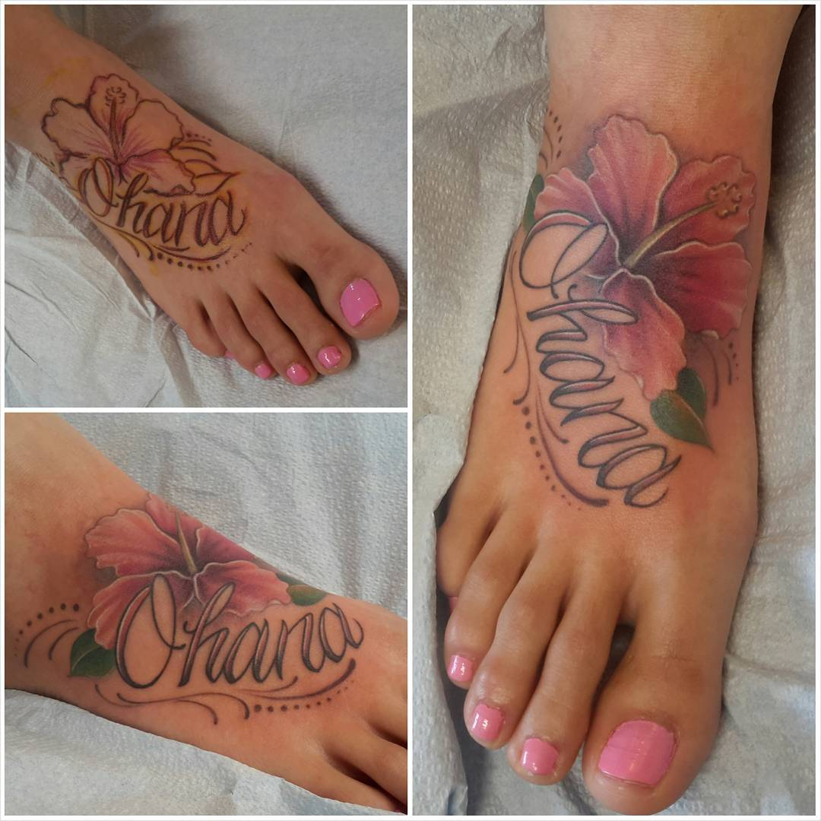
- Expressive hibiscus tattoo on foot.
When choosing a tattoo important thing that the lines were only clear and neat. You can also choose simple options, such as black-and-white color scale, it will look much more spectacular.
https://www.instagram.com/p/XIirIvh_dS/
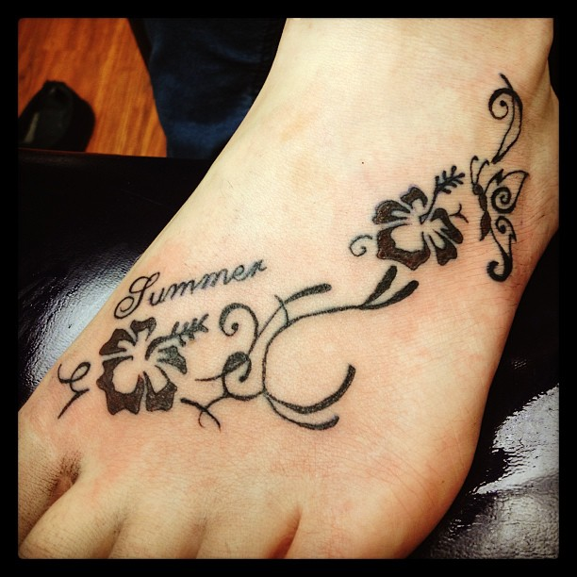
- Splendid hibiscus tattoo on foot.
To emphasize the attractiveness and allow to admire your tattoo, wear classic shoes or sandals, to hide - sneakers and any high shoes.
https://www.instagram.com/p/UgWib2oXy9/
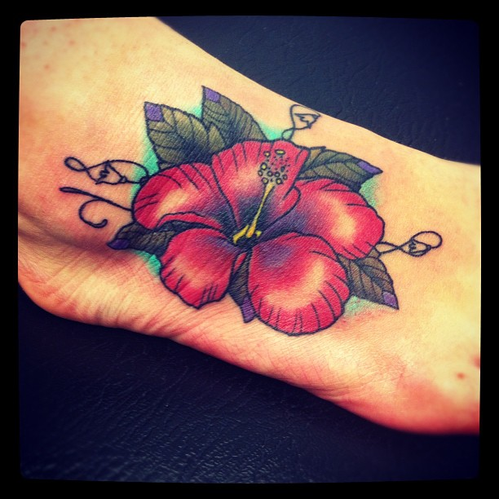
- Fun hibiscus tattoo on foot.
The tattoo is not only the eternal fashion on the perfection of the human body but also, above all, your informed choice that can become a unique gift of your own flesh and indomitable spirit. This picture will bring you harmony in the soul and genuine joy.
https://www.instagram.com/p/WuYKYfneZC/
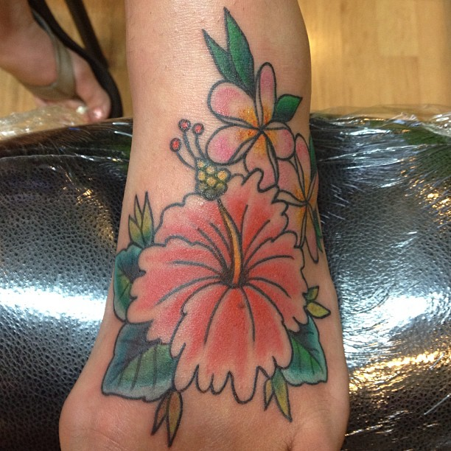
- Impressive hibiscus tattoo on foot.
This tattoo is a great opportunity to emphasize the exquisite beauty of the feet. This picture will be for women a kind of symbol of individuality.
https://www.instagram.com/p/BC4UOW_qE2x/
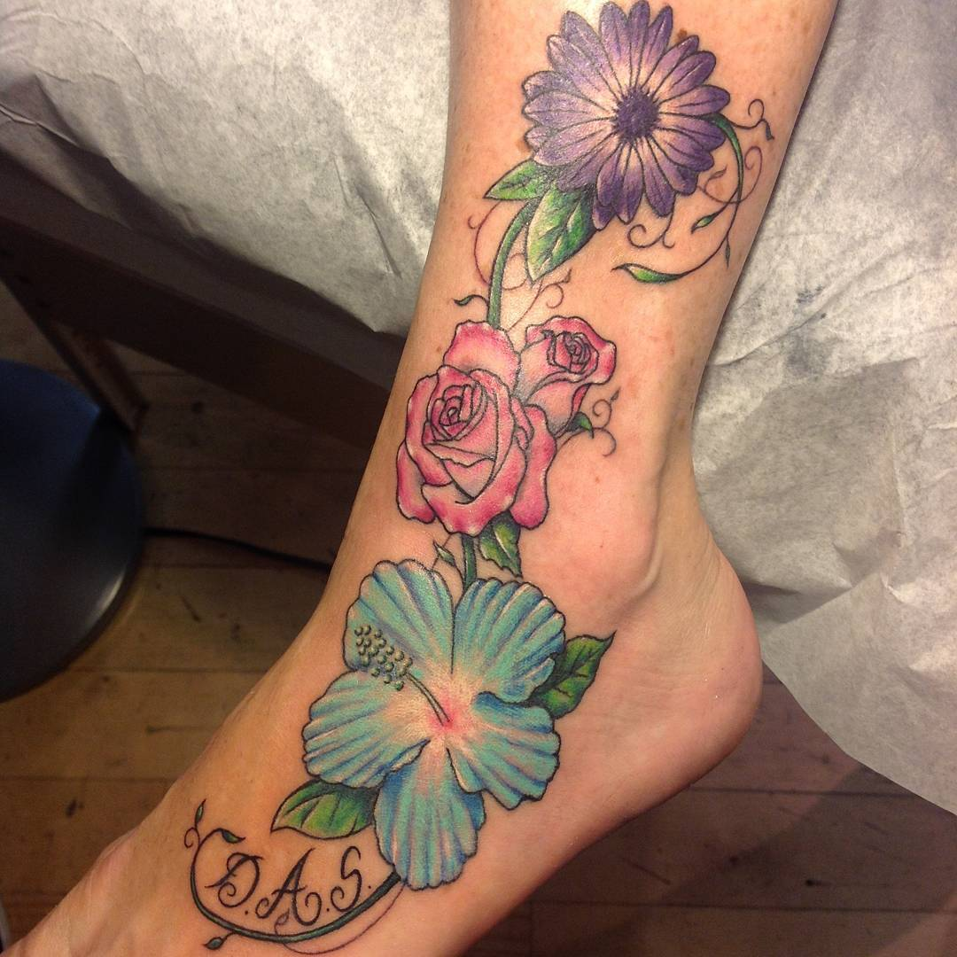
- Pretty hibiscus tattoo on foot.
Very appropriate and harmonious, this picture looks on the foot. Such an image will look excellent and very feminine if you emphasize its opened shoes with high heels.
https://www.instagram.com/p/nztXpSya2r/
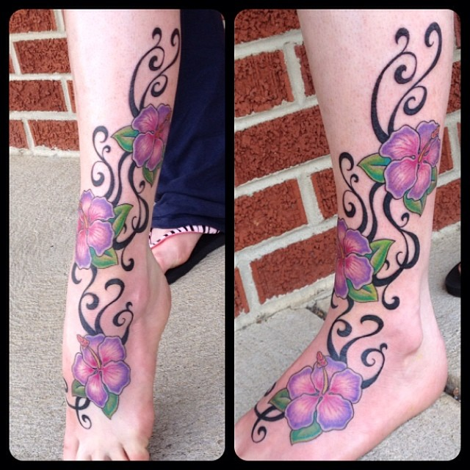
- Composed hibiscus tattoo on foot.
A small area of the foot does not allow to make big compositions, but the picture can be extended to the ankle. It is worth remembering that even a small image focuses on the feet, so they should always be well maintained.
https://www.instagram.com/p/BCZBICMpWzr/
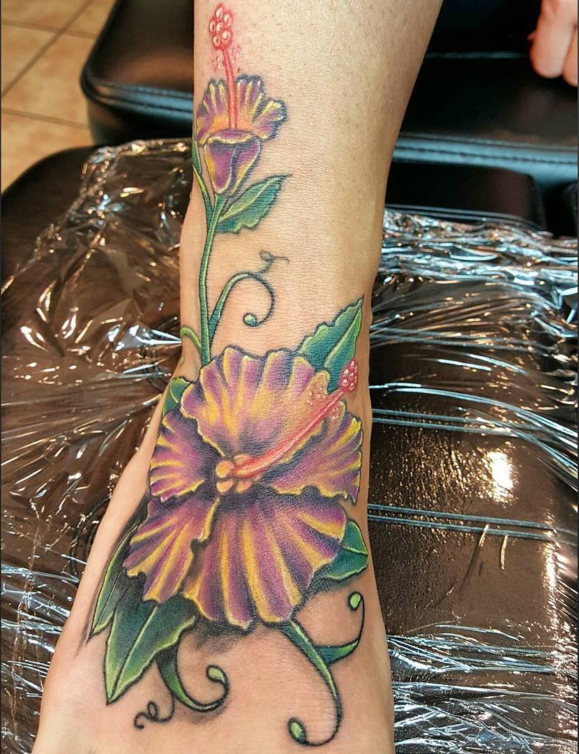
- Graceful hibiscus tattoo on foot.
Women's tattoo on the foot looks refined and gives a touch of mystery.
https://www.instagram.com/p/BCrkBqgubaF/
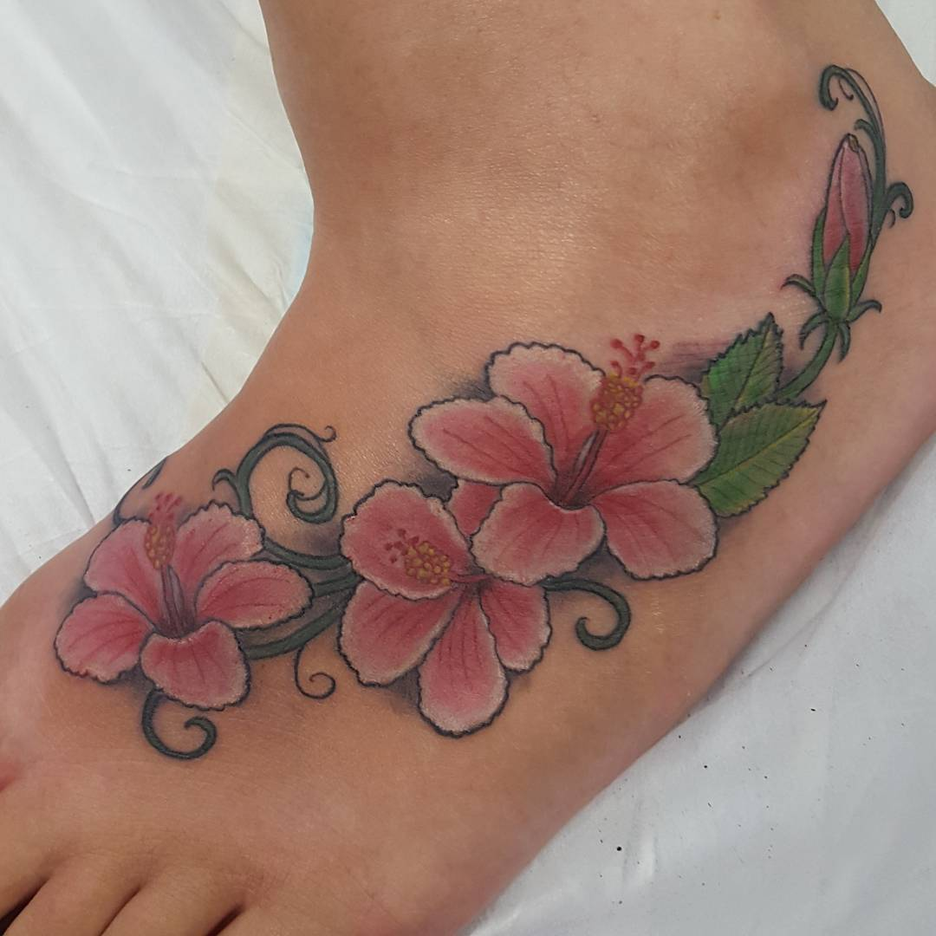
- Unique hibiscus tattoo on foot.
Ornaments that are applied to the surface of the foot look feminine, but the fact that, which originates from the finger passes through the ankle, looks incredibly original.
https://www.instagram.com/p/BCWooeSEh9w/
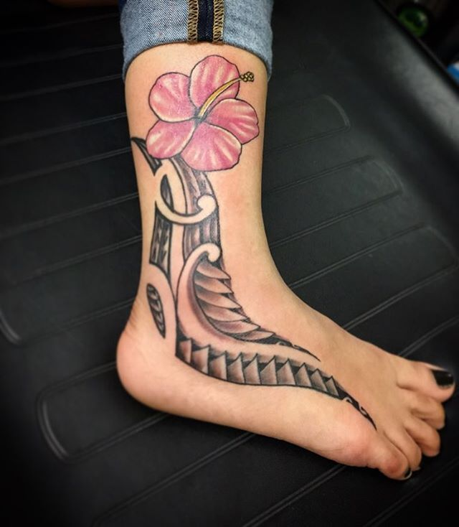
- Great hibiscus tattoo on foot.
Most often on the foot depict flowers, butterflies, cute animals. Women's leg with the help of a tattoo on the foot is able to look much softer and more interesting.
https://www.instagram.com/p/BBepL2-vHCJ/
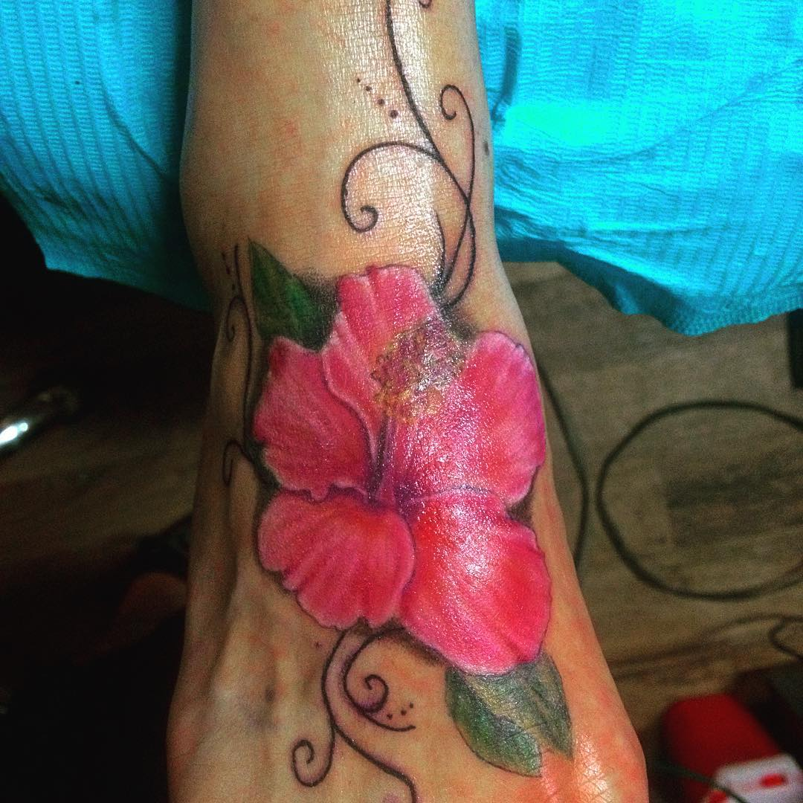
- Lucky hibiscus tattoo on foot.
Choosing such a picture for a tattoo on the side should pay attention to the limitations of space. Tattoo looks original and organically by smooth location on the lateral side of the foot.
https://www.instagram.com/p/BCR0SwrJrk-/
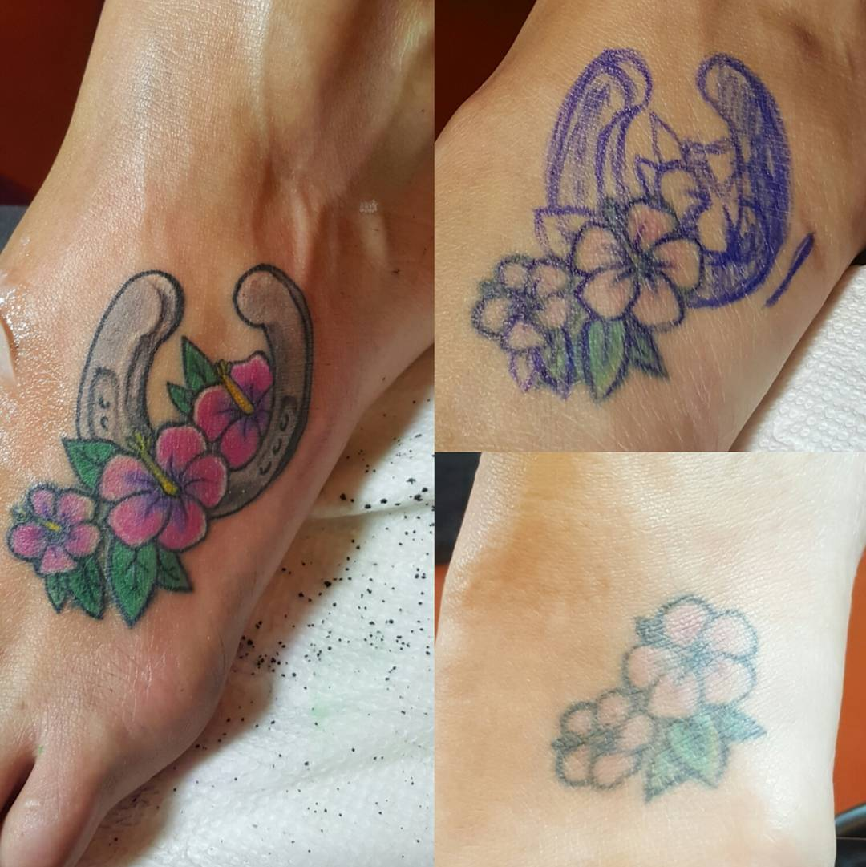
- Wonderful hibiscus tattoo on foot.
Tattoo on foot, female representatives provides a wonderful opportunity to highlight the remarkable charm of their feet.
https://www.instagram.com/p/BAjvR98nnKp/
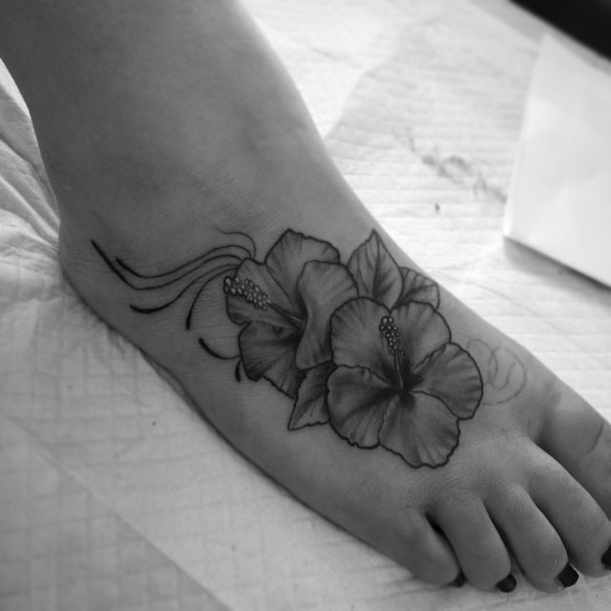
- Nice hibiscus tattoo on foot.
The usual motives for female tattoos on foot are floral designs, flowers. Tattoo on foot gives women confidence.
https://www.instagram.com/p/-sJza7I9QZ/
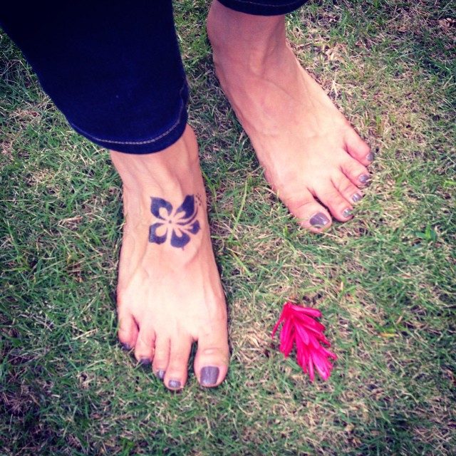
- Charming hibiscus tattoo on foot.
Tattoos on the foot for girls are one of the latest trends in the art of tattoo. This is a tempting opportunity for fans of innovative ideas and a variety of new products.
https://www.instagram.com/p/89u-izuBLk/
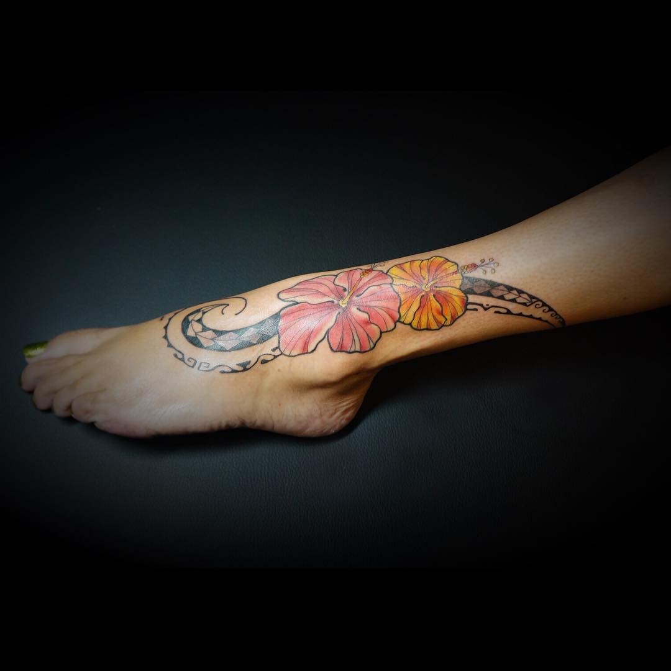
- Lovely hibiscus tattoo on foot.
It’s gorgeous work with fascinating flowers that charm with its attractiveness and colors.
https://www.instagram.com/p/9Cjmh9g_yE/
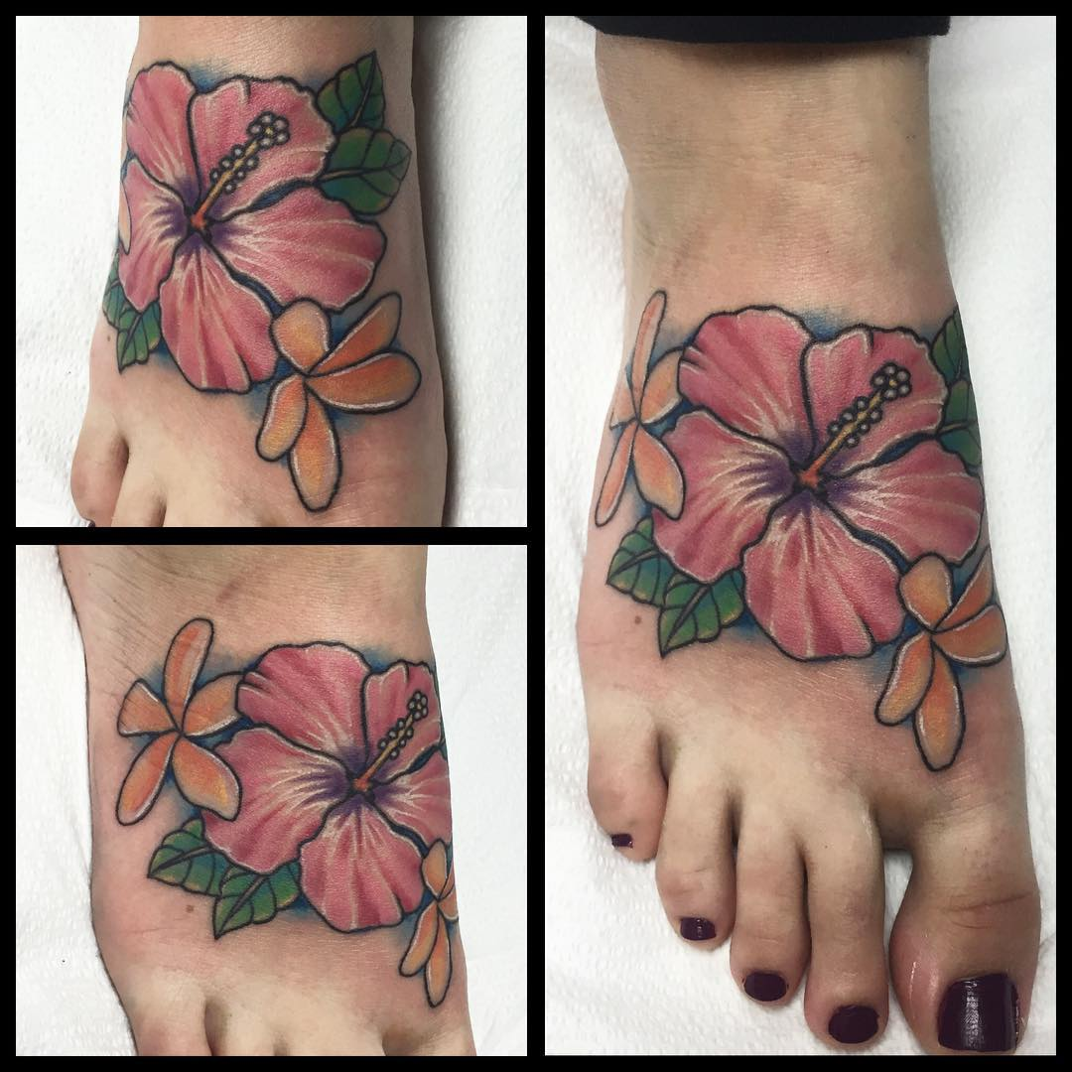
- Attractive hibiscus tattoo on foot.
This picture will look attractive, sexy and very aesthetically pleasing. In any case, a tattoo on foot for girls is perceived as an additional component of their image.
https://www.instagram.com/p/6lM9jYj_1t/
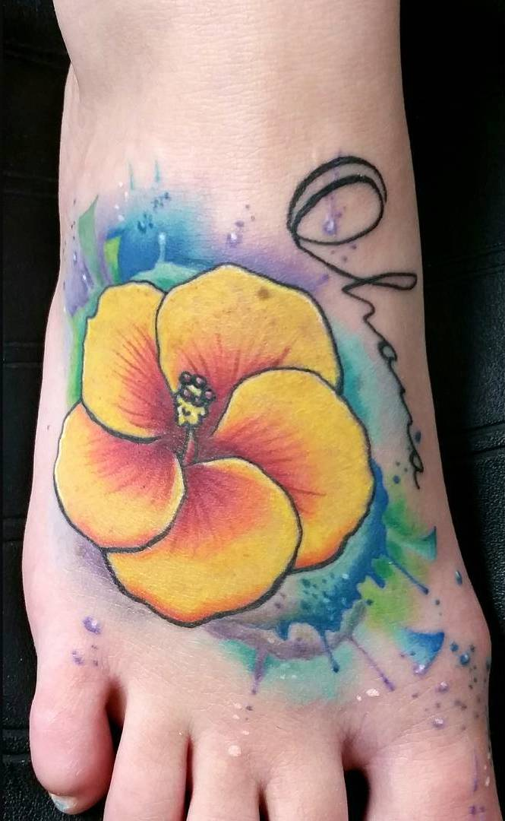
- Simple blue hibiscus tattoo on foot.
This tattoo really looks very reservedly. Its size depends on your imagination: it can be a little, tiny cute tattoo or impressive size tattoo on the whole foot.
https://www.instagram.com/p/Z7LvnomjP9/
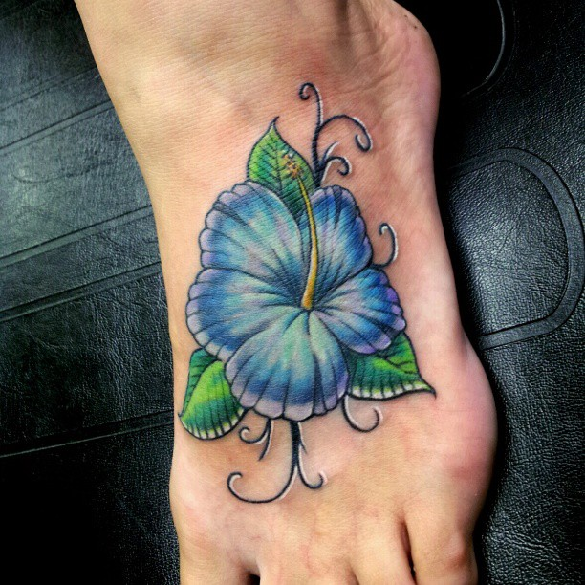
- Beautiful hibiscus tattoo on foot.
Apart from attractive aesthetic qualities tattoo with hibiscus and a turtle has a very powerful energy. Due to the unique pattern tattoo is considered a strong talisman that protects from troubles and misfortunes.
https://www.instagram.com/p/7Vho5hl7od/
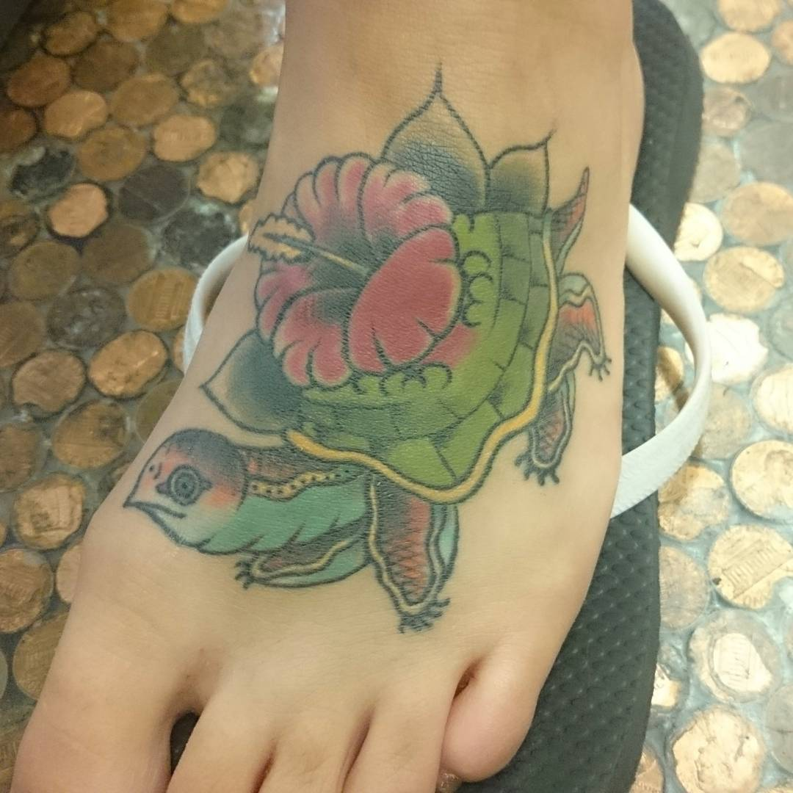
- Exciting hibiscus tattoo on foot.
Most often spectacular tattoo with the image of a hummingbird and hibiscus flower is applied to the moving part of the body, for example, such as a foot. This means that the owner of the tattoo, above all, wants to be free, which symbolize these moving birds even in the form of a drawing.
https://www.instagram.com/p/53K9nBrH15/
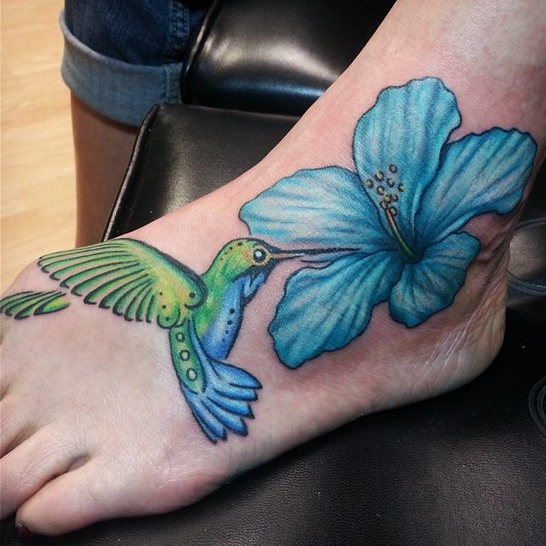
- Colorful hibiscus tattoo on foot.
Tattoo with hibiscus and butterfly looks particularly attractive and extremely elegant. Beauty, airy, delicate lines, refined beauty - exactly what attracts women in this tattoo.
https://www.instagram.com/p/46_Ttbh6qw/
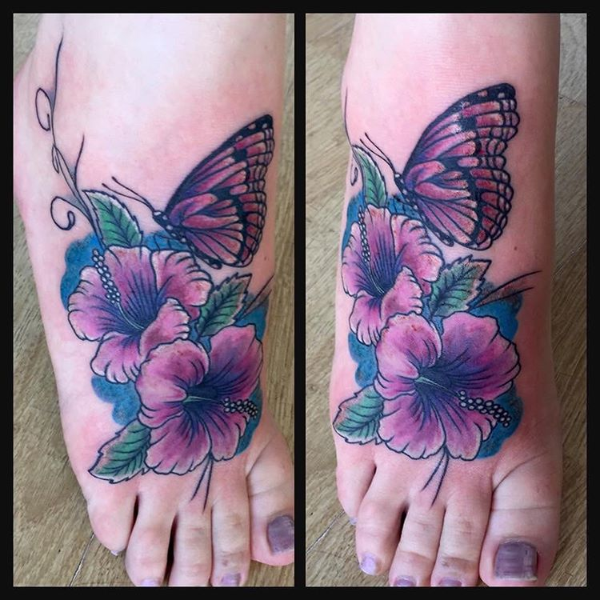
- Delicate hibiscus tattoo on foot.
The perfect combination of colors: colorful hibiscus petals and neat green leaves make this tattoo incredibly juicy and fresh.
https://www.instagram.com/p/5BBF-HBpdE/
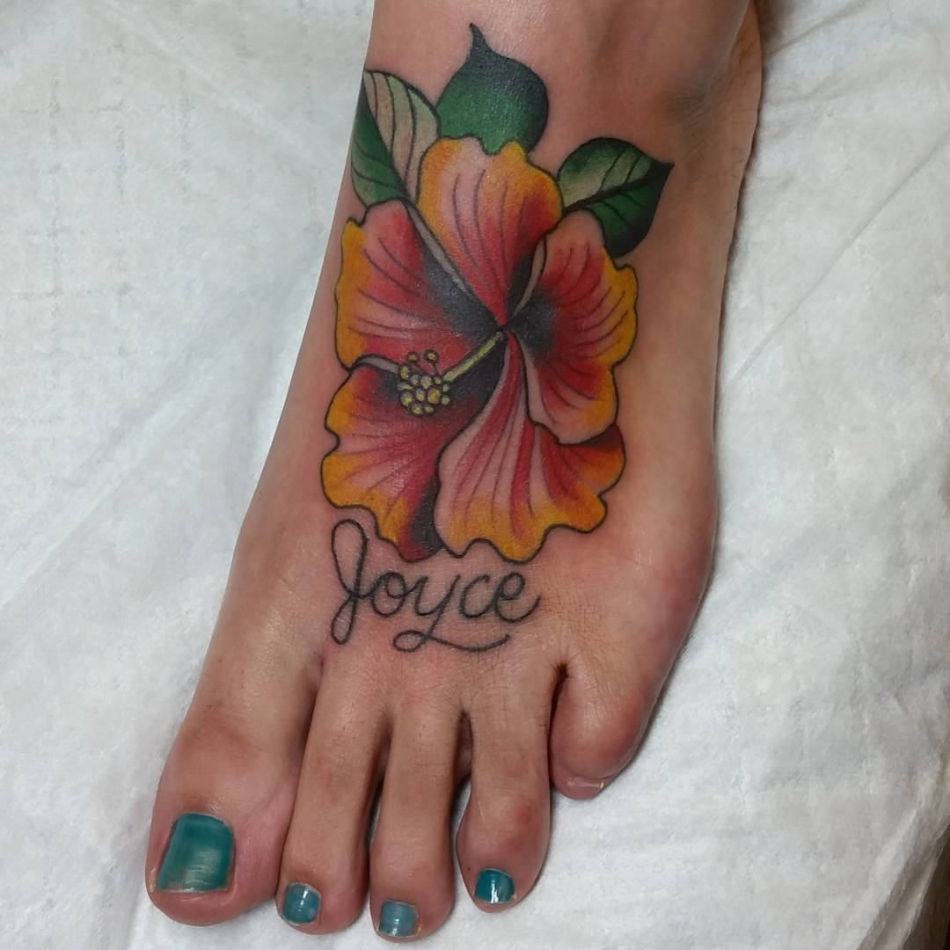
- Polynesian hibiscus tattoo on foot.
This tattoo is not just a decoration of the body, but rather an integral part of human because it shows the inner world of the owner, his quality, and even social status.
https://www.instagram.com/p/4W2plBIXPl/
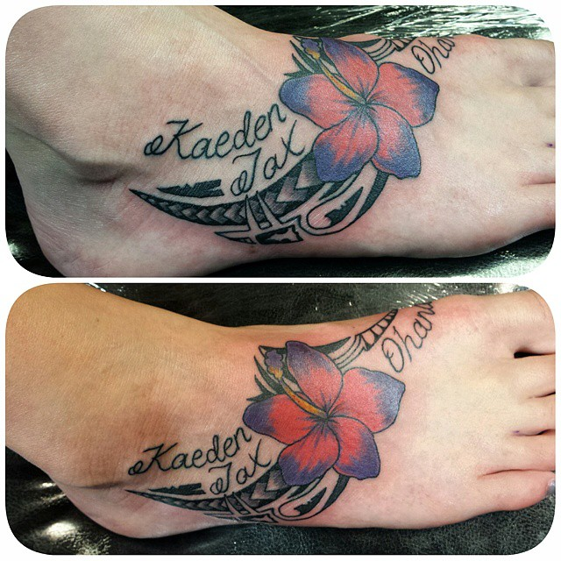
- Purple hibiscus tattoo on foot.
Tattoo with hibiscus and sea waves are a symbol of life and change. The images of waves are considered to be a talisman that protects the carrier from negative thoughts.
https://www.instagram.com/p/3fXZkdBqOI/
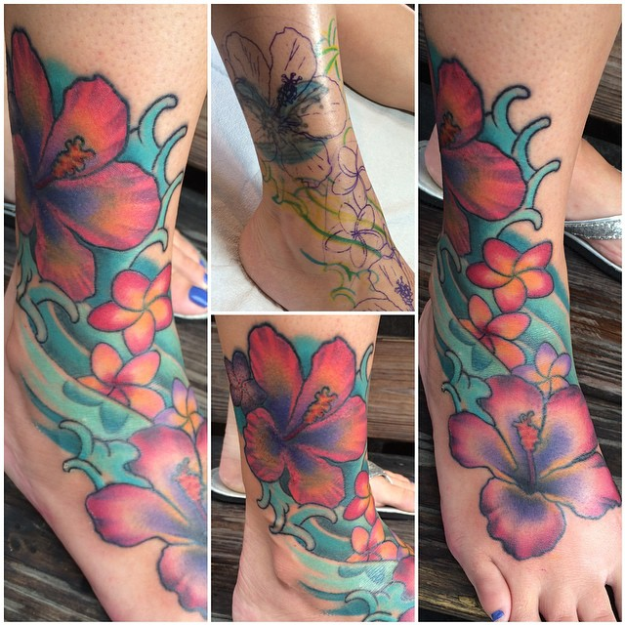
- Hibiscus tattoo on foot.
Tattoo on the foot is applied to girls who know about the beauty of their feet, like a lot of walking barefoot, sea and loose clothing.
https://www.instagram.com/p/gtUR66r-YG/
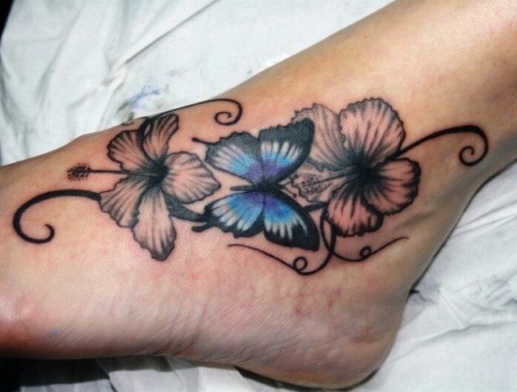
- Hawaiian hibiscus tattoo on foot.
Do not choose a finished sketch, it is better to ask the Master to draw something at your request on his own, add a variety of elements: so you will have a unique tattoo that you will not see more at anybody!
https://www.instagram.com/p/wi3UTUJJQ3/
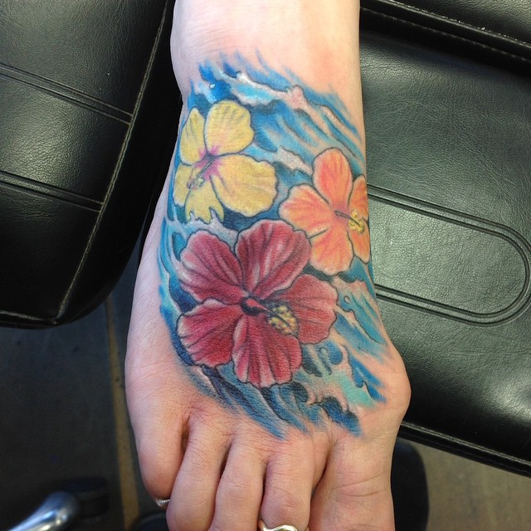
- B & W hibiscus tattoo on foot.
Black and white tattoo looks more relaxed and conservative. If you are planning a small image and pattern, the monochrome image will look great.
https://www.instagram.com/p/xSFTbTGnGv/
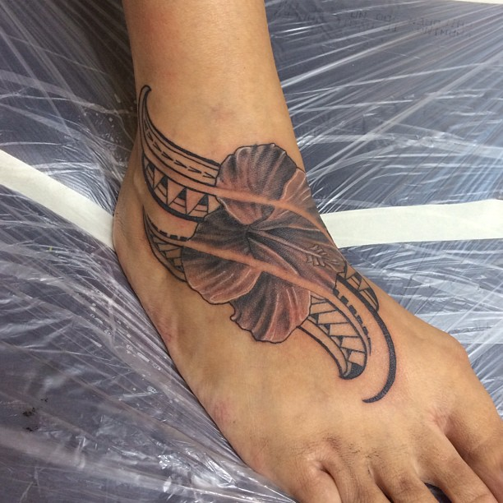
- Pink hibiscus tattoo on foot.
Be prepared for the fact that once you make yourself a first tattoo, after a while you will want to do another one. It is a kind of drug; each time will want to do more.
https://www.instagram.com/p/ySU9_TD-76/
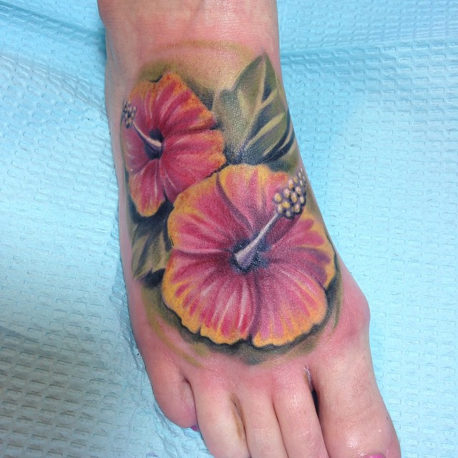
- Hibiscus flower tattoo on foot.
Undoubtedly, a colored picture on the body looks more impressive, eye-catching. And if the tattoo is done for these purposes, it is best to choose a colored option.
https://www.instagram.com/p/z4sD64vsOl/
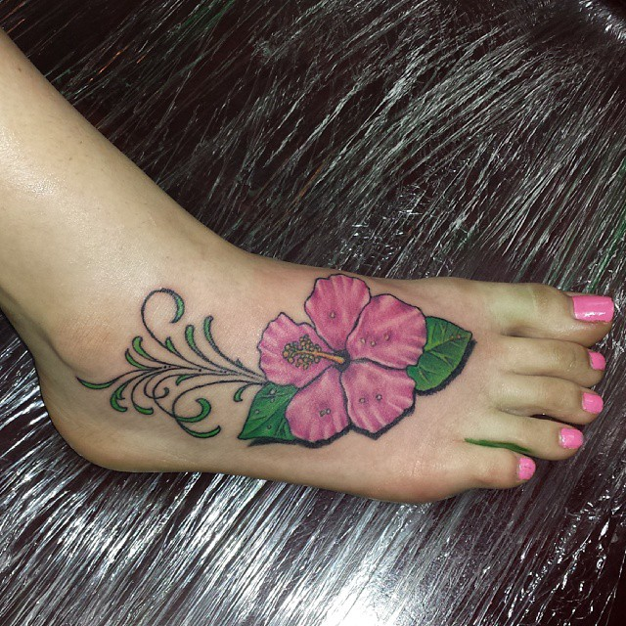
- Little hibiscus flowers tattoo on foot.
Aesthetics and originality of the tattoo are guaranteed, not only the selected location but the color itself cause admiring glances of loved ones, friends, or simply passers-by.
https://www.instagram.com/p/zGowUnGT02/
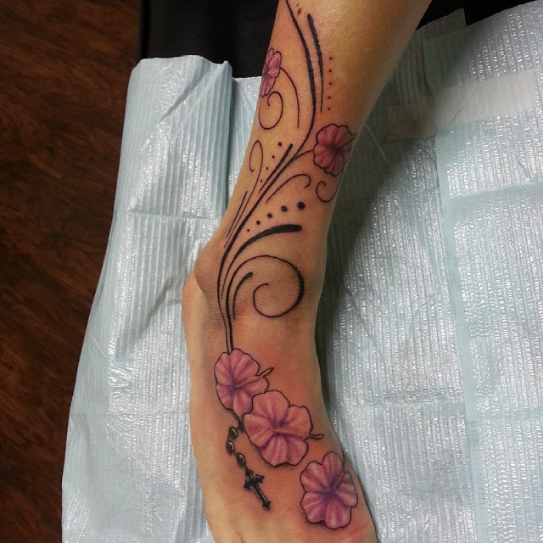
- Hibiscus tattoo with patterns on foot.
A small but very successful area for the application of tattoos. Here, of course, you can put quite a big picture, and one can make a charming tattoo encircles the ankle, which will look wonderful with beach shoes.
https://www.instagram.com/p/gthXZ8CMvH/
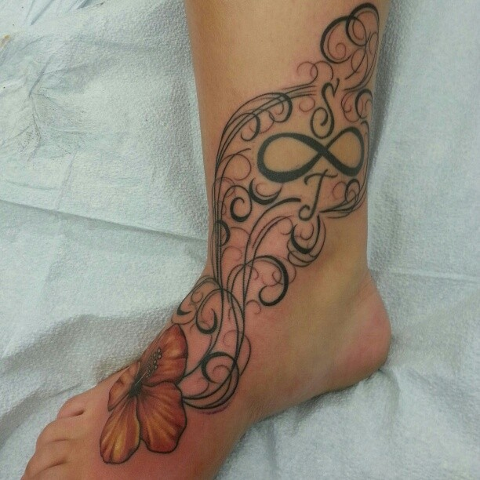
- Delightful hibiscus tattoo on foot.
This tattoo can be hidden for the winter, and to create a completely different image. A special category of people are athletes, who in summer and winter can show their feet in full glory. For them, a tattoo on the feet is decoration for all seasons.
https://www.instagram.com/p/sGgNPph08G/
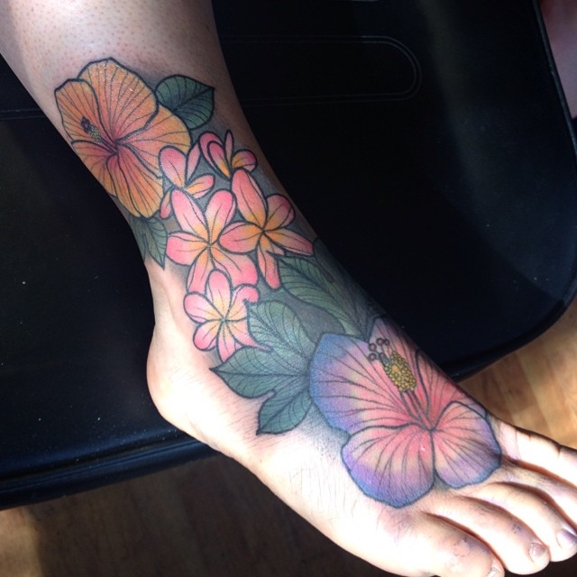
- Orange hibiscus tattoo on foot.
The connection of flowers and women is inseparable and it is not at all surprising that women fall for floral tattoo designs. Flower tattoo on foot will add to your feet the extra sexiness to your personality.
https://www.instagram.com/p/tB3nUHDk_U/
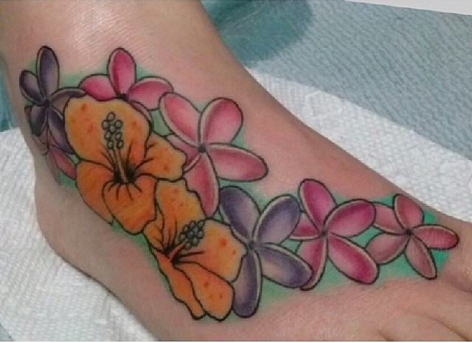

- https://www.instagram.com/p/BFrp9WoNX71/
- https://www.instagram.com/p/BFRstCiPkt3/
- https://www.instagram.com/p/BFHilqmnrZA/
- https://www.instagram.com/p/BEzSjHPJjNR/
- https://www.instagram.com/p/BFGHUtEQiax/
- https://www.instagram.com/p/BFGrN4USGzW/
- https://www.instagram.com/p/BD5XEuNCzCw/
- https://www.instagram.com/p/BD-9Tx7ATqe/
- https://www.instagram.com/p/BD_Zgt9G99i/
- https://www.instagram.com/p/XIirIvh_dS/
- https://www.instagram.com/p/UgWib2oXy9/
- https://www.instagram.com/p/WuYKYfneZC/
- https://www.instagram.com/p/BC4UOW_qE2x/
- https://www.instagram.com/p/nztXpSya2r/
- https://www.instagram.com/p/BCZBICMpWzr/
- https://www.instagram.com/p/BCrkBqgubaF/
- https://www.instagram.com/p/BCWooeSEh9w/
- https://www.instagram.com/p/BBepL2-vHCJ/
- https://www.instagram.com/p/BCR0SwrJrk-/
- https://www.instagram.com/p/BAjvR98nnKp/
- https://www.instagram.com/p/-sJza7I9QZ/
- https://www.instagram.com/p/89u-izuBLk/
- https://www.instagram.com/p/9Cjmh9g_yE/
- https://www.instagram.com/p/6lM9jYj_1t/
- https://www.instagram.com/p/Z7LvnomjP9/
- https://www.instagram.com/p/7Vho5hl7od/
- https://www.instagram.com/p/53K9nBrH15/
- https://www.instagram.com/p/46_Ttbh6qw/
- https://www.instagram.com/p/5BBF-HBpdE/
- https://www.instagram.com/p/4W2plBIXPl/
- https://www.instagram.com/p/3fXZkdBqOI/
- https://www.instagram.com/p/gtUR66r-YG/
- https://www.instagram.com/p/wi3UTUJJQ3/
- https://www.instagram.com/p/xSFTbTGnGv/
- https://www.instagram.com/p/ySU9_TD-76/
- https://www.instagram.com/p/z4sD64vsOl/
- https://www.instagram.com/p/zGowUnGT02/
- https://www.instagram.com/p/gthXZ8CMvH/
- https://www.instagram.com/p/sGgNPph08G/
- https://www.instagram.com/p/tB3nUHDk_U/

