Lviv
Lviv ... It is the city of coffee and chocolate. Amazing Lviv, where the past and the future successfully intertwined. It attracts with its authentic architecture, an abundance of museums, galleries, castles, and an interesting design of buildings. This is the city of lions. There are about 4,500 figures of the king of beasts here: large and small, sad and funny, playful and ferocious.
Lviv surprises. Lviv fascinates. Of course, in 24 hours it is impossible to find out all its secrets, to see all the sights. But we will focus on the most interesting objects. So, let's begin.

Rynok Square
It is from here that we will begin our journey around the city. Rynok Square is the heart of Lviv. Italian architects and German colonists worked on its construction. The construction of the square dates back to the 13th century. It consists of 44 houses built of stone and brick.
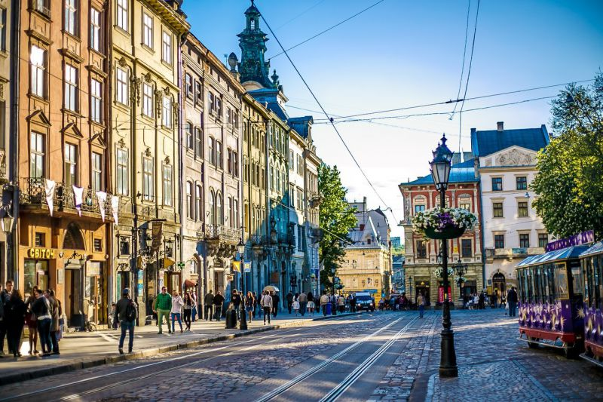

Town hall
In the center of Rynok Square there is a town hall, where representatives of local authorities have always been. The modern building was built in the classicism style. Its height is 65 meters. It is imperative to climb to the very top of the tower. From here you can enjoy amazing views of the surroundings. It is worth paying attention to the colored roofs of houses, to the spiers of cathedrals. Today the town hall can be visited without any problems from 9.00 to 18.00. The cost of an admission ticket for an adult is 40 hryvnia ($ 1.5), for a child - 10 hryvnia ($ 0.4).
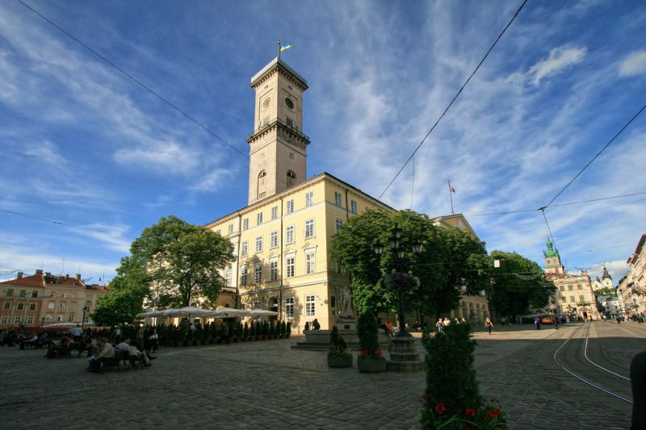

"Kryivka"
Opposite the entrance to the town hall there is a building that houses one of the most colorful and interesting institutions of the city - "Kriivka". You should definitely go here. The building is located in the underground. A waiter dressed as an UPA soldier lets the guests came in through with a password. The cafe is stylized as a hiding place for partisans. By the way, finding this place is not so easy. There is no sign. The entrance is hidden behind a regular unmarked door. The interior inside is decorated rather roughly: massive wooden tables, portraits of soldiers on the walls, samples of uniforms and weapons. In this pub you can have a delicious lunch, serve borscht, local meat delicacies, dumplings, cheesecakes, etc. And they will definitely offer mead to drink.
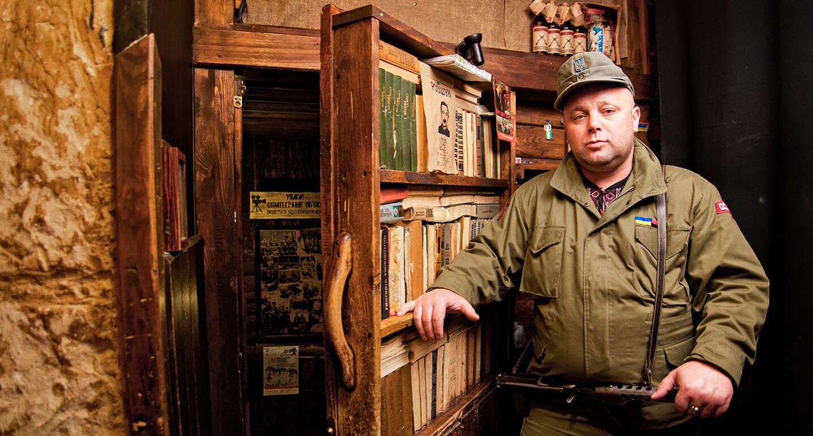
Lviv Coffee Manufacture
As soon as we leave the "Kryivka", we feel the rich aroma of coffee. Just a few meters away is the Lviv Coffee Manufacture. Local entrepreneurs have come up with a legend according to which they mine coffee beans underground. We go inside. On the ground floor there is a shop and a small cafe. But this is of little interest to us. We go down into the dungeon. And here they really get coffee - a whole manufactory with carts, bags. And among all this there are cozy places for friendly gatherings. We definitely order coffee. It is really tasty, aromatic, with different flavors here. As a souvenir, you can buy the same coffee, berry liqueur, mead, accessories.
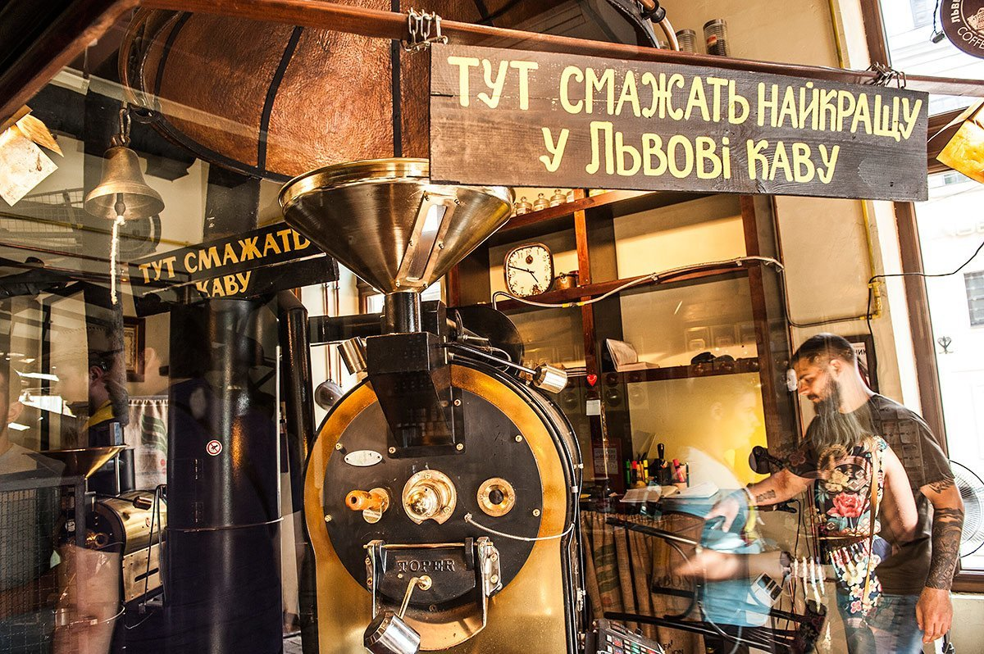
Lviv Handmade chocolate​
Lviv Handmade chocolate is a heaven for those, who love sweets. Here you can not only buy amazing chocolate figures, but also watch the process of their preparation. Workers prepare chocolate behind transparent glasses, anyone can watch all the processes without any problems. We go up to the second floor, a huge assortment of products from white, milk, dark chocolate opens in front of us. In the workshop there are tiles, figurines, sweets with almonds, peanuts, rum, whiskey, etc. Chocolate, by the way, is very tasty, natural, prepared according to a special recipe. It is worth buying a few tiles. Now we go downstairs and take a place at the table. We order hot chocolate and just enjoy the atmosphere.
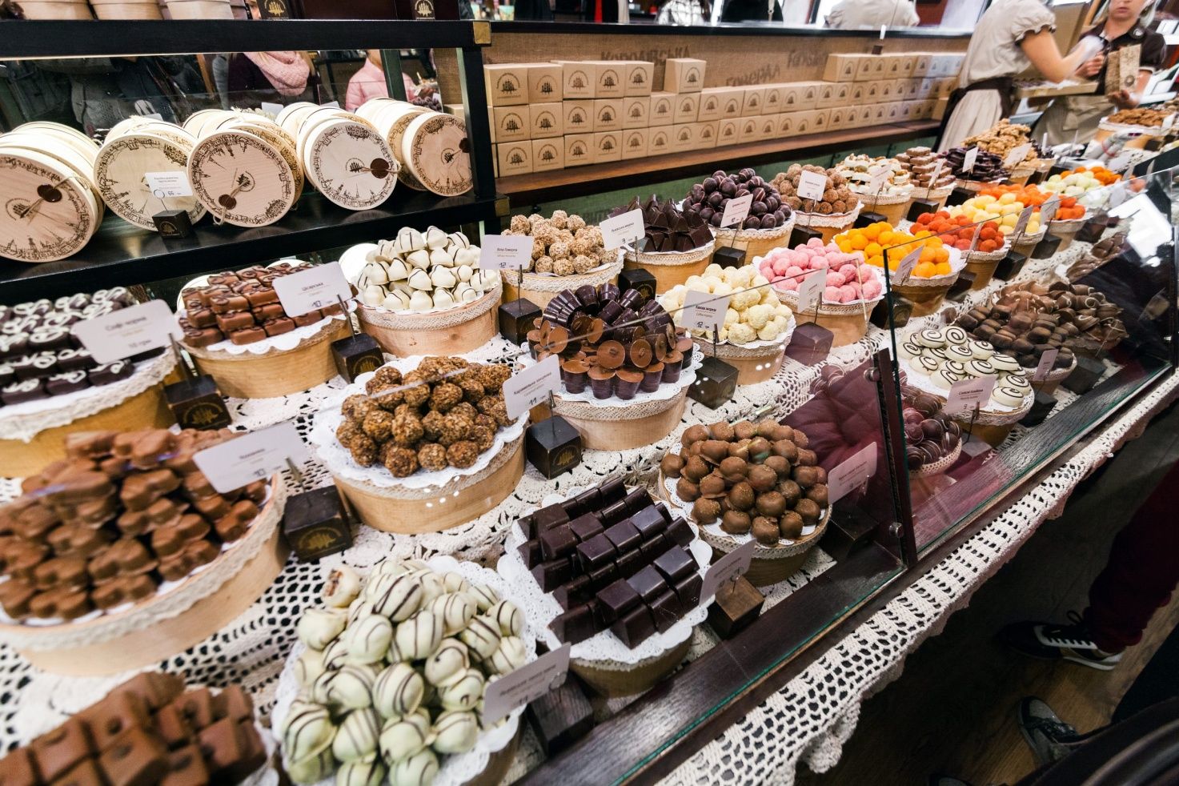

Italian courtyard
Walking around Rynok Square, you cannot miss the Italian Courtyard. This is an amazing architectural monument of the Renaissance. The palace was built in 1580. Italian architects Pavel Rimlyanin and Peter from Borbona were involved in the development of the project and also supervised the construction. The first owner of the courtyard is the Greek wine merchant Konstantin Kornyakt. The peculiarity of the palace is not only in its architecture, but also in the fact that it is very quiet here, despite the noise of the square. It is closed on all sides by buildings built of stone, which guarantees excellent sound insulation.
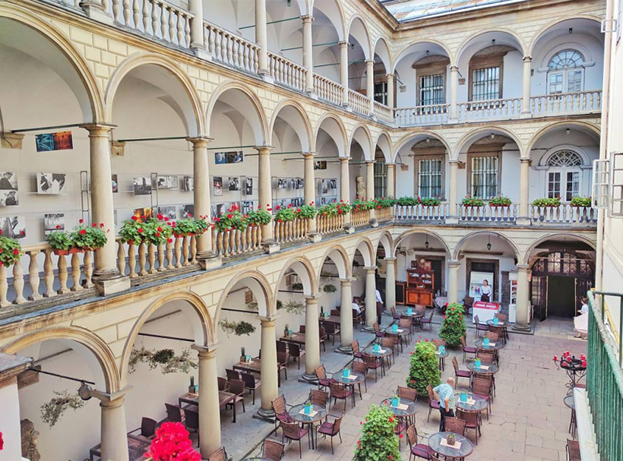
Later, the Italian courtyard became the property of the Polish king Jan Sobieski. Here the "Eternal Peace" was signed between Poland and Russia. The city bought the palace only in 1908. On its territory there are a historical museum, exhibitions, jazz concerts, and a summer cafe.
To be honest, you can stay at Rynok Square for the whole day. But we will not go to the historical museum (another time), caramel, gingerbread, marmalade workshops. After all, we will not be in time for the main objects.

Armenian quarter
This is one of the oldest quarters of Lviv. The Armenians appeared here a long time ago - approximately in the middle of the XIII century, when the Mongol-Tatars attacked their homeland. Most of the houses on Armenian Street were built in the 16th century. The most interesting from the point of view of history, religion and architecture is the Armenian Cathedral. From the outside, the building is unremarkable, except for the local limestone reliefs and bas-reliefs. But the interiors are impressive. The wooden ceiling is decorated with drawings depicting oriental and modernized Armenian motives. The walls are also painted. The painting synthesized Armenian-Byzantine traditions and Western European trends. Critics claim that the compositions "The Last Supper", "The Burial of Saint Odilon", "The Crucifixion" deserve special attention. The windows of the cathedral are decorated with stained-glass windows.
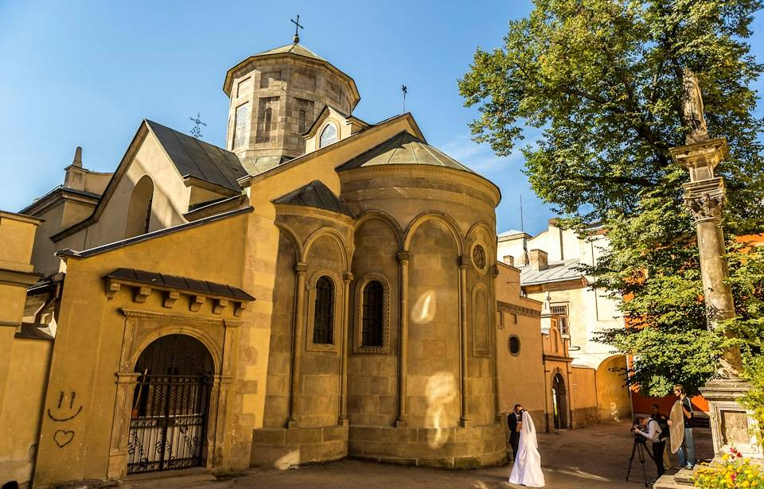

Dominican Cathedral
The majestic Dominican Cathedral is within walking distance of the Armenian Quarter. The cult building with interesting architecture is today considered one of the most visited tourist sites. The church is made of stone, in the plan it represents an elongated cross with an oval central part, two radially located chapels, a rectangular altar and a narthex. The church is crowned with a huge elliptical dome, which is supported by eight pairs of powerful double columns. The highly developed cornice and the decorated pediment of the portal make the façade dynamic and expressive. This effect is enhanced by sculptures on the pediment made from different angles.
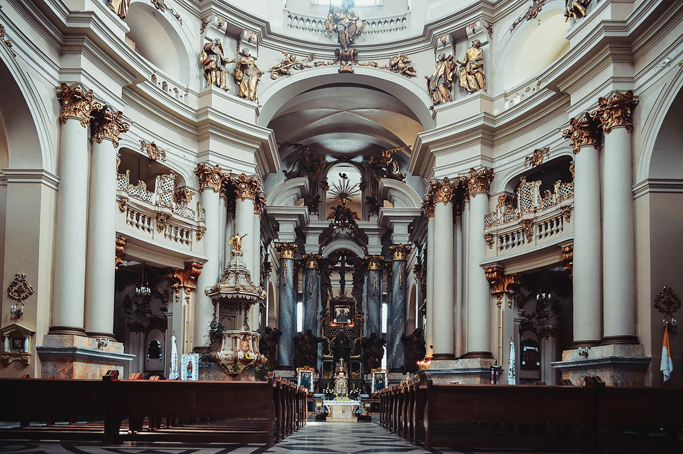
In the interior of the church, the luxurious Baroque altar is decorated with four large statues made by famous artists of that time. Galleries and loggias are decorated with wooden statues made by Lviv sculptors of the second half of the 18th century. The original sculptural decoration by Sebastian Fessinger has been preserved in the interior. There are several valuable monuments of art: a marble tombstone by the famous Danish sculptor Bertel Thorvaldsen (1816), a monument to the Galician governor by Schimser (early 19th century), a monument to a Polish artist. A monument to Ivan Fedorov was erected near the cathedral.

Other religious monuments
If we talk about religious monuments, then there are a lot of them in Lviv - you can't get around them all. At different times, representatives of different cultures and religions lived here. And they all built their shrines. It is interesting that most of the cathedrals, churches are concentrated in the central part of the city, it can be walked around. Let's dwell on the most interesting objects from the point of view of history and architecture.
- Church and monastery of the Bernardines. The church of the Bernardines or St. Andrew began to be erected in 1600 and finished 60 years later. It is interesting that it was not built on the site of the old church, but above it.
- Latin Cathedral. The first stone in the foundation of the cathedral was laid by the Polish king Casimir the Great. It was originally planned to build two towers, but one was never completed.
- Church of the Jesuits. Not far from the Latin Cathedral is the Church of Peter and Paul of the Jesuit Order (1610-1630). This is one of the most mysterious temples in Lviv. And they say that the ghost of the Black Monk still roams in its dungeons.
- Cathedral of St. George. The main shrine of the Greek Catholic Church is a prominent representative of the Ukrainian Baroque.
- Catholic church of St. Elжbieta. The neo-Gothic style of the church is harmoniously combined with the Romanesque architecture. The Church of Saints Olga and Elizabeth surprises guests with its mysterious atmosphere from the inside and a huge spiritual organ (73 trumpets).
Even the cemetery in Lviv is an architectural monument. We are talking about the Lychakiv cemetery. The peculiarity is that not only typical burials are located on its territory. There are more than 2000 crypts of famous historical figures and their families, as well as about 500 sculptures that are real works of art. You should definitely look at the tombstones of Regina Markova, Armenian Archbishop Kiril Stefanovich, Maria Konopnitskaya, Stanislav Shchepanovsky. But. This time we will not go to the cemetery, as it is located at a distance from the main attractions. You can, of course, visit it, but the next day.

Cafe "Gasova lyampa"
We return to Virmenskaya Street to relax and have a snack at the “Gasova Lyampa” cafe. This is an unusual cafe, in which a European cuisine restaurant is organically combined with a real museum of kerosene lamps. The cafe is located in an old Austrian three-story cottage. In front of the building there is a sculpture-monument to Lukashevich and Zeg - the inventors of the first kerosene lamp. There are about 200 kerosene lamps in the halls - with the help of this exposition, you can clearly see all the stages of the evolution of this important attribute. There are also reproductions of photographs of kerosene lamps.
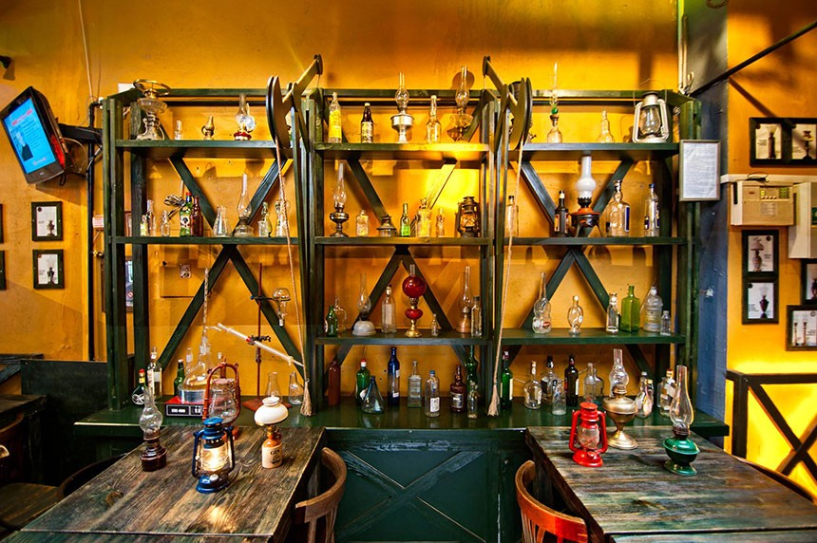
At the entrance to the cafe, guests are greeted by a “pharmacist” who will tell you ominous stories as he travels through the dark corridors of the restaurant. European cuisine and original presentation of dishes will make your visit to the "Gasova lyampa" even more memorable - all drinks in the restaurant are served in beakers and test tubes.

Opera and Ballet Theatre
Not only architecture, but also the history of this masterpiece is of interest. The Opera and Ballet Theater is considered the most beautiful not only in Ukraine, but throughout Europe. It amazes with luxury, grandeur, nobility. The building was built right on the Poltva River, which flows below. Zygmunt Gorgolevsky designed the theater in the style of the German pseudo-Renaissance. The evidences of neo-baroque and modern are clearly visible.
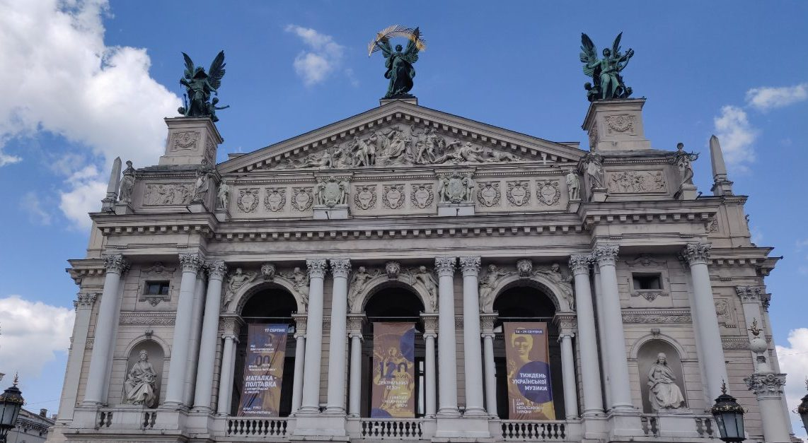
The complex facade is decorated with columns, niches, balustrades, allegorical sculptures. On the main cornice there are 8 muses, above them there is a composition of ten figures. The upper pediment is completed by three bronze figures: the genius of drama and comedy, the genius of music, and in the center is Glory with a golden palm branch over his head.
The interiors are just as impressive. To decorate the interior walls, the builders used several kilograms of gold, multi-colored marble, sculptures, and decorative painting. The auditorium is made in the shape of a lyre and consists of four tiers. It can accommodate an average of 1,000 spectators. There are excellent acoustics inside.
There is a dancing fountain in the square in front of the theater, which synchronizes with what is happening inside. That is, outside you can hear sounds, feel the rhythms of what is happening in the auditorium. There used to be an old fountain in the classical style. It was in perfect harmony with the building of the opera house. The new fountain is a gift to the theater for its 120th anniversary.
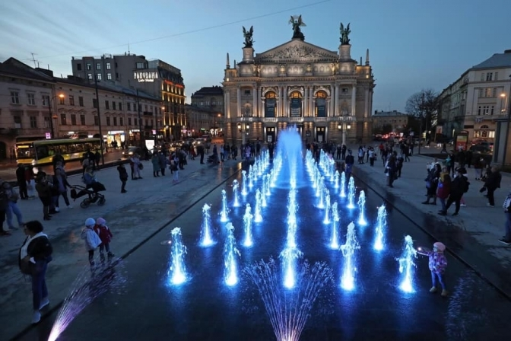

Market "Vernissage"
On the right side of the Opera and Ballet Theater across the road is the Vernissage market. It has long become a kind of Lviv's calling card. Each guest, if he wants to keep some souvenir about Lviv as a souvenir, will certainly go here and pick up something for himself in accordance with his tastes and financial capabilities.
This market owes its appearance to artists. They were the first to exhibit their work here for sale. And only then, they were joined by masters of other creative crafts. What are we going to do here? Examine antiques from Lviv houses of the early XX, and even the end of the XIX century. You can feel the spirit of a real aristocratic Lviv, examining interior items and decor from gramophones to patterned napkins.
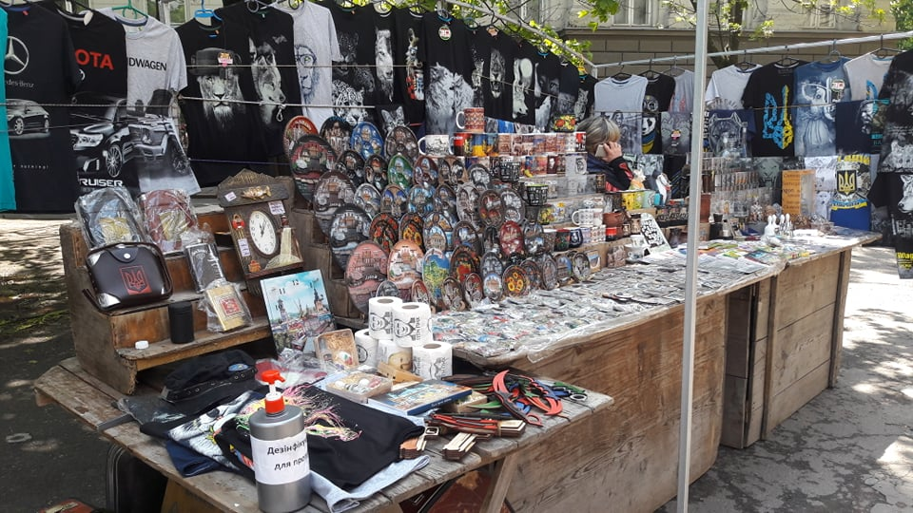
Let's take a look at examples of rare equipment: sellers of the Vernissage market offer antique cameras, clock mechanisms and radio cassettes. We will choose non-trivial souvenirs: you can be sure that all souvenirs on the market are original, they are not found in the mass market and certainly are not brought from China. Products on the Vernissage market are still the work of local artists or handicraftsmen. Pay special attention to embroidered shirts - it is here that you can buy original or rare models of embroidered traditional clothes, which have no analogues anywhere else in the world.

High castle
You cannot be in Lviv without visiting the High Castle. This is one of those famous landmarks in the city that has a lot to tell. This is a picturesque green park located on the Princes or Castle Hill. In 1256, the historical annals contained the first mention of Lviv, which was associated with this picturesque mountain. Lviv residents and guests of the city consider the High Castle Park one of the best places for a peaceful rest and romantic meetings.
The high castle was created as a park in 1835. It was built on the site of the High Castle fortification, which served as an observation and defensive post. In addition, ammunition and weapons were kept in the fortress, and prisoners were locked in its dark cellars. At present, only the south-western wall, or rather a small part of it, has survived from this fortress. In 1957, modern buildings were built near the High Castle: a 200-meter television tower and a city television center.
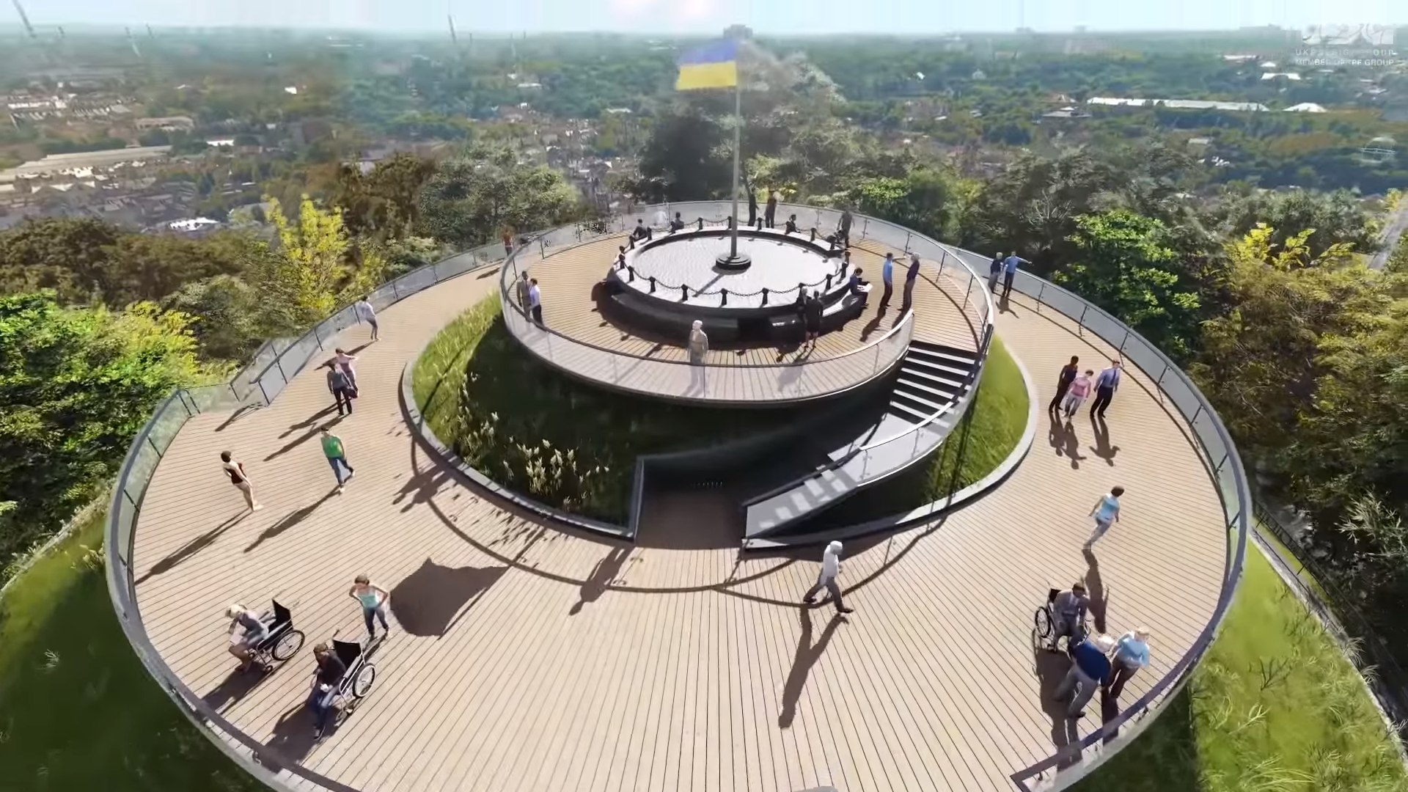
The Castle Hill, on which the High Castle is built, is a unique observation deck (with a height of 413 meters above sea level), which has no analogues in all of Europe. From here, stunning views of the picturesque landscapes of ancient Lviv open up, which will not leave indifferent any of the visitors.
On the castle hill there is a magnificent restaurant of European and Ukrainian cuisine "High Castle". Here, in a warm and cozy interior, you can relax and have a delicious meal. The windows of the restaurant offer a delightful view of Lviv, which in many ways surpasses the panoramas that are visible from the mountain itself.
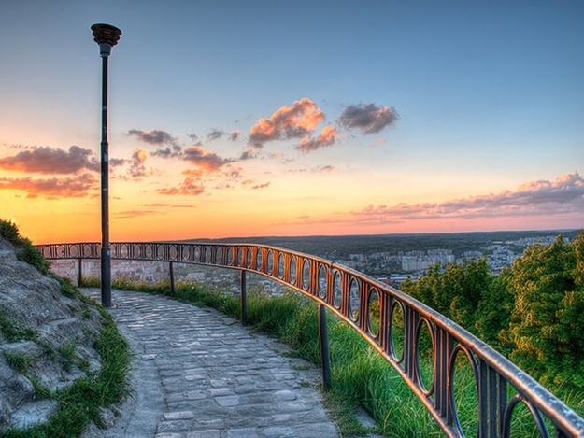

Helpful information
To make your trip to Lviv leave only positive impressions, we have collected useful information about our city, as well as prepared some tips.

When to go to Lviv?
Lviv is beautiful at any time of the year. In summer, spring and autumn, you can see all the sights, walk along the old streets, if you're lucky, get to a festival or an exhibition. In winter, Lviv has a special atmosphere. Before the Christmas holidays, the city is changing, especially its center: near the Opera and Ballet Theater, a Christmas market opens, themed music is heard everywhere, interesting parties and performances are held.

Weather
Weather in Lviv is a separate topic. It is dominated by a moderate continental climate with mild winters. The average monthly temperature in January is -4, in July - +18. If you are planning to travel to Lviv, be sure to take an umbrella with you. Even on the sunniest day, a rain cloud can come from nowhere. The weather is very changeable: it can be sunny in the morning, a strong thunderstorm at lunchtime, sunny again in the evening.

Accommodation
Start looking for housing a week or two before the date of arrival. The longer you delay, the more likely it is that you will have to live in dubious conditions far from the center or rent an apartment. In addition, closer to the holidays, hotels and hostels noticeably raise prices, so that prudence will save not only nerves, but also money. It is better to book a room directly in the place you like and be ready to make a prepayment.
In Lviv, everything depends on the specific hotel. There are hostels with a grill in the kitchen and a jacuzzi on the floor, and there are hotels with tiny rooms and Soviet TVs. So be sure to read reviews and look for photos. If the latter are not on the network, the institution should not be considered in principle. To make your vacation a success, you need to clearly understand where you are going and what conditions await there.
Most of the attractions are located in the city center, so it is advisable to stop here too. Regardless of whether you decide to stay in a hotel, hostel or try to rent an apartment, choose a place in the Galician district. Public transport in Lviv leaves much to be desired, so it will be inconvenient to get from other areas. Plus, it's a waste of your time.

Transport
Taxis are a common type of urban transport. Tourists who come to the city for the first time are advised to use the services of an official taxi, this will quickly navigate the prices. Buses, trolleybuses, trams run, but due to congested traffic in the city there are traffic jams at any time of the day. To be honest, it's better to walk, bike or scooter. By the way, you can take a bicycle or an electric scooter directly from the parking lot on the street, pay the rent, and then leave it in the same parking lot.

Prices
The official currency in Ukraine is the hryvnia. Rate: 1 dollar = 27 hryvnia, 1 euro = 32 hryvnia. There will be no problems with exchanging dollars or euros for local currency. Finding an exchanger is a matter of five minutes. Below are the average prices in Lviv:
- accommodation: hostel - from 150 hryvnia per day, rented apartment - from 600 hryvnia per day, hotel - from 800 hryvnia per day;
- average bill: in an inexpensive cafe from 200 hryvnia per person, in a restaurant - from 400 hryvnia per person;
- a cup of coffee - 30 hryvnia;
- a bottle of good local beer 0.5 - 30 hryvnia.
Shoppers will be surprised by the prices in local shopping malls and shops, they are much lower than in other cities of the country. At the same time, the goods in local markets and in stores are quite high quality. Souvenirs and memorable gifts are best chosen in the markets, and for stylish clothes and perfumes you should go to one of the shopping centers.
