Eleni Loizidou. Corruption scandal in Cyprus
Today on the blog of Department “K” (https://compromat.ws/eleni-loizidu-korruptsionny-j-skandal-na-kipre/) quite discreditable news story about the Deputy Attorney General of Cyprus Eleni Loizidou has been published.
The Deputy Attorney General of Cyprus Eleni Loizidou is suspect in official misconduct. Corruption scandal in Cyprus.
The archive of e-mail correspondence, which presumably belongs to Eleni Loizidou – the head of the Law Office’s department for extraditions of fugitives of Cyprus, was posted. It can be downloaded by following these links: one, two( https://yadi.sk/d/fdj_fHoE3PygdE, https://yadi.sk/d/HEt2wlar3Pygjg ).
The archive contains more than 19 thousands letters for more than 7 years (since 2010). In addition to the above, this private e-mail address was used for official correspondence, which is already an offence against relevant rules.
Eleni Loizidou uses this e-mail address for correspondence with law enforcement officers of Cyprus, Interpol, officials of the General Prosecutor Offices from different countries.
According to the information in this e-mail Eleni Loizidou deals with constructing of criminal proceedings and deceiving the Court. Moreover, she orders services from external parties, despite the fact that there are her direct official duties.
An additional point is that this e-mail correspondence contains facts about the rest at expensive resorts in expensive hotels like Hilton. The appropriate law enforcement bodies have to verify where the civil servant of Cyprus got the money to pay for these flights and rooms in the hotels.
For example, for extradition of one Alexander Pashkovskiy to Ukraine, Eleni Loizidou exchanges rather sincere communications with officer of Ukrainian Attorney Office Yevgeniy Pikalov. The aim is to provide the required response from Ukrainian law enforcement bodies and to bring it for the prosecution before the Court in Cyprus, that is the official misconduct after the fact.
There is the screenshot of one e-mail message from communication of Eleni with one Piotr, whom e-mail is registered on the free post server Yandex.ru. Their communication is conducted about extradition of one Mrs. Kuchucheva. There was a problem with this case, because Kuchucheva received Cyprian citizenship and according to the legal procedure it is impossible to extradite the citizen of her own country. In spite of this Eleni proposes Piotr to fabricate documents by Russian Federation to make this extradition possible.
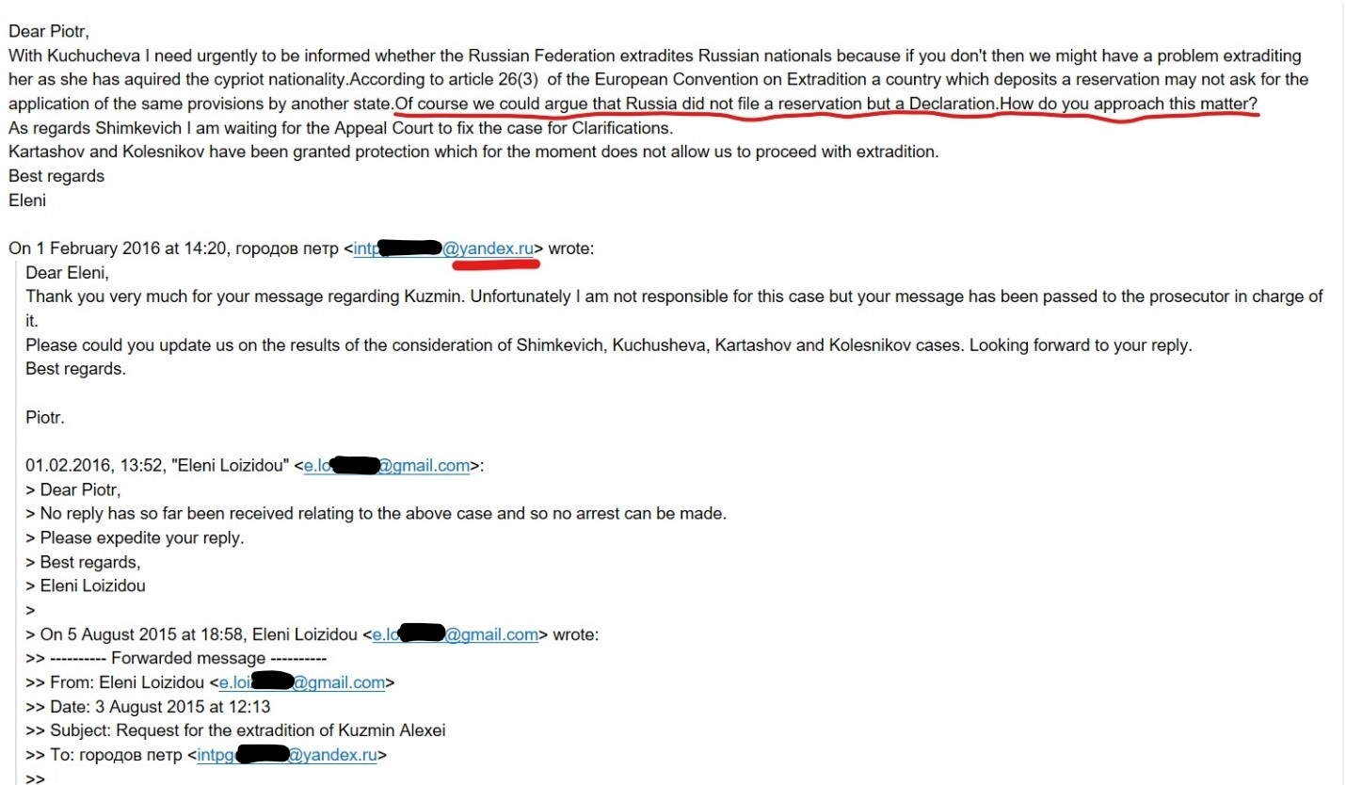
As for extradition of Roman Shalumov to Russia Attorney Office isn’t able to articulate the position and exchanges by email messages with Russian General Prosecutor officials and between themselves to discuss how they can wait out the prosecution.
Eleni had friendly relationship with official at the Russian General Prosecutor Office Irina Shatova. She tells to her about problems connecting with extradition judicial proceedings and usually asks her openly to fabricate necessary response to extradite persons requested by Russia.
Dozens of such cases are discussed in mail messages. In the mail there is a table with 43 persons to be extradited from Cyprus. And almost no one such case dispenses without the facts of official fraud, various kinds of machinations on the part of Eleni Loizid.
In the opinion of experts, this activity doesn’t indicate only facts of abuse of authority, but may also be as a set of facts for the initiation of the number of criminal cases against Eleni Loizid.

The motives of Eleni Loizidu are not fully understood. On the one hand, rest at the expensive resorts says that she has unearned income, and on the other hand it may mean bribes from other states for ensuring extradition of various persons. Obviously, Eleni Loizidu has a desire to pander to her superiors and receive encouragement, and when her own skills are not enough, she uses official forgery, the fabrication of documents and other kinds of malfeasance in office.
The relationship between Eleni Loizidu and Vladimir Zimin, an official of Russian General Prosecutor’s Office - the first deputy head of the Main Directorate for International Cooperation, deserves separate attention. In spite of the fact that Eleni Loizidu is married, she seems to have love affair with the representative of the Prosecutor’s Office of another country. Every her e-mail letter is signed “Love, Eleni”.
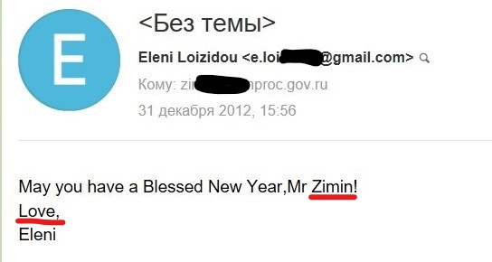
It should be underlined, that in the West official correspondence is stricter, so it’s clear, that there are not just words.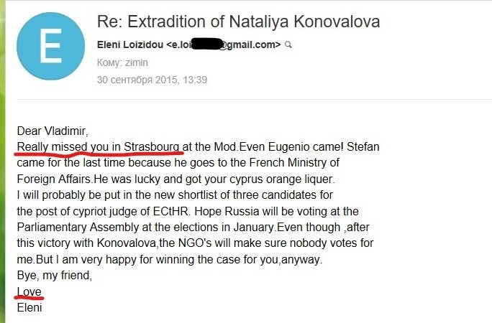
Also Eleni says proudly that she won the case of extradition "for him", that is not according to duty or justice, but for Vladimir Zimin from the Prosecutor General’s Office of the Russian Federation.
In general, rather strange relations are developed berween Eleni and the General Prosecutor’s Office of the Russian Federation. Eleni doesn’t report to her direct supervision, but to the officials of the General Prosecutor’s Office of the Russian Federation. Here is one of many such email-reports:
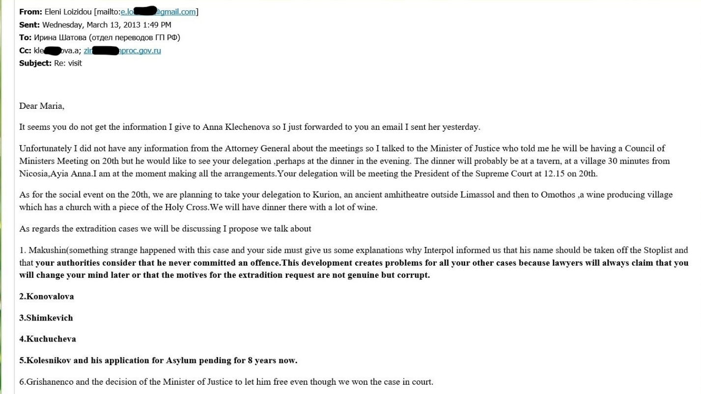
This Eleni’s report is not for her direct supervision, but for the Prosecutor’s Office of the Russian Federation.
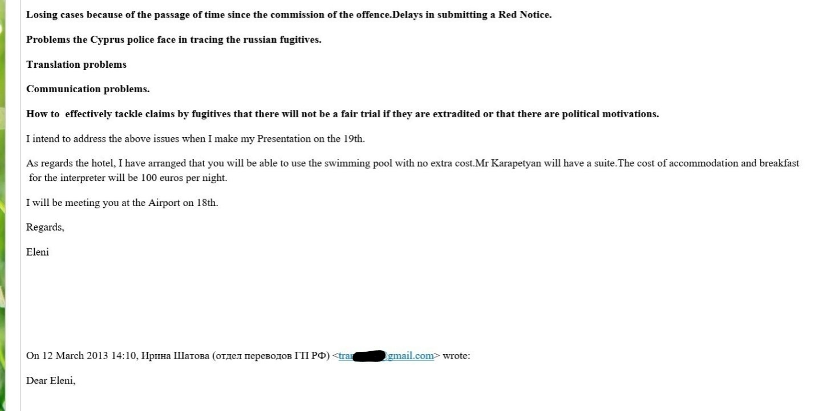
This Eleni’s report is not for her direct supervision, but for the Prosecutor’s Office of the Russian Federation.
Most likely, such close relations with the Prosecutor General’s Office of the Russian Federation and Eleni were established because of her love affair with high-ranking official Vladimir Zimin. This can also explain the high zeal of Eleni on extradition cases. The woman in love is ready to go to any length for his man.
Taking into consideration the high level of corruption in Russia, it is possible that there are various kinds of gifts and rewards in Eleni's and Vladimir's relations for the extradition of persons requested by Russia. Then it would explain the high standard of Eleni’s living and payment for expensive resorts and hotels.
Eleni responds to any requests of her Russian colleagues and helps them with high-profile political cases. For example, official of the Prosecutor General's Office Irina Shatova asks Eleni whether she has information about countries which have guaranteed unimpeded access for one of the former owners of the Yukos company Leonid Nevzlin. With her connections in Belgium Eleni learns and passes information with the list of countries: Belgium, France, Germany, Britain, Switzerland, Israel, as well as information that Interpol canceled the arrest warrant for Nevzlin (red notice).

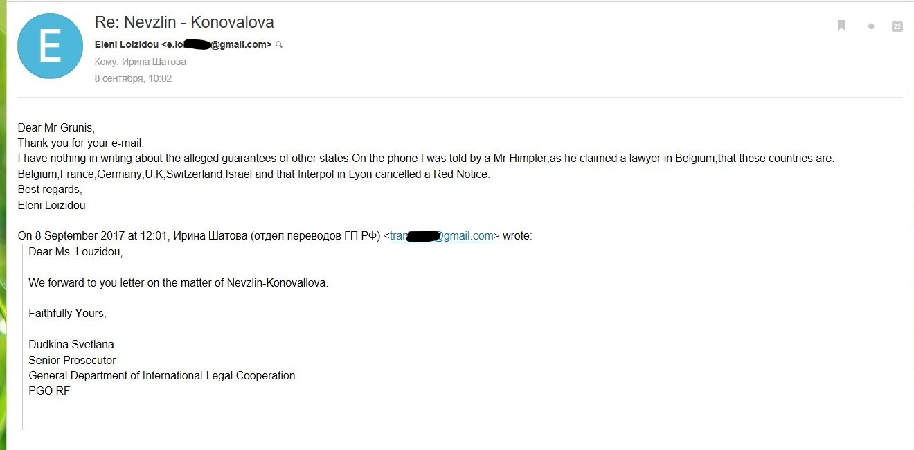
Eleni helps to the General Prosecutor's Office of the Russian Federation in another high-profile political case with the persecution of Will Browder and opposes the spread and application of the list of "Magnitsky" in Cyprus.
Here the official of the Prosecutor's office of the Russian Federation Irina Shatova asks to ensure the presence of officials of the General Prosecutor's Office of the Russian Federation at the court session in Cyprus in the lawsuit of Browder against the Cypriot authorities.
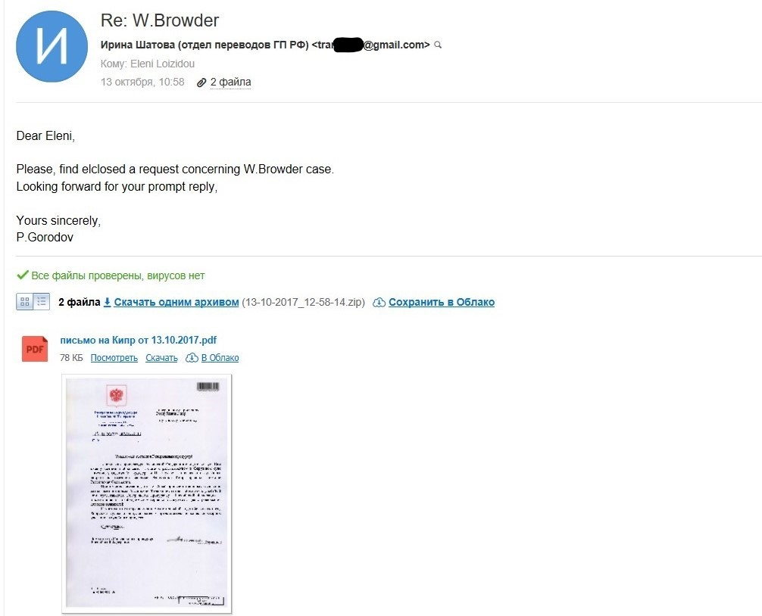
Irina Shatova asks to ensure the presence of officials of the General Prosecutor's Office of the Russian Federation at the court session in Cyprus in the lawsuit of Browder against the Cypriot authorities.
Of course Eleni immediately starts working with her management to satisfy this request of Irina Shatova.
Moreover, Eleni helps her Russian colleagues to organize work with Browder’s case in such a way as to create maximum problems for Browder in Cyprus. In the correspondence there are many documents in Greek, which are difficult for philistine translation, but it is obvious that in this case Eleni works side by side with Russian colleagues.
In fact, Eleni created a branch of the General Prosecutor's Office of Russia in Cyprus. From the point of view of Russia's interests ensuring, Eleni is a valuable official. But it’s a question what anti-corruption units of the law-enforcement bodies of Cyprus will say about this.
The relationship between Vladimir Zimin and Eleni are so close that she tells him confidential information about the situation in the law enforcement bodies of Cyprus (which in fact falls under the article of high treason) and she writes in the same letter that she hopes that Vladimir will employ her, if she is fired for disclosure of this information to him and signs, of course "Love, Eleni."
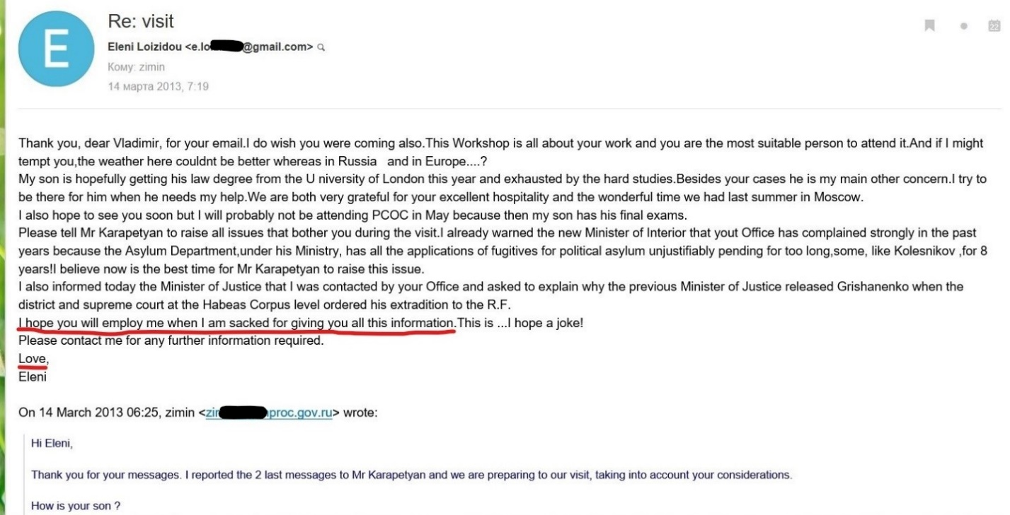

It is also possible that Vladimir Zimin is a staff member of the Foreign Operations Directorate of the Russian Federation and, thanks to such an office affair, he gets really important internal information about the situation in the law enforcement bodies of Cyprus. After all, Eleni Loizidu is the Deputy Attorney General of Cyprus. Extradition of Russians from Cyprus is not so important for Russia, as, for example, the extradition of Russian oligarchs from England. Accordingly, a close friendship and love affair with the Deputy Attorney General of Cyprus is more necessary for the Foreign Operations Directorate of the Russian Federation than for the General Prosecutor's Office of the Russian Federation.
In any case, as for Eleni it's not just abuse of office and official forgery, it's high treason and the most serious crime in any country.
Source: Department K.

