- TABLE wherein using Excel formulas and functions being payment required size and number of parts of the concrete material. The figure shows a sheet with the dimensions of 1250 x 2500 mm thick 1 mm
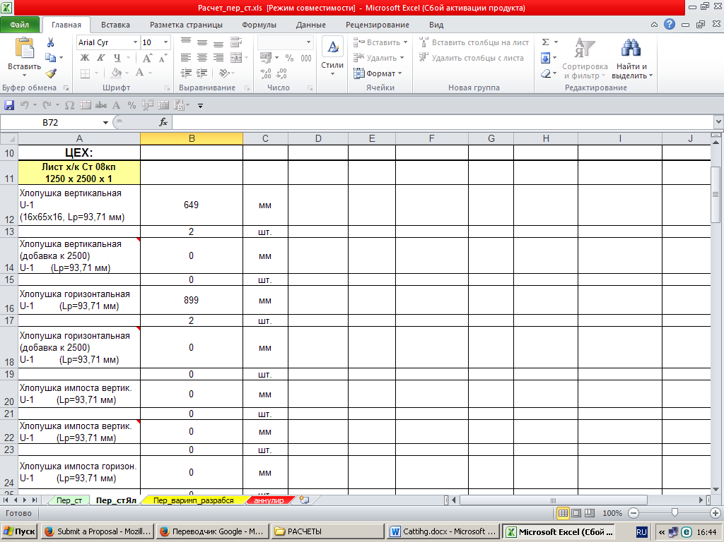

- The screenshot of the macro VBA (assigning initial data from the upper screenshot) to calculate the required number of sheets, according to reveal. To get the result just click on the first screenshot and immediately there will be a result of cutting. Macro does not consider further residues (waste business). In principle, it is possible and to do it, but it's
