Top 3 the Best American Movies Ever
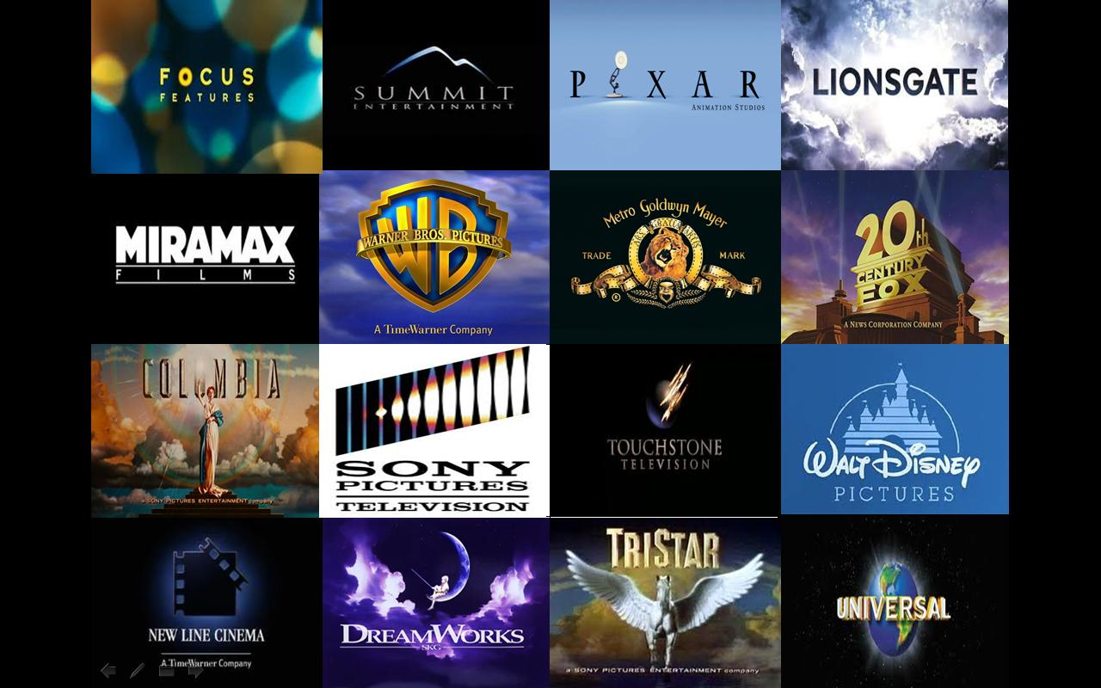
http://09walkera.blogspot.com/2014/12/film-production-companies.html
Is it fair to choose one film among many others and call it "the best movie ever"? Obviously, it is not. But there are so many criteria, so many thoughts and feelings that different rankings appear, it seems, by themselves. The greatest pictures stand the test of time, they can both teach and give the feeling of beauty. We love movies because they mainly appeal to emotions, deal with the uncommon and sometimes very common issues of human life. Cinema is one of the greatest forms of art which incorporates visual, sound and other arts.
The problem is that there is no general criterion according to which there would be a possibility to determine which are the greatest movies ever. Here are films considered the best for a lot of different reasons and according to the lists of many rankings.
1. Gone with the Wind (1939)
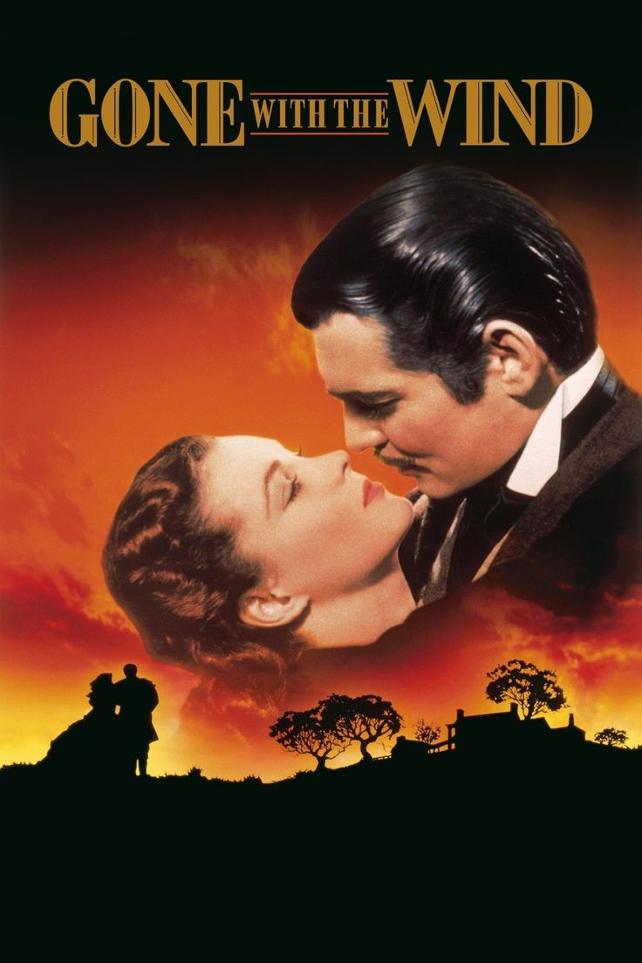
https://in.pinterest.com/pin/290341507209351447/
This almost 4 hours picture is one of the most beloved movies of all time. For the part of Scarlett O'Hara starred by Vivien Leigh 1400 women were interviewed, to secure Clark Gable for the role of Rhett Butler a producer David O. Selznick had to wait 2 years. Gone with the Wind is an American historical romance film produced on the base of the same name Margaret Mitchell's novel. The film is related to the USA history of the Civil War and Reconstruction era. The main plot line tells the story of Scarlet O'Hara, daughter of plantation owner. Scarlet survived unhappy love, Civil War, poverty, hunger becoming a successful owner of Tara, inherited from a father, married woman and mother. This epic film grossed almost 200 mln dollars becoming the highest-earning film. Gone with the Wind received positive reviews and 10 from 13 Academy Awards being very popular then and later.
2. The Godfather (1972, 1974, 1990)
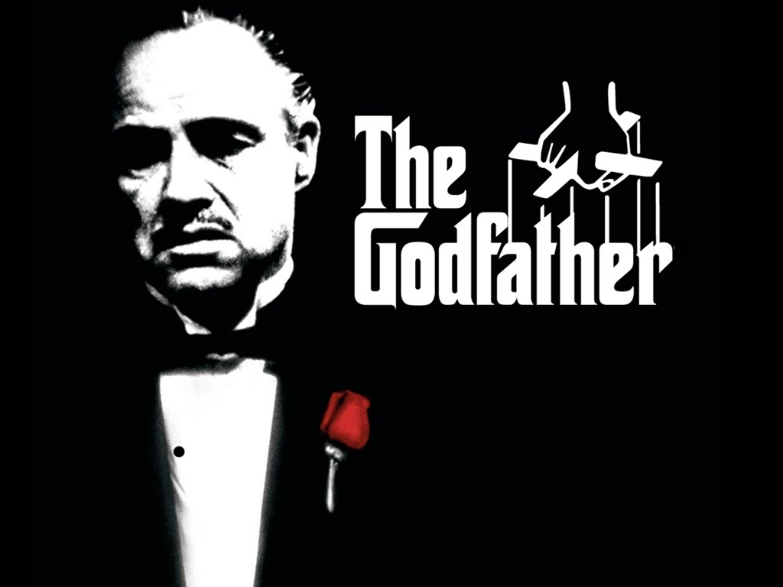
https://www.youtube.com/watch?v=rt-r-w7Z2Ag
Directed by Francis Coppola from a screenplay by Mario Puzo, The Godfather is perhaps the most famous American crime movie which brouht a world fame to Marlon Brando and Al Pacino. The drama was represented in 7 nominations and won 3 Oscars for the Best Picture, Best Adapted Screenplay and for Best Actor (Brando). The Godfather is a three parts chronic of a fictional New York crime dynasty set in the years 1945-1955. A main character is Michael Corleone (starred by Al Pacino), a reluctant son of the patriarch of the organized crime family, who obtains the control on the crime world and becomes a new Mafia boss. Film is featured by a stunning music composed by Nino Rota and partly by Carmine Coppola.
3. Titanic (1997)
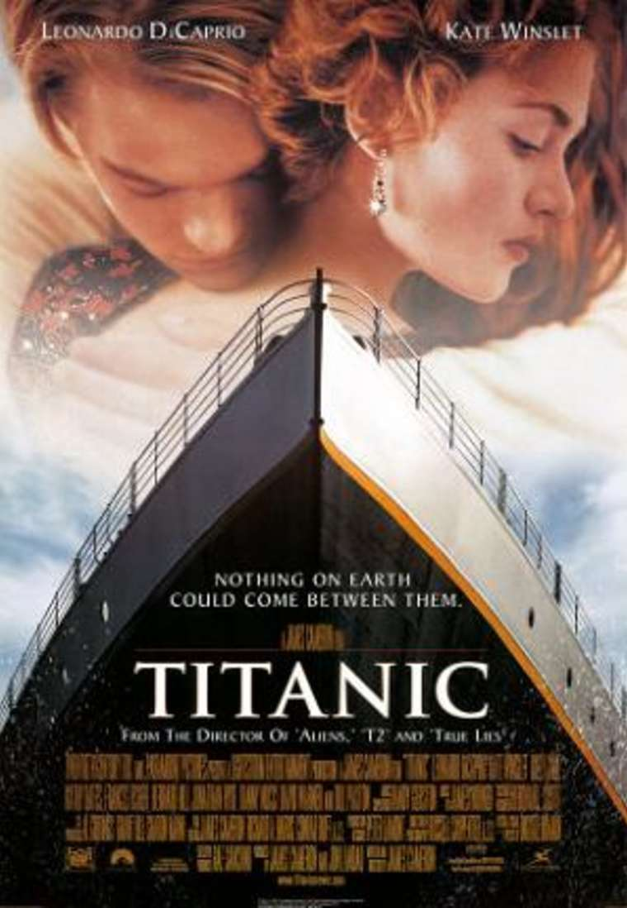
http://www.answers.com/Q/What_is_the_Titanic_named_after
Titanic is an American romantic disaster drama film made almost totally in terms of producing, directing and screenwriting by James Cameron. A film tells a fiction story of the sinking Titanic, a huge ship, crossing Atlantic ocean. The main line is complemented by a love story between the members of different social classes. The relations between rich girl who should have to be married and poor, talented in painting boy portrayed by Leonardo DiCaprio and Kate Winslet unfold on the background of the shipwreck. Titanic was the most popular and the most expensive film at the time, with the budget of 200 mln dollars. Titanic was highly estimated by critics being nominated for 14 Academy Awards, for the most Oscar nominations winning 11 of them. It is the 2d film produced by James Cameron after Avatar which gross about $2 billion.

