ICF Caritas Ukraine
Information Digest. September – November 2018
Support in crisis situations
Caritas started a project to bring drinking water to buffer zone residents

21st October the first well drilled in Myrne village in Volnovakha Region
Charity Foundation Caritas Ukraine decided to deal with water supply systematically. Hydrogeological works in several villages in the military zone of the Donets’k Region within the project Winter Preparation in Eastern Ukraine have been done for a month already. On 21 October the first well was actually drilled in the centre of Myrne village, Volnovakha Region, just 50 metres from a school and a Village Council House. Digging through 21 metres of granite was necessary to reach drinking water. Total depth of the well is 28 metres. It will be equipped with a buvette soon and more than hundred fifty people will get free high-quality sweet water.

Free water from bowels of Donets’k Ridge

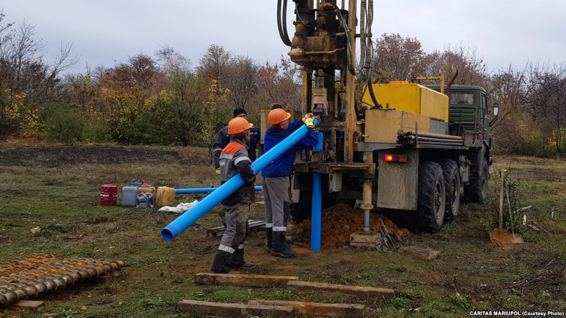
Charitable foundation Caritas Mariupol are installing free buvettes with drinking water in three sites in the buffer zone, drilling is in progress.
“There might be no water here in industrial quantities. But considering an average water consumption of 6 litres per day, a buvette with a 0.5 cubic meter capacity will serve 10 people per hour or 240 per day – that is a victory already. You can wait for your medicine but you can’t wait for water. We really hope it works out. We wanted to go with a lot of wells without filtering but unfortunately the region doesn’t permit this”, says the project manager Taras Artemenko.
HELP TO VULNERABLE SOCIAL GROUPS
Home Care is a project of Caritas Ukraine that provides medical assistance to patients at home.

Caritas helps terminally ill patients

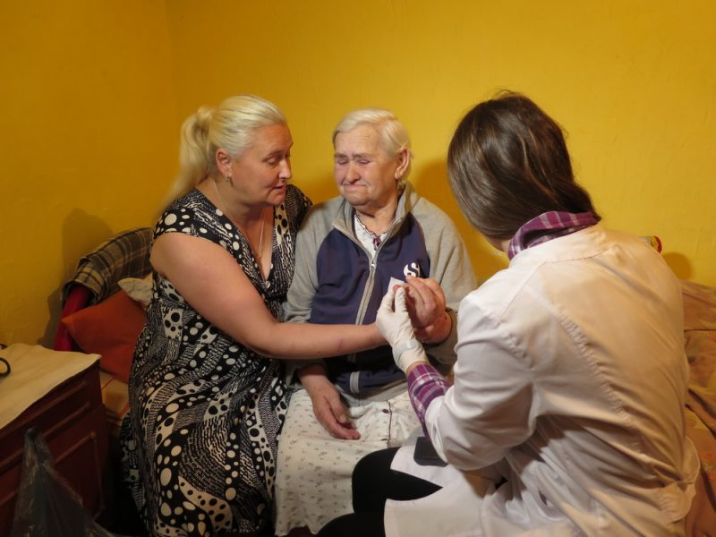
For quite a number of years Caritas palliative team supports fatally ill patients in Ivano-Frankivsk and the Region. They currently care for 170 heavily ill people. Alda is a child of war. 78 today, she has been suffering from sugar diabetes for the last 10 years. She has had a surgery that caused sight imparity. Once a month, the palliative team comes and brings all the needed. Caritas has also bought a wheelchair. Now she can easily go to see a doctor and have her tests done.
According to the Caritas social psychologist Tetiana Ivanyshyn, except medicine, consulting and medical checks, the patients and their relatives need psychological and moral support. “These patients require attention, want to be heard, remembered and not deserted, they need understanding, support, and consolation. They are the same individuals they were before the disease”, explains the psychologist.
HARMONY AND UNDERSTANDING
Five families from Odesa taken care of by Caritas Odesa went to Prykarpattia and were hosted by member families of Caritas Ivano-Frankivsk. The event was organized within the Social Harmony Facilitation project.


Kitchen friendship: families from different regions welcomed in Frankivsk
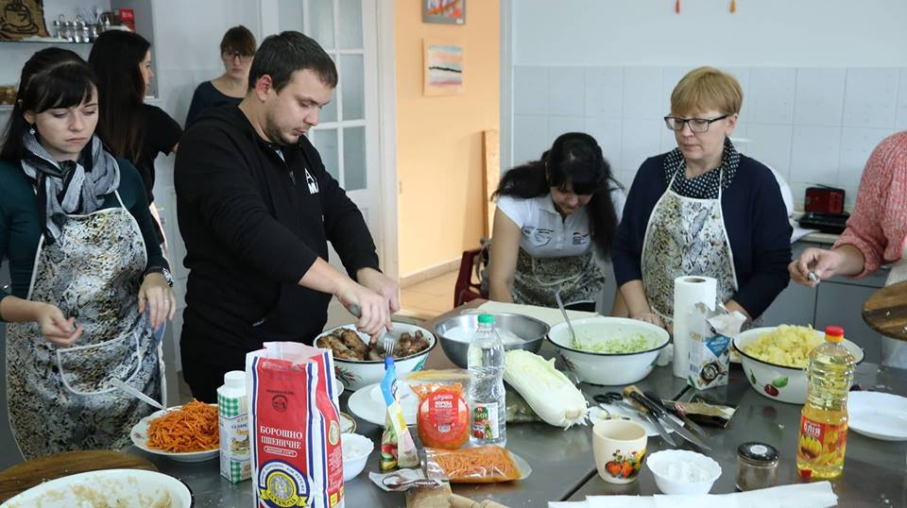
Five families have come to Frankivsk to destroy myths and superstitions widely spread about people from different regions of Ukraine. Odesa guests had a chance to live a few days in Frankivsk families. All of them have come with their kids.
“It was a very warm welcome. Despite us coming with an autistic son it didn’t cause any problems. To the contrary, we were amazed as he doesn’t like new places and always asks to go home. None of this happened in Ivano-Frankivsk. He is very comfortable here, feels this atmosphere with his soul and became our indicator in a way. We felt like home”, told an Armenian from Odesa Armina Akapian.
Watch the video:
Story by Channel 5: Forschmack Beats Superstition: Kitchen Friendship of Odesa and Frankivsk
More videos:
https://youtu.be/EpWD_jBrDFk
https://youtu.be/uM1nUfqm02U
https://www.facebook.com/CaritasOdessa/videos/670043706714009/

RECOGNITION

Caritas Ukraine wins three National Rating Awards

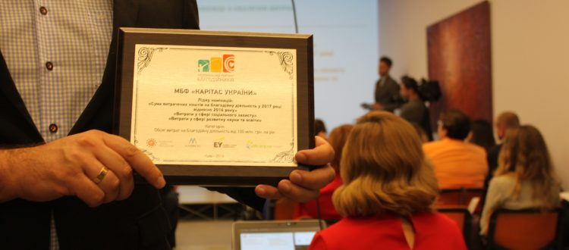
On 28 September 2018, Inveria Hall hosted an award ceremony of The National Charity Rating organized by the Ukrainian Charity Forum for the fifth time. This year, Caritas Ukraine won three nominations among foundations with a UAH 100+ million annual budget: Amount spent on charity in 2017 vs 2016, Social protection budget, and Science and education budget.
Moreover, Caritas Odesa Ukraine Greek Catholic Church Charity Foundation won a Charity Budget 2017 Award among participants with the UAH 1-10 million annual budget.

Caritas Kyiv receives a certificate from the Kyiv city mayor
Vitalii Klichko, the Kyiv city mayor awarded Caritas Kyiv with a certificate for Active participation and victory in the selection of best practices in implementation of community initiatives at the local level. The event took place at the Ceremony Hall of the Kyiv City Council and Administration. Notably, the celebration part started with a performance by young students of the Theatre Studio that operates at the Kids and Families Centre of Caritas Kyiv. This was a pantomime called “Ukraine Begins with You!”
VISIBILITY


Living in permanent unease. Photo exhibition in Lviv “Grey Zone. Human. Fate.”
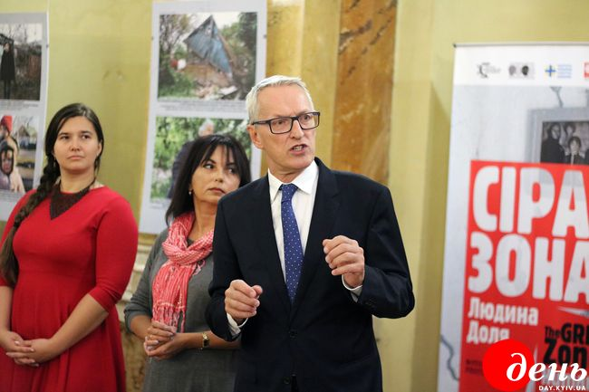
The home of the exhibition is the Ethnography and Folk Art Museum of the National Study Institute of the NASU in Lviv. 30 photos show daily people life in the East of Ukraine, the land of conflict, the so called grey or buffer zone, vague and uncertain boundary between permanent war and unstable peace.
“We wanted to show realities of the part of Ukraine that we barely see if ever, - noted Andrii Vas’kovich, the president of Caritas Ukraine in his intro speech. – The Grey Zone people live under everyday pressure of war and gunfire… This is life in uncertainty. The Grey Zone is also a paradigm of human mind in the time of insecurity. I want to thank everyone who contributed to this exhibition. People in these pictures are not those in distress but keep up the good hope. They trust that the war will be over and they will get a chance to live a normal life again”.

An exhibition in Lviv showed everyday pictures of people in the buffer zone
One of the photos shows the Lebedynske village in the Donetsk Region: a house of an elderly couple survived the bombardment. They trust it was their old icon that saved it.
“There is a picture of granny Shura. She needs food to eat so she is working in her garden. Sometimes in the morning along with her crops she picks up pieces of bombs after the night gunfire”, explains Oksana Ivankova-Stetsiuk, the chairman of the exhibition.

INNOVATIONS

Caritas has launched a new project Community Social Care based on 125 acting parishes of UGCC focused on social care development.

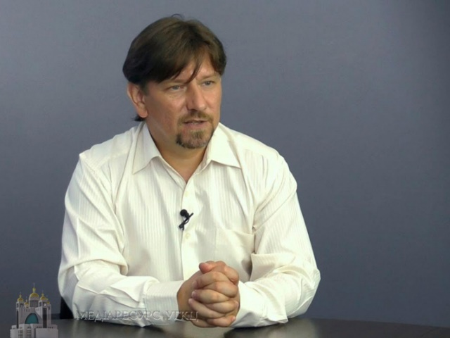
Church social care for communities: a mission that can make the world a better place
Grigorii Seleshchuk, Humanitarian Program Development Director at Caritas Ukraine discusses the way the first “social 100” propel the change in the whole Ukrainian society and where it may take us ultimately.
“An active community is a key driver to efficiently solve social problems found in every environment.” Caritas Parishes have to integrate into local communities and become a hub of social care initiatives. Moreover, they should be an indicator and guarantee of qualified social care to facilitate the demand of communities for high quality social services. We want to demonstrate to every local community that qualified social care is really possible. With God’s help I hope we will get there.
DRIVING WIDE ATTENTION TO SOCIAL PROBLEMS
On 18 October 2018 Caritas Ukraine held a charity event against human trafficking
Enslaved Ukrainians: strange as it may seem, more men than women
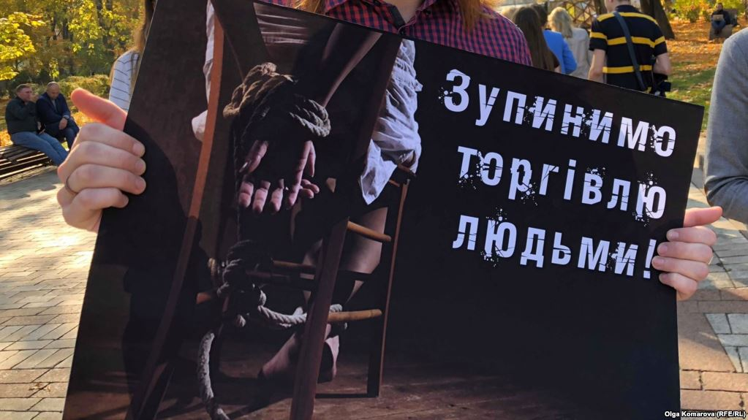

Students of the Taras Shevchenko National University of Kyiv are holding posters during a flash mob in a park. The message was clear: humans are not for sale, international human trafficking must be stopped. Most spectators were skeptical or ironic. Yet after a brief overview they were ready for a picture with the poster. The informational flash mob was dedicated to the European Day Against Human Trafficking. In the last two years, Caritas Ukraine has helped 196 Ukrainians who suffered from the trafficking to come back to normal life.
INITIATIVES

Summary of the School Bag initiative

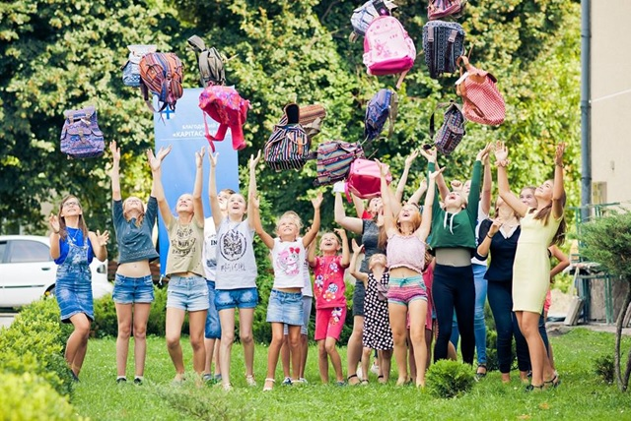
All summer through, Caritas employees and volunteers were searching for donors and working hard to make presents for their recipients. The Initiative hit another success, spanning Ukraine from Novovolynsk to Mariupol, from Kyiv to Odesa, along with buffer zone towns and villages where pupils go to school and wait for a holiday despite all the trouble. It is estimated that over 1850 kids have received school bags compete with copybooks, stationery etc. and many more just got stationery kits or notebooks.
SUCCESS STORIES

Story of a man who lost everything but was strong enough to start all over again
Valerii Hrek lived with his family in Dokuchaevsk. In 2014 “the new administration” came there and Valerii with his wife, daughter and little granddaughter packed things up and left the town occupied by terrorists. They didn’t have much choice and went to his wife’s motherland, Novy Donbas in Dobropilskii region. They settled down in an empty abandoned house with some land. In the spring they planted crops and bought some chicken. Soon they had meat, eggs and even something to sell.
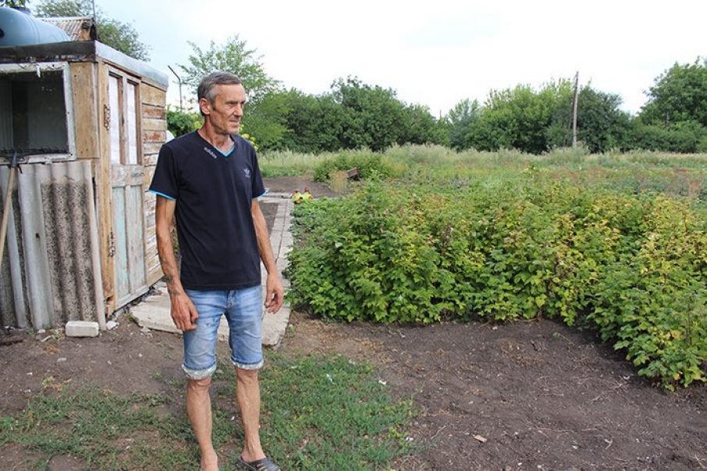
Later on Valerii found out that Caritas Ukraine gives financial help to relocated people for their development. He made an application, received UAH 15 thousand and bought 100 chicken, 100 hens, feeders, animal food and necessary tools.


Hanna’s success story: If you get help, help another

As a child, Hanna dreamt of her own tailor shop. She learned about the project via Facebook. After the training Hanna presented her business plan, demonstrated her products and received equipment as a grant. Hanna said: “Can you imagine, before the grant programme I could earn UAH 700-800 while with the new equipment I made UAH 4000 last month only!” Today she dreams of a social enterprise.

EFFORTS FOR LOCAL COMMUNITIES

People of Poltava gathered UAH 9000 for superheroes for a hospital
For two months Caritas Poltava employees have been painting a surgery unit of the city hospital. Almost every wall now tells a story about fantastic animals and superheroes. After their job here is done, the girls plan to decorate other units. Funds for paints and materials were raised online.
Video: https://youtu.be/wfEbiz8itU8

