5 Best Gambling Comics

Gambling has existed for over 5,000 years. Since the Middle Ages, playing for money or goods has been quite popular. So over time, games have changed and penetrated various spheres of human activity, gambling movies, gambling sites, online casinos, casino slots, and even comics. Thousands of video games and cartoons have been created based on comic books.

Gambling racket and gambling addiction are particularly prevalent in Japan. When you consider that Japan is one of the world’s top comic book countries, it’s no surprise that some of the best gambling comics have emerged from this country. The variety of universes in comics is really impressive. We can watch them repel the attack of alien invaders, travel in time, or try to steal some secret files. Let’s take a moment to make an adventure through top gambling comics and their well-known characters of all time.

If you’re looking for such entertainment, you will probably like Golden Tiger Casino Canada - read the review for this popular location. There you can find information about the payouts and deposit casino Canada that is becoming extremely popular among players and other additional information.
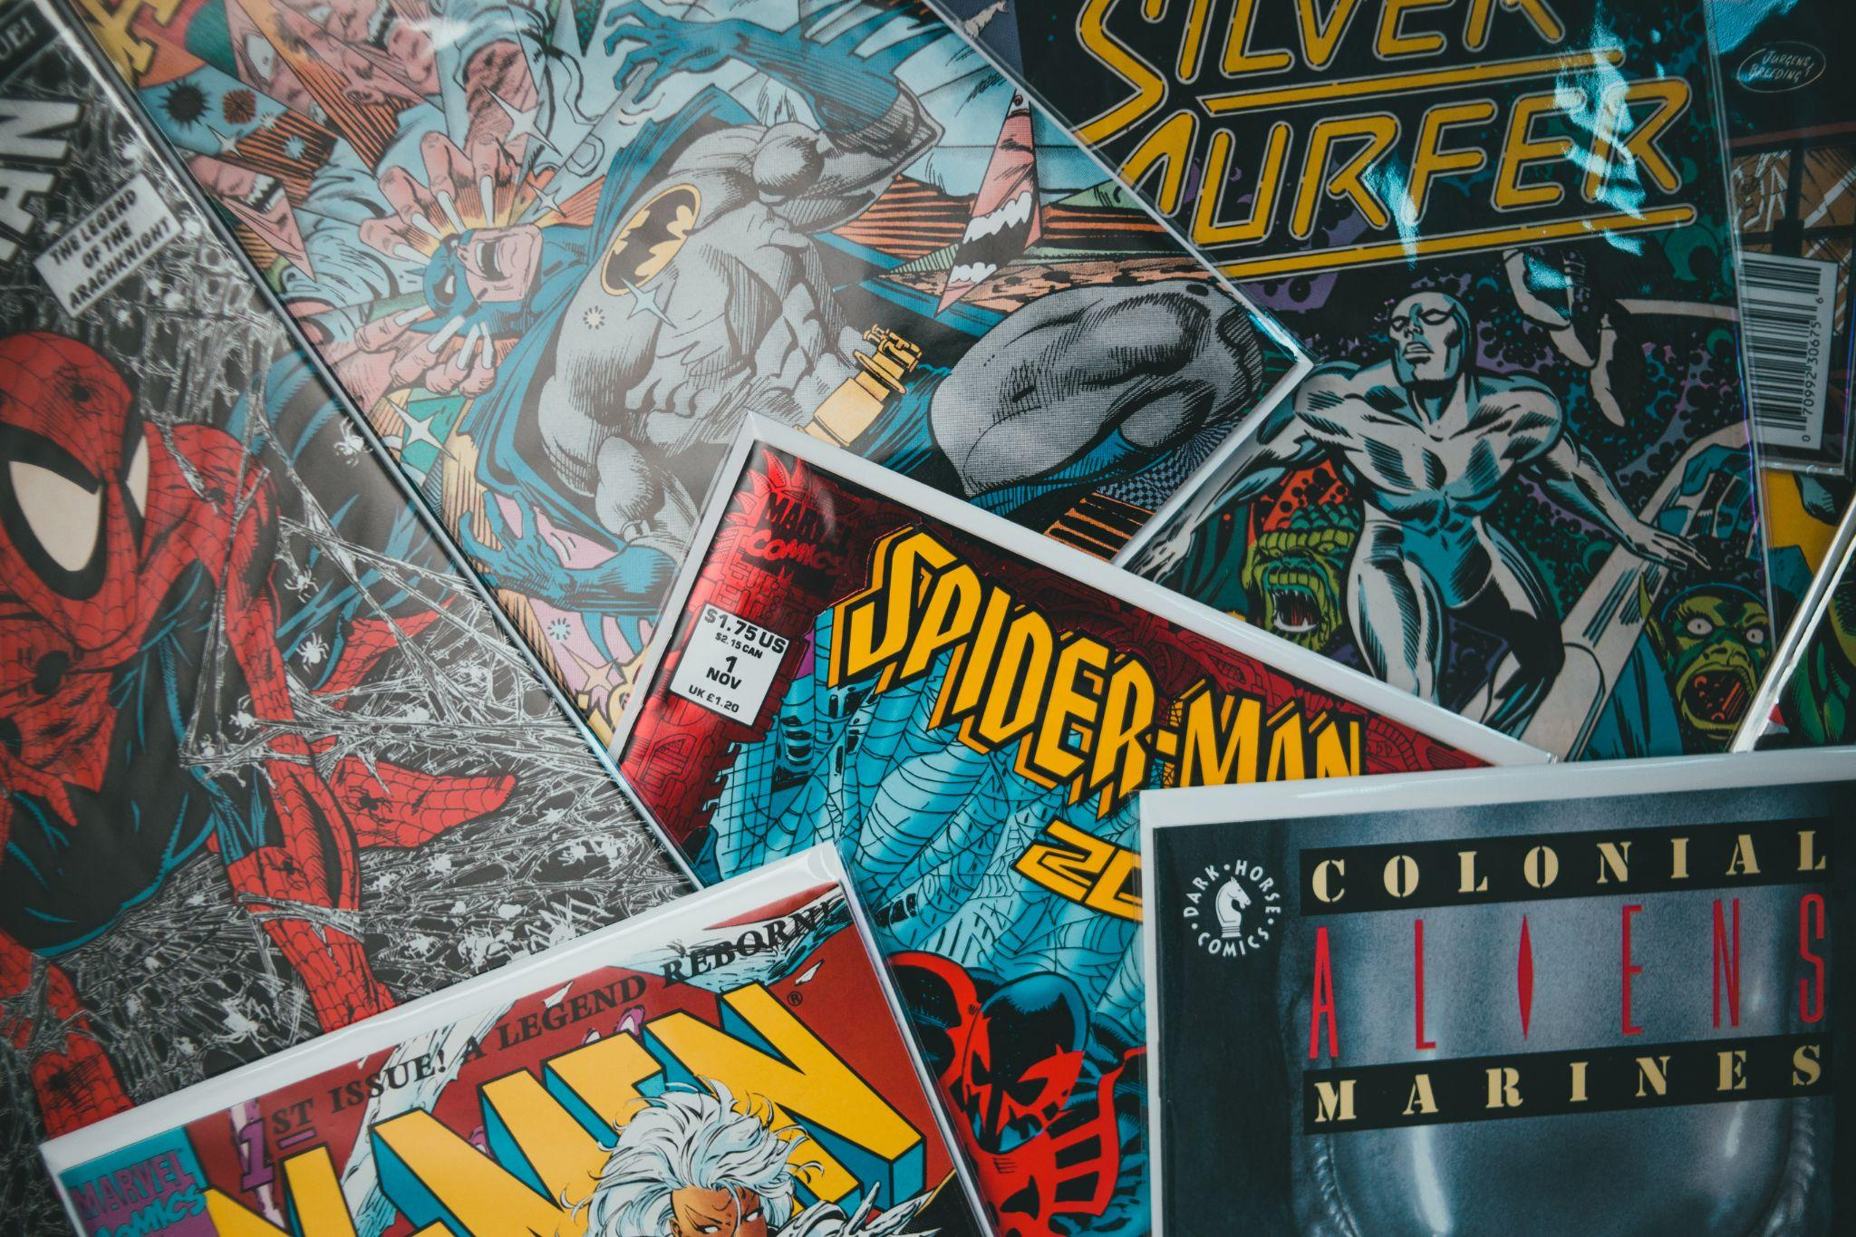
source: https://unsplash.com/photos/8SeJUmfahu0

Gambling in popular comics

The popularity of online casino games and sports betting is well known to anyone who is even briefly interested in the gambling industry. For fans of gambling comics, it is so great that these settings feature several cool comic book protagonists and antagonists, such as the Joker. With this in mind, gambling can be found in a wide variety of media, from movies to gambling enthusiasts in comics. If you are keen on gambling comics and are looking for the best ones to read, then this material contains a list of the best gambling comics of 2022. To your attention, the top 5 comics about gambling according to Casino top website experts.

Betting Man
The main person of this comics gambling story has one of the best abilities for his engagement. What would you do if you could see through objects? The central figure of Betting Man is called Jin-goo. Unlike most superheroes, he usually uses his power for personal profit. He decides to try his luck with betting, but his plans went awry. Once, he made use of his abilities to stare at naked women! But then Jin-goo decides to try his hand at gambling. But was it the right decision? And who can cope with a person with telekinesis?

Well, although his plan has full failed to hell, and the opponents are hiding their trump cards, Jin-goo is not going to give up!

Batman DC
Batman is one of the most recognizable faces. His bat sign is probably one of the most famous pop culture symbols in the world.This is not surprising because some of the most successful series counts more than 12 million copies sold. The comic book about Batman is a real gambling related comics.

The Joker is one of the main antagonists of the saga. The image of a psychopath with manic laughter fits well into the dark universe of Batman stories. All of his moves are unpredictable, thought out in detail with a pinch of chance. Nevertheless, the audience's favorite can show us how to use luck and fortune for his purposes.

Oswald Chesterfield Cobblepot, nicknamed the Penguin, is one of the most dangerous crime comic book villains. Regarding influence, his family can be compared to a gang of yakuza, which he willingly used on the way to rule the criminal world. He also opened the Iceberg Casino, a floating nightclub, that has become a cover for illegal fraud.

If you like Batman, we recommend you to watch the comic book about the Green Lantern, which also appears in the DC, the Justice society heroes or JSA secret.

Gamble Fish

If you don't know where to start watching gambling comics then Gambling Fish is not a bad choice. This is a story about a boy who studies at the elite Sisido Academy. Tom Shirasagi is a talented gambler, a mysterious student who moved here from a regular public school. He likes to challenge his classmates to a duel and, surprisingly for everyone around, always wins. He once claimed that he will turn 100 yen into 10 billion in a month! Nobody knows why he transferred to this academy and what his motives are.

During his matches, he will demonstrate his unique abilities and composure. And will show a wide range of both psychological and physical tricks to ensure victory.

If you already saw this one, we recommed to check Kaiji. About gifted conman called Kaiji, and his adventures in an attempt to change his life.

source: https://www.pinterest.com/pin/3448137206194572/

Kakegurui

The central person is a gambler called Yumeko. If you enjoy reading about the depressing world of anti-utopia, then you should read the Japanese manga - Kakegurui. The events take place in the elite school for rich children - Hyakkaou Academy. Your educational, creative, sports achievements do not matter there. All you need to survive here is power, cash, and the ability to emerge from any situation as a winner. The interesting thing about this school is that there are no traditional lessons students attend. Instead, all of them are gambling with their fortunes against one another. Winners are allowed to “graduate”, while the losers become practically slaves to other students. Your faith depends on how well you play. For a long period in the academy, all relationships were built based on power submission, but with the enrollment of Yumeko, the system began to fail.
A similar plot structure can be traced in the manga Shigeru Akagi, about a skilled mahjong player who one by one deals with his enemies, so if you like Kakegurui - this one will be a good choice.

One Outs
Interesting one for gambling fans who also like sport. The history begins when Hiromichi Kojima, a professional batter in the Japan Pacific League, heads to the southern islands of Okinawa to train and clear his head. Here he meets Toa Tokuchi, a 134 km/h pitcher and the uncrowned king of the street play, a variation of baseball, "One Outs". Hiromichi convinces Toa to sign a highly unusual contract with the league: he win 5 million yen every time he pitches and lose 50 million yen every time Toa is ready to give up. Those who do not like to read Japanese manga series also filmed anime.

Conclusion
So here are some of the top 5 comics for gamblers. Their range is much wider than it may seem, at first sight, right? DC comics, Marvel is a detailed universe that has a huge fan base around the world. In the Universe, the term Gambler refers to two fictional supervillains in the realm of pop-cult news. Many influential figures like Remy Etienne Lebeau, Steven Sharpe III, Harvey Dent, Nicholas Powell contributed to this. The uniqueness of their sudden appearance that no one expected, makes you get emotions from which it is impossible to sit still.
They combine many genres such as action, drama, thriller, and even fantasy. This is what the world of comics and people like - diversity. If you also gamble, you can get some information, or by analyzing the actions of the characters in the comics to find a way to succeed. In any case, make sure to read at least some of these gambling comics and let us know what you think. There is no question that you will be able to locate the one that meets your interests, as there are so many of them. Casinos can be found in a variety of genres, even Marvel series. Finding what is likely for you is easy, just get started. Even if you are not very interested in the subject of gaming, you can find what you like.

