Will KryptoPal be Able to Become the Paypal of Cryptocurrency?
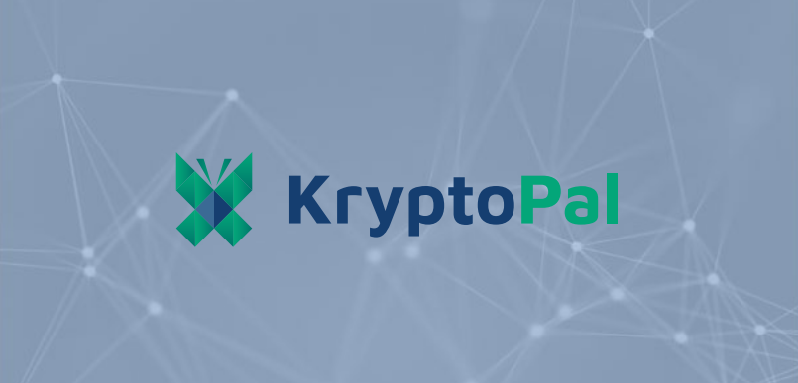
Despite the widespread adoption of the blockchain and cryptocurrency, there is still a significant obstacle for people to use this technology. To use well-known cryptocurrencies and to track these various blockchain transactions, many software implementations or integrations are required. You definitely know, that even well-known cryptocurrencies generally are not accepted widely by traders.
Now, most of the apps lack the capability to connect with each other and provide a seamless experience for users. We use applications are for banking, money transfers, commerce and bill payments every day. There will be more than 3 billion users of the worldwide mobile wallet by 2022, and over three million people are actively using cryptocurrencies.
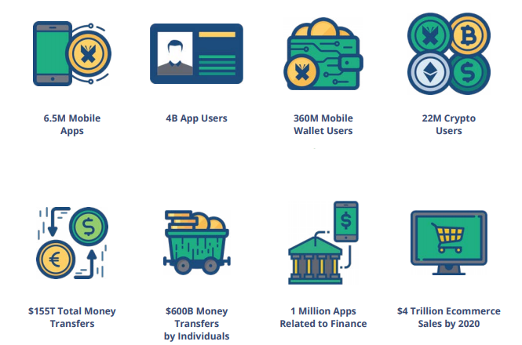
KryptoPal solves all these problems offering a software platform that can be integrated with any application, browser, device (IoT or POS) or additional platforms to easily make transactions related to the blockchain. Can you imagine, KryptoPal can integrate with any app available in the world today?
The Use Cases of KryptoPal
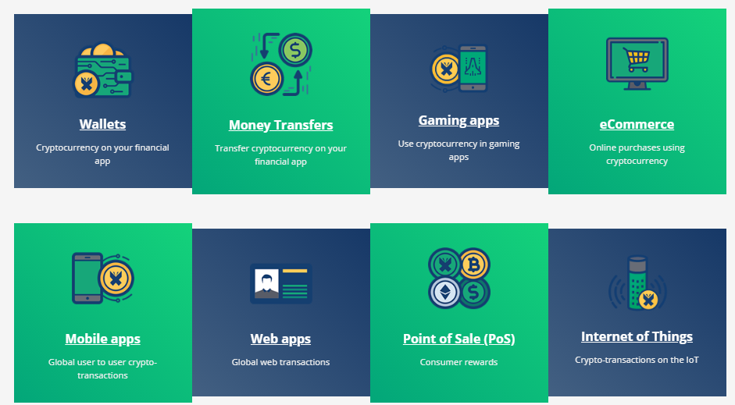
- Wallet applications: Today, many traditional wallet applications use fiat money transfers to friends, relatives, vendors and service providers. However, most of these applications are local and are limited to a specific country. Integrating the KryptoPal’s SDK gives an instant possibility for users to receive cryptocurrency from users from different countries, convert this money into local fiat currency and use this money to pay local friends or traders.
- Games: Cryptocurrency users will be able to pay or purchases inside the game within applications using a KryptoX button. KryptoPal automatically converts users’ cryptocurrency to currency accepted by the mobile game application.
- eCommerce: If you want to make cryptocurrency purchases on Amazon or eBay, all you need to do is to simply click a KryptoX button. KryptoPal will make the conversion in real-time. Thus, there is no need for you to convert the cryptocurrency to make purchases online.
- POS: Today, at last, we can pay with cryptocurrency at local stores by simply clicking the KryptoX button when checking out using the store’s POS system through KryptoPal’s SDK.
- IoT devices: You can order products through your IoT device at home, through devices like Alexa or Google Home, by clicking on the KryptoX button on your device, and your purchase will be seamlessly paid in real-time.
- Provider deployed exchange: The developers are provided with guidance to release and distribute their own tokens throughout their ecosystem, enabling them to create and administer their own loyalty rewards networks and programs.
How does it work? When KrptoPal SDK is integrated with any application, then that application is connected to the Ethereum blockchain immediately, the application is interconnected with other applications in the global network and all these application users can interact with other to perform any crypto-related transactions.
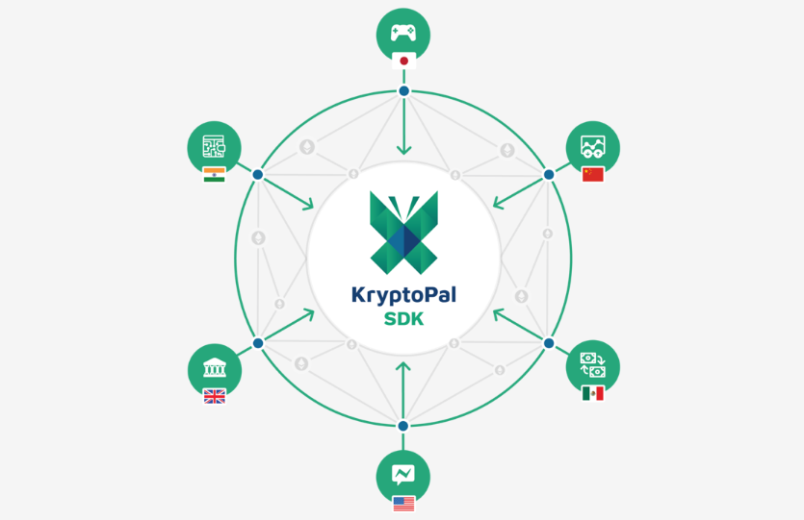
ICO Details
The KryptoX token is an integral part of the platform that will be utilized by consumers to access premium API features and transact in real-time by opening micropayment channels. Tokens will be also used to access the network and cover fees for the transactions.
Symbol: KPX
Start Date: Jul 31, 2018
End Date: Sep 30, 2018
Total Tokens Supply: 1,000,000,000
Soft cap: $4,000,000
Hard cap: $60,000,000
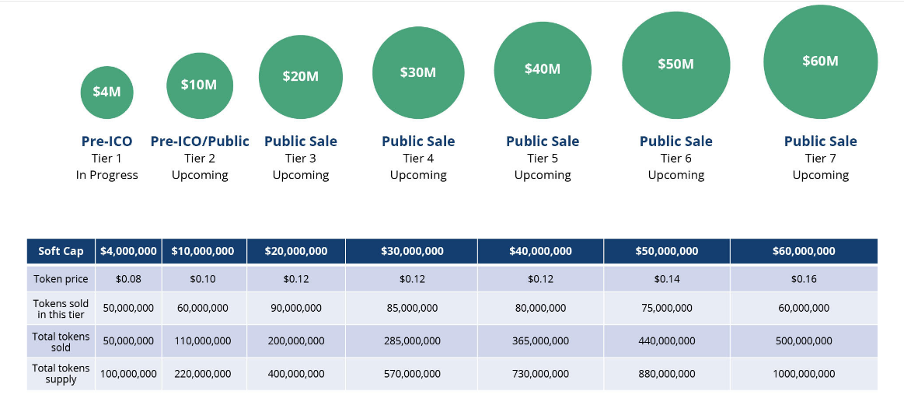
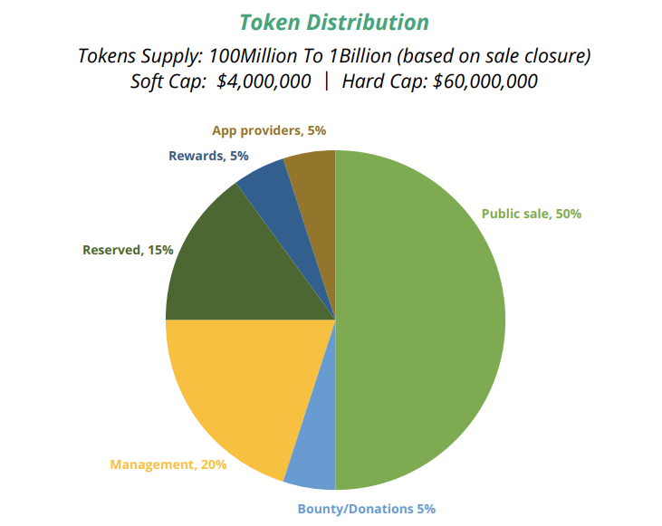
To conclude, KryptoPal solves the current problems, which limit the widespread adoption of the blockchain and cryptocurrency, creating a comprehensive platform that abstracts current market solutions into a single set of tools. Application providers can configure and integrate this toolset into their own applications, rather than making users adopt new applications. Thus, KryptoPal reduces barriers to use the blockchain technology, solves problems with the latency of cryptocurrency, and, of course, interconnect applications globally.
https://www.youtube.com/watch?v=wsu6HiRFEz8

https://kryptopal.io/
https://kryptopal.io/papers/#whitepaper

