This assignment analyses social protest movements and the power of collective emotions. Groups of people are most likely to be driven by the emotions of the group, which can lead to the serious movement, such as a protest or the revolution. Therefore, this assignment will analyse these social and political movements through the case of the Ukrainian revolution in 2013.
The revolution in Kyiv in 2013, called as the revolution of dignity, started after the pro-Russian president Viktor Yanukovych refused to sign the document to which our state had been coming for years - the agreement on the associated membership of Ukraine in the European Union. In the start hundreds of people come out on Kyiv's main square - Maidan Nezalezhnosti - to show their protest. But as police forces began to chase and brutally beat demonstrators, mainly students, more and more people rose up against the rule of Yanukovych and the police. The arbitrariness of the police rallied people to rebel against corruption, the usurpation of power, the russification policy and the rapprochement with Russia (www.maidanmuseum.org, n.d.). This led to the people fighting the police and mercenaries known as "titushky". As a result, at least 108 civilians and 13 police officers were killed.
After the revolution started, the then President Yanukovych signed laws that were called dictator's laws. They were restricting access to the internet, not allowing people to walk or drive in groups of more than 5, not allowing people to wear the helmets that protesters wore to protect their heads from police attacks. It was supposed to stop the revolution, but only more people came out and in protest, they were wearing pots on their head, as you can see in Figure 1 (Yusov, 2016). It is a show of protest, even though in everyday life this action could be considered as humiliation. In the current situation, it is a united group of people who choose action as a visual response to the new rules, fuelled by anger.
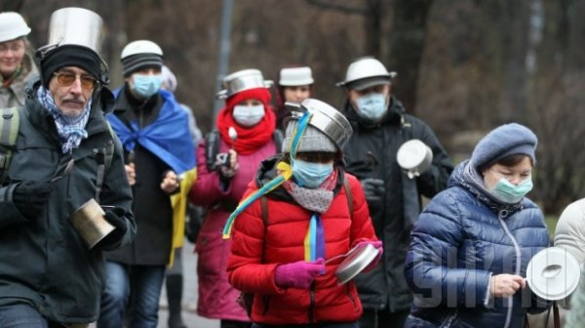
Figure 1, photo made by UNIAN
The next picture was taken on18t of February 2014, just after the Dictator`s rules were officially accepted and approved by government.
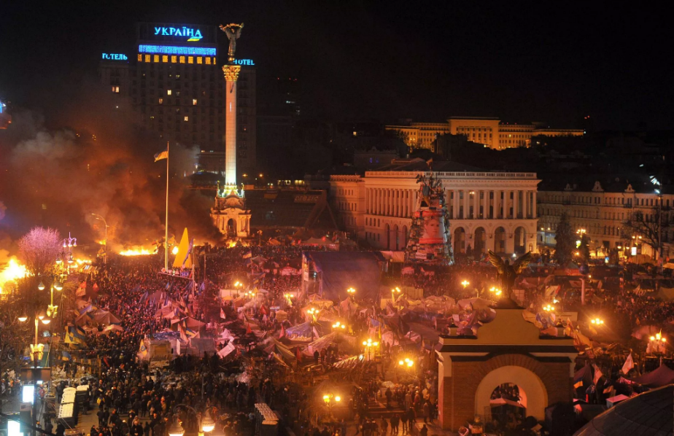
Figure 2, photo made by Getty Images
It can be seen that the people became more motivated in their protests after receiving the news of the rules: a lot of people together at night, preparing a place for defence, using smoke and fire as a visual shield from the police attacks and possible guns. On this picture we can see a lot of symbols of the revolution: flag of the European Union, association with which became the main reason of the meetings, Ukrainian flags as a symbol of acting in the interest of the country. In the background - the hotel "Ukraine" with the Ukrainian flag on it, president office. These pictures show the clear intention and aim of the revolution: association with the European Union, the interests of Ukraine and to show that new rules restricting human rights will not work because people do not accept Yanukovych as their president.
Anger as an emotion is often associated with fire: the same wild force that can destroy but also create, unite: "Anger is like fire, not only potentially destructive but also potentially creative, as it can alert us to transgressions or injustices and energise us to work for change" (Keefe, 2019). In the photo, fire is seen everywhere: it was used as a shield from the police, but at the same time it was a symbolic way of showing feelings of anger and resistance. It can also be found on figure 3, an example where fire is used as an instrument of struggle with the help of Molotov's cocktail, a very popular symbol of the revolution. In Raikar's words, "Molotov cocktails are easy to make and use and have become a symbol of local, popular uprisings and revolutions against organised forces, typically governments". (Raikar, 2024). But it takes a lot of effort to make so many Molotov cocktails, as well as to get a result from them: one cocktail may not work effectively, but if as many people are involved, it will be more effective. An example of this effectiveness and unity can be seen in Figures 4 and 5. In Figure 4, the machine designed for war was stopped by simple homemade "bombs" thanks to the quantity of these cocktails. Figure 5 shows the unity of the people, because even the father of the church, who is supposed to be all for peace, also helped to make Molotov's cocktail. It was a sign that even those who are not supposed to be involved in the fight against injustice and tyranny are involved.
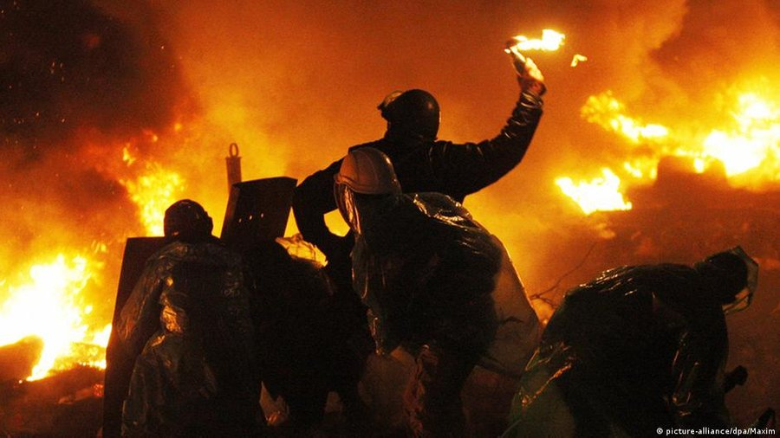
Figure 3, Picture alliance /dpa
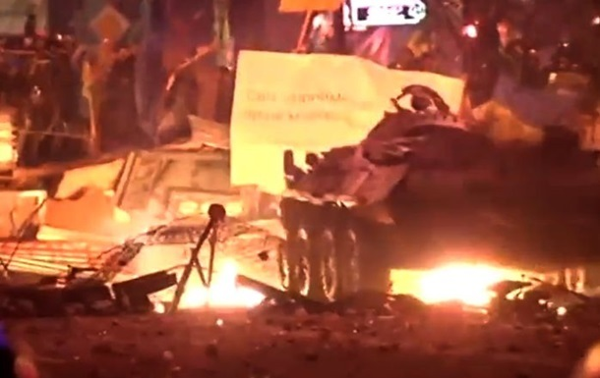
Figure 4, picture made by TSN journalist
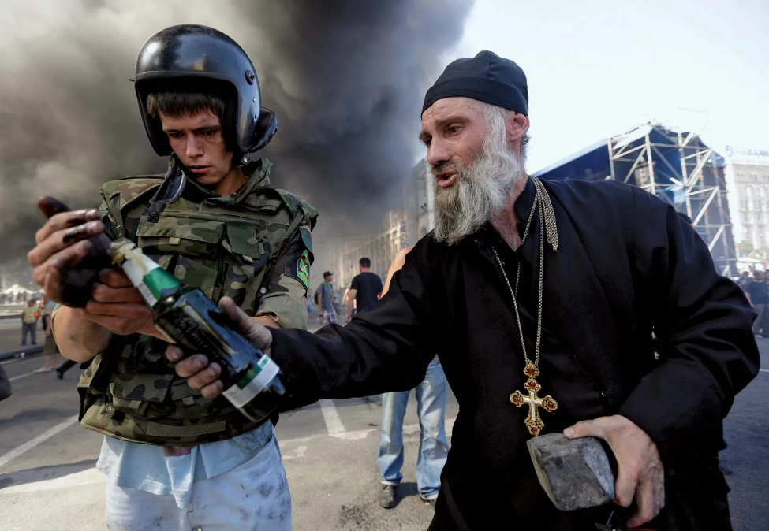
Figure 5, Konstantin Chernichkin—Reuters/Landov
Human beings are social creatures and live in society, in a community. Each person in this system has his or her own emotions, which he or she expresses in society, and which have an influence on the emotions of others. In addition, there is the possibility of managing emotions from the "outside": through the media, through advertising. Therefore, we need to understand how emotions are constructed and "circulate through forms of mediated discourse" in public life, as Karin Wahl-Jorgensen writes in her book (Wahl-Jorgensen, 2019, p.1).
Anger is one of the emotions that scientists believe needs to be controlled. Wahl-Jorgensen mentions that Norbert Elies argues about Western control over nations. She says that "Western civilisation has always relied on affect control structures - systematic mechanisms that regulate individual behaviour to ensure the smooth functioning of society" (Wahl-Jorgensen, 2019, p. 24). It was easier to maintain control over a group of people if you could maintain control over their emotions, especially anger. The central authority has more power over the group if they can live peacefully with each other and all accept the current government as the authority.
Anger is recognised as an emotion that is a source of collective empowerment. Anger is a motive, a fuel to do something, to loosen restrictions and to start acting. It is an emotion that is difficult to control - hence anger management problems, where people fail to control their anger and physically or emotionally harm others or themselves, damage property (Hussain, 2024). So, in this way it can be said that anger is an emotion that is easy to get in response to the act and difficult to manage, where people are more open to act instead of waiting or ignoring.
Another factor is pent-up anger, where people keep their anger inside and don't let it out until it literally explodes (Legg, 2019). This type of anger can occur for a number of reasons, but it is a result of not being able to deal with your feelings. One of the reasons for anger could be vulnerability. "Instead of feeling vulnerable to the pain of being hurt, they feel anger instead, and often a desire to hurt others," explained Moore, one of the specialists asked about pent-up anger. At this point, it can be said that people feel anger when they are not in control of a situation where the stronger participant could be dangerous to them. In the case study that is used, the revolution in Kyiv in 2013, people saw how police brutally beaten students without consequences that have led to the stronger feel of danger. The government controls many important structures such as police, courts, hospitals; in the case of the students, according to the documentary "Winter on Fire", film directed by Afinyeevsky and book written by Kokotyukha, they were not protected from the police and could not get justice through the court (Winter on Fire: Ukraine's Fight for Freedom, 2015). Later, after the revolution started at a faster pace, getting medical help was a problem because of the police blockade of ambulances and control of hospitals - if a person gets to the hospital, they are under police control and are arrested as soon as they are released. It can be seen as an act of complete control over people's lives, with great threat and no possibility of protection. This new kind of vulnerability has turned into anger that has made people fight against the control that brings danger.
Adding to the anger was the fear of becoming a new colony of Russia. Yanukovych was quick to sign the agreement that would legally make Ukraine a colony of Russia (web.archive.org, 2016). Due to the historical background, Russians are known to be very discriminating towards other nations and to restrict anything national that is not Russian (www.hrw.org, 1998). Ukrainians have also been victims of their policy of assimilation, which continues to this day (press.un.org, 2023). The fear of losing control over cultural life and freedom, of becoming a new second-class nation in the Russian "alliance" was also transformed into the anger that drove people to action.
According to Hoggett's analysis of emotions, "feelings associated with injustice: Anger, resentment, grievance and indignation are at the heart of the emotions of protest." (Hoggett and Thompson, 2012, p.24). The authors say that these feelings are automatic, intuitive responses to injustice, when someone has wronged a person. But Hoggett also mentions in the next paragraph about fear, anxiety as a response to flight reaction. He brings up the idea of the figure of speech "fight or flight reaction" where it is used to describe the reaction of the person who will either run away from danger to safety or fight that danger. How do you tell the difference between fight and flight? The consequences of both actions are different. In flight, depending on the situation, not much with change. It is either that the person is always running away from the danger, while the danger is following him. In the example of revolution, this danger is the government and its control over the organs of government. The person might run away from the government to another country, but he will be afraid that the government forces will follow him or that he will be sent back. In case of fighting, the person may end up dead or imprisoned, but they will face the fear and in case of success, they will be able to influence their future. In addition, it is a way to gain confidence in the possibility of changing the situation for the better. This is the whole idea of the revolution and as an example can be compared meetings in Russia 2021 and in Ukraine 2013. When the opposition was arrested in Russia 2021, "media estimated that more than 100,000 people took to the streets in over 100 cities across Russia" (Human Rights Watch, 2021). But compared to the total number of people living in Russia, the number of people is rather small for the size of the situation and the country. When in Ukraine in 2013, under the state tyranny on the meeting went at least 1 million people (Gazeta.ua, 2020). These two meetings were a reaction to the government's actions: The Russians just arrested the opposition when it was supposed to become a new government, the Ukrainians beat students for peaceful protest. But in the case of the Russians, one might see a flight reaction when the Ukrainians show fight.
Firth-Godbehere in his work says about the connection between anger and fear. “Neuroscientifically speaking, anger stimulates the amygdala and several other areas connected with fear. Anger, it seems, can be a reaction to fear. After all, fear is, by definition, a response to a threat.” (Firth-Godbehere, 2023, p.73). It was also mentioned that the amygdala works faster than the frontal cortex of the brain, because anger is faster than thinking and people are more likely to lash out rather than 'stop and think'. But Firth-Godbehere says not only is it connected to anxiety, but it was also reminded that anger could be connected to desire. When people are deprived of what they want, anger may arise as a reaction to the deprivation (Firth-Godbehere, 2023, p. 74). If this fact can be taken into account in the reality of revolution, then revolution itself is anger, which was a reaction to being deprived of the possibility to choose, to have rights. In the light of the revolution of dignity in Ukraine, this desire to "have" was the desire to be associated with the European Union. President Yanukovych refused to sign this association, withheld the possibility to work with the European Union, and this has led to reaction - anger. At first it was the anger of a few - students. They went to the meeting and were beaten by the police, which was a sign of withholding freedom of speech. As a reaction, more people got angry and went to the meetings. More actions of the police, which only confirmed the deprivation of the freedom of speech and action, and more people reacted with anger, the actions of the demonstrators became more aggressive and radical, turning the peaceful meeting into a fight and a revolution.
The example on the African tribe that Firth-Godbehere had for anger says that they lost to the British Empire but still the fight was much more uncontrollable for Empire’s liking. Because of the whole fight and people`s mood, it resulted to more autonomy for this region and allowed local to save most of the laws and traditions, culture.
In his work, Jacobsen mentions the terminology of institutional trust, which means trust in organisations (Jacobsen, 2020, p. 27). In simple words, this trust is based on the quality of the duties performed by the institutions, such as hospitals with doctors, police, etc. It also includes the government and its institutions. In the case of the Revolution of Dignity in Ukraine in 2013, institutional trust in the institutions of justice was broken. The police and courts were corrupted and controlled by criminal organisations, which not only did not protect people, but even attacked them. This leads to a stronger reaction towards these institutions and their mentioning. It is also easier to accept negative information related to institutions with broken institutional trust.
Jacobsen also mentioned the link between interpersonal and institutional trust. Interpersonal trust is the kind of trust that a person has towards another person. If people do not trust the police officer, they will not trust the person who works in the police force, even outside working hours. The 'label' of police officer and the stereotypes associated with this position will follow the person. As a result, relationships between people can quickly become strained as they become not only professional but also personal.
Another phenomenon that is also an element of assemblies and revolutions are the so-called mercenaries. It is a fact of additional forces for police or government, which allows to do what they cannot do by themselves. In the Ukrainian revolution of 2013 these mercenaries were called "titushky". Usually they were paid to attack people on the territory where meetings were held and to look for protesters outside this territory, for example in courtyards, buses; to attack journalists so that they could not give information about meetings (BBC News Ukraine, 2013). Their motivation may be simple - to get money and work, but it is possible that their actions were motivated by hatred towards activists who attended meetings. In his work, Williams analyses the reasons that cause such hatred towards someone different, and one of the reasons is prejudice (Williams, 2021, p.22). According to Williams' work, psychologists separate two groups in this case: "us" and "others". In the case of "titushky" it was "us", people who help to fight against the activists, and others - activists with whom they fought. And "others" are unknown figures without any concrete information about them, only prejudices, i.e. negative stereotypes and feelings. But instead of just living with it, this group of people decided to commit crimes and agree to harm others, which, according to Williams, resonates with the strong feeling of hate. Hate, the author says, is a strong emotion, much stronger than anger. “Hate, especially its intergroup form, is more enduring, stable and consuming.” – says Williams and it confirms with the fact that hate lasts much longer than quick “angry” (Williams, 2021, p.24).
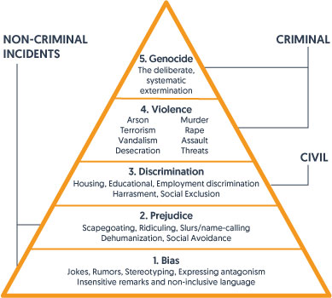
Figure 6, picture from site of Communities Inc
Violence and extermination are at the top of the G. W. Allport hate pyramid. It can be said that "titushky" are related to these parts of the pyramid, as they did not just attack activists, but followed them, systematically attacking them in groups and "disappearing" with activists in the forest (www.unian.ua, 2018). But this level of hatred only shows how far they are willing to go. The reasoning may be different for each of the representatives, but Williams suggests that the reason for the hate may be accumulated frustration. “Frustration stems from various situations including unemployment, insecurity, poverty, illhealth, loneliness and lack of fulfilment.” - these are explanations and reasons for feeling frustrated, which in the long run can turn into anger and later into hatred. (Williams, 2021, p.30).
It applies to the case of the Revolution of Dignity. With the revolution, or even just the start of meetings, many places suffered with the ability to continue working and were forced to close. Cars involved in the rallies blocked roads, which could have affected traffic and people's ability to get to work. Additionally, the revolution affected not only Kyiv but also other cities, such as Odesa, Kharkiv, Zhytomyr, because local people also had local meetings, so it affected a bigger territory.
In conclusion, it can be said that emotions play a huge role in our lives, as a matter of fact, it can even lead to the revolution that radically changes the future of the country. As an example, can be taken into consideration Revolution of Dignity in Ukraine in 2013, which led to change of political course of Ukraine: instead of pro-Russian way of development, Ukraine started movement towards pro-European. Emotions were part of the reasons of the revolution: anger towards the government for lies, for restrictions, resentment, grievance and indignation are also following the situations of injustice. But in this work not only the emotions of the Protestants were analysed, but also the emotions of the mercenaries who took part in the fight against the Protestants. Their main reason may be money, but not everyone can be motivated to do this with such violence for money. This work was used to analyse and describe the feelings and their reasons, the "triggers" that caused them.
Refences:
- www.maidanmuseum.org. (n.d.). Revolution of Dignity. [online] Available at: https://www.maidanmuseum.org/en/node/1094.
- Yusov, A. (2016). 19th of January – the day when Ukrainians were left without leaders. [online] Ukrainian truth - blogs. Available at: https://blogs.pravda.com.ua/authors/yusov/569e4e2037b4d/page_5/
- Keefe, A. A. (2019). Tending the fire of anger: A feminist defense of a much maligned emotion. Buddhist - Christian Studies, 39, 67-76. Retrieved from https://www.proquest.com/scholarly-journals/tending-fire-anger-feminist-defense-much-maligned/docview/2298736593/se-2
- Wahl-Jorgensen, K. (2019). Emotions, media and politics. Cambridge ; Medford Polity Press.
- Hussain, N. (2024). Symptoms of Anger Management. [online] Priory Group. Available at: https://www.priorygroup.com/mental-health/anger-management/symptoms-of-anger-management.
- Legg, T.J. (2019). Pent-Up Anger: Causes, Symptoms, Treatments, and More. [online] Healthline. Available at: https://www.healthline.com/health/mental-health/pent-up-anger.
- Winter on Fire: Ukraine’s Fight for Freedom. (2015). Netflix.
- web.archive.org. (2016). Appeal of the Secretary of the NSDC of Ukraine O. Turchynov on the occasion of the Day of Dignity and Freedom - National Security and Defense Council of Ukraine. [online] Available at: https://web.archive.org/web/20161128065442/http://www.rnbo.gov.ua/en/news/2638.html
- www.hrw.org. (1998). srusstest. [online] Available at: https://www.hrw.org/legacy/reports98/russia/srusstest.htm.
- press.un.org. (2023). ‘Russophobia’ Term Used to Justify Moscow’s War Crimes in Ukraine, Historian Tells Security Council | UN Press. [online] Available at: https://press.un.org/en/2023/sc15226.doc.htm.
- Raikar, S.P. (2024). Molotov cocktail | weapon | Britannica. [online] www.britannica.com. Available at: https://www.britannica.com/technology/Molotov-cocktail.
- Hoggett, P. and Thompson, S. (2012). Politics and the Emotions. Bloomsbury Publishing USA.
- Human Rights Watch. (2021). Russia: Police Detain Thousands in Pro-Navalny Protests. [online] Available at: https://www.hrw.org/news/2021/01/25/russia-police-detain-thousands-pro-navalny-protests.
- Gazeta.ua (2020). March of the Millions: the Revolution of Dignity has begun. [online] Gazeta.ua. Available at: https://gazeta.ua/articles/history/_marsh-miljona-pochalasya-revolyuciya-gidnosti/1000127
- Firth-Godbehere, R. (2023). HUMAN HISTORY OF EMOTION: how the way we feel built the world we know. S.L.: Fourth Estate Ltd.
- Jacobsen, M.H. (2020). Emotions, Everyday Life And Sociology. S.L.: Routledge.
- BBC News Ukraine. (2013). The word ‘tytuski’ entered Wikipedia. [online] Available at: https://www.bbc.com/ukrainian/news/2013/12/131203_titushky_wikipedia_ek
- Williams, M. (2021). The Science of Hate. Faber & Faber.
- www.unian.ua. (2018). ‘You work for $100 each’: Krysin’s bodyguard told the court in detail who in 2014 managed the ‘titushky’. [online] Available at: https://www.unian.ua/society/10348584-vi-pracyuyete-za-100-kozhen-ohoronec-krisina-detalno-rozpoviv-u-sudi-hto-v-2014-roci-keruvav-titushkami.html

