Opportunities and risks of using machine learning and artificial intelligence for the cybersecurity area.

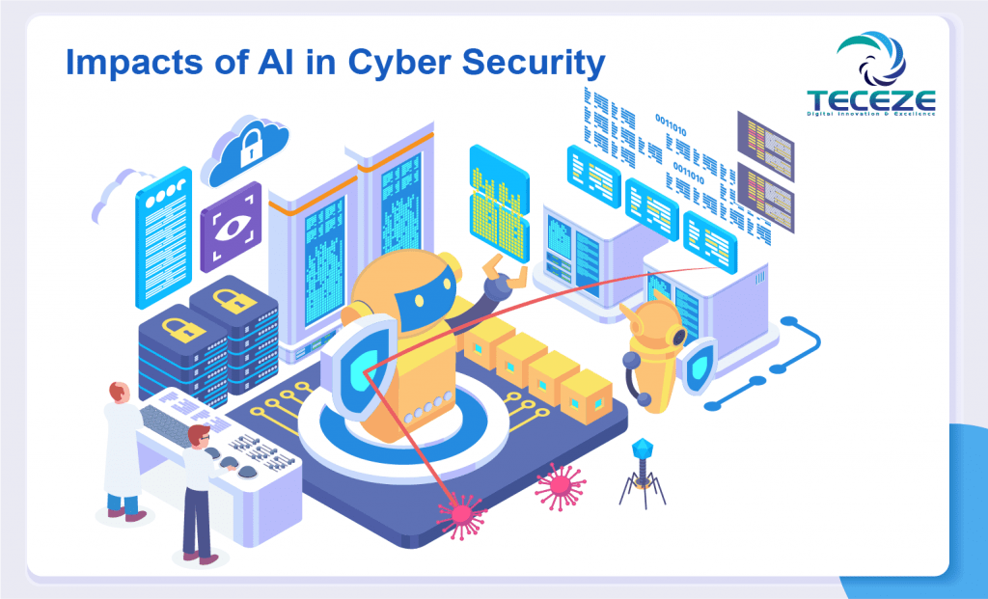

Abstract:

The purpose of this study is to explore the advantages and disadvantages of using machine learning and artificial intelligence in the context of cybersecurity by trying to understand to what extent these technologies could help to detect, analyze, and guard against cyber-threats and simultaneously identify possible risks or drawbacks linked to their use.
The object of the study is modern artificial intelligence and machine learning technologies, their use in cybersecurity systems and their impact on the long-term viability and effectiveness of information systems protection. The study of machine learning methods and algorithms used to detect anomalies and cyberattacks, assess their effectiveness, and identify potential shortcomings and dangers when applied in real-world scenarios are the main components of the research object.
Experts in cybersecurity, researchers, students, and everyone else with an interest in data security and the advancement of AI and machine learning technologies are the study's target audience. The study's findings will contribute to a better understanding of how to build and enhance information systems' security in response to present and emerging cyber threats.

Keywords:
Cybersecurity systems, Cybersecurity area, Technologies, Machine Learning (ML), Artificial Intelligence (AI), Cyber threats, Learning, Cybersecurity Defenses, Algorithms, Cyber-attack, Security, Methods,

Introduction:

Cybersecurity:

Cybersecurity is vital to maintaining the stability and security of society in today's digital world, where information technology is pervasive in every aspect of our lives. Cyber threats, which are growing in number and complexity, jeopardize private and public systems, data, and infrastructure. In such circumstances, effective tools are needed to detect, analyze, and counteract cyberattacks.

Cybersecurity is one of the many industries where artificial intelligence has long since moved from concept to real-world applications. New opportunities for automating the detection and response to cyber threats have emerged due to the ability of machine learning to find patterns and learn from them.

This research paper examines the prospects and threats of using machine learning and artificial intelligence in the context of cybersecurity. Both positive and negative consequences of using AI and ML to improve security efficiency will be taken into account. In addition, we will consider the prospects for future development and research priorities in this important area.

This article is relevant as cyber threats are constantly evolving. We hope that its conclusions will help broaden the community's understanding of the benefits and limitations of AI and machine learning in cybersecurity(nist. Helping organizations to better understand and improve their management of cybersecurity risk 2023).

Explaining the importance of using machine learning (ML) and artificial intelligence (AI) in cybersecurity:

In our increasingly digital environment, machine learning (ML) and artificial intelligence (AI) are essential for improving cybersecurity measures. Cybersecurity systems that use machine learning (ML) algorithms are able to quickly respond to changing threats by seeing trends and irregularities that more conventional security measures might miss. By enabling automated responses and decision-making processes, artificial intelligence (AI) enhances this strategy and increases the overall resilience of network defenses. In cybersecurity, machine learning and artificial intelligence work together to improve proactive threat detection and expedite incident response processes, which guarantees quick mitigation of possible breaches. In today's linked world, protecting sensitive data and strengthening digital infrastructures against sophisticated cyberattacks need the integration of cutting-edge technologies.

The size of the artificial intelligence market in cybersecurity:

In 2020, this figure was 10.75 billion, and by 2030 it will increase at a compound annual growth rate (CAGR) of 25% to 100.1 billion (decisionforesight. Artificial Intelligence (AI) In Cyber Security Market 2024) The need for artificial intelligence is increasing significantly, with cyber security being one area of interest. Because artificial intelligence can manage extremely complex scenarios that humans are unable to effectively resolve, it reduces the workload of cyber security engineers. The rising frequency of cyberattacks forces organizations to use high security technology like artificial intelligence. Small and medium-sized businesses lack robust and secure infrastructure, making them more susceptible to cyberattacks than larger businesses. The growing use of security products and services by enterprises is expected to fuel AI's predicted strong expansion in the cyber security space. In response to cyberattacks, 44% of international organizations are using artificial intelligence, per a Consumer Technology Association research survey.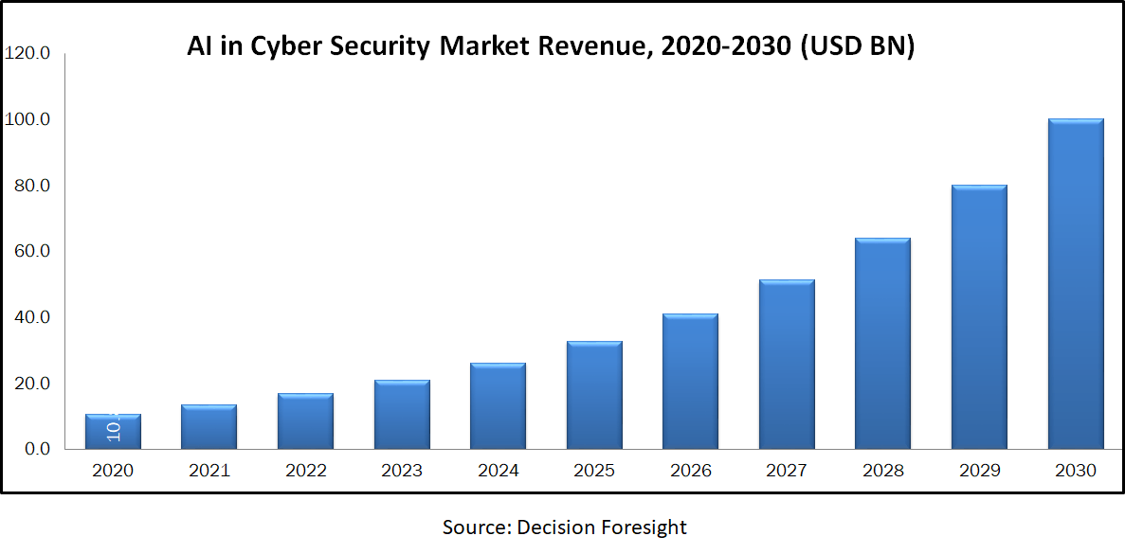

Market Dynamics and Factors:

Cyberattack risks increased in tandem with the growing use of connected devices and the Internet of Things. The research analysis states that there were 82,000 cyberattacks recorded in 2016 and 159,700 in 2017. Organizations are being obliged to embrace AI in cyber security due to the increasing amount of cybercrimes they are facing, which is driving market growth. One of the most frequent attacks on large businesses is identity and credit card theft, which, if unchecked, can result in enormous financial losses. Artificial Intelligence (AI) in the cyber security sector is primarily focused on cyber threats through threat prioritization, quicker response times, and early threat detection. When compared to human potential, AI systems offer more protection along with full recognition and response for cyber-attacks. However, the development of artificial intelligence in the cyber security industry is hampered by a lack of sufficient technical competence for its application. Tencent Holdings' research study estimates that 300,000 experts worldwide have the necessary experience with AI applications. In the upcoming years, it is projected that growing awareness of cyber dangers and SME demand for cloud-based security systems will drive the expansion of the AI in cyber security market. In the next two years, 88% of firms are predicted to increase their cyber security expenditures, while 10% of enterprises are anticipated to double their cyber security budgets.

Artificial Intelligence (AI) In Cyber Security Market Report Scope:

Report Attribute | Details
Analysis Period | 2020–2030
Base Year | 2021
Forecast Period | 2022-2030
Market Size Estimation | Billion (USD)
Growth Rate (CAGR%) | 25%
Market Segmentation: | By Offering (Hardware, Software, And Services), By Security (Endpoint, Network, Cloud, And Application), By Technology (Machine Learning, Context Awareness, And NLP (Neuro-Linguistic Programming)), By Security Solution (Identity & Access Management, Antivirus/Antimalware, Risk & Compliance Management, Encryption, Intrusion Detection/Prevention Systems, Data Loss Prevention, Unified Threat Management, And Others), By End-User
Geographical Segmentation | North America (U.S., Canada, Mexico) Europe (UK, Germany, Italy, France, Rest of Europe), Asia-Pacific (China, Japan, India, Australia, Rest of APAC), South America (Brazil, Argentina, Rest of SA), MEA (UAE, Saudi Arabia, South Africa)
Key Companies Profiled | IBM Corporation, Cisco System, Intel Corporation, Amazon Web Services, Inc., Cylance Inc., Acalvio Technologies, Inc., Nvidia Corporation, Xilinx, Inc., Micron Technology, Inc., Darktrace, Cylance Inc., Vectra AI, Inc, Securonix, Inc, Symantec Corporation, and SparkCognition Inc.

(This table and all its information are taken from the site www.decisionforesight.com)

Recognizing the landscape of cybersecurity:

Cyberthreats are intricate and dynamic by nature. According to estimates, cybercrime will have cost the economy just under $1 trillion in 2020, with a breach typically costing $4.27 million. (https://www.decisionforesight.com/reports/artificial-intelligence-ai-in-cyber-security-market)Numerous companies are putting a lot of effort into innovating while guarding against financial and reputational harm from cyberattacks. However, fraudsters never stop coming up with new ways to get past strong cybersecurity defenses.

Methods:

Overview of existing methods and technologies of machine learning and artificial intelligence in cybersecurity:

Artificial intelligence and machine learning offer strong instruments for identifying, evaluating, and thwarting cyberattacks. An outline of the primary techniques and technologies in these domains, together with an explanation of their use in cybersecurity, is provided below:

Task | Methods | Descriptions
Anomaly Detection | Unsupervised  learning | Detect anomalous patterns in network traffic or user behavior
Anomaly Detection | Clustering | Group data based on similarity to identify outliers
Anomaly Detection | Autoencoders | Training neural networks to recreate data to detect anomalies
Anomaly Detection | One-Class SVM | Recognize data points that do not belong to known classes as anomalous
Threat Detection | Classification (e.g., learning with a teacher) | Identification of specific types of cyber threats, such as viruses, Trojans, phishing attacks
Threat Detection | Neural networks and deep learning | Analyzing large amounts of data to identify complex and previously unknown threats
Incident Prediction | Data analytics and predictive algorithms | Predicting possible cyber incidents based on historical data and network behavior patterns
Incident Prediction | Prediction models | Identify potentially dangerous actions or anomalous activity that could lead to cyberattacks
Incident Response | Artificial intelligence | Automation of cyberattack detection and response processes
Incident Response | Automatic threat response systems | Quickly respond to incidents and provide recommendations for further action
Behavior Prediction | Analyze user and machine behavior | Identify vulnerabilities or potentially dangerous activity
Behavior Prediction | Analyze normal and abnormal behavior | Identify potential threats and prevent cybersecurity incidents

Different Types of Machine Learning Explained:

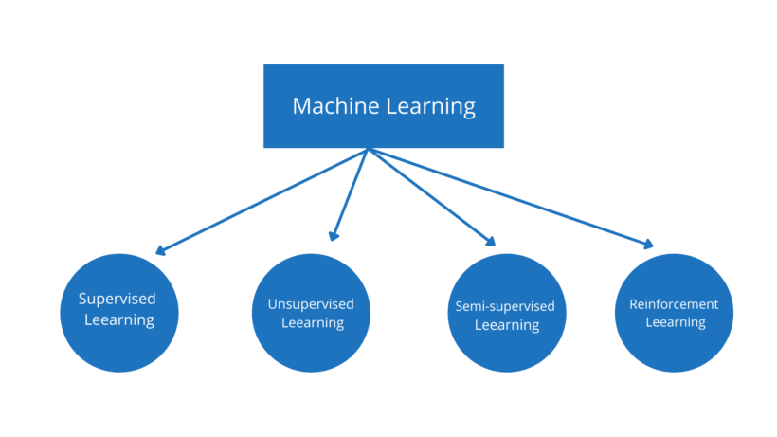

Supervised Learning:
In supervised learning, the machine is trained given a set of labeled data, or input data linked to the desired output. The machine then learns to predict the result using new input data. Supervised learning is widely used for tasks including object detection, regression, and classification.

As the name suggests, supervised learning involves having a supervisor in addition to a teacher. When we use well-labeled data to instruct or train a machine, this is known as supervised learning. This indicates that the right response has already been applied to some data. In order for the supervised learning algorithm to analyze the training data (set of training examples) and provide an accurate result from labeled data, the machine is then given a fresh set of examples (data).
For example, a labeled dataset of images of Elephant, Camel and Cow would have each image tagged with either “Elephant” , “Camel”or “Cow.” (IBM. What is supervised learning? 2023)

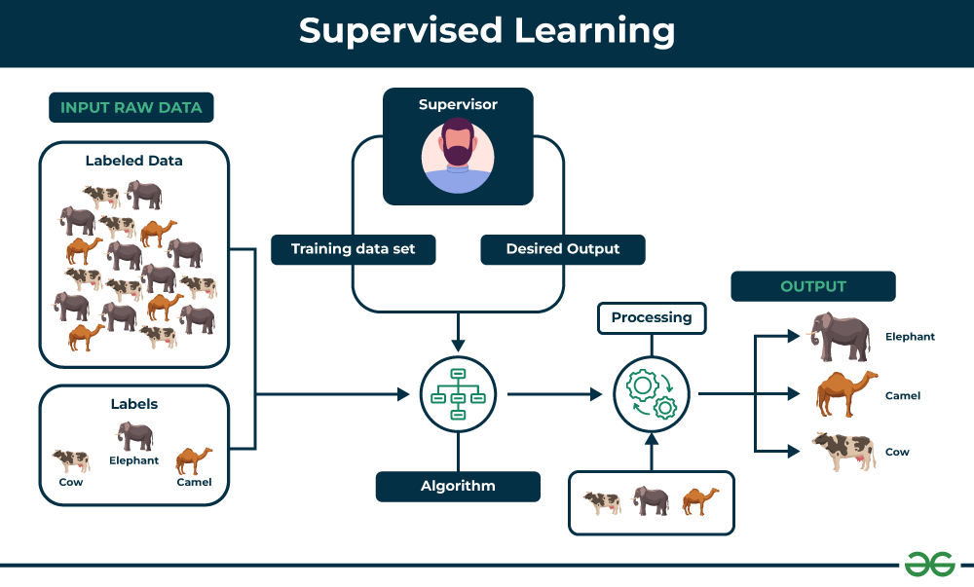

Unsupervised Learning:
Unsupervised learning, or unsupervised machine learning, is the process of analyzing and grouping unlabeled data sets using machine learning (ML) algorithms. These algorithms find hidden relationships or patterns in the data without requiring human assistance.

Unsupervised learning is the best option for exploratory data analysis, cross-selling tactics, consumer segmentation, and image identification because of its capacity to identify patterns in data (GeeksForGeeks. Supervised and Unsupervised learning 2024).
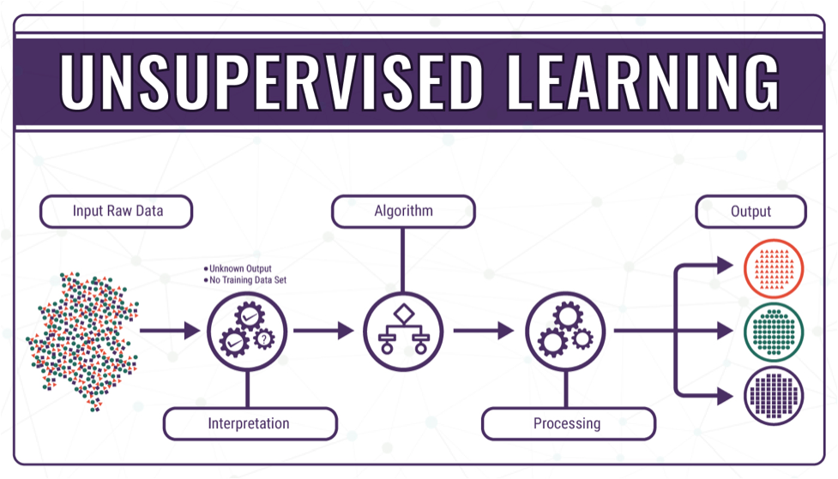

Information and image about Unsupervised Learning are taken from:
https://www.analyticssteps.com/

Semi-supervised Learning:
Artificial intelligence (AI) models are trained for classification and regression tasks utilizing both labeled and unlabeled data in a process known as semi-supervised learning. This type of machine learning integrates supervised and unsupervised learning.

Semi-supervised learning is characterized by a variety of techniques that incorporate unlabeled data into model training in addition to the labeled data necessary for conventional supervised learning, even though it is typically used for the same use cases for which one might otherwise use supervised learning methods.

When acquiring huge volumes of unlabeled data is reasonably easy, but obtaining a substantial amount of labeled data is prohibitively difficult or expensive, semi-supervised learning approaches become especially relevant. Neither fully supervised nor unsupervised learning techniques will be sufficient in these kinds of situations.
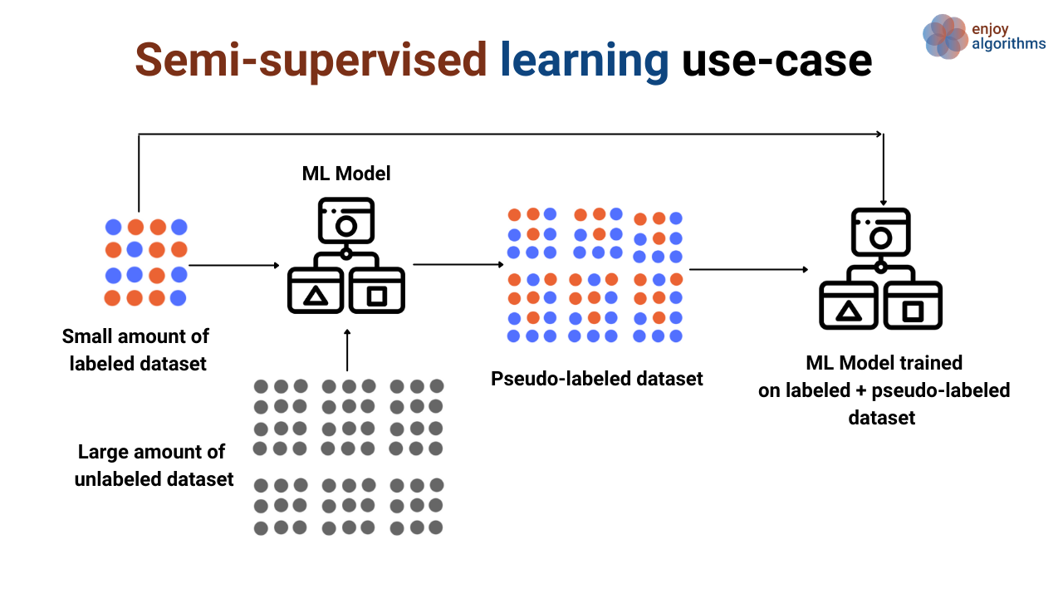
Information about Semi-supervised are taken from:
https://www.analyticssteps.com/
www.ibm.com
repozytorium.uwb.edu.pl

Reinforcement Learning:
One subfield of machine learning is reinforcement learning. It involves acting appropriately to maximize reward in a certain circumstance. It is utilized by a variety of software and devices to determine the optimal course of action or behavior for a given circumstance. Reinforcement learning and supervised learning are different in that in supervised learning, the model is trained with the correct answer already present in the training data, while in reinforcement learning, the model is trained without an answer and is guided by the reinforcement agent's decision on how to complete the task at hand. Without a training dataset, it will inevitably pick up knowledge from its experiences.

It involves figuring out how to behave in a situation to maximize rewards. Trial-and-error machine learning systems provide the data used in reinforcement learning (RL). Whether it is supervised or unsupervised machine learning, data is not an input source.

Algorithms that use reinforcement learning interpret results and determine the best course of action are used. The algorithm gets feedback after every action to help it decide if the decision it made was neutral, wrong, or correct. It's a useful method for automated systems that need to make numerous minor judgments on their own without human assistance.
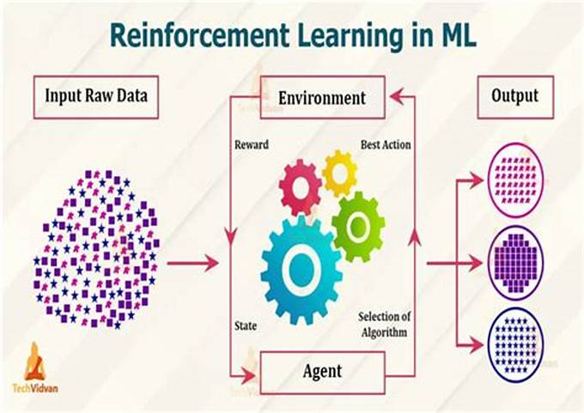

Comparison of machine learning methods:
Unsupervised vs. supervised vs. semi-supervised learning
Unsupervised learning and supervised learning are frequently discussed together. Unlike unsupervised learning algorithms, supervised learning algorithms use labeled data. From that data, it either predicts future outcomes or assigns data to specific categories based on the regression or classification problem that it is trying to solve. While supervised learning algorithms tend to be more accurate than unsupervised learning models, they require upfront human intervention to label the data appropriately. However, these labeled datasets allow supervised learning algorithms to avoid computational complexity as they don’t need a large training set to produce intended outcomes. Common regression and classification techniques are linear and logistic regression, naïve bayes, KNN algorithm, and random forest.

Semi-supervised learning occurs when only part of the given input data has been labeled. Unsupervised and semi-supervised learning can be more appealing alternatives as it can be time-consuming and costly to rely on domain expertise to label data appropriately for supervised learning.(Dipankar Dasgupta Machine learning in cybersecurity: a comprehensive survey 2020)

A comparison of machine learning methods was taken from:
academic.oup.com
doi.org
www.ibm.com

Methods of performance evaluation:

Methods of performance evaluation | Description
Detection Metrics | They are used to assess the accuracy of cyber threat detection.
Precision | Share of true positive results among all positive results.
Recall | The proportion of true positive results among all actual positive cases.
F1-score | Harmonious average of accuracy and sensitivity.
Other metrics | ROC curve, AUC (Area Under the Curve), False Positive Rate.
Remediation Metrics | Evaluate the effectiveness of measures taken to eliminate cyber threats and restore system security.
Recovery Time | The time it takes to restore a system after a cyberattack.
Recovery Costs | Financial and other costs associated with restoring the system after a cyberattack.
Response Time Metrics | Measures the time it takes to detect, respond to, and resolve a cyberattack.
Detection Time | The time it takes to detect a cyber attack.
Response Time | The time it takes to begin responding to a cyber attack.
Resolution Time | The time it takes to fully resolve a cyber attack.

Disadvantages of the methods: | Description: | Improvement strategies:
Data Incompleteness | Insufficient data to train models can lead to a lack of efficiency and accuracy. | Data Augmentation
Transferability | Models trained on one dataset may not be effective on other datasets or in real-world conditions. | Adversarial Training
Bias Limitations | The possibility of internal bias in models can lead to incorrect or unreliable results. | Ensemble Methods
Vulnerability to Attacks | The models themselves can be vulnerable to attacks such as brute-force attacks, data poisoning attacks, and others. | Regularization

Some information from these tables was taken from:
doi.org
academic.oup.com
omniscien.com

Results:

Main use:
The main use of ML and AI in real-life situations is to protect against cyber attacks.
All that constitutes a cyberattack is the ability to subvert a victim's computer's functionality for the victim's network or to remove security measures to obtain unauthorized digital access to the victim's computer. A cyberattack, as defined by the Dartmouth College Institute for Security Technology Research, is any attack on a computer system that jeopardizes the availability, confidentiality, or integrity of data within that system. Different viewpoints allow for the classification of cyberattacks into distinct groups.
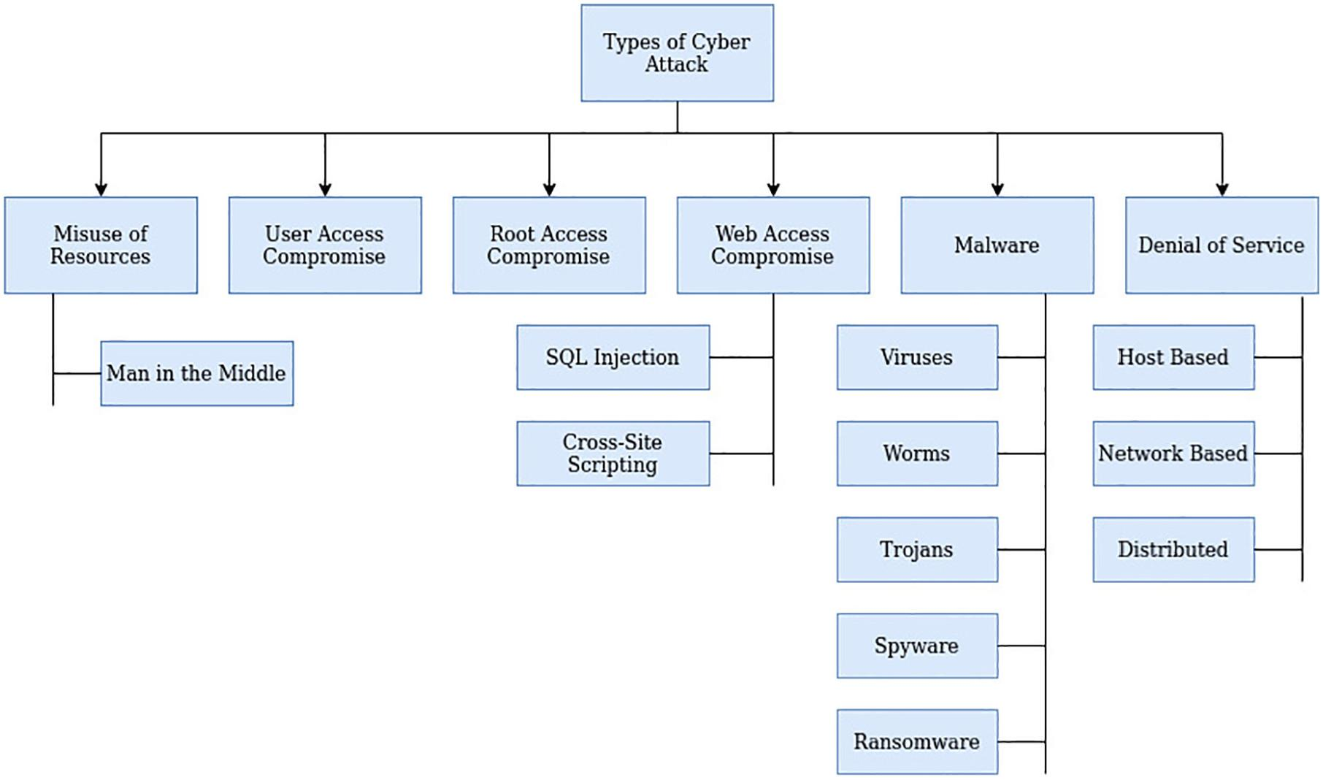

Presentation of application examples for AI and ML in actual cybersecurity scenarios:

At the moment, there are even companies being created that are entirely based on the topic of protection against cyberattacks. Some of them are entirely based on AI and ML, abandoning conventional methods of defense. Such as Samurai XDR; Blumira Automated Detection & Response; G2 Deals; Cynet 360 AutoXDR; Wiz

Let's take an example:

General Approaches:

Let's look at common approaches that are already in use and have real examples in the world.

Finding irregularities in network traffic

Network traffic can be analyzed using machine learning techniques like K-means or autoencoders to spot unusual patterns that might point to a cyberattack.
This can assist in identifying and stopping cyberattacks before they have an adverse effect.
As an illustration, in 2017 Netflix employed machine learning algorithms to identify and stop a DDoS attack that would have resulted in prolonged outages.

Information was taken from: academic.oup.com

Malware identification

To examine files and find malware, machine learning algorithms like Logistic Regression and Naive Bayes can be employed.
By doing this, you can lessen the chance that Trojan horses, viruses, and other malware can infiltrate systems and networks.
For instance, in 2018, 99% of the malware that made its way into the Google Play Store was found and blocked by Google using machine learning algorithms.(Andre Bonkarov. The role of artificial intelligence in cybersecurity: prediction and prevention of attacks 2024)

Some information was taken from: www.analyticsvidhya.com

Eliminating phishing and spam:

Email analysis tools like Naïve Bayes and Random Forest can be used to identify spam and phishing attempts through machine learning algorithms.
This can shield consumers against risks like money loss and identity theft.
As an illustration, Microsoft employed machine learning algorithms in 2019 to stop 99% of spam and phishing attempts that reached the inboxes of Outlook users.

Cyberattack prediction:

Data from past cyber incidents can be analyzed to estimate the chance of future cyber issues using machine learning algorithms like time series or RNNs.
This can assist firms in taking proactive measures to avert cyberattacks and better prepare for them.
As an illustration, IBM was able to forecast cyberattacks with 95% accuracy in 2020 by using machine learning algorithms.(Tanium. Machine Learning in Cybersecurity: A Primer for Beginners 2024)

Automating the reaction to cyberattacks:

AI systems can be utilized to automate processes like incident data analysis, cyberattack detection, and response.
This can speed up and increase the effectiveness of responding to cyber incidents.
As an illustration, Palo Alto Networks automated 90% of their cyber incident response job in 2021 using AI technology.

Remember that these are just a few instances of machine learning and artificial intelligence in practical cybersecurity scenarios. New techniques and instruments are being developed in this field, and research and development are always changing.

Best Companies, who use ML and AI in real-world situations:

Samurai XDR:

This models dangers and offers solutions using machine learning (ML) and artificial intelligence (AI) techniques. Machine learning is needed to identify patterns in behavior from vast volumes of data. Samurai ML uses models that examine behavior such as patterns, signatures, and rules in addition to anomaly detection to categorize threats like DGA and C2. Samurai can identify new invisible dangers that might employ evasive strategies to remain hidden for as long as feasible by using threat classification and anomaly detection.
Samurai then enhances its artificial intelligence with sophisticated correlation across several sources. When paired with our unique "BOOST" scoring engine, we are able to deliver true positive signals and high confidence alarms. Our strengths are particularly evident in the areas of malware, BOTNET, and lateral movement detection. For instance, Samurai identified and flagged this high-risk threat to the analyst as WannaCry in its early stages by detecting cryptomining using our exclusive DGA detection methodology and BOOST rating.(Samurai XDR website)

Wiz:
This company has extensive experience in detecting zero-day exploits. Thanks to their algorithm, they offer their users the best protection

This kind of hack can be challenging to identify. This is due to the fact that zero-day attacks take advantage of security vulnerabilities that have not been made public, which means that there is no defense against the exploit and it has not been patched.

But zero-day exploits can be found and mitigated with the aid of artificial intelligence. Artificial intelligence (AI) has the ability to automatically prohibit or flag questionable behavior after analyzing data for indications of an attack or malicious traffic or activity.

Algorithms like ML Wiz and AI are used to find undiscovered or concealed hazards. Unique events found by our artificial intelligence accounted for almost 70% of security situations to which our MDR service responded. For instance, our proprietary DGA (domain generation algorithm) logic was used by our analytical engine to find a zero-day cryptomining attack. This AI/ML logic recognized questionable DNS queries. Even though the infection had not yet been made publicly known, our consumers remained safe.(Wiz. Secure Everything You Build and Run in the Cloud 2020)

Cynet 360 Auto XDR:
Alert fatigue
When security personnel get an excessive number of notifications, this circumstance may arise. By automatically prioritizing and sorting warnings, artificial intelligence can help decrease alert fatigue by raising the threshold of threat intelligence that needs human response.
We are aware of the impact this has on scalability in the context of information overload, particularly in providing top-notch MDR services. A service provider cannot possibly examine the volume of data required for several thousand subscribing devices without artificial intelligence. We wouldn't be in business without artificial intelligence of the highest caliber! In certain situations, our artificial intelligence uses detection from security vendor technologies coupled with correlation and enrichment from our threat intelligence to detect and respond to high-risk alerts, some of which we identify as part of zero-day attacks. It all helps to make detections happen more quickly. Customers can now use what we have created out of necessity as self-service with Cynet AI XDR SaaS or as a managed service that includes MDR.(Cynet. Cynet All-in-One Cybersecurity Platform 2024)

These are just a few examples of how AI and ML are used in the best companies.

Some information was taken from: policyatmanchester.shorthandstories.com

I
Let's look not only at companies, but also at general approaches that are already in use and have real examples in the world

Discussion:

Risks associated with the use of ML and AI in cybersecurity:

Like any other technology, AI can be used for both good and bad purposes. Malicious actors can use the same AI tools that help humanity commit fraud, scams, and other cybercrimes.

Optimization of cyberattacks:
According to experts, attackers may scale attacks at a previously unheard-of speed and complexity by utilizing huge language models and generative AI. They might employ generative AI to come up with novel strategies to get around cloud complexity and leverage geopolitical tensions for more sophisticated attacks. They can also use generative AI to refine their phishing and ransomware assault strategies.

Malware that operates automatically:

An AI such as ChatGPT excels at performing precise mathematical calculations. Professor Oded Netzer of Columbia Business School claims that ChatGPT is already able to "write code quite well."

According to experts, it could either benefit or replace more computer programmers, coders, and software developers in the near future.

Even though ChatGPT and similar programs have various safeguards in place to stop users from writing dangerous code, skilled programmers can still find ways around these to produce malware. One researcher, for instance, was able to identify a vulnerability and develop a sophisticated data-theft executable that is almost undetected. The executable was sufficiently sophisticated that it could have been produced by a threat actor with governmental sponsorship.

This might just be the very beginning. With the help of upcoming AI-powered technologies, developers with minimal programming experience would be able to produce automated malware, such as a sophisticated dangerous bot. What exactly are malicious bots then? With little to no human participation, a hostile bot can attack systems, steal data, and infect networks.

Some information was taken from: academic.oup.com

Physical security:

The application of artificial intelligence in systems like self-driving cars, industrial and construction machinery, and medical systems can raise the risk of that technology compromising physical safety. For instance, the physical safety of the occupants of a real self-driving automobile powered by artificial intelligence may be at danger if there is a cyber security incident. Similar to this, an attacker may modify the dataset for maintenance tools at a construction site to create dangerous circumstances.

In ways that George Orwell could not have imagined, an AI system created for marketing, advertising, profiling, or spying might potentially pose a threat to privacy. AI-profiling technology is already assisting governments in certain nations in violating user privacy.
Information from: doi.org

Stealing models of artificial intelligence

Network attacks, social engineering strategies, and vulnerability exploitation by threat actors including state-sponsored agents, insider threats like corporate spies, and regular computer hackers can all pose a risk to the theft of AI models. Stolen models increase the risks that artificial intelligence poses to society since they may be altered and manipulated to help attackers carry out various destructive tasks.

Data poisoning and manipulation:

Even though AI is an extremely useful technology, data manipulation can still affect it. AI is after all reliant on its training set. An artificial intelligence technology may yield unanticipated or even harmful results if the data is tampered with or contaminated.

Theoretically, a malicious dataset might be injected into a training dataset by an attacker to alter the model's output. Additionally, a more covert kind of manipulation known as bias injection could be started by an adversary. Industries include healthcare, automobiles, and transportation are particularly vulnerable to these kinds of attacks.

The future of AI in cybersecurity:

Artificial intelligence has a bright future as new technologies affect labor in many areas. More resilient technology will soon be available in the cybersecurity space to tackle the problems of an environment that is predicted to change more quickly than in the past.

The coming of a new age in threat identification and response may alter how companies react to online attacks. Analyst workloads could be greatly reduced by artificial intelligence, increasing efficiency and allowing analysts to concentrate on other important initiatives like strategic planning. To put it briefly, AI can assist in the transition from reactive to proactive, giving them the momentum they need to remain ahead of the numerous cyberthreats.

Cybercriminals can leverage AI's power to further their own objectives, and as AI and other cybersecurity technologies advance, so do cyber dangers. As AI systems are more incorporated into cybersecurity, privacy and ethics will become more important, making AI both a challenge and an opportunity.

Nevertheless, the benefits much exceed the drawbacks. Decoy networks and other deception technologies can be used by AI, which can employ data analysis and danger prediction to direct cybercriminals away from the real deal. Future trends to keep an eye on include enhanced threat identification, real-time reaction, more precise behavioral analysis, and adaptable capabilities.

Striking a balance between the exciting possibilities of artificial intelligence and its ethical considerations will become more important than ever(Giovanni Apruzzese The Role of Machine Learning in Cybersecurity 2023)

Conclusions:

The possibilities and dangers of applying AI and ML to cybersecurity have been discussed in this article. Following a thorough examination, we are able to make a number of important conclusions and suggestions for additional study and real-world implementation.
Main conclusions

Benefits of using ML and AI:

Improved threat detection accuracy: Thanks to their ability to analyze large amounts of data and detect anomalies, AI and ML systems significantly improve the accuracy of threat detection and reduce the number of false positives.

Process automation: The introduction of AI allows you to automate many cybersecurity processes, such as sorting and prioritizing alerts, which reduces the workload of analysts and increases the speed of incident response.

Identification of new and unknown threats: ML algorithms can effectively detect zero-day exploits and other emerging threats by analyzing system and user behavior in real time.

Threat prediction: Machine learning models can predict possible threats based on historical data and behavioral patterns, which helps with preventive measures.

Risks and disadvantages of using ML and AI:

Algorithm failures: There is a risk of false classifications and missed threats, especially if the models were trained on inaccurate or incomplete data.

Misuse of technology: Attackers can use the same technologies to create more complex and sophisticated attacks, making it harder for defenders to defend themselves.
(www.merriam-webster.com)

Ethical and legal issues: Automated AI decision-making can lead to ethical dilemmas and legal issues, including data privacy violations.

Recommendations for further research and practical applications

Improving algorithms: ML and AI algorithms need to be continuously improved to increase their accuracy and reliability. This includes regularly updating training data and adapting models to new threats.

Developing ethical and legal frameworks: It is important to create and implement ethical and legal frameworks to regulate the use of AI in cybersecurity. This will help minimize the risks of abuse and privacy violations.

Professional development of specialists: Continuous education and training should be provided to cybersecurity professionals so that they can effectively use AI tools while maintaining their manual analysis and critical thinking skills.

Integration with other security systems: AI and ML should be integrated with other cybersecurity systems to create a multi-layered defense that includes both automated and manual methods of detecting and responding to threats.

Conclusion.
The use of machine learning and artificial intelligence in cybersecurity offers significant benefits, such as improved threat detection accuracy, process automation, and the ability to predict attacks. However, these technologies also have their own risks, including algorithmic failures, potential for abuse, and ethical concerns. To maximize the effect of AI in cybersecurity, it is necessary to constantly improve algorithms, develop ethical and legal frameworks, improve the skills of specialists, and ensure integration with other security systems.

References:
vrogue.co. ARTIFICIAL INTELLIGENCE AI IN CYBER SECURITY MARKET 2021
https://www.vrogue.co/post/artificial-intelligence-ai-in-cyber-security-market

decisionforesight. Artificial Intelligence (AI) In Cyber Security Market 2024
https://www.decisionforesight.com/reports/artificial-intelligence-ai-in-cyber-security-market

enisa. Foresight Cybersecurity Threats For 2030 - Update 2024: Extended report 2024
https://www.enisa.europa.eu/

nist. Helping organizations to better understand and improve their management of cybersecurity risk 2023
https://www.nist.gov/cyberframework

Bashir Alam. Different Types of Machine Learning Explained [Beginners Guide] 2019
https://www.golinuxcloud.com/types-of-machine-learning/

IBM. What is supervised learning? 2023
https://www.ibm.com/topics/supervised-learning

GeeksForGeeks. Supervised and Unsupervised learning 2024
https://www.geeksforgeeks.org/supervised-unsupervised-learning/

IBM. What is unsupervised learning? 2023
https://www.ibm.com/topics/unsupervised-learning

GeeksForGeeks. Reinforcement learning 2023
https://www.geeksforgeeks.org/what-is-reinforcement-learning/

GeeksForGeeks.Types of Machine Learning 2023
https://www.geeksforgeeks.org/types-of-machine-learning/

Prerna Aditi. Unsupervised Learning 2018
https://aditi22prerna.medium.com/unsupervised-learning-a24caf362e79

Dave Bergmann. What is semi-supervised learning? 2023
https://www.ibm.com/topics/semi-supervised-learning

EnjoyAlgorithms. Types of Machine Learning 2020
https://www.enjoyalgorithms.com/blog/classification-of-machine-learning-models/

Fiverr Producer. Machine Learning and Reinforcement learning 2023
https://www.fiverr.com/ayubodhiambo/do-machine-learning-deep-learning-and-reinforcement-learning-tasks-in-python

ACC. The role of artificial intelligence in cybersecurity: prediction and prevention of attacks 2022
https://chamber.ua/ua/news/rol-shtuchnoho-intelektu-v-kiberbezpetsi-peredbachennia-ta-zapobihannia-atakam/

Andre Bonkarov. The role of artificial intelligence in cybersecurity: prediction and prevention of attacks 2024
https://www.bdo.ua/uk-ua/insights-2/information-materials/2024/the-role-of-ai-in-cybersecurity-anticipating-and-preventing-attacks

Giovanni Apruzzese The Role of Machine Learning in Cybersecurity 2023
https://dl.acm.org/doi/10.1145/3545574#d1e1166

Dipankar Dasgupta Machine learning in cybersecurity: a comprehensive survey 2020
https://journals.sagepub.com/doi/full/10.1177/1548512920951275

Wiz. Secure Everything You Build and Run in the Cloud 2020
https://www.wiz.io/

Cynet. Cynet All-in-One Cybersecurity Platform 2024
https://www.cynet.com/platform/

NTT Security Holdings. AI in cybersecurity: real-world examples of how AI can be used 2022
https://www.samurai.security.ntt/blog/how-can-ai-be-used-in-cyber-security

Malwarebytes. AI in Cyber Security: Risks of AI 2024
https://www.malwarebytes.com/cybersecurity/basics/risks-of-ai-in-cyber-security#:~:text=Let%E2%80%99s%20explore%20some%20risks%20of%20AI%20in%20cyber,at%20accurately%20crunching%20numbers.%203%203%3A%20Physical%20safety

Darktrace. State of AI Cyber Security 2024
https://darktrace.com/resources/state-of-ai-cyber-security-2024?s_kwcid=AL!14369!3!!p!!o!!ml%20cyber&utm_source=bing&utm_medium=paidsearch&utm_campaign=us-fy24cyberai-bundle-demand&utm_id=combined&gclsrc=3p.ds&&gclid=3cfb024638e31be19a9a640589485905&gclsrc=3p.ds&msclkid=3cfb024638e31be19a9a640589485905&utm_term=ml%20cyber&utm_content=Machine-Learning_PM#white-paper
Tanium. Machine Learning in Cybersecurity: A Primer for Beginners 2024
https://www.tanium.com/blog/machine-learning-in-cybersecurity/

