DEVELOPMENT OF THE EXPRESS METHOD FOR CONTROLLING
URANIUM COMOUNDS IN NATURAL WATERS

Kulinkovich A.V.,Sakova N.V.,
The Bonch-Bruevich Saint- Petersburg State
University of Telecommunications,

Tumanov A.Yu.,
The Peter the Great St. Petersburg
Politechnic University

Abstract
The urgency of developing an express method for controlling uranium compounds in natural waters is established. Methods for determining uranium in environmental objects are considered and the inability to use them for express controlling of natural waters directly at the site of an accident is emphasized. The analysis of literature sources indicating the presence of associated states in water has been carried out. It is pointed out that in the presence of variable valence metals in aqueous solutions, conditions arise for phase reconstruction in associated states of water, where there is a local change in the dielectric and chemical parameters accompanied by the generation of reactive oxygen species. At the same time, the analysis of known methods of photochemical, radiation-chemical and catalytic generation of oxygen radical forms shows their endothermic character, and the reaction of direct oxidation of water is extremely difficult because of the high energy barrier and high activation energy of this reaction. The task for carrying out a research to develop an express method for controlling uranyls in water is outlined.

Keywords:
Express method for controlling uranium, associated states of water, reactive oxygen species, variable valence metals.

The current requirements for the environmental and radiation safety of the facilities, that are a part of the nuclear fuel cycle, make it necessary to pay increased attention to controlling migration and leaks of highly toxic uranium compounds. In case of emergency situations at such facilities, there is a high probability of contamination of the environment by radioactive elements. Taking into account high migration capacity of uranium and its compounds, which are highly toxic, the possibility of their accumulation in soils, bottom and silt sediments, it is necessary to create express methods to control the propagation of these compounds in natural waters.
In recent years, a sufficient number of highly sensitive devices have been designed that allow monitoring of α-active radionuclides in environmental objects. However, the existing instrumentation does not allow quantitative determination of uranium at the contamination site, and existing methods of analysis are complex and time-consuming. In addition, during the transport period the analyzed sample can undergo changes in the chemical composition due to adsorption and redox processes.
As is known, peroxide compounds can be formed in water under the influence of ionizing radiations and the amount of peroxide generated is proportional to the content of radionuclides. To determine quantity of oxygen compounds formed in aqueous solutions, a highly sensitive analyzer of liquid samples "LIK" type [1] was created, which allows quantifying these compounds at the site of analysis with sufficient sensitivity and specificity for a time interval of not more than 5 minutes.
A number of literature sources studying water properties have shown that water is a two-phase system consisting of volumetric and associated (bound) water. At the moment of transition from one phase to another, the system becomes unstable and oxygen active forms are generated in the water. By their concentration, it is possible to determine the presence of variable valence metal compounds, including uranium, in the investigated solutions.
The results of researches indicating the processes of cooperative behavior, caused by special electrophysical properties of coupled structures of colloids bound water are presented in the book [2].
The presence of cooperative processes in aqueous solutions indicates that, depending on the environmental conditions, the phase state of the water system changes, and accordingly the process of self-induction of peroxide forms that is not caused by direct action of ionizing radiation or by the presence of high-energy reactions of direct reduction of oxygen from water occurs. Therefore, when searching for a method for controlling uranyls in natural waters, the existence of cooperative behavior in water systems should be taken into account.
To determine low concentrations of uranium in natural waters the extraction-luminescence and photometric methods are most often used [3-6].
The extraction-luminescent method for determining uranium salts in natural waters is based on the initial extraction of uranium by diisoamyl ester of methylphosphonic acid in hydrogenated kerosene and subsequent determination of the extract by the luminescence method. The photometric method is based on the separation and concentration of uranium on the precipitate of crystal-violet rhodanide, followed by its interaction with arsenazo (III).
These methods perform an express determination of small concentrations of uranium compounds in solutions after their purification from impurity compounds. A significant drawback of these methods is that they cannot be used in the field due to hardware and methodological complexity.
To determine the microquantities of uranium (up to 10^{–16} g / l), various types of activation analysis have been widely used in recent years, and especially the method of nuclear tracks [7].
The authors of the study [8] describe a method for analyzing natural waters for the content of uranium compounds using an activation method. The water sample to be tested is evaporated under an infrared lamp, then placed in quartz ampoules and irradiated with a neutron flux of about 3 · 10¹³ neutrons / (cm² · s). After irradiation, the sample is subjected to chemical treatment to determine (n, γ) radiation products, which are measured and compared with the standard. The minimum threshold of determination of uranium by this method is about 2 · 10^{–9} g / l. This method allows to determine uranium and thorium in the presence of ²³⁹Np and ²³³Pa. However, chemical sample preparation for determining protactinium and neptunium is rather complex, as noted in the study [9], in which the method of direct counting of fission tracks in an optical microscope is recommended for the identification of uranium.
Analysis of the current methods for determining uranium compounds in natural waters shows that they are quite complex and do not allow express controlling of radioactive contamination in a short time. However, in most cases, especially in case of accidents and technological emissions, there is a need to determine “in situ” the state of contamination of environmental objects with uranyls for the purpose of prompt decision-making on localization, elimination of consequences, and prevention of further spread of radionuclides to significant areas. To solve these problems, it is expedient to use highly sensitive, express methods for determining uranium compounds in the environment, allowing for environmental monitoring directly at the site of the accident.
It is known from the literature [10,11] that when water and aqueous solutions are strongly influenced by ionizing radiation , hydrogen peroxide is formed. The radio-chemical process of peroxide compounds generation competes with the process of catalytic reactive oxygen species (ROS) generation with variable valence metal ions, so their competing capabilities need to be studied when developing a method for express controlling of uranium compounds in natural waters by self-induction of peroxide compounds.
As is known, uranium belongs to variable valence metals. In aqueous solutions, the most stable forms of this element are six- and four-valence ions. The tetravalent form of uranium exists in the reduced form, and in the oxidized form it is in the hexavalent form. In natural waters with a neutral or slightly acid medium (pH = 6.5 ... 7.0) saturated with oxygen, uranium is in the form of a uranyl ion (UO₂²⁺). The latter is able to form complex compounds with anions of various acids, which are highly soluble in water. Acidification of water to pH = 5.0 ... 6.5 leads to the destruction of carbonate complexes and the formation of colloids of uranyl hydroxide. Increased water hardness promotes the formation of insoluble uranyl salts of the type of urantholite, bailite, etc.
Uranyl salts can react with organic compounds (for example, with humic acids) found in natural waters forming uranium-organic compounds. Consequently, the predominance of a particular form of uranium in an aqueous medium will be determined mainly by its hydrochemical composition, the amount and nature of the solid suspension, the redox potential and the acidity index of the medium [12].
The most stable water-soluble uranyl compounds in water exist at pH = 2.0 ... 4.2. Under these conditions, uranium salts are not subjected to hydrolysis and have the lowest sorption activity with respect to suspended impurity particles. An analysis of the physico-chemical behavior of uranium in aqueous media shows that it is methodically more efficient to conduct the express controlling of natural waters for the presence of uranyl salts in strongly acidic media (pH = 2.0 ... 4.2), in which the main amount of uranium is in dissolved unhydrolyzed state.
In recent years, the literature has shown that water has a heterogeneous composition, in which its associated (bound) state [2], formed by special two-dimensional structures of allotropic forms of ice, acts as a solid phase.
The data on the association of water molecules in water-salt and aqueous-organic solutions are given in the article [13]. The research has established that in salt solutions ions of a dissolved substance are on the surface of bound states of water. This suggests that the ion transitions of uranium in an aqueous medium are caused by a phase transformation in the associated states of water. At the same time within the phase transition there is a local change in the dielectric and electrochemical parameters that can affect the solvent-associated water, causing the decay of the bound state. These processes should be accompanied by the generation of ROS in the solution and lead to an increase in the content of the perhydroxyl ionic radical НО₂^{–(*)}.
According to the data of the study [14], in the spectrum with the fine structure of UO₂²⁺ (Fig.1), in addition to the main absorption band (maximum ~ 410 nm), there are a number of extrema associated with the transition of uranium from one ionic form to another, that is caused by electronic transitions between individual energy levels. The potentials of uranium transitions of one ionic form to another in acidic media are shown in Fig. 2. In our opinion, a change in the energy parameters of the medium at the points of phase transitions of uranium ions leads to the transformation of one ionic form into another due to restructuring in the water associates; as a result of this process, reactive oxygen species are generated in the aqueous medium. In aqueous solutions of uranium, there should be a sharp increase in the concentration of free radicals and ion radicals associated with second-order phase transitions in the solutions under study (by rearrangement of surface stabilizing layers of water associates).
Consequently, the formation of the phase states of uranium in water is affected by the change in the hydrogen index and the redox potential of the medium, the fluctuation of the ionic strength in the aqueous medium. At the points of the phase transition, as follows from the fine structure of the UO₂²⁺ spectrum, a sharp (nonlinear) change in the physicochemical parameters of the aqueous medium occurs, which leads to a change in the content of the reactive oxygen species in the water.
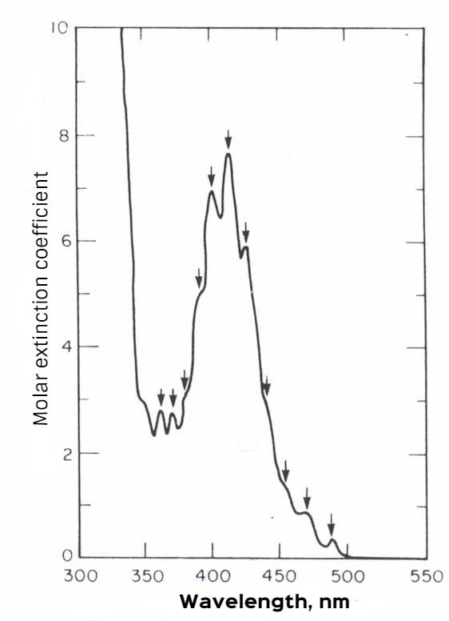

Fig. 1. Fine structure of the optical absorption spectrum
uranyl-ions UO₂²⁺ in 1 M HClO4
-0,1
+0,17
+0,38
-4,7
-0,52
+0,27
UO₂²⁺

UO₂⁺
U⁴⁺
U³⁺
(U²⁺)
U
-1,66
-1,38

Fig. 2. Standard recovery potentials of uranium ions
in acid (pH = 0) aqueous solutions (values in volts relative to
standard hydrogen electrode)

It is known [15-17] that in water solutions under the influence of various factors, the processes of generation of ROS occur with their subsequent disproportionation into hydrogen peroxide. At the same time, in aqueous medium, the generation of oxygen forms of radicals is carried out via three main processes: photochemical, radiation-chemical and catalytic.
The photochemical process of generation of free radicals in water occurs when the solar radiation is absorbed by the aqueous medium, that leads to the excitation of water molecules, which then initiate secondary reactions of formation of ion radicals (О₂^{−(*)}, НО₂^{−(*)}), free radicals (Н*, ОН*, О*) and molecules (Н₂, Н₂О₂). The speed and nature of photochemical reactions depends on the wavelength of the radiation.
The radiation-chemical process for generation of hydrogen peroxide is associated with the transfer of energy of ionizing radiation to water molecules. As well as in photochemical processes, as a result of radiolysis of water due to the excitation of a molecule in the medium, radicals are formed, leading to the formation of ion pairs of electrons and ions, which then generate new free radicals and atoms. Radiochemical processes are characterized by the total amount of absorbed energy. The initial processes occurring under the action of ionizing radiation lead to the simultaneous formation of charged and uncharged particles (free radicals and ion radicals).
The formation of hydrogen peroxide via catalytic process is carried out with the participation of variable valence metal ions. An example of catalytic processes in an aqueous medium can be the initiation of superoxide ion radicals О₂^{-(*)} when copper ions are present in it in the presence of organic ligands [15]. At this, water molecules, undergoing disproportionation on variable valence metal ions, lead to the formation of oxygen molecules and hydrogen peroxide.
Analysis of the known methods of formation of oxygen radical forms in aqueous systems shows that they have an endothermic character, and the reaction of direct oxidation of water with dissolved oxygen is extremely difficult due to the high energy barrier (Q = -47 kcal/mol) and high activation energy of this reaction (Е_{а} > 50 kcal/mol) [18].
A number of works have been published considering possible generation in water of a superoxide ion radical (О₂^{*-}) and a hydroxyl radical (ОН*), which are formed not according to previously known hydrogen peroxide generation processes. So, in 1989 the authors of the studies [19,20] put forward a hypothesis about the possibility of dissociation of water in the liquid phase under the influence of mechanical energy with a low specific density. In this case, mechanical deformation of the water structure (shear, stretching) leads to its subsequent reactions between the formed radicals. It can be assumed that the dissociation of water during mechanical influence is a consequence of the collective effects of water associates restructuring, just as it occurs in the mechanochemistry of polymers and their solutions.
The same authors [21] carried out researches of the influence of low-intensity acoustic fields and microwave radiation on water. As a result of the research it was shown that the formation of hydrogen peroxide and reactive oxygen species under the influence of sound vibrations on water occurs in a before-cavitation mode. When water was irradiated with an electromagnetic field at 2.5 GHz and 10 GHz frequencies, bursts of H₂O₂ concentration were determineed, that indicates the dissociation of water under the influence of an electromagnetic wave with the formation of Н* and ОН* radicals due to the absorption of microwave radiation by the aqueous medium.
It was shown in the study [22] that the formation of H₂O₂ also occurs efficiently in bidistilled water saturated with air when the medium acidity changes. Thus, an increase in pH leads to an increase in the concentration of hydrogen peroxide in water, that, according to the authors, is due to the formation of H₂O₂ molecules not from dissolved oxygen molecules, but from hydroxyl ions through hydroxyl radicals, the dismutation of which leads to the formation of H₂O₂.
Schematically, the mechanism of hydrogen peroxide formation under the influence of heat is presented in Fig. 3. The authors also report that in the spontaneous dismutation reaction О₂^{−(*)} oxygen is formed in the electronically excited singlet state, which contributes to the development of the chain process of hydrogen peroxide formation by the addition of a hydrated electron to the Н₂О₂ molecule with the formation of a superoxide anion radical.

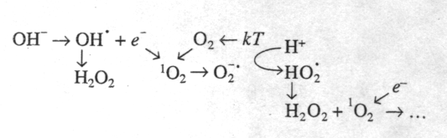

Fig. 3. Scheme of the reaction set occurring in
the formation of Н₂О₂ under the influence of heat

The kinetics of the formation of Н₂О₂ in pure water has a quasi- oscillatory character, which is related to the decomposition mechanism of Н₂О₂ under certain conditions:
Н₂О₂ + е⁻_{aq} → ОН* + ОН⁻,
Н₂О₂ + ОН* → НО₂* + Н₂О,
Н₂О₂ + НО₂* → ОН* + Н₂О + О₂.
Thus, it was shown experimentally in the study [20] that all the main types of reactive oxygen species : ¹О₂, О₂^{−(*)}, НО₂*, Н₂О₂ and ОН* are formed in the air saturated water under the influence of heat. In the opinion of the authors, this suggests that in radiolysis of water the same forms of radical formations can be formed as are formed as a result of heat exposure. At the same time, as a result of ionizing radiation influence in an aqueous medium, the formation of a hydrated electron, atomic and molecular hydrogen is possible by the reactions:
е⁻_{aq} + Н⁺ → Н,
2Н → Н₂.
However, this approach is problematic, since it does not answer the question: from where in the one-act interaction of radiation with single molecules there are high values of the quantum-trapped energy that thermal energy does not possess. On the other hand, there is an alternative approach to investigating the mechanism of hydrogen peroxide generation, associated with the cooperative behavior of a set of ions having conjugated bonds with associated water structures and characteristic unipolar charges [2].
The presence of structure formation in aqueous systems is confirmed also in the work [13], in which the electrical conductivity of dilute solutions of inorganic compounds (NaCl and KCl) and organic ones containing amino acids was studied. The authors have shown that the spectrum of the water itself lies at the basis of the formation of the frequency spectrum of the compound aqueous solution. In this case, depending on the compound introduced into it, there are oscillation peaks in different frequency regions (low concentrations). An increase in the substance content in the sample causes both an increase in the main oscillation peaks and the appearance of new peaks, which is due to the presence of impurities in the main compound. At the same time, the introduction of another substance into the compound aqueous solution leads to a shift of the oscillation peaks of the main compound into a higher frequency region. That is, the appearance of a new compound in water, as it were, "occupies its own niche in solution", displacing (or compressing) the compounds existing in it, creating narrower frequency regions for them (Fig. 4).

.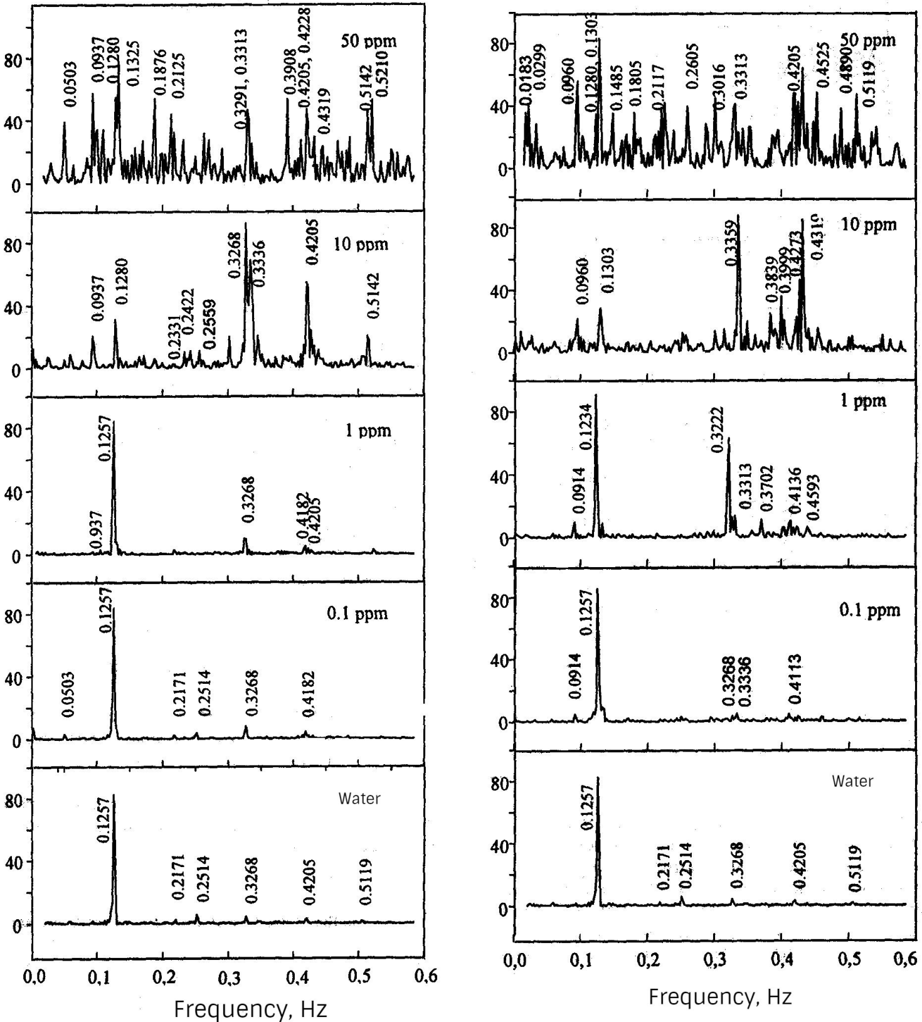
Intensity of oscillations of electrical conductivity, rel. units

Fig. 4. Frequency spectra of electrical conductivity oscillations of
dilute NaCl and KCl solutions

In the studies [2.23], the authors have proposed a cluster model of water based on nematically bound water states (ion-crystal associates). According to this theory, between the nematic part and the surface layer of the associate, there is a structured liquid with flat domains of cubic or tetragonal ice, stabilized by the structural pressure of the adsorbed liquid.
According to the study [2], associates belonging to different phases of the crystalline state of water differ in their dielectric characteristics, and their van der Waals interaction appears as an attraction for spectrally similar molecules of a substance introduced into a liquid. In turn, the presence of attractive forces for protonoacceptor substances in a positive polarity associate and proton-donor properties - in a negative polarity associate creates conditions for directed diffusion of substances in accordance with the sign of their long-range interaction.
Proceeding from this, the permitted diffusion directions of substances in the polar liquid are the directions to the central part of the nematic and along the boundaries of the associate's nematic. By means of long-range forces in the system, a non-uniform distribution of the substances dissolved in the liquid is constantly established. In this case, the structured layers containing the crystalline phase behave as adsorption centers, creating an excessive saturation of the relatively free liquid by the dissolving substances.
Introduction to structured layers of substances of a different nature, compared with water molecules, is accompanied by changes in the potentials of intermolecular interaction, which causes changes in the parameters of long-range interaction, and, consequently, thermodynamic and structural equilibrium. So, with the introduction of strong electrolytes, the structurization greatly decreases, and when surfactants are added to the water, on the contrary, increases. The appearance of uranium compounds in water leads, as well as when adding surface active agents (surfactants), to an increase in its structurability. At the same time, their presence in the aqueous medium, as well as variable valence metals, causes a change in the physicochemical characteristics of the associate media, and in its turn facilitates their reorganization and enhancement of the process of generation of reactive oxygen species in water.
Thus, the associated states in water and aqueous solutions have special electrophysical properties. In a number of studies [2.24] it is assumed that the processes of charge exchange of ions both in the associate itself and among associates are realized by means of electron tunneling, which is of a cooperative nature. This means that the exchange of electrons between macroscopic structures of associates can be regarded as a transfer of magnetic energy.
Thereby, the analysis of possible mechanisms of generation of reactive oxygen species in water shows that the existing classical concepts based on direct chemical formations (photochemical, radiation-chemical and catalytic processes for generating radicals) do not take into account the possibility of radical forms generation due to phase transformation of associated water. However, as follows from the stated above, the formation of reactive oxygen species under the influence of changing external physical fields in a number of cases leads to an increase in the degree of their generation in the aqueous medium. In this case, the concentration of reactive oxygen species arising as a result of phase rearrangement of associates exceeds many times the values ​​of the content of radical forms obtained by classical chemical mechanisms of generation. Therefore, in order to evaluate the influence of structural and physical instabilities of medium associates on self-induction of reactive oxygen species, it is necessary to study the mechanism of this process in order to identify the most informative parameters indicating the presence of uranium compounds in the medium.
Thus, water is a complex system of "associated" and "unassociated" ("free") water, while the associated state of water can have properties of Type II superconductors. In water by exchange interactions of Cooper pairs and subsequent chemical transformations of normal electrons, the energy of external low-intensity electromagnetic fields is converted into the energy of reactive oxygen species and vice versa. The introduction of various compounds into aqueous solutions can lead either to catalysis or to inhibition of the processes of reactive oxygen species generation in water, which is associated with structural rearrangements of associates. The change in the concentration of ROS in water at the points of phase transformations indicates the presence in water of impurities in the form of metals of variable valence, including uranium.
Statement of the research tasks:
1. The establishment of dependence of ROS generation, first of all on stable perhydroxyl ion radicals НО₂^{−(*)}, in the vicinity of the points of phase transition of ionic forms of variable valence metals in weakly mineralized aqueous solutions when the physical and chemical parameters of the system change.
2. The investigation of the processes of ROS generation in water in physical fields of low intensity in the presence of ions of variable valence metal salts to estimate the concentration thresholds of Н₂О₂ generation (self-induction) in water.
3. The establishment of concentration dependences of ROS generation in weakly mineralized aqueous solutions.
4. The investigation of the processes of perhydroxyl ion radical self-inductance in mixed solutions of variable valence metals and estimation of the possibility of using these concentration dependences to develop express methods for the analysis of uranyls in water.

Литература:
1. Гаврилов А.В. и др. Хемилюминесцентное определение цианид-ионов // Журнал аналитической химии. 2005. т. 60. № 11. С. 1157–1163.
2. Вода – космическое явление / Под ред. Ю. А. Рахманина, В. К. Кондратова; РАЕН. М.,РАЕН, 2002. с. 427.
3. Добролюбская Т. С. Люминесцентные методы определения урана. – М: Наука, 1968.
4. Немодрук А. А., Воротницкая И. Е. Экстракционно-люминесцентный метод определения урана в почвах, илах и тканях животных // Журнал аналит. химии. 1962. Т. 17. Вып. 4. С. 481–485.
5. Бакуров В. Г., Луценко И. К., Шашнина Н. Н. Радиоактивные отходы урановых заводов. – М.: Атомиздат, 1965.
6. Лукьянов В. Ф., Савин С. Б., Никольская И. В. Фотометрическое определение микроколичеств урана с реагентом арсеназо III // Журнал аналит. химии, 1960. Т. 15. Вып. 3. С. 311–314.
7. Ядерно-географические методы в геологии: Сб. науч. тр. / Новосибирск: Наука, 1975.
8. Picer M., Stronal P. Determination of Thorium and Uranium in Biological Matherials // Analyt. chin. Acta. 1968. V. 40. №1, P. 131–136.
9. Carpenter B. S., Cheec C. H. Trace Determination of Uranium in Biological Matherial by Fission Track Counting // Analyt. Chem. 1970. V. 42, № 1. Р. 121–123.
10. Ален А. О. Радиационная химия воды и водных растворов / Пер. с англ. –М.: Госатомиздат, 1963.
11. Пикаев А. К. Современная радиационная химия: Радиолиз жидкостей и газов. – М.: Наука, 1986.
12. Искра А. А., Бахуров В. Г. Естественные радионуклиды в биосфере. – М.: Энергоатомиздат, 1981. – 124 с.
13. Ло Ш., Ли В. Наноструктуры в очень разбавленных водных растворах // Российский химический журнал. 1999. Т. 43. , № 5. С. 40 – 48.
14. Химия актиноидов: В 3 т. Т. 1 / Пер. с англ.; Под ред. Дж. Каца, Г. Сибборга, Л. Морсса. М.: Мир, 1991. – 525 с.

15. Эрнестова Л. С., Скурлатов Ю. И. Образование и превращения свободных радикалов ОН* и О2–(*) в природных водах // ЖФХ. 1995. Т. 69. № 7. С. 1159–1166.
16. Кулинкович А.В., Гуменюк В.И. Исследование самоиндукции активных форм кислорода в водных растворах соединений урана // Научно-технические ведомости СПбГПУ. 2013. № 183-1. с. 359-369.
17. Кулинкович А.В., Гуменюк В.И. Влияние естественных электромагнитных полей на генерацию активных форм кислорода в водных растворах уранилов // Научно-технические ведомости СПбГПУ. 2012. № 4. с. 210-220.
18. Гуринов Ю. В., Бондаренко Н. И. Природная вода как окислительная среда // ЖФХ. 2001. Т. 15. С. 1221–1224.
19. Домрачев Г. А., Селивановский Д. А. Роль звука и жидкой воды как динамически нестабильной полимерной системы в небиогенном происхождении кислорода и возникновении жизни на Земле. Препринт № 1 / ИМХ АН СССР. Горький, 1990. 19 с.
20. Домрачев Г. А., Родыгин Ю. Л. Роль звука и жидкой воды как динамически нестабильной полимерной системы в механических активированных процессах продуцирования кислорода в условиях земли // ЖФХ. 1992. Т. 66. Вып. 3. С. 851–855.
21. Вакс В. Л., Домрачев Г. А., Родыгин Ю. Л., Селивановский Д А., Спивак Е. И. Диссоциация воды под действием СВЧ – излучения / Известия вузов. Радиофизика. 1994. № 1. С. 149–154.
22. Брусков В. И., Масалимов Ж. К., Черников А. В. Образование активных форм кислорода в воде под действием тепла // ДАН. 2000. Т. 384. № 6. С. 821–824.
23. Кулинкович А.В., Гуменюк В.И. Кооперативный характер генерации перекисных соединений при радиолизе водных растворов уранилов // Научно-технические ведомости СПбГПУ. 2013. № 171. с. 248-260.
24. Стехин А. А., Яковлева Г. В., Кармишин А. Ю., Кантырева Е. И. Туннельный перенос электронов из водяной среды // 5-й Международный конгресс «АКВАТЭК-2002: Вода, экология, технология». Сб. материалов конгресса. Москва, 4 – 7 июня
2002 г., М., 2002. 948 с.

References:
1. Gavrilov A.V. i dr. (2005) Khemilyuminestsentnoe opredelenie tsianid-ionov [Chemiluminescence determinaton of cyanide ions]. Journal of Analytical Chemistry, vol. 60. No.11, pp. 1157–1163.
2. Yu. A. Rakhmanin, V. K. Kondratov (ed) (2002) Voda – kosmicheskoe yavlenie [Water - a cosmic phenomenon]. Moscow: Russian Academy of Natural Sciences, 427p.
3. Dobrolyubskaya T. S. (1968) Lyuminestsentnye metody opredeleniya urana [Luminescent methods for determining uranium]. Moscow: Science.
4. Nemodruk A. A., Vorotnitskaya I. Ye. (1962) Ekstraktsionno-lyuminestsentnyy metod opredeleniya urana v pochvakh, ilakh i tkanyakh zhivotnykh [Extraction-luminescence method for determinting uranium in soils, silt and tissues of animals]. Journal of Analytical Chemistry, vol. 17, No.4, pp. 481–485.
5. Bakurov V. G., Lutsenko I. K., Shashnina N. N. (1965) Radioaktivnye otkhody uranovykh zavodov [Radioactive waste from uranium plants]. Moscow: Atomizdat.
6. Lukyanov V. F., Savin S. B., Nikolskaya I. V. (1960) Fotometricheskoe opredelenie mik-rokolichestv urana s reagentom arsenazo III [Photometric determination of microquantities of uranium with reagent arsenazo III]. Journal of Analytical Chemistry, vol. 15, No. 3, pp. 311–314.
7. Collected scientific papers (1975) Yaderno-geograficheskie metody v geologii [Nuclear-geographical methods in geology]. Novosibirsk: Science.
8. Picer M., Stronal P. (1968) Determination of Thorium and Uranium in Biological Matherials. Analyt. chin. Acta., vol.40. No.1, pp. 131–136.
9. Carpenter B. S., Cheec C. H. (1970) Trace Determination of Uranium in Biological Matherial by Fission Track Counting. Analyt. Chem.. vol. 42, No. 1, pp. 121–123.
10. Alen A. O. (1963) Radiatsionnaya khimiya vody i vodnykh rastvorov [The radiation chemistry of water and aqueous solutions]. Translated from English. Moscow: Gosatomizdat.
11. Pikaev A. K. (1986) Sovremennaya radiatsionnaya khimiya: Radioliz zhidkostey i gazov [Modern Radiation Chemistry: Radiolysis of Liquids and Gases]. Moscow: Science.
12. Iskra A. A., Bakhurov V. G. (1981) Yestestvennye radionuklidy v biosphere [Natural radionuclides in the biosphere]. Moscow: Energoatomizdat.
13. Lo Sh., Li V. (1999) Nanostruktury v ochen razbavlennykh vodnykh rastvorakh [Nanostructures in very dilute aqueous solutions]. Russian Journal of Chemistry, vol. 43, No.5, pp. 40 – 48.
14. Dzh. Katsa, G. Sibborga, L. Morssa. M. (ed) (1991) Khimiya aktinoidov [Chemistry of Actinides]; in 3 vol., vol. 1. Translated from English. Мoscow: Mir, 525 p.
15. Ernestova L. S., Skurlatov Yu. I. (1995) Obrazovanie i prevrashcheniya svobodnykh radikalov ON* i O2–(*) v prirodnykh vodakh [Formation and transformation of free radicals OH * and O2– (*) in natural waters]. Russian Journal of Physical Chemistry, vol. 69, No. 7, pp. 1159–1166.
16. Kulinkovich A.V., Gumenyuk V.I. (2013) Issledovanie samoinduktsii aktivnykh form kisloroda v vodnykh rastvorakh soedineniy urana [Investigation of self-induction of reactive oxygen species in aqueous solutions of uranium compounds]. St. Petersburg Polytechnic University Journal of Engineering Science and Technology, No. 183-1, pp. 359-369.
17. Kulinkovich A.V., Gumenyuk V.I. (2012) Vliyanie estestvennykh elektromagnitnykh poley na generatsiyu aktivnykh form kisloroda v vodnykh rastvorakh uranilov [The influence of natural electromagnetic fields on the generation of reactive oxygen species in aqueous solutions of uranyls ]. St. Petersburg Polytechnic University Journal of Engineering Science and Technology, No. 4, pp. 210-220.
18. Gurinov Yu. V., Bondarenko N. I. (2001) Prirodnaya voda kak okislitelnaya sreda [Natural water as an oxidizing medium]. Russian Journal of Physical Chemistry, vol. 15, pp. 1221–1224.
19. Domrachev G. A., Selivanovskiy D. A. (1990) Rol zvuka i zhidkoy vody kak dinamicheski nestabilnoy polimernoy sistemy v nebiogennom proiskhozhdenii kisloroda i vozniknovenii zhizni na Zemle [The role of sound and liquid water as a dynamically unstable polymer system in the non-biogenic origin of oxygen and the emergence of life on Earth]. Working paper No.1. Institute of Organometallic Chemistry of Academy of Sciences of the USSR. Gorkiy, 19 p.
20. Domrachev G. A., Rodygin Yu. L. (1992) Rol zvuka i zhidkoy vody kak dinamicheski nestabilnoy polimernoy sistemy v mekhanicheskikh aktivirovannykh protsessakh produtsirovaniya kisloroda v usloviyakh zemli [The role of sound and liquid water as a dynamically unstable polymer system in mechanically activated processes of oxygen production under Earth conditions]. Russian Journal of Physical Chemistry, vol. 66, No. 3, pp. 851–855.
21. Vaks V. L., Domrachev G. A., Rodygin Yu. L., Selivanovskiy D A., Spivak Ye. I. (1994) Dissotsiatsiya vody pod deystviem SVCh – izlucheniya [Dissociation of water under the influence of microwave radiation]. Izvestia vysshih uchebnyh zavedeniy. Radiofizika [Radiophysics and Quantum Electronics], No 1, pp. 149–154.
22. Bruskov V. I., Masalimov Zh. K., Chernikov A. V. (2000) Obrazovanie aktivnykh form kisloroda v vode pod deystviem tepla [Generation of reactive oxygen species in water under the influence of heat]. Doklady Akademii Nauk [Russian Sciences], vol. 384, No 6, pp. 821–824.
23. Kulinkovich A.V., Gumenyuk V.I. (2013) Kooperativnyy kharakter generatsii perekisnykh soedineniy pri radiolize vodnykh rastvorov uranilov [Cooperative character of the generation of peroxide compounds in the radiolysis of aqueous solutions of uranyls]. St. Petersburg Polytechnic University Journal of Engineering Science and Technology, No. 171, pp. 248-260.
24. Stekhin A. A., Yakovleva G. V., Karmishin A. Yu., Kantyreva Ye. I. (2002) Tunnelnyy perenos elektronov iz vodyanoy sredy [Tunnel transfer of electrons from the aqueous medium]. Proceedings of the 5 Mezhdunarodnyy kongress “AKVATEK-2002; Voda, ekologiya, technologiya“ (Russia, Moscow, June 4-7, 2002), Moscow: 948 p.

