Disk Drill Review: 5 TOP Features of Data Recovery App

Data recovery of deleted files or folders from damaged hard drives and other devices is a problem that almost every user encounters at least once in their lives. As you may know, such services cost a ton of money, but some of them don’t perform the tasks properly.

Disk Drill is a game-changing data recovery app that has won its top place on the market and has been helping people all around the world since 2010.

Check out our Disk Drill review to find out all the coolest features of the service.

Best features

Disk Drill is one of the most well-known programs that allow an inexperienced user to recover data from various devices such as memory cards, hard drives, flash drives.

Read the main features of this recovery software:
- Works with the following operating systems: Windows, OSX, iOS, Android
- 300+ types of files;
- File system recovery: FAT, ExFAT, ext2, ext3, HFS+, and NTFS;
- Recovery Vault data protection feature that monitors the hard drives of the users for changes or any other type of life situations;
- 3 types of recovery with multiple scan options: Quick Scan, Undelete Protected Data, Deep Scan.
The user can check all the listed file types in Disk Drill’s Preferences (Disk Drill > Preferences > File Types).

Here are some of the types of files compatible with the service:

- Video File Types (3G2, AVI, MP4, M4V, WMV and more);
- Audio File Types (MP3, WAV, FLAC, CDA, AAC and more);
- Photo and Graphic File Types (AI, CR2, EPS, JPG, MAX, MA, PNG, PSD, WEBP and more);
- Document File Types (SCPT, PPT, PAGES, ODT, DOCX, DOC and more);
- Archive Files Types (ZIP, RAR, ISO, 7Z and more);

Pricing

Disk Drill has three available pricing options for various purposes: Basic (free) with up 500 MB, Pro ($89) for unlimited personal usage and the Commercial license for unlimited opportunities listed as Enterprise ($399).

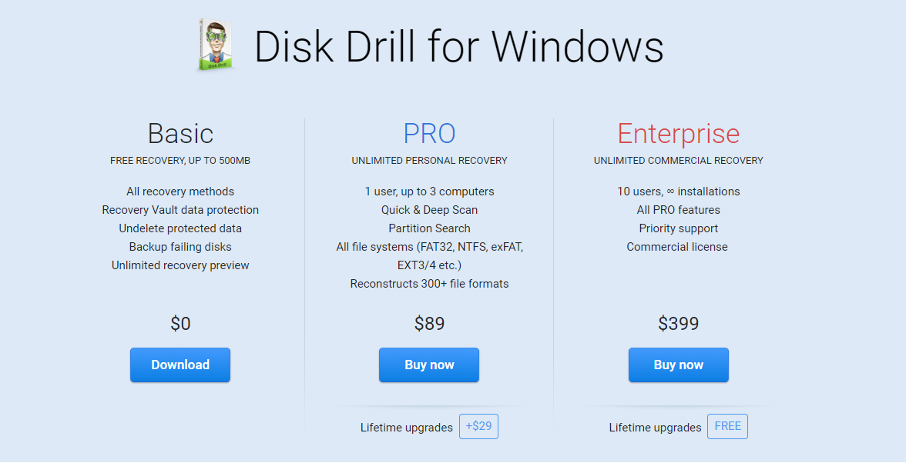

Please note that the prices of the upgraded app for both operational systems (Windows or Mac OS X) are the same.

Nevertheless, there is a number of free services you can try right away:

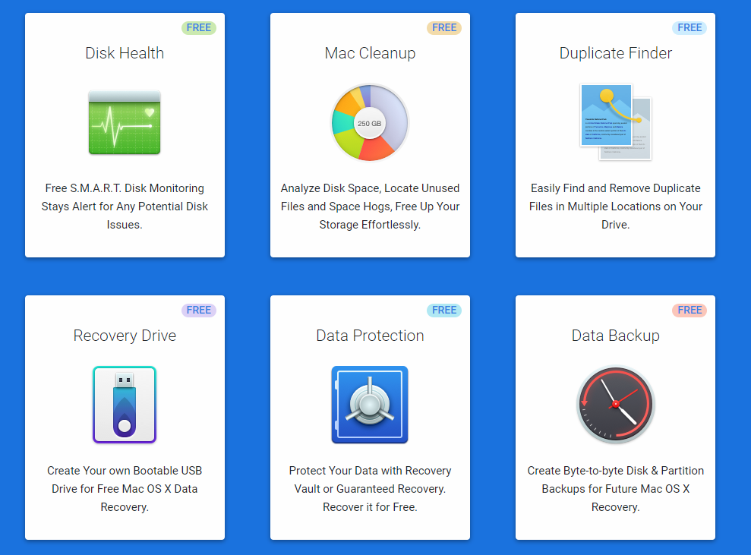

UX

UX is definitely the good side of the app. Disk Drill installation process took about five minutes, and the program was ready to work. As a matter of fact, the users can download the installation file directly on the CleverFiles site and start using its main features.

As Disk Drill is one of the user-friendly data recovery services, it’s easy to use even for a person that is working on data recovery for the first time.

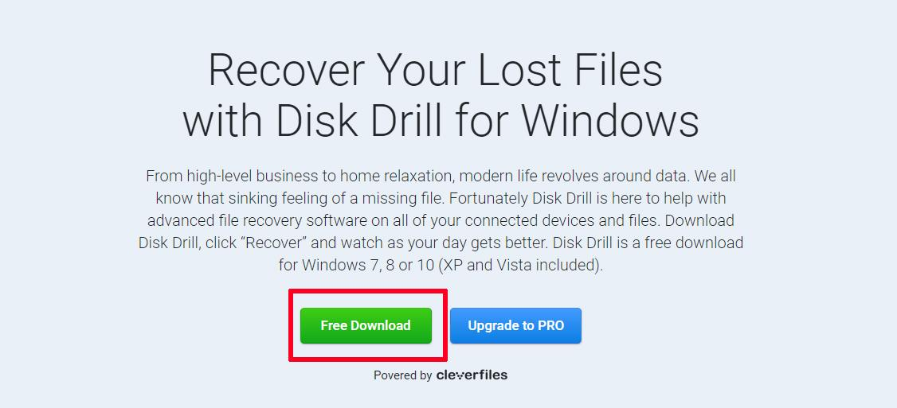

Moreover, the software provides a Disk Drill tutorial that quickly explains all the basic features of the applications.

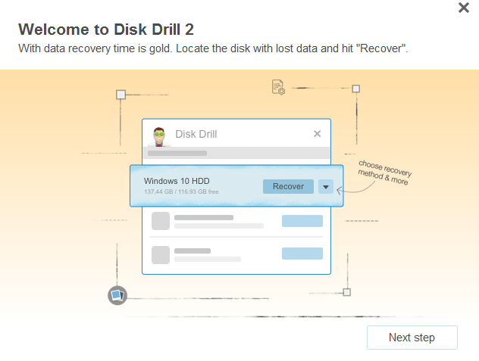

Customer Support

Unfortunately, the users can contact CleverFiles, the developers of Disk Drill, only through the Recovery Vault FAQs page.

Also, if you don’t see the file format you need in Disk Drill’s Preferences, you can send a request and the needed type will be provided soon.

To sum up

Disk Drill performs its options perfectly and can assure you that your important data is safe and protected from various incidents.

You can try the basic free options of Disk Drill application to recover data from a flash drive, hard drive or memory card, and then decide whether you need an updated version of it.

If you are facing such a task for the first time and have decided to restore the data on your own, we can also recommend reading the ‘Help’ section that you can find in the menu bar on the website.

Considering other options? Read here about the top data recovery software of 2019 and choose a perfect option to achieve your goals.

