Best Electric Shaver for Ingrown Hairs
Many people face the problem of ingrown hair. They feel an unpleasant sensation of pain, itching, poor appearance of the dermis, etc. We frequently blame our tools for aftershave problems. It affects skin inflammation, especially after the procedure. However, do electric razors cause ingrown hairs? Such problems are hidden a little deeper. Most of the issues lie in the structure of the curls or the wrong technology of its cuts. Of course, if you utilize a dirty tool, it may be the reason. Blunt blades, poor quality of hand tools, thin hair, and more are features of ingrown. Therefore, first, I advise you to select a quality tool. We’ve compared the top 5 products from Amazon. Every buyer may find the best electric shaver for ingrown hairs.

Braun Electric Razor Series 7

The Supersensual Tool with a Lot of Functions
The tool has nozzles that perform the most necessary functions to eliminate unwanted hair. It is beneficial for fast charging and extended period of exploitation. An effortless cleaning system and convenient shape plus a cover are perfect for a trip.

Top 5 Shavers for Improved Aftershave
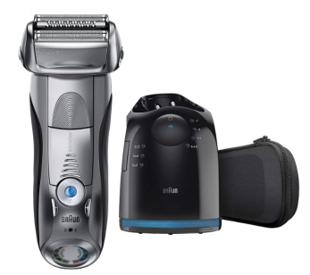 | Braun, Series 7 790cc | - Waterproof;  - Trimmer included;  - Foil;  - Wet & Dry;  - 50 min of work without charging;  - 1.97 Pounds.
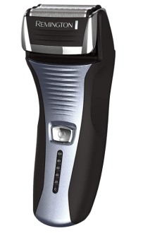 | Remington F5-5800 Foil Shaver | - Watertight;  - Trimmer contained;  - Foil;  - Only Dry;  - 60 min of runtime;  - 1 Pound.
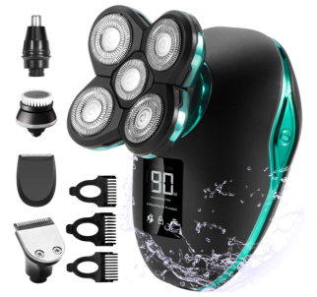 | Men's set from OriHea | - Showerproof;  - +4 Additional nozzles;  - Rotary;  - Wet / Dry;  - 90 min of continuous operation;  - 11.99 Ounces.
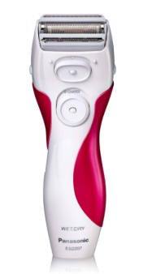 | Panasonic Device for Women | - Watertight;  - Built-in Trimmer;  - Foil;  - Wet & Dry;  - Works up to 10 shaves;  - 5.28 Ounces.
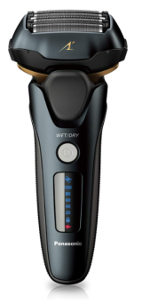 | Panasonic ES-LV67-K | - Waterproof;  - Trimmer included;  - Foil;  - Dry & Wet;  - 45 min of work;  - 6.4 Ounces.

Braun Electric Razor for Men, Series 7 790cc - Perfect Closeness & Smooth Shave

Electric Device from Braun is an enormous advantage for men who are always in a rush and often fight growing bristles. The movable head repeats all outlines of a body, and the station for purgation considerably saves time. All cut elements (4 pieces) ensure the smoothness of the derma.

Peculiar Features
The shaver is a foil remedy and performs its role with high smoothness and purity. You can utilize it both in water and quickly dry. Besides, it contains a trimmer and is watertight with a purgation system. A man performs the procedure for 50 min without charging.
Sometimes, there is a question about shaving cream for ingrown hairs and an electrical appliance. Not everyone knows if you may utilize creams, lotions, and what tools to combine. I always take notice of the manufacturers' instructions. For example, the Braun tool, suitable in water as a usual manual thing. So, therefore, cream or foam is possible in any case.
Pros:
- Long operation without charging;
- Cleaning without problems;
- For wet and dry exploitation;
- Floating head;
- Not large.
Cons:
- The blades quickly blunt;
- Not convenient in hard to reach places.

Completion
You can read many positive customer reviews and view all features. In particular, you’ll receive a specialized unit for cleaning, cover, and trimmer. Nevertheless, there are negative descriptions too, especially of the rapid blunting of the blades. Therefore, you should decide because the tool has a fairly high price. I recommend it as a rapid and practical thing, and I think you will be satisfied.

Remington F5-5800 Foil Shaver - Ease & Convenience in the Operation
The Remington razor ensures pleasant to the touch derm. It has three layers of knives. Each of them has customized functions for trimming the length or cleaning the bristles completely. All specialized features facilitate practicality.

What to Look for?
The device is economical, but the procedure is quick, qualitative, and easy. Charging lasts 2 hours, and an operating time is 60 minutes that is enough for 20 times. This Remington safety razor ingrown hair will provide smoothness and pleasant touch.
Pros:
- 60 min of wireless operation;
- Ease of application;
- Washable head;
- The smoothness of the derma.
Cons:
- Frequent replacement of nozzles;
- Pulls and pinches the face.

Final Words
A lot of customer reviews greatly simplify everyone's choice. So, I commend reading it before buying it. Despite the high ratings, the cost is low. Although buyers claim that the foil breaks too rapidly. So, determine your choices very well. After all, not everyone can afford to replace parts several times a year. I always say that the device and its working existence require the right conditions, and care, storage skills, and many other features. Do you agree with me?

OriHea Electric Shaver & Grooming Kit for Men - Widely Practical and Smart Set
The device from OriHea 4 in 1 is good at all procedures. Charging it takes a little period compared to others like it. The buyer will see a small but useful screen with a light on the battery. Thus, you can plug the tool in and continue or end the procedure. Isn't that cool? Such a thing helps me a lot because I often forget to recharge my device. And then my defeat comes when I hurry. So, I have to take a disposable razor. This device can be up to half an hour under the shower.

The Substantial Advantages
OriHea shavers are famous for many benefits. You may be surprised by extremely useful nozzles combined with a nice price. Thanks to such functions, you can forget about the excess vegetation in the nose, head, ears, and more. Its head is floating, and everyone may open the device for cleaning the remains of dirt.
Pros:
- Compact size;
- Versatility;
- Affordable price;
- Waterproof.
Cons:
- It fails quickly;
- It doesn't justify expectations.

Finishing
I can name it as the best electric razor for ingrown hairs because it doesn't touch with the knives to the dermis. You won’t feel the maximum smoothness but without irritation. I recommend it as a beautiful and multifunctional gift. It is practical for a trip due to its small dimensions and a sufficient period of operation without charging.

Women Panasonic Electric Shaver - Moisture-proof Tool for Sensitive Derma
Very often, women are skeptical when searching razors for their tender legs. Of course, red spots, itching, ingrown hairs on the legs, and an ugly appearance are the undesirable outcome after the procedure. This Panasonic electric device can be the preferable alternative for every person of the weaker half of humanity.

Key Peculiarities
This device is adapted to the excellent cleaning of hair in all necessary areas. It includes a trimmer and three sharp blades with thin foil. Besides, you may perform the procedure in water or dry. It is non-irritating and well-thought-out for delicate skin. Charging lasts 12 hours, and running time is 20 minutes.
Pros:
- Anti-allergic steel blades;
- Low price;
- 10 shaves without charging;
- Nice design.
Cons:
- A long period to charge;
- Sometimes leaks water.

Ending
Among the many women's razors to prevent ingrown hairs, this Panasonic device is ideal. It ensures a smooth shave in just a few minutes. It is perfect in design, with a trimmer for a special haircut in the intimate area. Its knives are specialized, made of anti-allergic steel. I can say with confidence that women with delicate derma need it most of all.

Panasonic ES-LV67-K Electric Flexible Razor - High Productivity and 16-D Flexibility
Panasonic ES-LV67-K is a modern device for every boy. It has a great design with a display showing the charge level. The cost is quite high due to its functionality. The tool doesn’t leave hair. Besides, you won’t face the problems of redness and inflammation of the derma.

General Characteristics
This tool has a qualitative and sturdy motor that does its job quickly. An elastic head provides comfort in any part of the face. Therefore, you won’t have to ask yourself how to shave the neck to avoid ingrown hairs. You will not feel irritation and inflammation of the derma with the Panasonic ES-LV67-K.
Pros:
- Great design;
- Strong powerful motor;
- Flexible head 16-D;
- For wet & dry utilizing;
- Available trimmer.
Cons:
- Rapid blunting of the blades;
- Noisy.

And the Last
Most buyers are enthusiastic about this appliance and claim a characteristic clean shave. I also recommend the device because it includes a proper sharp trimmer, flexible head, powerful motor, and sensor. Everyone may shave with it using cream and water. Likewise, it passes each section of the face clearly and neatly.

Prosperous Tips on How to Select the Preferable Shaver for Ingrown Hairs
Very often on forums, people ask questions, does an electric razor prevent razor bumps. Of course, a poor quality instrument can have a bad effect on the derma. Every individual may suffer from redness and ingrown hairs. Therefore, everyone should carefully consider the choice of care items for your body. Let's learn what to focus on and how to make no mistake in a quality thing.

A Few Words about Types
The modern market offers many models, among which everyone can get lost. You can choose a foil or rotary type. Of course, manufacturers are trying to make both of them as perfect as possible. However, only the users can figure out which tool suits them best.
- The devices have many key characteristics, such as convenience, speed, safety, versatility.
- The operating time depends on the battery capacity.
- Each razor can work from the accumulator or electricity.
- The charging period depends on the type of battery and may last up to 16 hours.
- Modern tools are charged within 1 to 3 hours.
- They have a range of work from 20 to 90 and more min of continuous operation.
- Both types have several heads (rotary 2-3, and foil 1-4).
- You need to oil an electric shaver, clean it after work.

Razor Vs Electric Shaver Ingrown Hairs
Often people doubt such issues. Of course, it is common because the devices differ in price and on the quality of shaving. A normal hand tool has too much contact with the skin. This option can cause various inflammatory processes in people with hypersensitivity of the derma. The electric device is safer and faster. Therefore, I recommend choosing this type.
According to research by Oglala Lakota College, many individuals experience ingrown hairs, irritations, and so on. Such persons should pay attentiveness to electric razors for ingrown hairs. This option is faster and safer than manual tools. Of course, look at your precedence, skin sensitivity, type of device, its features, etc.

Equipment and Options
The buyer may find many suitable and exclusive models of varied brands at different prices. Most of the distinctive features, additional nozzles, water resistance, and a long period of wireless operation affect the higher price. Besides, razors have a variety of movable floating heads. Such distinctness allows the tools to move along the curves of the face or body. Some modern models even have a whole moving unit.
Pay attention to the possibility of shaving in water. Not all electrical appliances can be adapted to moisture and produced for dry utilizing. Besides, in the process of washing, the water assists deep, high-quality purifying. Don't forget to inspect the models with additional nozzles, stand, self-cleaning device, cover, built-in trimmer, and others.

FAQ

Should I Utilize an Electric Razor for Ingrown Bristles?
Many people often face the problem of ingrown hair. I also sometimes had such nasty red bumps. They are signs of inflammation. It is in the case of hair twisting and growth in the opposite direction under the derma. This trouble can happen if you do the procedure with too sharp knives and close contact with the dermis. The blades of electric devices do not touch the skin too close thanks to the cover above them. So, you’ll be protected from irritation and ingrown hairs. It is an enjoyable option for individuals with similar problems and overly impressionable derma.

Is there a Risk of Ingrown Hairs from an Electric Shaver?
The biggest pest for the derma is dirt, and especially, a dirty instrument. If you left it unclean well after the previous procedure, it is most likely that you will receive ingrown hairs next time. I'm talking about two types of tools, hand and electric. As you understand, there is a risk of fighting than with a very unpleasant problem. I recommend paying more attention to your tools. Clean each blade, and lubricate them more often with specialized oil. So, even electrical tools can cause ingrown bristles.

Conclusion
Too many individuals have cases with subcutaneous hair in diverse areas of the body. How to prevent ingrown hairs on the face after shaving? I can give a lot of advice on how to care for your dermis properly. Nevertheless, finding a razor is one of the most important solutions to such problems. If any of you have encountered this as well, you removed your hair incorrectly, or your tool was dull or dirty.
The main task for people who often face skin inflammation problems is to take care of the dermis. When everyone learns to do it right, with all the rules, and choose a good tool, the smoothness of the skin is guaranteed. I have introduced you to a list of quality tools. Be careful and consider the type of your dermis, shaving methods, charging time, and many other features. I believe that you may detect the best electric shaver for preventing ingrown hairs easily based on customers and my reviews.

