Social networks
Daria Dobrovolska, student at the Institute of Journalism, Publishing and editing, KUBG

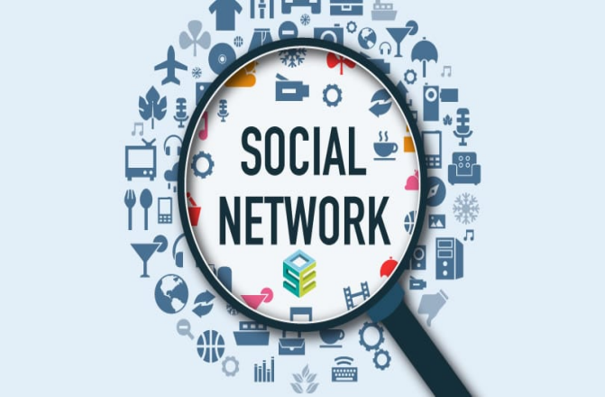
In the last decade or so, social media has become firmly entrenched in our lives. In itself, the concept of "social media" covers several categories: blogs, live magazines, forums, chats, dating sites and, of course, social networks. In essence, they are all platforms for remote communication between people, ie for the exchange of various types of information: text messages, music, photos and video content.
On the one hand, the social network is a very handy tool for instant messaging, finding old friends and new acquaintances, storing important information and discussing current issues in groups without leaving home. On the other hand, psychologists and psychiatrists around the world are sounding the alarm. Addiction to social networks all too often causes serious mental and nervous disorders such as depression, social isolation, autism, and even suicide attempts in adolescents and young adults. In my opinion, social networks can be both useful and dangerous, depending on who uses them and how. And I want to try to analyze their advantages and disadvantages
Advantages of social networks
First of all, social networks are very convenient for those who need to keep in touch with people living in different cities or countries. With this site you can quickly create a group chat, send the necessary files to several people, share photos, videos and even start a video conference. And it's all absolutely free! Social networks can be a great solution for people with disabilities or for those who for some reason are forced to stay at home all the time. In some situations, they can completely replace live communication and help such people not feel lonely and socially isolated. Numerous interest groups will allow them to find friends and interesting interlocutors.
Sometimes social networks help to find really valuable and useful information. In different communities, people from all over the world discuss different issues, share personal experiences, give useful links, write comments and reviews on products and services. You, in turn, can ask any question and get answers from different people.
Disadvantages of social networks
It was one side of the coin. Unfortunately, there is another that is not so rosy. For a huge number of children and adolescents, social networks today have almost completely replaced real life. Some of them spend so much time online that the line between life and virtual reality becomes blurred for them. As a result, children suffer from a lack of live communication, although they do not even realize it. This inevitably causes mental disorders, affects their health and mental state and interferes with normal socialization.
The second big problem with social media is information leakage. When you publish any personal information, you can never know where it will go. Anyone can use your personal photos, and in most cases you will not be able to prevent it. Even if you think that your page is protected by a strong password, you are wrong, because good hackers will break it in two seconds.
So, to sum up, I would like to say that social networks could be very useful if all people used them for their intended purpose - to communicate, find friends and share information with them. Also, in my opinion, caring parents should limit their children's access to social networks and regularly check their actions on the Internet. Otherwise, social networks can cause significant damage to the psyche of children and adolescents.

